**Installation Tools:**

1. .Net Core SDK (translate/execute C# code into instruction for the machine)
2. Any Editor like (VS code)
3. Add C# extension in VS code

Any high level language needs additional software to execute the code

**Variables:**

We can use var for all types

Double x =3.45 the same as var x =3.45

Need first initialization to use variable

Wrong   
int x;   
x=x+1;

Right   
int x=0;  
x=x+1;

**Arrays:  
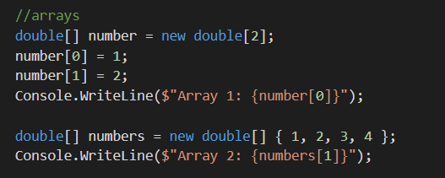**

**List:**

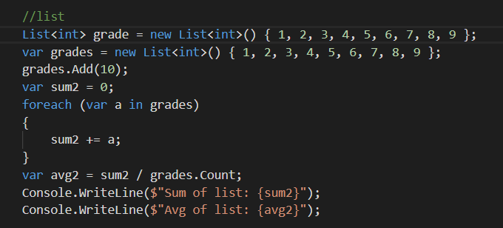

**Loop:**  
