Commands

1. Git status: inform you where are u(current branch) and if there is any commits not pushed yet  
   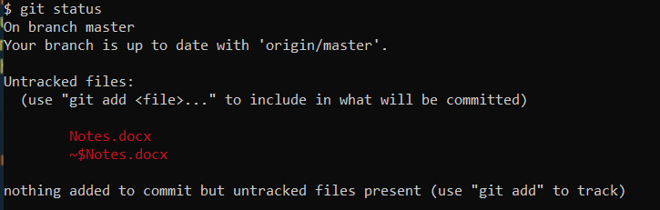
2. File Stages: Committed -> modified -> Staged
3. Git status -s: short status  
   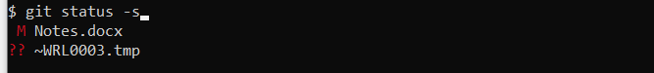

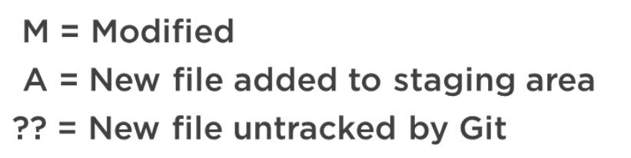

1. Git log: to check the history of commits

Seven rules to write a commit message:

1. Separate subject from the body with a blank line
2. Limit the subject line to 50 characters
3. Capitalize the subject line
4. Do not end the subject line with a period
5. Use the imperative mood in the subject line
6. Wrap the body at 72 characters
7. Use the body to explain what and why vs. how

Branches:

Merge: