

|  |
| --- |
| Business Template  **Subject areas** |
| **Logo / Image** |

Contents

1 Business Description 3

1.1 Business background 3

1.2 Problems. Current Situation 3

1.3 The benefits of implementing a database. Project Vision 3

2 Model description 3

2.1 Definitions & Acronyms 3

2.2 Logical Scheme 3

2.3 Objects 3

# 

# Business Description

## Business background

The auction house serves as a marketplace for antiques and artwork, connecting sellers and buyers. Sellers submit things to the auction house, which assigns each item a lot number and schedules it for auction. Buyers bid on these products, and the winning bid at the end of the auction sets the ultimate sale price. After an item is sold, the buyer completes the transaction, and the seller is paid.

## Problems. Current Situation

Data Inconsistencies – Manual records lead to errors in tracking auction lots, bids, and transactions.

Slow Processing – Retrieving information about past auctions, bids, and payments is time-consuming.

Lack of Integration – Different departments (finance, operations, sales) store data separately, making reporting difficult.

Limited Buyer/Seller Insights – No clear record of purchase history or seller performance.

Risk of Data Loss – Paper-based or spreadsheet systems do not provide secure storage or backups.

## the Benefits of implementing a database. Project Vision

By implementing a relational database, the auction house will achieve:

* Improved Data Integrity – No duplicate records, ensuring accuracy in auction tracking.
* Faster Processing – Quick access to buyer, seller, and auction details with real-time updates.
* Better Financial Tracking – Clear records of bids, payments, and transactions for accountability.
* Enhanced Security – User authentication and access control to protect data.
* Automated Reports – Sales trends, buyer activity, and auction performance analytics.

# Model description

## Definitions & Acronyms

Auction – A scheduled event where items are sold to the highest bidder.

Lot Number – A unique identifier assigned to an item within a specific auction.

Seller – An individual or organization that submits items for sale at an auction.

Buyer – An individual or organization that bids on and purchases items at an auction.

Bid – An offer made by a buyer to purchase an item at a specific price.

Transaction – The final sale process after an auction is completed, recording the buyer, final price, and item details.

Payment – The financial settlement made by the buyer to complete a purchase.

Auction Lot – The association between an auction and an item, including the starting price.

Category – The classification of an auction item (e.g., paintings, antiques, sculptures).

Employee – Auction house staff members, including auction managers and assistants.

Location – The venue where an auction takes place.

## Logical Scheme

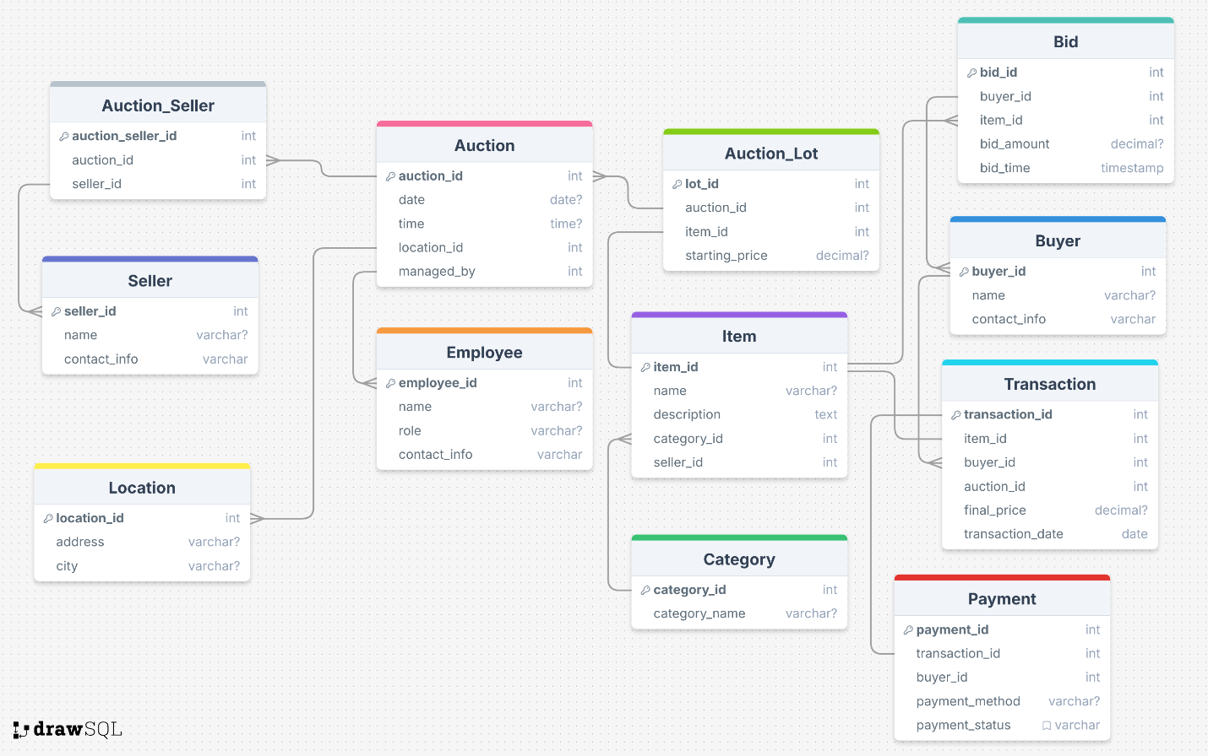

## Objects

Table Description

|  |  |  |  |
| --- | --- | --- | --- |
| Table Name | Field name | Field Description | Data Type |
| Auction | auction_id | Unique auction ID (PK) | Int |
| date | Auction event date | date |
|  | time | Auction event time | time |
|  | location | Auction venue ID | int |
|  | managed_by | Auction venue ID | int |

|  |  |  |  |
| --- | --- | --- | --- |
| Table Name | Field name | Field Description | Data Type |
| Item | item_id | Unique item ID (PK) | Int |
| name | Item name | varchar |
|  | description | Item details | text |
|  | category_id | Item category (FK) | int |
|  | seller_id | Seller of item (FK) | int |
| Table Name | Field name | Field Description | Data Type |
| Seller | seller_id | Unique seller ID (PK) | Int |
| name | full name | varchar |
|  | contact_info | Sellers contact details | text |
| Table Name | Field name | Field Description | Data Type |
| Buyer | buyer_id | Unique buyer ID (PK) | Int |
| name | full name | varchar |
|  | contact_info | buyers contact details | text |

|  |  |  |  |
| --- | --- | --- | --- |
| Table Name | Field name | Field Description | Data Type |
| Bid | bid_id | Unique bid ID (PK) | Int |
| buyer_id | Buyer placing bid | int |
|  | Item_id | Item being bid | int |
|  | bid_amount | Bid price offered | decimal |
|  | bid_time | Time of bid | time |

|  |  |  |  |
| --- | --- | --- | --- |
| Table Name | Field name | Field Description | Data Type |
| Transaction | transaction_id | Unique transaction ID (PK) | Int |
| buyer_id | Buyer completing purchase (FK) | int |
|  | Item_id | Purchased item ID (FK) | int |
|  | auction_id | Auction selling item | int |
|  | final_price | Sold item price | int |
|  | transaction_date | Sale completion date | date |

|  |  |  |  |
| --- | --- | --- | --- |
| Table Name | Field name | Field Description | Data Type |
| Auction_lot | lot_id | Unique lot ID (PK) | Int |
| auction_id | Auction holding item (FK) | int |
|  | item_id | Item in auction (FK) | int |
|  | starting_price | Initial bid price | decimal |

|  |  |  |  |
| --- | --- | --- | --- |
| Table Name | Field name | Field Description | Data Type |
| Category | category_id | Unique category ID (PK) | Int |
| category_name | Type of item | varchar |

|  |  |  |  |
| --- | --- | --- | --- |
| Table Name | Field name | Field Description | Data Type |
| Location | location_id | Unique location ID (PK) | Int |
| address | Location address | varchar |
|  | city | Location city | varchar |

|  |  |  |  |
| --- | --- | --- | --- |
| Table Name | Field name | Field Description | Data Type |
| Employee | employee_id | Unique employee ID (PK) | Int |
| name | full name | varchar |
|  | role | Job role | varchar |
|  | contact_info | employee contact details | text |

|  |  |  |  |
| --- | --- | --- | --- |
| Table Name | Field name | Field Description | Data Type |
| payment | payment_id | Unique payment ID (PK) | Int |
| transaction_id | Payment transaction ID (FK) | int |
|  | buyer_id | Paying buyer ID (FK) | int |
|  | payment_method | Payment type | decimal |
|  | payment_status | Payment completion state |  |

|  |  |  |  |
| --- | --- | --- | --- |
| Table Name | Field name | Field Description | Data Type |
| Auction_seller | auction_seller_id | Unique relation ID (PK) | Int |
| auction_id | Auction selling items (FK) | int |
|  | seller_id | Seller in auction (FK) | int |

Comments on table relationships

Auction - Location (One-to-Many)

One location can host many auctions.

Foreign Key: Auction.location_id → Location.location_id

2. Auction - Employee (One-to-Many)

One employee (manager) can manage many auctions.

Foreign Key: Auction.managed_by → Employee.employee_id

3. Auction - Auction_Lot (One-to-Many)

One auction can have many auctions lots (each containing an item).

Foreign Key: Auction_Lot.auction_id → Auction.auction_id

4. Item - Auction_Lot (One-to-One)

One item is part of one auction lot.

Foreign Key: Auction_Lot.item_id → Item.item_id

5. Item - Seller (Many-to-One)

Many items can be owned by one seller.

Foreign Key: Item.seller_id → Seller.seller_id

6. Item -Category (Many-to-One)

Many items can belong to one category.

Foreign Key: Item.category_id → Category.category_id

7. Buyer - Bid (One-to-Many)

One buyer can place many bids.

Foreign Key: Bid.buyer_id → Buyer.buyer_id

8. Item - Bid (One-to-Many)

One item can receive many bids from different buyers.

Foreign Key: Bid.item_id → Item.item_id

9. Buyer - Transaction (One-to-Many)

One buyer can complete many transactions.

Foreign Key: Transaction.buyer_id → Buyer.buyer_id

10. Item - Transaction (One-to-One)

One item can be sold in one transaction.

Foreign Key: Transaction.item_id → Item.item_id

11. Auction -Transaction (One-to-Many)

One auction can have many transactions (for sold items).

Foreign Key: Transaction.auction_id → Auction.auction_id

12. Transaction - Payment (One-to-One)

One transaction corresponds to one payment.

Foreign Key: Payment.transaction_id → Transaction.transaction_id

13. Seller - Auction_Seller (Many-to-Many)

One seller can participate in many auctions.

One auction can include many sellers.

Junction Table: Auction_Seller

Auction_Seller.auction_id → Auction.auction_id

Auction_Seller.seller_id → Seller.seller_id

Auction

|  |  |  |  |  |
| --- | --- | --- | --- | --- |
| Auction_id | date | time | Location_id | Managed_by |
| 1 | 2025-04-10 | 18:00 | 1 | 104 |

Item

|  |  |  |  |  |
| --- | --- | --- | --- | --- |
| item_id | name | description | category_id | seller_id |
| 1 | Antique Vase | 19th century vase | 1 | 201 |

Seller

|  |  |  |
| --- | --- | --- |
| seller_id | name | Contact_info |
| 201 | John Dao | johndao@gmail.com |

Buyer

|  |  |  |
| --- | --- | --- |
| buyer_id | name | Contact_info |
| 301 | Mark Green | mark@gmail.com |

Bid

|  |  |  |  |  |
| --- | --- | --- | --- | --- |
| bid_id | buyer_id | Item_id | bid_amount | bid_time |
| 1 | 301 | 1 | 500 | 18:05 |

Transaction

|  |  |  |  |  |  |
| --- | --- | --- | --- | --- | --- |
| transaction_id | Item_id | buyer_id | auction_id | final_price | transaction_date |
| 1 | 1 | 302 | 1 | 550 | 2025-04-10 |

Auction_lot

|  |  |  |  |
| --- | --- | --- | --- |
| lot_id | auction_id | Item_id | Starting_price |
| 1 | 1 | 1 | 400 |

Category

|  |  |
| --- | --- |
| category_id | Category_name |
| 1 | Ceramics |

Location

|  |  |  |
| --- | --- | --- |
| location_id | address | city |
| 1 | 12 Main St | Los Angeles |

Employee

|  |  |  |  |
| --- | --- | --- | --- |
| emloyee_id | name | role | Contact_info |
| 101 | Mark Johnson | Auctioneer | mark@gmail.com |

Payment

|  |  |  |  |  |
| --- | --- | --- | --- | --- |
| payment_id | transaction_id | buyer_id | payment_method | payment_status |
| 1 | 1 | 301 | Credit Card | Completed |

Auction_seller

|  |  |  |
| --- | --- | --- |
| Auction_seller_id | Auction_id | Seller_id |
| 1 | 1 | 201 |