PR approval guideline

Pre-requisite: you cannot have PO lines merging several FPCs. It has to be separated by PO or by line inside same PO
If the PR doesn’t relate to one of the below FPC, contact guillaume on keep on hold.

- Product S79/S77/F35/F19/S60/S12/S13/S14/S17/S18/F98

Check the account number by clicking additional info until you see the account:
- License capex: “perpetual only” Capex= code 4XXXX sinon Opex code 5XXXXX ou code 6XXXX
Check the PO validity date
Check the purchasing category

1/ Check Product in the PR description: Make sure this is in the List S79/S77/F35/F19/S60/S12/S13/S14/S17/S18/F98 and consistency with OCD proposal description (item 5/ below)
- 1 line in the PO per FPC (no line merging several FPCs)
2/ Check the Value:
- Check the value is matching the OCD proposal (value and currency)
- When OCD proposal is a mail from OCD or looks to be global order for several gold order
  - Ask Gold Order complete list
  - Ask confirmation Gold order value sums up to the total
  - Ask confirmation all Gold order are under the same product

3/ Check the Financial set up
- Read the OCD proposal to understand the OTC/MRC/which period
- Make sure this is ERS or managed and consistent (ERS cannot be MRC, etc…)
- Make sure the invoice period in the PO is aligned with Gold (for ex 12 months invoicing period in Gold should be 12 lines of MRC in the PO)
- Check that the OTC breakdown (if any) is aligned with delivery schedule as described in OCD quote (split in several lines if needed)
- Check with the Gold print screen (exception PMI and JTI using websource)
  - Value to match
  - FPC to match
  - OTC/MRC to match (1 line in PR for OTC, A line per month/FPC for MRC)
- Specific case of Zero Gold order value: additional screen copy have to be attached

When the number of related gold order is 5 or less:
  - 1 print screen of Zero gold order where we see the link with real gold order ref (comment field with standardized text (to allow IT extract)
  - Usual gold order print screen for each related real gold order
  - For example: 1 zero gold order with 5 real gold order should contains 6 print screen
    - 1 print screen of zero gold order showing the reference of the 5 real gold order
    - 5 sprint screen of each real gold order (usual print screen showing value/FPC/OTC/MRC)
    - Total of the 5 needs to match with PR to OCD value OTC/MRC/FPC

When the number of related gold order is more than 5: Pre-approval need to be given by Guillaume (all gold order/matching data needs to be provided by mail) and attached to PR. Mail title must be “pre approval requested xxxx” and to send to Guillaume/Florian/Vadisha.

4/ Check the entities
- OB and OCD local to local
- Check the supplier name (OCD name must match the entity)
- If in OBI Fusion, please use this table

NFPS Entity | Fusion BU | Country
GNK | 0811 | Netherlands
GS5 | 0819 | Switzerland
GPI | 0822 | Portugal
GGM | 0872 | UK

5/ Check the MC/CDR

6) Check the margins
- DPS84 to DPS88 and SC21J to SC21P are revenue transfers MC: Margin should be 0% except specifically agreed by G.Bierce/G.Moulin
- DPS10/DPS13/SC21R/SC21S are “purchase on behalf” made by OB for OCD and component of customer services. Margins, as such, doesn’t make sense. Cannot be negative but can be any %age.
7) Check the consistency of different components

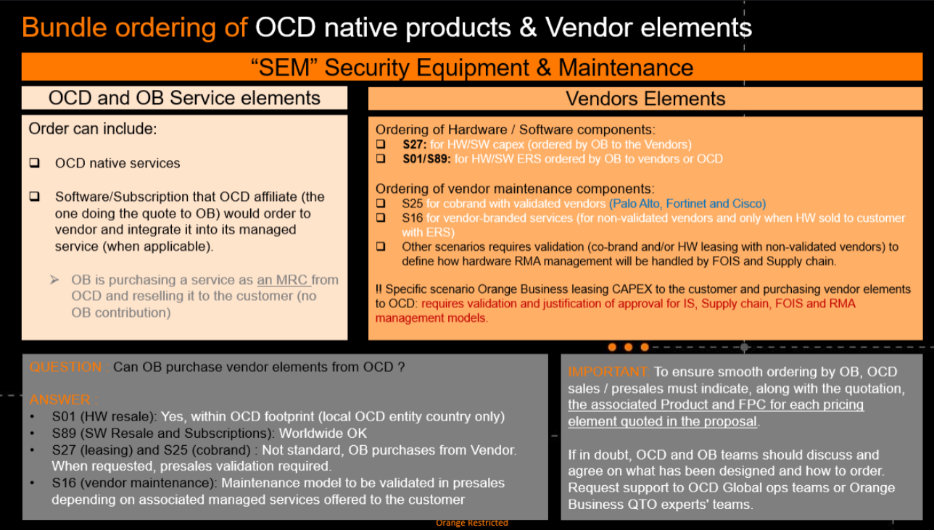
For example:
- a S79 order cannot contain HW
- a S79 order can contain software but cannot be 1 shot invoice invoice to end customer (else this is S89)
- etc…

We need to ask Product reclass if needed (for ex A HW that is invoice 1 shot needs to go back to S01, a HW that is owned by OB needs to go S27, etc…)

8) Specific Morocco order (sales channel in Morocco)
- S89 may lead to a PR in Fusion France to OCD France, please use SC21J to SC21P (as per section 8/B below)
- For S79/S60/S12/S13/S14/S17/S18/F98, it may happen the OCD quote value is below the Gold order amount if OB/OCD teams in Morrocco are delivering part of the service. Please ask a per exception validation to G.Moulin & G.Bierce.

- S27 Bucket
Check all items 1/, 5/, 6/, but MC to be DPS09.
Supplier cannot be OCD except approved by Tax dpt (Xavier Badoy for HW) and RMA / maintenance model has been validated.

- S25/S16/S01/S89
is not validated by me, normally thru IS chain. Any request in that product list is probably a mistake. Exception in France, the ERS process can generate a PR
- to OCD France: use a revenue transfer CDR
- to external supplier: PoB CDRs (SC21S)

Contacts:
- Richa Sharma- ESO Manager (Team in charge of issuing the orders)
- KHWAZADA Safikul Rahiman - process owner
- Moulin Gwenaelle / Bergam Ouissam - Finance
- Eric Alessio - Service

C/ Purchase on behalf sur produit legacy OB
OB Legacy product where OCD « intercept » orders in OB system
1/ Order to suppliers for delivery/staging in France land resend to OB country thru Hub de Rennes.
2/ On some countries not covered thru Hub de Rennes, PO needs to be local to local thru OB
3/ On some countries not covered thru Hub de Rennes and without OB local presence, those HW/SW are ordered as a service to the supplier Octopian
1/2/3 can be recognized by a single PR initiator MALIK Yusuf Ali OBS/GDO, In case of doubt, contact Patrick Hernot at OCD
Choice of 1/2/3 to be confirmed with hub de Rennes country list - hub de rennes

- To validate1:
- Capex control as for pt with Finance
- Check the MC DPS09
- Check OCD is the only possible supplier, check amount with central team ( BHANDARE Parag OBS/GDO – GILLESPIE Ciaran OBS/FIN

- To validate2:
- Capex control as for S27 with Finance
- Check the MC (DPS 10 for Build, DPS13 for Run)
- Check OCD and Octoptian are not the supplier, and that sourcing has approved in the chain

- To validate3:
- Check the MC (DPS 10 for Build, DPS13 for Run)
- Check Octopian is the supplier, and that sourcing has approved in the chain

Important: it may happen that the Gold order is not available for various reason like
- Mistake in selecting wrong product code
- Gift to the customer (to cover quoting, over commitment)
- …..
In such situation, this is OBI decision and not revenue trans and should therefore impact its P&L. please reject and redirect to former MC (DPS22/DPS23 or any other OBI orders)

D/ revenue transfer OCD France (1st of july)
To draft

PO reception guideline

PO Int NFPS
OTC- proceed with reception at the “Planned delivery date” in Gold. (Richa S to confirm the exact date in Gold with Vineet)
MRC- same check with account team but only from the start date (this is aligned month #1 in PO), alert Finance if gap

PO Ofusion (when we have a gold order)
OTC- check that OCD delivery is done (as per delivery milestone) with account team (service owner) before actionning total reception on a given PO line with the real delivery status.
MRC- same check with account team but only from the start date (this is aligned month #1 in PO), alert Finance if gap

PO closure

