Client-Server Application
Server Test cases :

1- Verify that the server starts correctly and begins listening on the specified port

Steps:
1. Configure the server with a specific port number.(43869)

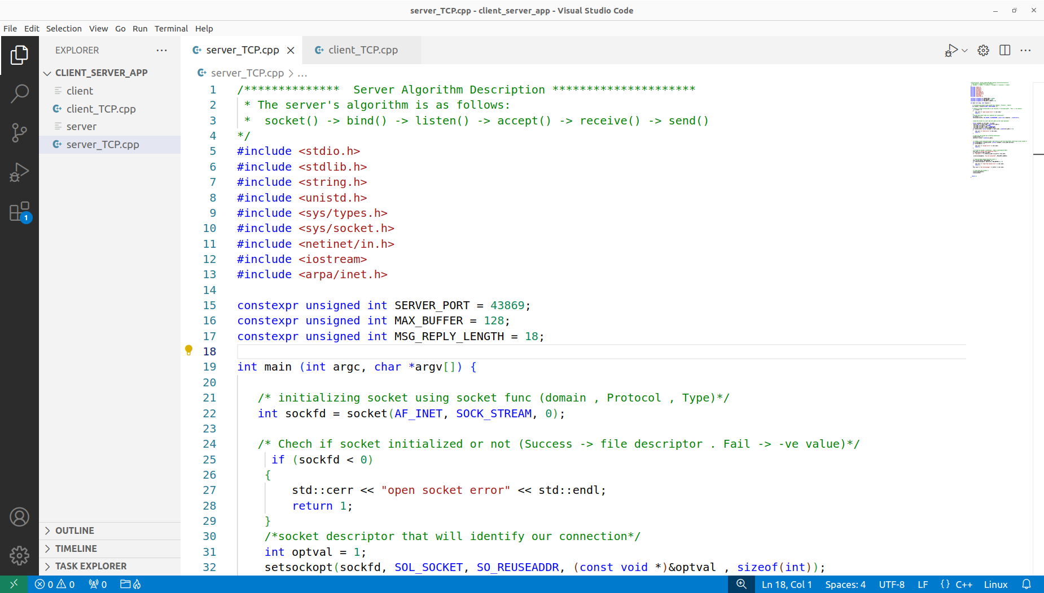
2. Start the server.
3. Check if the server is listening on the specified port (ss -a -t)

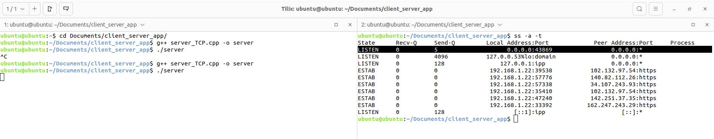

2- Ensure that the server correctly listens on different specified ports.
Steps :
1. Start the server with port (43869).
2. Verify the server is listening on port (43869).

3. Stop the server and restart it with port (50567)
4. Verify the server is listening on port (50567)
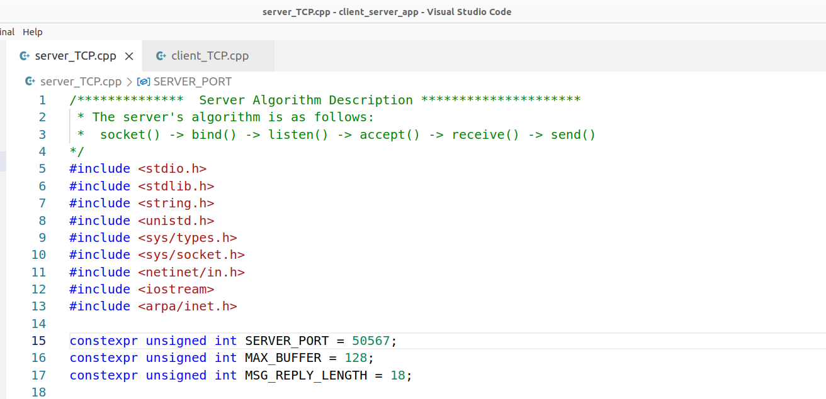

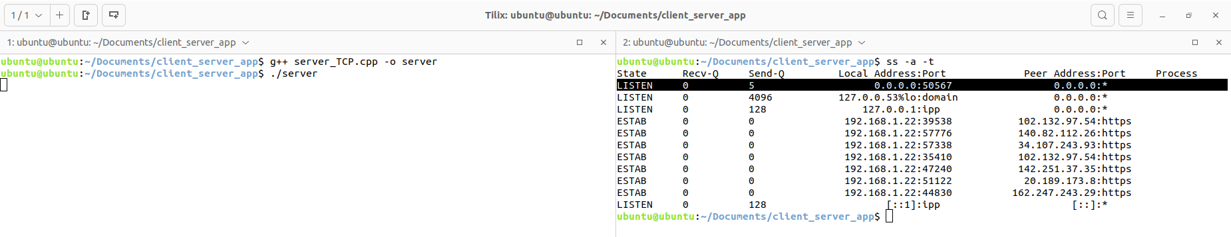
3- Confirm that the server accepts incoming connections.
Steps :

1.Start the server.
2. Use a client to attempt a connection to the server.
3. Check the server logs or use a monitoring tool to verify the connection was accepted. ( netstat -ntp)

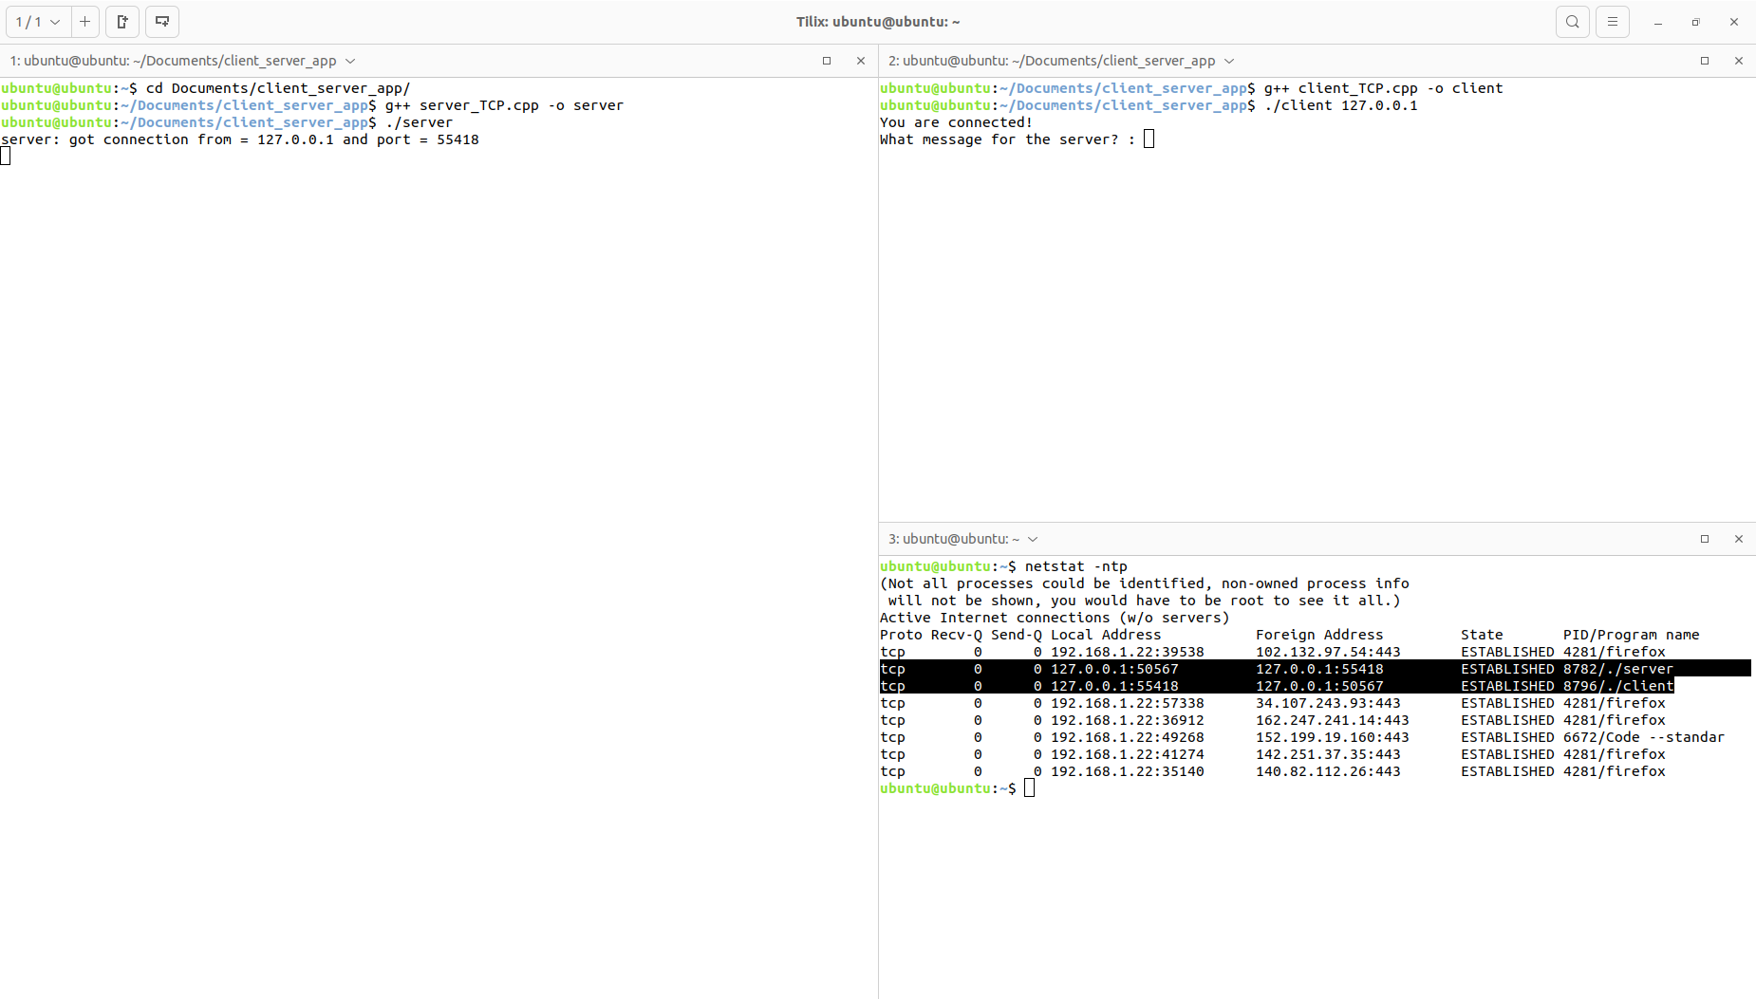

Client Test cases :
1- Ensure the client starts correctly and attempts to connect to the server.

Steps:
1.Start the client with a valid server IP and port number.
(telnet IP Port Number)
2. Check if the client sends a connection request to the server.
(netstat -ntp)

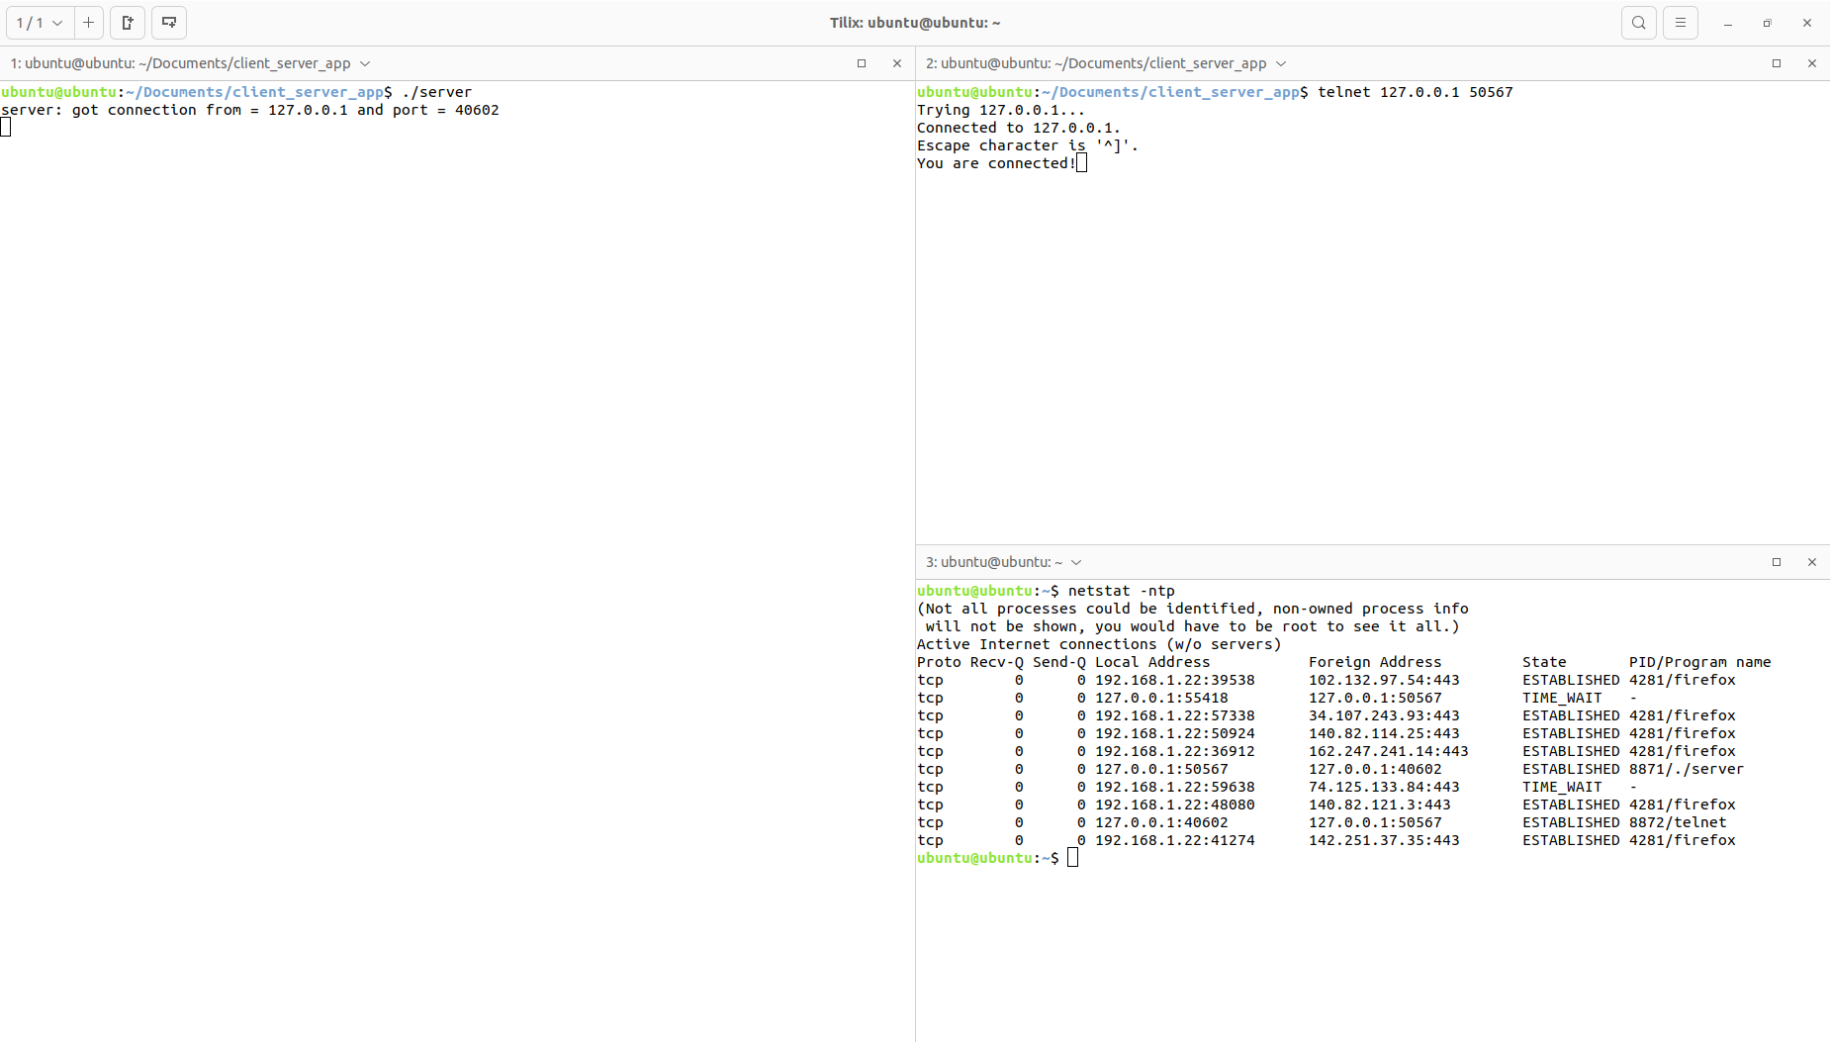

2- Ensure the client correctly handles cases where the server is unavailable or refuses the connection.
Steps:
1. Start the client with a server IP and port where no server is running.
2. Observe how the client reacts to the failed connection attempt.

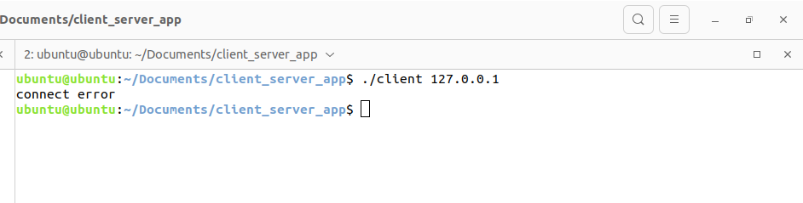
Running State of Application :

