E-COMMERCE CLICKSTREAM ANALYTICS PLATFORM
Gold Layer: Data Modeling & Data Marts
Technical Documentation & Implementation Report
Author: Youssef Mahmoud Abu Ali
Track: Big Data Architecture & Cloud Engineering
Platform: Microsoft Fabric (OneLake) · Delta Lake · Power BI
Dataset: REES46 eCommerce Clickstream

Table of Contents

1. Executive Summary & High-Level Architecture

1.1 Project Purpose & Core Objectives
This documentation details the production-grade Data Modeling and Data Marts architecture engineered for an enterprise-scale Clickstream Analytics Platform. The platform ingests, cleanses, structures, and aggregates a high-velocity log containing 8,248,730 raw interactions (spanning 117,286 unique products and 709,231 users).
The primary objective of the Gold Layer is to convert uncurated, semi-structured clickstream logs into a high-performance analytical data warehouse. The architecture serves two distinct consumers:
- Business Intelligence (BI) Analysts: sub-second query latency for executive dashboards and funnel analytics in Power BI.
- Machine Learning Engines: structured, leakage-free historical feature stores for recommendation algorithms and customer profiling.

1.2 Enterprise Cloud Platform Shift (Azure Databricks to Microsoft Fabric / OneLake)
To align with modern lakehouse paradigms and eliminate data movement across multi-cloud services, the platform's processing engine was migrated from standalone Databricks clusters to Microsoft Fabric (OneLake). Data flows through the Medallion layers as shown below.
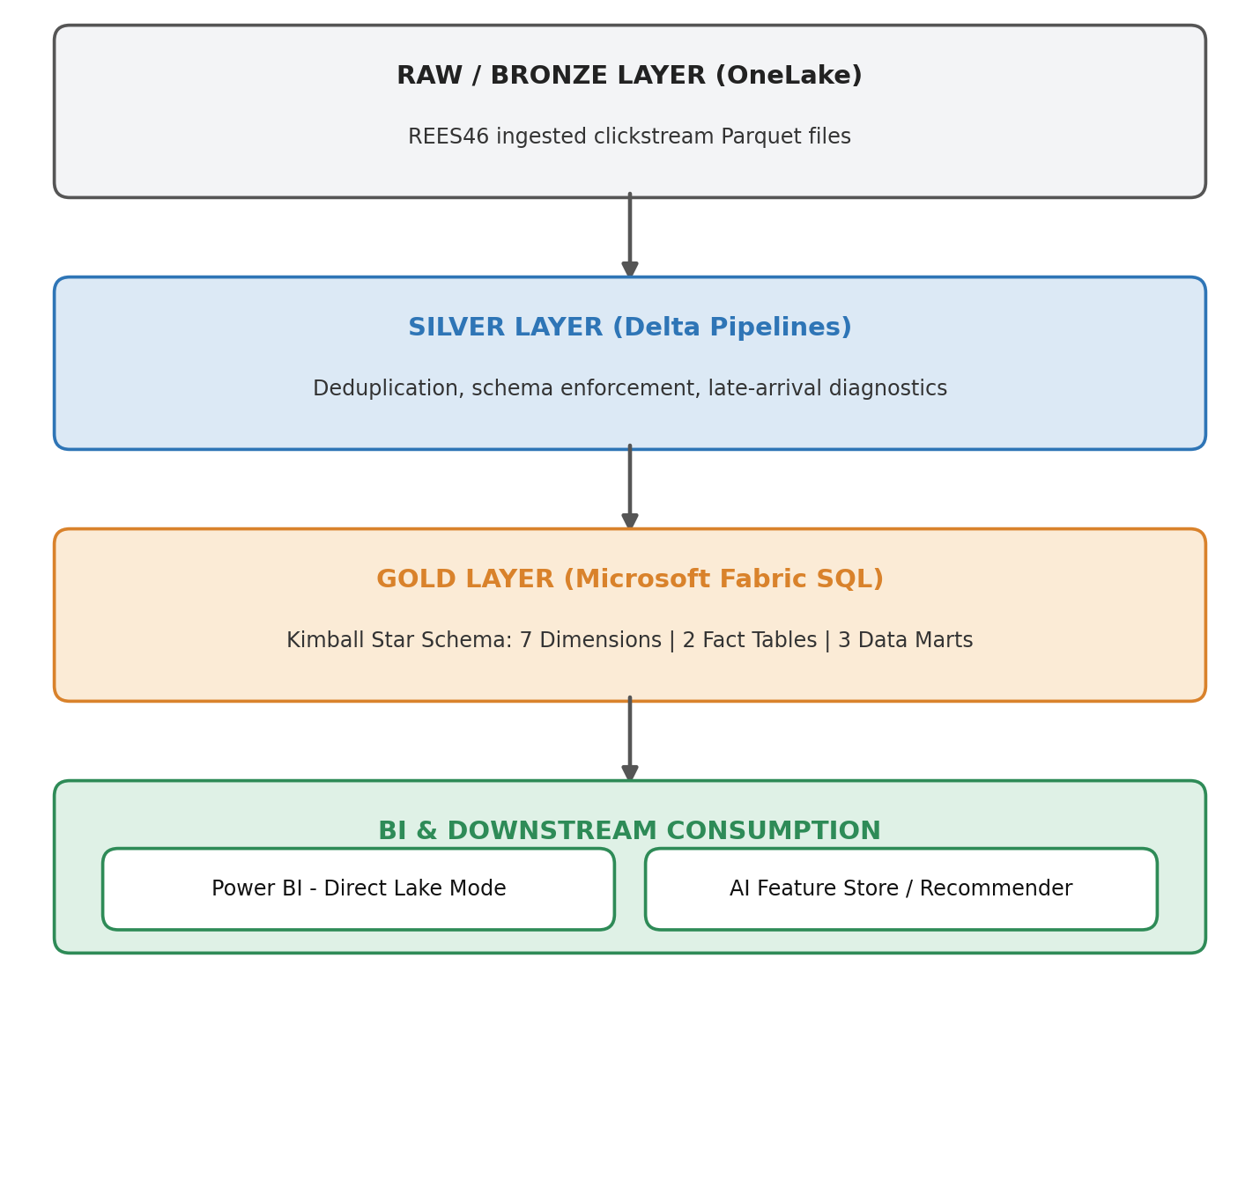
Figure 1: Medallion architecture on Microsoft Fabric / OneLake
- Storage Architecture: Delta Lake tables stored natively inside OneLake using Delta Parquet format.
- Execution Engine: Fabric Spark Engine / SQL Endpoints executing idempotent Delta Lake DDL and Data Manipulation SQL queries.
- BI Consumption: Power BI Direct Lake mode, which reads Delta tables directly from OneLake without requiring Import or DirectQuery refresh cycles.

1.3 Modeling Methodology: The Kimball Design Lifecycle
The Gold Layer strictly adheres to the Ralph Kimball Data Warehouse Lifecycle, transforming transactional event logs into a clean, intuitive Star Schema.
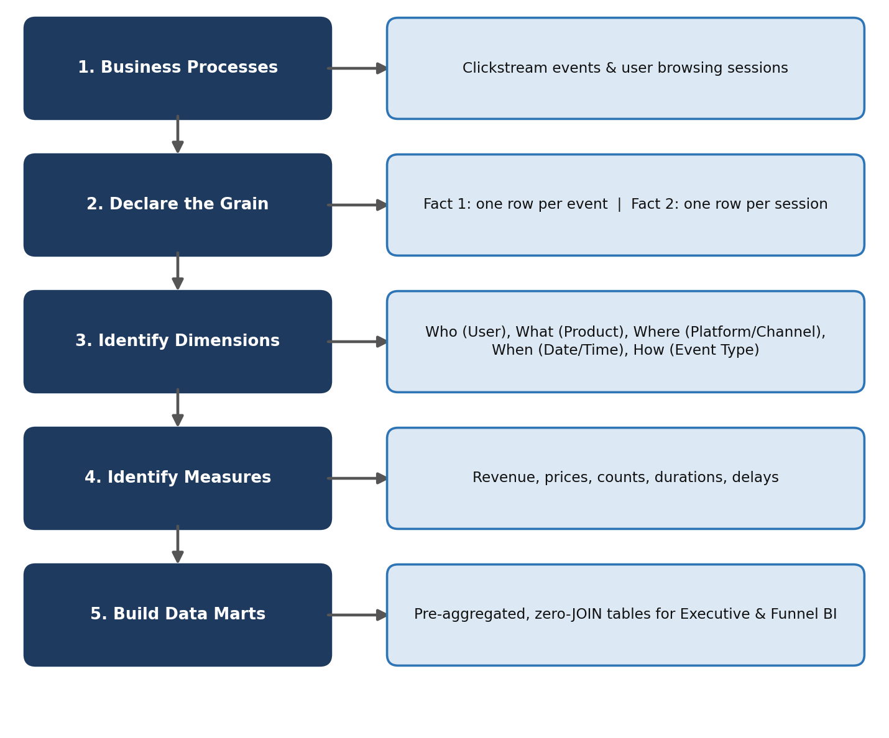
Figure 2: Kimball design lifecycle applied to the clickstream domain
By decoupling raw transaction logs into distinct Fact grains and pre-aggregating common analytical dimensions into Data Marts, the warehouse eliminates double-counting risks, reduces computing overhead, and provides an optimized star-schema layout.

1.4 Core Architecture by the Numbers
7 Dimensions | 2 Fact Tables | 3 Data Marts | 12 Features
Product (SCD2), User (SCD1), Date, Time, Platform, Channel, Event Type | fact_events (atomic event), fact_sessions (session snapshot) | mart_executive_marketing, mart_funnel_behavior, mart_product_brand_performance | 9 native REES46 attributes + 3 synthetic injections

- 7 Dimensional Tables: dim_product (SCD Type 2), dim_user (SCD Type 1), dim_date (Role-Playing), dim_time (Role-Playing), dim_platform, dim_marketing_channel, and dim_event_type.
- 2 Fact Tables: fact_events (Atomic Transactional Grain) and fact_sessions (Accumulating Snapshot Grain).
- 3 Data Marts: mart_executive_marketing, mart_funnel_behavior, and mart_product_brand_performance.
- 12 Schema Features: 9 native REES46 source attributes combined with 3 synthetic pipeline injections (platform, marketing_channel, ingestion_time).

2. Data Lineage & Source Features

2.1 The 12 Core Schema Features
The clickstream dataset combines 9 raw interaction columns from the REES46 eCommerce benchmark with 3 injected enterprise attributes. This schema provides complete coverage across user activity, product taxonomies, session dynamics, and system pipeline performance.
# | Column Name | Source | Data Type | Engineering Role & Analytical Purpose
1 | event_time | Native (REES46) | TIMESTAMP (UTC) | Exact clock timestamp of the user event. Used to derive event_date_key, event_time_key, session durations, and time-decay vectors.
2 | event_type | Native (REES46) | STRING | Categorizes the user interaction (view, cart, remove_from_cart, purchase). Serves as the driver for funnel progression.
3 | product_id | Native (REES46) | BIGINT | Durable Business Key. Persistent catalog item identifier across all historical version changes and price updates.
4 | category_id | Native (REES46) | BIGINT (Nullable) | Numerical taxonomy key provided by the source catalog.
5 | category_code | Native (REES46) | STRING | Dot-delimited taxonomy hierarchy string (e.g., computers.network.router). Parsed during ETL into category_level1, level2 and level3.
6 | brand | Native (REES46) | STRING | Manufacturer / brand name. Imputed with 'Unknown' when null to maintain filtering consistency in BI.
7 | price | Native (REES46) | DECIMAL(12,2) | Momentary list price shown at event time. Non-additive during views, additive revenue during purchases.
8 | user_id | Native (REES46) | BIGINT | Persistent Customer Key. Tracks interaction histories across visits, enabling repeat-rate and cohort analyses.
9 | user_session | Native (REES46) | STRING (UUID) | Degenerate Dimension. Unique session identifier per browsing period. Hashed to session_key via xxhash64.
10 | platform | Injected | STRING | Access channel (web or mobile). Invariant for the entire duration of a session.
11 | marketing_channel | Injected | STRING | Attribution channel (organic, paid, email, social) that brought the user to the session.
12 | ingestion_time | Injected | TIMESTAMP | Engine ingestion timestamp. Used to calculate ingestion_delay_seconds and flag late-arriving events.

2.2 Deep Architectural Breakdown of Injected Features

1. user_session as a Degenerate Dimension & xxhash64 Key Generation
- Degenerate Dimension Strategy: in Kimball modeling, an attribute that is a unique identifier (like an invoice number or session string) with no descriptive attributes is retained inside the Fact table rather than creating an empty dimension table.
- Surrogate Hashing (session_key): joining large Delta tables on string UUIDs creates heavy memory overhead during Spark join shuffles. To optimize performance, the pipeline applies xxhash64(user_session) to generate a 64-bit integer surrogate key:
session_key = xxhash64(user_session)
This integer hash accelerates joins between fact_events and fact_sessions by up to 10x in Microsoft Fabric Spark SQL.
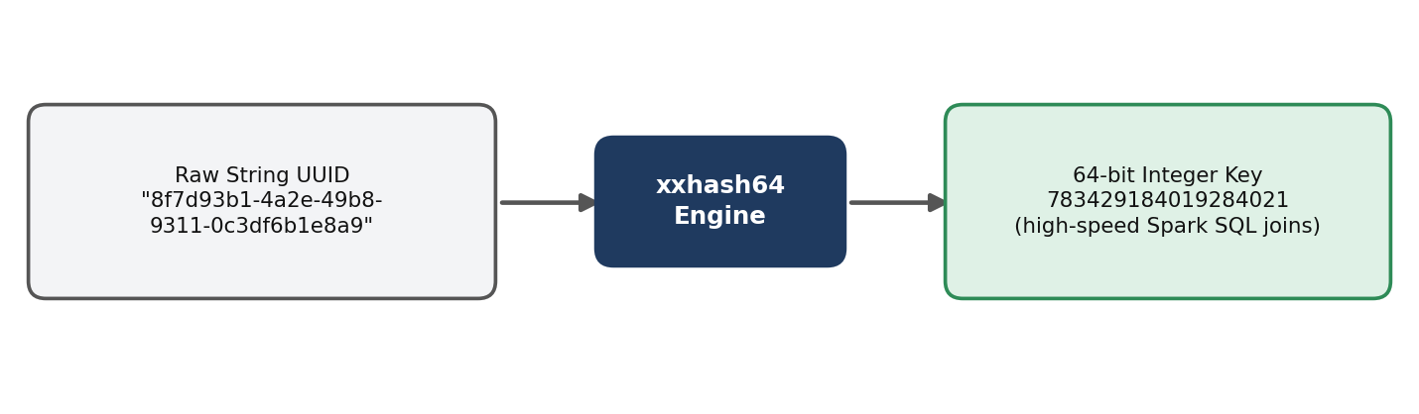
Figure 3: From raw string UUID to a 64-bit integer surrogate key

2. System Reliability & Diagnostics via ingestion_time
In real-world streaming pipelines, network latency, system outages, or batched uploads cause events to arrive out of order. The injected ingestion_time feature enables Late-Arriving Event Detection and SLA Health Monitoring:
ingestion_delay_seconds = ingestion_ts - event_ts
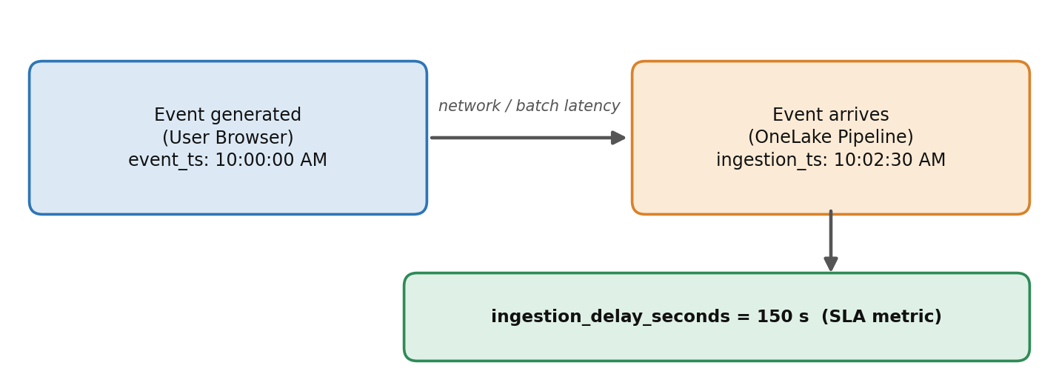
Figure 4: Ingestion delay as an SLA metric
- If ingestion_delay_seconds > 0: the event is properly diagnosed and attributed to the correct temporal date key (event_date_key) while recording the ingestion audit date (ingestion_date_key).
- An enforced CHECK constraint (chk_events_delay: ingestion_delay_seconds >= 0) guarantees that no corrupt events with future timestamps enter the warehouse.

3. Attributable Session Dimensions (platform & marketing_channel)
To evaluate e-commerce channel performance, the pipeline injects platform (Web vs. Mobile) and marketing_channel (Organic, Paid, Email, Social).
- Rule: both features remain strictly invariant during a single user_session.
- Storage: mapped to integer keys (platform_key, channel_key) in Gold tables.
These two features are mapped to lookup dimensions (dim_platform and dim_marketing_channel). They serve as foreign keys across both Fact tables and all three Data Marts, allowing BI users to slice revenue, conversion rates, and session durations by acquisition channel.

3. Dimensional Modeling Strategy

3.1 Overview of the 7 Conformed Dimensions
In accordance with Kimball's dimensional modeling framework, all entity contexts are decoupled into conformed dimensions. This design ensures consistency across downstream Fact tables and Data Marts while eliminating unnormalized text duplicates from transaction logs.
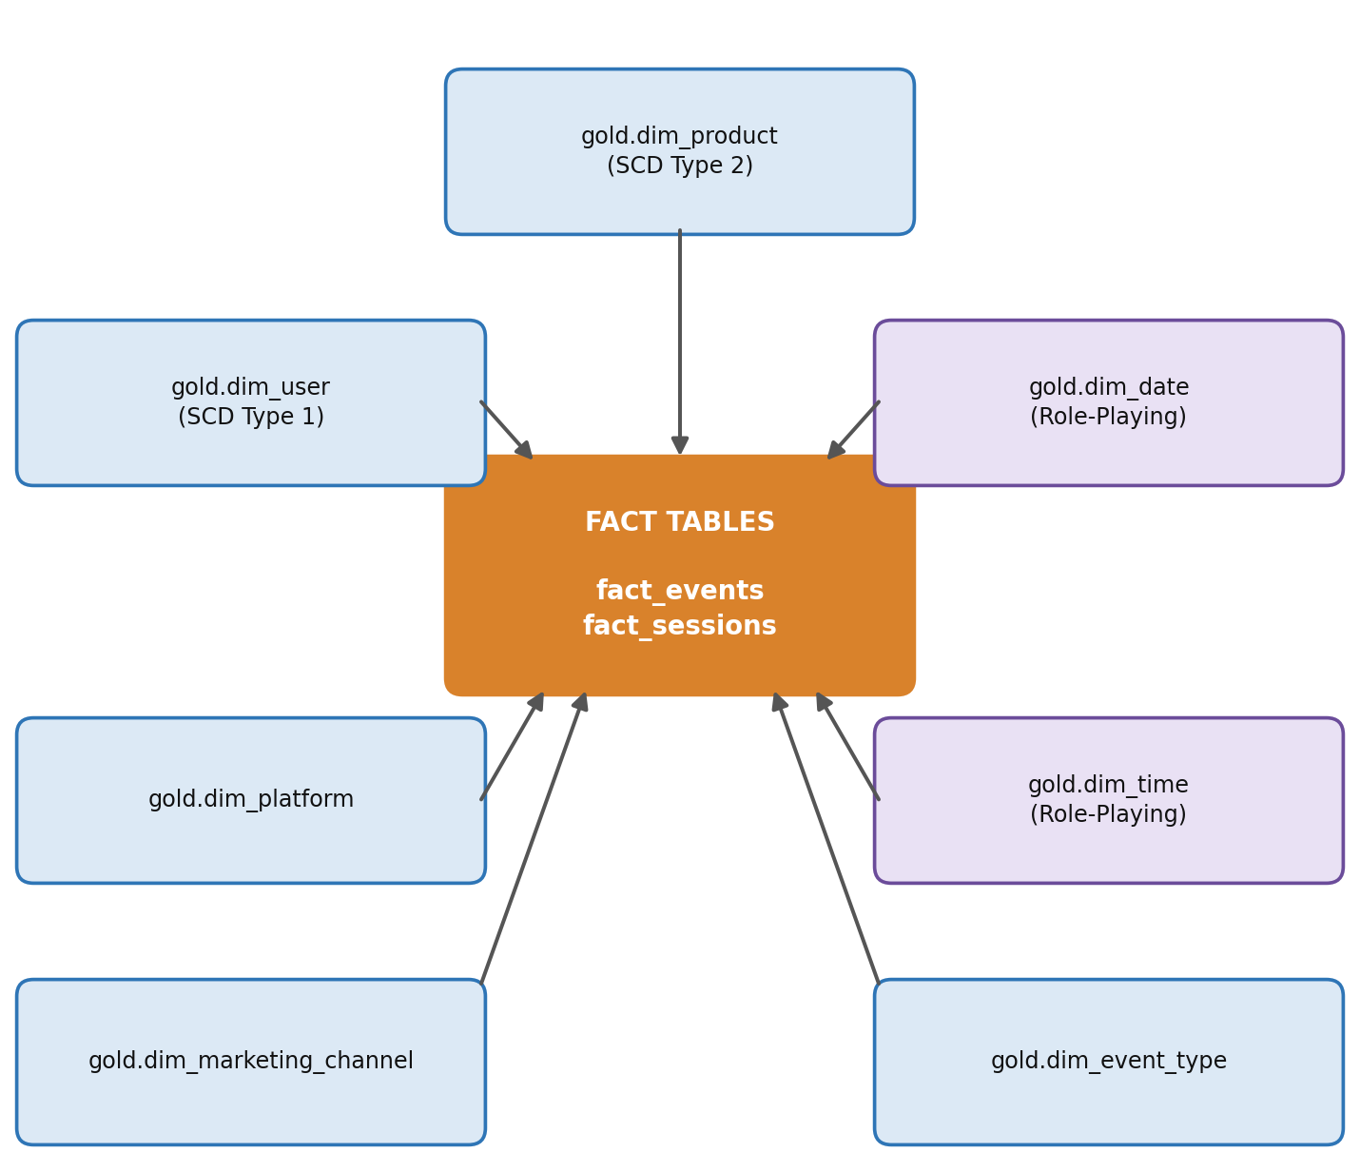
Figure 5: Star schema: 7 conformed dimensions around the two fact tables

3.2 Deep Technical Specification of Dimensions

1. gold.dim_product: Slowly Changing Dimension (SCD Type 2)
Strategy: e-commerce catalog items experience price fluctuations, brand re-namings, or category re-classifications over time. To preserve historical accuracy, dim_product is built as an SCD Type 2 table:
SQL
CREATE TABLE IF NOT EXISTS gold.dim_product (
product_key BIGINT NOT NULL GENERATED BY DEFAULT AS IDENTITY,
product_id BIGINT NOT NULL, -- Durable Business Key
category_id BIGINT,
category_code STRING NOT NULL,
category_level1 STRING NOT NULL,
category_level2 STRING NOT NULL,
category_level3 STRING NOT NULL,
brand STRING NOT NULL,
base_price DECIMAL(12,2),
valid_from TIMESTAMP NOT NULL, -- Version validity start (inclusive)
valid_to TIMESTAMP NOT NULL, -- Version validity end (exclusive; 9999-12-31 = current)
is_current BOOLEAN NOT NULL -- Active version flag
) USING DELTA;

- Surrogate Key vs. Business Key: product_key is an auto-generated integer surrogate key that increments with every historical change. product_id remains the durable business key from the source.
- Temporal Integrity: active records carry is_current = TRUE and an open-ended boundary (valid_to = '9999-12-31 23:59:59'). valid_from is inclusive and valid_to is exclusive, so historical transactions join to dim_product where event_ts >= valid_from AND event_ts < valid_to.
- The Kimball Default Member (product_key = -1): to maintain strictly non-null foreign keys in fact_events without dropping events that reference deleted or unknown catalog items, a default 'Unknown' row is seeded at key -1:
SQL
INSERT INTO gold.dim_product
(product_key, product_id, category_id, category_code, category_level1,
category_level2, category_level3, brand, base_price, valid_from, valid_to, is_current)
SELECT -1, -1, NULL, 'Unknown', 'Unknown', 'Unknown', 'Unknown', 'Unknown', NULL,
TIMESTAMP'1970-01-01 00:00:00', TIMESTAMP'9999-12-31 23:59:59', TRUE
WHERE NOT EXISTS (SELECT 1 FROM gold.dim_product WHERE product_key = -1);

2. gold.dim_user: Slowly Changing Dimension (SCD Type 1)
Strategy: designed as an SCD Type 1 dimension, storing user_key (surrogate key) and user_id (business key). User profile metadata updates overwrite existing rows without maintaining version histories.

3. gold.dim_date & gold.dim_time: Role-Playing Dimensions
The storage optimization problem: dim_date is a static calendar from 2019-01-01 to 2030-12-31 (12 years, 4,383 days). Combining date and time into a single timestamp dimension at second-level granularity would generate over 378 million rows (4,383 days x 86,400 seconds).
Decoupled role-playing design: by separating date (4,383 rows) and time (86,400 rows), total dimension storage drops to only 90,783 rows, a roughly 4,170x storage reduction.
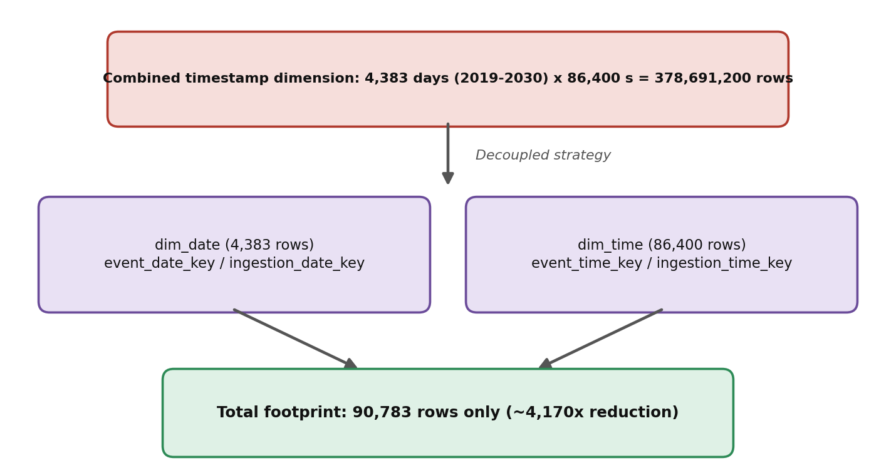
Figure 6: Decoupling date and time dimensions
- Role-Playing Aliases: rather than creating duplicate tables, dim_date and dim_time play dual roles in fact_events via role-playing SQL views.
- event_date_key & event_time_key → date/time when the user clicked.
- ingestion_date_key & ingestion_time_key → date/time when the system ingested the log (accessed via the dim_ingestion_date and dim_ingestion_time views).
- Seasonal Peak Isolation: dim_date includes is_seasonal_peak to explicitly tag organic shopping holidays (e.g., Black Friday) without confounding them with injected system anomalies.
- Key formats: date_key is an integer in YYYYMMDD format (e.g., 20191001). time_key is the number of seconds since midnight (0 to 86,399).
- time_category: dim_time buckets each hour into Morning (06-11), Peak (12-17), Evening (18-22) or Night (all other hours).

4. gold.dim_platform, gold.dim_marketing_channel & gold.dim_event_type
Static, low-cardinality lookup tables:
Dimension | Key Mapping
dim_platform | 1 = web, 2 = mobile
dim_marketing_channel | 1 = organic, 2 = paid, 3 = email, 4 = social
dim_event_type | 1 = view, 2 = cart, 3 = remove_from_cart, 4 = purchase

3.3 Taxonomy Hierarchy Parsing (Hierarchy Drilling)
The source dataset provides category_code as a raw dot-separated string (e.g., electronics.audio.headphone). During Silver-to-Gold extraction, PySpark / Delta SQL parses this string into three explicit level attributes using string splitting:
Output Attribute | Meaning | Example
category_level1 | Department | electronics
category_level2 | Category | audio
category_level3 | Sub-Category | headphone

SQL
SELECT
category_code,
split(category_code, '\\.')[0] AS category_level1,
COALESCE(split(category_code, '\\.')[1], 'Unknown') AS category_level2,
COALESCE(split(category_code, '\\.')[2], 'Unknown') AS category_level3
FROM silver.events;

This structure enables BI analysts in Power BI to perform instant Hierarchy Drilling from high-level departments down to specific product sub-categories without writing runtime regular expressions.

4. The Fact Tables Architecture

4.1 Architectural Necessity: Why Two Fact Tables?
A common antipattern in clickstream modeling is attempting to collapse both atomic events and session-level metrics into a single Fact table.
- The Double-Counting Risk: if session revenue ($100) is stored on every event row of a 4-event session, executing a simple SUM(session_revenue) across all events yields $400 instead of $100.
- The Granularity Anchor Rule: Kimball design dictates that every Fact table must maintain a single, unified grain.
To serve both real-time item-level analytics and session funnel metrics without corruption, the warehouse builds two distinct Fact tables:
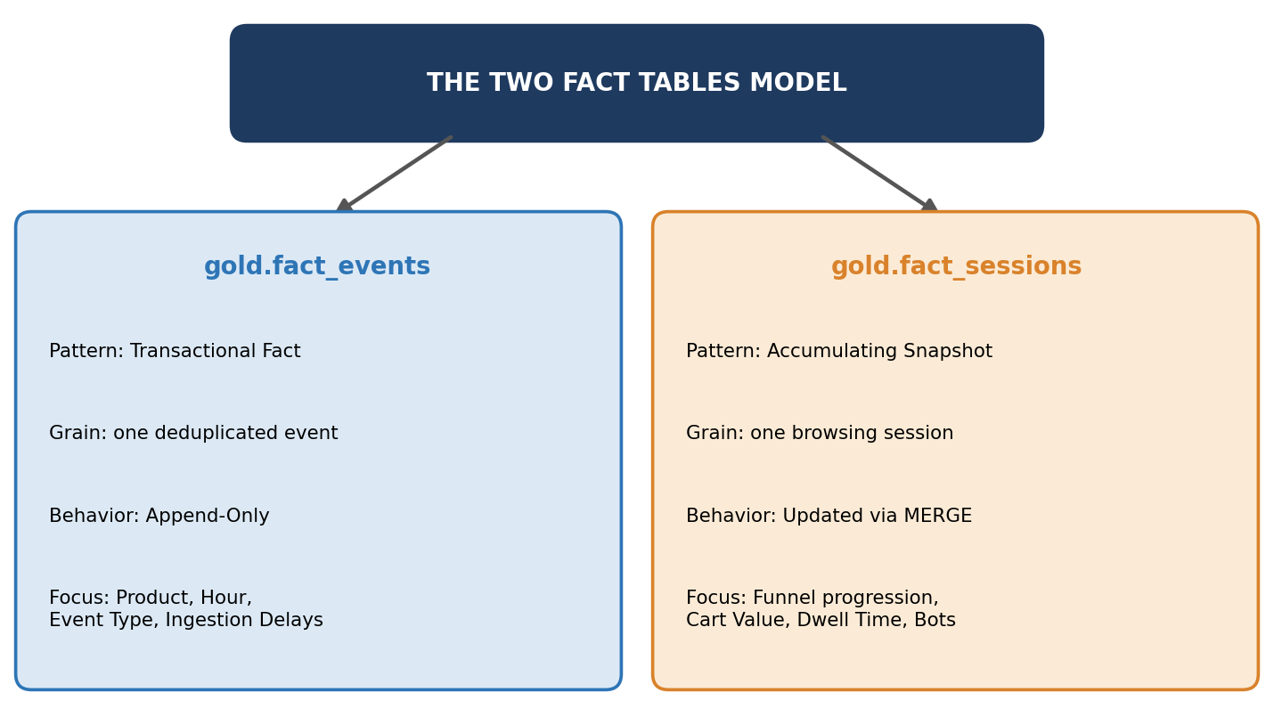
Figure 7: The two fact tables model

4.2 Fact Table 1: gold.fact_events (Transactional Atomic Grain)
- Grain: one deduplicated user interaction event (view, cart, remove_from_cart, or purchase).
- Deduplication Key: formed via deterministic hashing: event_id = hash(user_session, event_time, event_type, product_id).
- Partitioning: PARTITIONED BY (event_date_key) for rapid partition pruning during date-range filtering.
- Session link: session_key (xxhash64 of user_session) is an informational foreign key to fact_sessions.session_key; user_session itself stays in the fact as a degenerate dimension.
- Timestamps: event_ts is the replay clock used for all time logic, source_event_ts keeps the original REES46 time, and ingestion_ts is when the pipeline received the event.
- Other attributes: product_id (durable business key kept next to the versioned product_key) and is_bot (0/1, copied from the session). In total the table has 21 columns and 10 foreign keys.
Additive vs. Non-Additive Measures:
Measure | Additivity | Definition
event_price | Non-additive | Summing item list prices across views is mathematically invalid.
revenue | Additive | Equals event_price when event_type_key = 4 (purchase), and 0.00 otherwise.
event_count | Additive | Hardcoded constant = 1 to accelerate SUM(event_count) aggregations.
ingestion_delay_seconds | Derived | ingestion_ts - event_ts.

4.3 Fact Table 2: gold.fact_sessions (Accumulating Snapshot Grain)
- Grain: one unique browsing session (session_key = xxhash64(user_session)).
- Lifecycle & State Updates: built as an Accumulating Snapshot Fact Table. When a user begins a session, a record is inserted. As subsequent clicks, cart additions, or purchases arrive, the existing session row is updated in Delta Lake via MERGE INTO operations.
Pre-calculated Session Metrics:
Metric | Definition
session_duration_seconds | MAX(event_ts) - MIN(event_ts)
time_to_first_cart_seconds | MIN(event_ts of cart events) - MIN(event_ts of the session)
events_per_session | COUNT(event_id)
session_cart_value | Total monetary value of items added to cart during the session.
session_revenue | Final completed purchase revenue generated by the session.

Additional columns: user_key, session_start_date_key and session_start_time_key (the session start is the date/time role), platform_key, channel_key, session_start_ts, session_end_ts, last_updated_ts, the quality flags is_bot, is_first_session and is_impossible_sequence, and the counters view_count, cart_count and purchase_count. time_to_first_cart_seconds is NULL when the session has no cart event. The table has 24 columns and 5 foreign keys, and is PARTITIONED BY (session_start_date_key).
Funnel State Flags (0/1 Boolean Integers): has_view, has_cart, has_purchase. These flags eliminate runtime subqueries, allowing Power BI to evaluate funnel drop-offs with simple SUM() operations.

4.4 Fact Table Comparison Matrix
Feature / Attribute | gold.fact_events | gold.fact_sessions
Kimball Fact Pattern | Transactional Fact Table | Accumulating Snapshot Fact Table
Declared Granularity | One single event per row | One single browsing session per row
Write Strategy | Append-Only (Immutable) | Upsert / Delta MERGE INTO updates
Primary Key | event_id (String Hash) | session_key (64-bit Integer Hash)
Primary Measures | event_price, revenue, ingestion_delay_seconds | session_duration_seconds, time_to_first_cart, session_revenue
Primary Analytics Use Case | Product-level hourly activity, price trends, late arrivals | Executive ROI, funnel conversion rates, cart abandonment
Query Speed Improvement | Standard event scan | ~100x faster for funnel & session duration queries

5. Business Data Marts & KPIs

5.1 Architecture & Design Philosophy of Data Marts
While Fact tables store atomic and session-level granularity, business executives and domain teams require pre-aggregated, zero-JOIN data structures. In Kimball architecture, Data Marts serve as specialized summary layers that aggregate atomic measures across key dimensions (Date, Platform, Channel, Product).
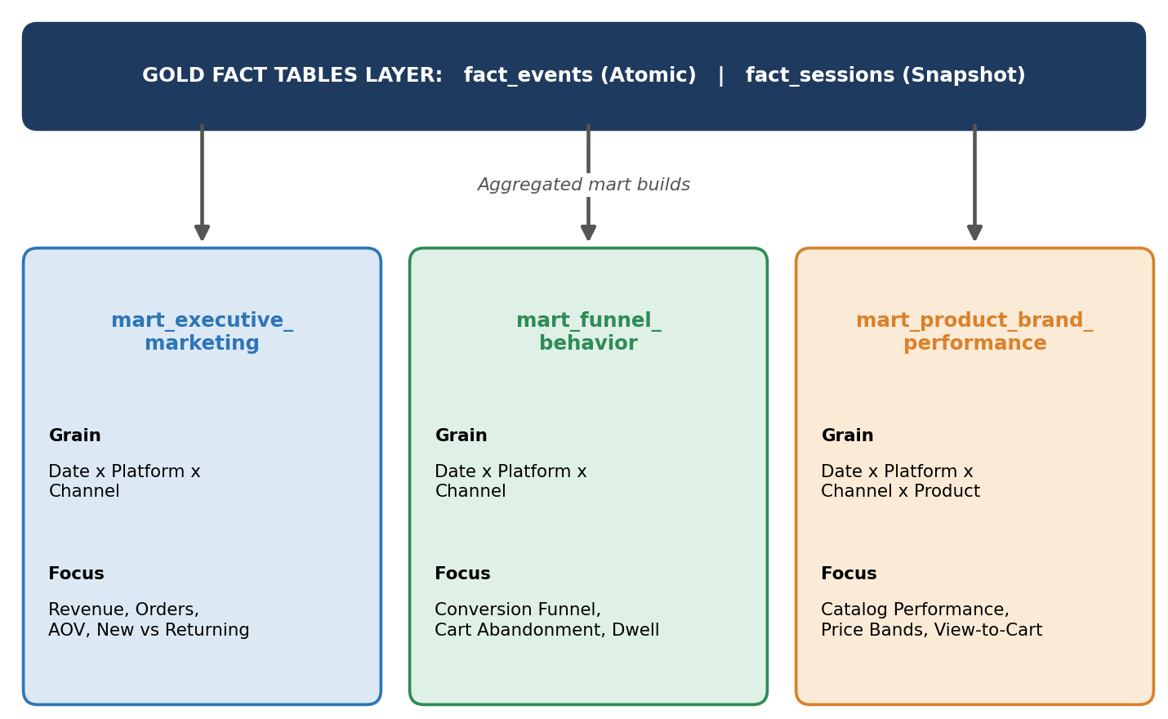
Figure 8: Data marts built on top of the gold fact tables
Golden Rule of Aggregated Marts: Data Marts store only additive base measures (counts, sums, durations) rather than pre-calculated percentages or ratios. Calculating ratios at runtime in Power BI (Σ numerator / Σ denominator) ensures mathematical correctness when slicing across different date ranges or channels.

5.2 Deep Breakdown of the 3 Data Marts & KPIs

Mart 1: gold.mart_executive_marketing (Executive & Marketing Analytics)
- Target Audience: C-Suite Executives, CMOs, and Marketing Channel Managers.
- Declared Granularity: one row per date_key x platform_key x channel_key (bots excluded).
- Underlying Source: built from gold.fact_sessions.
SQL
CREATE TABLE IF NOT EXISTS gold.mart_executive_marketing (
date_key INT NOT NULL,
platform_key INT NOT NULL,
channel_key INT NOT NULL,
total_sessions BIGINT NOT NULL,
total_orders BIGINT NOT NULL, -- Sessions with a purchase
total_revenue DECIMAL(14,2) NOT NULL, -- Last-touch session revenue
view_events BIGINT NOT NULL,
purchase_events BIGINT NOT NULL,
first_sessions BIGINT NOT NULL, -- New users
returning_sessions BIGINT NOT NULL -- Repeat users
) USING DELTA;

KPI | Formula | Meaning
Total Revenue | Σ total_revenue | Total monetary inflow generated.
Orders | Σ total_orders | Total completed purchase sessions.
Average Order Value (AOV) | Σ total_revenue / Σ total_orders | Average revenue per order.
Session Conversion Rate | Σ total_orders / Σ total_sessions | Share of sessions that purchase.
New vs. Returning Ratio | Σ first_sessions / Σ returning_sessions | Retention and acquisition efficiency.

Mart 2: gold.mart_funnel_behavior (Product & UX Funnel Analytics)
- Target Audience: Product Managers, UX Designers, and E-Commerce Conversion Rate Optimization (CRO) Teams.
- Declared Granularity: one row per date_key x platform_key x channel_key (population = sessions with has_view = 1).
- Underlying Source: built from gold.fact_sessions.
SQL
CREATE TABLE IF NOT EXISTS gold.mart_funnel_behavior (
date_key INT NOT NULL,
platform_key INT NOT NULL,
channel_key INT NOT NULL,
view_sessions BIGINT NOT NULL,
cart_sessions BIGINT NOT NULL,
purchase_sessions BIGINT NOT NULL,
abandoned_cart_sessions BIGINT NOT NULL,
no_view_sessions BIGINT NOT NULL, -- Excluded from funnel, shown for transparency
lost_revenue DECIMAL(14,2) NOT NULL, -- Monetary value of abandoned carts
sum_dwell_time_seconds BIGINT NOT NULL,
sum_events BIGINT NOT NULL,
sum_time_to_first_cart_seconds BIGINT NOT NULL
) USING DELTA;

KPI | Formula | Meaning
Funnel Conversion Rate | Σ purchase_sessions / Σ view_sessions | Viewers who end up purchasing.
Cart Abandonment Rate (%) | Σ abandoned_cart_sessions / Σ cart_sessions | Users who added to cart but left without buying.
Total Lost Revenue | Σ lost_revenue | Potential revenue trapped in abandoned carts.
Average Session Dwell Time | Σ sum_dwell_time_seconds / Σ view_sessions | Average browsing duration per valid session.
Average Time to First Cart | Σ sum_time_to_first_cart_seconds / Σ cart_sessions | Friction metric: time before initial cart intent.

Mart 3: gold.mart_product_brand_performance (Merchandising & Category Analytics)
- Target Audience: Category Managers, Merchandising Specialists, and Brand Strategy Leads.
- Declared Granularity: one row per date_key x platform_key x channel_key x product_key.
- Underlying Source: built from gold.fact_events joined with product price quantiles.
SQL
CREATE TABLE IF NOT EXISTS gold.mart_product_brand_performance (
date_key INT NOT NULL,
platform_key INT NOT NULL,
channel_key INT NOT NULL,
product_key BIGINT NOT NULL,
total_views BIGINT NOT NULL,
total_carts BIGINT NOT NULL,
total_purchases BIGINT NOT NULL,
total_revenue DECIMAL(14,2) NOT NULL,
sum_view_price DECIMAL(16,2) NOT NULL, -- Used to compute Average Displayed Price
price_band STRING NOT NULL -- Low, Mid, High, or Unknown via ntile(3)
) USING DELTA;

Automated Price Band Classification (ntile(3)): the ETL dynamically ranks all active catalog items into three price tiers based on average view prices:
ntile(3) bucket | price_band | Meaning
1 | Low | Lowest third by average view price
2 | Mid | Middle third
3 | High | Highest third
none | Unknown | Product has no view events (bots excluded), so no band can be computed

KPI | Formula | Meaning
Product View-to-Cart Efficiency | Σ total_carts / Σ total_views | How often views lead to a cart add.
Product View-to-Purchase Efficiency | Σ total_purchases / Σ total_views | How often views lead to a purchase.
High Views, Low Sales List | High total_views AND low total_purchases | Candidates for price cuts or positioning adjustments.
Average Displayed Price | Σ sum_view_price / Σ total_views | Average list price shown to users.

5.3 Supporting Views
Besides the three Delta mart tables, the Gold layer exposes three views that need no build step:
- gold.dim_ingestion_date and gold.dim_ingestion_time: role-playing views over dim_date and dim_time, used for the ingestion role of fact_events.
- gold.vw_hourly_activity: hourly views, carts, purchases and revenue by date, hour, platform, channel and category_level1 (bots excluded). It supports the promo-surge impact analysis and the same-hour cart-to-purchase check.

6. Physical Schema (ERD)
This section shows the physical Gold schema exactly as created by the build script (data_model_and_marts.sql): 7 dimensions, 2 fact tables and 3 data marts. The relationships are split into one diagram per fact table so that every foreign key can be followed from its column to its dimension without crossing lines.

6.1 Dimension Bus Matrix
The matrix summarizes which table uses which conformed dimension and through which key column.
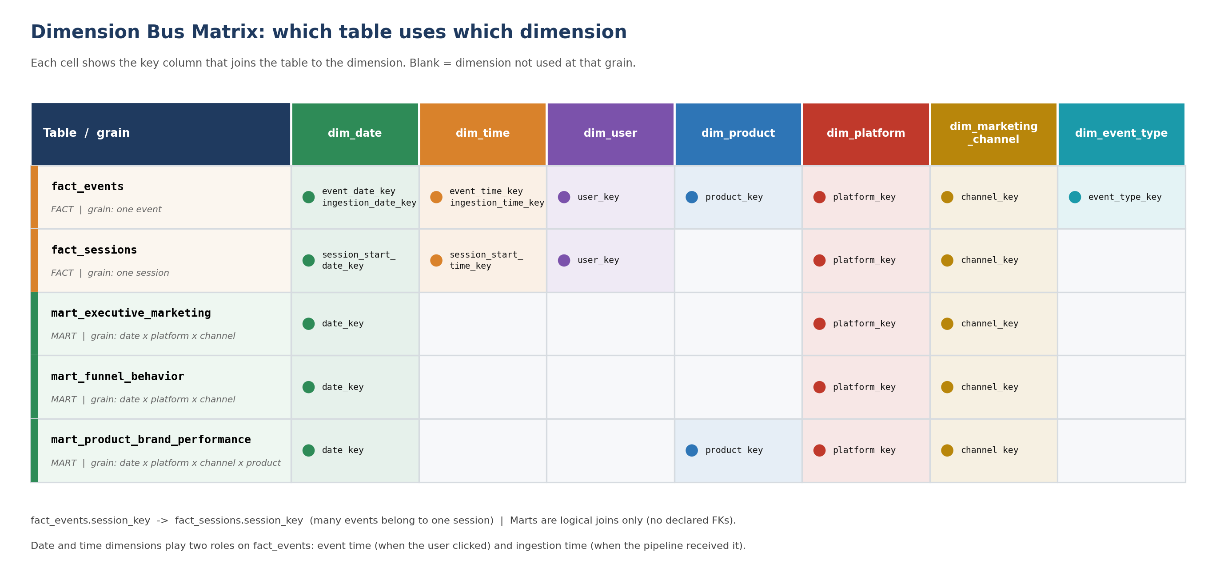
Figure 9: Dimension bus matrix for the 2 fact tables and 3 data marts

6.2 Star Schema 1: fact_events
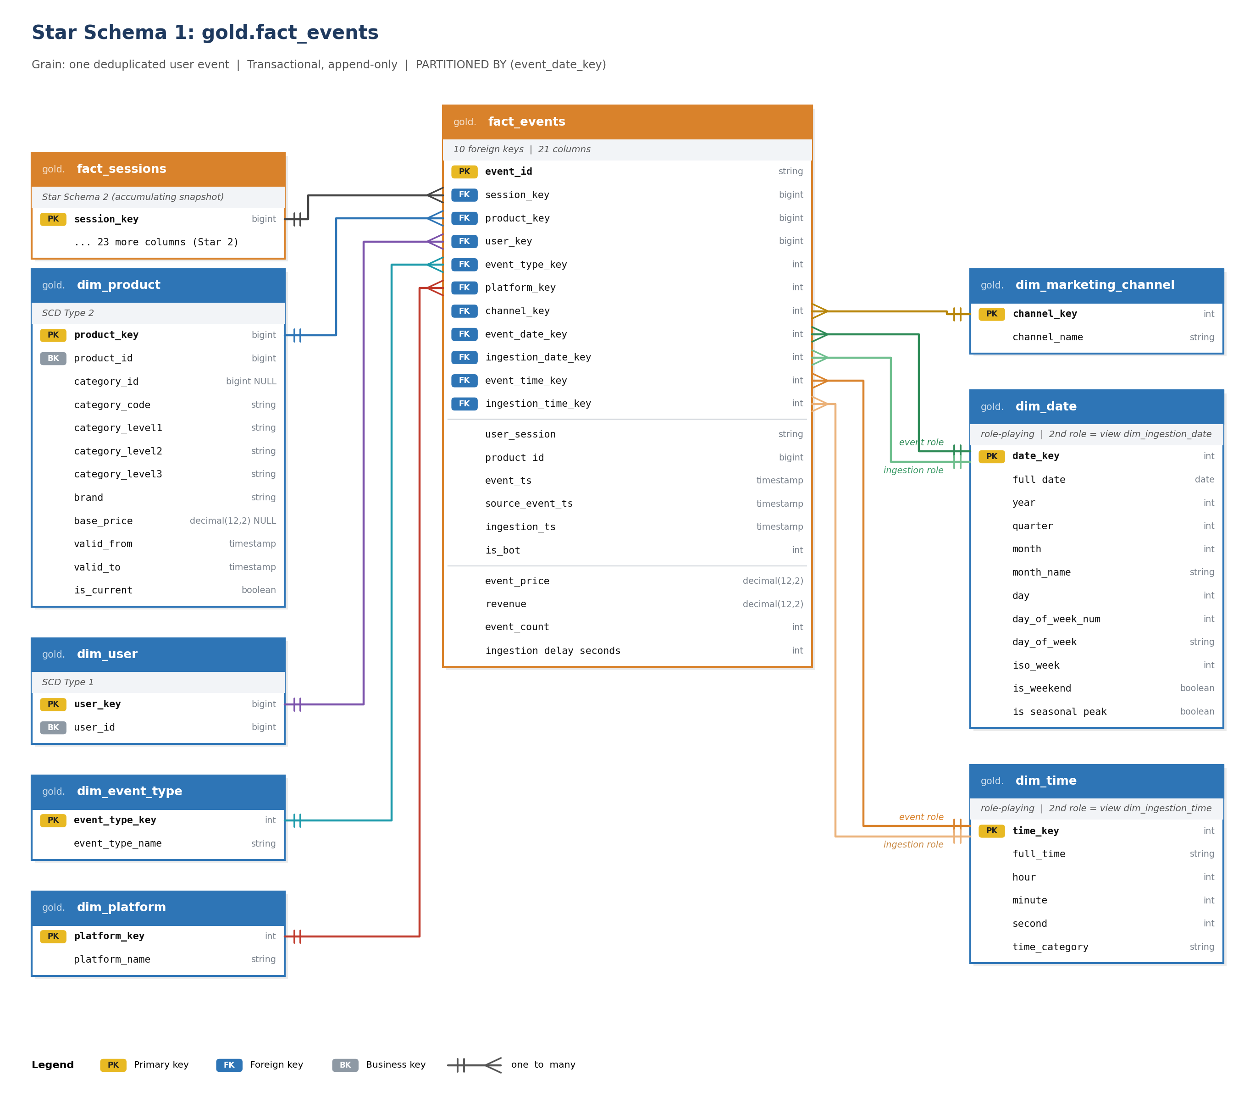
Figure 10: fact_events (transactional grain) with its 10 foreign keys

6.3 Star Schema 2: fact_sessions
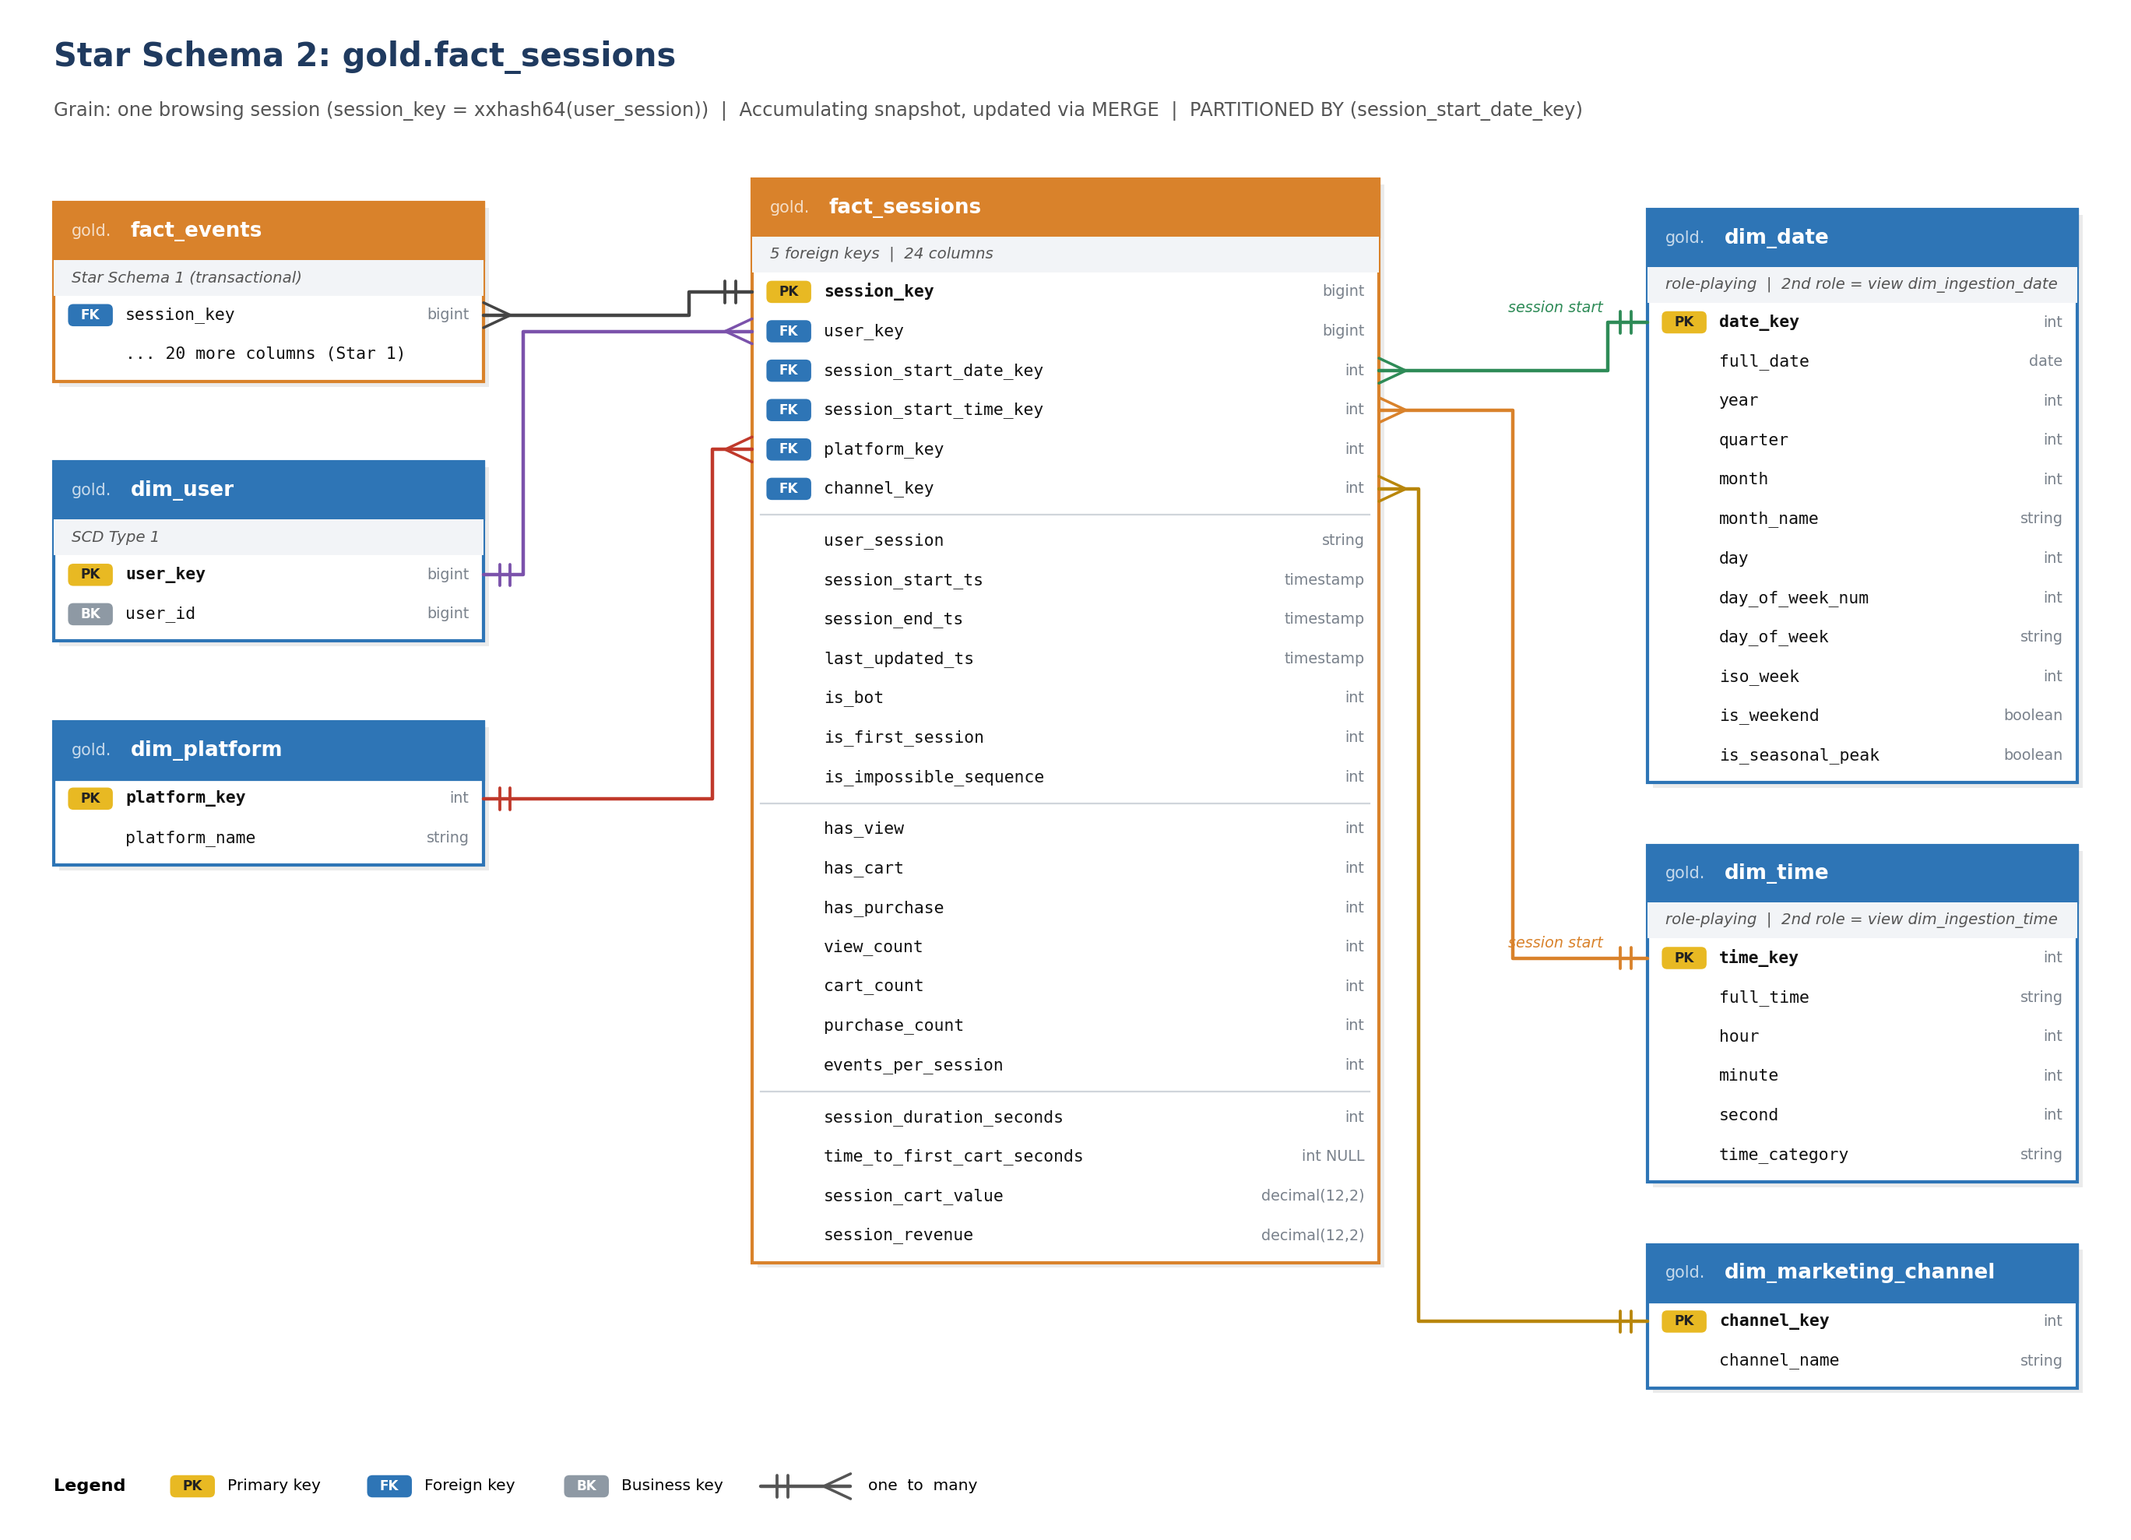
Figure 11: fact_sessions (accumulating snapshot grain) with its 5 foreign keys

6.4 Data Marts: Lineage and Logical Keys
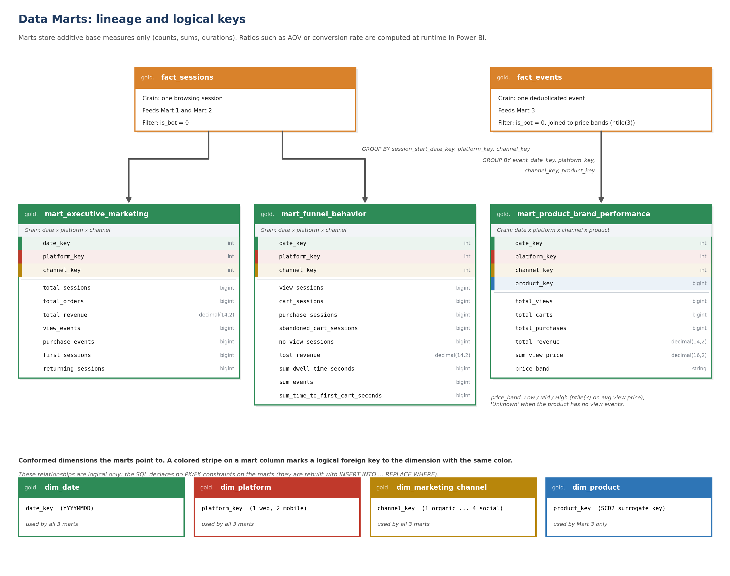
Figure 12: Data marts, their source facts and the dimensions they point to

7. Constraints, Data Integrity & Idempotency

7.1 Data Quality Safeguards: Informational vs. Enforced Constraints
Microsoft Fabric SQL Endpoints and Databricks Delta Lake treat database constraints using two distinct operational paradigms:
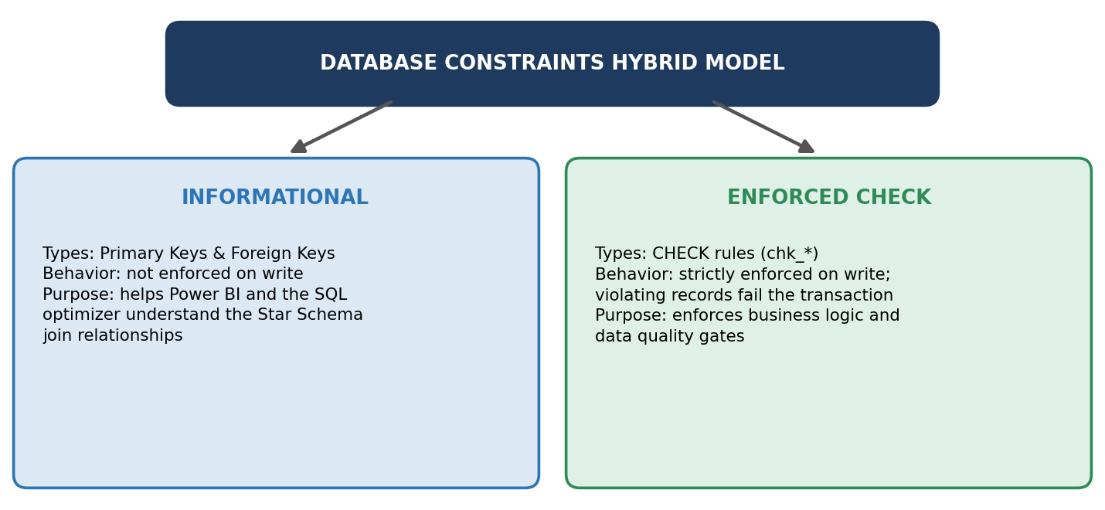
Figure 13: Hybrid constraint model
Enforced CHECK Constraints (Data Quality Gates): to guarantee that corrupted or invalid telemetry data never lands inside Gold tables, strict CHECK constraints are attached to physical Delta tables:
SQL
-- Product validity constraint
ALTER TABLE gold.dim_product ADD CONSTRAINT chk_product_validity CHECK (valid_from < valid_to);

-- Event Fact quality gates
ALTER TABLE gold.fact_events ADD CONSTRAINT chk_events_price CHECK (event_price > 0);
ALTER TABLE gold.fact_events ADD CONSTRAINT chk_events_revenue CHECK (revenue >= 0);
ALTER TABLE gold.fact_events ADD CONSTRAINT chk_events_bot CHECK (is_bot IN (0, 1));
ALTER TABLE gold.fact_events ADD CONSTRAINT chk_events_count CHECK (event_count = 1);
ALTER TABLE gold.fact_events ADD CONSTRAINT chk_events_delay CHECK (ingestion_delay_seconds >= 0);

-- Session Fact quality gates
ALTER TABLE gold.fact_sessions ADD CONSTRAINT chk_sessions_flags CHECK (
is_bot IN (0, 1) AND is_first_session IN (0, 1) AND is_impossible_sequence IN (0, 1)
AND has_view IN (0, 1) AND has_cart IN (0, 1) AND has_purchase IN (0, 1)
);
ALTER TABLE gold.fact_sessions ADD CONSTRAINT chk_sessions_measures CHECK (
events_per_session >= 1 AND session_duration_seconds >= 0
AND session_cart_value >= 0 AND session_revenue >= 0
AND session_start_ts <= session_end_ts
);

- Informational keys: primary keys exist on all 9 tables (7 dimensions + 2 facts); 10 foreign keys are declared on fact_events and 5 on fact_sessions. The data marts carry no declared constraints.
- Safe re-runs: the script drops each CHECK constraint with DROP CONSTRAINT IF EXISTS before adding it again, so it can be executed repeatedly.

7.2 Idempotency Strategy: Atomic Re-runs via REPLACE WHERE
In enterprise pipelines, pipeline failures, late-arriving batch files, or backfill requests require re-executing ETL runs over historical date ranges.
- The Double-Counting Hazard: executing standard INSERT INTO queries during a re-run duplicates historical metrics, corrupting revenue and session counts.
- The Solution: all Data Mart build queries use Delta Lake's INSERT INTO ... REPLACE WHERE construct.
SQL
-- Idempotent build step for Executive Mart over targeted dates
INSERT INTO gold.mart_executive_marketing
REPLACE WHERE date_key BETWEEN 20191001 AND 20191007
SELECT session_start_date_key, platform_key, channel_key,
COUNT(*),
SUM(has_purchase),
SUM(session_revenue),
SUM(view_count),
SUM(purchase_count),
SUM(CASE WHEN is_first_session = 1 THEN 1 ELSE 0 END),
SUM(CASE WHEN is_first_session = 0 THEN 1 ELSE 0 END)
FROM gold.fact_sessions
WHERE is_bot = 0 AND session_start_date_key BETWEEN 20191001 AND 20191007
GROUP BY session_start_date_key, platform_key, channel_key;

The example above targets one week. In the delivered build script each mart statement uses REPLACE WHERE date_key BETWEEN 20190101 AND 20301231 for a full rebuild; for incremental loads the range is narrowed to the dates the load touched (:from_key and :to_key parameters). Mart 3 price bands depend on the whole product mix, so after a large load Mart 3 is re-run over the full date range.
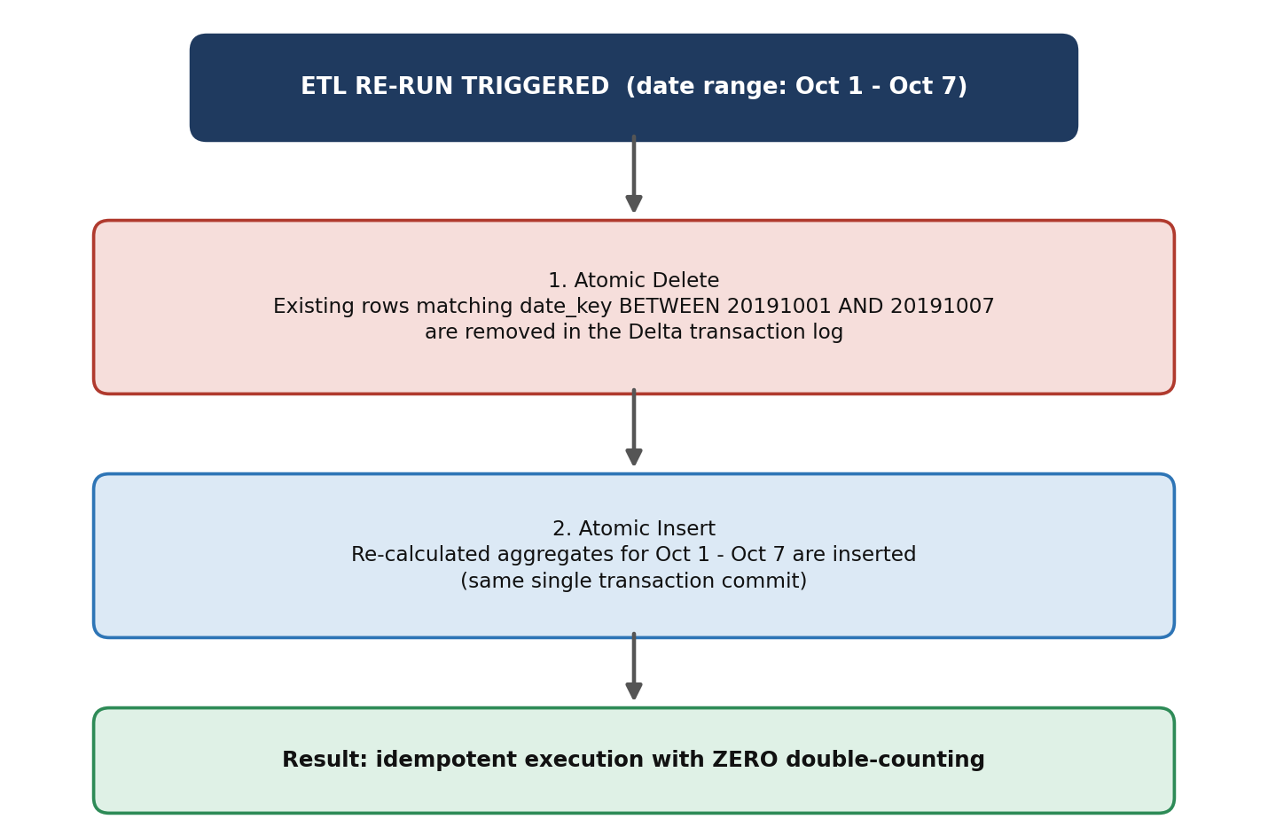
Figure 14: Atomic re-run flow with REPLACE WHERE
Benefits of REPLACE WHERE over MERGE:
- Atomicity: deletion and insertion occur in a single Delta Lake transaction log commit (_delta_log).
- Performance: replaces partition slices directly without performing expensive row-level join scans.
- Zero Double-Counting: running the build pipeline once or one hundred times yields identical, deterministic figures.

