Week 3 Progress Report — Context Engineering and Retrieval-Augmented Generation
Course: BSE4104 AI Agentic Capstone
Reporting period: 14–18 September 2026 | GROUP B EVENING CLASS

1. Objective for the week
Week 2 established a foundation model (Gemini 2.0 Flash) and a versioned system prompt, but every answer still came from the model’s parametric memory. The Week 3 goal was to make the helpdesk agent answer from a controlled, traceable knowledge source instead: a curated corpus of Centenary Bank material, retrieved at query time and passed to the model as explicit evidence, with each answer carrying a trace back to the documents that produced it.
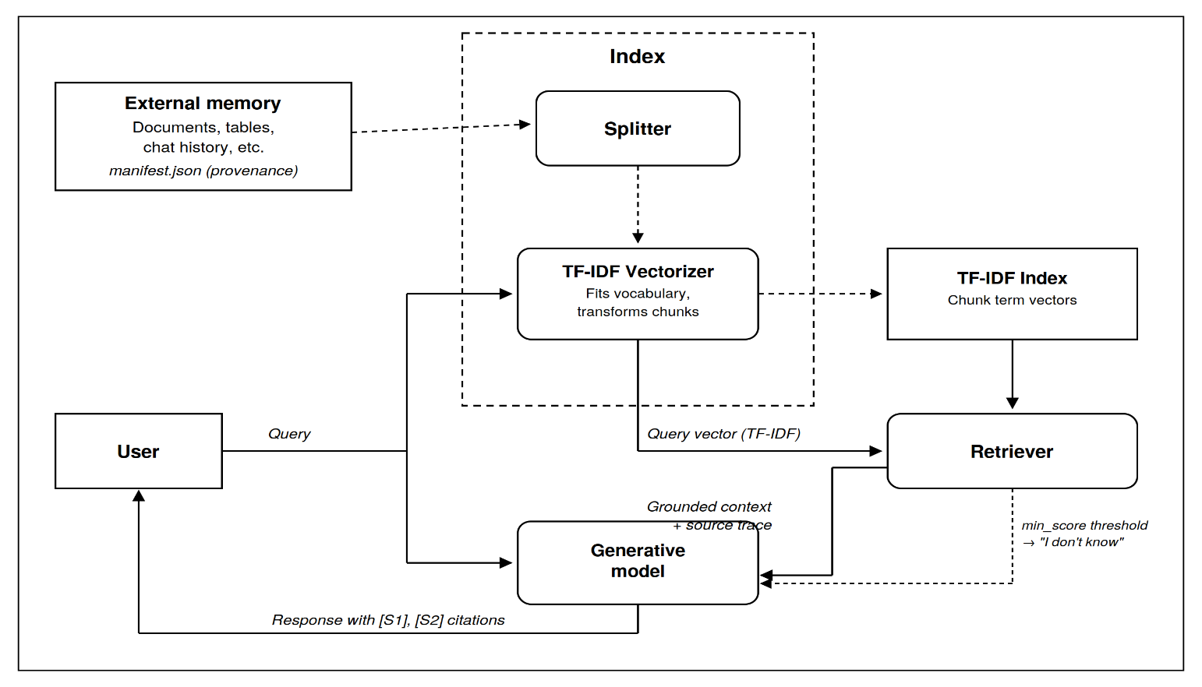
Figure 0.1 RAG architecture

2. Corpus and provenance
The source data was assembled as a CSV export of Centenary Bank customer FAQ entries, covering records across product areas e.g. accounts, cards, digital banking, loans. Each record was collected from the public Centenary Bank website FAQ pages.
Provenance is recorded in a manifest file (corpus/manifest.json) that holds one record per document. The manifest doubles as the Corpus/Source Register deliverable: every record carries at minimum doc_id, title and file, and any additional fields (source_type, date_added, category, version) are propagated automatically onto every chunk produced from that document and onto every source returned with an answer. Provenance therefore survives the whole pipeline rather than being lost at ingestion.

3. Pipeline implementation
The pipeline was implemented as six small Python modules, each owning exactly one stage so that failures can be isolated to a single component. Every module carries a self-test entry point that runs on throwaway strings, so any stage can be exercised without the full corpus.
Module | Output type | Responsibility
ingest.py | Document | Load corpus files together with their provenance metadata
chunk.py | Chunk | Split documents into retrievable segments
index_store.py | RagIndex | Build a TF-IDF index over all chunks
retrieve.py | RetrievedChunk | Top-k similarity search with scores
context_builder.py | GroundedContext | Assemble prompt context plus the source trace
pipeline.py | RagPipeline | Wire all stages into a single answer() call

Chunking is paragraph-aware by default, with a 200-word target and 30-word overlap, falling back to a fixed sliding window for documents with no paragraph structure. These values are provisional: short FAQ entries may warrant smaller chunks, and the parameters will be tuned once evaluation results indicate whether retrieval is returning too much or too little context.
Indexing uses TF-IDF with cosine similarity (scikit-learn) rather than a vector database. At a corpus of this size a sparse keyword index is fast, dependency-light and auditable every match can be explained by which terms overlapped, which is valuable while debugging

4. Context construction and source grounding
The context builder returns a ready-made message list (a system message carrying the retrieved evidence and a user message carrying the question), which is passed to Gemini 2.0 Flash, the same foundation model selected in Week 2, so that any change in answer quality is attributable to retrieval rather than to a model switch. The model is instructed to cite inline markers ([S1], [S2], …) that map one-to-one onto the returned source list, so the citation shown to the user is verifiable against the trace rather than generated freely.
Two mechanisms support grounding. First, a minimum similarity threshold acts as the safety valve for unanswerable questions: when no chunk scores above it, no evidence is returned and the prompt explicitly directs the model to state that it does not know instead of guessing. Second, each answer is accompanied by a list of source references (document id, chunk id, similarity score and the exact retrieved text), logged alongside the query and answer. This separates the two failure modes that look identical to a user the wrong chunk was retrieved, or the right chunk was retrieved and the model ignored it.

5. RAG evaluation (15 cases)
A 15-question evaluation set was designed across three categories: fully answerable from the corpus, partially answerable (the corpus covers part of the question), and deliberately unanswerable (the question concerns information the corpus does not contain). The partially answerable and unanswerable cases test whether the system declines and defers appropriately rather than filling gaps from model memory.

6. Retrieval and grounding failures

7. Team contributions
Member | Contribution | Status
Mariam Wambui | Source data collection; FAQ corpus assembled as CSV | Delivered
Yusuf Mugoya | RAG pipeline: ingestion, chunking, indexing, retrieval, context building | Delivered
Walusimbi Ashraf | 15-case RAG evaluation and results table | Delivered
Ssenoga Herman | RAG architecture diagram and Week 3 progress report | Delivered

8. Status and next steps
- Complete the 15-case evaluation run and record results against the source traces.
- Document at least three retrieval or grounding failures with their diagnosed causes.
- Tune chunk size, overlap, top-k and the minimum similarity threshold using the evaluation findings.
- If paraphrase misses appear in the results, prototype a dense embedding index as a drop-in replacement for the TF-IDF store.
- Expand the corpus beyond FAQ entries to product and policy documents, keeping manifest provenance consistent.

