Company Supervisor: Mr. Almo
Academic Supervisor: Amine ABDELJAOUAD
Internship Period: October 2026 – January 2027
PREDICTIVE MAINTENANCE ON SENSOR DATA
Supervised comparative study: Logistic Regression vs. Random Forest on the AI4I 2020 dataset.

Internship Report – Assignment 1
Student: Mariama Fofana
Engineering School: CESI Engineering School
Host Organization: EUTech Engineers
Location: Madrid, Spain
Academic Year: 2026–2027

INTRODUCTION AND BUSINESS OBJECTIVE

Industrial Context
In industrial environments, equipment reliability and availability are essential for ensuring productivity and operational efficiency. Unplanned breakdowns can lead to significant financial losses, production interruptions, and increased maintenance costs.
Predictive maintenance offers an alternative to traditional corrective maintenance by using data collected from industrial sensors to monitor equipment conditions and detect early warning signs of failure. By leveraging data analysis and Machine Learning techniques, predictive maintenance aims to anticipate breakdowns, optimize maintenance operations, and improve overall industrial performance.

Business Problem and Data Science Objective
The objective of this project is to develop a Machine Learning approach capable of identifying potential machine failures based on industrial sensor data.
The problem is formulated as a supervised binary classification task, where the target variable indicates whether a machine is operating normally or experiencing a failure:
$y=0$ (Normal Operation): The machining process operates under nominal physical conditions.
$y=1$ (Machine Failure): The machine exhibits imminent failure risks across mechanical, thermal, or electrical regimes.
The proposed approach aims to support maintenance decision-making by identifying potentially critical operating conditions before they result in unexpected breakdowns.

The Asymmetry of Decision Costs
In an industrial workshop, classification errors do not carry equal financial or operational consequences:
False Negatives (Missed Failures): Predicting nominal operation when a failure occurs leads to spindle seizure, cutter destruction, production stoppage, and costly repair hours. This is the most critical error to eliminate.
False Positives (False Alarms): Predicting a breakdown when the machine is healthy triggers an inspection by a technician. The cost is limited to labor check time, without material damage.

DATASET DESCRIPTION AND PREPROCESSING

Dataset Description: AI4I 2020
This project uses the AI4I 2020 Predictive Maintenance Dataset, which contains 10,000 observations representing machining operations and fourteen initial columns.
Variable | Description | Unit / Values
Type | Machine product quality type | L, M, H
Air temperature | Ambient air temperature | K
Process temperature | Temperature during the machining process | K
Rotational speed | Rotational speed of the machine | rpm
Torque | Torque applied during operation | Nm
Tool wear | Accumulated tool wear | min

Target Distribution and Class Imbalance
The dataset presents a significant class imbalance between normal operating conditions and machine failures.
Among the 10,000 observations:
9,661 observations (96.61%) correspond to normal operation.
339 observations (3.39%) correspond to machine failures.
This imbalance represents an important challenge for supervised classification. A model that predicts normal operation for every observation could achieve a high accuracy while failing to identify actual breakdowns.
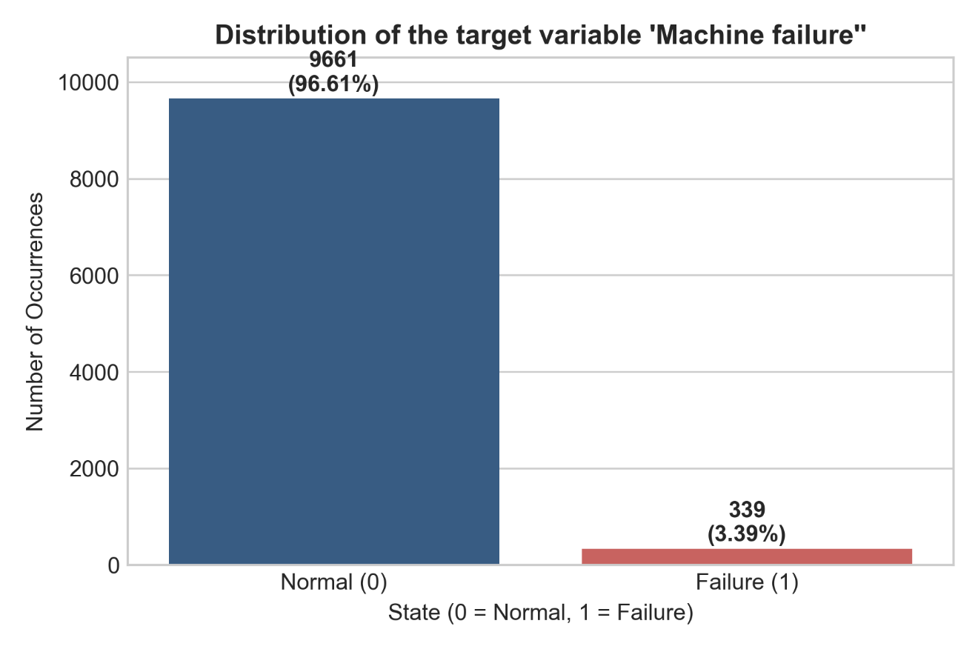

EXPLORATORY DATA ANALYSIS AND SENSOR SIGNATURES

Univariate Sensor Distributions and Failure Patterns
Exploratory Data Analysis (EDA) was performed across the five continuous operational sensors to analyze their statistical properties and identify behavioral shifts distinguishing nominal cycles from failure events.
Comparative distribution analysis using boxplots reveals pronounced mechanical and operational contrasts:
Torque [$Nm$] (Primary Mechanical Discriminator) :
Under nominal operation ($y=0$), torque values are tightly clustered around a median of 40.0 Nm. Under failure conditions ($y=1$), the distribution shifts upward to a median of 54.2 Nm, with the upper quartile reaching beyond 60.0 Nm. Additionally, prominent low-end outliers appear between 5 and 15 Nm. This bimodal spread reflects two distinct physical failure mechanisms: excessive resistant force during cutter overload (Overstrain Failure) versus instantaneous loss of mechanical resistance following tool breakage or motor stall.
Tool wear [$min$] (Cumulative Material Degradation):
Tool wear measures the cumulative active cutting duration sustained by the blade. The failure median reaches 165 minutes, compared to 105 minutes under nominal regimes, with over 75% of recorded breakdowns occurring after 85 minutes of accumulated operation. This progression demonstrates that surface micro-fractures, abrasive degradation, and edge bluntness strongly accelerate the probability of structural tool failure (Tool Wear Failure).
Rotational speed [$rpm$] (Kinematic Instabilities) :
Nominal operations exhibit a stable rotational velocity centered at approximately 1,500 rpm. In failure cycles, the median drops below 1,380 rpm. A long tail of extreme outliers extends up to 2,800 rpm. This behavior aligns with operational thresholds: low rotational speed restricts forced-air cooling (triggering Heat Dissipation Failure below 1,380 rpm), while high-speed excursions denote motor runaway or load loss (Power Failure).
Air and Process Temperatures [$K$] (Thermal Gradient Overlap):
Both ambient air temperature and process contact temperature exhibit significant distribution overlap between healthy and faulty states, with medians hovering around 300 K and 310 K respectively. Considered in isolation, absolute temperature values provide marginal discriminative power. Failure detection requires evaluating the thermal gradient ($ΔT$) rather than raw thermodynamic levels.
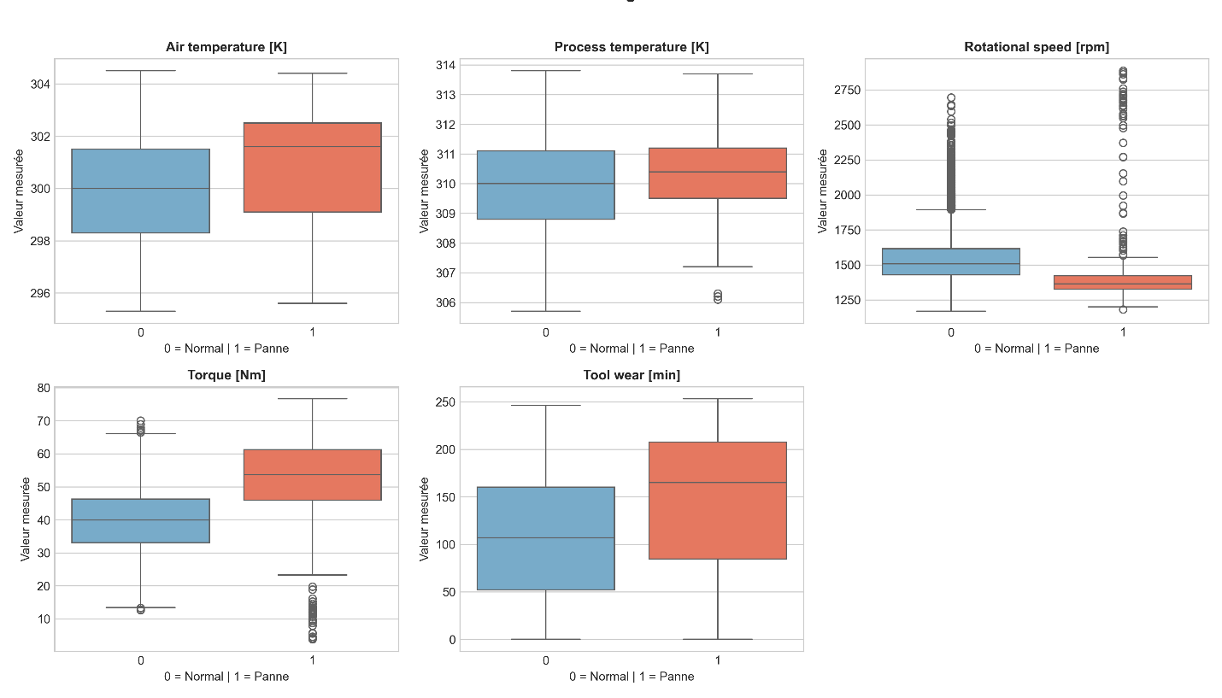

EXPERIMENTAL PROTOCOL AND MACHINE LEARNING MODELING

Data Splitting and Feature Scaling

Train / Test Split (80% / 20%)
In Machine Learning, evaluating a model on the same data used during training can lead to an overly optimistic estimate of its performance. This is because the model may learn patterns that are specific to the training data rather than generalizing well to unseen observations.
To evaluate its generalization ability, the dataset is divided into two independent subsets:
Training set (80% – 8,000 observations) : used to train the models. Logistic Regression estimates its coefficients, while Random Forest builds its decision trees.
Test set (20% – 2,000 observations) : kept separate from the training process and used only for the final evaluation. It simulates unseen machine operating conditions and provides an estimate of the models' ability to generalize.

Why Is Stratification (stratify=y) Important?
The AI4I 2020 dataset is highly imbalanced, with approximately 3.39% of observations corresponding to machine failures. A standard random split could produce different failure proportions in the training and test sets, potentially making the evaluation less representative.
The stratify = y parameter preserves the original class distribution as closely as possible in both subsets. This ensures that each set contains a representative proportion of normal operating conditions and machine failures.
With 339 failure observations in the full dataset, the split is expected to contain approximately:
Training set : 271 failure observations.
Test set : 68 failure observations.
Stratification is particularly important in this project because machine failures are rare events. Maintaining their proportion in both subsets helps ensure a more reliable evaluation of the models' ability to detect failures.

Comparative Assessment and Performance Analysis

Baseline Model: Logistic Regression
Logistic Regression is selected as the baseline classification model.
It provides a simple and interpretable approach for estimating the probability of machine failure based on operational parameters.
The model assumes that the relationship between the input features and the log-odds of failure can be represented by a linear combination of the predictors.
To address the class imbalance, the parameter: class_weight= 'balanced'
is used to assign greater importance to the minority class.
The baseline model provides a reference against which the performance of the more advanced model can be compared.

Advanced Model: Random Forest
Random Forest is selected as the advanced Machine Learning model.
Unlike Logistic Regression, Random Forest can capture nonlinear relationships, critical thresholds, and complex interactions between sensor measurements without assuming a linear decision boundary.
The model is based on an ensemble of decision trees whose predictions are combined to improve classification performance.

Summary Overview of Indicators
The performance of both approaches was calculated based on the 2,000 observations in the independent test set:

Model Evaluated | Accuracy | Precision | Recall | F1-Score
Logistic Regression (Baseline) | 85.75% | 17.80% | 88.24% | 0.2963
Random Forest (Advanced ML) | 99.00% | 96.15% | 73.53% | 0.8333

The dataset is divided into training and testing subsets using an 80/20 split.
Stratified sampling is applied to preserve the original class distribution, ensuring that both subsets contain a similar proportion of failure observations.
Feature scaling is performed using StandardScaler for the Logistic Regression model.
To prevent data leakage, the scaler is fitted exclusively on the training data and subsequently applied to the test data.

Model Evaluation and Comparison
The Logistic Regression and Random Forest models are evaluated using the same test dataset.
The following metrics are considered:
In-depth Analysis of Confusion Matrices
Comparing the confusion matrices highlights the divergence in the operational behavior of the two models when faced with the 68 actual failures in the test set:
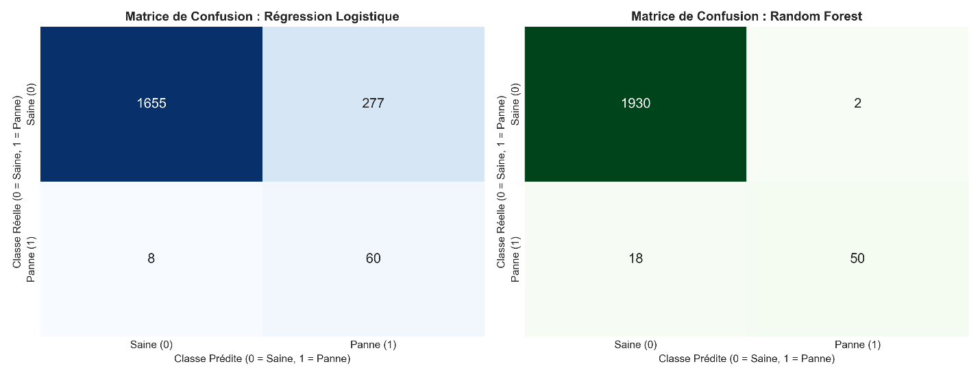
Logistic Regression Performance: Out of 68 actual failures, the logistic regression model detects 60 (a recall of 88.24%), leaving only 8 critical failures undetected. However, this result comes with 277 false alarms (false positives). In an industrial setting, such a high rate of false alarms would lead to "alarm fatigue," where maintenance teams might eventually begin to ignore the system's alerts.
Random Forest Performance: The Random Forest model achieves an impressive 96.15% precision, generating only 2 false alarms across 1,932 healthy machines. It successfully identifies 50 failures, though it records 18 false negatives (missed failures). Its F1 score of 0.8333 demonstrates a decision-making structure that is far more balanced than the linear baseline.

Interprétabilité Métier, Recommandations et Perspectives
The analysis of the Gini impurity reduction within the 100 trees of the Random Forest empirically validates the relevance of feature engineering:
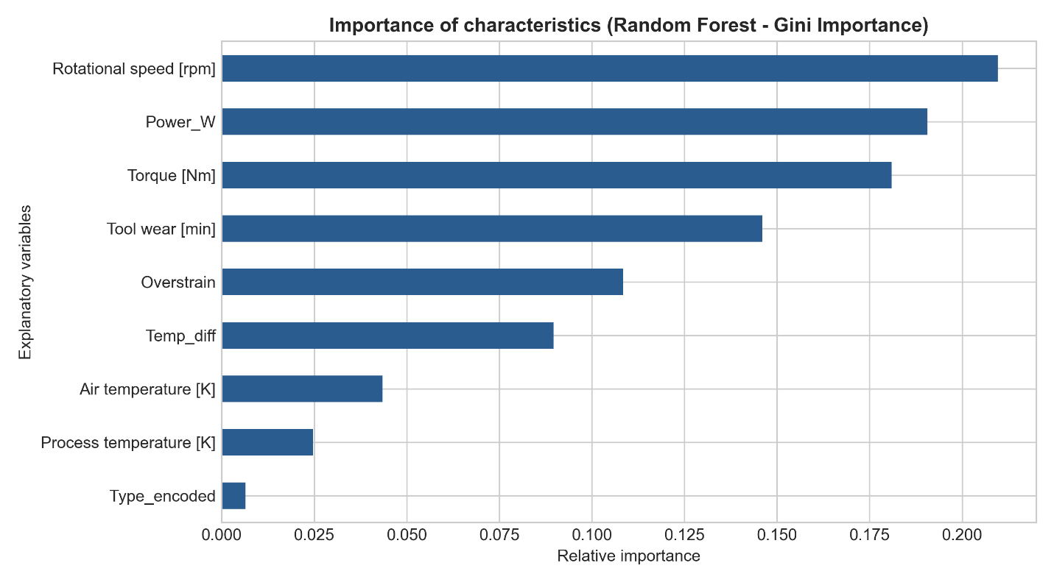
Dominance of kinematics and power: Rotational speed (21.0%), calculated mechanical power (Power_W, 19.1%), and mechanical torque (18.1%) together account for nearly 58% of the predictive power. This confirms that machining mechanisms are highly sensitive to energy-related instabilities.
Impact of cumulative wear: Tool wear (14.6%) and the interaction term "Overstrain" (10.8%) form the second key decision cluster, reflecting the cyclic fatigue of materials.
Thermodynamic insight: The derived variable "Temp_diff" (8.9%) significantly outperforms absolute air temperature (4.4%) and process temperature (2.5%), confirming that the thermal gradient is the only reliable indicator of cooling anomalies.

CONCLUSION
This project investigates the use of Machine Learning techniques for predictive maintenance using the AI4I 2020 dataset.
The proposed methodology includes data preprocessing, exploratory analysis, feature engineering, and the development of two supervised classification models: Logistic Regression and Random Forest.
The evaluation focuses on the detection of machine failures, with particular attention to Recall due to the operational consequences of undetected failures.
The results will provide insights into the effectiveness of the selected models and their potential contribution to improving industrial maintenance strategies.

