Riverside Health Network Patient Segmentation Using K-Means Clustering
1. Introduction & Context
Introduction
Riverside Health Network (RHN) is a regional healthcare organization that provides healthcare services to approximately 150,000 patients each year through hospitals, outpatient clinics, urgent care centers, and community health programs. As part of its digital transformation, RHN aims to use data analytics to improve patient outcomes, increase operational efficiency, and support better healthcare decision-making.
RHN currently faces several operational challenges, including high hospital readmission rates, rising healthcare costs, increasing numbers of missed appointments, and low participation in preventive care programs. Since patient populations have different healthcare needs and behaviors, applying the same care strategy to every patient may not be effective. Patient segmentation provides a way to identify groups of patients with similar characteristics so that healthcare providers can deliver more personalized and efficient care.
Project Objective
The objective of this project was to apply the K-Means clustering algorithm to a healthcare dataset containing 150,249 patient records to identify meaningful patient segments based on demographic characteristics, healthcare utilization, clinical complexity, lifestyle behaviours, patient engagement, and healthcare costs. By identifying these patient groups, RHN can develop targeted healthcare strategies that improve patient engagement, reduce hospital readmissions, optimize resource allocation, and support data-driven clinical and operational decision-making.
2. Methodology
Dataset
The dataset consists of 150,249 patient-level healthcare records collected from Riverside Health Network. Each record represents an individual patient and includes information describing demographic characteristics, healthcare utilization, clinical history, hospital admissions, treatment costs, patient engagement, lifestyle behaviours, and health outcomes.
The dataset includes variables such as patient age, gender, body mass index (BMI), admission and discharge dates, previous hospital admissions, medication count, procedure count, ICU admission, surgery status, treatment costs, out-of-pocket expenses, chronic disease status, comorbidity count, mortality risk score, medication adherence, follow-up compliance, diet score, alcohol consumption, smoking status, and physical activity. Together, these variables provide a comprehensive representation of each patient's healthcare needs and behaviours, making them suitable for patient segmentation using unsupervised machine learning.
Because the dataset contains information related to healthcare utilization, clinical severity, patient engagement, and lifestyle habits, it enables RHN to identify groups of patients who require different levels of clinical support and preventive care

Data Cleaning and Preprocessing
Before clustering, the dataset was carefully examined to ensure that the analysis was based on accurate and reliable information. Duplicate records and duplicate Patient_IDs were checked, and no duplicates were identified. Missing values were assessed across all variables, with only the Alcohol_Consumption variable containing missing values (37,704 records). Rather than replacing these values with the most frequent category, they were classified as "Unknown" to preserve the missing information and avoid introducing bias into the clustering model by incorrectly assigning alcohol consumption behaviour to thousands of patients.
Additional validation checks were performed to identify common data quality issues, including negative ages, ages greater than 120 years, negative BMI values, discharge dates occurring before admission dates, negative treatment costs, negative out-of-pocket costs, and negative previous admissions. All validation checks returned zero invalid records, indicating that the dataset was internally consistent and required no additional correction. Outliers were assessed using the Interquartile Range (IQR) method, and no significant outliers required treatment. Finally, all numerical variables were standardized using StandardScaler to ensure that variables measured on different scales contributed equally to the Euclidean distance calculations used by the K-Means algorithm. A summary of these preprocessing activities is provided in Table A1 (Appendix A).

Feature Engineering
Feature engineering was performed to transform the original patient-level variables into more meaningful measures that better represent healthcare behaviour and improve the clustering process. Rather than relying only on individual variables, related information was combined into engineered features that summarize healthcare utilization, patient engagement, lifestyle behaviours, and clinical complexity.
For example, Healthcare Utilization combined standardized values of previous admissions, medication count, procedure count, ICU admission, and surgery status to provide a single measure of healthcare service use. Engagement Score summarized medication adherence, follow-up compliance, and diet score to represent how actively patients participate in managing their health. Clinical Complexity combined comorbidity count, chronic disease status, and mortality risk score to represent the overall severity of a patient's health condition. Additional engineered variables, including Recency, Length of Stay, and Lifestyle Score, provided further insight into healthcare utilization patterns and patient behaviours.
These engineered variables reduced the complexity of the dataset while preserving important clinical information, allowing the K-Means algorithm to identify patient groups with similar healthcare characteristics more effectively. A detailed description of the calculation and purpose of each engineered feature is provided in Table F1 (Appendix F).

Clustering Method
K-Means clustering was selected because it is computationally efficient, easy to interpret, and widely used for patient segmentation in healthcare. The algorithm groups patients according to similarities in their characteristics by minimizing the distance between patients within the same cluster while maximizing the differences between clusters. Since K-Means is based on Euclidean distance, alnumerical variables were standardized before clustering to ensure that variables with larger numerical ranges did not disproportionately influence the results.
Determining an appropriate number of clusters was an important step in the analysis. The optimal value of K was evaluated using both the Elbow Method and the Silhouette Score. As shown in Figure B1 (Appendix B), the Elbow Method indicated that improvements in within-cluster variation became substantially smaller after K = 4, suggesting diminishing returns from creating additional clusters. The silhouette analysis shown in Figure C1 and Table C1 (Appendix C) indicated that the highest average silhouette score was obtained at K = 2, while the Elbow Method suggested diminishing improvements after K = 4. Although K = 2 provided greater statistical separation, K = 4 produced more detailed and operationally meaningful patient segments. Based on both evaluation methods and the interpretability of the patient groups, K = 4 was selected as the final clustering solution. Based on these complementary evaluation methods, K = 4 was selected as the final clustering solution.
3. Results
The K-Means algorithm successfully segmented the 150,249 patients into four distinct patient groups with different healthcare characteristics. As shown in Table E1 (Appendix E), the clusters were relatively balanced in size: Cluster 0 contained 37,577 patients (25.01%), Cluster 1 contained 37,754 patients (25.13%), Cluster 2 contained 37,208 patients (24.76%), and Cluster 3 contained 37,710 patients (25.10%). The balanced distribution indicates that the selected value of K = 4 produced meaningful patient segments without creating clusters that were excessively small or dominated by a large proportion of the patient population.
Cluster 0 – Low Engagement Patients
Cluster 0 consists of patients with the most recent healthcare visits, relatively low engagement, and less healthy lifestyle behaviours, while maintaining average healthcare utilization and clinical complexity. As shown in Figure G1 (Appendix G), these patients actively access healthcare services but may not consistently follow treatment recommendations or maintain healthy lifestyle habits.
From RHN's perspective, this group represents an opportunity for early intervention. Improving communication through appointment reminders, patient education, digital health applications, and follow-up outreach could increase treatment adherence, strengthen patient engagement, and improve long-term health outcomes.
Cluster 1 – Healthy Patients
Cluster 1 is characterized by the shortest average hospital stay, high engagement, and healthy lifestyle behaviours, while healthcare utilization and clinical complexity remain close to the overall average. These patients actively participate in managing their health and generally require shorter hospitalizations.
For RHN, this group represents a relatively healthy patient population that would benefit from continued preventive care, routine health screenings, wellness programs, and regular monitoring to maintain positive health outcomes and reduce future healthcare utilization.
Cluster 2 – Inactive Patients
Cluster 2 consists of patients with the least recent healthcare visits, low engagement, and less healthy lifestyle behaviours, while healthcare utilization and clinical complexity remain close to the overall average. Their limited interaction with healthcare services may indicate delayed healthcare seeking or lower participation in preventive care.
RHN could improve outcomes for this group through preventive health campaigns, patient outreach initiatives, appointment reminders, and routine health screenings that encourage earlier access to healthcare services and improve long-term patient engagement.
Cluster 3 – Long Stay Patients
Cluster 3 is characterized by the longest average hospital stay, together with high engagement and healthy lifestyle behaviours. Although these patients actively participate in managing their health, their extended hospitalizations suggest more intensive treatment, recovery, or rehabilitation needs.
RHN could improve outcomes for this patient group by strengthening discharge planning, enhancing care coordination between healthcare providers, and providing post-discharge follow-up and rehabilitation services to support recovery and reduce future hospitalizations.
Model Evaluation
The clustering solution was evaluated using three complementary techniques to ensure that the identified patient groups were both statistically meaningful and practically useful for healthcare decision-making.
The Elbow Method (Figure B1, Appendix B) demonstrated that reductions in within-cluster variation became much smaller after K = 4, indicating that additional clusters would provide only limited improvements in model performance.
The Silhouette Analysis (Figure C1 and Table C1, Appendix C) showed that the highest average silhouette score (0.138) was obtained at K = 2, indicating the greatest statistical separation between patient groups. However, the Elbow Method indicated that improvements in cluster compactness began to diminish after K = 4. Although the silhouette score for K = 4 (0.118) was lower than that of K = 2, the four-cluster solution produced more detailed and operationally meaningful patient segments that better reflected differences in healthcare utilization, length of stay, patient engagement, lifestyle behaviours, and clinical complexity. Consequently, K = 4 was selected because it provided a more practical and interpretable segmentation for Riverside Health Network despite the moderate overlap observed between some patient groups.
Finally, Principal Component Analysis (PCA) was used to visualize the clustering results. As shown in Figure D1 (Appendix D), the four patient clusters occupy distinguishable regions within the reduced feature space, although some overlap remains. This overlap is expected because healthcare data contain complex relationships that cannot always be separated perfectly in two dimensions. Nevertheless, the PCA visualization supports the effectiveness of the K-Means model by demonstrating that meaningful patient segments were identified.
Overall, the Elbow Method, Silhouette Analysis, PCA visualization, and the balanced cluster sizes presented in Table E1 (Appendix E) provide consistent evidence that the selected clustering model successfully identified meaningful patient groups that can support healthcare planning and decision-making.
4. Recommendations & Healthcare Impact
The patient segments identified through K-Means clustering provide Riverside Health Network with an opportunity to move from a one-size-fits-all approach to a more personalized model of healthcare delivery. Since each cluster demonstrates different patterns of healthcare utilization, patient engagement, hospitalization, and clinical complexity, targeted interventions can be implemented to improve patient outcomes while using healthcare resources more efficiently. The characteristics of each patient segment are summarized in Table E1 (Appendix E), while Figure G1 (Appendix G) illustrates the differences in the engineered patient features that support these recommendations.
Cluster | Recommendation | Expected Healthcare Impact
Low Engagement Patients | Implement automated appointment reminders, personalized patient education, telehealth follow-ups, and digital engagement tools to improve treatment adherence and encourage attendance at scheduled appointments. | Increased patient engagement, improved medication adherence, reduced missed appointments, and better long-term health outcomes.
Healthy Patients | Continue preventive screening, routine wellness assessments, health education, and lifestyle promotion programs to maintain healthy behaviours. | Sustained positive health outcomes, reduced future healthcare utilization, and lower risk of preventable health complications.
Inactive Patients | Increase patient outreach through preventive health campaigns, appointment reminders, routine health screenings, and patient education to encourage regular healthcare use. | Earlier detection of health conditions, improved patient engagement, and increased participation in preventive healthcare services.
Long Stay Patients | Strengthen multidisciplinary care coordination, discharge planning, rehabilitation services, and post-discharge monitoring to support recovery after hospitalization. | Reduced average length of stay, lower hospital readmission rates, improved continuity of care, and more efficient use of healthcare resources.

Implementing these targeted strategies enables Riverside Health Network to allocate healthcare resources more efficiently while improving patient outcomes, strengthening preventive care, enhancing care coordination, and supporting data-driven clinical decision-making.
5. Ethics & Limitations
The use of machine learning in healthcare requires careful consideration of ethical, legal, and operational responsibilities. Because this project analyzes patient-level healthcare information, protecting patient privacy and maintaining data confidentiality are essential. Personal identifiers should be removed or anonymized before analysis, and access to patient information should be restricted to authorized healthcare professionals in accordance with organizational policies and healthcare privacy regulations.
Although clustering can support clinical decision-making, the results should not replace the judgement of healthcare professionals. The patient segments identified in this study are intended to provide decision support by highlighting groups of patients with similar healthcare characteristics. Individual clinical decisions should continue to consider each patient's complete medical history, current health status, and professional medical assessment.
Healthcare organizations should also monitor clustering models for potential bias. Differences in demographic characteristics, healthcare access, socioeconomic factors, or missing information may influence clustering results. Regular model evaluation and validation are therefore necessary to ensure that recommendations remain fair, clinically appropriate, and beneficial for all patient populations.
Several limitations should also be considered when interpreting the findings. First, K-Means assumes that clusters are approximately spherical and may not capture more complex relationships that exist within healthcare data. Second, although the Elbow Method, Silhouette Analysis, and PCA visualization supported the selection of K = 4, other clustering techniques may identify alternative patient groupings. Third, healthcare data naturally contain overlapping patient characteristics, which explains the moderate silhouette score and partial overlap observed in the PCA visualization (Appendix C and Appendix D). Finally, the analysis was conducted using patient records from a single healthcare organization, which may limit the generalizability of the findings to other healthcare systems with different patient populations or clinical practices.
Despite these limitations, the clustering results provide meaningful insights into patient behaviour and demonstrate how machine learning can support evidence-based healthcare planning and operational decision-making.
6. Conclusion
This project successfully applied K-Means clustering to segment 150,249 patients at Riverside Health Network into four meaningful patient groups. Feature engineering was used to create patient-level measures, including Recency, Length of Stay, Healthcare Utilization, Engagement Score, Lifestyle Score, and Clinical Complexity, providing a more comprehensive representation of patient behaviour than the original variables alone. The Elbow Method, Silhouette Analysis, and Principal Component Analysis (PCA) were used to evaluate and validate the clustering results.
The identified patient segments demonstrated distinct differences in healthcare utilization, hospitalization, patient engagement, and lifestyle behaviours, enabling Riverside Health Network to better understand the needs of different patient populations. These findings support targeted interventions, improved patient engagement, enhanced care coordination, preventive healthcare initiatives, and more effective allocation of healthcare resources. Overall, this study demonstrates that K-Means clustering is an effective data-driven approach for supporting healthcare planning, operational decision-making, and improved patient outcomes within Riverside Health Network.

7. Appendix
Appendix A – Data Preprocessing
Table A1. Data Cleaning and Preprocessing Summary
Data Quality Check | Result
Duplicate records | No duplicate records found
Duplicate Patient_IDs | No duplicate Patient_IDs found
Missing values | Only Alcohol_Consumption contained missing values (37,704 records). Missing values were classified as "Unknown" to preserve missing information and avoid bias from assigning the most frequent category.
Invalid ages | None found (no ages below 0 or above 120 years)
Negative BMI values | None found
Invalid admission/discharge dates | None found
Negative treatment costs | None found
Negative out-of-pocket costs | None found
Negative previous admissions | None found
Outlier detection (IQR) | No significant outliers required treatment
Feature scaling | Numerical variables were standardized using StandardScaler before K-Means clustering.

Appendix B – Elbow Method
Figure B1. Elbow Method for Selecting the Optimal Number of Clusters
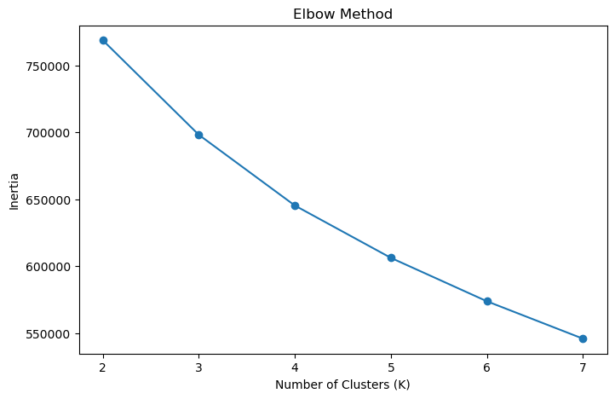

Appendix C – Silhouette Analysis
Figure C1. Silhouette Scores for Different Values of K
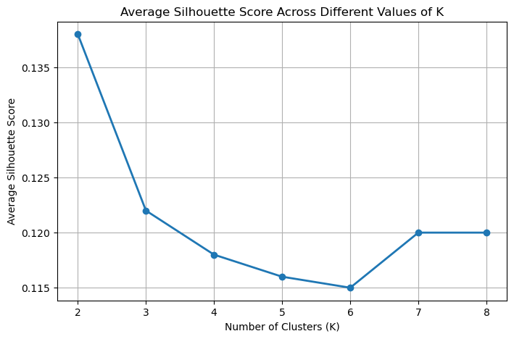

Table C1. Silhouette Scores
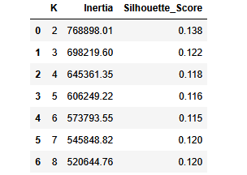

Appendix D – PCA Visualization
Figure D1. Principal Component Analysis (PCA) Visualization of the Four Patient Clusters 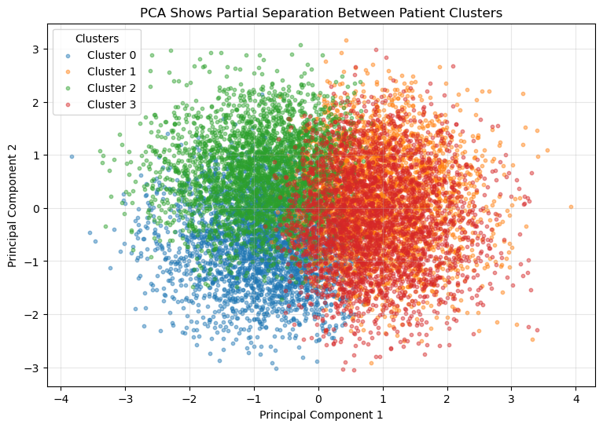
Figure D1. The PCA plot projects the six engineered patient features into two principal components to visualize the four patient clusters identified by the K-Means algorithm. Although some overlap exists, the clusters show meaningful separation, supporting the effectiveness of the clustering model for patient segmentation.
Appendix E – Cluster Summary
Table E1. Patient Cluster Distribution
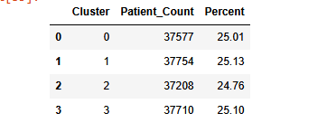
Appendix F – Feature Engineering
Table F1. Engineered Features Used for Clustering
Feature | Calculation | Purpose
Recency | Calculated as the number of days between the reference date (latest admission date in the dataset) and each patient's admission date. Recency = Reference Date − Admission Date | Measures how recently a patient used healthcare services. Smaller values indicate more recent visits, while larger values indicate patients who have not accessed healthcare services for a longer period.
Length of Stay | Calculated by subtracting the admission date from the discharge date. Length of Stay = Discharge Date − Admission Date | Measures the duration of hospitalization. Longer stays often indicate more intensive treatment or complex medical conditions.
Healthcare Utilization | Created by combining Previous Admissions, Medication Count, Procedure Count, ICU Admission, and Surgery Flag. Each variable was standardized using StandardScaler, and the healthcare utilization score was calculated as the average of the standardized values. | Summarizes a patient's overall use of healthcare services into a single measure, making it easier for the clustering algorithm to distinguish between low- and high-utilization patients.
Engagement Score | Calculated as the average of Medication Adherence, Follow-Up Compliance, and Diet Score. Engagement Score = (Medication Adherence + Follow-Up Compliance + Diet Score) ÷ 3. Since all three variables are measured on the same 0–100 scale, they were averaged directly without prior standardization. | Represents how actively a patient follows medical advice and participates in managing their health. Higher scores indicate better patient engagement.
Lifestyle Score | Created by combining Exercise Frequency, Sleep Hours, and Diet Score. These variables were standardized using StandardScaler before calculating the average to produce a single lifestyle score. | Represents the patient's overall healthy lifestyle behaviours by combining physical activity, sleep, and diet into a single measure. Higher scores indicate healthier lifestyle habits that may reduce future healthcare utilization.
Clinical Complexity | Created by combining Comorbidity Count, Chronic Disease Flag, and Mortality Risk Score. Each variable was standardized using StandardScaler, and the Clinical Complexity score was calculated as the average of the standardized values. | Measures the overall severity of a patient's health condition. Higher scores indicate patients with more complex healthcare needs and potentially greater demand for healthcare services.

Appendix G – Comparison of Standardized Patient Characteristics Across Clusters
Figure G1. Comparison of Standardized Patient Characteristics Across Clusters
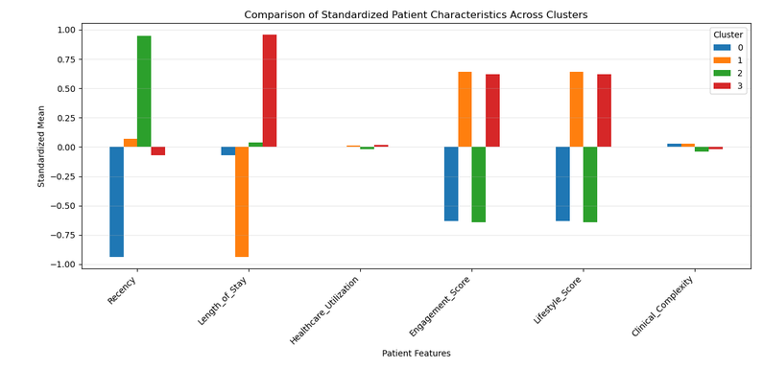
Figure G1. The figure compares the standardized mean values of the engineered patient features across the four patient clusters. The largest differences are observed in recency, length of stay, engagement score, and lifestyle score, while healthcare utilization and clinical complexity show relatively small variation across the clusters.

