1. Our design is a waterfall design

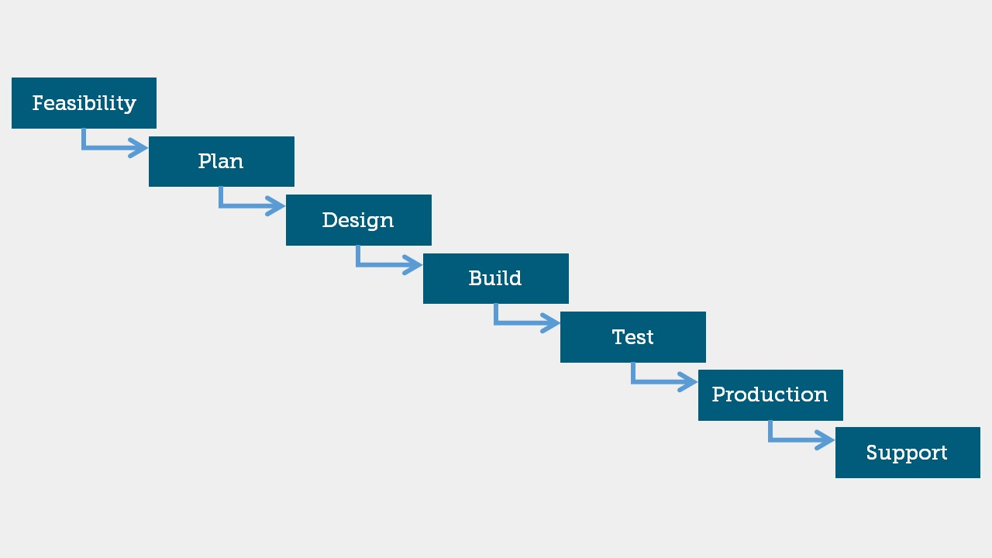

1. Feasibility Study
   1. Detailed document defining what is the problem and what is our solution.
   2. Detailed document about a study of the market needs.

**فى حالة وجود اى استفسار يرجى الاتصال بفريق العمل على الرقم   24032169**

<https://www.capmas.gov.eg/>

1. Plan
   1. Planning for the development and marketing for our project.
2. Design
   1. Design some pseudo screens to simulate our idea.

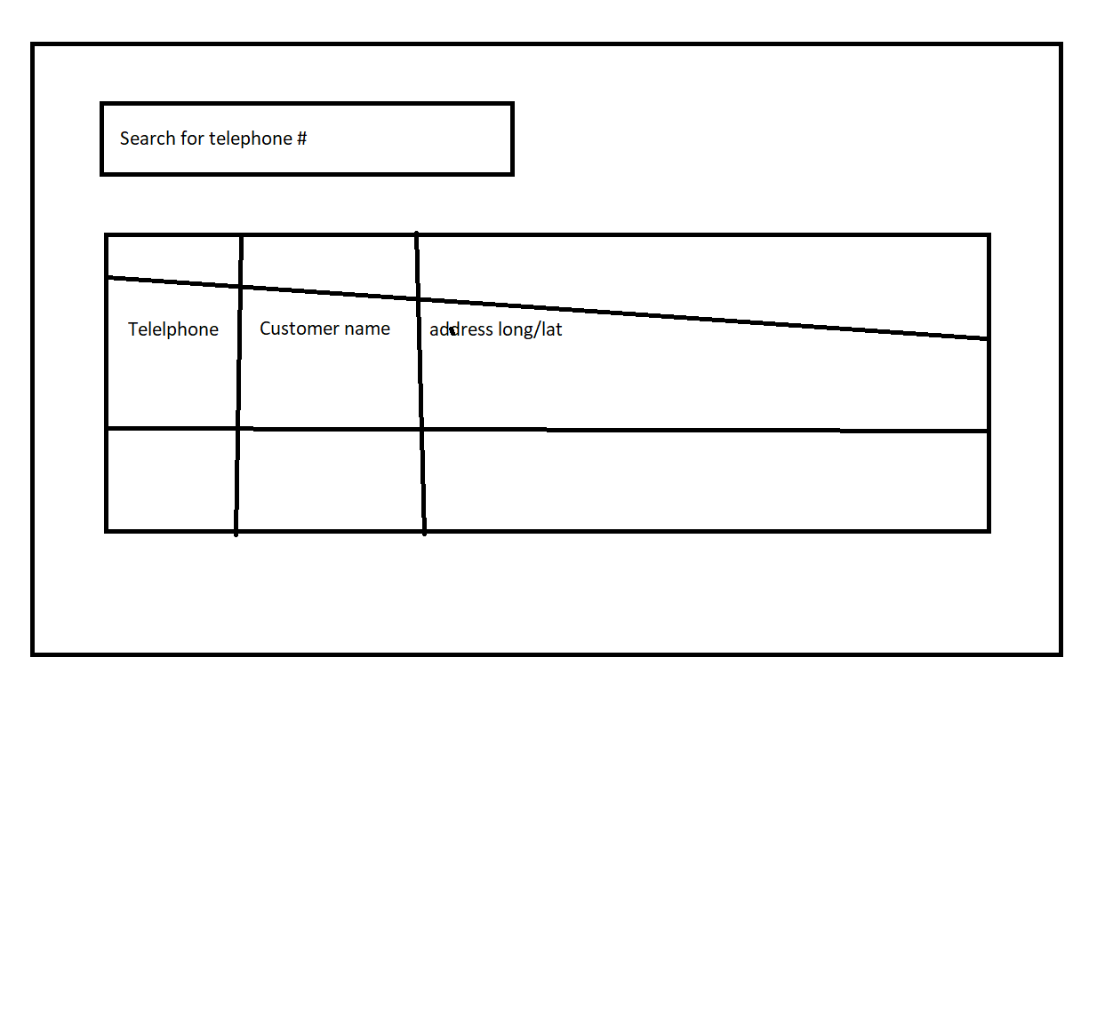

b- design some UML diagrams:

<https://www.tutorialspoint.com/uml/uml_standard_diagrams.htm>

<https://www.draw.io/>

* Use case diagrams
* flowchart diagrams
* Interaction diagrams
* Class diagram

c- Design database ERD

1. Development

Used Technologies:

1. Java EE
   * JSF (Primefaces framework <https://www.primefaces.org/primeng/#/>)
   * Eclipse IDE (Java EE)
   * Spring (optional if there is adequate time)
   * Test units
2. Git
3. Oracle database (free edition community edition)