**WEEK 5**

**6. WebApi_Handson**

**Kafka Integration with C#:**

**Outline:**

* Introduction to Kafka
* Kafka Architecture
* Topics
* Partitions
* Brokers
* Kafka plug in .NET
* Installation of Kafka
* Basics of Zookeeper
* Demo

**Hands On:**

1. Create a Chat Application which uses Kafka as a streaming platform and consume the chat messages in the command prompt.
2. Create a Chat Application using C# Windows Application using Kafka and consume the message in different client applications.

**Reference Links:**

1. <https://www.c-sharpcorner.com/article/apache-kafka-net-application/>
2. <https://www.c-sharpcorner.com/article/step-by-step-installation-and-configuration-guide-of-apache-kafka-on-windows-ope/>

**Output:**

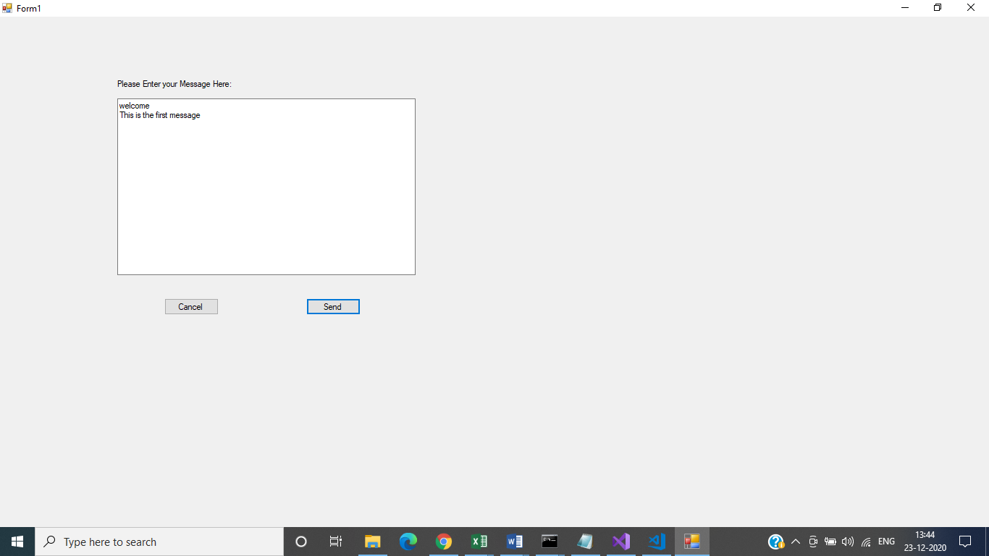

**Kafka Server Running:**

Kafka-server-start.bat ../../config/server.properties

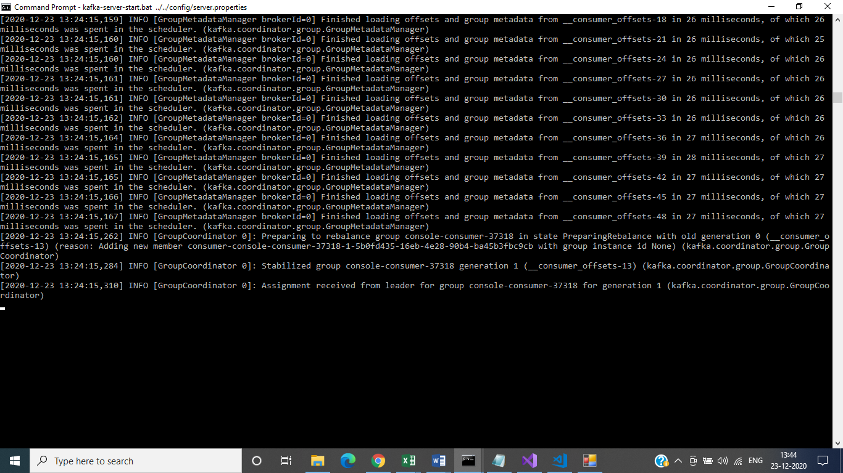

**Zookeeper Running:**

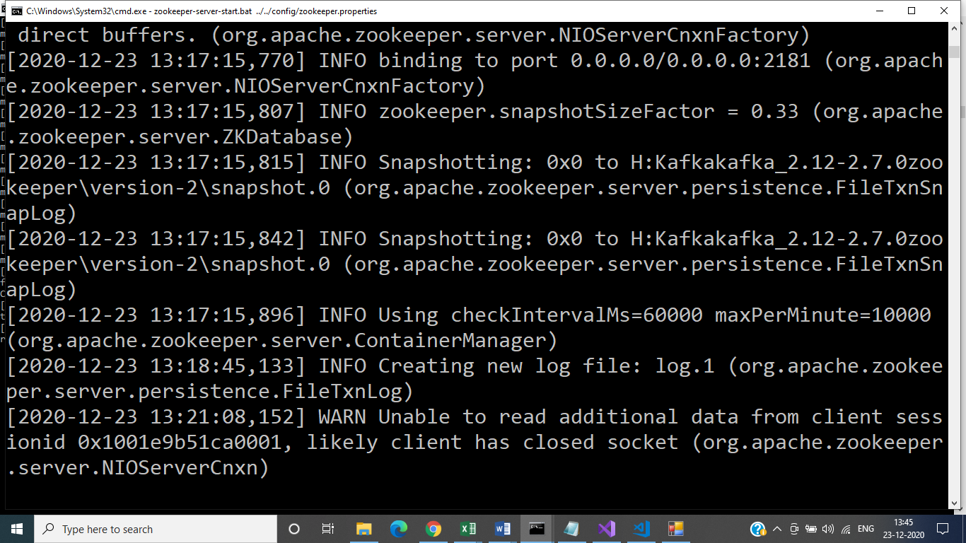

**Topic Created:**

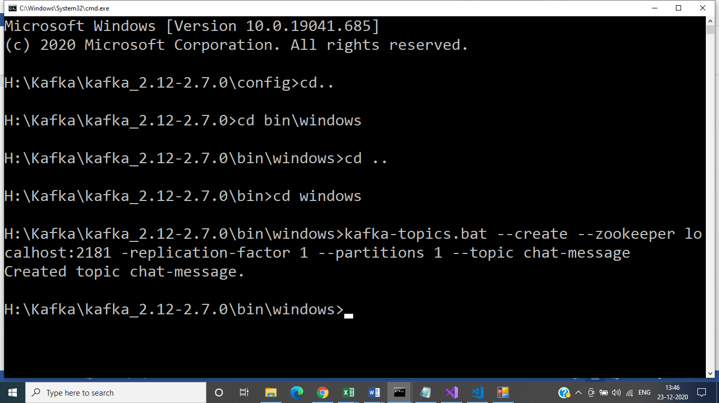

**Creating Publisher in Command Prompt:**

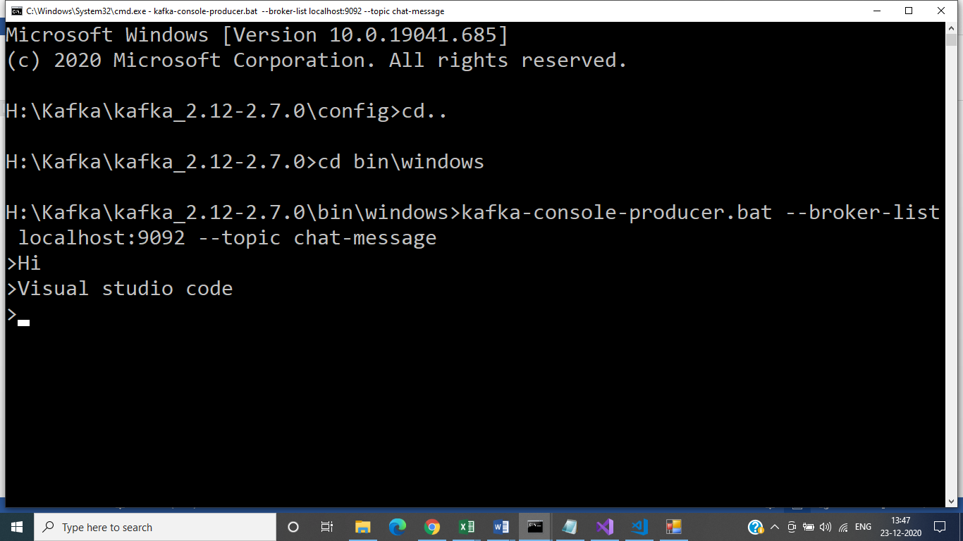

**Client Application:**

