**Letter Recognition**

*Philip George, Seif Nagi, Marian Kromel, Ahmed Osama, Youssif Assem*

**Abstract:**

gives a brief paragraph on the main target of the project, and the achievement of the

project

**1 Introduction**

We aim to apply multi classifiers on the data set and get the best accuracy to make a model that can predict output according to our fetchers after applying (MLP, Random Forest, SVM) we found that the best accuracy we get in SVM and Random Forest we get in the SVM and get in Random Forest. On the other hand, We aim to apply MLP with different activation functions and optimization techniques.

**2 Dataset**

**3 Experimental Results**

***MLP***

|  |  |  |  |  |  |  |  |  |
| --- | --- | --- | --- | --- | --- | --- | --- | --- |
| Classifier | Activation Function | Optimization | No Of Iterations | No Of Hidden layers | No Of  preceptorons | Accuracy | Precision | Recall |
| MLP | Relu | sgd | 2000 | 3 | 100 | 0.95 | 0.95 | 0.95 |
| MLP | Relu | adam | 2000 | 3 | 250 | 0.96 | 0.96 | 0.96 |
| MLP | logistic | adam | 2000 | 3 | 200 | 0.96 | 0.96 | 0.96 |

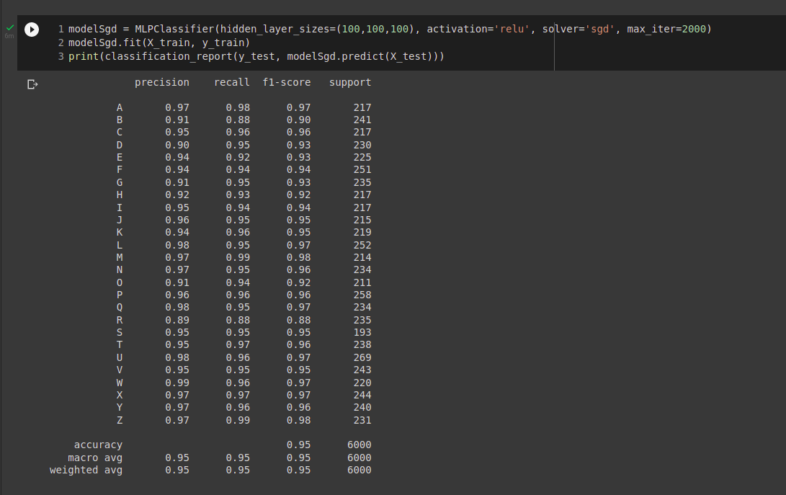

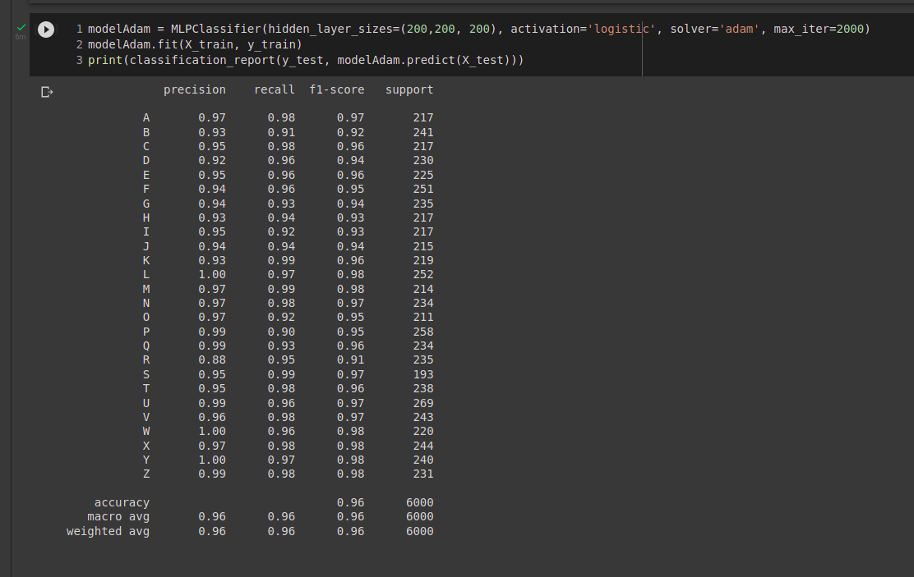

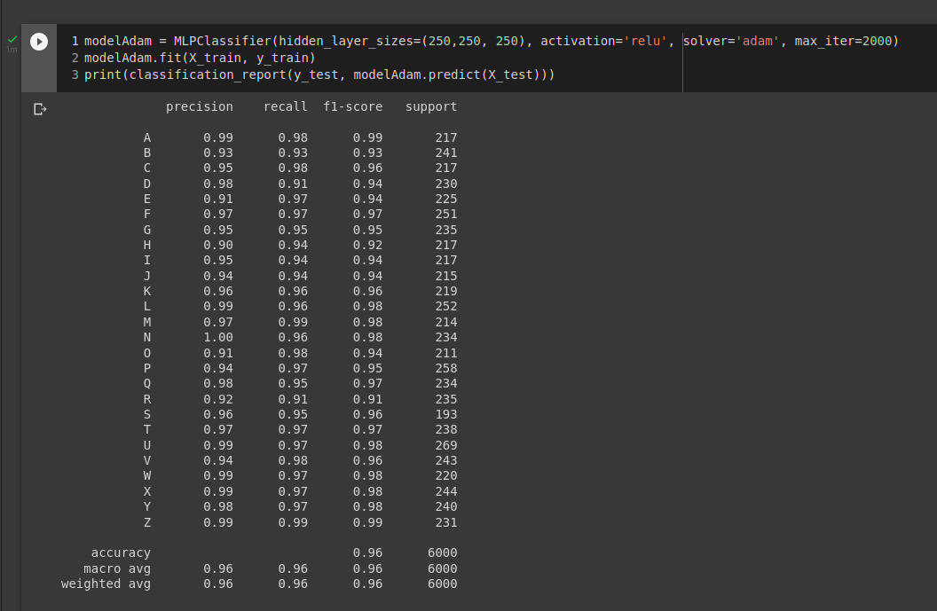

**References**

<https://www.kaggle.com/nishan192/letterrecognition-using-svm>