DRIVE-X
QNX Real-Time Driver Drowsiness and Attention Monitoring System

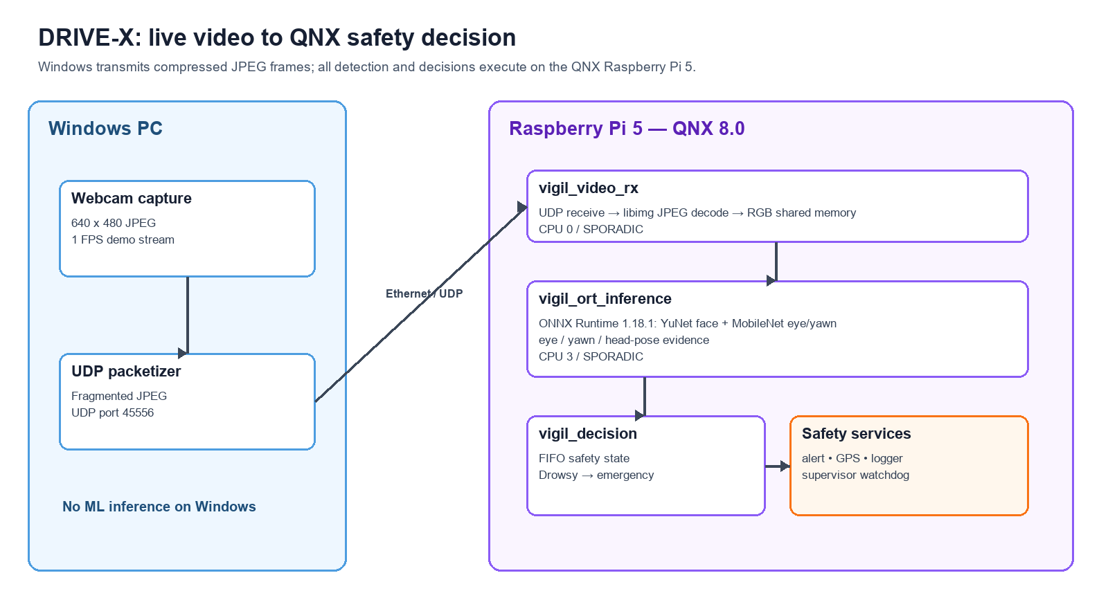
Project architecture: Windows supplies compressed camera frames; the Raspberry Pi 5 running QNX performs decoding, ML inference, decision-making, and safety response.
Team Sentinels | Automotive Theme | QNX SDP 8.0 | Raspberry Pi 5

Executive Summary
DRIVE-X is a real-time driver-monitoring prototype built around a Raspberry Pi 5 running QNX 8.0. A Windows camera source transmits fragmented JPEG frames over UDP. The Pi receives and decodes those frames locally, runs three ONNX Runtime models locally on QNX ARM64, produces eye, yawn, face, and head-pose evidence, and then sends that evidence to a deterministic QNX decision task. The decision task advances a safety state and can activate an emergency alert workflow.
The validated deployment intentionally places Windows outside the safety decision path: Windows supplies compressed video only. JPEG decode, face detection, eye-state inference, yawn inference, evidence fusion, and decision logic execute on the QNX Pi.

Document Roadmap
- Problem statement and proposed solution
- Feature capture, feature processing, decision task, and alert task
- Task pipelining, deadline scheduling, CPU budgeting, shared buffers, and message queues
- Experimental results, discussion, limitations, and future scope

1. Problem Statement
Driver fatigue and inattention can develop gradually and may not be captured by a single frame or a single sensor. A useful in-vehicle prototype therefore needs to observe several visual cues continuously, make a coherent state decision, and deliver a response without allowing non-critical work such as video transport or logging to interfere with safety functions.

Design challenge
- Acquire live driver video while retaining a low-bandwidth development setup.
- Run the complete machine-learning path on the QNX target rather than relying on a Windows host for the decision.
- Separate camera transport, inference, decision, alerting, GPS, and logging so individual failures are observable and recoverable.
- Demonstrate scheduling behavior with a QNX System Profiler trace rather than only reporting console output.

2. Proposed Solution
DRIVE-X uses QNX as the coordinating real-time operating system. The system is structured as a team of isolated processes, which matches QNX’s microkernel model: the kernel provides fundamental scheduling, synchronization, and message-passing services, while higher-level functions are implemented in separate processes. This structure allows the project to keep the safety decision path independent from the camera source and non-critical support services.
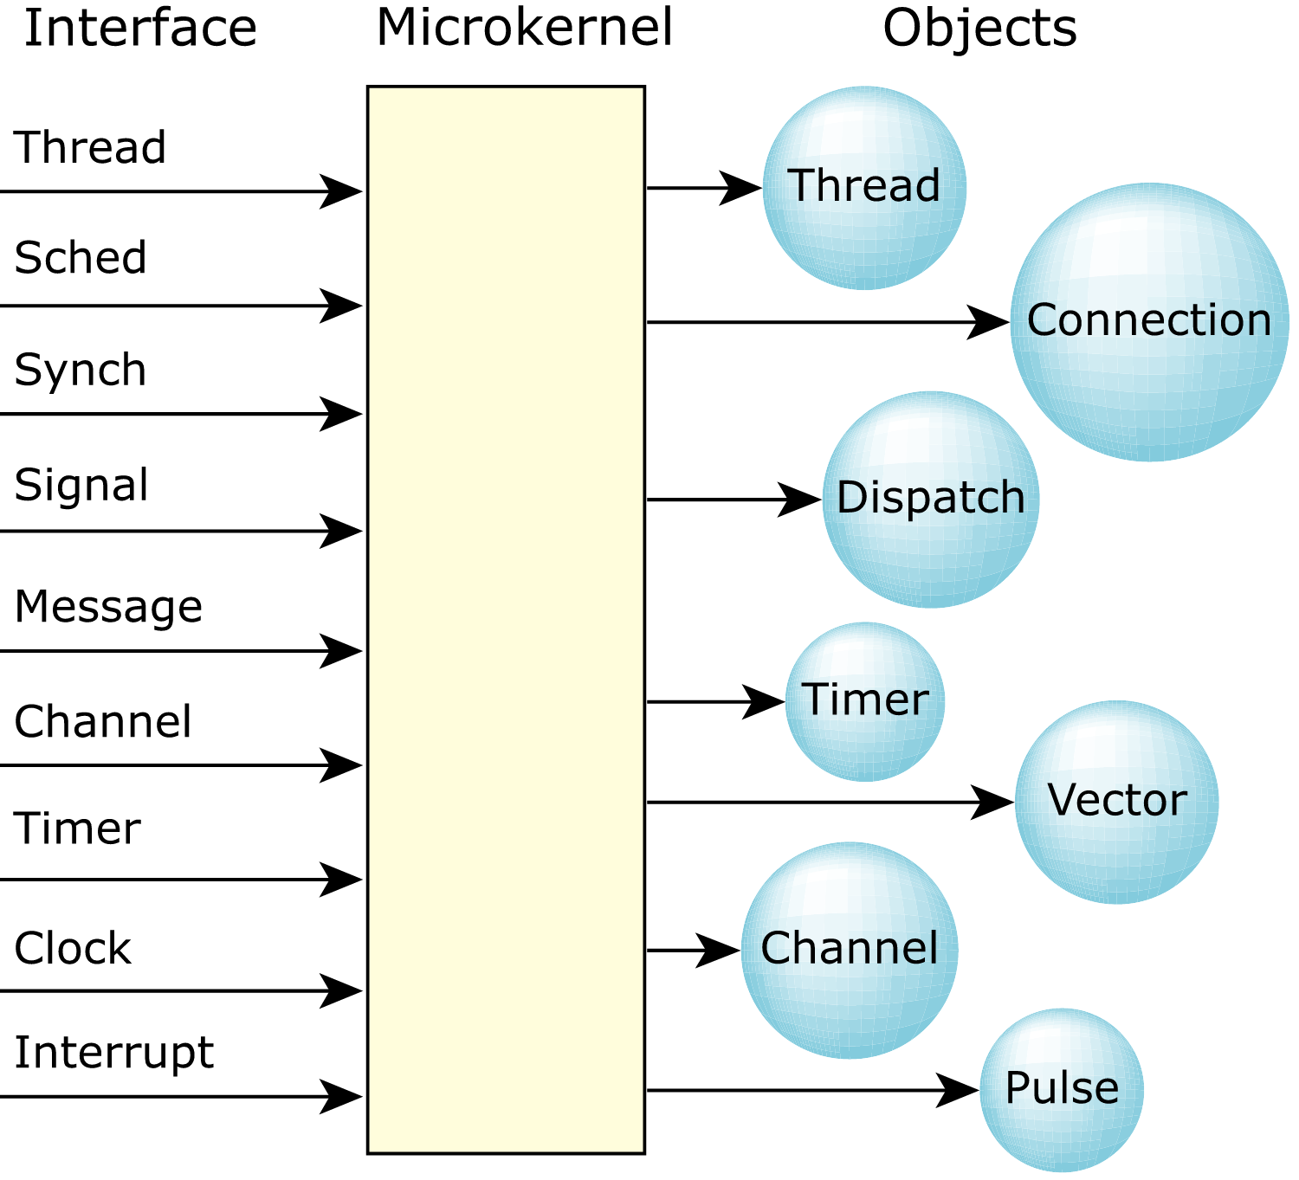
Official QNX figure: microkernel components. Source: QNX, “The QNX OS Microkernel.”
In DRIVE-X, Windows is a development camera source. It captures a 640×480 frame, JPEG-compresses it, fragments it for UDP, and transmits it to the Pi on port 45556. The Pi’s vigil_video_rx service reassembles the JPEG, uses QNX libimg to decode it, and publishes packed RGB pixels into shared memory. Every subsequent safety-stage operation executes locally on QNX.

3. How the Model Operates

3.1 Feature Capture
Feature capture begins after the Pi has decoded a complete JPEG frame. The receiver validates the protocol header, chunk count, payload length, and CRC before accepting a frame. A valid 640×480 RGB frame is placed in a double-buffered shared-memory object named /vigil_rgb_frames. The inference task takes a stable snapshot of the active frame and ignores frames that change during the copy.
- Input: live 640×480 JPEG camera frame from Windows.
- Decode: QNX libimg converts JPEG to RGB888 pixels.
- Capture quality controls: chunk validation, payload bounds, CRC validation, and frame generation counter.
- Feature sources: face rectangle, five YuNet landmarks, left/right eye regions, mouth region, and temporal yawn history.

3.2 Feature Processing
The local inference executable, vigil_ort_inference, uses ONNX Runtime 1.18.1 built for QNX ARM64. It loads three converted .ort models: YuNet face detection, an eye-state MobileNet classifier, and a yawn-frame MobileNet classifier. The models were first verified on QNX with fixed test tensors and host reference outputs before being connected to the live frame buffer.
Model | Purpose | Input | Validated QNX model time
YuNet face | Face box + five landmarks | 640×640 NCHW | 107.241 ms
Eye state | Closed/open evidence | 224×224 eye crop | 25.806 ms
Yawn frame | Yawn evidence | 224×224 mouth crop | 35.265 ms
YuNet generates the face rectangle and landmarks. The two eye crops are normalized with ImageNet mean and scale values before eye classification. The mouth crop is classified by the yawn model. The inference task averages the two eye results, uses a short temporal yawn window to reduce one-frame noise, and derives yaw, pitch, and roll relative to a short neutral-pose calibration.

3.3 Decision Task
The decision service is a separate QNX process. It receives a compact evidence message containing sequence number, timestamp, eye-closure probability, yawn probability, local inference time, and validity flags. It converts this evidence into a system state: SENSOR_LOST, WARMING_UP, ALERT, LOW_VIGILANCE, CHECKING, or DROWSY.
- A valid face and model-ready flag are required before visual evidence is trusted.
- Eye closure, yawn evidence, and sustained head-pose deviation are combined as separate cues rather than treating any one cue as definitive.
- The DROWSY state is the safety trigger. In the live demonstration, this state produced a DROWSINESS_ALERT event.
- The decision task is pinned to CPU 2 with FIFO priority 58 and a configured 10,000 µs decision deadline target.

3.4 Alert Task
The alert service is a distinct FIFO task at priority 62 on CPU 3. When the decision task publishes an emergency event, the alert service logs the event, collects available GPS information, and can relay a structured emergency payload to an external relay on UDP port 45557. The relay can be configured for notification delivery. GPS is optional during indoor demonstrations; the final live test correctly reported gps_valid=false when a usable device was not present.

4. Task Pipelining
The pipeline is deliberately decomposed so that each step has one responsibility and can be observed independently. This makes it easier to prove where time is spent, restart an affected service, and avoid placing image-sized data on a message queue.
DRIVE-X task pipeline. Windows supplies compressed video only; QNX runs decode, ONNX inference, decision, alerting, and supervision.
Stage | QNX service | Data transfer | Role
Receive | vigil_video_rx | UDP 45556 | Reassemble JPEG and decode RGB
Frame handoff | /vigil_rgb_frames | POSIX shared memory | Double-buffered RGB frame
Inference | vigil_ort_inference | Shared-memory snapshot | Face, eye, yawn, head pose
Decision | vigil_decision | QNX MsgSend/MsgReply | State estimation and timing
Response | vigil_alert | POSIX emergency queue | Alert / optional GPS relay
Support | logger, GPS, supervisor | Queues + heartbeat files | Audit, location, restart

5. Deadline Scheduling and CPU Budgeting
QNX schedules on a per-thread basis. DRIVE-X assigns critical response and decision services FIFO priorities, while the video and inference services use sporadic scheduling. Sporadic scheduling provides a foreground execution budget within a replenishment period and then lowers priority after that budget is consumed. This limits non-critical background work from consuming CPU time needed by higher-priority safety threads.
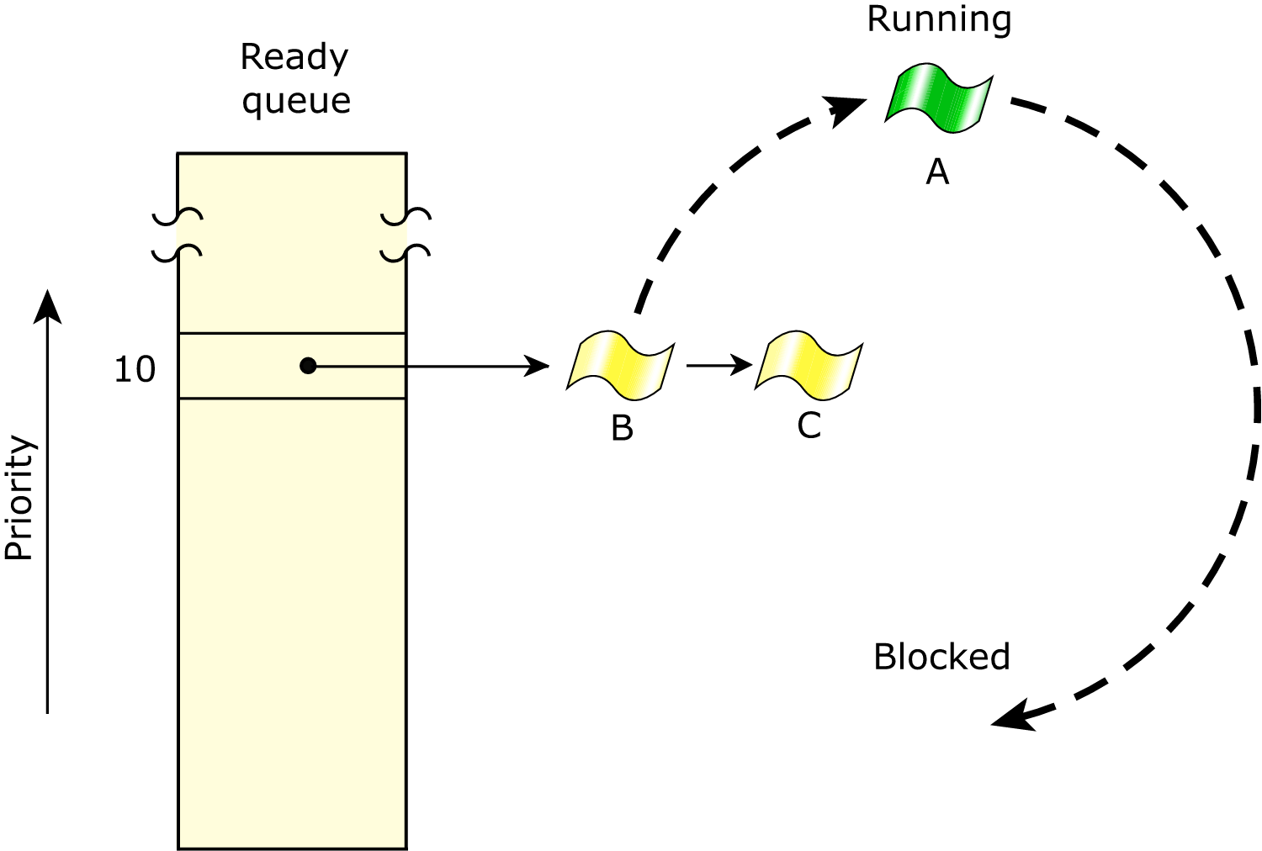
Official QNX figure: scheduling behavior when equal-priority threads compete. Source: QNX, “Scheduling policies.”
Service | CPU | Policy | Priority | Budget / deadline
vigil_alert | 3 | FIFO | 62 | Immediate safety response
vigil_ingest | 1 | FIFO | 60 | Evidence ingest
vigil_decision | 2 | FIFO | 58 | 10,000 µs target
vigil_supervisor | 3 | FIFO | 45 | Service monitoring
vigil_ort_inference | 3 | SPORADIC | 40 / 15 | 250 ms / 1000 ms
vigil_gps | 3 | SPORADIC | 35 / 12 | 5 ms / 100 ms
vigil_video_rx | 0 | SPORADIC | 25 / 10 | 40 ms / 100 ms
vigil_logger | 3 | SPORADIC | 20 / 8 | 5 ms / 100 ms
The measured full inference time was approximately 237–256 ms per sampled frame. This is close to the configured 250 ms budget; the prototype continued operating, but a production system would reserve additional margin and complete a full worst-case execution-time and schedulability analysis for the chosen frame rate and hardware.

6. Shared Buffers and Message Queues

6.1 Shared RGB Buffer
Image frames are large: a 640×480 RGB888 frame contains 921,600 bytes. DRIVE-X therefore uses shared memory rather than copying the full image through a message. The receiver maintains two frame slots. While it writes one slot, it marks a generation counter odd; after the write it publishes the completed slot with an even generation. The inference task copies only a stable slot and retries if the generation changes. This avoids reading a partially written image while keeping the data path simple and bounded.
QNX documentation describes this same design principle: shared memory provides high performance while message passing provides synchronization. In DRIVE-X, the frame buffer is shared memory and the decision evidence is a small synchronous message.

6.2 Synchronous Message Passing
vigil_ort_inference uses name_open() to locate the vigil_decision service and MsgSend() to submit evidence. The decision server receives it, computes the new state, and MsgReply() returns the decision result. The client blocks for the reply, which makes the inference-to-decision handoff explicit and naturally synchronized.
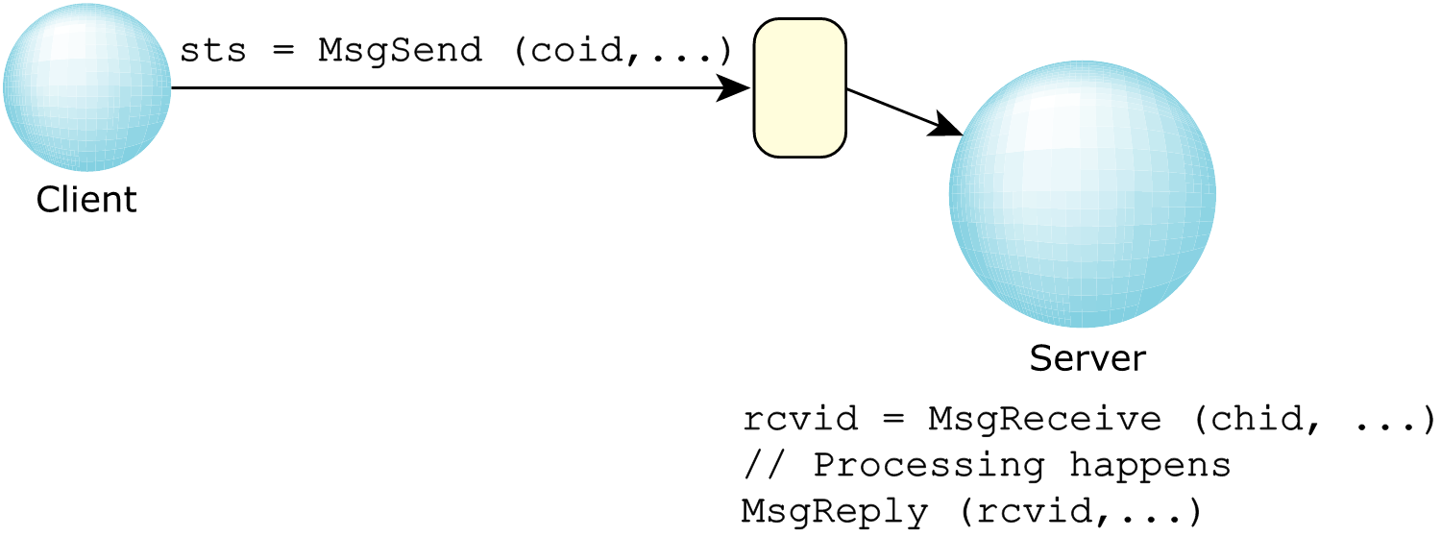
Official QNX figure: client/server message data flow. Source: QNX, “Message handling.”

6.3 POSIX Queues
DRIVE-X also uses two POSIX message queues for asynchronous support paths: /vigil_log for audit records and /vigil_emergency for emergency events. The logger and alert components consume these small messages, keeping those slower functions out of the decision service’s critical work.

7. Results

7.1 ONNX Runtime Validation on QNX ARM64
All three ONNX Runtime QNX smoke tests passed on the Raspberry Pi. The test compared QNX model outputs with reference outputs produced on the host. The eye model reported a maximum absolute error of 1.43051e-06 with no mismatches, the yawn model reported 0.00109005 with no mismatches, and the YuNet face model reported no mismatches across its outputs.

7.2 Live Pipeline Measurements
Metric | Observed result | Interpretation
JPEG decode | 7–11 ms | QNX libimg decoded incoming 640×480 frames
Live inference | 237–256 ms | Face + eye + yawn + head evidence on QNX
System trace | 5.000 s; 1,197,822 events | Kernel event trace recorded successfully
Dropped buffers | 0 | No trace-buffer loss during capture
vigil_ort_inference | 1.549 s running; 33.259 ms ready | Local ONNX task was active and rarely waiting
vigil_video_rx | 139.577 ms running | Local video receive and JPEG decode service was active
Decision recovery | 3,642 µs; target <2,000,000 µs | Observed recovery check passed
QNX System Profiler evidence: vigil_ort_inference accumulated 1.549 s of running time in the 5-second trace.
QNX System Profiler evidence: vigil_video_rx accumulated 139.577 ms of running time in the same trace.

7.3 How Profiling Evidence Was Collected
A Neutrino Kernel Event Trace was run through Momentics against the live Pi target. A five-second Wide trace was selected after an initial Fast trace did not expose enough process/thread detail. The completed trace contained zero dropped buffers and showed the running and ready times of the project processes.
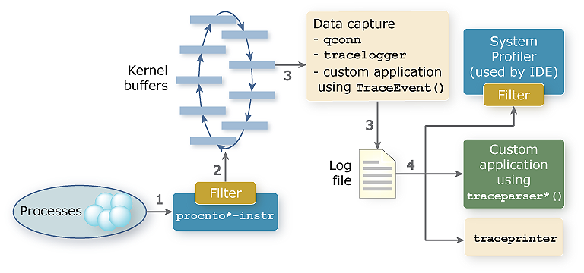
Official QNX figure: kernel event trace information flow. Source: QNX, “How kernel event tracing works.”

8. Conclusion and Discussion
DRIVE-X demonstrates a complete QNX-based driver-monitoring pipeline on Raspberry Pi 5. The project proved local decoding, local ONNX inference, deterministic message handoff, alert activation, process supervision, and system-level profiling. The division of responsibility is central: Windows provides a convenient video source, but it is not part of the QNX safety decision path.
The result is a functional prototype rather than an automotive-certified product. The local smoke tests prove that the exported models execute numerically as expected on QNX for their reference tensors, but they do not replace a full field accuracy study across drivers, lighting conditions, eyewear, camera placements, and demographics. Likewise, the observed scheduling trace is strong implementation evidence but not a complete hard-real-time safety case.

9. Future Scope
- Integrate vehicle CAN/ECU interfaces so a confirmed safety state can request controlled speed reduction or other vehicle actions.
- Use an automotive-grade camera, GNSS receiver, enclosure, power system, and communication path.
- Improve robustness for night driving, sunglasses, occlusion, multiple occupants, and changing camera pose.
- Collect a labeled validation dataset and report accuracy, false-positive rate, false-negative rate, and time-to-alert metrics.
- Allocate additional inference scheduling margin and conduct worst-case execution-time and multi-core schedulability analysis.
- Integrate secure communications, diagnostic logging, fault-injection tests, and automotive safety/cybersecurity lifecycle practices.

References and Figure Attribution
All external technical figures in this document are reproduced from official QNX SDP 8.0 documentation and are attributed below. Project architecture and profiler captures are DRIVE-X project material.
- QNX OS Microkernel: https://qnx.com/developers/docs/8.0/com.qnx.doc.neutrino.sys_arch/topic/kernel.html
- QNX Message Handling: https://www.qnx.com/developers/docs/8.0/com.qnx.doc.neutrino.getting_started/topic/s1_msg_Message_handling.html
- QNX Scheduling Policies: https://qnx.com/developers/docs/8.0/com.qnx.doc.neutrino.sys_arch/topic/kernel_SchedulingAlgorithms.html
- QNX Shared Memory with Message Passing: https://www.qnx.com/developers/docs/8.0/com.qnx.doc.neutrino.sys_arch/topic/ipc_Shared_memory_and_messages.html
- QNX Sporadic Scheduling: https://qnx.com/developers/docs/8.0/com.qnx.doc.neutrino.prog/topic/overview_Sporadic_scheduling.html
- QNX Kernel Event Tracing: https://qnx.com/developers/docs/8.0/com.qnx.doc.ide.userguide/topic/kernel_tracing_process.html

