Преобразуване от E/R към релационен модел на данни
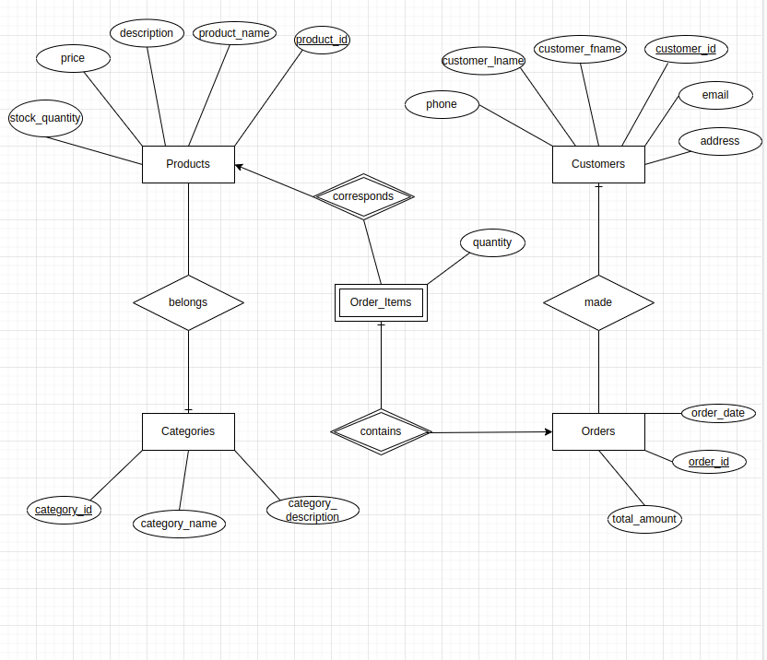
Схема на базата данни (в релационен модел):

Products(product_id, product_name, description, price, stock_quantity, category_id)
Categories(category_id, category_name, category_description)
Customers(customer_id, email, address, customer_fname, customer_iname, phone)
Orders(order_id, order_date, total_amount, customer_id)
Order_Items(order_id, product_id, quantity)

Ограничения:

Primary key

Products: PK(product_id)
Categories: PK(category_id)
Customers: PK(customer_id)
Orders: PK(order_id)
Order_Items: PK(order_id, product_id)

Foreign keys

Products: FK(category_id) → Categories(category_id)
Orders : FK(customer_id) → Customers(customer_id)
Order_Items: FK(order_id) → Orders(order_id)
Order_Items: FK(product_id) → Products(product_id)

Check
Products: CK(price > 0)
Customers: CK(email - @ .)
Order_Items: CK(quantity > 0)

