Software Requirements Specification
For
Distributed computer system for managing the activity of a library
Version 2.4 approved 2024
Prepared by:

Neagoe Dana-Maria
Radu Dragos Florian
Stan Marian-Cristian

<CR>
<11.03.2024>
Table of Contents
Table of Contents ii
Revision History ii
1. Introduction 1
1.1 Purpose 1
1.2 Document Conventions 1
1.3 Intended Audience and Reading Suggestions 1
1.4 Product Scope 1
1.5 References 1
2. Overall Description 2
2.1 Product Perspective 2
2.2 Product Functions 2
2.3 User Classes and Characteristics 2
2.4 Operating Environment 2
2.5 Design and Implementation Constraints 2
2.6 User Documentation 2
2.7 Assumptions and Dependencies 3
3. External Interface Requirements 3
3.1 User Interfaces 3
3.2 Hardware Interfaces 3
3.3 Software Interfaces 3
3.4 Communications Interfaces 3
4. System Features 4
4.1 System Feature 1 4
4.2 System Feature 2 (and so on) 4
5. Other Nonfunctional Requirements 4
5.1 Performance Requirements 4
5.2 Safety Requirements 5
5.3 Security Requirements 5
5.4 Software Quality Attributes 5
5.5 Business Rules 5
6. Other Requirements 5
Appendix A: Glossary 5
Appendix B: Analysis Models 5
Appendix C: To Be Determined List 6

Revision History
Name | Date | Reason For Changes | Version
Neagoe Dana-Maria | 11.03.2024 | Document formatting + Introduction + Overall Description | 1.0
Stan Marian-Cristian | 13.03.2024 | External Interface Requirements | 1.1
Radu Dragos-Florian | 13.03.2024 | Other Nonfunctional Requirements | 1.2
Neagoe Dana-Maria | 15.03.2024 | Sys Feature: Admin/Librarian and login and sign-up + User Login and sign-up | 1.3
Radu Dragos-Florian | 15.03.2024 | Sys Feat.: Log out + update Document Conventions | 1.4
Stan Marian-Cristian | 16.03.2024 | Fix Sys Feat headings, Sys Feat. Bookshelves + Reserved books | 1.5
Neagoe Dana-Maria | 16.03.2024 | Update images on User interfaces | 1.6
Radu Dragos-Florian | 17.03.2024 | Sys Feat.: Return | 1.7
Neagoe Dana-Maria | 17.03.2024 | Sys Feat.: Contact and update the Purpose and Product Scope | 1.8
Stan Marian-Cristian | 19.03.2024 | Update Software Interfaces + Update User Documentation + Sys Feat.: About | 1.9
Stan Marian-Cristian | 20.03.2024 | Update Operating Environment + User Interfaces + Design and Implementation Constraints + Performance requirements | 2.0
Neagoe Dana-Maria | 23.03.2024 | Update Stimulus/Response Sequences: Login – Sign up, Logout: Admin + User, Bookshelves | 2.1
Radu Dragos-Florian | 23.03.2024 | Update Stimulus/Response Sequences: Reserved + Return + Contact + About + Privacy | 2.2
Neagoe Dana-Maria | 24.03.2024 | Sys Feat: Review + Home | 2.3
Stan Marian-Cristian | 24.03.2024 | Sys Feat: Profile and minor changes (document format) and validation | 2.4

Introduction

Purpose
The proposed scope is to develop a software system to automate the process of managing the activity of a library. Activity of a library means: search for a book, add a review for a book, reserve a book, return a book, send feedback, contact the librarians.

Document Conventions
We write this document in Times New Roman font. For each chapter of this document that includes subchapters we used a font size equal to 18 and bold. The subchapters have a font size equal to 14 and bold. The description for each chapter or subchapter has a font size equal to 12.

Term | Definition
ID | Unique indicator
Admin | Administrator
DB | Database
National Identification Number | CNP

Intended Audience and Reading Suggestions
This document is intended for all groups of people who will have contact with this application. The types of audience for this document are the following: users, developers, and administrators.

Product Scope
Description: The product scope is to develop an innovative software system for automation the process of managing the activity of a library. This system will provide a complete digital solution, facilitating easy and fast access to library resources and optimizing interaction for both librarians and users.
The objective of our product aplication is to improve the quality services provided. For users it is very important to be very simple to find in a short time the list of books in the library.

Collecting data from the books;
Users can add reviews to books;
Providing information through a web portal;
Managing the activity of a library and its branches;
The users search for books by title, author.

Library Management System is a computerized system which helps the user (librarian) to manage the library daily activity in electronic format.

References

http://www.aman.ro/

https://docs.microsoft.com/en-us/aspnet/core/?view=aspnetcore-6.0

https://dzone.com/articles/insert-command-in-sql-server-2017

https://docs.microsoft.com/en-us/dotnet/csharp/

http://caxapa.ru/thumbs/468328/misra-c-2004.pdf

https://www.w3schools.com/cs/index.php

https://stackoverflow.com/

https://docs.microsoft.com/en-us/dotnet/api/system.stackoverflowexception?view=net-6.0

https://itsourcecode.com/free-projects/csharp/school-library-management-system-in-c-with-source-code/

http://www.noblecomputer.co.in/how-to-make-library-management-system-in-c-sharp.php

https://github.com/guptaanmol184/LibraryManagementSystem

https://www.codeitbro.com/how-to-create-asp-net-login-page-with-sql/

- https://www.c-sharpcorner.com/UploadFile/satyapriyanayak/registration-and-login-according-to-role-in-Asp-Net/

https://jakeydocs.readthedocs.io/en/latest/testing/integration-testing.html

https://docs.microsoft.com/en-us/dotnet/core/testing/unit-testing-with-dotnet-test

https://docs.microsoft.com/en-us/dotnet/core/testing/unit-testing-best-practices

- https://docs.microsoft.com/en-us/dotnet/architecture/modern-web-apps-azure/test-asp-net-core-mvc-apps

- https://xunit.net/docs/getting-started/netfx/visual-studio

- https://docs.microsoft.com/en-us/visualstudio/test/unit-test-basics?view=vs-2022

- https://geosoft.no/development/cppstyle.html

- https://www.c-sharpcorner.com/UploadFile/mahesh/understanding-message-box-in-windows-forms-using-C-Sharp/

- https://csharp-video-tutorials.blogspot.com/2015/01/javascript-popup-window.html

https://app.diagrams.net/

Overall Description

Product Perspective
Description: This system consists of a single part, a web application, which will be used by
librarian, but also by users. Also, the application will constantly communicate with the database. The application will be accessed using a computer that has at least the application with minimum user specifications.

The diagram who shows the major components of the overall system:

Application
Server

Database

Product Functions

The functionalities of the application:
- The user can create and delete their account from databases;
- The user can view the list of books;
- The user can reserve books from library;
- Books are reserved and returned by the user.
- The administrator can add/create, delete, or edit books from the list;
- Information about each book can be changed;
- The administrator can view the list of reserved books;
- The login page differentiates between administrator and user.

User Classes and Characteristics

Admin (Employees / Librarian):

- Employees who will have an ID (for authentication).

- They have the right to add books, delete books, update book details and manage the list of reserved books.

- The admin can see the books list containing the ID, name of the book, author and publishing of the book.

Users:

- They can visit the site, search for books by title, author or genre displayed in a list if they are found, and can read the description about the books searched according to the results searched and reserve books.

- The user can see the books list containing the name of the book, author and publishing of the book.

Users unauthenticated:
- Have all the functionality of the logged in users except reserving books.

Operating Environment
Users must have access to the Internet.

The application will work on PCs that runs on Windows Operating System:

- Windows Operating System 10 PRO, Version: 22H2, Operating System build: 19045.4170
Experience: Windows Feature Experience Pack 1000.19054.1000.0

- Windows Operating System 11 PRO, Version: 23H2, Operating System build: 22631.3296

The application runs on:

- Chrome Web Browser Minim Version 122.0.6261.129 (Official Build) (64-bit)

Design and Implementation Constraints
- License for Visual Studio 2022 (64-bit) version: 17.5.1, 17.3.6, 17.6.4;
- License for Visul Studio Code version 1.87.2
- License for Oracle MySQL version 8.3
- License for SourceTree version 3.4.13

User Documentation
All details about this application will be presented in this document.
Provide a tutorial in a video format on all implemented functionality.

Assumptions and Dependencies
Not applicable.

External Interface Requirements

User Interfaces

Home Page
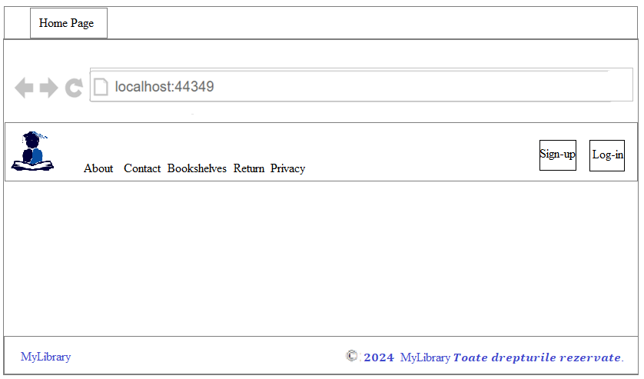

Sign-up Page
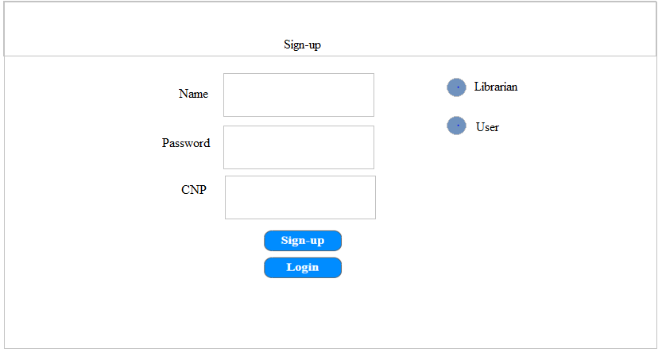
Login Page
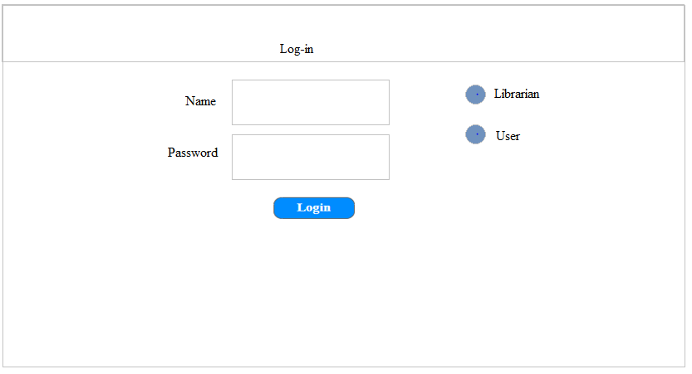

Contact Page
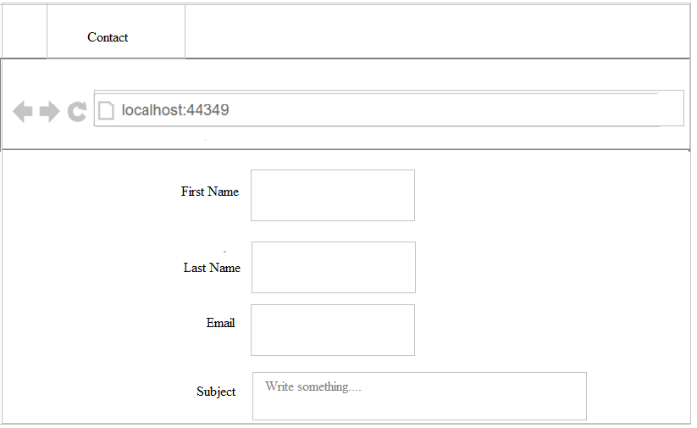
Privacy Page
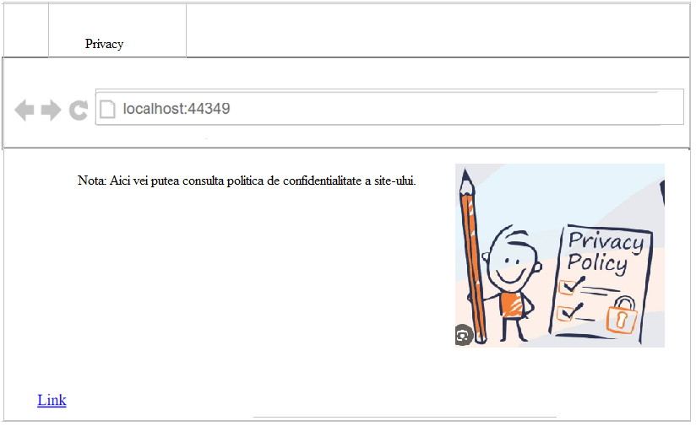

About Page
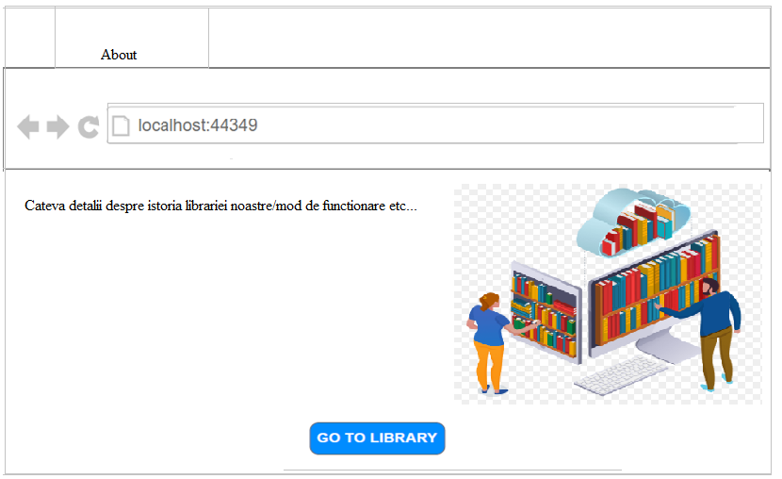

Bookshelves Page
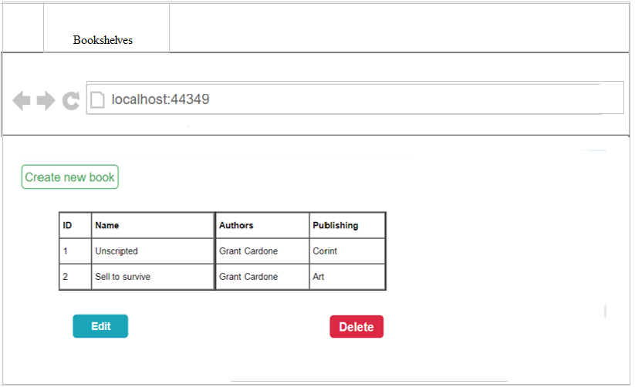

Return Page
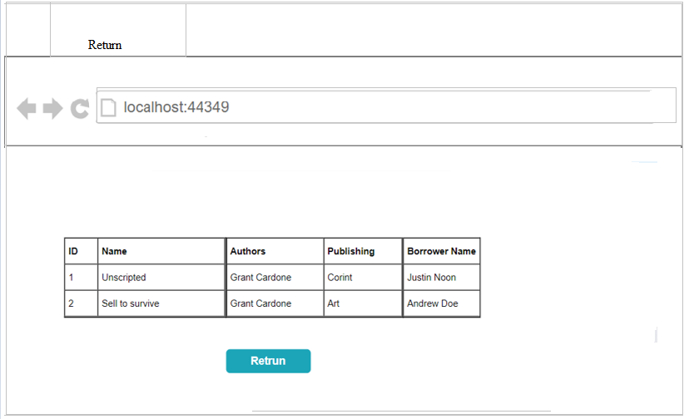

Reserved Page
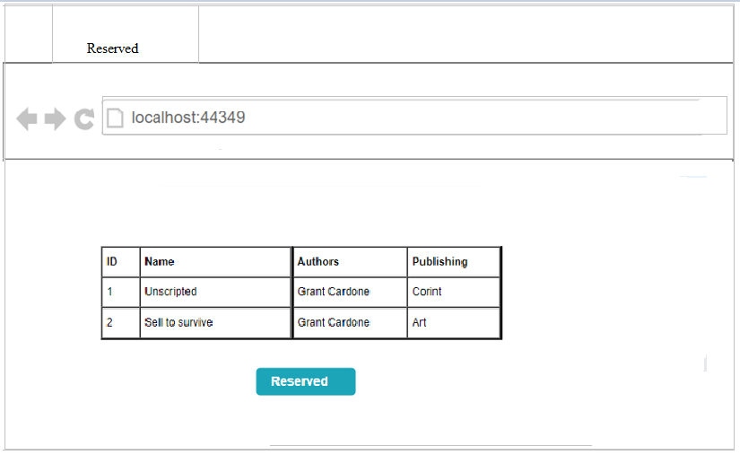

Hardware Interfaces
Not applicable

Software Interfaces
- Database Management
- Database: MySQL
- Purpose: Store all product(books) information, user’s data, etc.
- Communication: SQL queries are used to interact with the database (delete a book, add a book)

The connection between the database and the server will always be active. This app will contain various functions with different functionalities (to read from the DB, to write to the DB, or delete from the DB, there will also be a functionality that will view the DB information).
The communication between the website and database will be done using the HTTPS communication protocol.

Function prototypes are:

● private void Insert (object sender);
● private void Update (object sender);
● private void Delete (object sender);
● private void Display ();

Communications Interfaces
The connection between the database and the server will always be active. This app will contain various functions with different functionalities (to read from the DB, to write to the DB, or delete from the DB, there will also be a functionality that will view the DB information).
The communication between the website and database will be done using the HTTPS
communication protocol

System Features

Administrator/Librarian login and sign-up

Description and Priority
The administrator can create a new account if he does not already have an account.
The administrator will be able to login.
Priority: High

Stimulus/Response Sequences
Input: 3 Strings: username, password, optional: National Identification Number (CNP)
1 bool: if librarian option is checked use admin authorization, else switch to user

Output: if register add the account to the DB, else login in app with the account return to the Home page

Functional Requirements

- The admin pressed the “Sign-up” button.
- The admin creates his account.
- The admin enters the username, password and National Identification Number (ro: CNP)
- The admin check librarian option in the checkbox and sign up
- The admin pressed the “Login” button.
- The admin enters the username, password
- The admin check librarian option in the checkbox and login in

REQ-1: There must be a textbox in which the administrator enters the username.

REQ-2: There must be a textbox in which the administrator enters the password.

REQ-3: There must be a textbox in which the administrator enters the CNP.

REQ-4: If the username is wrong, the administrator cannot login with success.

REQ-5: The username needs to be unique and must contain at least 3 characters.

REQ-6: The password must contain at least 8 characters.

REQ-7: In the signup page if the librarian checks the Librarian’s checkbox, his account will be registered

REQ-8: The password will be encrypted, also the CNP.

REQ-9: There must be a login button that the administrator can switch to login page after the registration

REQ-10: After the login was successful, a pop-up message will be displayed to confirm that.

REQ-11: After the sign-up was successful, a pop-up message will be displayed to confirm that.
REQ-12: If the password does not correspond to the username then the administrator will not be able to login successfully.

User login and sign-up

Description and Priority
The user can create a new account if he does not already have an account.
The user will be able to login.
Priority: High

Stimulus/Response Sequences

Input: 3 Strings: username, password, optional: National Identification Number (CNP)
1 bool: if librarian option isn’t checked use user authorization, else switch to admin

Output: if register add the account to the DB, else login in app with the account return to the Home page

Functional Requirements

- The user pressed the “Sign-up” button.
- The user creates his account.
- The user enters the username, password and National Identification Number (ro: CNP)
- The user check user option in the checkbox and sign up
- The user pressed the “Login” button.
- The user enters the username, password
- The user check user option in the checkbox and login in

REQ-13: There must be a textbox in which the user enters the username.

REQ-14: There must be a textbox in which the user enters the password.

REQ-15: There must be a textbox in which the user enters the CNP.

REQ-16: If the username is wrong, the user cannot login with success.

REQ-17: The username needs to be unique and must contain at least 3 characters.

REQ-18: The password must contain at least 8 characters.

REQ-19: In the signup page if the user checks the user’checkbox, his account will be registered

REQ-20: The password will be encrypted, also the CNP.

REQ-21: There must be a login button that the user can switch to login page after the registration

REQ-22: After the login was successful, a pop-up message will be displayed to confirm that.

REQ-23: After the sign-up was successful, a pop-up message will be displayed to confirm that.
REQ-24: If the password does not correspond to the username then the user will not
be able to login successfully.

Log out Admin + User

Description and Priority
The administrator and user can log out by clicking on the logout button.
Priority: High

Stimulus/Response Sequences
  - Input: Mouse event click on logout button
  - Output: return to the Home Page with user unauthenticated status

Functional Requirements
1. The administrator selects the “Logout” button.

REQ-25: There must be a button for the administrator to press when they want to log out.

REQ-26: After pressing the button, the administrator is redirected to the home page.

REQ-27: The DB preserves the information about the last logged in person, even after that person logs out.

REQ-28: After the logout was successful, a pop-up message will be displayed to confirm that.

2. The user selects the “Logout” button.
REQ-29: There must be a button for the user to press when they want to log out.

REQ-30: After pressing the button, the user is redirected to the home page.

REQ-31: The DB preserves the information about the last logged in person, even after that person logs out.

REQ-32: After the logout was successful, a pop-up message will be displayed to confirm that

Bookshelves

Description and Priority
The administrator (librarian) can add, edit and delete books.
The User can look out for a book by category. After he choose a book he can see or leave a review about it
Priority: High

Stimulus/Response Sequences

  - Input admin: Mouse event click on Add/Edit/Delete/View buttons, Add (add a book to the bookshelves list in DB), edit (change attributes of the book in DB), delete (remove the book from DB).
  - Output: The DB is updated according to the Add/Edit/Delete operations. View - extracts the attributes from DB and show them on the screen)

  - Input user: Mouse event click on View or Mouse event click on a category

  - Output: View - extracts the attributes of the book from DB and show them on the screen. Category – extracts from DB the books that are part of the chosen category.

Functional Requirement
1. The administrator selects the Create/Edit/Delete buttons.

REQ-33: On the bookshelves page the admin can select the create button to add a new book to the list.

REQ-34: On the bookshelves page the admin can select the edit button to edit the description of a book in the list.

REQ-35: On the bookshelves page the admin can select the delete button to delete a book from the list.

REQ-36: The administrator can see on the bookshelves page, the list of the books including the id, the name of the book, the author and the publishing.

2. The user can look out for a book by category and see the reviews or add one or reserved it

REQ-37: On the bookshelves page, the user can navigate through the list of books, switching by category, so there will be an option bar where he can select a category using something like radio options.

REQ-38: The books after the user choosed the category will apear on a silder or cards with a short description, author, publisher.

REQ-39: On the page, after the user select or choose a book, there will be two buttons, first will lead to the review section of the book and other will lead to the reserved page .

Reserve book

Description and Priority
The user can view the books in the library and can reserve a book.
Priority: High

Stimulus/Response Sequences
  - Input: mouse event click on “reserve” button

  - Output: The DB is updated, and the book is assigned to the user by id

Functional Requirements
1. The user selects the reserved button.

REQ-37: The user can press the Reserved button in order to reserve a book displayed on the Books list.

REQ-38: After the book was successfully reserved by the user, a pop-up message will be displayed to confirm that.

REQ-39: If the book is already reserved by someone else, when a user tries to reserve that book, a pop-up will be displayed informing the user that he cannot reserve the book.

Return books

Description and Priority
The user can return the borrowed book/books.
Priority: High

Stimulus/Response Sequences
  - Input: mouse event click on “submit button”, 3 strings: user’s name, name of the book, date of return

  - Output: The DB is updated, and the book is no longer assigned to the user by id

Functional Requirements
REQ-40: There must be a textbox in which the user enters his name

REQ-41: There must be a textbox in which the user enters the name of the book he wants to return

REQ-42: There must be a textbox in which the user enters the date of return

REQ-43: All of the above textboxes must be in a form format.

REQ-44: At the bottom of form, there will be a submit button.

REQ-45: After the book was successfully returned by the user, a pop-up message will be displayed to confirm that.

REQ-46: If the book wasn’t successfully returned by the user, a pop-up message will be displayed to inform the user

Contact

Description and Priority
The user can send a ticket to the user support regarding any bugs/issues encountered while in the web application.
Priority: High

Stimulus/Response Sequences
  - Input: 3 Strings: User’s name, email, Subject/Content, mouse event click on “send” button
  - Output: The data entered by the user will be stored.

Functional Requirements
1. The user enters the first name, last name, email.
2. The user enters the subject regarding the problem.
3. The user selects the “Send” button.

REQ-47: There must be a textbox in which the user enters the first name.

REQ-48: There must be a textbox in which the user enters the last name.

REQ-49: There must be a textbox in which the user enters the email.

REQ-50: There must be a textbox in which the user enters the subject regarding the issues found.

REQ-51: There must be a Send button that the user must press after entering the data.

REQ-52: After the ticket was successfully sent by the user, a pop-up message will be displayed to confirm that.

About

Description and Priority
The user can see an essential source of information that can help him understand the functionality of the application.
Priority: Low

Stimulus/Response Sequences
  - Input: mouse event click on “About”

  - Output: redirects the use to the About page

Functional Requirements
1. Description shows and navbar

REQ-53: In the page will be the same navbar as in Home Page and tables/boxes with a description about the library.

Privacy

Description and Priority
The user can see the privacy and policy of the web application according to the regulations and data stored within the database.
Priority: Low

Stimulus/Response Sequences
  - Input: mouse event click on “Privacy”

  - Output: redirects the use to the Privacy page

Functional Requirements
1. Privacy shows and navbar

REQ-54: In the page will be the same navbar as in Home Page and tables/boxes with privacy details about the library

Review

Description and Priority
The user can add a book review
Priority: Medium

Stimulus/Response Sequences
  - Input: 2 Strings: rating (1-5 stars), content of the review.
Mouse event click “submit review” button

  - Output: a review for the book will be added to the DB

Functional Requirements
1. Fill the data for the review and send it

REQ-55: There must be a textbox in which the user enters content of review.
REQ-56: There must be a option in which the user selects how many stars he gives.
REQ-57: There must be a review section of the book, where the user can see all the reviews.
REQ-58: There must be a “submit button” that the user must press after entering the data.

Home

Description and Priority
The Home feature serves as the landing page of the application
Priority: Medium

Stimulus/Response Sequences
  - Input: No specific user input required for the Home page feature.
Navbar: mouse event click.

  - Output: No specific user input required for the Home page feature.
Navbar: Redirects the user to the specific page.

Functional Requirements
1. navbar

REQ-59: There must be a navigation bar (navbar) present on the Home page.
REQ-60: The navbar should include links for easy navigation to different sections or features of the application, such as: Home, Bookshelves, Profile, Contact, About, Log Out

Profile

Description and Priority
The Profile feature allows users to view and manage their personal information and account settings
Priority: Medium

Stimulus/Response Sequences
  - Input: Strings: username, CNP, password. Mouse event click on “save” button

  - Output: The DB is updated according to the changes.

Functional Requirements
REQ-61: Users should be able to view their personal information, including: username, CNP and more
REQ-62: Users should be able to change their personal information, including: username, password and more
REQ-63: Users should have the ability to log out of their account from the Profile page.
REQ-64: There must be textboxes for personal information
REQ-65: There must be a “save” button. To save all the changes.

Other Nonfunctional Requirements

Performance Requirements
- Loading Speed
  - The web application should load within 5 seconds on average under normal server load conditions.

- Memory Usage
  - The web application should consume no more than 1GB of RAM per instance under typical usage scenarios.

- Processor Utilization:
  - The web application should utilize no more than 50% of the CPU resource on the server under normal load conditions. The CPU must have freq 1 GHz or better

Safety Requirements
- Not applicable

Security Requirements
- Users log-in using a unique account based on National Identification Number (ro: CNP).
- The National Identification Number will be encrypted in the database.
- The password will be encrypted in the database.
- Only the administrator can manage the list of books

Only the administrator can see the personal data of the userSoftware Quality Attributes
Coding rules:

- Every ‘if’ must be followed by an ‘else’;
- Each variable has to have a suggestive name;
- All statements must have open and closed accolades;
- Each comment will be placed on a separate line;
- Each class has to have a suggestive name;
- Each method must be written one per line;
- Each accolade has to be placed on a separate line;
- Short comments will be written by using ‘//’
- The comments will be written for an easier understanding of the code;
- Each class must not have more than 1000 lines written;
- Use trycatch instructions for most exceptions handling;
- The public, protected and private keywords must be used explicitly in the class declaration;
- The code should be properly indented;
- Every class should have at least one constructor;
15.Switch statements have the case at the same indentation as the switch.

Business Rules
Not applicable

Other Requirements
Appendix A: Glossary
Appendix B: Analysis Models

Appendix C: To Be Determined List

