# Stock price prediction

## Functional requirements:

User Authentication

Mark certain stocks as ’Favorite’

Follow the evolution of a certain stock

Forum functionality- comments about stock prediction

Database and Auto Migrations

## Nonfunctional requirements

Dark Theme

Clean code

Ecrypted passwords and JWT authentication

## Project structure – github

https://github.com/MarianIosub/StockPricePrediction

## Project stack - .NET 5; Angular

## ADH/ADR

https://www.kaggle.com/jacksoncrow/stock-market-dataset?select=stocks

## C4 Model diagrams

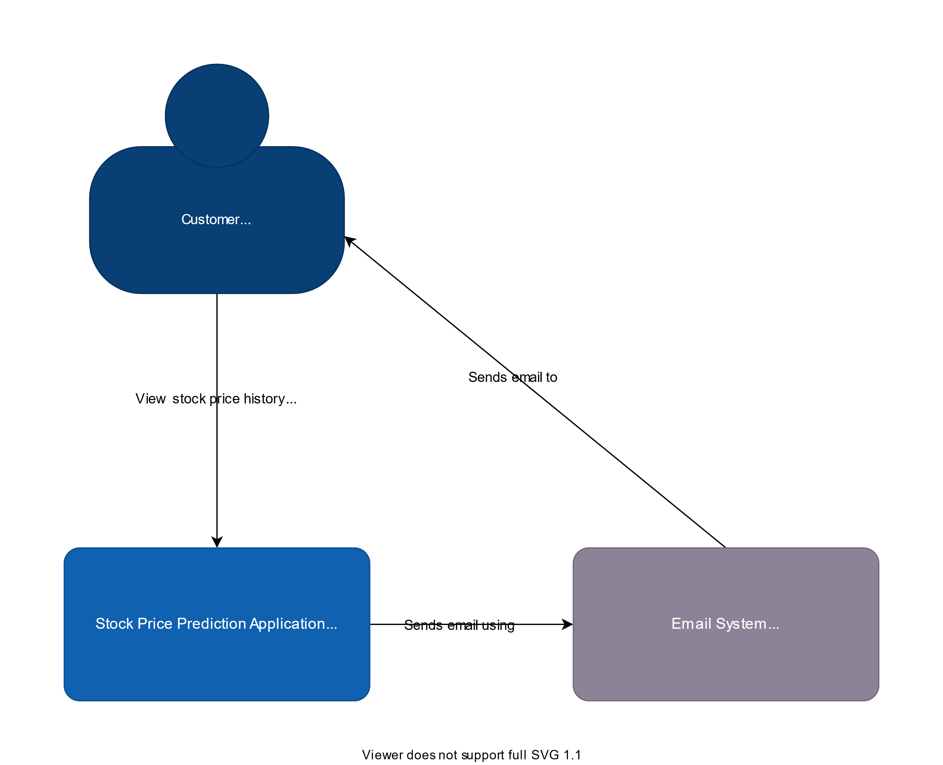

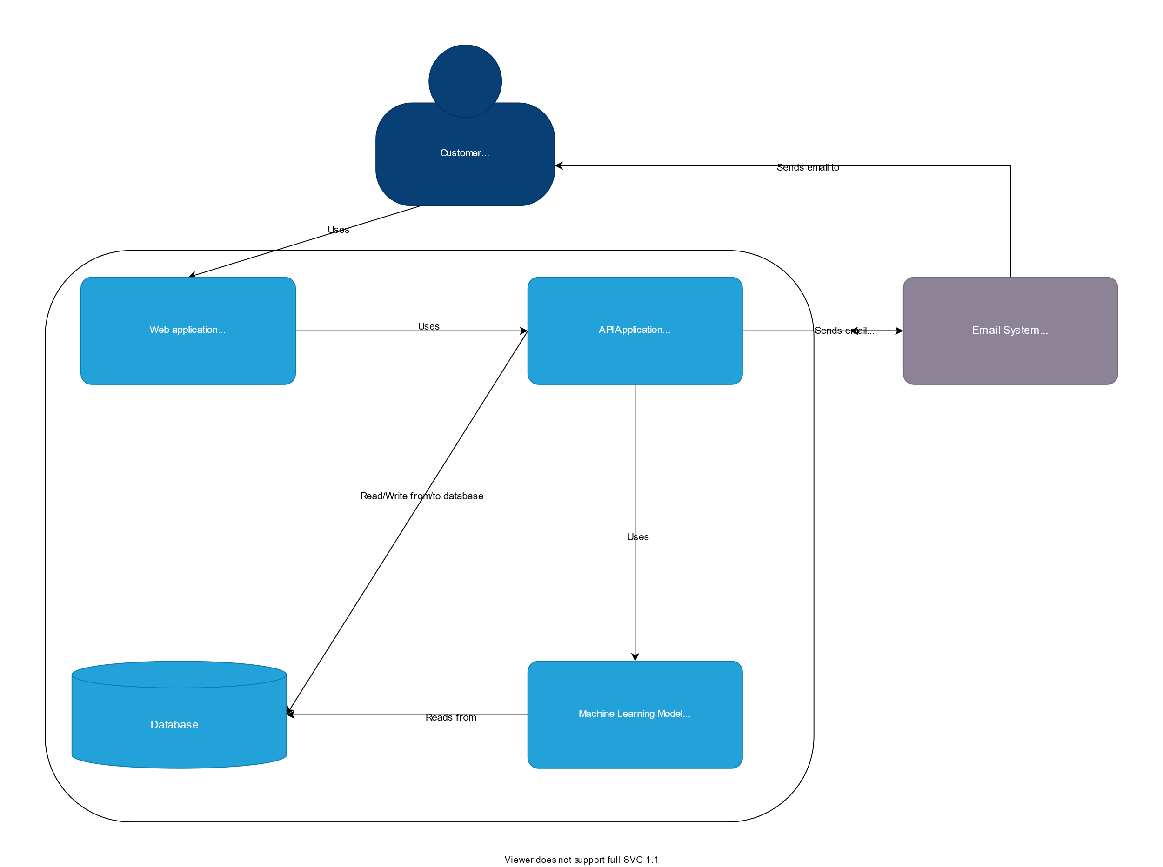

## SQ instance – Oracle Database

## Bonus

### AI/ML - ML.NET

CI/CD pipeline

### 