After reading the prompt, I immediately set out to recreate the mechanical features of Breath of the Wild and Tears of the Kingdom Cooking System. For this, I needed to research a bit further how the system worked from a player’s perspective, so I used https://botw-recipes.com to experiment with mixing ingredients and checking their own recipe catalogue.

I didn’t have a lot of time to think creatively and critically about a crafting system, so I knew reproducing an existing one would allow me to showcase what I can code, without worrying about questions of design.

In Breath of the Wild a mixture can either be successful or a failure. A recipe will only result in failure if the player mixes monster products with non-monster products.
We won’t replicate failures, and instead focus on being able to mix any such ingredients.

There are cases where I’m uncertain how Breath of the Wild decides which recipe to follow, per example:
1. mixing rice + salt + meat = meat rice bowl,
2. but mixing rice + curry + meat = meat curry.
What happens if you mix rice + salt + curry + meat? Is there a pre-defined recipe priority embed in the system or does it chose the recipe based on the order in which you placed ingredients in your hand? For this three-day project we will let Unity’s alphabetic order decide the priority of our mixing system.

It’s also important to keep in mind that players do not have access to the recipes in Breath of the Wild within the game. They mix and match ingredients and they learn to memorize the recipes (or look up online).

Because I knew I wanted to reproduce most of Breath of the Wilds system, I began by writing a graph to help me visualize how I wanted to develop this system.

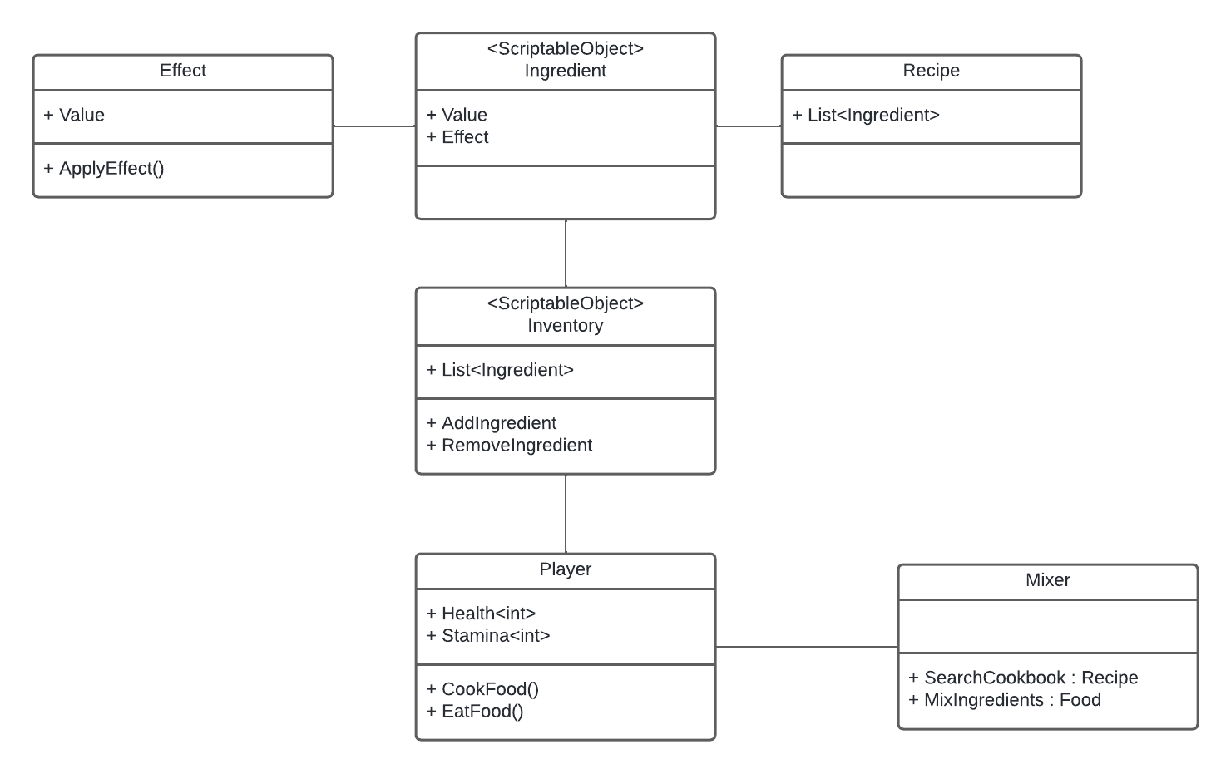
(Made using LucidChart.)
After feeling confident about my approach, I set a Repository and I begin coding.

I load every possible ingredient as a toggle on the canvas with a “mix” button”. This is the interface I will use to test my code. For now, I do not worry about user experience.

I make ScriptableObjects of Ingredients and Recipes. Ingredients must expand to later include values such as “special effects” or “heart restoration”. Recipes only include which ingredients are required to make them.

When “mixing ingredients”, I retrieve data from a large List<Recipes> using Linq. I used LINQ to make the process of retrieving data simpler to write and read.

I struggled with mixing the ingredients. Imagine having a recipe that holds a single ingredient and another that holds two ingredients:
1. steamed meat requires meat,
2. grilled meat requires meat and pepper.
When you search through the query, while holding meat and pepper, you will receive both of these recipes as an equally valid recipe. But we know that grilled meat should take priority over steamed meat, because if fulfils more ingredient requirements.
This problem took me awhile to solve, because it was my first time writing Linq and I often used the wrong keyword, reverting logic or other such silly and goofy mistakes.

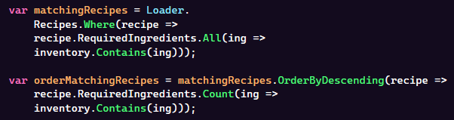
In the end, I got to a reasonable approach. I begin by searching for matching recipes, and then I order them by how many ingredients they fulfil. If two recipes fulfil the same amount of ingredients that you hold, I let the alphabet decide what you should make.

As night approached, I decided to end coding. I tested my code, wrote down any issues I found or ideas I wanted to implemented the following day, sent a commit to update the document in my repository, and I went to bed. Hopeful that the next day would have less smoke and brighter ideas.

***

On the second day I began working on the effects system. In Breath of The Wild, if two “special ingredients” are used, they nullify each other’s effects. So, per recipe, only one ingredient can have an effect. The effects is independent of the recipe. Using the same ingredient on a different recipe will yield the same effect.

I began by creating a scriptable object that would store information about the effect. The loader would also load those effects into a Dictionary, for easier access.

I created a Player Class that holds information and functions about different stats (health and stamina). This would allow me to test the effects.

I added a function to the Mixing Static Class to determine the effects that should be apply on a given selection of ingredients. Using Linq, I query for Effects that are present in the ingredients, I group them by effect. If there are more than two group (or if there are no effects), I return null, otherwise, I return the first effect on the list.

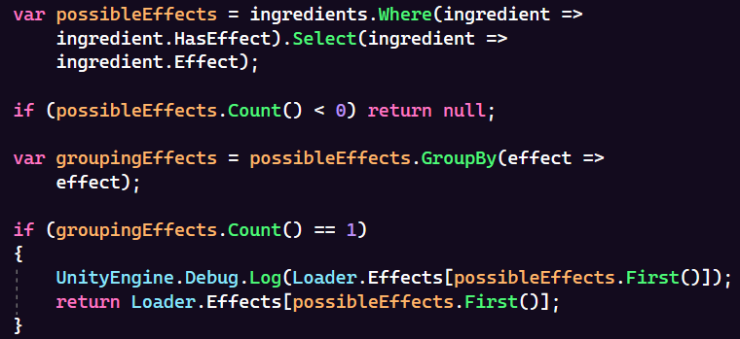

I added a Unity Unit Test to verify ingredients that didn’t have an associated recipe. To do this, I require the user to have at least one recipe that uses only the provided ingredient. Remember that in Breath of the Wild, any ingredient can yield a result.

At this point, I realized that I didn’t prepare my code for a relevant feature of cooking in Breath of The Wild. In BOTW, the player can cook with different kinds of fruit, but have them yield the same recipes with different effects. I didn’t prepare my code for this, so, with only two days left, I decided I would leave this feature for a hypothetical future.

I added the Player Game Object as a prefab, together with the corresponding scripts related to behaviour and food consumption and I connected the effect Unity Events to the corresponding player functions.

The Cooking System was done and working, but I was missing the context in which it would function: the game. All that was left was the hardest part.

***

I decided that I would go for a simplistic approach to my game. As a player, you work at the “Super Cachorrão” during Aveiro’s Feira de Março and must server your endless line of clients as quickly as possible to optimize your profit and leave clients happy. Every client will ask for a hot-dogs with different ingredients, but you can use “special sauces” to alter the mood of a client (either bringing more clients to your stand, increasing the money they give or the overall patience of the waiting line).

Because I only had about a day and a half of work, I decided to draw my gameplay graph in paint to help me visualize my mechanics.

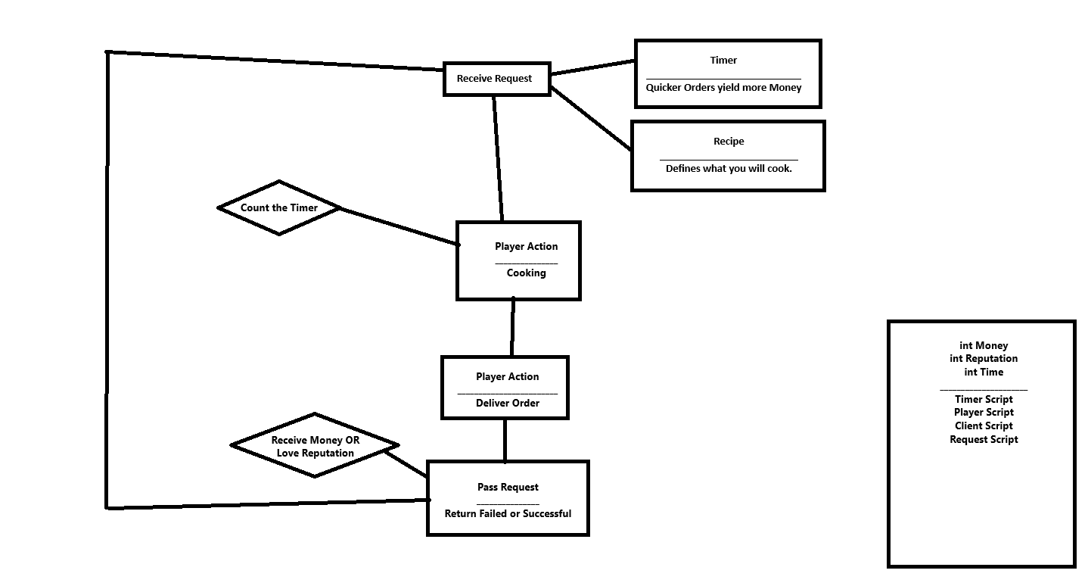
I began by switching to the new Input System and working on simple player movement and receiving requests from clients. To simplify my process, the requests would be displayed as UI in some portion of the map.

As the end of the second day approached, I started worrying less about the quality and reusability of my code and more about having a project finalized. I tried my best to keep the code clean and consistent, but also knew I still had about a day to clean any major atrocities and finalize my documentation.

After finishing my game loop, I decided to add some quality of life improvements, such as: highlighting clickable assets, adding text to read inventory, requests, available ingredients and player errors/warnings and a ding sound for when you get a recipe right.

Because sound was optional, I didn’t focus too much on making it scalable. I simply added a Sound Manager class with an Action that could be invoked to play a default correct sound (Bell Ring).

Before I continued to the final day, I decided to clean my code in areas where I was certain I still had more to expand in terms of mechanical play.

Future Work:

I would have liked to have a bit more time to collect ingredients by type, so that different kinds of meat could yield the same food with different effects.

I don’t think Scriptable Objects for Ingredients and Recipes were the best solution, because they are dependent on the Unity Game Engine and can’t be edited outside of them. They are harder to track as each exists in their individual file. However, this felt like the quickest solution and I didn’t have to code a Parser or be intimidated by things like SQLite.

Because I wanted to work fast, I ended up defaulting to some bad habits, like not using curly braces, or adding paragraphs where it’s typically not paragraphed.

I would’ve used less public Unity Events. In cases like communicating within it’s Game Object scope, they do were not necessary and mostly caused clutter.

I would have liked to separate data from functionality a bit further, but I chose not to spend too much time dwelling on that.

