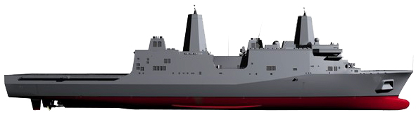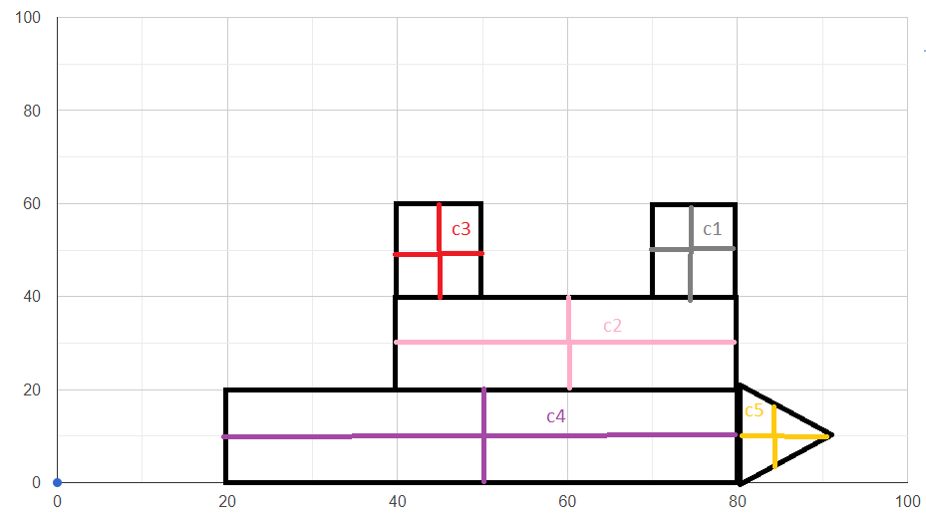

Vessel Type 71:

C1 (10,10) m1 = 2000kg

C2(40,10) m2 = 5000kg

C3(10,10) m3 = 2000kg

C4(60,10) m4 = 8000kg

C5(2.5,10) m5 = 1000kg

$$xc=\frac{2000*10+5000*40+2000*10+8000*60+2.5*1000}{2000+5000+2000+8000+1000}=40.1$$

$yc= \frac{2000*10+10*5000+10*2000+10*8000+1000*2.5}{2000+5000+2000+8000+1000}=9.6$

Massa Total = 18 000

Cbarco (40.1,9.6)

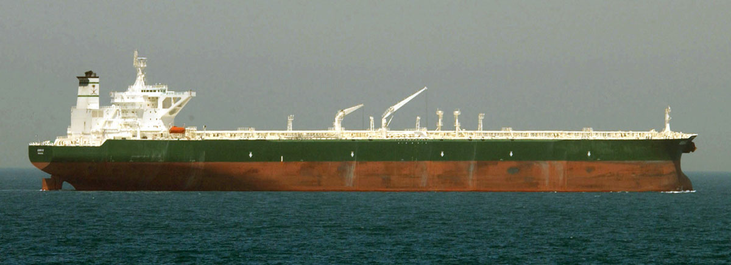

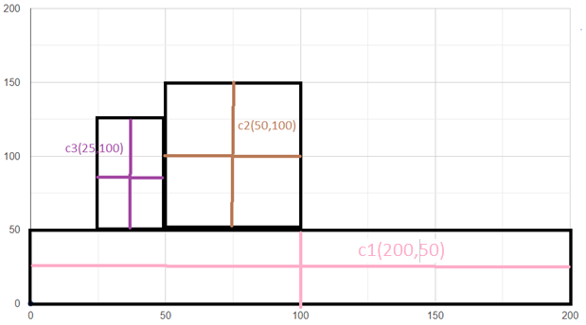

Vessel Type 80:

C1(200,50) m1 = 10000kg

C2(50,100) m2 = 3000kg

C3(25,100) m3 = 2000kg

$$xc=\frac{10000*200+3000*50+2000*25}{15000}=26.7$$

$yc=\frac{10000*50+3000*100+2000*100}{15000}=66.7$

Massa Total = 15 000kg

CBarco(26.7,100)

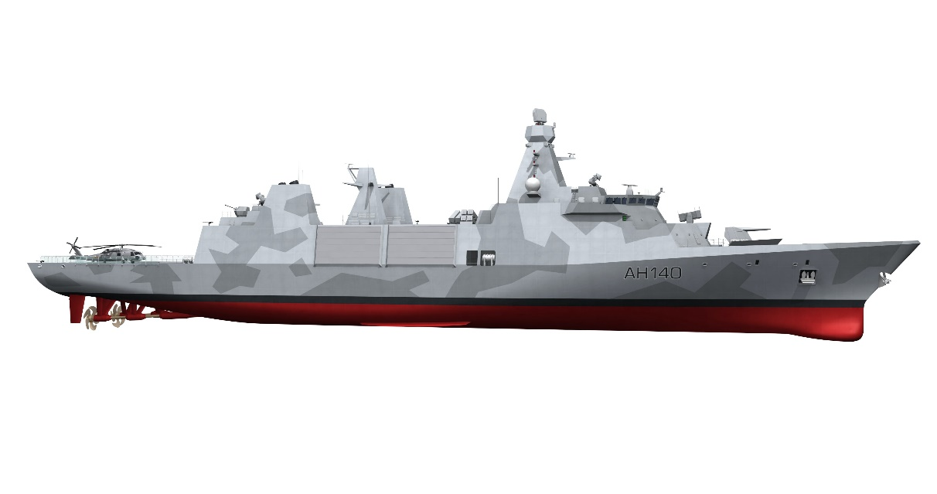

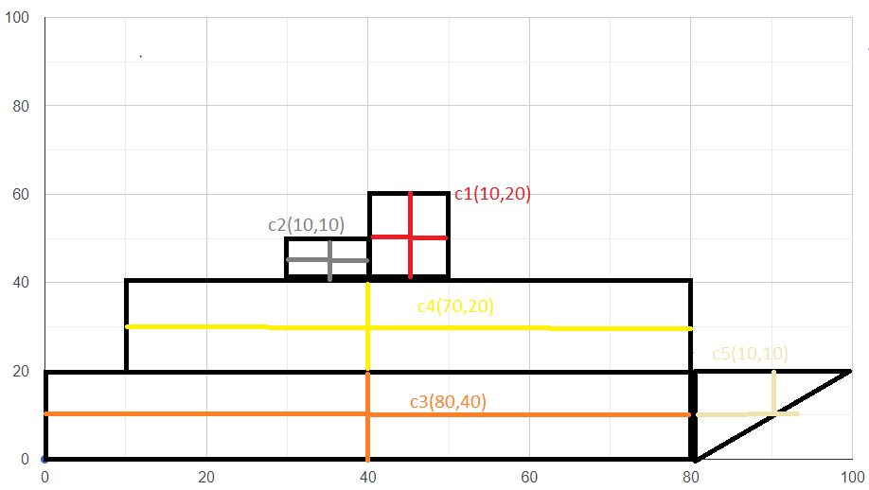

Vessel Type 31:

C1(10,20) m1 =2000 kg

C2(10,10) m2=1000 kg

C3(70,20) m3=6000 kg

C4(80,40) m4=8000 kg

C5(10,10) m5=1000 kg

MTotal = 18 000 kg

$xc= \frac{2000*10+10*1000+70*6000+80*8000+10*1000}{18000}=61.1$

$$yc= \frac{2000*20+1000*10+20*6000+40*8000+10*1000}{18000}=27.8$$