**IPv6 AS-Path Inflation**

This project consists in analyzing the path inflation between IPv4 and IPv6 paths in the Middle East (MENOG region).

**Features**

* Global statistics
* Inflation in the number of hops
* Inflation in the AS path
* Changes for the three past years

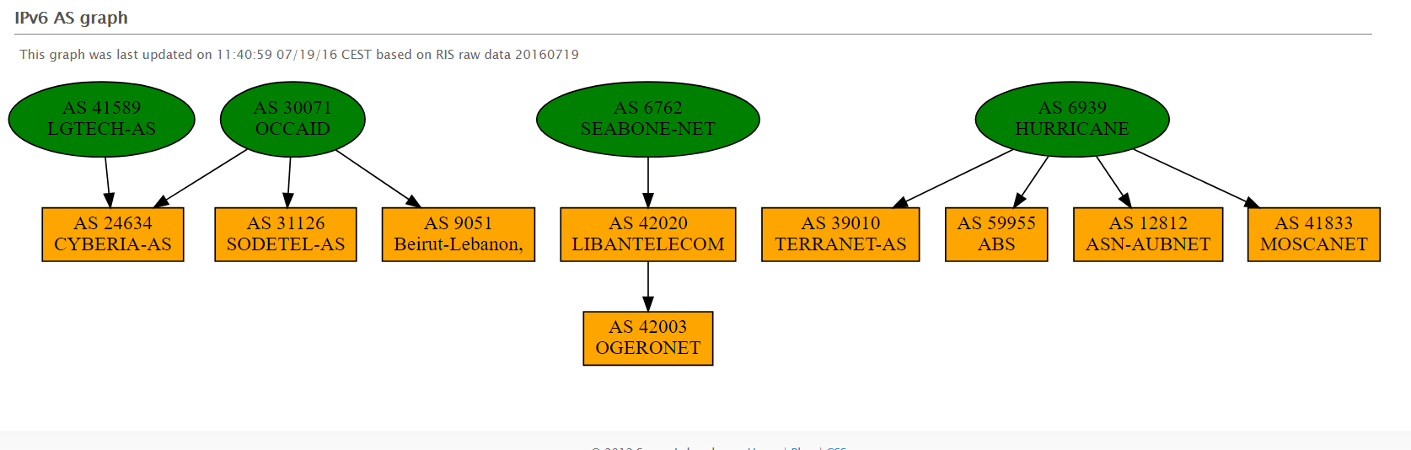

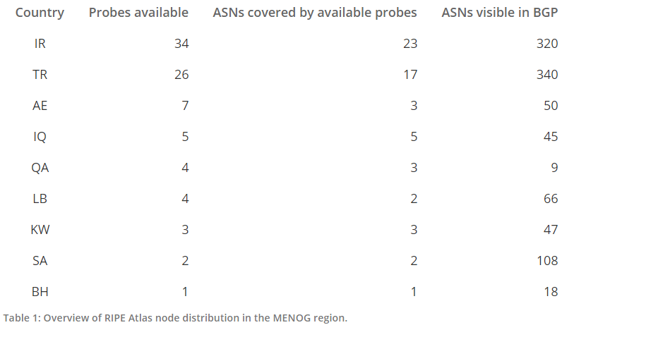

Tasks list:

-choose different AS covered by available probes that covers the MENOG region

- see which AS have ipv4 and ipv6 prefix

- choose several (3) network destinations outside the region

- using traceroute see the number of AS and number of hops in each AS to reach the network in ipv4 and ipv6 and the RTT for each path (**9 April**)

-using BGP ipv6 and ipv4 tables, see the AS paths possible from the different AS to the networks destinations (**15 April**)

- compare the path between ipv4 and ipv6: (**17 April**)

>histogram shows the percentage in difference in number of hops (less than 2, between 2 and 5, between 5 and ten, more than ten) for each path

>histogram that shows the difference of ipv4&ipv6 RTT for each path

>histogram shows number of ipv4 and ipv6 hops per AS in the path

> histogram shows the percentage of ipv4 &ipv6 hops per AS

-compare to past: (**24 April**)

> see if the paths have changed: number of hops, of AS

>see if the RTT has regressed