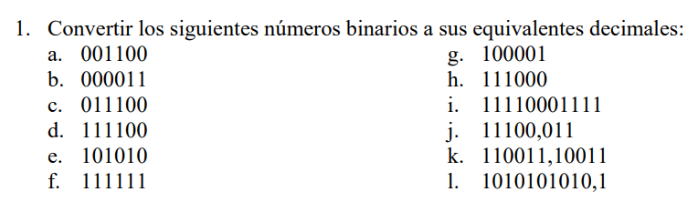

= 682.5

= 51.59375

= 28.375

= 1935

= 56

= 33

= 63

= 42

= 60

= 28

= 3

= 12

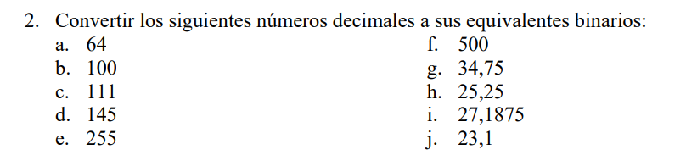

= 10111.0001100110

= 11011.0011

= 11001.01

= 100010.11

= 111110100

= 11111111

= 10010001

= 1101111

= 1100100

= 1000000

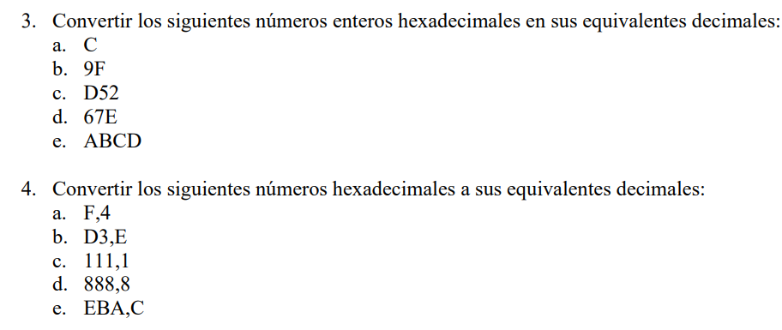

=3770.75

= 2184.5

= 273.0625

= 211.875

= 15.25

= 43981

1662

= 3410

= 159

= 12