Volleyball Canada Registration Database Project
Final Group Project – DBAS 1007

Group Members:
Christelle Denny
Hyeonkyeong Kim
Mariana Noda
Romulo Raposo
DBAS 1007 – Data Fundamentals
Professor George Campanis
Nova Scotia Community College
November 30, 2025

Table of Contents

1.Introduction 3
2.Project Form (Original Registration Form) 4
3.Entity Relationship Diagram (ERD) 6
4.Data Dictionary 7
5.Database Scripts 18
6.Microsoft Access & SQL Server Interoperability 23
7.Conclusion 29
8.References 30

1.Introduction
The purpose of this project is to design a well-structured relational database based on the Volleyball Canada registration form. The original form collects a wide range of information about athletes, parents or guardians, training preferences, and previous volleyball experience. However, because all of this information is stored together on a single form, it is not suitable for efficient data storage or long-term management. To address this problem, our group transformed the form into a normalized database that can store the information more clearly, reduce redundancy, and support future data analysis.
In this project, we identify the main entities from the form, define their relationships, and develop an Entity Relationship Diagram (ERD) using Crow’s Foot notation. In addition, we create a complete data dictionary that explains each table and attribute, including data types and constraints. Finally, we produce the SQL scripts needed to build the database. Through this process, we aim to demonstrate our understanding of normalization principles and to create a functional database structure that could be used by a real volleyball organization to manage athlete registrations more effectively.

2.Project Form (Original Registration Form)
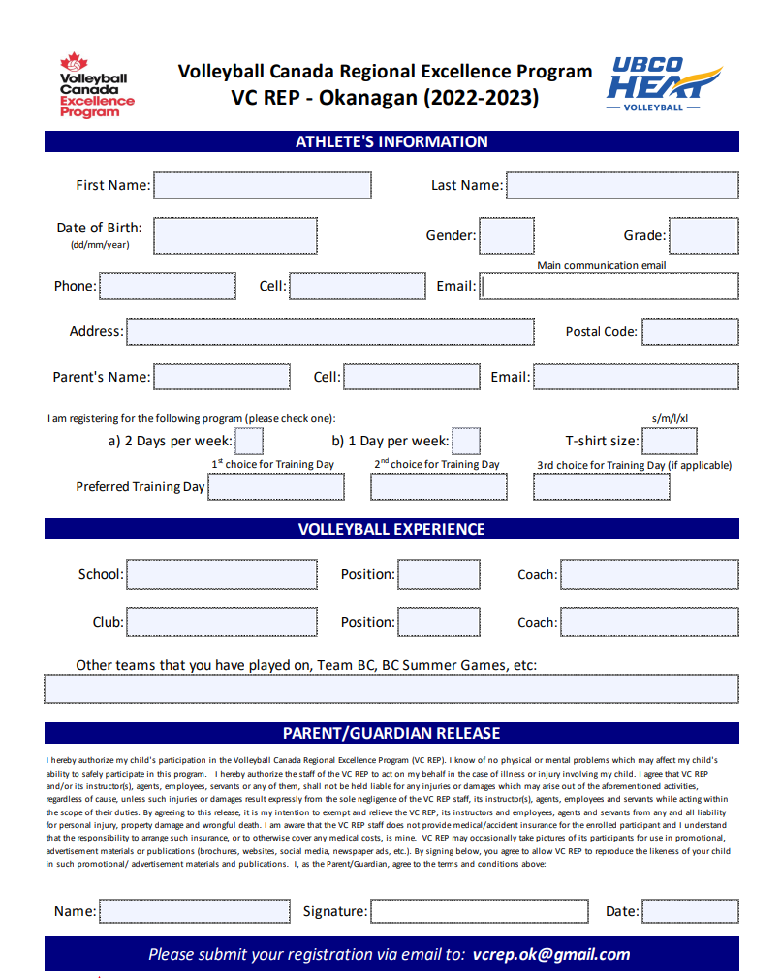

3.Entity Relationship Diagram (ERD)
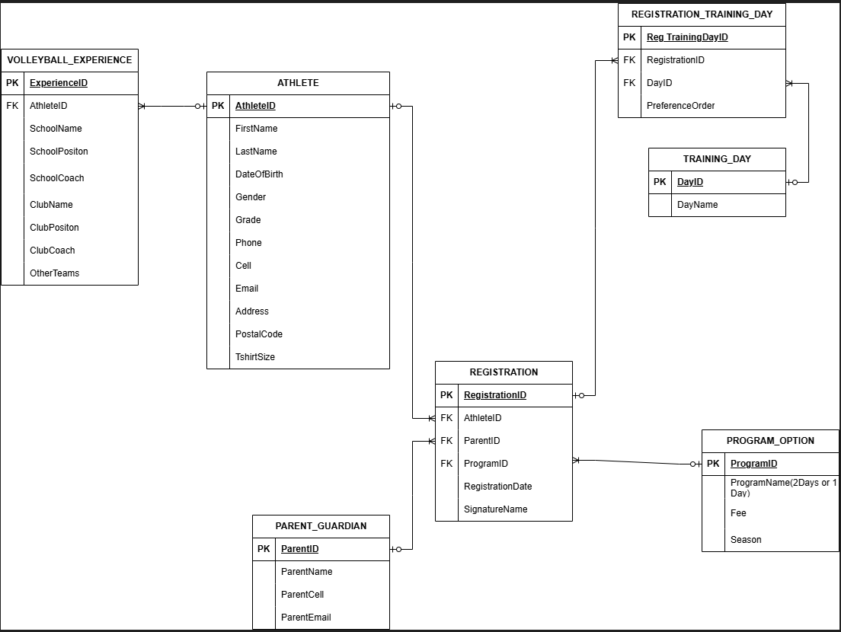

4.Data Dictionary
The screenshot below shows the full Excel Data Dictionary. The original Excel file has also been attached separately.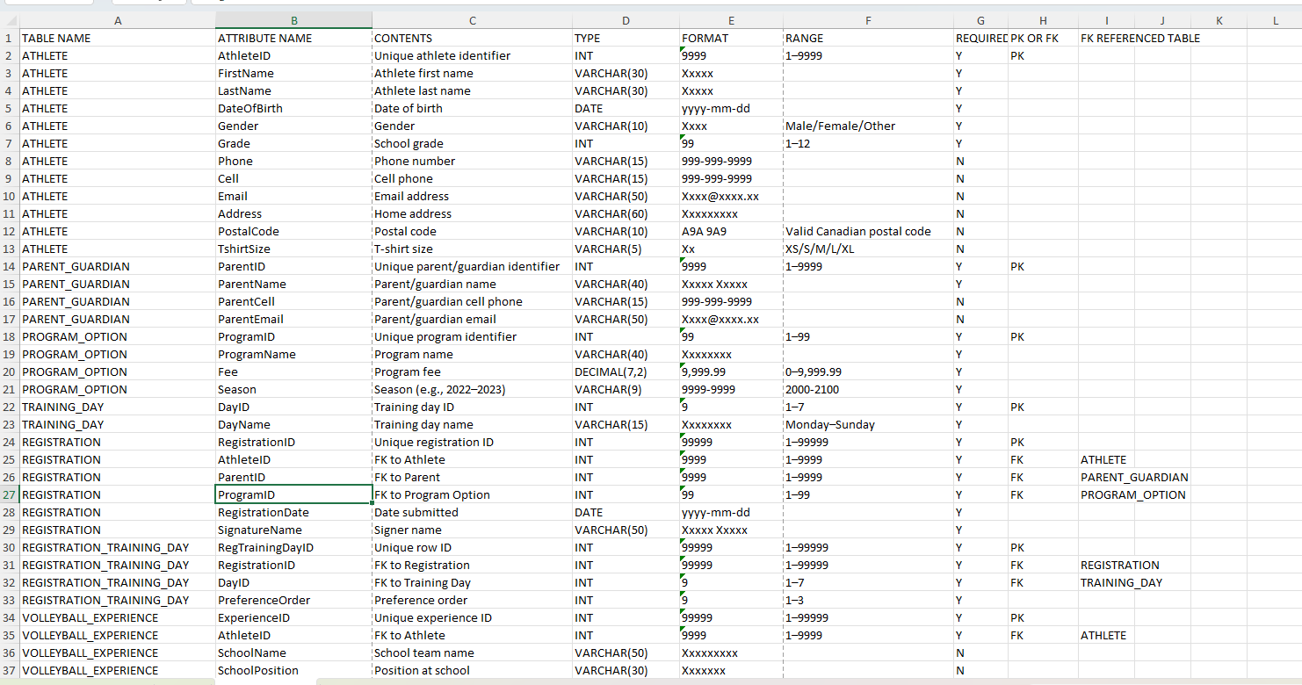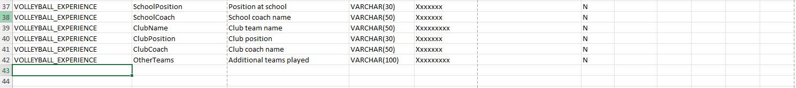

We separated the full Excel Data Dictionary into individual tables and created a table for each one.
4.1. Table: ATHLETE
TABLE NAME | ATTRIBUTE NAME | CONTENTS | TYPE | FORMAT | RANGE | REQUIRED | PK OR FK | FK REFERENCED TABLE
ATHLETE | Athlete  ID | Unique athlete identifier | INT | 9999 | 1–9999 | Y | PK
ATHLETE | FirstName | Athlete first name | VARCHAR(30) | Xxxxx |  | Y
ATHLETE | LastName | Athlete last name | VARCHAR(30) | Xxxxx |  | Y
ATHLETE | Date  Of  Birth | Date of birth | DATE | yyyy-mm-dd |  | Y
ATHLETE | Gender | Gender | VARCHAR(10) | Xxxx | Male/Female/Other | Y
ATHLETE | Grade | School grade | INT | 99 | 1–12 | Y
ATHLETE | Phone | Phone number | VARCHAR(15) | 999-999-9999 |  | N
ATHLETE | Cell | Cell phone | VARCHAR(15) | 999-999-9999 |  | N
ATHLETE | Email | Email address | VARCHAR(50) | Xxxx@xxxx.xx |  | N
ATHLETE | Address | Home address | VARCHAR(60) | Xxxxxxxxx |  | N
ATHLETE | Postal Code | Postal code | VARCHAR(10) | A9A 9A9 | Valid Canadian postal code | N
ATHLETE | Tshirt  Size | T-shirt size | VARCHAR(5) | Xx | XS/S/M/L/XL | N

4.2. Table: PARENT_GUARDIAN
TABLE NAME | ATTRIBUTE NAME | CONTENTS | TYPE | FORMAT | RANGE | REQUIRED | PK OR FK | FK REFERENCED TABLE
PARENT_GUARDIAN | Parent  ID | Unique parent/guardian identifier | INT | 9999 | 1–9999 | Y | PK
PARENT_GUARDIAN | ParentName | Parent/  guardian name | VARCHAR(40) | Xxxxx Xxxxx |  | Y
PARENT_GUARDIAN | ParentCell | Parent/guardian cell phone | VARCHAR(15) | 999-999-9999 |  | N
PARENT_GUARDIAN | ParentEmail | Parent/guardian email | VARCHAR(50) | Xxxx@xxxx.xx |  | N

4.3. Table: PROGRAM_OPTION
TABLE NAME | ATTRIBUTE NAME | CONTENTS | TYPE | FORMAT | RANGE | REQUIRED | PK OR FK | FK REFERENCED TABLE
PROGRAM_OPTION | ProgramID | Unique program identifier | INT | 99 | 1–99 | Y | PK
PROGRAM_OPTION | Program Name | Program name | VARCHAR(40) | Xxxxxxxx |  | Y
PROGRAM_OPTION | Fee | Program fee | DECIMAL(7,2) | 9,999.99 | 0–9,999.99 | Y
PROGRAM_OPTION | Season | Season (e.g., 2022–2023) | VARCHAR(9) | 9999-9999 | 2000-2100 | Y

4.4. Table: REGISTRATION
TABLE NAME | ATTRIBUTE NAME | CONTENTS | TYPE | FORMAT | RANGE | REQUIRED | PK OR FK | FK REFERENCED TABLE
REGISTRATION | RegistrationID | Unique registration ID | INT | 99999 | 1–99999 | Y | PK
REGISTRATION | AthleteID | FK to Athlete | INT | 9999 | 1–9999 | Y | FK | ATHLETE
REGISTRATION | ParentID | FK to Parent | INT | 9999 | 1–9999 | Y | FK | PARENT_GUARDIAN
REGISTRATION | ProgramID | FK to Program Option | INT | 99 | 1–99 | Y | FK | PROGRAM_OPTION
REGISTRATION | RegistrationDate | Date submitted | DATE | yyyy-mm-dd |  | Y
REGISTRATION | SignatureName | Signer name | VARCHAR(50) | Xxxxx Xxxxx |  | Y

4.5. Table: TRAINING_DAY
TABLE NAME | ATTRIBUTE NAME | CONTENTS | TYPE | FORMAT | RANGE | REQUIRED | PK OR FK | FK REFERENCED TABLE
TRAINING_DAY | DayID | Training day ID | INT | 9 | 1–7 | Y | PK
TRAINING_DAY | DayName | Training day name | VARCHAR(15) | Xxxxxxxx | Monday–Sunday | Y

4.6. Table: REGISTRATION_TRAINING_DAY
TABLE NAME | ATTRIBUTE NAME | CONTENTS | TYPE | FORMAT | RANGE | REQUIRED | PK OR FK | FK REFERENCED TABLE
REGISTRATION_TRAINING_DAY | RegTrainingDayID | Unique row ID | INT | 99999 | 1–99999 | Y | PK
REGISTRATION_TRAINING_DAY | RegistrationID | FK to Registration | INT | 99999 | 1–99999 | Y | FK | REGISTRATION
REGISTRATION_TRAINING_DAY | DayID | FK to Training Day | INT | 9 | 1–7 | Y | FK | TRAINING_DAY
REGISTRATION_TRAINING_DAY | PreferenceOrder | Preference order | INT | 9 | 1–3 | Y

4.7. Table: VOLLEYBALL_EXPERIENCE
TABLE NAME | ATTRIBUTE NAME | CONTENTS | TYPE | FORMAT | RANGE | REQUIRED | PK OR FK | FK REFERENCED TABLE
VOLLEYBALL_EXPERIENCE | ExperienceID | Unique experience ID | INT | 99999 | 1–99999 | Y | PK
VOLLEYBALL_EXPERIENCE | AthleteID | FK to Athlete | INT | 9999 | 1–9999 | Y | FK | ATHLETE
VOLLEYBALL_EXPERIENCE | SchoolName | School team name | VARCHAR(50) | Xxxxxxxxx |  | N
VOLLEYBALL_EXPERIENCE | SchoolPosition | Position at school | VARCHAR(30) | Xxxxxxx |  | N
VOLLEYBALL_EXPERIENCE | SchoolCoach | School coach name | VARCHAR(50) | Xxxxxxx |  | N
VOLLEYBALL_EXPERIENCE | ClubName | Club team name | VARCHAR(50) | Xxxxxxxxx |  | N
VOLLEYBALL_EXPERIENCE | ClubPosition | Club position | VARCHAR(30) | Xxxxxxx |  | N
VOLLEYBALL_EXPERIENCE | ClubCoach | Club coach name | VARCHAR(50) | Xxxxxxx |  | N
VOLLEYBALL_EXPERIENCE | OtherTeams | Additional teams played | VARCHAR(100) | Xxxxxxxxx |  | N

5.Database Scripts
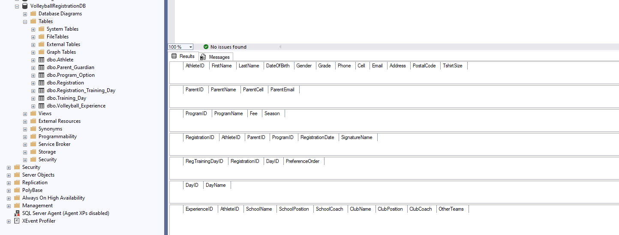

-- 1. DATABASE CREATION --

CREATE DATABASE VolleyballRegistrationDB;
GO

USE VolleyballRegistrationDB;
GO

-- 2. TABLE CREATION --

-- ATHLETE TABLE
CREATE TABLE Athlete (
AthleteID INT PRIMARY KEY,
FirstName VARCHAR(30) NOT NULL,
LastName VARCHAR(30) NOT NULL,
DateOfBirth DATE NOT NULL,
Gender VARCHAR(10) NOT NULL,
Grade INT NOT NULL,
Phone VARCHAR(15),
Cell VARCHAR(15),
Email VARCHAR(50),
Address VARCHAR(60),
PostalCode VARCHAR(10),
TshirtSize VARCHAR(5)
);

-- PARENT / GUARDIAN TABLE
CREATE TABLE Parent_Guardian (
ParentID INT PRIMARY KEY,
ParentName VARCHAR(40) NOT NULL,
ParentCell VARCHAR(15),
ParentEmail VARCHAR(50)
);

-- PROGRAM OPTION TABLE
CREATE TABLE Program_Option (
ProgramID INT PRIMARY KEY,
ProgramName VARCHAR(40) NOT NULL,
Fee DECIMAL(7,2) NOT NULL,
Season VARCHAR(9) NOT NULL
);

-- TRAINING DAY TABLE
CREATE TABLE Training_Day (
DayID INT PRIMARY KEY,
DayName VARCHAR(15) NOT NULL
);

-- REGISTRATION TABLE
CREATE TABLE Registration (
RegistrationID INT PRIMARY KEY,
AthleteID INT NOT NULL,
ParentID INT NOT NULL,
ProgramID INT NOT NULL,
RegistrationDate DATE NOT NULL,
SignatureName VARCHAR(50) NOT NULL
);

-- REGISTRATION TRAINING DAY TABLE
CREATE TABLE Registration_Training_Day (
RegTrainingDayID INT PRIMARY KEY,
RegistrationID INT NOT NULL,
DayID INT NOT NULL,
PreferenceOrder INT NOT NULL
);

-- VOLLEYBALL EXPERIENCE TABLE
CREATE TABLE Volleyball_Experience (
ExperienceID INT PRIMARY KEY,
AthleteID INT NOT NULL,
SchoolName VARCHAR(50),
SchoolPosition VARCHAR(30),
SchoolCoach VARCHAR(50),
ClubName VARCHAR(50),
ClubPosition VARCHAR(30),
ClubCoach VARCHAR(50),
OtherTeams VARCHAR(100)
);

-- 3 & 4. FOREIGN KEYS WITH CASCADE RULES --

-- Registration → Athlete
ALTER TABLE Registration
ADD CONSTRAINT FK_Registration_Athlete
FOREIGN KEY (AthleteID)
REFERENCES Athlete(AthleteID)
ON UPDATE CASCADE
ON DELETE CASCADE;

-- Registration → Parent_Guardian
ALTER TABLE Registration
ADD CONSTRAINT FK_Registration_Parent
FOREIGN KEY (ParentID)
REFERENCES Parent_Guardian(ParentID)
ON UPDATE CASCADE
ON DELETE CASCADE;

-- Registration → Program_Option
ALTER TABLE Registration
ADD CONSTRAINT FK_Registration_Program
FOREIGN KEY (ProgramID)
REFERENCES Program_Option(ProgramID)
ON UPDATE CASCADE
ON DELETE CASCADE;

-- Registration_Training_Day → Registration
ALTER TABLE Registration_Training_Day
ADD CONSTRAINT FK_RegTrainingDay_Registration
FOREIGN KEY (RegistrationID)
REFERENCES Registration(RegistrationID)
ON UPDATE CASCADE
ON DELETE CASCADE;

-- Registration_Training_Day → Training_Day
ALTER TABLE Registration_Training_Day
ADD CONSTRAINT FK_RegTrainingDay_TrainingDay
FOREIGN KEY (DayID)
REFERENCES Training_Day(DayID)
ON UPDATE CASCADE
ON DELETE CASCADE;

-- Volleyball_Experience → Athlete
ALTER TABLE Volleyball_Experience
ADD CONSTRAINT FK_VolleyballExperience_Athlete
FOREIGN KEY (AthleteID)
REFERENCES Athlete(AthleteID)
ON UPDATE CASCADE
ON DELETE CASCADE;

-- END OF SCRIPT --

6.Microsoft Access & SQL Server Interoperability
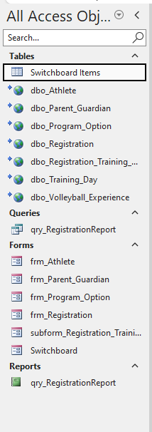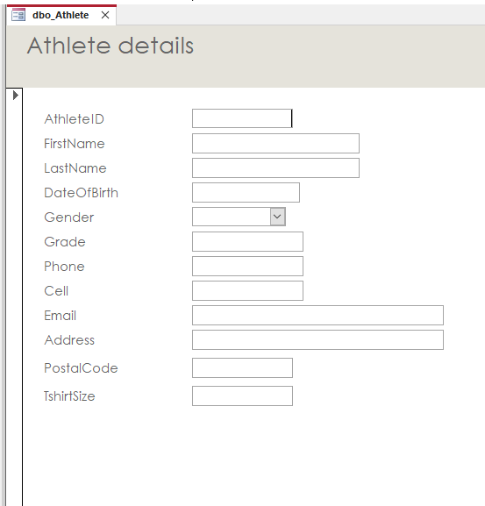
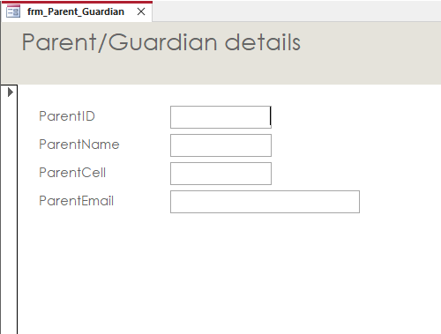

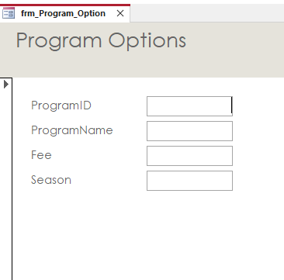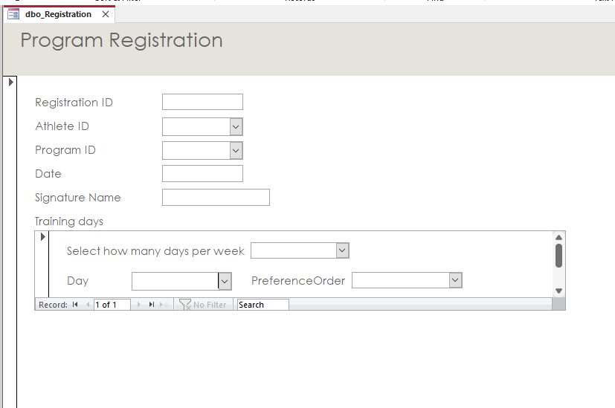

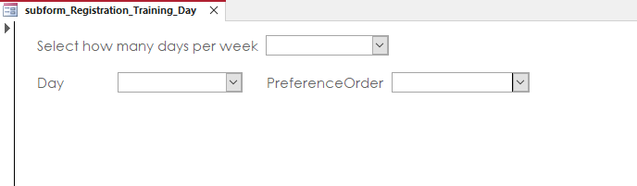

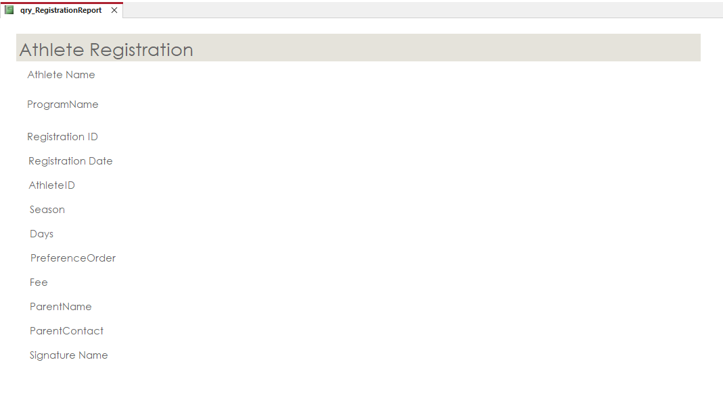

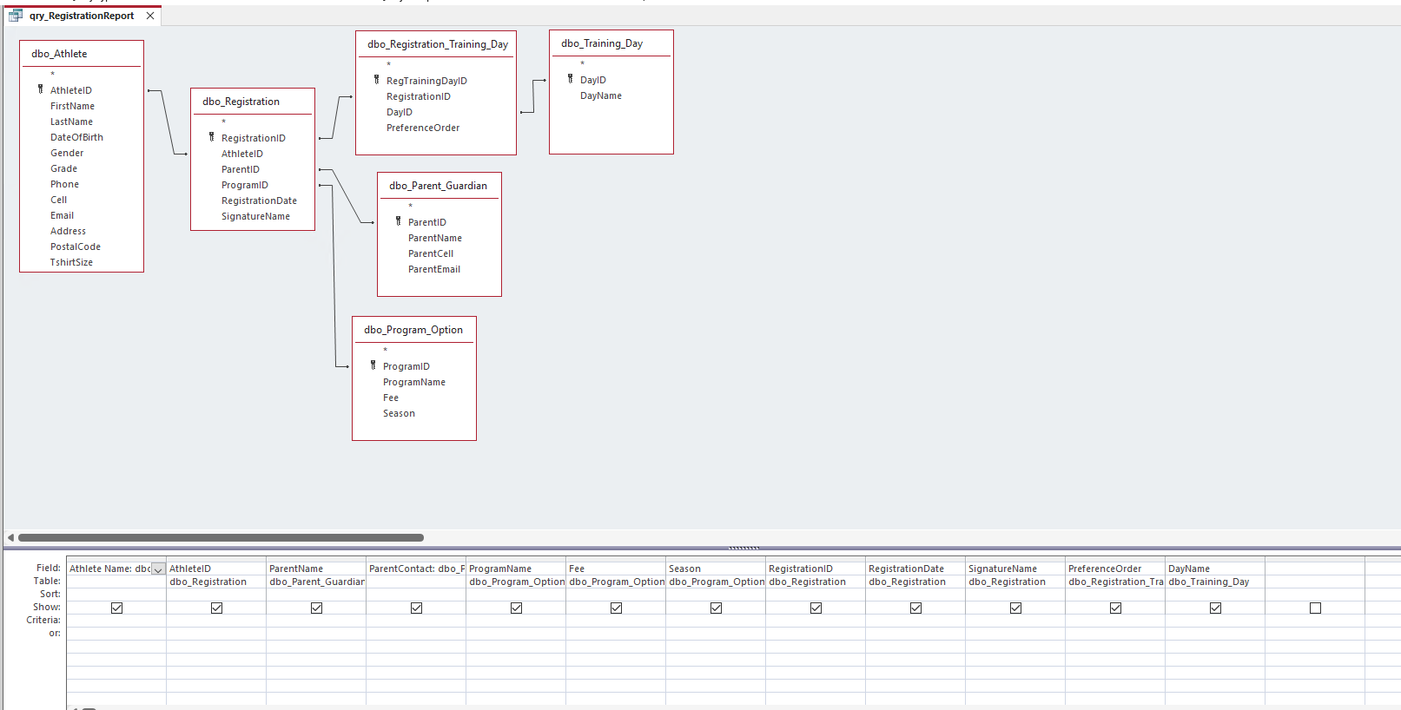

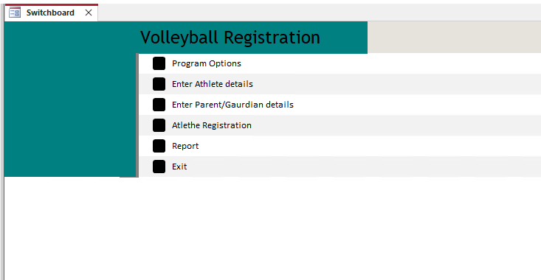

7.Conclusion
This project allowed our group to apply the full database development process from start to finish. We began by analyzing the original registration form and identifying the required entities, attributes, and relationships. Based on this information, we designed an Entity Relationship Diagram (ERD) that clearly represented how athletes, parents, program options, training days, and registration details were connected.
After finalizing the ERD, we created a complete data dictionary that defined each table, field, data type, and key. This step helped us maintain consistency and ensured accuracy when writing the database scripts. We then implemented the database in SQL Server using structured CREATE TABLE statements with proper primary and foreign keys. Insert statements were added to test the system and confirm that relationships and constraints were functioning correctly.
Finally, we demonstrated interoperability between Microsoft Access and SQL Server by linking all SQL tables through an ODBC connection. Forms, queries, and reports were tested to confirm that the front-end could retrieve and display data from the SQL database. Through these steps, we were able to show a working end-to-end system that supports the registration workflow.
Overall, this project strengthened our understanding of relational database design, SQL development, and front-end integration. It also improved our teamwork skills, as each member contributed to different parts of the project. By completing all components, we successfully met the project requirements and gained practical experience that will be valuable for future courses and real-world applications.

8.References

Coronel, C., & Morris, S. (2019). Database systems: Design, implementation, & management (13th ed.). Cengage Learning.

Group Name: B
Group Members:

Christelle Denny
Hyeonkyeong Kim
Mariana Noda
Romulo Raposo

Project Documentation (20pts) | Entity Relationship Diagram (15pts) |  |  | Data Dictionary(5pts)
Scripts (45pts) | Database Creation (2pts) | Table Creation (20pts) | PK/FK  (10pts) | Relationships  (10pts) | Cascading Updates and Deletes (3pts)
MS Access- MS SQL Interoperability (20) | ODBC Conn (2pts) | Dashboard (4pts) | Forms (Add/Edit) (8pts) | Report (4pts) | Query (2pts)
Presentation (15pts) | Clearly described ERD and Data Dictionary (5pts) | Execution of DDL/DML Worked (5pts) |  | MS Access Data Input, Reporting, Query  (5pts)
Notes:

