Guião 9 10/05/2020

Mariana Pinto e Gonçalo Arieiro

**Problema 9.1)**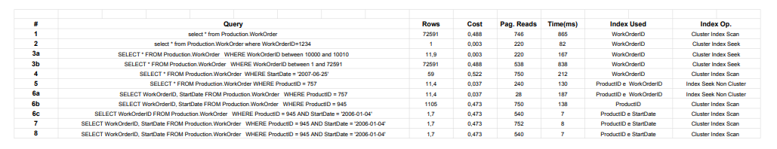

**Problema 9.2)**

1. CREATE CLUSTERED INDEX idxrid on mytemp(rid)
2. Executando:

“SELECT * FROM sys.dm_db_index_physical_stats (DB_ID(), OBJECT_ID('mytemp'), NULL, NULL, 'DETAILED') as S”

Avg_frag = 99,1947852760736 (99%)

Avg_page_space = 68,4583024462565 (68%)

1. **Fillfactor 65:**

Avg_frag = 99,2865636147444 (99%)

Avg_page_space = 69,7558561897702 (69%)

**Fillfactor 80:**

Avg_frag = 98,963133640553 (99%)

Avg_page_space = 67,5852606869286 (68%)

**Fillfactor 90:**

Avg_frag = 99,2974238875878 (99%)

Avg_page_space = 68,693612552508 (69%)

**d)**

**e)** Quando usamos índices o tempo de inserção aumenta, mas por outro lado, o tempo de consulta diminui.

**Problema 9.3)**

1. CREATE UNIQUE CLUSTERED INDEX IdxSSN ON Employee(Ssn);
2. CREATE CLUSTERED INDEX IdxEmployeeName ON Employee(FName, LName);
3. CREATE INDEX IdxDnoON Employee(Dno);

CREATE UNIQUE CLUSTERED INDEX IdxDnumberON Department(Dnumber);

1. CREATE INDEX IdxPnoON Works_On(Pno);

CREATE UNIQUE CLUSTERED INDEX IdxPnumberON Project(Pnumber);

1. CREATECLUSTERED INDEX IdxEssnON Dependent(Essn);
2. CREATE CLUSTERED INDEX IdxDnum On Project(Dnum);