SERVER SIDE

GeneralRepositoryMain - Diagram
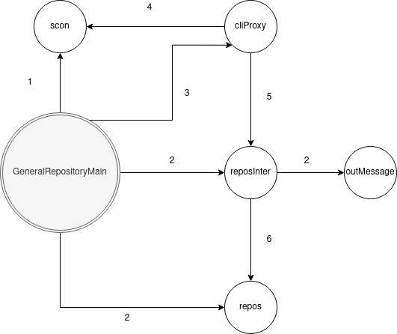
1 – instantiate, start, end, accept
2 – instantiate
3 – instantiate, start
4 – readObject, writeObject, close
5 – processAndReply
6 – setPilotState, setHostessState, setPassengerState, sumUp, shutdown, getInF, getPTAL, setInF, setPTAL, setArrivedAtDest, setEmptyPlaneDest, isArrivedAtDest, initSimul

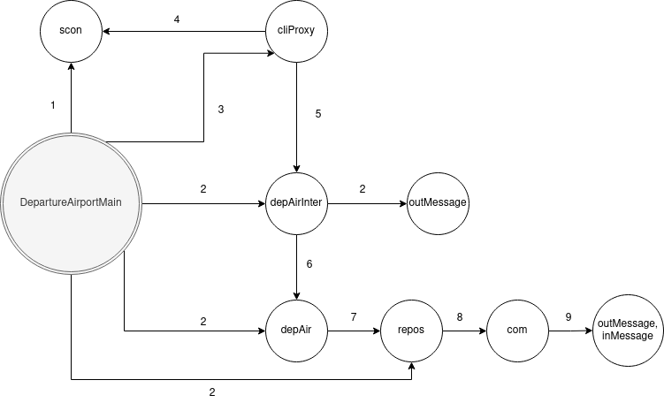
DepartureAirportMain – Diagram

1 – instantiate, start, end, accept
2 – instantiate
3 – instantiate, start
4 – readObject, writeObject, close
5 – processAndReply
6 – informPlaneReadyForBoarding, prepareForPassBoarding, waitInQueue, checkDocuments, showDocuments, waitForNextPassenger, boardThePlane, waitForNextFlight, parkAtTransferGate
7 – setHostessState, setPilotState, setPassengerState, setID
8 – instantiate, readObject, writeObject, close, open
9 – getMsgType, getState, getPassID, isInformPlane

PlaneMain – Diagram

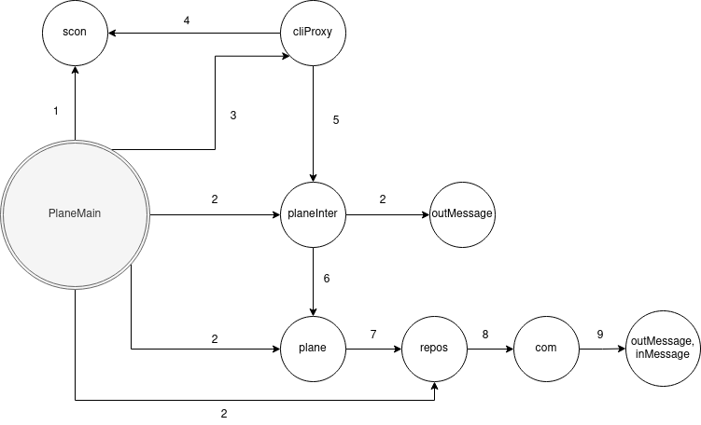

1 – instantiate, start, end, accept
2 – instantiate
3 – instantiate, start
4 – readObject, writeObject, close
5 – processAndReply
6 – waitForAllInBoard, flyToDestinationPoint, informPlaneReadyToTakeOff, waitForEndOfFlight, announceArrival, flyToDepartureAirport
7 – setPilotState, setHostessState, setID, setPassengerState
8 – instantiate, readObject, writeObject, close, open
9 – instantiate, getMsgType, getState

DestinationAirportMain – Diagram

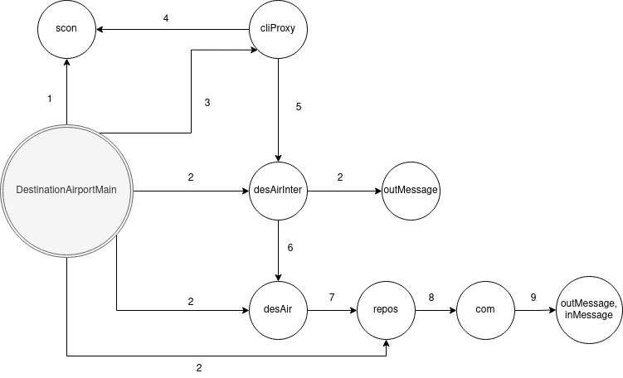
1 – instantiate, start, end, accept
2 – instantiate
3 – instantiate, start
4 – readObject, writeObject, close
5 – processAndReply
6 – leaveThePlane, announceArrival
7 – setPilotState, setPassengerState, setInF, getInF, setPTAL, getPTAL, setArrivedAtDestination, setEmptyPlaneDest
8 – instantiate, readObject, writeObject, close, open
9 – instantiate, getMsgType, getState, getPassID

CLIENT SIDE

PilotMain – Diagram
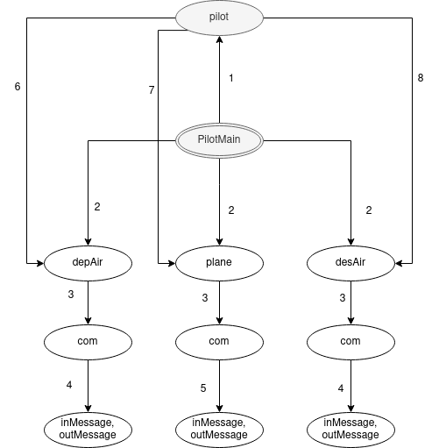

1 – instantiate, start, join
2 – instantiate
3 – instantiate, open, readObject, writeObject, close
4 – getState, getMsgType, getID, instantiate
5 – instantiate, getState, getMsgType, getID
6 – informPlaneReadyForBoarding, parkAtTransferGate
7 – waitForAllInBoard, flyToDestinationAirport, flyToDepartureAirport
8 - AnnounceArrival

HostessMain – Diagram
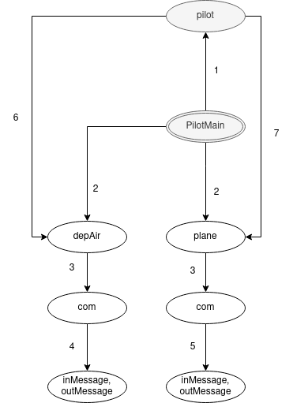

1 – instantiate, start, join
2 – instantiate
3 – instantiate, open, readObject, writeObject, close
4 – getState, getMsgType, getID, instantiate
5 – instantiate, getState, getMsgType, getID
6 – prepareForPassBoarding, waitForNextPassenger, checkDocuments, isInformPlane, waitForNextFlight
7 - informPlaneReadyToTakeOff

PassengerMain Diagram

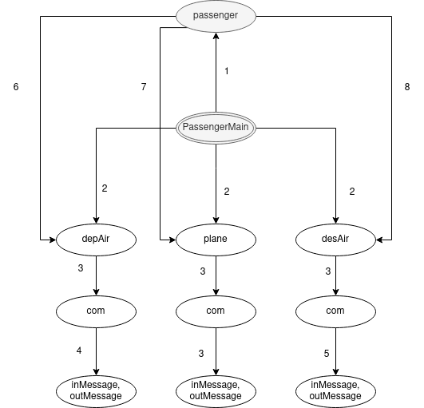
1 – instantiate, start, join
2 – instantiate
3 – instantiate, open, readObject, writeObject, close
4 – getState, getMsgType, getID, instantiate
5 – instantiate, getState, getMsgType, getID
6 – waitInQueue, showDocuments, boardThePlane
7 – waitForEndOfFlight
8 - leaveThePlane

