SERVER SIDE

ServerRegisterRemoteObject – Diagram

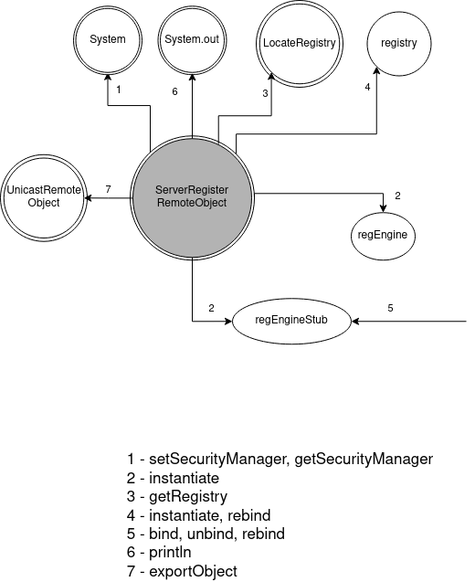
GeneralRepositoryMain – Diagram

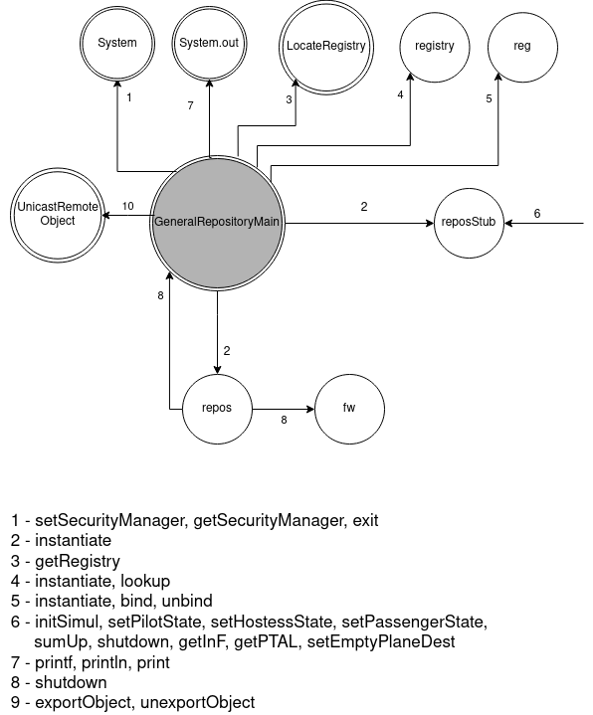

DepartureAirportMain – Diagram

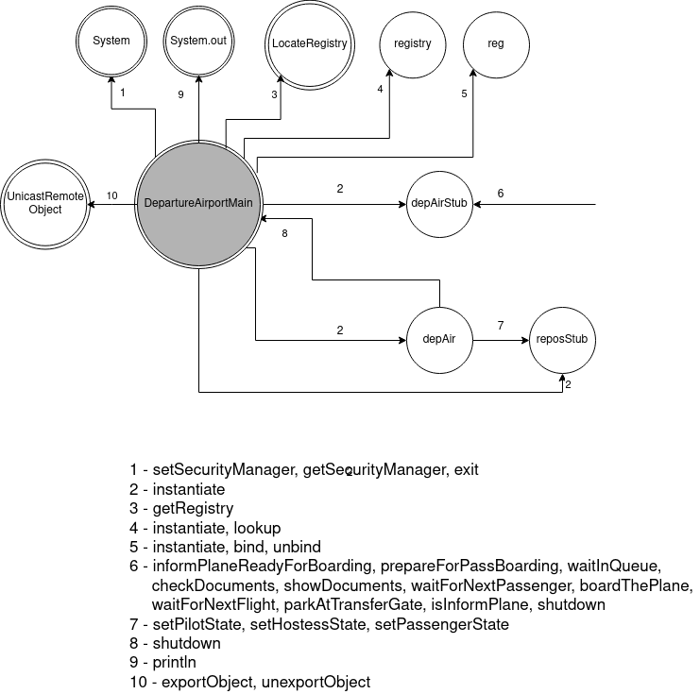

PlaneMain – Diagram

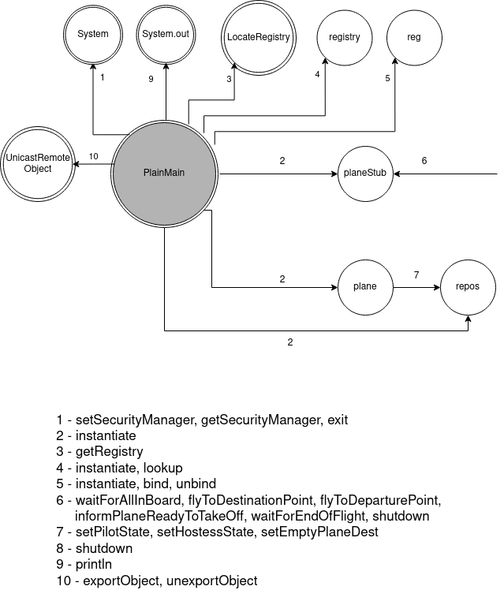

DestinationAirportMain – Diagram

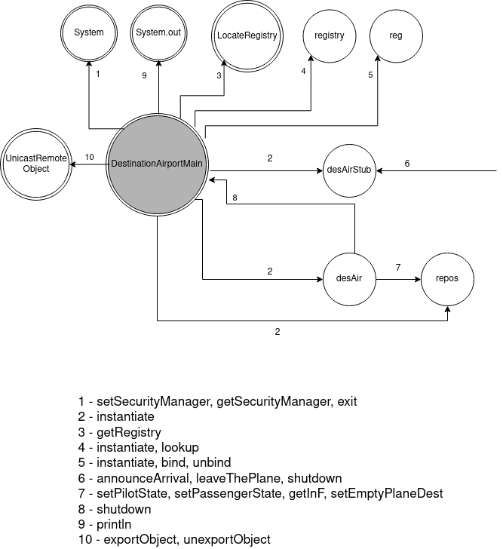

CLIENT SIDE
PilotMain – Diagram

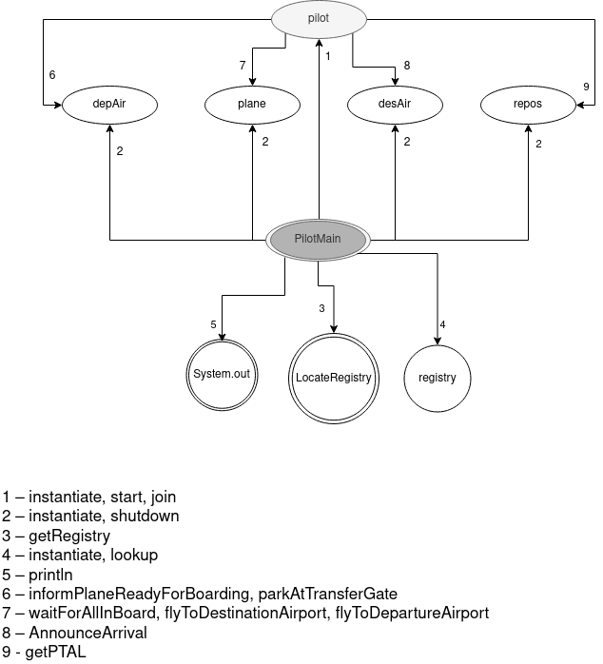

HostessMain – Diagram

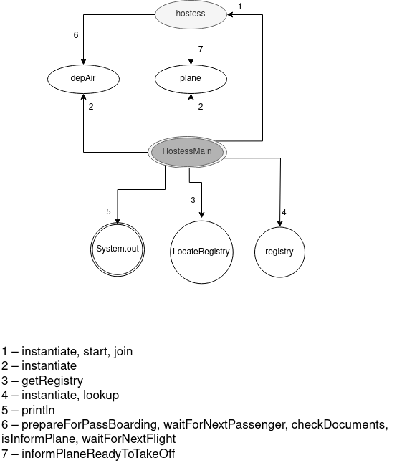

PassengerMain – Diagram

