## Part One: Group Work

**(…)** 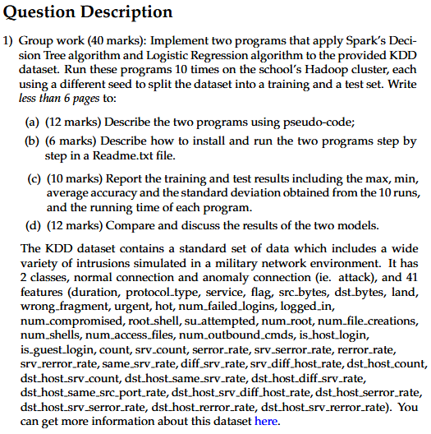

**(1.a) Describe the two programs using Pseudo-code.**

|  |  |
| --- | --- |
| ***Decision Tree (DT) Pseudo-code*** | ***Logistic Regression Pseudo-code*** |
| ***FOR EACH seed in seed-1 to seed-10:***  ***Load*** *dataset*  ***Preprocess*** *dataset*   * ***Convert*** *all categorical variables into*   *numerical form*   * ***Merge*** *all feature columns into a single*   *feature representation*   * ***Convert*** *target labels into numerical format*   ***Split dataset*** *into train/test sets on current*  *seed*  ***Initialise*** *a* ***DT classifier***  ***Train******DT classifier*** *on training set*  ***Test*** *the trained model’s predictions on the*  *testing set*  ***Evaluate*** *the Acc./F1/Precision/Recall*  *Predictions*   * ***Acc =*** *(TP+TN) / (TP+TN+FP+FN)* * ***P =*** *TP / (TP+FP)* * ***R =*** *TP / (TP+FN)* * ***F1 =*** *2*(P*R) / (P+R)*   ***Record*** *run results of current seed*  ***END FOR*** | ***FOR EACH seed in seed-1 to seed-10:***  ***Load*** *dataset*  ***Preprocess*** *dataset*   * ***Convert*** *all categorical variables into*   *numerical form*   * ***Merge*** *all feature columns into a single*   *feature representation*   * ***Convert*** *target labels into numerical format*   ***Split dataset*** *into train/test sets on current*  *seed*  ***Initialise*** *a* ***Logistic Regression model***  ***Train******Log-Reg model*** *on training set*  ***Test*** *the trained model’s predictions on the*  *testing set*  ***Evaluate*** *the Acc./F1/Precision/Recall*  *Predictions*   * ***Acc =*** *(TP+TN) / (TP+TN+FP+FN)* * ***P =*** *TP / (TP+FP)* * ***R =*** *TP / (TP+FN)* * ***F1 =*** *2*(P*R) / (P+R)*   ***Record*** *run results of current seed*  ***END FOR*** |

**(1.b) README.txt**

txtxtxtxtxt.

**(1.c) Report Results**

txtxtxtxtxt.

**(1.d) Model Discussion**

txtxtxtxtxt.