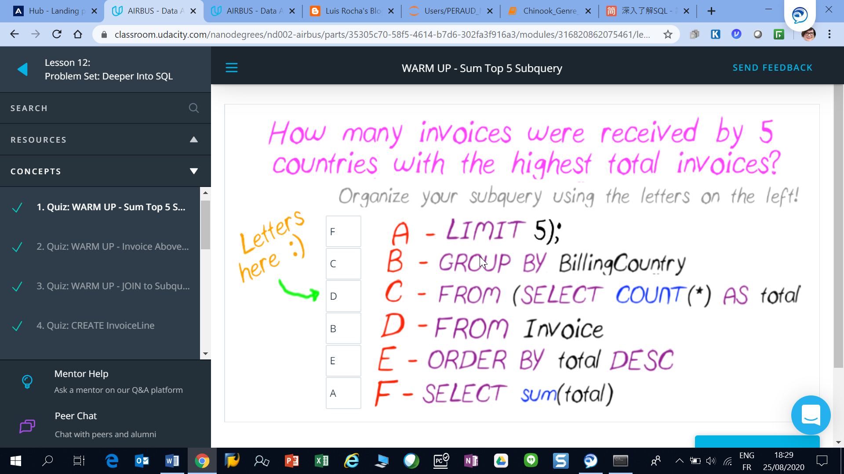

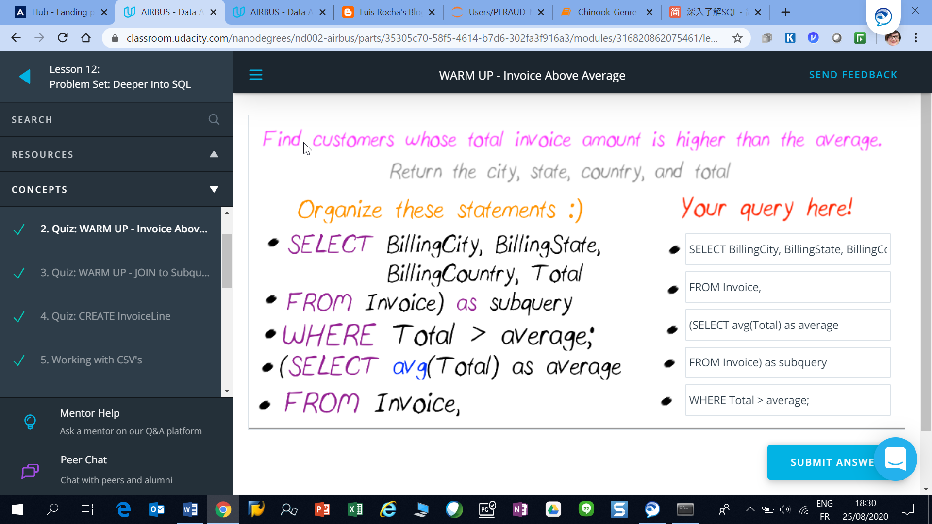

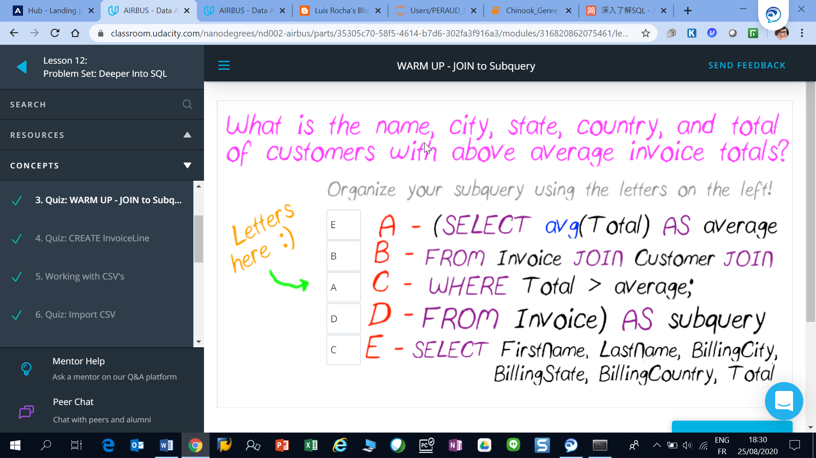

**Create InvoiceLine**

## After all the success promoting your music tour last section,

## a new friend has asked to partner up and build your own music website!

## You'll need to rebuild your own database and import the data to your new system.

## Let's first take a closer look at how to build and populate your local database.

## The box below shows the Album table schema including Primary and Foreign Keys.

## Have a look at this table and the CREATE TABLE statement below to see how they

## relate.

'''

First, disconnect from your Chinook database.

> .exit

Create a new database named whatever you'd like your store to be called.

$ sqlite3 UdaciousMusic.db

Now we can populate this database with our first table.

Here's a graphic showing some information about the Album table.

We can use this to build a table in our new database.

######################################################################

# Table: Album #

######################################################################

+--------------------+---------------+-----------------+--------------+

| Columns | Data Type | Primary Key | Foreign Key |

+====================+===============+=================+==============+

| AlbumId INTEGER YES NO |

| Title TEXT NO NO |

| ArtistId INTEGER NO YES |

| UnitPrice REAL NO NO |

| Quantity INTEGER NO NO |

+====================+===============+=================+==============+

We can use this information to decide how our schema should look.

Do you see how the schema below reflects the table above?

CREATE TABLE Album

(

AlbumId INTEGER PRIMARY KEY,

Title TEXT,

ArtistId INTEGER,

FOREIGN KEY (ArtistId) REFERENCES Artist (ArtistId)

);

Try pasting the schema into your local database.

Let's check to see if anything happened.

sqlite> .tables

Album <--- Do you see the Album table? I hope so!

Now, do we have any data in our new table?

sqlite> SELECT * FROM Album;

Do you see data? I hope not, we haven't added any yet!

Open the Album.sql tab. You can copy and paste these lines directly into

your sqlite terminal. (Use Ctrl+A or Command+A to select all lines when the

code editor is selected to select all the lines at once.)

Now try to run your query again. You've got data... NICE!

'''

## Use the previous example to help you construct the InvoiceLine table.

## When you're ready, run you query to CREATE and populate the InvoiceLine table

## using data from the InvoiceLine.sql file.

QUERY='''CREATE TABLE InvoiceLine

(

InvoiceLineId INTEGER Primary key,

InvoiceId INTEGER,

TrackId INTEGER,

UnitPrice REAL,

Quantity INTEGER,

FOREIGN KEY (InvoiceId) REFERENCES Invoice(InvoiceId)

FOREIGN KEY (TrackId) REFERENCES Track(TrackId)

);

'''

'''

######################################################################

# Table: InvoiceLine #

######################################################################

+--------------------+---------------+-----------------+--------------+

| Columns | Data Type | Primary Key | Foreign Key |

+====================+===============+=================+==============+

| InvoiceLineId INTEGER YES NO |

| InvoiceId INTEGER NO YES |

| TrackId INTEGER NO YES |

| UnitPrice REAL NO NO |

| Quantity INTEGER NO NO |

+====================+===============+=================+==============+

'''

## These examples should help you build any remaining tables from the Chinook database.

## Use .schema when connected to the Chinook database to see the tables and columns

## in your Chinook database, and try recreating them in your new database.

## You can populate these tables using the sql files from the Downloadables section, or

## with CSV files, which you'll learn to do next!

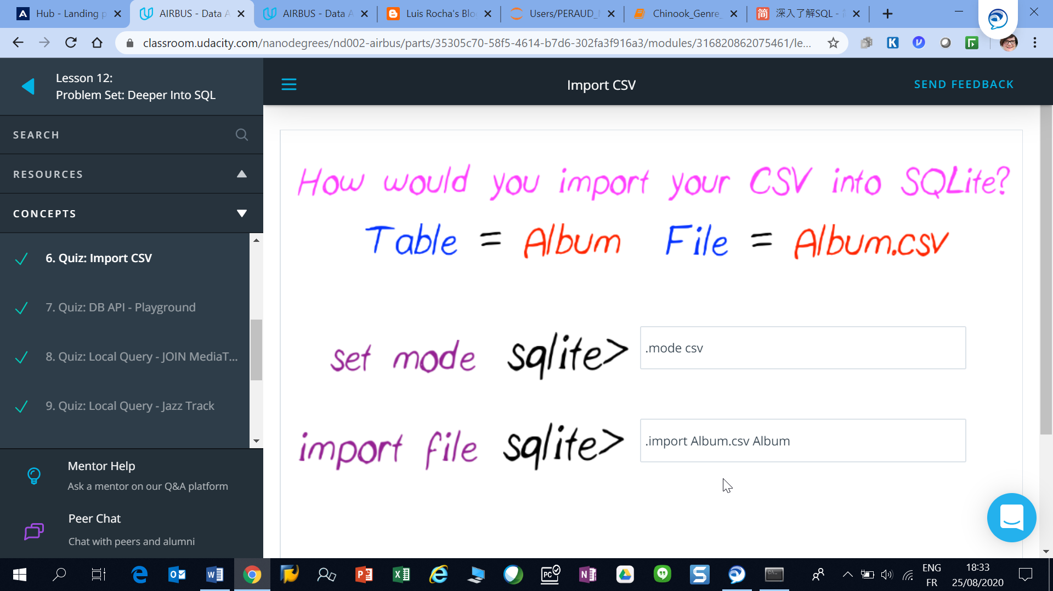

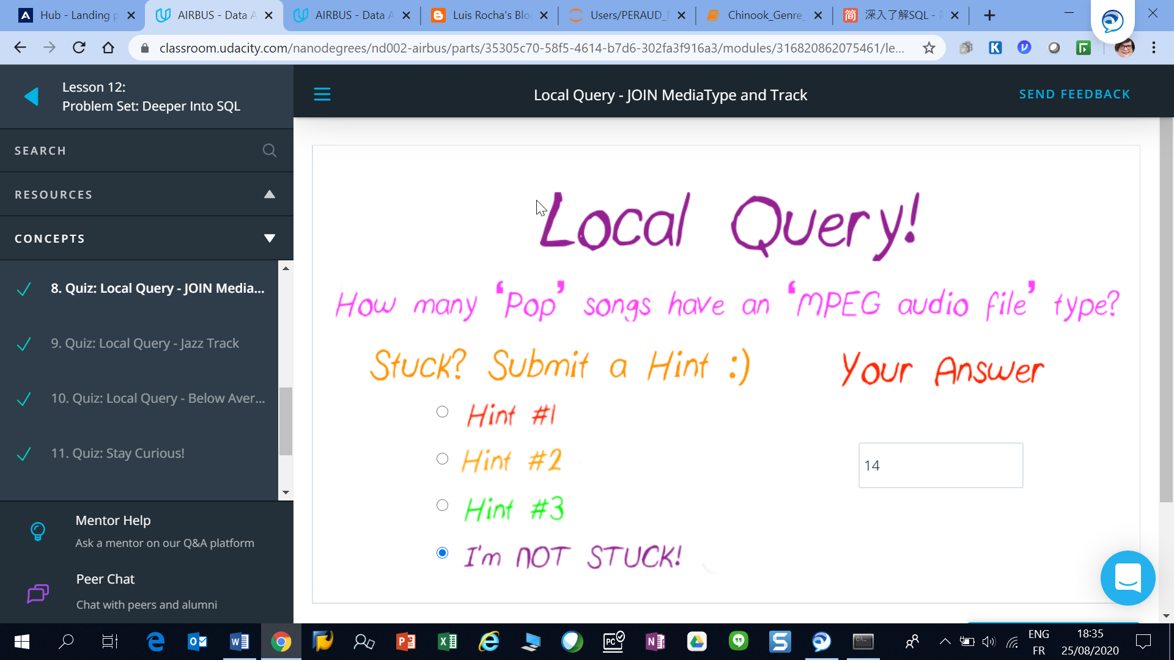

Answer from python : Chinook_number_of_Pop_MPEG_files :

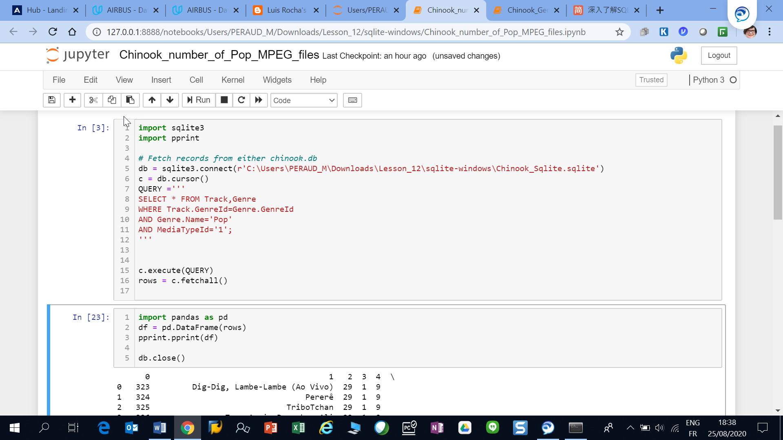

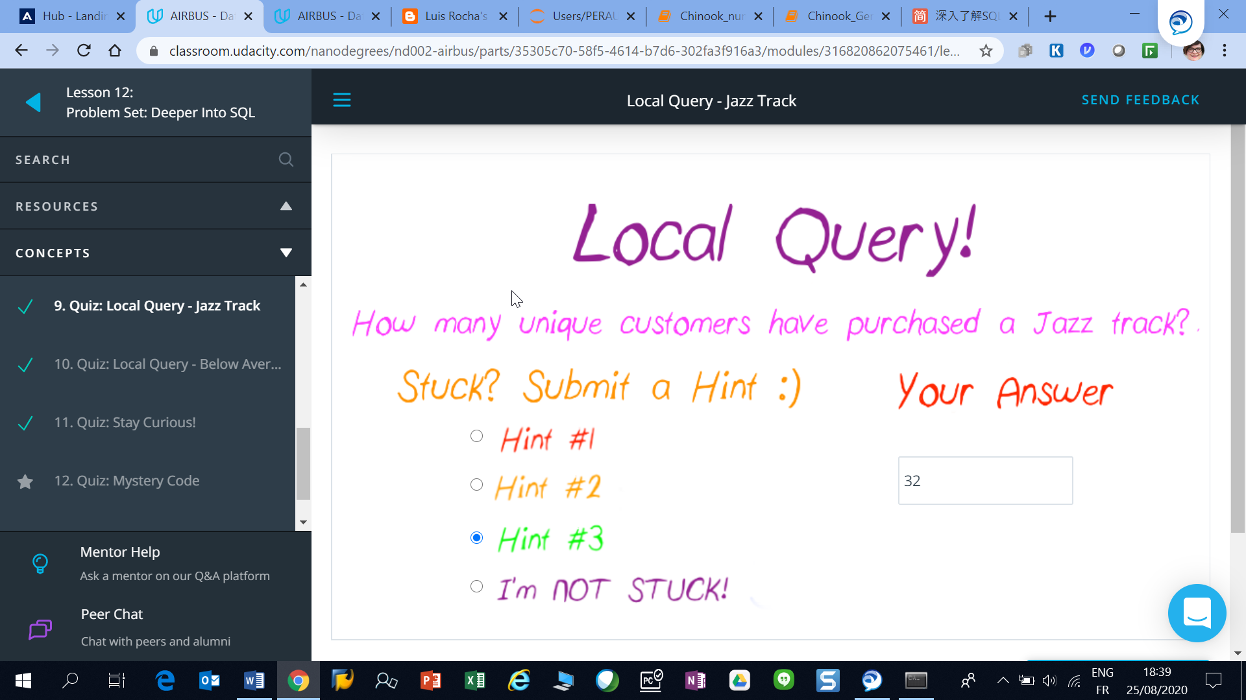

Answer from Chinook_number_of_Jazz_Customers

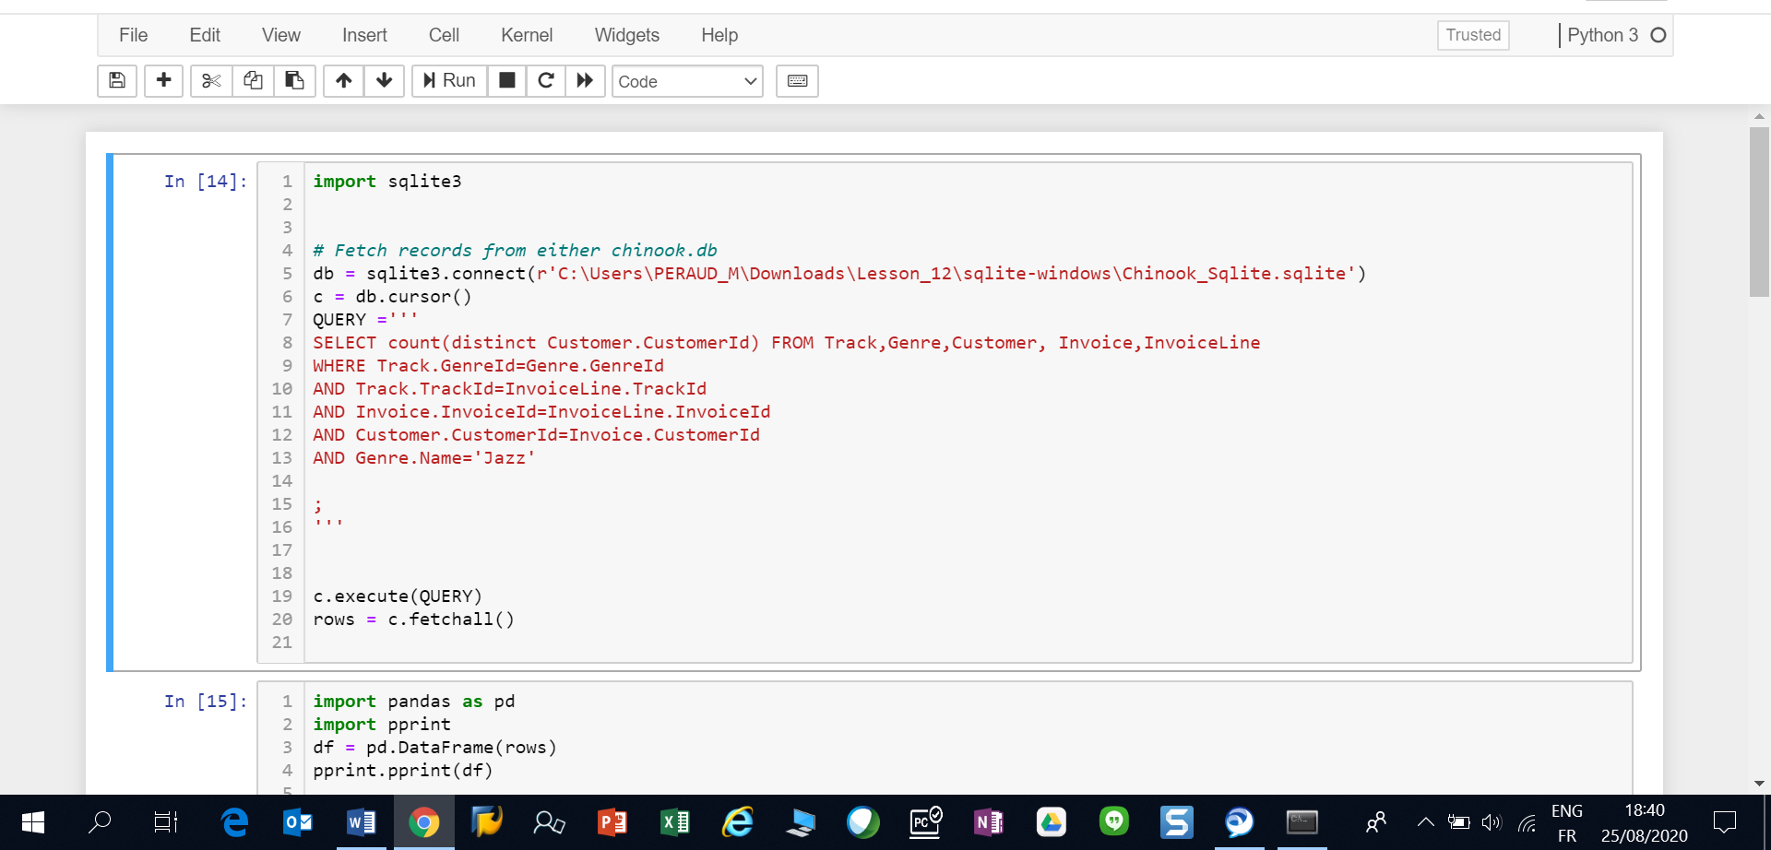

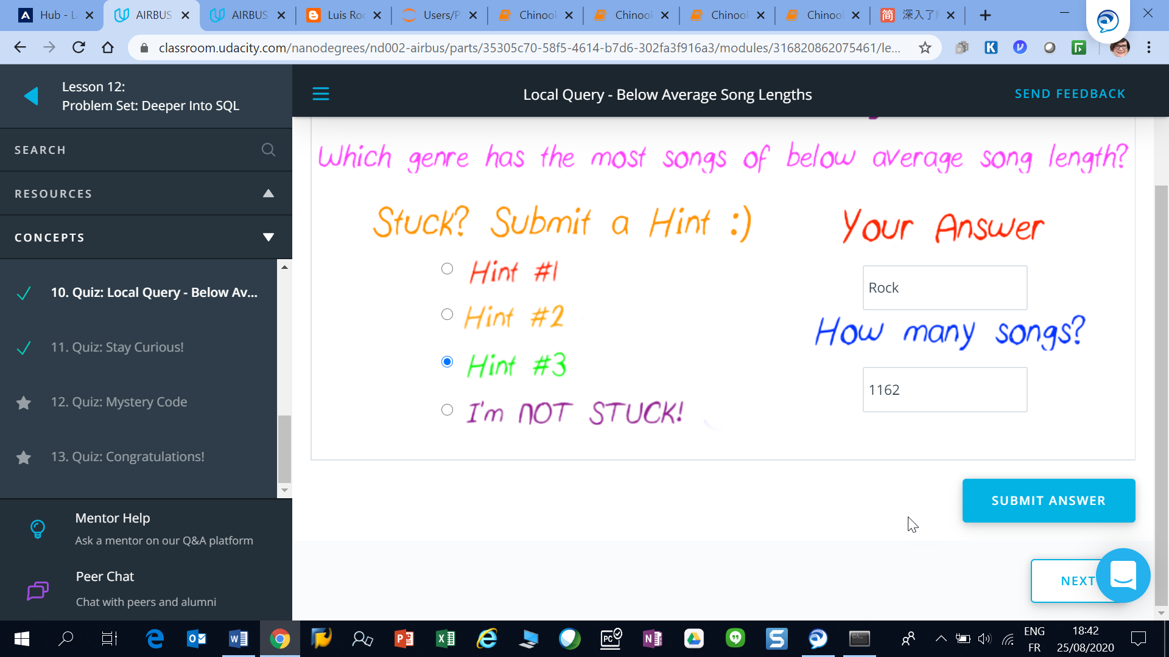

Solution from <https://www.jianshu.com/p/d652466d571e>

