**ALUMNOS**

**Ortega Maximiliano Carlos Jesús** Legajo VINF04840

**Calvano Pablo Martín** Legajo: VINF08724

**Manzanares Johana Romina** Legajo: VINF01938

**Deville, Mariano Ariel** Legajo: VINF08043

SEMINARIO DE ACTUALIZACIÓN EN PROGRAMACIÓN

Licenciatura en Informática

Prof. JULIO MARCELO GUTIERREZ

indice

Prototipo interfaz 2

Diagrama de navegación 7

Código fuente 7

Supercharger.java 7

LogErrores.java 9

Ventanas.java 11

VentanaPrincipal.java 12

VentanaRecepcion.java 18

VentanaConsultarAgenda.java 24

VentanaRegistrarAsistencia.java 29

VentanaNuevoCliente.java 37

VentanaListarTrabajos.java 47

VentanaTaller.java 51

VentanaFichaTaller.java 54

VentanaAdministracion.java 60

VentanaEmitirInforme.java 64

# Prototipo interfaz

Figura 1: Ventana principal.

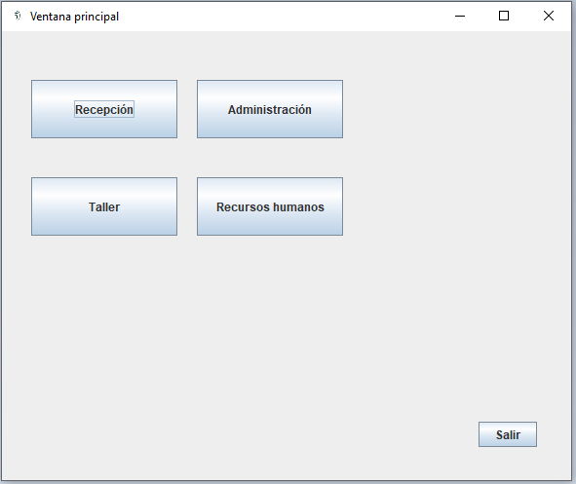

Figura 2: Pantalla de recepción, opciones del recepcionista.

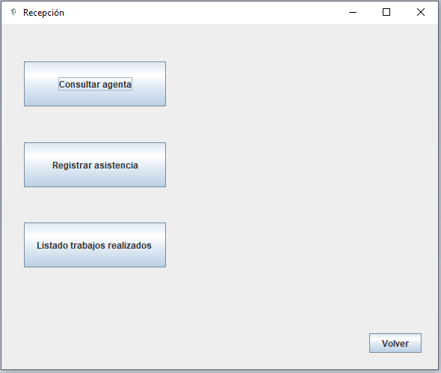

Figura 3: Consulta agenda y reserva del turno.

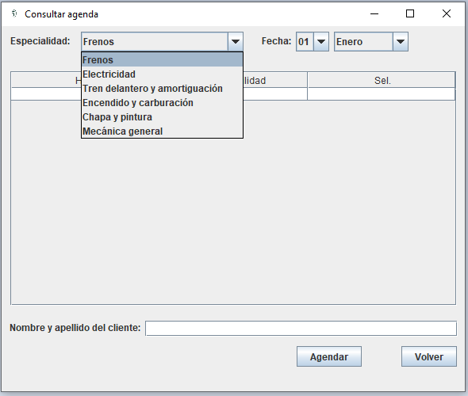

Figura 6: Registrar asistencia, si el cliente existe se puede seleccionar de la lista de clientes registrados, para hacer la búsqueda más simple en el campo cliente se puede escribir para reducir la lista de búsqueda.

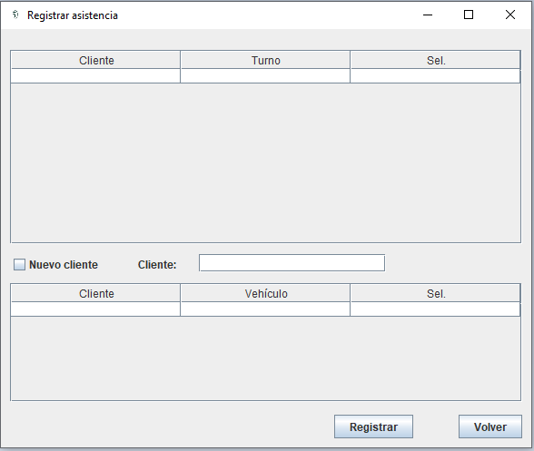

Figura 7: Registrar asistencia, si el cliente nunca fue registrado al presionar el botón registrar nos lleva a una nueva ventana para completar los datos y guardarlos.

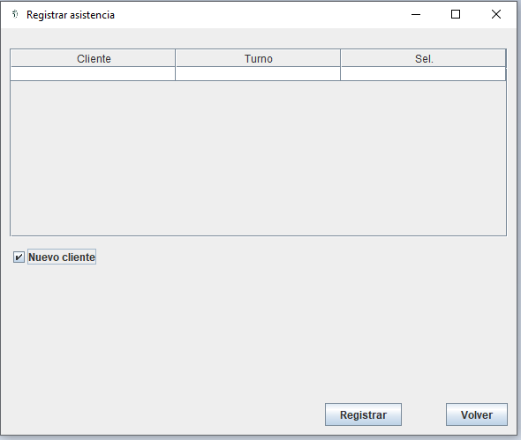

Figura 8: Ventana para rellenar con la información del cliente y el vehículo.

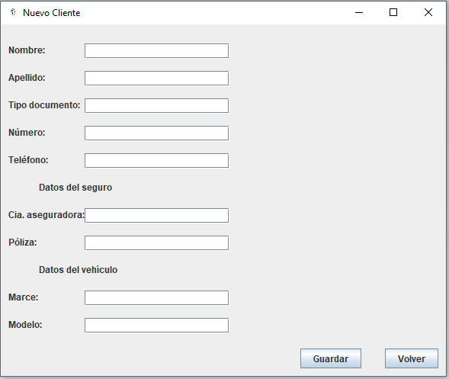

Figura 9: Ventana de trabajos realizados en el día.

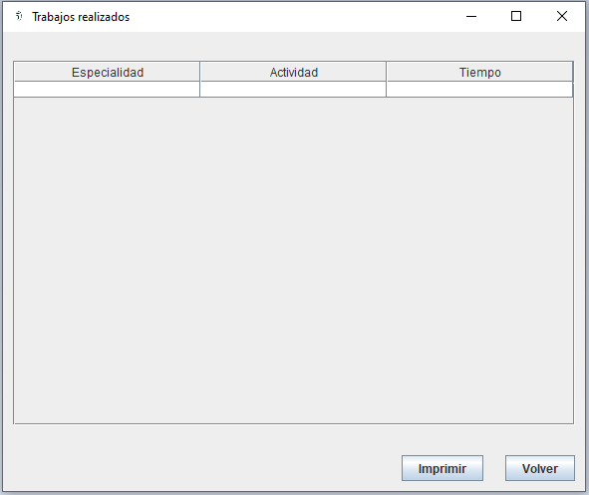

Figura 10: Ventana con las opciones para el sector administración.

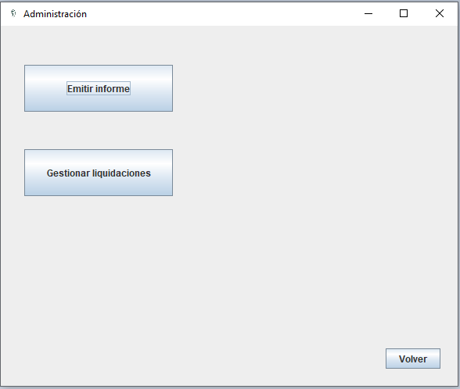

Figura 11: Ventana de generación de informe mensual.

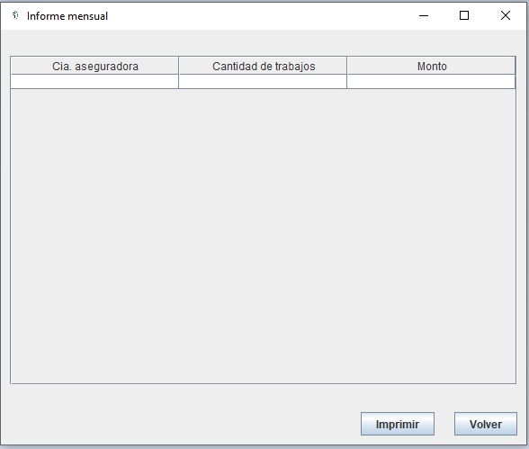

Figura 12: Ventana con las opciones para el sector taller.

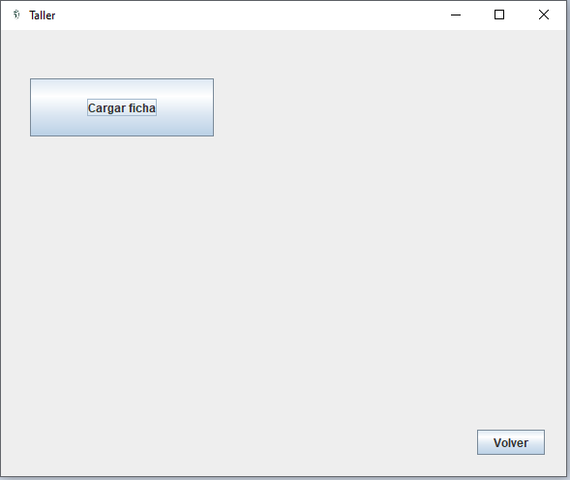

Figura 13: Ventana para la carga de los trabajos realizados.

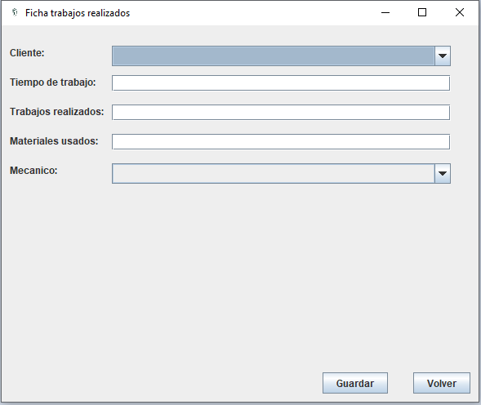

# Diagrama de navegación

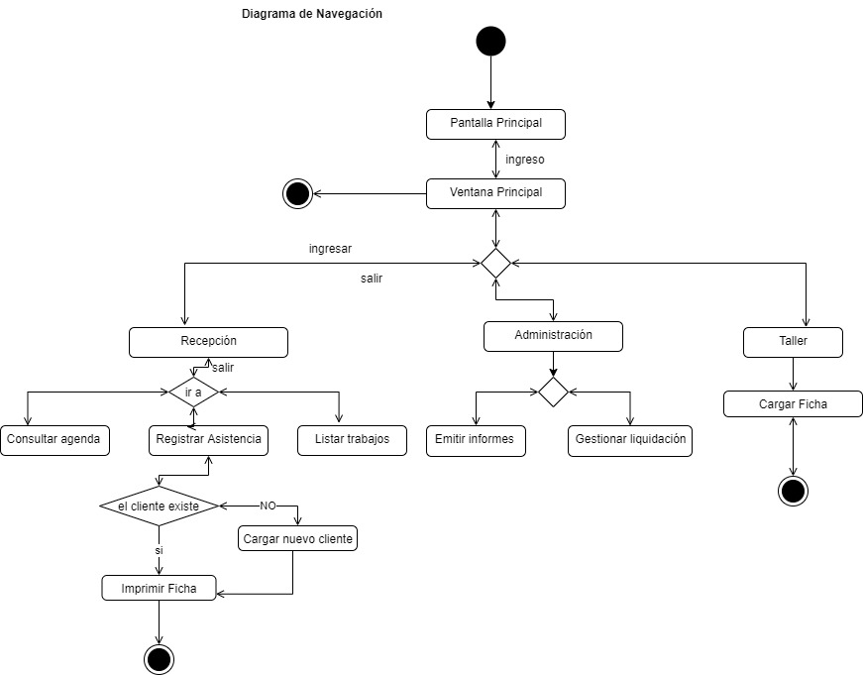

# Código fuente

El proyecto se realizó con el IDE Eclipse, al cual se le agregó el plugin WindowsBuilder para la utilización Java Swing.

## Supercharger.java

package seminarioProgramacion;

import java.awt.EventQueue;

public class Supercharger {

public static void main(String[] args) {

EventQueue.invokeLater(new Runnable() {

public void run() {

try {

VentanaPrincipal frame = new VentanaPrincipal("Ventana principal");

frame.setVisible(true);

} catch (Exception e) {

e.printStackTrace();

LogErrores.escribirLog("Error al intentar abrir la ventana principal.");

}

}

});

}

}

## LogErrores.java

package seminarioProgramacion;

import java.io.BufferedWriter;

import java.io.File;

import java.io.FileWriter;

import java.io.IOException;

import java.util.Calendar;

import java.util.GregorianCalendar;

public class LogErrores {

static public void escribirLog(String contenido) {

BufferedWriter bw = null;

FileWriter fw = null;

String nombreArchivo = "LOG:C:\\logSupercharger.txt";

Calendar fechaSistema = new GregorianCalendar();

String dateEvento = (fechaSistema.get(Calendar.DAY_OF_MONTH)<10? "0" + fechaSistema.get(Calendar.DAY_OF_MONTH):fechaSistema.get(Calendar.DAY_OF_MONTH)) + "/"

+ ((fechaSistema.get(Calendar.MONTH)+1)<10? "0" + (fechaSistema.get(Calendar.MONTH)+1):(fechaSistema.get(Calendar.MONTH)+1)) + "/"

+ fechaSistema.get(Calendar.YEAR) + " "

+ (fechaSistema.get(Calendar.AM_PM)==0? fechaSistema.get(Calendar.HOUR):fechaSistema.get(Calendar.HOUR)+12)

+ ":" +(fechaSistema.get(Calendar.MINUTE)<10? "0" + fechaSistema.get(Calendar.MINUTE):fechaSistema.get(Calendar.MINUTE))

+ ":" +(fechaSistema.get(Calendar.SECOND)<10? "0" + fechaSistema.get(Calendar.SECOND):fechaSistema.get(Calendar.SECOND));

System.err.println(contenido);

try {

File archivo = new File(nombreArchivo);

if (!archivo.exists())

archivo.createNewFile();

fw = new FileWriter(archivo.getAbsoluteFile(), true); // flag true, indica adjuntar información al archivo.

bw = new BufferedWriter(fw);

bw.write(dateEvento + " - " + contenido + "\r\n");

} catch (IOException e) {

System.err.println("No se pudo escribir en el archivo.");

} finally {

try {

if (bw != null)

bw.close();

if (fw != null)

fw.close();

} catch (IOException ex) {

ex.printStackTrace();

}

}

}

}

## Ventanas.java

package seminarioProgramacion;

import javax.swing.JFrame;

import java.awt.Dimension;

import java.awt.Toolkit;

public abstract class Ventanas extends JFrame {

private static final long serialVersionUID = 1L;

public Ventanas(String nombreVentana) {

setTitle(nombreVentana);

setIconImage(Toolkit.getDefaultToolkit().getImage("E:\\Java\\Eclipse\\Supercharger\\Imagenes\\Logo.png"));

setDefaultCloseOperation(JFrame.DISPOSE_ON_CLOSE);

setBounds(10, 10, 600, 500);

// setExtendedState(JFrame.MAXIMIZED_BOTH);

setMinimumSize(new Dimension(600, 500));

}

}

## VentanaPrincipal.java

package seminarioProgramacion;

import javax.swing.JFrame;

import javax.swing.JPanel;

import javax.swing.SpringLayout;

import javax.swing.JButton;

import java.awt.event.ActionListener;

import java.awt.EventQueue;

import java.awt.event.ActionEvent;

public class VentanaPrincipal extends Ventanas {

private static final long serialVersionUID = 1L;

private JPanel contentPane;

public VentanaPrincipal(String nombreVentana) {

super(nombreVentana);

setDefaultCloseOperation(JFrame.EXIT_ON_CLOSE);

contentPane = new JPanel();

setContentPane(contentPane);

SpringLayout sl_contentPane = new SpringLayout();

contentPane.setLayout(sl_contentPane);

JButton btnRecepcion = new JButton("Recepción");

sl_contentPane.putConstraint(SpringLayout.NORTH, btnRecepcion, 50, SpringLayout.NORTH, contentPane);

sl_contentPane.putConstraint(SpringLayout.WEST, btnRecepcion, 30, SpringLayout.WEST, contentPane);

sl_contentPane.putConstraint(SpringLayout.SOUTH, btnRecepcion, 110, SpringLayout.NORTH, contentPane);

sl_contentPane.putConstraint(SpringLayout.EAST, btnRecepcion, 180, SpringLayout.WEST, contentPane);

btnRecepcion.addActionListener(new ActionListener() {

public void actionPerformed(ActionEvent e) {

EventQueue.invokeLater(new Runnable() {

public void run() {

try {

VentanaRecepcion frame = new VentanaRecepcion("Recepción");

frame.setVisible(true);

} catch (Exception e) {

e.printStackTrace();

}

}

});

}

});

contentPane.add(btnRecepcion);

JButton btnAdministracion = new JButton("Administración");

sl_contentPane.putConstraint(SpringLayout.NORTH, btnAdministracion, 50, SpringLayout.NORTH, contentPane);

sl_contentPane.putConstraint(SpringLayout.WEST, btnAdministracion, 200, SpringLayout.WEST, contentPane);

sl_contentPane.putConstraint(SpringLayout.SOUTH, btnAdministracion, 110, SpringLayout.NORTH, contentPane);

sl_contentPane.putConstraint(SpringLayout.EAST, btnAdministracion, 350, SpringLayout.WEST, contentPane);

btnAdministracion.addActionListener(new ActionListener() {

public void actionPerformed(ActionEvent e) {

EventQueue.invokeLater(new Runnable() {

public void run() {

try {

VentanaAdministracion frame = new VentanaAdministracion("Administración");

frame.setVisible(true);

} catch (Exception e) {

e.printStackTrace();

}

}

});

}

});

contentPane.add(btnAdministracion);

JButton btnTaller = new JButton("Taller");

sl_contentPane.putConstraint(SpringLayout.NORTH, btnTaller, 40, SpringLayout.SOUTH, btnRecepcion);

sl_contentPane.putConstraint(SpringLayout.WEST, btnTaller, 0, SpringLayout.WEST, btnRecepcion);

sl_contentPane.putConstraint(SpringLayout.SOUTH, btnTaller, 100, SpringLayout.SOUTH, btnRecepcion);

sl_contentPane.putConstraint(SpringLayout.EAST, btnTaller, 0, SpringLayout.EAST, btnRecepcion);

btnTaller.addActionListener(new ActionListener() {

public void actionPerformed(ActionEvent e) {

EventQueue.invokeLater(new Runnable() {

public void run() {

try {

VentanaTaller frame = new VentanaTaller("Taller");

frame.setVisible(true);

} catch (Exception e) {

e.printStackTrace();

}

}

});

}

});

contentPane.add(btnTaller);

JButton btnRRHH = new JButton("Recursos humanos");

sl_contentPane.putConstraint(SpringLayout.NORTH, btnRRHH, 40, SpringLayout.SOUTH, btnAdministracion);

sl_contentPane.putConstraint(SpringLayout.WEST, btnRRHH, 0, SpringLayout.WEST, btnAdministracion);

sl_contentPane.putConstraint(SpringLayout.SOUTH, btnRRHH, 100, SpringLayout.SOUTH, btnAdministracion);

sl_contentPane.putConstraint(SpringLayout.EAST, btnRRHH, 0, SpringLayout.EAST, btnAdministracion);

btnRRHH.addActionListener(new ActionListener() {

public void actionPerformed(ActionEvent e) {

}

});

contentPane.add(btnRRHH);

JButton btnSalir = new JButton("Salir");

btnSalir.addActionListener(new ActionListener() {

public void actionPerformed(ActionEvent e) {

dispose();

}

});

sl_contentPane.putConstraint(SpringLayout.SOUTH, btnSalir, -34, SpringLayout.SOUTH, contentPane);

sl_contentPane.putConstraint(SpringLayout.EAST, btnSalir, -35, SpringLayout.EAST, contentPane);

contentPane.add(btnSalir);

}

}

## VentanaRecepcion.java

package seminarioProgramacion;

import javax.swing.JFrame;

import javax.swing.JPanel;

import javax.swing.SpringLayout;

import javax.swing.JButton;

import java.awt.event.ActionListener;

import java.awt.EventQueue;

import java.awt.event.ActionEvent;

import javax.swing.SwingConstants;

public class VentanaRecepcion extends Ventanas {

private static final long serialVersionUID = 1L;

private JPanel contentPane;

public VentanaRecepcion(String nombreVentana) {

super(nombreVentana);

setDefaultCloseOperation(JFrame.DISPOSE_ON_CLOSE);

contentPane = new JPanel();

setContentPane(contentPane);

SpringLayout sl_contentPane = new SpringLayout();

contentPane.setLayout(sl_contentPane);

JButton btnConsultarAgenda = new JButton("Consultar agenta");

sl_contentPane.putConstraint(SpringLayout.WEST, btnConsultarAgenda, 30, SpringLayout.WEST, contentPane);

sl_contentPane.putConstraint(SpringLayout.EAST, btnConsultarAgenda, -364, SpringLayout.EAST, contentPane);

btnConsultarAgenda.addActionListener(new ActionListener() {

public void actionPerformed(ActionEvent e) {

EventQueue.invokeLater(new Runnable() {

public void run() {

try {

VentanaConfultarAgenda frame = new VentanaConfultarAgenda("Consultar agenda");

frame.setVisible(true);

} catch (Exception e) {

e.printStackTrace();

}

}

});

}

});

sl_contentPane.putConstraint(SpringLayout.NORTH, btnConsultarAgenda, 50, SpringLayout.NORTH, contentPane);

sl_contentPane.putConstraint(SpringLayout.SOUTH, btnConsultarAgenda, 110, SpringLayout.NORTH, contentPane);

contentPane.add(btnConsultarAgenda);

JButton btnRegistrarAsistencia = new JButton("Registrar asistencia");

sl_contentPane.putConstraint(SpringLayout.NORTH, btnRegistrarAsistencia, 48, SpringLayout.SOUTH, btnConsultarAgenda);

sl_contentPane.putConstraint(SpringLayout.WEST, btnRegistrarAsistencia, 30, SpringLayout.WEST, contentPane);

btnRegistrarAsistencia.addActionListener(new ActionListener() {

public void actionPerformed(ActionEvent e) {

EventQueue.invokeLater(new Runnable() {

public void run() {

try {

VentanaRegistrarAsistencia frame = new VentanaRegistrarAsistencia("Registrar asistencia");

frame.setVisible(true);

} catch (Exception e) {

e.printStackTrace();

}

}

});

}

});

contentPane.add(btnRegistrarAsistencia);

JButton btnListarTrabajos = new JButton("Listado trabajos realizados");

sl_contentPane.putConstraint(SpringLayout.SOUTH, btnRegistrarAsistencia, -47, SpringLayout.NORTH, btnListarTrabajos);

sl_contentPane.putConstraint(SpringLayout.EAST, btnRegistrarAsistencia, 0, SpringLayout.EAST, btnListarTrabajos);

sl_contentPane.putConstraint(SpringLayout.NORTH, btnListarTrabajos, 265, SpringLayout.NORTH, contentPane);

sl_contentPane.putConstraint(SpringLayout.WEST, btnListarTrabajos, 30, SpringLayout.WEST, contentPane);

sl_contentPane.putConstraint(SpringLayout.EAST, btnListarTrabajos, -364, SpringLayout.EAST, contentPane);

sl_contentPane.putConstraint(SpringLayout.SOUTH, btnListarTrabajos, -136, SpringLayout.SOUTH, contentPane);

btnListarTrabajos.setHorizontalAlignment(SwingConstants.LEADING);

btnListarTrabajos.addActionListener(new ActionListener() {

public void actionPerformed(ActionEvent e) {

EventQueue.invokeLater(new Runnable() {

public void run() {

try {

VentanaListarTrabajos frame = new VentanaListarTrabajos("Trabajos realizados");

frame.setVisible(true);

} catch (Exception e) {

e.printStackTrace();

}

}

});

}

});

contentPane.add(btnListarTrabajos);

JButton btnVolver = new JButton("Volver");

btnVolver.addActionListener(new ActionListener() {

public void actionPerformed(ActionEvent e) {

dispose();

}

});

sl_contentPane.putConstraint(SpringLayout.SOUTH, btnVolver, -22, SpringLayout.SOUTH, contentPane);

sl_contentPane.putConstraint(SpringLayout.EAST, btnVolver, -22, SpringLayout.EAST, contentPane);

contentPane.add(btnVolver);

}

}

## VentanaConsultarAgenda.java

## package seminarioProgramacion;

## import javax.swing.JFrame;

## import javax.swing.JPanel;

## import javax.swing.SpringLayout;

## import javax.swing.table.DefaultTableModel;

## import javax.swing.JScrollPane;

## import javax.swing.JTable;

## import javax.swing.JButton;

## import javax.swing.JLabel;

## import javax.swing.JComboBox;

## import java.awt.event.ActionListener;

## import java.awt.event.ActionEvent;

## import javax.swing.DefaultComboBoxModel;

## import javax.swing.JTextField;

## public class VentanaConfultarAgenda extends Ventanas {

## private static final long serialVersionUID = 1L;

## private JPanel contentPane;

## private JScrollPane scrollTabla;

## private JTable agenda;

## private JComboBox<Object> comboBoxEspecialidad;

## private JComboBox<Object> comboBoxMes;

## private JComboBox<Object> comboBoxDia;

## private JTextField txtNombreApellido;

## public VentanaConfultarAgenda(String nombreVentana) {

## super(nombreVentana);

## setDefaultCloseOperation(JFrame.DISPOSE_ON_CLOSE);

## contentPane = new JPanel();

## setContentPane(contentPane);

## SpringLayout sl_contentPane = new SpringLayout();

## contentPane.setLayout(sl_contentPane);

## 

## scrollTabla = new JScrollPane();

## sl_contentPane.putConstraint(SpringLayout.NORTH, scrollTabla, 57, SpringLayout.NORTH, contentPane);

## sl_contentPane.putConstraint(SpringLayout.SOUTH, scrollTabla, -108, SpringLayout.SOUTH, contentPane);

## contentPane.add(scrollTabla);

## agenda = new JTable();

## agenda.setModel(new DefaultTableModel(

## new Object[][] {

## 

## {null, null, null},

## },

## new String[] {

## "Hora", "Disponibilidad", "Sel."

## }

## ));

## sl_contentPane.putConstraint(SpringLayout.WEST, scrollTabla, 11, SpringLayout.WEST, contentPane);

## scrollTabla.setViewportView(agenda);

## 

## JLabel lblEspecialidad = new JLabel("Especialidad:");

## sl_contentPane.putConstraint(SpringLayout.NORTH, lblEspecialidad, 10, SpringLayout.NORTH, contentPane);

## sl_contentPane.putConstraint(SpringLayout.WEST, lblEspecialidad, 11, SpringLayout.WEST, contentPane);

## contentPane.add(lblEspecialidad);

## 

## comboBoxEspecialidad = new JComboBox<Object>();

## sl_contentPane.putConstraint(SpringLayout.NORTH, comboBoxEspecialidad, -3, SpringLayout.NORTH, lblEspecialidad);

## sl_contentPane.putConstraint(SpringLayout.WEST, comboBoxEspecialidad, 14, SpringLayout.EAST, lblEspecialidad);

## comboBoxEspecialidad.setModel(new DefaultComboBoxModel<Object>(new String[] {"Frenos", "Electricidad", "Tren delantero y amortiguaci\u00F3n", "Encendido y carburaci\u00F3n", "Chapa y pintura", "Mec\u00E1nica general"}));

## contentPane.add(comboBoxEspecialidad);

## 

## JLabel lblFecha = new JLabel("Fecha:");

## sl_contentPane.putConstraint(SpringLayout.NORTH, lblFecha, 0, SpringLayout.NORTH, lblEspecialidad);

## sl_contentPane.putConstraint(SpringLayout.WEST, lblFecha, 23, SpringLayout.EAST, comboBoxEspecialidad);

## contentPane.add(lblFecha);

## 

## comboBoxDia = new JComboBox<Object>();

## sl_contentPane.putConstraint(SpringLayout.NORTH, comboBoxDia, -3, SpringLayout.NORTH, lblEspecialidad);

## sl_contentPane.putConstraint(SpringLayout.WEST, comboBoxDia, 6, SpringLayout.EAST, lblFecha);

## comboBoxDia.setModel(new DefaultComboBoxModel<Object>(new String[] {"01", "02", "03", "04", "05", "06", "07", "08", "09", "10", "11", "12", "13", "14", "15", "16", "17", "18", "19", "20", "21", "22", "23", "24", "25", "26", "27", "28", "29", "30", "31"}));

## contentPane.add(comboBoxDia);

## 

## comboBoxMes = new JComboBox<Object>();

## sl_contentPane.putConstraint(SpringLayout.NORTH, comboBoxMes, -3, SpringLayout.NORTH, lblEspecialidad);

## sl_contentPane.putConstraint(SpringLayout.WEST, comboBoxMes, 6, SpringLayout.EAST, comboBoxDia);

## comboBoxMes.setModel(new DefaultComboBoxModel<Object>(new String[] {"Enero", "Febrero", "Marzo", "Abril", "Mayo", "Junio", "Julio", "Agosto", "Septiembre", "Octubre", "Noviembre", "Diciembre"}));

## contentPane.add(comboBoxMes);

## 

## JButton btnVolver = new JButton("Volver");

## sl_contentPane.putConstraint(SpringLayout.EAST, scrollTabla, 0, SpringLayout.EAST, btnVolver);

## btnVolver.addActionListener(new ActionListener() {

## public void actionPerformed(ActionEvent e) {

## 

## dispose();

## }

## });

## sl_contentPane.putConstraint(SpringLayout.SOUTH, btnVolver, -31, SpringLayout.SOUTH, contentPane);

## sl_contentPane.putConstraint(SpringLayout.EAST, btnVolver, -10, SpringLayout.EAST, contentPane);

## contentPane.add(btnVolver);

## 

## JButton btnAgendar = new JButton("Agendar");

## btnAgendar.addActionListener(new ActionListener() {

## public void actionPerformed(ActionEvent e) {

## 

## // Asigna un turno y lo guarda en la base de datos.

## }

## });

## sl_contentPane.putConstraint(SpringLayout.NORTH, btnAgendar, 0, SpringLayout.NORTH, btnVolver);

## sl_contentPane.putConstraint(SpringLayout.EAST, btnAgendar, -50, SpringLayout.WEST, btnVolver);

## contentPane.add(btnAgendar);

## 

## JLabel lblNombreApellido = new JLabel("Nombre y apellido del cliente:");

## sl_contentPane.putConstraint(SpringLayout.NORTH, lblNombreApellido, 19, SpringLayout.SOUTH, scrollTabla);

## sl_contentPane.putConstraint(SpringLayout.WEST, lblNombreApellido, 10, SpringLayout.WEST, contentPane);

## contentPane.add(lblNombreApellido);

## 

## txtNombreApellido = new JTextField();

## sl_contentPane.putConstraint(SpringLayout.NORTH, txtNombreApellido, 0, SpringLayout.NORTH, lblNombreApellido);

## sl_contentPane.putConstraint(SpringLayout.WEST, txtNombreApellido, 6, SpringLayout.EAST, lblNombreApellido);

## sl_contentPane.putConstraint(SpringLayout.EAST, txtNombreApellido, 400, SpringLayout.EAST, lblNombreApellido);

## contentPane.add(txtNombreApellido);

## txtNombreApellido.setColumns(10);

## }

## }VentanaRegistrarAsistencia.java

package seminarioProgramacion;

import javax.swing.JFrame;

import javax.swing.JPanel;

import javax.swing.JScrollPane;

import javax.swing.JTable;

import javax.swing.SpringLayout;

import javax.swing.table.DefaultTableModel;

import javax.swing.JButton;

import java.awt.event.ActionListener;

import java.awt.event.ItemEvent;

import java.awt.event.ItemListener;

import java.awt.EventQueue;

import java.awt.event.ActionEvent;

import javax.swing.JCheckBox;

import javax.swing.JLabel;

import javax.swing.JTextField;

public class VentanaRegistrarAsistencia extends Ventanas {

private static final long serialVersionUID = 1L;

private JPanel contentPane;

private JScrollPane scrollTablaAsistencia;

private JTable asistencia;

private JScrollPane scrollClientes;

private JTable clientes;

private JButton btnVolver;

private JButton btnRegistrar;

private JTextField txtBusquedaCliente;

private JLabel lblCliente;

public VentanaRegistrarAsistencia(String nombreVentana) {

super(nombreVentana);

setDefaultCloseOperation(JFrame.DISPOSE_ON_CLOSE);

contentPane = new JPanel();

setContentPane(contentPane);

SpringLayout sl_contentPane = new SpringLayout();

contentPane.setLayout(sl_contentPane);

scrollTablaAsistencia = new JScrollPane();

sl_contentPane.putConstraint(SpringLayout.NORTH, scrollTablaAsistencia, 23, SpringLayout.NORTH, contentPane);

sl_contentPane.putConstraint(SpringLayout.WEST, scrollTablaAsistencia, 10, SpringLayout.WEST, contentPane);

sl_contentPane.putConstraint(SpringLayout.SOUTH, scrollTablaAsistencia, -224, SpringLayout.SOUTH, contentPane);

sl_contentPane.putConstraint(SpringLayout.EAST, scrollTablaAsistencia, -10, SpringLayout.EAST, contentPane);

contentPane.add(scrollTablaAsistencia);

asistencia = new JTable();

asistencia.setModel(new DefaultTableModel(

new Object[][] {

{null, null, null},

},

new String[] {

"Cliente", "Turno", "Sel."

}

));

scrollTablaAsistencia.setViewportView(asistencia);

JCheckBox chckbxNuevoCliente = new JCheckBox("Nuevo cliente");

chckbxNuevoCliente.setSelected(false);

sl_contentPane.putConstraint(SpringLayout.NORTH, chckbxNuevoCliente, 10, SpringLayout.SOUTH, scrollTablaAsistencia);

sl_contentPane.putConstraint(SpringLayout.WEST, chckbxNuevoCliente, 10, SpringLayout.WEST, contentPane);

chckbxNuevoCliente.addItemListener(new ItemListener() {

@Override

public void itemStateChanged(ItemEvent e) {

actualizar(!chckbxNuevoCliente.isSelected());

}

});

contentPane.add(chckbxNuevoCliente);

lblCliente = new JLabel("Cliente:");

sl_contentPane.putConstraint(SpringLayout.NORTH, lblCliente, 4, SpringLayout.NORTH, chckbxNuevoCliente);

sl_contentPane.putConstraint(SpringLayout.WEST, lblCliente, 40, SpringLayout.EAST, chckbxNuevoCliente);

contentPane.add(lblCliente);

txtBusquedaCliente = new JTextField();

sl_contentPane.putConstraint(SpringLayout.NORTH, txtBusquedaCliente, 11, SpringLayout.SOUTH, scrollTablaAsistencia);

sl_contentPane.putConstraint(SpringLayout.WEST, txtBusquedaCliente, 25, SpringLayout.EAST, lblCliente);

sl_contentPane.putConstraint(SpringLayout.EAST, txtBusquedaCliente, 231, SpringLayout.EAST, lblCliente);

contentPane.add(txtBusquedaCliente);

txtBusquedaCliente.setColumns(10);

scrollClientes = new JScrollPane();

sl_contentPane.putConstraint(SpringLayout.NORTH, scrollClientes, 280, SpringLayout.NORTH, contentPane);

sl_contentPane.putConstraint(SpringLayout.WEST, scrollClientes, 10, SpringLayout.WEST, contentPane);

sl_contentPane.putConstraint(SpringLayout.SOUTH, scrollClientes, -50, SpringLayout.SOUTH, contentPane);

sl_contentPane.putConstraint(SpringLayout.EAST, scrollClientes, -10, SpringLayout.EAST, contentPane);

contentPane.add(scrollClientes);

clientes = new JTable();

clientes.setModel(new DefaultTableModel(

new Object[][] {

{null, null, null},

},

new String[] {

"Cliente", "Vehículo", "Sel."

}

));

scrollClientes.setViewportView(clientes);

btnVolver = new JButton("Volver");

sl_contentPane.putConstraint(SpringLayout.EAST, btnVolver, -10, SpringLayout.EAST, contentPane);

btnVolver.addActionListener(new ActionListener() {

public void actionPerformed(ActionEvent e) {

dispose();

}

});

sl_contentPane.putConstraint(SpringLayout.SOUTH, btnVolver, -10, SpringLayout.SOUTH, contentPane);

contentPane.add(btnVolver);

btnRegistrar = new JButton("Registrar");

btnRegistrar.addActionListener(new ActionListener() {

public void actionPerformed(ActionEvent e) {

// Guardo en la base de datos las asistencia.

if(chckbxNuevoCliente.isSelected()) {

EventQueue.invokeLater(new Runnable() {

public void run() {

try {

VentanaNuevoCliente frame = new VentanaNuevoCliente("Nuevo Cliente");

frame.setVisible(true);

} catch (Exception e) {

e.printStackTrace();

}

}

});

} else {

// Imprimo la planilla para el taller

}

}

});

sl_contentPane.putConstraint(SpringLayout.NORTH, btnRegistrar, 0, SpringLayout.NORTH, btnVolver);

sl_contentPane.putConstraint(SpringLayout.EAST, btnRegistrar, -50, SpringLayout.WEST, btnVolver);

contentPane.add(btnRegistrar);

}

private void actualizar(boolean visivilidad) {

lblCliente.setVisible(visivilidad);

txtBusquedaCliente.setVisible(visivilidad);

scrollClientes.setVisible(visivilidad);

}

}

## VentanaNuevoCliente.java

package seminarioProgramacion;

import javax.swing.JFrame;

import javax.swing.JPanel;

import javax.swing.SpringLayout;

import javax.swing.JLabel;

import javax.swing.JButton;

import java.awt.event.ActionListener;

import java.awt.event.ActionEvent;

import javax.swing.JTextField;

public class VentanaNuevoCliente extends Ventanas {

private static final long serialVersionUID = 1L;

private JPanel contentPane;

private JTextField txtNombre;

private JTextField txtApellido;

private JTextField txtTipoDocumento;

private JTextField txtNumeroDocumento;

private JTextField txtTelefono;

private JTextField txtCiaAseguradora;

private JTextField txtPoliza;

private JTextField txtMarca;

private JTextField txtModelo;

public VentanaNuevoCliente(String nombreVentana) {

super(nombreVentana);

setDefaultCloseOperation(JFrame.DISPOSE_ON_CLOSE);

contentPane = new JPanel();

setContentPane(contentPane);

SpringLayout sl_contentPane = new SpringLayout();

contentPane.setLayout(sl_contentPane);

JLabel lblNombre = new JLabel("Nombre:");

sl_contentPane.putConstraint(SpringLayout.NORTH, lblNombre, 25, SpringLayout.NORTH, contentPane);

sl_contentPane.putConstraint(SpringLayout.WEST, lblNombre, 10, SpringLayout.WEST, contentPane);

contentPane.add(lblNombre);

txtNombre = new JTextField();

sl_contentPane.putConstraint(SpringLayout.NORTH, txtNombre, 25, SpringLayout.NORTH, contentPane);

sl_contentPane.putConstraint(SpringLayout.WEST, txtNombre, 110, SpringLayout.WEST, contentPane);

sl_contentPane.putConstraint(SpringLayout.EAST, txtNombre, 300, SpringLayout.WEST, contentPane);

contentPane.add(txtNombre);

txtNombre.setColumns(10);

JLabel lblApellido = new JLabel("Apellido:");

sl_contentPane.putConstraint(SpringLayout.NORTH, lblApellido, 20, SpringLayout.SOUTH, lblNombre);

sl_contentPane.putConstraint(SpringLayout.WEST, lblApellido, 10, SpringLayout.WEST, contentPane);

contentPane.add(lblApellido);

txtApellido = new JTextField();

sl_contentPane.putConstraint(SpringLayout.NORTH, txtApellido, 0, SpringLayout.NORTH, lblApellido);

sl_contentPane.putConstraint(SpringLayout.WEST, txtApellido, 110, SpringLayout.WEST, contentPane);

sl_contentPane.putConstraint(SpringLayout.EAST, txtApellido, 300, SpringLayout.WEST, contentPane);

contentPane.add(txtApellido);

txtApellido.setColumns(10);

JLabel lblTipo = new JLabel("Tipo documento:");

sl_contentPane.putConstraint(SpringLayout.NORTH, lblTipo, 20, SpringLayout.SOUTH, lblApellido);

sl_contentPane.putConstraint(SpringLayout.WEST, lblTipo, 10, SpringLayout.WEST, contentPane);

contentPane.add(lblTipo);

txtTipoDocumento = new JTextField();

sl_contentPane.putConstraint(SpringLayout.NORTH, txtTipoDocumento, 0, SpringLayout.NORTH, lblTipo);

sl_contentPane.putConstraint(SpringLayout.WEST, txtTipoDocumento, 110, SpringLayout.WEST, contentPane);

sl_contentPane.putConstraint(SpringLayout.EAST, txtTipoDocumento, 300, SpringLayout.WEST, contentPane);

contentPane.add(txtTipoDocumento);

txtTipoDocumento.setColumns(10);

JLabel lblNumero = new JLabel("Número:");

sl_contentPane.putConstraint(SpringLayout.NORTH, lblNumero, 20, SpringLayout.SOUTH, lblTipo);

sl_contentPane.putConstraint(SpringLayout.WEST, lblNumero, 10, SpringLayout.WEST, contentPane);

contentPane.add(lblNumero);

txtNumeroDocumento = new JTextField();

sl_contentPane.putConstraint(SpringLayout.NORTH, txtNumeroDocumento, 0, SpringLayout.NORTH, lblNumero);

sl_contentPane.putConstraint(SpringLayout.WEST, txtNumeroDocumento, 110, SpringLayout.WEST, contentPane);

sl_contentPane.putConstraint(SpringLayout.EAST, txtNumeroDocumento, 300, SpringLayout.WEST, contentPane);

contentPane.add(txtNumeroDocumento);

txtNumeroDocumento.setColumns(10);

JLabel lblTelefono = new JLabel("Teléfono:");

sl_contentPane.putConstraint(SpringLayout.NORTH, lblTelefono, 20, SpringLayout.SOUTH, lblNumero);

sl_contentPane.putConstraint(SpringLayout.WEST, lblTelefono, 10, SpringLayout.WEST, contentPane);

contentPane.add(lblTelefono);

txtTelefono = new JTextField();

sl_contentPane.putConstraint(SpringLayout.NORTH, txtTelefono, 0, SpringLayout.NORTH, lblTelefono);

sl_contentPane.putConstraint(SpringLayout.WEST, txtTelefono, 110, SpringLayout.WEST, contentPane);

sl_contentPane.putConstraint(SpringLayout.EAST, txtTelefono, 300, SpringLayout.WEST, contentPane);

contentPane.add(txtTelefono);

txtTelefono.setColumns(10);

JLabel lblSeguro = new JLabel("Datos del seguro");

sl_contentPane.putConstraint(SpringLayout.NORTH, lblSeguro, 20, SpringLayout.SOUTH, lblTelefono);

sl_contentPane.putConstraint(SpringLayout.WEST, lblSeguro, 50, SpringLayout.WEST, contentPane);

contentPane.add(lblSeguro);

JLabel lblCiaAseguradora = new JLabel("Cia. aseguradora:");

sl_contentPane.putConstraint(SpringLayout.NORTH, lblCiaAseguradora, 20, SpringLayout.SOUTH, lblSeguro);

sl_contentPane.putConstraint(SpringLayout.WEST, lblCiaAseguradora, 10, SpringLayout.WEST, contentPane);

contentPane.add(lblCiaAseguradora);

txtCiaAseguradora = new JTextField();

sl_contentPane.putConstraint(SpringLayout.NORTH, txtCiaAseguradora, 0, SpringLayout.NORTH, lblCiaAseguradora);

sl_contentPane.putConstraint(SpringLayout.WEST, txtCiaAseguradora, 110, SpringLayout.WEST, contentPane);

sl_contentPane.putConstraint(SpringLayout.EAST, txtCiaAseguradora, 300, SpringLayout.WEST, contentPane);

contentPane.add(txtCiaAseguradora);

txtCiaAseguradora.setColumns(10);

JLabel lblPoliza = new JLabel("Póliza:");

sl_contentPane.putConstraint(SpringLayout.NORTH, lblPoliza, 20, SpringLayout.SOUTH, lblCiaAseguradora);

sl_contentPane.putConstraint(SpringLayout.WEST, lblPoliza, 10, SpringLayout.WEST, contentPane);

contentPane.add(lblPoliza);

txtPoliza = new JTextField();

sl_contentPane.putConstraint(SpringLayout.NORTH, txtPoliza, 0, SpringLayout.NORTH, lblPoliza);

sl_contentPane.putConstraint(SpringLayout.WEST, txtPoliza, 110, SpringLayout.WEST, contentPane);

sl_contentPane.putConstraint(SpringLayout.EAST, txtPoliza, 300, SpringLayout.WEST, contentPane);

contentPane.add(txtPoliza);

txtPoliza.setColumns(10);

JLabel lblVehiculo = new JLabel("Datos del vehículo");

sl_contentPane.putConstraint(SpringLayout.NORTH, lblVehiculo, 20, SpringLayout.SOUTH, lblPoliza);

sl_contentPane.putConstraint(SpringLayout.WEST, lblVehiculo, 50, SpringLayout.WEST, contentPane);

contentPane.add(lblVehiculo);

JLabel lblMarca = new JLabel("Marce:");

sl_contentPane.putConstraint(SpringLayout.NORTH, lblMarca, 20, SpringLayout.SOUTH, lblVehiculo);

sl_contentPane.putConstraint(SpringLayout.WEST, lblMarca, 10, SpringLayout.WEST, contentPane);

contentPane.add(lblMarca);

txtMarca = new JTextField();

sl_contentPane.putConstraint(SpringLayout.NORTH, txtMarca, 0, SpringLayout.NORTH, lblMarca);

sl_contentPane.putConstraint(SpringLayout.WEST, txtMarca, 110, SpringLayout.WEST, contentPane);

sl_contentPane.putConstraint(SpringLayout.EAST, txtMarca, 300, SpringLayout.WEST, contentPane);

contentPane.add(txtMarca);

txtMarca.setColumns(10);

JLabel lblModelo = new JLabel("Modelo:");

sl_contentPane.putConstraint(SpringLayout.NORTH, lblModelo, 20, SpringLayout.SOUTH, lblMarca);

sl_contentPane.putConstraint(SpringLayout.WEST, lblModelo, 10, SpringLayout.WEST, contentPane);

contentPane.add(lblModelo);

txtModelo = new JTextField();

sl_contentPane.putConstraint(SpringLayout.NORTH, txtModelo, 0, SpringLayout.NORTH, lblModelo);

sl_contentPane.putConstraint(SpringLayout.WEST, txtModelo, 110, SpringLayout.WEST, contentPane);

sl_contentPane.putConstraint(SpringLayout.EAST, txtModelo, 300, SpringLayout.WEST, contentPane);

contentPane.add(txtModelo);

txtModelo.setColumns(10);

JButton btnVolver = new JButton("Volver");

btnVolver.addActionListener(new ActionListener() {

public void actionPerformed(ActionEvent e) {

dispose();

}

});

sl_contentPane.putConstraint(SpringLayout.SOUTH, btnVolver, -10, SpringLayout.SOUTH, contentPane);

sl_contentPane.putConstraint(SpringLayout.EAST, btnVolver, -10, SpringLayout.EAST, contentPane);

contentPane.add(btnVolver);

JButton btnGuardar = new JButton("Guardar");

btnGuardar.addActionListener(new ActionListener() {

public void actionPerformed(ActionEvent e) {

// Guardo los datos en la base de datos e imprimo la ficha para el taller.

}

});

sl_contentPane.putConstraint(SpringLayout.NORTH, btnGuardar, 0, SpringLayout.NORTH, btnVolver);

sl_contentPane.putConstraint(SpringLayout.EAST, btnGuardar, -31, SpringLayout.WEST, btnVolver);

contentPane.add(btnGuardar);

}

}

## VentanaListarTrabajos.java

package seminarioProgramacion;

import javax.swing.JFrame;

import javax.swing.JPanel;

import javax.swing.JScrollPane;

import javax.swing.JTable;

import javax.swing.SpringLayout;

import javax.swing.table.DefaultTableModel;

import javax.swing.JButton;

import java.awt.event.ActionListener;

import java.awt.event.ActionEvent;

public class VentanaListarTrabajos extends Ventanas {

private static final long serialVersionUID = 1L;

private JPanel contentPane;

private JScrollPane scrollTabla;

private JTable trabajos;

public VentanaListarTrabajos(String nombreVentana) {

super(nombreVentana);

setDefaultCloseOperation(JFrame.DISPOSE_ON_CLOSE);

contentPane = new JPanel();

setContentPane(contentPane);

SpringLayout sl_contentPane = new SpringLayout();

contentPane.setLayout(sl_contentPane);

scrollTabla = new JScrollPane();

sl_contentPane.putConstraint(SpringLayout.NORTH, scrollTabla, 29, SpringLayout.NORTH, contentPane);

sl_contentPane.putConstraint(SpringLayout.WEST, scrollTabla, 10, SpringLayout.WEST, contentPane);

sl_contentPane.putConstraint(SpringLayout.SOUTH, scrollTabla, -100, SpringLayout.SOUTH, contentPane);

contentPane.add(scrollTabla);

trabajos = new JTable();

trabajos.setModel(new DefaultTableModel(

new Object[][] {

{null, null, null},

},

new String[] {

"Especialidad", "Actividad", "Tiempo"

}

));

scrollTabla.setViewportView(trabajos);

JButton btnImprimir = new JButton("Imprimir");

btnImprimir.addActionListener(new ActionListener() {

public void actionPerformed(ActionEvent e) {

// Imprimo la tabla.

}

});

sl_contentPane.putConstraint(SpringLayout.SOUTH, scrollTabla, -30, SpringLayout.NORTH, btnImprimir);

contentPane.add(btnImprimir);

JButton btnVolver = new JButton("Volver");

sl_contentPane.putConstraint(SpringLayout.EAST, scrollTabla, 0, SpringLayout.EAST, btnVolver);

btnVolver.addActionListener(new ActionListener() {

public void actionPerformed(ActionEvent e) {

dispose();

}

});

sl_contentPane.putConstraint(SpringLayout.SOUTH, btnVolver, -10, SpringLayout.SOUTH, contentPane);

sl_contentPane.putConstraint(SpringLayout.NORTH, btnImprimir, 0, SpringLayout.NORTH, btnVolver);

sl_contentPane.putConstraint(SpringLayout.EAST, btnImprimir, -22, SpringLayout.WEST, btnVolver);

sl_contentPane.putConstraint(SpringLayout.EAST, btnVolver, -10, SpringLayout.EAST, contentPane);

contentPane.add(btnVolver);

}

}

## VentanaTaller.java

package seminarioProgramacion;

import java.awt.EventQueue;

import java.awt.event.ActionEvent;

import java.awt.event.ActionListener;

import javax.swing.JButton;

import javax.swing.JFrame;

import javax.swing.JPanel;

import javax.swing.SpringLayout;

public class VentanaTaller extends Ventanas {

private static final long serialVersionUID = 1L;

private JPanel contentPane;

public VentanaTaller(String nombreVentana) {

super(nombreVentana);

setDefaultCloseOperation(JFrame.DISPOSE_ON_CLOSE);

contentPane = new JPanel();

setContentPane(contentPane);

SpringLayout sl_contentPane = new SpringLayout();

contentPane.setLayout(sl_contentPane);

JButton btnCargarFicha = new JButton("Cargar ficha");

sl_contentPane.putConstraint(SpringLayout.EAST, btnCargarFicha, 220, SpringLayout.WEST, contentPane);

btnCargarFicha.addActionListener(new ActionListener() {

public void actionPerformed(ActionEvent e) {

EventQueue.invokeLater(new Runnable() {

public void run() {

try {

VentanaFichaTaller frame = new VentanaFichaTaller("Ficha trabajos realizados");

frame.setVisible(true);

} catch (Exception e) {

e.printStackTrace();

}

}

});

}

});

sl_contentPane.putConstraint(SpringLayout.NORTH, btnCargarFicha, 50, SpringLayout.NORTH, contentPane);

sl_contentPane.putConstraint(SpringLayout.WEST, btnCargarFicha, 30, SpringLayout.WEST, contentPane);

sl_contentPane.putConstraint(SpringLayout.SOUTH, btnCargarFicha, 110, SpringLayout.NORTH, contentPane);

contentPane.add(btnCargarFicha);

JButton btnVolver = new JButton("Volver");

btnVolver.addActionListener(new ActionListener() {

public void actionPerformed(ActionEvent e) {

dispose();

}

});

sl_contentPane.putConstraint(SpringLayout.SOUTH, btnVolver, -22, SpringLayout.SOUTH, contentPane);

sl_contentPane.putConstraint(SpringLayout.EAST, btnVolver, -22, SpringLayout.EAST, contentPane);

contentPane.add(btnVolver);

}

}

## VentanaFichaTaller.java

package seminarioProgramacion;

import java.awt.event.ActionEvent;

import java.awt.event.ActionListener;

import javax.swing.JButton;

import javax.swing.JFrame;

import javax.swing.JLabel;

import javax.swing.JPanel;

import javax.swing.JTextField;

import javax.swing.SpringLayout;

import javax.swing.JComboBox;

public class VentanaFichaTaller extends Ventanas {

private static final long serialVersionUID = 1L;

private JPanel contentPane;

private JTextField txtTiempoTrabajo;

private JTextField txtTrabajoRealizado;

private JTextField txtMaterialesUsados;

public VentanaFichaTaller(String nombreVentana) {

super(nombreVentana);

setDefaultCloseOperation(JFrame.DISPOSE_ON_CLOSE);

contentPane = new JPanel();

setContentPane(contentPane);

SpringLayout sl_contentPane = new SpringLayout();

contentPane.setLayout(sl_contentPane);

JLabel lblCliente = new JLabel("Cliente:");

sl_contentPane.putConstraint(SpringLayout.NORTH, lblCliente, 25, SpringLayout.NORTH, contentPane);

sl_contentPane.putConstraint(SpringLayout.WEST, lblCliente, 10, SpringLayout.WEST, contentPane);

contentPane.add(lblCliente);

JComboBox comboBoxClientes = new JComboBox();

sl_contentPane.putConstraint(SpringLayout.NORTH, comboBoxClientes, 25, SpringLayout.NORTH, contentPane);

sl_contentPane.putConstraint(SpringLayout.WEST, comboBoxClientes, 135, SpringLayout.WEST, contentPane);

sl_contentPane.putConstraint(SpringLayout.EAST, comboBoxClientes, 550, SpringLayout.WEST, contentPane);

contentPane.add(comboBoxClientes);

JLabel lblTiempo = new JLabel("Tiempo de trabajo:");

sl_contentPane.putConstraint(SpringLayout.NORTH, lblTiempo, 20, SpringLayout.SOUTH, lblCliente);

sl_contentPane.putConstraint(SpringLayout.WEST, lblTiempo, 10, SpringLayout.WEST, contentPane);

contentPane.add(lblTiempo);

txtTiempoTrabajo = new JTextField();

sl_contentPane.putConstraint(SpringLayout.NORTH, txtTiempoTrabajo, 0, SpringLayout.NORTH, lblTiempo);

sl_contentPane.putConstraint(SpringLayout.WEST, txtTiempoTrabajo, 135, SpringLayout.WEST, contentPane);

sl_contentPane.putConstraint(SpringLayout.EAST, txtTiempoTrabajo, 550, SpringLayout.WEST, contentPane);

contentPane.add(txtTiempoTrabajo);

txtTiempoTrabajo.setColumns(10);

JLabel lblTipoTrabajo = new JLabel("Trabajos realizados:");

sl_contentPane.putConstraint(SpringLayout.NORTH, lblTipoTrabajo, 20, SpringLayout.SOUTH, lblTiempo);

sl_contentPane.putConstraint(SpringLayout.WEST, lblTipoTrabajo, 10, SpringLayout.WEST, contentPane);

contentPane.add(lblTipoTrabajo);

txtTrabajoRealizado = new JTextField();

sl_contentPane.putConstraint(SpringLayout.NORTH, txtTrabajoRealizado, 0, SpringLayout.NORTH, lblTipoTrabajo);

sl_contentPane.putConstraint(SpringLayout.WEST, txtTrabajoRealizado, 135, SpringLayout.WEST, contentPane);

sl_contentPane.putConstraint(SpringLayout.EAST, txtTrabajoRealizado, 550, SpringLayout.WEST, contentPane);

contentPane.add(txtTrabajoRealizado);

txtTrabajoRealizado.setColumns(10);

JLabel lblMateriales = new JLabel("Materiales usados:");

sl_contentPane.putConstraint(SpringLayout.NORTH, lblMateriales, 20, SpringLayout.SOUTH, lblTipoTrabajo);

sl_contentPane.putConstraint(SpringLayout.WEST, lblMateriales, 10, SpringLayout.WEST, contentPane);

contentPane.add(lblMateriales);

txtMaterialesUsados = new JTextField();

sl_contentPane.putConstraint(SpringLayout.NORTH, txtMaterialesUsados, 0, SpringLayout.NORTH, lblMateriales);

sl_contentPane.putConstraint(SpringLayout.WEST, txtMaterialesUsados, 135, SpringLayout.WEST, contentPane);

sl_contentPane.putConstraint(SpringLayout.EAST, txtMaterialesUsados, 550, SpringLayout.WEST, contentPane);

contentPane.add(txtMaterialesUsados);

txtMaterialesUsados.setColumns(10);

JLabel lblMecanico = new JLabel("Mecanico:");

sl_contentPane.putConstraint(SpringLayout.NORTH, lblMecanico, 20, SpringLayout.SOUTH, lblMateriales);

sl_contentPane.putConstraint(SpringLayout.WEST, lblMecanico, 10, SpringLayout.WEST, contentPane);

contentPane.add(lblMecanico);

JComboBox comboBoxMecanico = new JComboBox();

sl_contentPane.putConstraint(SpringLayout.NORTH, comboBoxMecanico, 0, SpringLayout.NORTH, lblMecanico);

sl_contentPane.putConstraint(SpringLayout.WEST, comboBoxMecanico, 135, SpringLayout.WEST, contentPane);

sl_contentPane.putConstraint(SpringLayout.EAST, comboBoxMecanico, 550, SpringLayout.WEST, contentPane);

contentPane.add(comboBoxMecanico);

JButton btnVolver = new JButton("Volver");

btnVolver.addActionListener(new ActionListener() {

public void actionPerformed(ActionEvent e) {

dispose();

}

});

sl_contentPane.putConstraint(SpringLayout.SOUTH, btnVolver, -10, SpringLayout.SOUTH, contentPane);

sl_contentPane.putConstraint(SpringLayout.EAST, btnVolver, -10, SpringLayout.EAST, contentPane);

contentPane.add(btnVolver);

JButton btnGuardar = new JButton("Guardar");

btnGuardar.addActionListener(new ActionListener() {

public void actionPerformed(ActionEvent e) {

// Guardo los datos en la base de datos e imprimo la constancia para el cliente.

}

});

sl_contentPane.putConstraint(SpringLayout.NORTH, btnGuardar, 0, SpringLayout.NORTH, btnVolver);

sl_contentPane.putConstraint(SpringLayout.EAST, btnGuardar, -31, SpringLayout.WEST, btnVolver);

contentPane.add(btnGuardar);

}

}

## VentanaAdministracion.java

package seminarioProgramacion;

import java.awt.EventQueue;

import java.awt.event.ActionEvent;

import java.awt.event.ActionListener;

import javax.swing.JButton;

import javax.swing.JFrame;

import javax.swing.JPanel;

import javax.swing.SpringLayout;

public class VentanaAdministracion extends Ventanas {

private static final long serialVersionUID = 1L;

private JPanel contentPane;

public VentanaAdministracion(String nombreVentana) {

super(nombreVentana);

setDefaultCloseOperation(JFrame.DISPOSE_ON_CLOSE);

contentPane = new JPanel();

setContentPane(contentPane);

SpringLayout sl_contentPane = new SpringLayout();

contentPane.setLayout(sl_contentPane);

JButton btnEmitirInforme = new JButton("Emitir informe");

sl_contentPane.putConstraint(SpringLayout.EAST, btnEmitirInforme, 220, SpringLayout.WEST, contentPane);

btnEmitirInforme.addActionListener(new ActionListener() {

public void actionPerformed(ActionEvent e) {

EventQueue.invokeLater(new Runnable() {

public void run() {

try {

VentanaEmitirInforme frame = new VentanaEmitirInforme("Informe mensual");

frame.setVisible(true);

} catch (Exception e) {

e.printStackTrace();

}

}

});

}

});

sl_contentPane.putConstraint(SpringLayout.NORTH, btnEmitirInforme, 50, SpringLayout.NORTH, contentPane);

sl_contentPane.putConstraint(SpringLayout.WEST, btnEmitirInforme, 30, SpringLayout.WEST, contentPane);

sl_contentPane.putConstraint(SpringLayout.SOUTH, btnEmitirInforme, 110, SpringLayout.NORTH, contentPane);

contentPane.add(btnEmitirInforme);

JButton btnGestionarLiquidaciones = new JButton("Gestionar liquidaciones");

sl_contentPane.putConstraint(SpringLayout.NORTH, btnGestionarLiquidaciones, 48, SpringLayout.SOUTH, btnEmitirInforme);

sl_contentPane.putConstraint(SpringLayout.WEST, btnGestionarLiquidaciones, 30, SpringLayout.WEST, contentPane);

sl_contentPane.putConstraint(SpringLayout.SOUTH, btnGestionarLiquidaciones, -243, SpringLayout.SOUTH, contentPane);

sl_contentPane.putConstraint(SpringLayout.EAST, btnGestionarLiquidaciones, 0, SpringLayout.EAST, btnEmitirInforme);

btnGestionarLiquidaciones.addActionListener(new ActionListener() {

public void actionPerformed(ActionEvent e) {

}

});

contentPane.add(btnGestionarLiquidaciones);

JButton btnVolver = new JButton("Volver");

btnVolver.addActionListener(new ActionListener() {

public void actionPerformed(ActionEvent e) {

dispose();

}

});

sl_contentPane.putConstraint(SpringLayout.SOUTH, btnVolver, -22, SpringLayout.SOUTH, contentPane);

sl_contentPane.putConstraint(SpringLayout.EAST, btnVolver, -22, SpringLayout.EAST, contentPane);

contentPane.add(btnVolver);

}

}

## VentanaEmitirInforme.java

package seminarioProgramacion;

import java.awt.event.ActionEvent;

import java.awt.event.ActionListener;

import javax.swing.JButton;

import javax.swing.JFrame;

import javax.swing.JPanel;

import javax.swing.JScrollPane;

import javax.swing.JTable;

import javax.swing.SpringLayout;

import javax.swing.table.DefaultTableModel;

public class VentanaEmitirInforme extends Ventanas {

private static final long serialVersionUID = 1L;

private JPanel contentPane;

private JScrollPane scrollTabla;

private JTable trabajos;

public VentanaEmitirInforme(String nombreVentana) {

super(nombreVentana);

setDefaultCloseOperation(JFrame.DISPOSE_ON_CLOSE);

contentPane = new JPanel();

setContentPane(contentPane);

SpringLayout sl_contentPane = new SpringLayout();

contentPane.setLayout(sl_contentPane);

scrollTabla = new JScrollPane();

sl_contentPane.putConstraint(SpringLayout.NORTH, scrollTabla, 29, SpringLayout.NORTH, contentPane);

sl_contentPane.putConstraint(SpringLayout.WEST, scrollTabla, 10, SpringLayout.WEST, contentPane);

sl_contentPane.putConstraint(SpringLayout.SOUTH, scrollTabla, -100, SpringLayout.SOUTH, contentPane);

contentPane.add(scrollTabla);

trabajos = new JTable();

trabajos.setModel(new DefaultTableModel(

new Object[][] {

{null, null, null},

},

new String[] {

"Cia. aseguradora", "Cantidad de trabajos", "Monto"

}

));

scrollTabla.setViewportView(trabajos);

JButton btnImprimir = new JButton("Imprimir");

btnImprimir.addActionListener(new ActionListener() {

public void actionPerformed(ActionEvent e) {

// Imprimo la tabla.

}

});

sl_contentPane.putConstraint(SpringLayout.SOUTH, scrollTabla, -30, SpringLayout.NORTH, btnImprimir);

contentPane.add(btnImprimir);

JButton btnVolver = new JButton("Volver");

sl_contentPane.putConstraint(SpringLayout.EAST, scrollTabla, 0, SpringLayout.EAST, btnVolver);

btnVolver.addActionListener(new ActionListener() {

public void actionPerformed(ActionEvent e) {

dispose();

}

});

sl_contentPane.putConstraint(SpringLayout.SOUTH, btnVolver, -10, SpringLayout.SOUTH, contentPane);

sl_contentPane.putConstraint(SpringLayout.NORTH, btnImprimir, 0, SpringLayout.NORTH, btnVolver);

sl_contentPane.putConstraint(SpringLayout.EAST, btnImprimir, -22, SpringLayout.WEST, btnVolver);

sl_contentPane.putConstraint(SpringLayout.EAST, btnVolver, -10, SpringLayout.EAST, contentPane);

contentPane.add(btnVolver);

}

}