%Ejercicio 1.- a):
x=linspace(-5,5);y=x./2;
plot(x,y),grid
clear y
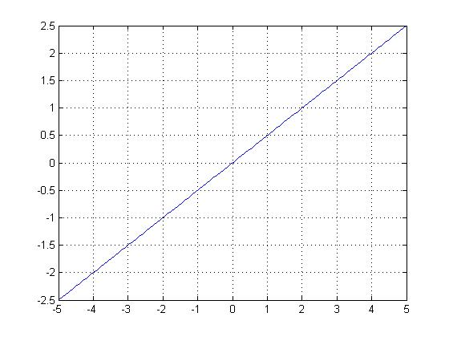
%Ejercicio 1.- b):
x=linspace(-5,5);y=x./2;
plot(x,y),grid
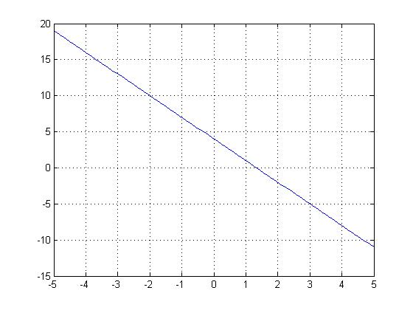
%Ejercicio 1.- c):
x=linspace(-5,5);y=x./2;
plot(x,y),grid
clear all
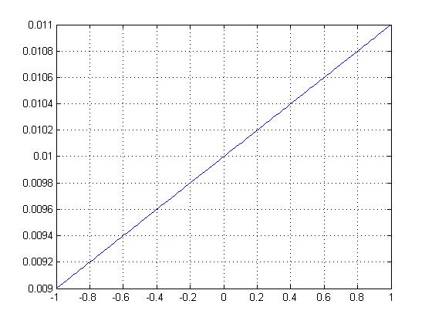
%Ejercicio 2:
x=linspace(-299.25,299.25);y=693.8-68.8.*cosh(x/99.7);
plot(x,y,'g'),grid
clear all
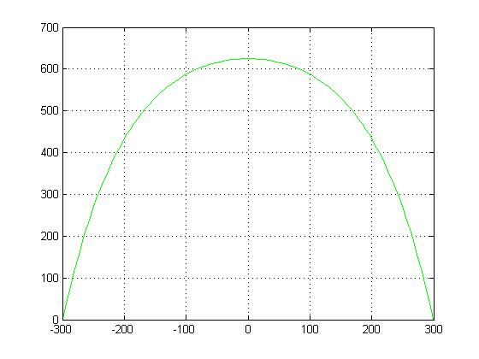

%Ejercicio 3:
x=[19.1 25 30 36 40 45 50 54]; y=[76.3 77.8 79.75 80.8 82.35 83.9 85.1 86.3];
plot(x,y,'*',x,y,'b'),grid,ylabel('R'),xlabel('C')
clear all
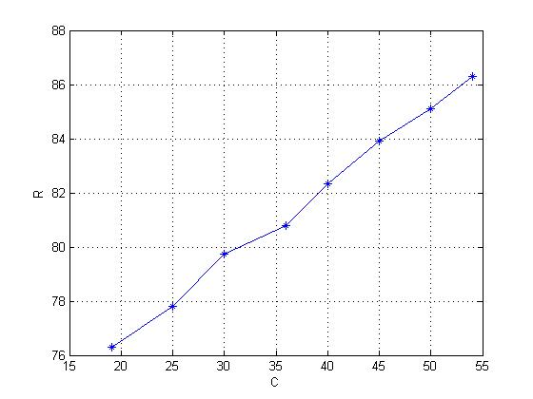

%Ejercicio 4:
x=[29.1 48.2 72.7 92 118 140 165 190]; y=[0.0493 0.0821 0.123 0.154 0.197 0.234 0.274 0.328];
plot(x,y,'*',x,y,'b'),grid,ylabel('I'),xlabel('D')
clear all
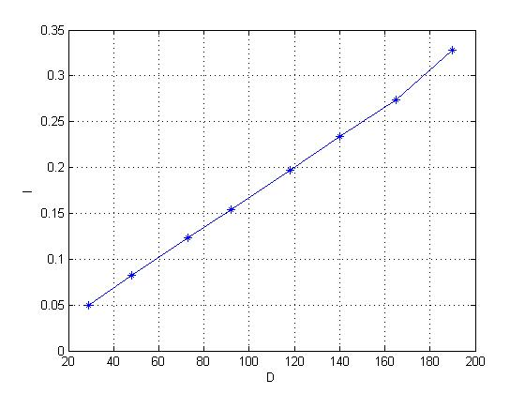
%Ejercicio 5:
x=linspace(-10,10);
y1=2+x;y2=1+x;y3=-1+x;y4=x;
subplot(2,2,1),plot(x,y1),grid ,title('y=2+x')
subplot(2,2,2),plot(x,y2),grid,title('y=1+x')
subplot(2,2,3),plot(x,y3),grid,title('y=-1+x')
subplot(2,2,4),plot(x,y4),grid,title('y=x')
clear all
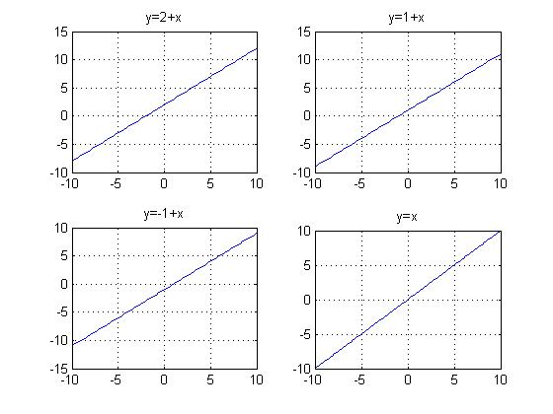
%Ejercicio 6:
t=0:150; P=5.43-0.0053*t;
plot(t,P),grid,ylabel('P'),xlabel('t')
clear all
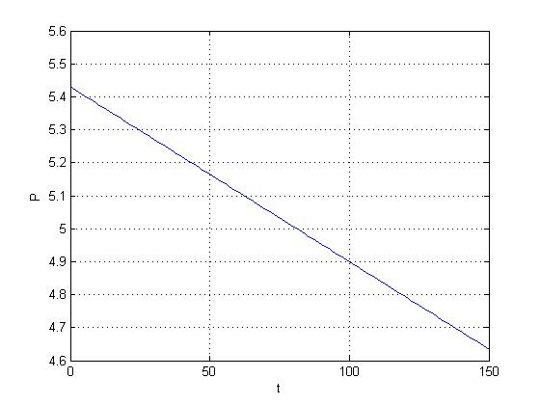
%Ejercicio 7:
x=linspace(-20,20);
y1=0.5*x;y2=x;y3=2*x;y4=-2*x;y5=-x;y6=-0.5*x;
subplot(2,3,1),plot(x,y1),grid,title('y=0.5x'),
axis([-20 20 -10 10])
subplot(2,3,2),plot(x,y2),grid,title('y=x'),
axis([-20 20 -10 10])
subplot(2,3,3),plot(x,y3),grid,title('y=2x'),
axis([-20 20 -10 10])
subplot(2,3,4),plot(x,y4),grid,title('y=-2x'),
axis([-20 20 -10 10])
subplot(2,3,5),plot(x,y5),grid,title('y=-x'),
axis([-20 20 -10 10])
subplot(2,3,6),plot(x,y6),grid,title('y=-0.5x'),
axis([-20 20 -10 10])
clear all
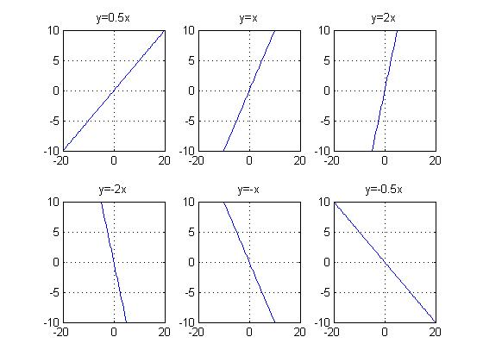

%Ejercicio 8:
x=linspace(0,5);
y1=2*x.^(-2);y2=2*x.^(-1);y3=2*x.^(-0.5);
y4=2*x.^(-0.25);y5=2*x;y6=2*x;y7=2*x.^0.5;
y8=2*x.^2;
subplot(2,4,1),plot(x,y1),grid,
axis([0 5 0 5]),title('y=0.5x')
subplot(2,4,1),plot(x,y1),grid,a
xis([0 5 0 5]),title('y=2x^(-2)')
subplot(2,4,2),plot(x,y2),grid,
axis([0 5 0 5]),title('y=2x^(-1)')
subplot(2,4,3),plot(x,y3),grid,
axis([0 5 0 5]),title('y=2x^(-0.5)')
subplot(2,4,4),plot(x,y4),grid,
axis([0 5 0 5]),title('y=2x^(-0.25)')
subplot(2,4,5),plot(x,y5),grid,
axis([0 5 0 5]),title('y=2x')
subplot(2,4,6),plot(x,y6),grid,
axis([0 5 0 5]),title('y=2x^(0.5)')
subplot(2,4,7),plot(x,y7),grid,
axis([0 5 0 5]),title('y=2x^(1.5)')
subplot(2,4,8),plot(x,y8),grid,
axis([0 5 0 5]),title('y=2x^(2)')
clear all
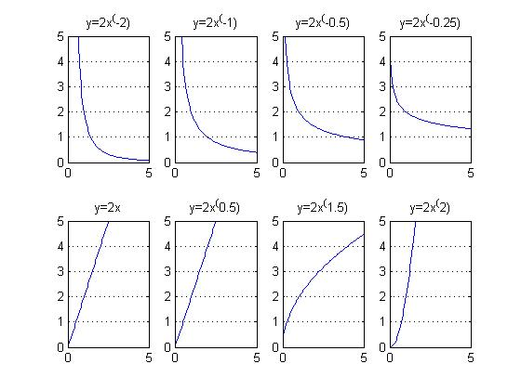

%Ejercicio 9:
x=linspace(0,5);y1=x;y2=x.^1.5;y3=x.^2;
y4=x.^2.5;y5=x.^3;y6=x.^4;
subplot(2,3,1),plot(x,y1),grid,
axis([0 5 0 20]),title('y=x')
subplot(2,3,2),plot(x,y2),grid,
axis([0 5 0 20]),title('y=x^1.5')
subplot(2,3,3),plot(x,y3),grid,
axis([0 5 0 20]),title('y=x^2')
subplot(2,3,4),plot(x,y4),grid,
axis([0 5 0 20]),title('y=x^2.5')
subplot(2,3,5),plot(x,y5),grid,
axis([0 5 0 20]),title('y=x^3')
subplot(2,3,6),plot(x,y6),grid,
axis([0 5 0 20]),title('y=x^4')
subplot(2,3,2),plot(x,y2),grid,
axis([0 5 0 20]),title('y=x^1.5')
clear all
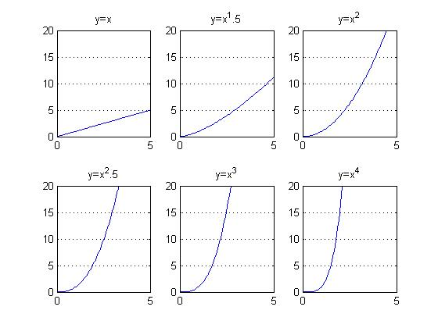
%Ejercicio 10:
x=linspace(0,5);y1=3./x.^2;y2=5./(2*sqrt(x));
subplot(1,2,1),plot(x,y1),grid,
axis([0 5 0 10]),title('y=3/x^2')
subplot(1,2,2),plot(x,y2),grid,
axis([0 5 0 10]),title('y=3/(2*sqrt(x))')
clear all
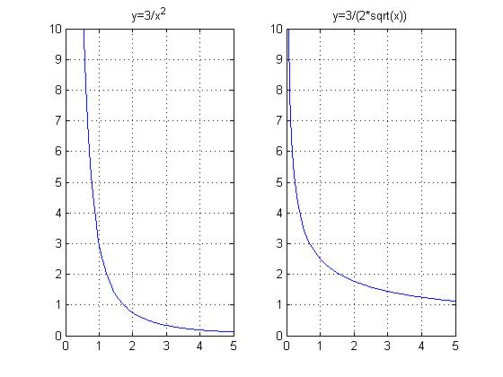
%Ejercicio 11:
t=linspace(0,12);
p1=0.1.^t;p2=0.5.^t;p3=0.8.^t;p4=0.9.^t;p5=0.95.^t;
subplot(2,3,1),plot(t,p1),grid,
axis([0 12 0 1]),title('P=0.1^t')
subplot(2,3,2),plot(t,p2),grid,
axis([0 12 0 1]),title('P=0.5^t')
subplot(2,3,3),plot(t,p3),grid,
axis([0 12 0 1]),title('P=0.8^t')
subplot(2,2,3),plot(t,p4),grid,
axis([0 12 0 1]),title('P=0.9^t')
subplot(2,2,4),plot(t,p5),grid,
axis([0 12 0 1]),title('P=0.95^t')
clear all
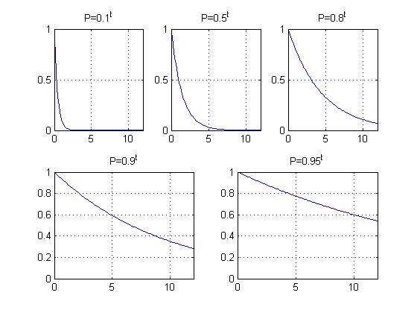
%Ejercicio 12:
x=linspace(-15,15);y1=2.^x;y2=x.^3;y3=2.^(-x);
subplot(1,3,1),plot(x,y1),grid,
axis([-15 15 0 20]),title('y=2^x')
subplot(1,3,2),plot(x,y2),grid,
axis([-15 15 0 20]),title('y=x^3')
subplot(1,3,3),plot(x,y3),grid,
axis([-15 15 0 20]),title('y=2^(-x)')
clear all
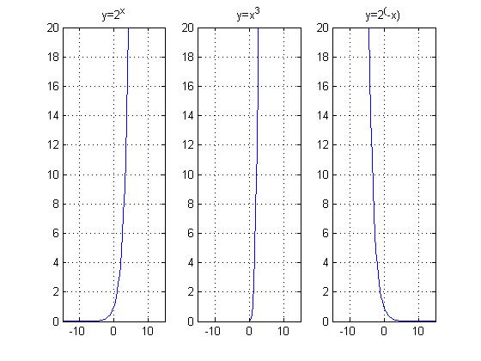
%Ejercicio 13 (primero):
curva;0.5; 4
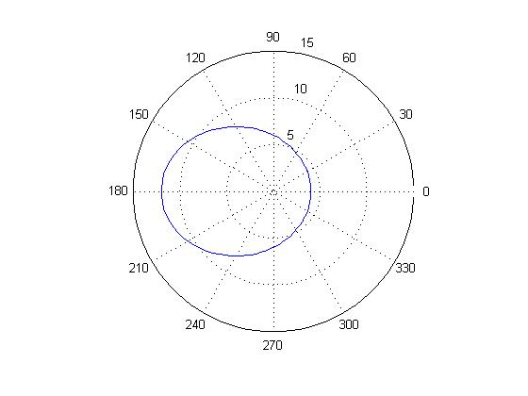
SCRIPT: curva
%Grafica la posición de un cuerpo a lo largo de una orbita
ex=input('Introduce la excentricidad ')
rm=input('Introduce rmin ')
ang=linspace(0,2*pi);
r = rm.*(1+ex)./(1+ex.*cos(ang));
polar(ang,r)

%Ejercicio 13 (segundo):
t=linspace(1790,2000);
P=197273000./(1+exp(-0.0313.*(t-1913.25)));
plot(t,P),ylabel('P'),xlabel('t'),grid
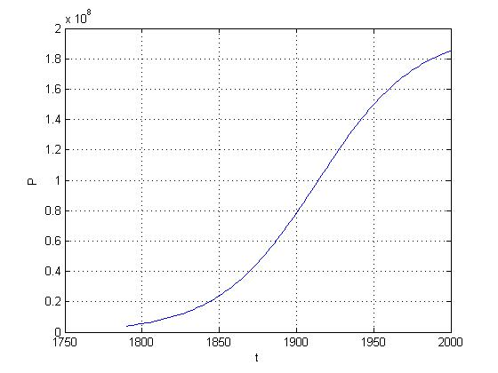
P2012=197273000./(1+exp(-0.0313.*(2012-1913.25)))
P2012 =
1.8869e+008
clear all

%Ejercicio 14:
s=inline('0.01*55^0.25*h.^0.75')
s =
Inline function:
s(h) = 0.01*55^0.25*h.^0.75
h=[158 160 162 164 166 170];
plot(h,s(h)),grid
clear all
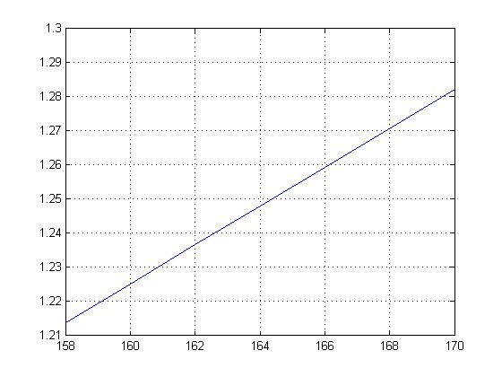

%Ejercicio 15:
y=inline('x./(a+b*x)+c*exp(d*x)')
y =
Inline function:
y(a,b,c,d,x) = x./(a+b*x)+c*exp(d*x)
x=0:0.01:5;
subplot(1,3,1),
plot(x,y(-0.25,0.25,0.25,0.3,x)),grid,
axis([0 5 -40 70])
subplot(1,3,2),
plot(x,y(-0.15,0.35,0.12,0.025,x)),grid,
axis([0 5 -40 70])
subplot(1,3,3),plot(x,y(-0.09,0.2,0.15,0.05, x)),
grid, axis([0 5 -40 70])
clear all

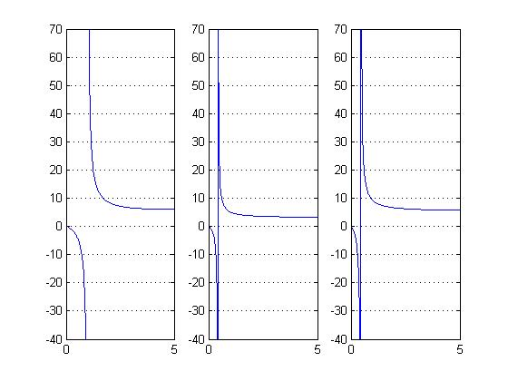

%Ejercicio 16:
y=inline('a*x.*exp(-b*x)')
y =
Inline function:
y(a,b,x) = a*x.*exp(-b*x)
x=0:0.01:8;
subplot(2,3,1),plot(x,y(15,1,x)),
grid,title('a=15,b=1')
subplot(2,3,2),plot(x,y(12,.75,x)),
grid,title('a=12,b=0.75')
subplot(2,3,3),plot(x,y(9,.7,x)),
grid,title('a=9,b=0.7')
subplot(2,2,3),plot(x,y(7,.6,x)),
grid,title('a=7,b=0.6')
subplot(2,2,4),plot(x,y(5,.5,x)),
grid,title('a=5,b=0.5')
clear all
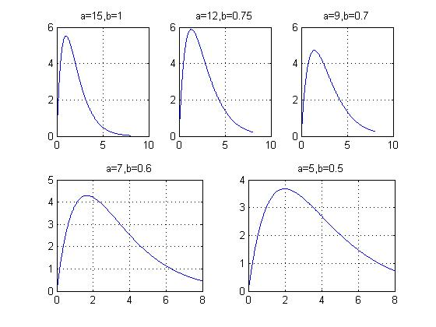

%Ejercicio 17:
M=inline('1./sqrt((1-r.^2).^2+(2*c*r).^2)')
M =
Inline function:
M(c,r) = 1./sqrt((1-r.^2).^2+(2*c*r).^2)
r=0:0.01:3;
subplot(2,3,1),plot(r,M(1,r)),grid,title('c=1'),
axis([0 3 0 5])
subplot(2,3,2),plot(r,M(.7,r)),grid,title('c=0.7'),
axis([0 3 0 5])
subplot(2,3,3),plot(r,M(.25,r)),grid,title('c=0.25')
axis([0 3 0 5])
subplot(2,2,3),plot(r,M(.1,r)),grid,title('c=0.1'),
axis([0 3 0 5])
subplot(2,2,4),plot(r,M(.01,r)),grid,title('c=0.01')
axis([0 3 0 5])
clear all
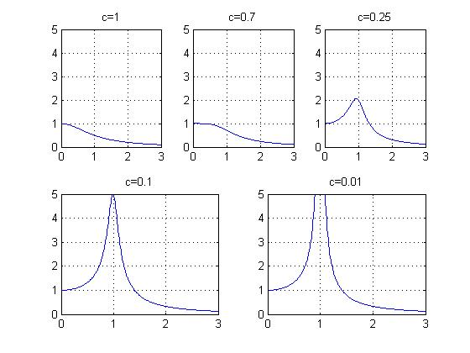

%Ejercicio 18:
Tf=[2+0+1+2+6+4+0+1++3+1 75 200 400];
idiodo(tf)

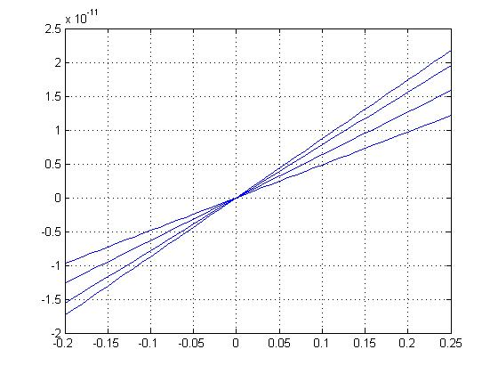
FUNCION: idiodo
function idiodo( tf )
%Calcula la corriente que fluye por un diodo.
id=inline('io*(exp(q*vd./(k*tk))-1)');
tk=inline('5/9*(tf-32)+273.15');
io=2e-4;
k=1.38e23;
q=1.6e19;
vd=-0.2:0.01:0.25;
for c=[tf]
plot(vd,id(io,k,q,tk(c),vd)),
hold on
end
grid, hold off
end

%Ejercicio 19:
drango(-20,20,-5,5)

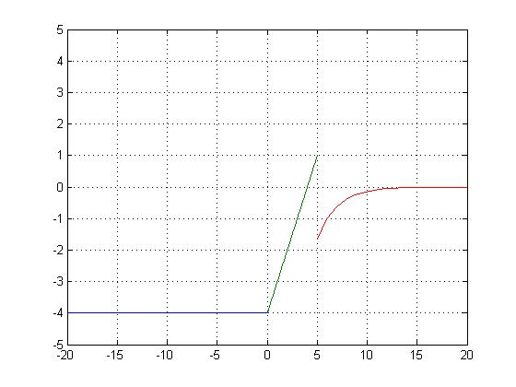
FUNCION: drango
function drango(xo,xf,yo,yf)
%Funcion definida en tres tramos, el usuario delimita el intervalo mostrado.
x1=linspace(-100,0);
x2=linspace(0,5);
x3=linspace(5,100);
y1=linspace(-4,-4,length(x1));
y2=x2-4;
y3=-20*exp(-0.5*x3);
plot(x1,y1,x2,y2,x3,y3), grid, axis([xo xf yo yf])
%el límite inferior es -100 y el superior 100 (en eje x).
end

