Table of Contents

I. INTRODUCTION 4
A. Project Rationale 4
1. Research Context 5
a. Review of Related Literature 5
(1). Local Literature 5
(2). Foreign Literature 6
(3). Synthesis of Related Literature 8
b. Research Methods and Findings 8
2. Statement of the Problem 8
a. General Problem 8
b. Specific Problems 9
B. Project Narrative 9
1. Description and Objectives 9
a. Project Description 9
b. Alignment with Sustainable Development Goals (SDGs) 9
c. General Objective 9
d. Specific Objectives 9
2. Scope and Limitations 10
a. Scope 10
(1) User Management Module 10
(2) Child Profile Management Module 10
(3) Health Records Module 10
(4) Growth and Development Monitoring Module 10
(5) Reminder and Information Module 10
(6) Memory and Documentation Module 10
(7) QR-Based Consultation Access Module 10
(8) Security and Audit Module 11
b. System Coverage 11
c. Limitations 11
3. SWOT Analysis of the Proposed System 12
a. Project Evaluation 13
(1) Respondents 13
(2) Research Instrument 13
(3) Analysis 13
II. REVIEW OF RELATED WORKS 15
A. Related Studies 15
1. Educational Value of Baby Books 15
2. Baby Books and Parental Well-Being 15
3. Parent-Held Child Health Records and Healthcare Utilization 15
4. Digital Applications for Child Development Monitoring 15
5. Digital Technologies for Immunization Recordkeeping 15
B. Related Systems 17
1. MrBaby 17
2. TheParentZ 17
3. Pediary 18
4. CDC Milestone Tracker App 18
5. Baby Connect 19
III. DESIGN METHODOLOGY 20
A. Conceptual Framework 20
1. Input 21
a. Child Profile Information 21
b. Healthcare Information 21
c. Health Records 21
d. Growth and Development Records 21
e. Nutrition Records 21
f. Memories 21
g. Account Information 21
h. System Inputs 22
2. Process 22
a. Data Collection and Validation 22
b. Record Management 22
c. Growth and Development Monitoring 22
d. Reminder Processing 22
e. QR-Based Consultation Access 22
f. Security and Privacy Management 22
3. Output 22
a. Digital Baby Book 22
b. For Healthcare Professionals 22
c. System Outputs 22
4. Feedback 23
5. Overall System Flow 23
B. Project Timeline 23
1. Term 1: (April 2026 - July 2026) 23
2. Term 2: (August 2026 - November 2026) 24
C. System Scope 24
1. In-Scope Features 24
2. Out-of-Scope Features 25
D. Requirements Specification 26
1. Functional Requirements 26
2. Non-Functional Requirements 26
3. System Requirements 27
a. Software Requirements 27
b. Hardware Requirements 28
E. System Analysis and Design 29
1. Use Case Diagram 29
2. Use Case Description 30
3. Activity Diagram 36
a. User Registration and Login Activity Diagram 36
b. Child Profile Management Activity Diagram 37
c. Health Record Management Activity Diagram 38
d. Reminder Notification Activity Diagram 39
e. QR Consultation Access Activity Diagram 40
4. Entity Relationship Diagram (ERD) 41
5. Database Design 41
a. User Table 41
b. Child Table 42
c. Vaccination Table 42
d. Checkup Table 43
e. Medical History Table 43
f. Growth Record Table 44
g. Milestone Table 44
h. Nutrition Record Table 44
i. Memory Table 45
j. Reminder Table 45
k. QR Access Table 45
l. Access Log Table 46
REFERENCES 47

BabyBook+: A Digital Child Health & Development Recordkeeping System with Parent-Controlled QR-Based Consultation Access
Ken Martin Escolar
CIIT College of Innovation and Integrated Technology
ken.escolar@ciit.edu.ph

Arzad Mariano
CIIT College of Innovation and Integrated Technology
arzad.mariano@ciit.edu.ph

Jacob Conrad M. Quendangan
CIIT College of Innovation and Integrated Technology
jacob.quendangan@ciit.edu.ph

Ian C. Roncesvalles
CIIT College of Innovation and Integrated Technology
ian.roncesvalles@ciit.edu.ph

I. INTRODUCTION
The first six years of a child's life are vital for their physical and cognitive development, as well as for their emotional and social development. This period of development is where the primary caretakers of the child, including the parents and guardians, are mainly responsible for monitoring and keeping records of certain information. This information includes details of the child’s birth, immunization records, medical history, developmental milestones, nutrition, healthcare visits, and more. This information may be kept in baby books, vaccination cards, medical records, and notes.
As the world rapidly advances in technology and begins to integrate new technologies in everyday life, there are innovations that help optimize and improve the organization and management of information. Digital recordkeeping systems may help parents keep, organize, access, and update their child’s records in one comprehensive system. Such systems may also enhance the availability of vital information to physicians during medical consultations and healthcare visits.

This study intends to develop BabyBook+, a digital recordkeeping system of the health and developmental records of children from birth to six years. This system will provide a comprehensive and organized system to parents and guardians and will enable the system’s user to share select records and information for healthcare consultations through QR codes.

A. Project Rationale
Parents and guardians often manage child health information across multiple physical documents such as baby books, vaccination cards, prescriptions, laboratory results, and medical records. Though traditional systems for documenting health and development utilize systems that are unstructured, fragmented, and unfamiliar, these systems tend to be documented, easily transported, and organized. Unfortunately, these systems are unstructured and may result in incomplete documentation. This leads to information that is critical being unavailable to the parents and guardians when it’s needed, especially during medical consultations and healthcare visits.
A centralized recordkeeping solution that helps parents digitally file and classify their child’s health and development information triggered the creation of BabyBook+. BabyBook+ allows parents to aggregate information about their child’s vaccinations, illnesses, treatments, growth, development, and nutrition and more. Parents are no longer burdened with the need to manage multiple file systems.
In addition, BabyBook+ offers a QR-Access feature that allows parents to manage their child’s health information by selectively sharing their child’s health records with the practitioner of their choice. This feature makes health record management easy, allows parents to create health record interventions, and legitimizes the parent’s right to privacy. BabyBook+ combines these features to transform child health record management, in particular, to support parents during the most formative years of their child’s development.

1. Research Context
Child health and development records allow monitoring of a child's health, growth, vaccinations, and development. These documents include child's birth information, vaccinations, sicknesses, allergies, medications and hospital visits, growth charts, and developmental milestones. These records can also document a child's nutrition and medical check-ups. For children from birth to six years, these documents can be vital, as these years are marked by rapid development.
For many families, child health and development records consist of baby books, baby vaccination cards, medical certificates, laboratory results, handwritten notes, printed prescriptions, and photographs. The baby book is often a keepsake for parents. These health records also have sentimental value. The records can also be left at home, misplaced, damaged, and become incomplete over time. Parents can also manage a number of different documents from a number of health sources, such as pediatricians, health centers, and vaccination sites. This can result in parents being unable to provide the pediatrician or health professional with the requisite documents during a child's medical check-up.

For pediatricians and health professionals in the community, being able to view a child's health records can help during a child's medical check-up. For the proposed system, the main focus is on parent-managed child health and development record keeping. The proposed system ensures parent-managed child health and development records are secure and organized. With QR based records, health professionals can view a child's records on a digital platform to aid in developing an informed care plan.
BabyBook+ is a proposed app that helps parents by putting a digital baby book on their devices while still allowing parents to have a physical baby book to use as a keepsake or a backup. The app provides a way for parents to digitally store and organize records and information about their children's health and development. Some possible features are reminders and health centers and services (with checkup and vaccination information), milestone and nutrition trackers, and access for health professionals through QR codes during consultations. BabyBook+ helps parents by giving them control over what information their child is viewed and when, while keeping child records for future use, in a safe consultation.
The project helps facilitate monitoring child health and vaccination to organize health records and supports easier health consultations for parents, which relates to Sustainable Development Goal 3: Good Health and Well-Being.

a. Review of Related Literature

(1). Local Literature
Child Immunization Records and Home-Based Health Documentation in the Philippines
In the Philippines, several home-based records document child immunization and health records, including vaccination cards and child immunization records. The Republic of the Philippines Department of Health has a record classified as a home-based record, the Child Immunization Record. This classification indicates the value that the Department of Health places on the physical documentation of a child’s health and vaccination status. These records are designed to allow parents and health care workers easier access to the child’s health and immunization records. Nevertheless, physical records may still be lost, damaged, and updated irregularly. Such records may be misplaced and may contain incomplete information, all of which hinders a child’s health information’s accessibility and continuity..
Digital Transformation of Immunization Recordkeeping in the Philippines
The surge in the use of modern technologies in health care has paved the way for the development of new systems that enhance the management of child health records. In this regard, UNICEF Philippines has cited the introduction of DigiVacc, a framework that incorporates the automation of the documentation regarding children’s vaccinations, including the capture, storage, and retrieval of children’s immunization records (DigiVacc, n.d.). This initiative illustrates the capability of modern technologies to improve the accuracy, efficiency, and accessibility of the documentation of children’s vaccinations.
Enduring Presence of Tangible Baby Books in Filipino Households
Even with the growth of digital systems, tangible baby books and vaccine cards are culturally and practically relevant to Filipino families. Parents keep these cards as mementos of their child’s early formative years, in addition to their function as formal medical documentation. This practice illustrates the importance of keeping cards that describe memorable moments and milestones. Understanding this, BabyBook+ was developed to be a digital accompaniment of family baby books to help parents organize and secure baby and development cards, and retain the physical cards as family keepsakes.

(2). Foreign Literature
Parent-Held Child Health Records in Other Countries
Countries have begun implementing parent-held child health records to monitor children’s health and development. In the UK, the system is the Personal Child Health Record (PCHR), or Red Book. This record is given to parents upon the birth of their child. The Royal College of Paediatrics and Child Health (n.d.) states the PCHR records the child’s health and growth, the developmental milestones of the child, and the child’s contact with health services. The system shows that standardizing parent-held records has the ability to foster continuity of care in early childhood.
Singapore’s Child Health Booklet is a parent-held book that contains information about a child’s birth, growth, developmental milestones, immunizations, and health care visits. The booklet is a complete record of a child’s health and development (HealthHub, 2022). There is a parent-held book system in Singapore that is supported by a digital system. The digital system is used to supplement the parent book by providing access to a child’s health record and vaccination status.
Japan’s Maternal and Child Health Handbook is a parent-held health record system. Takeuchi (2016) explains that the handbook promotes health and records the mother and child’s health and childbirth as well as health assessments and immunizations. Suzuki (2024) states that the handbook Fincludes growth charts and early child care tips. It provides health education and aids to support parents in monitoring their child’s developmental milestones. The handbook’s continuous use demonstrates the value of parent-held health records.
Child Health Monitoring and Preventive Care Frameworks
In Canada, the Rourke Baby Record is an example of an evidence-based preventive healthcare guide, covering the first five years of life. The Canadian Paediatric Society (2024) describes the record as offering developmental screening, growth and nutrition check, immunization status, physical examination, and safety and health promotion and family health and record assessment. While its primary purpose is for use by a healthcare provider, the record’s format may help others understand what information may be relevant to document and monitor during childhood.
The evidence summary for the Rourke Baby Record describes the importance of organized, accurate, and permanent record keeping for the monitoring of development and preventive healthcare. These same principles are applicable to BabyBook+, as they demonstrate the information about health and development that may be relevant for both the provider and recipient during a healthcare encounter.
Digital Tools for Developmental Milestone Tracking
The rise of digital technology has prompted the development of applications for the purpose of monitoring development. The CDC Milestone Tracker app supports the developmental tracking of children from the infant to the early childhood years, utilizing age specific checklists and instructional materials (CDC, 2026a).
CDC (2026b) describes developmental milestones as vital to the understanding of the domains of learning, speaking, playing, behaving, and moving, for children. They also advocate for developmental screenings to be conducted on a specified age basis to facilitate the early identification of concerns. These tenets lend credence to the scope of BabyBook+ for developmental monitoring and milestone tracking.
Advancement of Digital Child Health Records
Child health care has a new research focus due to health record digitization. Suhaimi and Ghazali (2023) created a Web-Based Baby Health Record System, which was inspired by Malaysia's Baby and Children's Health Record Book (RKK). They listed the poor health record documentation system's physical deterioration, disaster vulnerability, and poor management documentation as examples of the obstacles posed by manual health record keeping. The web based system showed the capability of digital innovations to improve accessibility and the order and the preservation of child health data.
This study is applicable to BabyBook+ as it shows that traditional child health record systems can be digitized with modifications, while the original function of the systems is preserved.
Understanding the Use of Parent-Held Child Health Records
Parent-held child health records have utilized and improved the accessibility of preventive health care services. Chutiyami, Wyver, and Amin (2019) conducted a meta-analysis of the availability and use of parent-held child health records in the developed and developing world. The study concluded the active maintenance of these records was associated with the improved degree of scheduled vaccinations, attendance to antenatal care, and the performance of child health promoting activities.
The review documented the use of parent-held health records during health care visits. The review provides evidence that the use of the parent-held health record supports the communication of health care, the monitoring of child development, and the performance of preventive health care activities.
Digital Health Applications for Child Development and Immunization Monitoring
There is evidence that digital child health applications enhance the ability of parents to engage with the health of their children and keep health records. According to Otte et al. (2019), parents who used development-tracking applications felt more confident about tracking their children’s development. They also liked the development-tracking applications because the applications provided tailored feedback. The authors of the study believed that digital development-tracking applications empowered parents to make better child care decisions.
Studies that have focused on digital health applications and immunization have shown that the use of electronic reminders, digital immunization records, and appointment-tracking applications increases immunization compliance and reduces the number of missed immunizations. These digital health applications make health records easy to access and support the ongoing care of children.
All of these studies have shown that digital health applications can organize and improve access to child health information. Many of the digital child health applications currently in use have focused on only one child health issue, such as immunization, developmental milestones, or parenting. BabyBook+ is an attempt to integrate multiple child health features into one digital application.

(3). Synthesis of Related Literature
The studies and systems discussed highlight the role of parent-held child health records, developmental monitoring, and digital health tools in the management of child health care. Many systems are focused on particular features, such as tracking immunizations, milestones, or storing health records. BabyBook+ is designed to combine child health records with the developmental monitoring and documentation of milestones and nutrition, along with immunization reminders and parent-controlled, QR-based view access. With this design, the system aims to give parents an organized, centralized digital tool that functions as a modern baby book while offering privacy and control concerning sensitive child data.

b. Research Methods and Findings
The reviewed systems indicate that child health management is made easier by having child health records that are accessible, organized, and regularly updated. Health records that are held by parents, like baby books and child health booklets, are systems that allow families to capture health and development data. Digital systems are better suited for integrating reminders and health records quick view.
For systems evaluation, the successful child health record systems capture information about the event of birth, the immunizations, the growth, the developmental milestones, the health checkups, and health advice. The reviewed systems also indicate that because the system contains sensitive child health information, privacy by design is a justified concern. This is also seen in the design of BabyBook+ and that the record management is largely the parents’ role; the QR code allows view access to the specific information in the system for the consultation.
In this study, interviewing the barangay health workers, parents, and possibly pediatricians, will help in understanding the challenge of child record management. Parents and potential users will complete a survey questionnaire for the collection of quantitative data. The qualitative data will be analyzed thematically. The qualitative data from the surveys and system evaluations will be analyzed using simple statistics which include frequency, percentage, mean, and weighted mean.
Evaluating child health record systems in literature adopts different methodologies. For instance, Suhaimi and Ghazali (2023) developed a prototype for the first version of a web-based baby health record system. BabyBook+ can draw from this as the design, development, and user evaluation of the system will fall within the boundaries of the project. Chutiyami et al. (2019) carried out a systematic review and meta-analysis of parent-held child health record systems. In addition to evaluating the advantages and disadvantages of child health records, the authors were able to illustrate the significance of literature reviews. Reich et al. (2010) and Ochoa et al. (2021) examined the impact of baby books on maternal knowledge and stress as well as other parent-related outcomes. Based on the aforementioned literature, it is suggested that BabyBook+ combines prototype methodology and usability assessment with surveys and other quantitative, and statistically grounded, methodologies.

2. Statement of the Problem

a. General Problem
This study aims to understand how BabyBook+ offers parents and legal guardians a safe, innovative, and systematic digital platform to store and manage their child’s health records and milestones in development from birth to six years of age. Furthermore, this system allows parents and guardians to manage QR-based selective information for health consultations and check-ups.

b. Specific Problems
The study attempts to address the following questions.:
- What problems do parents or guardians face when trying to hold and manage their child’s health and developmental records?
- What aspects of a child’s health and development should be reflected in a digital recordkeeping system that parents can access?
- What challenges do health care workers face when attempting to retrieve and evaluate a child’s health records during health-related meetings and assessments?
- What features should a QR-based system include to enable parents-gate secure access to select child records during health care meetings?
- What safeguards should be included to protect sensitive child health data in terms of privacy, security, and access?
- What privacy, security, and access control challenges need to be addressed to protect the sensitive health information of children?

B. Project Narrative

1. Description and Objectives

a. Project Description
BabyBook+ is a digital recordkeeping system of child health and development for guardians of children from birth to six years. It is a parent-managed digital child health record management system inspired by the traditional baby book.
This system will give parents the ability to create profiles for their kids. Profiles will allow parents to input and store basic information regarding their kids including demographics, health and immunization records, health history, allergies, hereditary health conditions, illnesses, medications, and hospital visits. The system will include the ability to store pictures of kids to track their development over time.
BabyBook+ will also include the ability to send parents and guardians reminders for their kids’ upcoming health appointments. The system will also include basic information regarding health vaccinations, health centers, and health announcements. This system will also support health consultations. It will use a QR code that is parent or guardian controlled to allow health care providers access to the system.

b. Alignment with Sustainable Development Goals (SDGs)
This study aligns with Sustainable Development Goal (SDG) 3: Good Health and Well-being. Sustainable Goal 3 is focused on ensuring the well-being of children while promoting the management of child healthcare. It encourages the use of digital tools to keep healthcare records. It incorporates reminders for vaccination and check-ups. It includes a secure way for parents and child healthcare providers to share health records. BabyBook+ aims to offer more access to orderly health data for organized health care services that can result in better health for children.

c. General Objective
The design and development of BabyBook+ will provide a system of parent or guardian controlled digital health and development record keeping for children that will allow the safe storage, organization, management, and sharing of health records for children from birth to six years.

d. Specific Objectives
This study will focus on the following areas:
- The problems that parents or guardians face when they manage physical health and development records for children.
- The problems that health care professionals face when they access child records for health consultations and checkups.
- The critical health and development data that should be available in the system.
- The design and development of record keeping that is digital and allows health record and profile features, development and nutrition tracking, milestone documentation, and reminder features.
- The design and development of a QR code that parents or guardians controlled viewing feature for child records that allows secure access for health consultations.
- Establish suitable privacy, security, and access control mechanisms to protect sensitive information regarding minors.
- Analyze the system in terms of security, effectiveness, and acceptance by the users to whom it is intended.

2. Scope and Limitations

a. Scope
This study includes the creation of BabyBook+, a system for the digital recording of the health and development of children aged from zero (0) to six (6) years. The system will allow parents or guardians to have a secure, central system for the storage and management of the health and developmental record of their children.
The system will have these modules and features:

(1) User Management Module
- Registration
- Secure authentication
- Profile management

(2) Child Profile Management Module
- Child profile management
- Capture child’s birth information
- Capture information on the hospital, OB-GYNE, and pediatrician

(3) Health Records Module
- Capture immunization and vaccination history
- Capture information on illnesses and their medical history
- Capture information on allergies and hereditary conditions
- Capture information on hospitalizations
- Capture information on medications and treatments

(4) Growth and Development Monitoring Module
- Track growth (height, weight, and age indicators)
- Track developmental milestones
- Monitor nutrition (milk and solid food)

(5) Reminder and Information Module
- Reminders for vaccinations and checkups
- Vaccination information and educational materials
- Information for the nearest health center
- Health center announcements for vaccination drives and health advisories (if available)

(6) Memory and Documentation Module
- Storage and organization of photos documenting the growth and development of the child

(7) QR-Based Consultation Access Module
- QR codes for parent authorized access
- View select child health records for authorized health care professionals during consultation or checkup
- Parent access permission control

(8) Security and Audit Module
- Record view monitoring (if possible)
- Child health information protection (e.g. data privacy)

b. System Coverage
The system is designed for the parents and guardians of children from birth to six (6) years old, for them to use BabyBook+ to organize and maintain the health and development records of their children.
Secondary users may be pediatricians, barangay health personnel, nurses, midwives, and other health service providers. They may be granted temporary access to select child records through the system’s parent-approved QR-based access during checkups, consultations, immunizations, or other health-related services.
Participants in the study’s requirements-gathering phase will include parents, barangay health personnel, and, if possible, pediatricians and other health professionals. These participants will help identify user requirements, workflows, and concerns regarding privacy and security. Participants will also help identify functional requirements for the system.

c. Limitations
This study is limited to the design and development of BabyBook+, a digital tool for keeping a health and developmental record system for children staying from birth to six (6) years. The system is designed for parent(s) or guardians to save and manage their children’s health and developmental records.
The system will not substitute for the health records kept by hospitals, clinics, and/or pediatricians and other health services. The system will also not be a vaccination registry or a health information system of other government systems.
The QR-based access will allow health personnel to view a record during consultation or checkup only with the permission of the parent or guardian. The access will not allow external users to create, edit, or delete records of children in the system.
The study will also not include the development of public health dashboards, community health analytics, aggregated reports, and direct integration to barangay, LGU, hospitals, and/or government systems. The access to child information will remain with the parent or guardian
The records' accuracy, thoroughness, and promptness depend on the input from the parent or guardian. The system will not offer a medical diagnosis, suggest a treatment method or prescribe a course of treatment or perform a clinical evaluation. All health-related decisions ought to be made with the advice of a licensed health care practitioner.
Also, certain functions will be dependent on the internet and available technical resources. These include certain functions, such as notifications, QR-based record sharing, the ability to upload photos, and cloud data storage. The final design of the system (as either a web app, a mobile app, or a hybrid) will rely on the project’s technical needs, available resources, and the project’s development schedule.

3. SWOT Analysis of the Proposed System

Figure 1.1. SWOT Analysis of the Proposed BabyBook+ System
Strengths | Weaknesses
• This provides a central location to organize health and development records for children ages birth to six.  • Unifies health and developmental records along with nutrition and vaccination histories and milestones and memorable moments.  • Includes reminders for vaccinations and checkups that help parents keep an updated and timely schedule.  • Supports QR based access for viewing and sharing specific records for consultation.  • Better continuity of records than physical documents, vaccination cards, and notebooks.  • Designed to work along with traditional baby books. | • Data relies on parents and guardians to record, and most likely update, records.  • Data relies on user input. If input is incomplete, outdated, or incorrect, then so is data.  • Digital literacy and/or health record literacy may be a barrier to some parents.  • Some features may be unusable due to poor connectivity.  • Managing a large amount of health and development records may increase complexity and decrease usability of the system if not properly managed.  • Manual checks of records may be a requirement for consultations due to lack of verification for health record systems.
Opportunities | Threats
• Greater adoption and usage of smartphones and hand held devices to provide family health management support.  • Increased user adoption may be supported by knowledge of early child health in relation to health development.  • May lead to better organization of health and development records for child readiness to engage in pediatric consultation.  • Can be adapted to suit Philippine healthcare, vaccination schedules, and family recordkeeping.  • May work with healthcare, pediatric clinics, and health center partners for consultation support.  • Can broaden features for educational, parenting, and child development tracking. | • User trust and adoption may be impacted by privacy and security issues with sensitive child health information.  • Cyberattacks and data breaches may result in the loss of confidential data.  • Some may prefer the traditional paper-based baby book and resist transitioning to an online baby book.  • Data privacy and healthcare policy changes may lead to system changes.  • Reliance on external services (cloud storage, notifications, QR technologies) may introduce risks.  • Extended availability and other technical issues may impact user experience.

a. Project Evaluation

(1) Respondents
The evaluation of BabyBook+ will target respondents concerned with the child healthcare profession, with an interest in recordkeeping and system usability. The primary respondents will most likely be the parents or guardians of children between birth and six (6) years old, as they will be the primary users of the system. Other possible respondents may be the pediatricians, nurses, midwives, and the barangay health staff that may require the QR-based viewing system during their consultations and health-based services. The IT professionals may also be respondents, as they will be evaluating the system on its technical dimension.
The ease of use, accessibility, and the preference of the system in organizing and reminding the users will be assessed by the parents and guardians of the children. The healthcare professionals will look at the relevance, the accessibility, and the completeness of the information through the QR-based viewing system. The professionals in IT will assess the functionality and the ease of use and the system’s reliability and security.

(2) Research Instrument
Both qualitative and quantitative methods will be used during the study to gather and analyze data pertaining to the development of BabyBook+.
Interview Guide
Semi-structured interviews will be conducted with parents/ guardians and barangay health staff and other healthcare professionals. Questions will be developed to focus on the current practices employed in child recordkeeping, and the difficulties faced with record management and consultations, The following scale will be used to interpret the weighted mean results:as well as their concerns with the privacy and security of information and especially its accessibility.

System Evaluation Questionnaire
A survey will be distributed to assess BabyBook+ on the dimensions of quality and acceptability post-system testing. The survey will measure the system’s functionality, usability, and customers’ perceptions regarding the system’s efficiency, effectiveness, reliability, security, and satisfaction.
Table 1.1. Four-Point Likert Scale
Scale | Verbal Interpretation
4 | Strongly Agree
3 | Agree
2 | Disagree
1 | Strongly Disagree

System Usability Evaluation Form
The form will focus on usability factors such as navigation, layout and design, information accessibility, and user experience.
Observation Checklist
An observation checklist will be made to record user interaction with the prototype, navigation issues, and system performance while task completion.

(3) Analysis
The study will use quantitative and qualitative data analyses.
Thematic Analysis
Thematic analysis will be used for the interviews with parents, guardians, and health care and barangay health personnel. Themes, experiences, and issues will be organized around the recommendations for record keeping on children, consultations, and the QR-based access.
Descriptive Statistical Analysis
The evaluation of the surveys and the assessment of the system will be based on the ensuing calculations of frequency, percent, average, and the weighted average. This will give the users an assessment of the functionality, usability, efficiency, reliability, security, and the overall acceptance of the system.
Weighted Mean Formula
X̄ = (Σfx)/N
Where:
- X̄ – Weighted Mean
- Σ – Summation
- f – Frequency of Responses
- x – Numerical Value Assigned to Each Response
- N – Total Number of Responses
Table 1.2. Interpretation of the Weighted Mean
Mean Range | Interpretation
3.26–4.00 | Highly Acceptable
2.51–3.25 | Acceptable
1.76–2.50 | Less Acceptable
1.00–1.75 | Not Acceptable
To evaluate the effectiveness and acceptance of the BabyBook+ system as a parent-controlled system of digital child health and development record keeping, the results of the qualitative and quantitative data analyses will be considered.

II. REVIEW OF RELATED WORKS

A. Related Studies

1. Educational Value of Baby Books
In the study by Reich et al. (2010), educational baby books enhanced first-time mothers' knowledge of child health and nutrition, parenting and child injury prevention. The findings of this study indicate that knowledge of child health, knowledge of parenting, and the health information BabyBook+ app will help in the evaluation of BabyBook+. The proposed system will help parents gain an understanding of their child's health and developmental needs.

2. Baby Books and Parental Well-Being
In this study, Ochoa, Reich, and Díaz (2021) executed a randomized control trial of 167 low-income first-time mothers and discovered that in addition to increased engagement in parenting, educational baby books helped to enhance mothers’ confidence to parent, and to reduce depression and stress related to parenting. Based on the earlier mentioned findings, confidence to parent and stress to parent can be used to measure the extent to which BabyBook+ helps parents of young children in the early years of development.

3. Parent-Held Child Health Records and Healthcare Utilization
Chutiyami, Wyver, and Amin (2019) conducted a systematic review and a meta-analysis of the studies on parent-held child health records in both the developed and developing nations. The analyses liked the adoption of the child health records with increased child vaccination, increased health service utilization, and increased use of child health records during health service encounters. The meta-analysis had child health record access, child vaccination, child health service utilization, and the perceived value of child health records as outcome measures. These outcomes are similar to the objective of BabyBook+ since it seeks to enhance the organization, the ease of access and the availability of child health records during health service encounters.

4. Digital Applications for Child Development Monitoring
Otte et al. (2019) studied the uGrow parenting app, which had participants who reported increased development and monitoring confidence. This, in turn, improved their engagement in the development and health care of children. This study shows that digital child development care apps positively support the participants to be more involved in the care of children. These outcomes can assist in measuring the extent that BabyBook+ engages users in active monitoring of the development and health of children.

5. Digital Technologies for Immunization Recordkeeping
Research shows that using a digital immunization system improves compliance and lessens the incidence of missed vaccinations. This is achieved, in part, through the use of electronic notifications, digital immunization records, and appointment tracking. A few outcomes this research focused on were the effectiveness of the reminders, vaccination management, and continuity of care. Given that BabyBook+ has vaccination reminders and health record management, these aspects can help determine the success of BabyBook+ in aiding parents in keeping their schedules of bringing their children for vaccinations and health checkups within the set time.

Table 2.1. Variables Derived from Related Studies
Variable | How to Measure Before | How to Measure After
Record Accessibility | How easy is it to find current records? | Did BabyBook+ make records easier to access?
Consultation Readiness | Do you usually have a hard time getting records ready for checkups? | Did BabyBook+ help you get ready for consultations?
Vaccination/Checkup Management | Do you forget schedules or do you need cards/manual reminders? | Did reminders help you track vaccines/checkups?
Parenting Confidence | How confident are you in organizing your child’s records? | Did BabyBook+ help your confidence?
Perceived Usefulness | Would a digital baby book be useful? | How useful was BabyBook+ after you tested it?
User Satisfaction | No way to measure before use | Measure after prototype testing

The variables listed in the related studies were derived from the studies and have been used to develop the BabyBook+ pre-test and post-test surveys. The goal was to use variables that would be related to record keeping, parental participation, and new technologies in the context of child health. The focus of this study is on the user-perceived outcomes related to record accessibility, consultation readiness, vaccination/checkup management, parenting confidence, perceived usefulness, privacy and security, and user satisfaction.
These variables help determine how well BabyBook+ solves the problems that parents/guardians face when dealing with the organization of the records with respect to the health and development of their children when they are on the go. They will also help assess the system in relation to the objectives, scope and delimitations of the study. They are also useful in measuring the system for its functionality, usability, and acceptability and provide the potential effectiveness of the system as a parent-centered digital system in keeping the health and development records of their children.

B. Related Systems

1. MrBaby
MrBaby is a digital tracking tool for child health. It offers features for parents to track child growth, vaccinations, developmental milestones, prescriptions, and healthcare visits. This application offers WHO standard growth charts, vaccination reminders, and photo timelines. MrBaby focuses on the consolidation of child health records to a single platform. However, unlike BabyBook+, MrBaby does not offer parent controlled consultation sharing.

2. TheParentZ
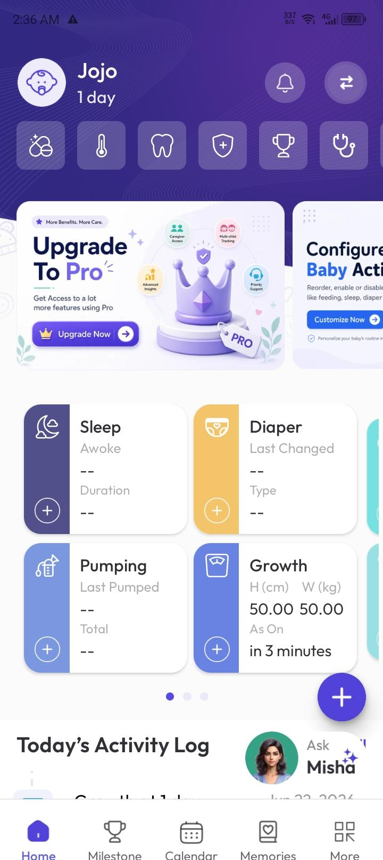
TheParentZ is a highly developed child health and growth tracking application. TheParentZ offers vaccination monitoring, milestone tracking, medication logs, growth charts, appointment reminders, and document storage. This application offers more features and shows the rising trend of user demand for consolidated digital child health and growth tracking applications within the market.
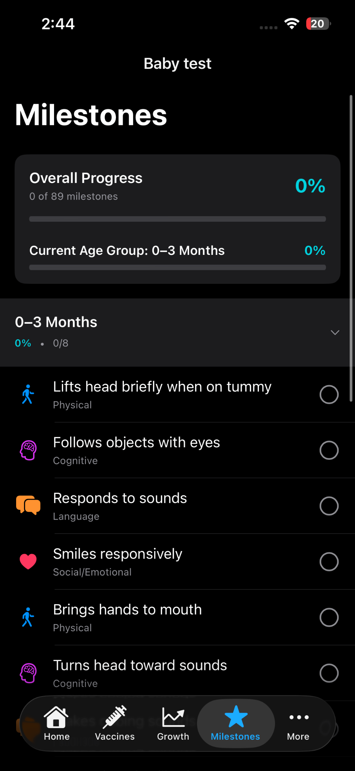

Figure 2.1. MrBaby Application

Figure 2.2. TheParentZ Application

3. Pediary
Pediary is a digital child health record application. Through this application, parents can track symptoms, medications, health temperatures, and child growth. This system also offers features that focus more on the everyday health care monitoring and record organization. This application shows that digital recording and health care monitoring tools have a lot of potential for health management for parents.

4. CDC Milestone Tracker App
The CDC Milestone Tracker App is a digital tool that offers parents a way to track their child’s developmental milestones. The application uses age specific milestone checklists and offers parents suggestions on development activities. The application focuses more on developmental tracking rather than record keeping, but the digital tool offers a way for parents to track developmental milestones and concerns.
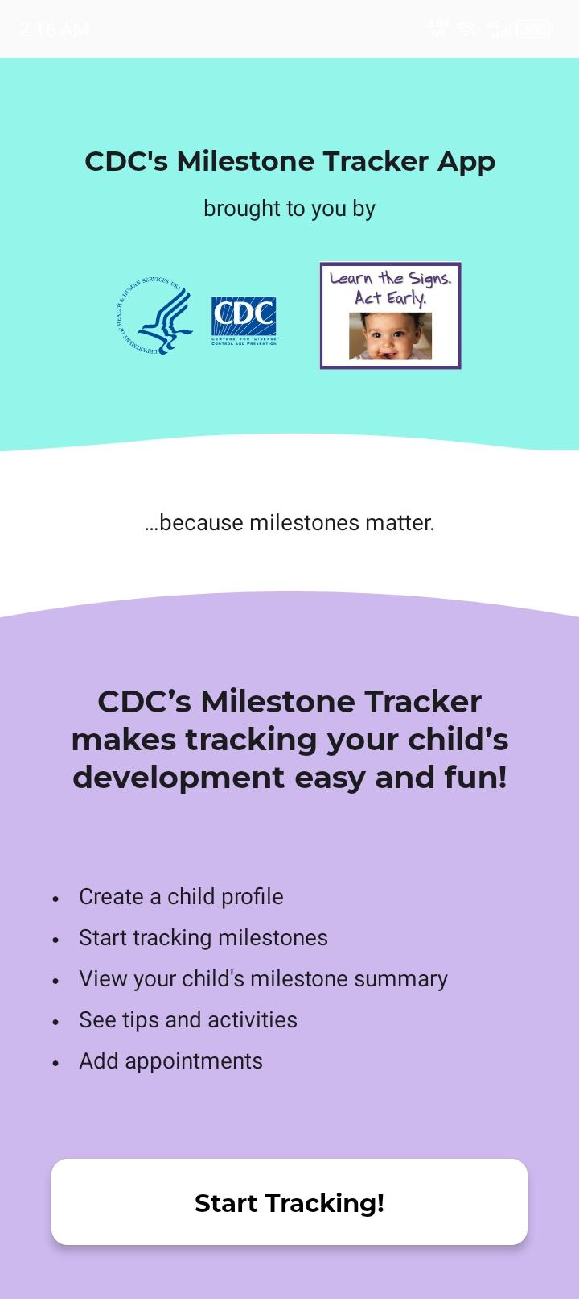
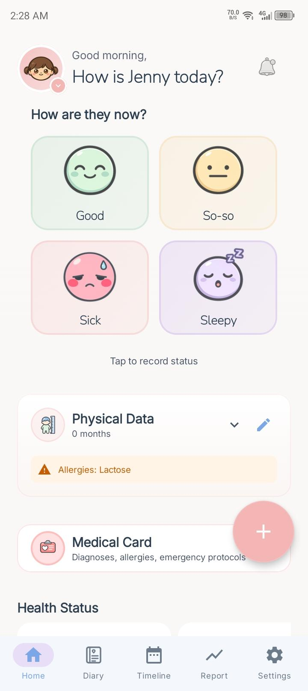

Figure 2.3. Pediary Application

Figure 2.4. CDC Milestone Tracker Application

5. Baby Connect
Baby Connect is an all-in-one baby tracking app that records a child's growth, vaccinations, medications, baby milestones, feeding, and even medical history. The app allows data sharing for authorized caregivers and generates tracking reports. Baby Connect's recordkeeping ability is a great reference for the development of BabyBook+.
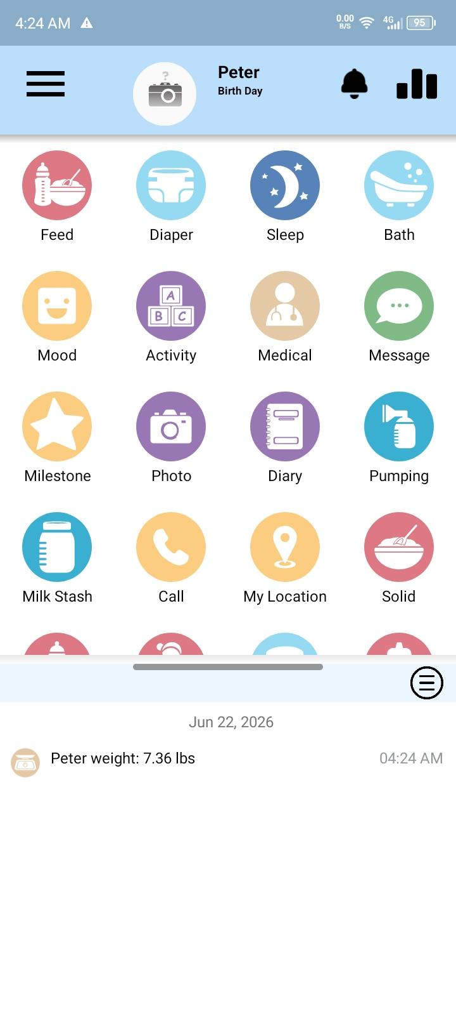
Figure 2.5. Baby Connect Application

III. DESIGN METHODOLOGY
This Chapter explains BabyBook+’s design methodology. It explains the project’s conceptual framework, project timeline, the scope of the system, and the system’s requirements. This chapter will describe the analysis and design models and systems that illustrate how the system will function and process information efficiently while catering to the needs of its target users. In line with these methodologies, the proponents intend to develop BabyBook + using a practical and systematic approach to complement and achieve the objectives systemically outlined in the previous chapters.

A. Conceptual Framework
The Input-Process-Output (IPO) Model was used by the proponents as the study’s conceptual framework. The IPO Model shows data entered into the BabyBook+ system, how they are processed, and the meaningful outputs produced. It helps to understand the information flow in the proposed system, and it also verifies that the functionalities and features of the system are directed toward the study’s goals.
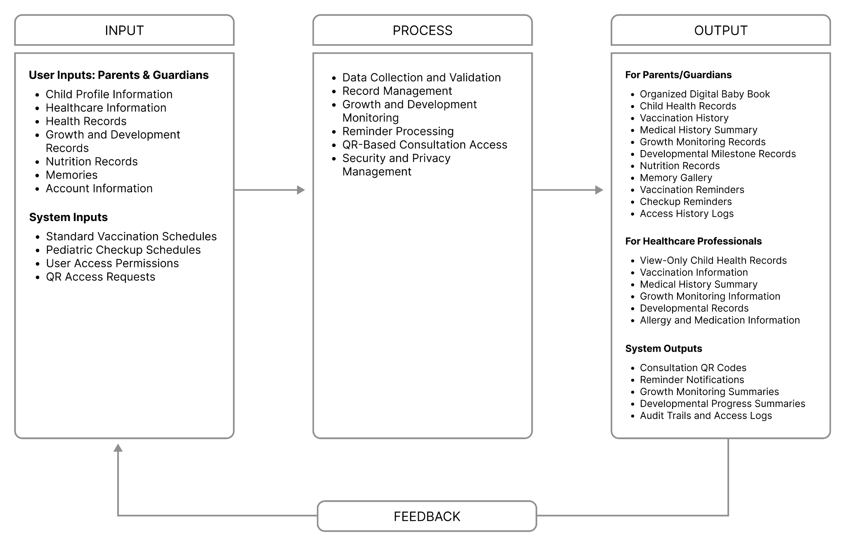
Figure 3.1. Input–Process–Output (IPO) Conceptual Framework of BabyBook+

1. Input

a. Child Profile Information
This contains essential personal details of the child, including:
- full name
- nickname
- date of birth
- sex
- blood type
- birth weight
- birth length
- place of birth
- birth hospital
- other birth-related details
These records will establish the base of the child’s digital profile in BabyBook+.

b. Healthcare Information
This contains details of the child’s:
- pediatrician,
- clinic or hospital
- OB-GYNE
- preferred health center
- emergency contacts.
These details help the parent or guardian retrieve important medical references during check-ups, consultations, or emergencies.

c. Health Records
This includes the child’s:
- vaccination history
- checkup records
- illnesses
- allergies
- medications
- hospitalizations
- hereditary conditions
- and other medical notes
This assists the parent to monitor the child’s health and provide information to health professionals when needed.

d. Growth and Development Records
This includes the child’s:
- height
- weight
- head circumference
- progress in growth and development
- developmental milestones
These records help the parent or guardian retain information that assists in monitoring the child’s progress in growth and development.

e. Nutrition Records
This includes:
- feeding information
- milk intake
- solid food introduction
- food preferences
- feeding schedule
- possible food reactions
- and notes on nutrition.
These records help the parent or guardian monitor the child’s nutrition from early childhood to later stages.

f. Memories
Through BabyBook+, parents are able to record and save memories in different formats including:
- photos
- captions
- developmental milestones
- personal notes related to the child’s early years.
BabyBook+ combines child health recordkeeping and the preservation of memories, thus, functioning as a digital child health record system and a digital baby book.

g. Account Information
This includes:
- user credentials
- parent or guardian profile data
- login information
- account setup
- QR-sharing preferences.
These are used for the management of account/app control and secure consulting.

h. System Inputs
These include:
- preset vaccination schedules
- pediatric checkup schedules
- reminders
- access permissions
- request for QR access
- system-generated configurations that enable BabyBook+ operations.

2. Process

a. Data Collection and Validation
Information submitted by parents/guardians undergoes a validation process to ensure accuracy and completeness prior to being saved in the system. To limit the occurrence of data entry errors, the system has features that validate date entries, check for multiple records and validate that all required data has been entered.

b. Record Management
The system supports the organization and categorization of records into various modules such as child profile, health records, vaccination records, checkup history, records of growth and development, nutrition records, and memories. This system aims to support the users to easily store, retrieve, and update, and manage information.

c. Growth and Development Monitoring
The system captures and supports the tracking of growth and development of a child. Growth and developmental milestones are checked and the system is designed to allow parents to record and update the child’s growth, weight, height, nutrition and milestones based on their observations, checkups or healthcare visits.

d. Reminder Processing
Vaccinations, checkups and other related activities have reminders and notifications generated by the system to ensure parents/guardians are prepared for the upcoming visits to the health center and/or for the scheduled pediatric consultations and follow up checkups.

e. QR-Based Consultation Access
To allow healthcare professionals, pediatricians, and barangay health personnel view select child records for health checkup and consultations, the system generates QR codes. This access is temporary, parental controlled, and for view only.

f. Security and Privacy Management
Authentication, access control, secure storage, QR access control, and logging of activities, are some of the security features of the system. These control and limit access of child records to the users for the purpose of health consultation only.

3. Output

a. Digital Baby Book
The organized digital records system for children includes child profile information, digital health records, vaccination records, checkup records, records of monitored growth, developmental records, nutrition records, reminders, and memory archives. These system outputs improve records accessibility and management for parents.

b. For Healthcare Professionals
The system offers permitted, view-only access to appropriate children’s health records for checkups/consultations. This may help Health Care Professionals view certain records required to make an informed consultation, such as vaccination records, allergy records, medication and illness records, and more.

c. System Outputs
The system includes generation of consultation QR codes, reminder notifications, summary of progress, summary of child records, and access logs. System outputs support management of records and readiness for consultation and security check.

4. Feedback
Feedback will be gathered from parents, guardians, health care professionals, barangay health personnel, and IT evaluators to measure the usability, effectiveness, and functionality, security, and overall performance of BabyBook+. Feedback will be used by the proponents to improve the system, enhance features, address usability, and improve privacy and security in the system.

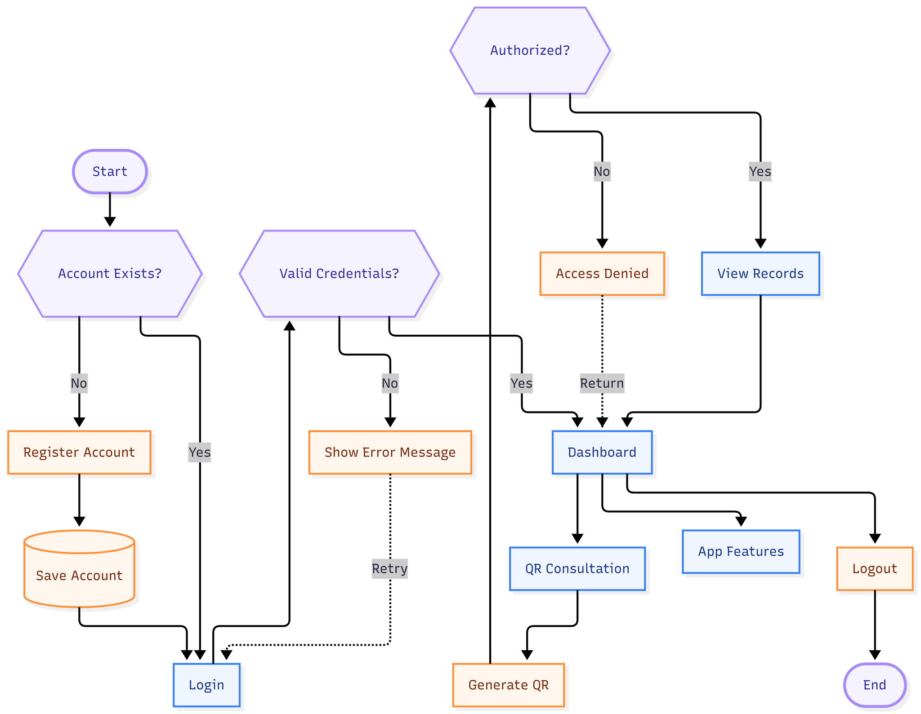
5. Overall System Flow
Figure 3.2. System Flow Diagram of BabyBook+

B. Project Timeline

1. Term 1: (April 2026 - July 2026)
In order to establish a framework for documenting, developing, and evaluating project milestones, the project schedule organizes this work into packages, moving each package one after another. Each work package bears the start and end dates. Work packages are structured to optimize the degree to which activities are performed simultaneously. The project schedule captures overlapped and dependent work for large project milestones and is structured by a Gantt chart.
During the first term, the documentation, project proposal, and drafts of Chapters 1 to 3, along with the development of the prototype, will all be completed. Testing of the prototype will begin at the same time as the technical concepts are being developed. Given the degree of concurrency of the activities and tasks, the time taken to go from technical concepts to fully developed working components will be significantly decreased.
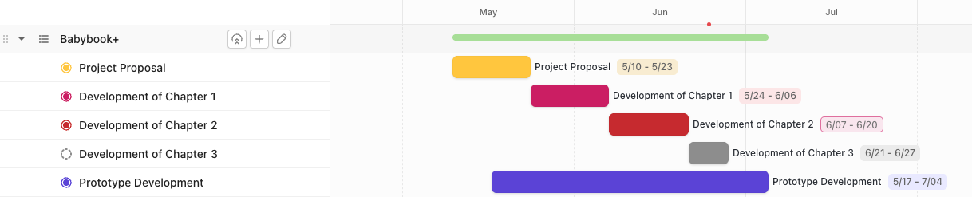
Figure 3.3. Gantt Chart of the Project Timeline

2. Term 2: (August 2026 - November 2026)

C. System Scope
BabyBook+ is a mobile application for tracking child health and development, providing a digital solution for organizing and managing child-related information from birth to age six. Building on the concept of a classic baby book, BabyBook+ integrates a variety of tools to help parents document health and development milestones, nutrition, and memories of the early years. The app incorporates parent-controlled QR-based consultation access, enabling the health professional to view the child’s record in a secure and private manner during a scheduled consultation. The goal of the system is to record accessibility and organization, readiness for record-based consultation, and data privacy.

1. In-Scope Features
a.. Parent Registration/Login
Parents and guardians will have the option to secure an account through the system to log-in and edit their account information.

b. Child Profile Management
The system will create and manage child profiles for users, including personally identifying information and birth information.
c. Vaccination Records
Users will be able to add, edit, and review their child’s vaccination history.
d. Checkup Records
Users will have the option to document checkup records and pediatric consultation records.
e. Medical History
The system shall have a record of a child’s medical conditions, illness, and medical care history.
f. Allergy Records
Users will have the option to document any and all allergies that a child may have.
g. Medication Records
Users will have the option to document any medication that a child may have taken or been prescribed.
h. Hospitalization Records
Users will have the option to document all hospital stays and the related information.
i. Growth Monitoring
Users will have the option to document and track growth measurements.
j. Developmental Milestones
Users will have the option to document and track developmental milestones.
k. Nutrition Records
Users will have the option to document feeding and track food introductions.
l. Photo Memories
Users will have the option to document their childhood memories in the form of photos and notes.
m. Vaccine Reminders
Users will be sent reminders when there are upcoming vaccinations.
n. Checkup Reminders
The system will remind parents about scheduled pediatric visits and routine checkups.
o. QR Consultation Access
The system will allow parents to create QR codes that grant consulting healthcare professionals view-only access to certain child records.

2. Out-of-Scope Features
a. Telemedicine or Online Consultation
No video calls, online consultations, or direct contact between parents and linked healthcare professionals will be offered by the system.
b. Diagnosis Generation
The system will not offer health record assessments to determine or generate a diagnosis or health condition of a child.
c. Prescription Issuance
The system will neither generate, issue, or create any form of control on the medical prescriptions of healthcare professionals.
d. Treatment Recommendation
The system will not offer treatment plans, recommendations on the use of medications, or other healthcare advice on medical conditions.
e. Hospital Electronic Medical Record (EMR) Integration
The system will not offer any form of connection or data integration with hospital, clinic, or healthcare facility record systems.
f. Government Health Analytics
The system will not offer large scale health data analysis to government or public health unit services.
g. Barangay or LGU Public Health Dashboard
The application will not include dashboards to evaluate community health data or local government public health.
h. Birth, Death, or Population Based Health Data Reporting
The system will not offer reports on health data or population statistic reporting.
i. Automatic Authentication of Official Medical Records
The application will not provide automated authentication of medical records of the official health system.
j. Replacement of Official Hospital, Clinic, or Government Health Records
BabyBook+ isn't a substitute for medical records from hospitals or clinics. BabyBook+ adds a digital recordkeeping option for parents and guardians.

D. Requirements Specification

1. Functional Requirements
a. User Authentication and Account Management
Users will be able to securely register, log in, log out, and manage their accounts.
b. Child Profile Management
Users will have the capability to manage their child’s profile.
c. Health Record Management
Users will be able to manage children’s records of vaccinations, check-ups, illnesses, medications, allergies, and other health conditions. Users can also upload supporting documents (e.g. vaccination stickers, prescription, etc) to act as reference for each health record.
d. Growth and Development Monitoring
Users will be able to view and record milestones pertaining to growth and development.
e. Nutrition Record Management
Users will be able to record feeding and milk intake, along with preferences and reactions to food.
f. Memory Management
Users should have the option to upload photos, captions and notes to memories and milestones.
g. Reminder Management
Users should have the option to set reminders for upcoming vaccinations and checkups and for other child health-related activities.
h. QR Consultation Access
Parents and guardians should have the option to create a QR code of child records for consultation request of view-only access to the child records.
i. Access Log Management
The system should log the date and time of QR based child record view requests, if possible.

2. Non-Functional Requirements
a. Usability
The system should have a user-friendly interface for parents, guardians and other authorized users.
b. Security
User accounts and child records will use authentication and access control, with storage and encrypted QR consultation tokens.
c. Privacy
Parents/guardians will choose which records are accessible via QR access for consultation.
d. Reliability
The system will perform expected functions with a minimal chance of loss or incorrect retrieval of records.
e. Availability
The system will be within reach given the appropriate connectivity and the right device.

f. Maintainability
The system will be designed in a way to facilitate future updates, bug repairs, and enhancements.
g. Performance
The system shall retrieve records, generate QR codes, and display reminders within a reasonable response time under normal operating conditions.

3. System Requirements

a. Software Requirements
Table 3.1. Software Requirements for Development
Components | Requirements
Operating System | iOS  Minimum Version: macOS 13.0 (Ventura)  Recommended Version: macOS 14.0 (Sonoma) or newer  Windows  Minimum Version: Windows 10 (64-bit)  Recommended Version: Windows 11 (64-bit)
Front-end Framework | React-native
Back-end Framework | Express JS
Database Management System | PostgreSQL
Design Tool | Google Stitch
Development Tools | Visual Studio Code
Testing Tools | Jest / React Native Testing Library

Table 3.2. Software Requirements for Users
Components | Requirements
Mobile Operating System | Android  Minimum: Android 6.0 (Marshmallow)  Recommended: Android 10.0  iOS  Minimum: iOS 15.1  Recommended: iOS 16.0 or higher.
Application Access | iOS Devices: Apple App Store  Android Devices: Google Play Store
Internet Connectivity | Wi-Fi or Mobile Data 3G/4G/5G

b. Hardware Requirements
Table 3.3. Hardware Requirements for Development
Components | Requirements
Computer | MacOS, Windows, Ubuntu Linux
Processor | Minimum  Quad-core Intel Core i5  AMD Ryzen 5  Apple Silicon M1  Recommended  Intel Core i7  AMD Ryzen 7
Memory (RAM) | Minimum: 8GB LPDDR4 / DDR4  Recommended: 16GB LPDDR5 / DDR5
Storage | Minimum: 50GB (SSD)  Recommended: 256GB (NVMe PCIe SSD)
Internet Connection | Minimum: 10 Mbps Broadband  Recommended:50 Mbps Fiber Optic
Mobile Testing Device | Expo Go Companion App

Table 3.4. Hardware Requirements for Users
Components | Requirements
Device | Android Smart Phone (Android 8.0)  Iphone or Ipad (iOS 13.0 or higher)
Camera | 5 MP Camera or Higher
Internet Connection | Wi-Fi or Mobile Data 3G/4G/5G
Available Storage | 10 GB Free Storage

E. System Analysis and Design

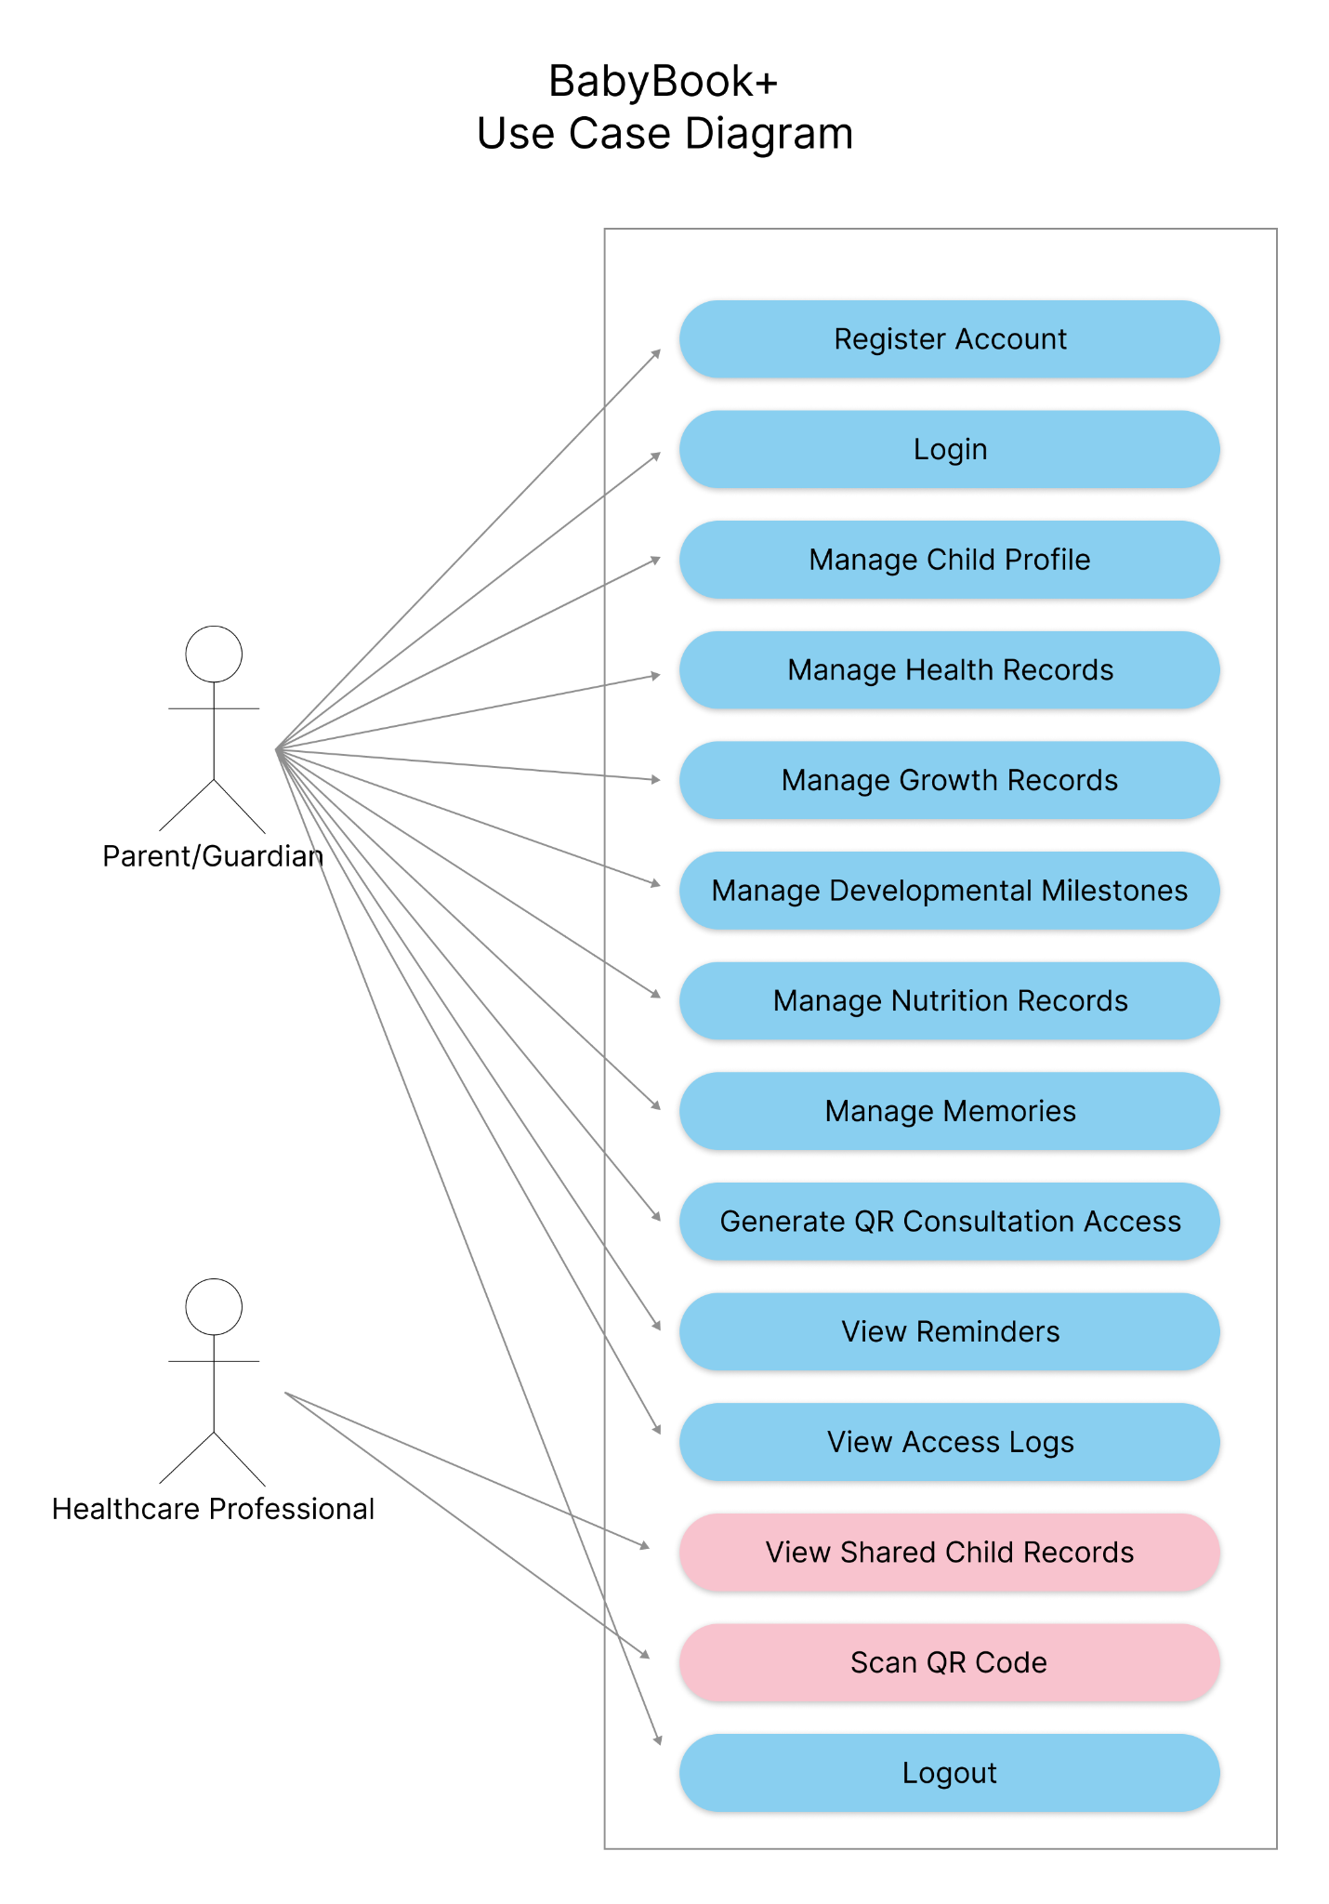
1. Use Case Diagram

Figure 3.4. Use Case Diagram of BabyBook+
The Use Case Diagram shows how Parent/Guardian and Healthcare Professional actors engage with the BabyBook+ system. Features of the BabyBook+ system allow Parent/Guardians to manage child profiles, health records, and developmental and nutritional records, as well as memories. Parent/Guardians can also manage QR based
consultation appointment access. The Healthcare Professional manages the system by scanning QR codes to view child records during consultation appointment/session. These functionalities achieve the system’s goal of providing parents and guardians with a safe and convenient way to manage and organize child health and development records.

2. Use Case Description
Table 3.5 Use Case Description – Register Account
Field | Description
Use Case Name | Register Account
Actor | Parent/Guardian
Description | Allows the creation of a BabyBook+ account to user.
Preconditions | User does not have an account.
Main Flow | 1. User clicks Register.  2. User types account data.  3. System checks account data.  4. System registers account.
Postconditions | Account is created.
Alternative Flow/Exceptions | Account exists, and/or account fields are incorrectly completed.

Table 3.6. Use Case Description – Login
Field | Description
Use Case Name | Login
Actor | Parent/Guardian
Description | Provides access to the system to a user through the use of account credentials.
Preconditions | User owns an account.
Main Flow | 1. User types credentials.  2. System checks credentials.  3. User dashboard access.
Postconditions | User is logged in.
Alternative Flow/Exceptions | Credentials are incorrect.

Table 3.7. Use Case Description – Manage Child Profile
Field | Description
Use Case Name | Manage Child Profile
Actor | Parent/Guardian
Description | Provides the ability to create and edit child profile data.
Preconditions | User is logged in.
Main Flow | 1. User clicks Child Profile.  2. User types profile data.  3. System checks profile data.  4. System edits profile.
Postconditions | Child profile is updated.
Alternative Flow/Exceptions | Profile data is incomplete.

Table 3.8. Use Case Description – Manage Health Records
Field | Description
Use Case Name | Manage Health Records
Actor | Parent/Guardian
Description | System provides the ability to create/edit/ delete records of vaccination, health checkup, illness, allergy, medication, and hospitalization.
Preconditions | Child profile is created.
Main Flow | 1. User clicks Health Records.  2. User creates/ edits records.  3. The user may upload a supportive document or image.  4. System saves data.
Postconditions | Health Records are created/ updated.
Alternative Flow/Exceptions | Profile data is incomplete.

Table 3.9. Use Case Description – Manage Growth Records
Field | Description
Use Case Name | Manage Growth Records
Actor | Parent/Guardian
Description | Users can enter height, weight, and head circumference.
Preconditions | Child profile is created.
Main Flow | 1. User selects Growth Records.  2. User submits measurements.  3. System saves and records growth history.
Postconditions | Growth Records are created/ updated.
Alternative Flow/Exceptions | Submitted measurements are invalid.

Table 3.10. Use Case Description – Manage Developmental Milestones
Field | Description
Use Case Name | Manage Developmental Milestones
Actor | Parent/Guardian
Description | Users can track and enter milestones.
Preconditions | Child profile is created.
Main Flow | 1. Milestones is selected.  2. Achievement of Milestone is recorded.  3. The system updates the record.
Postconditions | Milestone record updated.
Alternative Flow/Exceptions | Submitted milestone details are insufficient.

Table 3.11. Use Case Description – Manage Nutrition Records
Field | Description
Use Case Name | Manage Nutrition Records
Actor | Parent/Guardian
Description | Users can edit feeding and nutrition records.
Preconditions | Child profile is created.
Main Flow | 1. User selects Nutrition Records.  2. User submits feeding details.  3. System saves the record.
Postconditions | Nutrition Records updated.
Alternative Flow/Exceptions | Submitted nutrition records are insufficient.

Table 3.12. Use Case Description – Manage Memories
Field | Description
Use Case Name | Manage Memories
Actor | Parent/Guardian
Description | Users can record important moments and upload pictures.
Preconditions | User must be authenticated.
Main Flow | 1. User selects Memories.  2. User submits picture or note.  3. System saves the content.
Postconditions | Memory saved.
Alternative Flow/Exceptions | File format is not supported. System failed to upload.

Table 3.13. Use Case Description – Generate QR Consultation Access
Field | Description
Use Case Name | Generate QR Consultation Access
Actor | Parent/Guardian
Description | Users can generate a QR Code to provide temporary consultation access.
Preconditions | Child records are available.
Main Flow | 1. Parent/Guardian selects Generate QR Consultation Access.  2. Parent/Guardian selects the child records to share.  3. The system generates an encrypted QR token containing temporary access permissions.  4. The system displays the generated QR code.  5. Parent/Guardian shares the QR code with the healthcare professional.
Postconditions | A secure QR code is produced and is available for viewing.
Alternative Flow/Exceptions | An error occurs while attempting to generate QR.

Table 3.14. Use Case Description – View Reminders
Field | Description
Use Case Name | View Reminders
Actor | Parent/Guardian
Description | Users can see vaccination and checkup reminder postings
Preconditions | Reminder postings are scheduled.
Main Flow | 1. User clicks on View Reminders.  2. System shows scheduled postings.
Postconditions | Reminders are seen.
Alternative Flow/Exceptions | No reminders are posted.

Table 3.15. Use Case Description – View Access Logs
Field | Description
Use Case Name | View Access Logs
Actor | Parent/Guardian
Description | Users can see consultation access logs.
Preconditions | Access QR has been used.
Main Flow | 1. User clicks on View Access Logs.  2. System shows access logs.
Postconditions | Access logs are seen.
Alternative Flow/Exceptions | Access logs are empty.

Table 3.16. Use Case Description – Scan QR Code
Field | Description
Use Case Name | Scan QR Code
Actor | Healthcare Professional
Description | Users can scan consultation QR code.
Preconditions | Valid QR code is presented.
Main Flow | 1. Healthcare professional scans the QR code.  2. The system opens a secure web viewer.  3. The system validates the QR token and its expiration.  4. If valid, the system retrieves the authorized child records.  5. The system displays the records in view-only mode.  6. The system records the access in the access log.
Postconditions | Authorized records are available.
Alternative Flow/Exceptions | Unauthorized or expired QR code.

Table 3.17. Use Case Description – View Shared Child Records
Field | Description
Use Case Name | View Shared Child Records
Actor | Healthcare Professional
Description | Users can see authorized child records.
Preconditions | Authorization via QR is successful.
Main Flow | 1. User clicks on View Records.  2. System shows authorized records.
Postconditions | Child records are seen.
Alternative Flow/Exceptions | Access has not been granted.

Table 3.18. Use Case Description – Logout
Field | Description
Use Case Name | Logout
Actor | Parent/Guardian
Description | Securely ends session
Preconditions | Must be logged in.
Main Flow | 1. Select Logout.  2. Session is terminated.
Postconditions | Logged out
Alternative Flow/Exceptions | Session times out.

3. Activity Diagram

a. User Registration and Login Activity Diagram
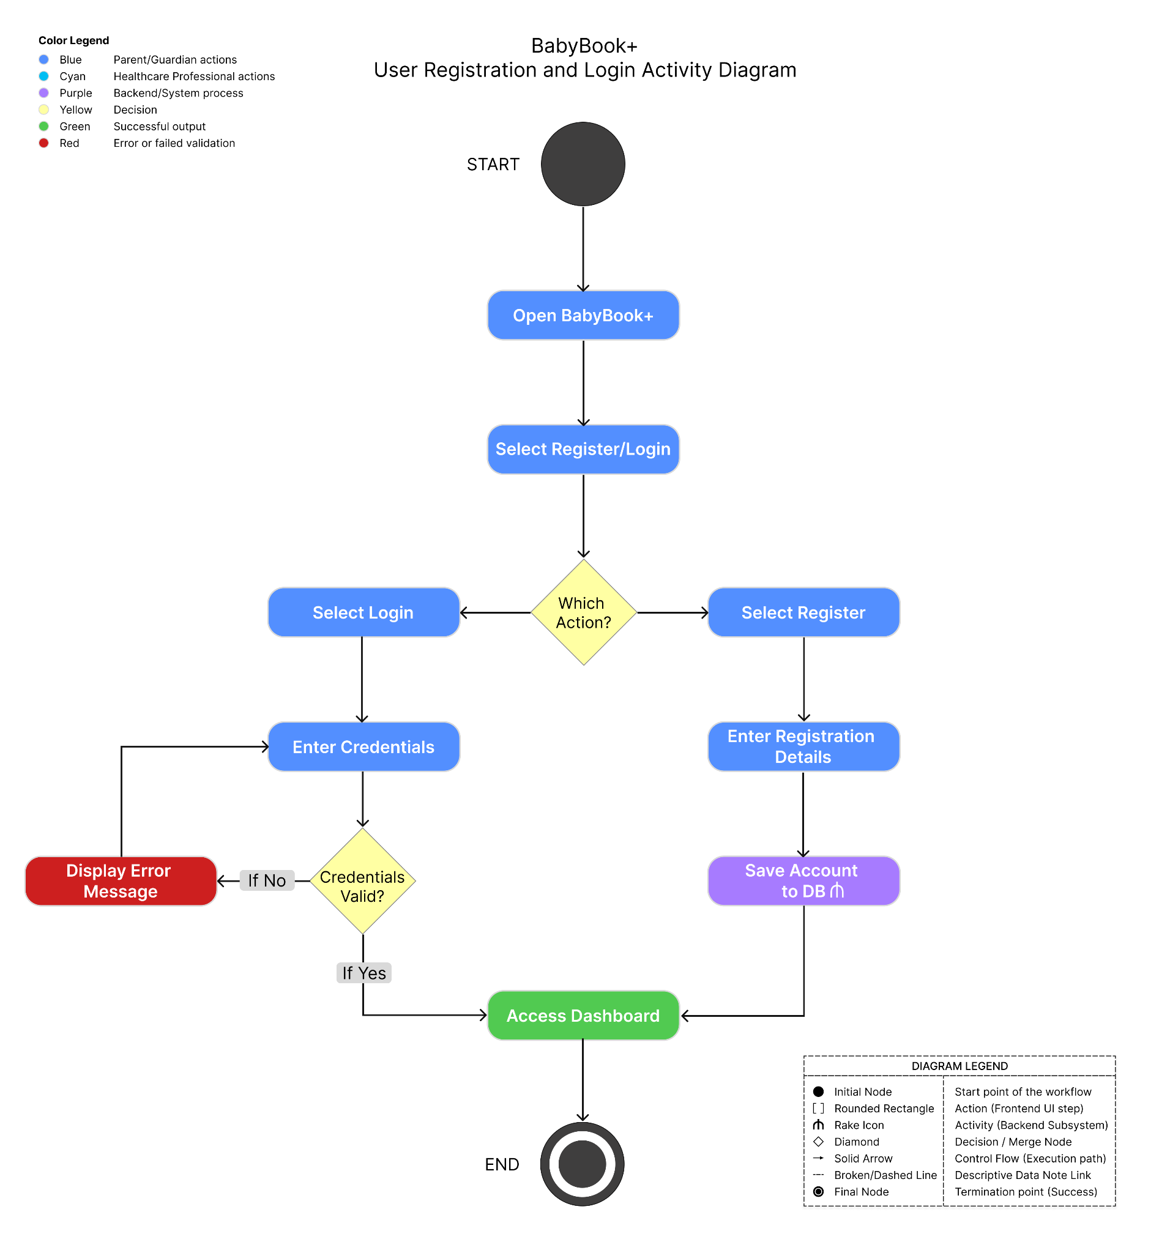
Figure 3.5. User Registration and Login Activity Diagram

b. Child Profile Management Activity Diagram
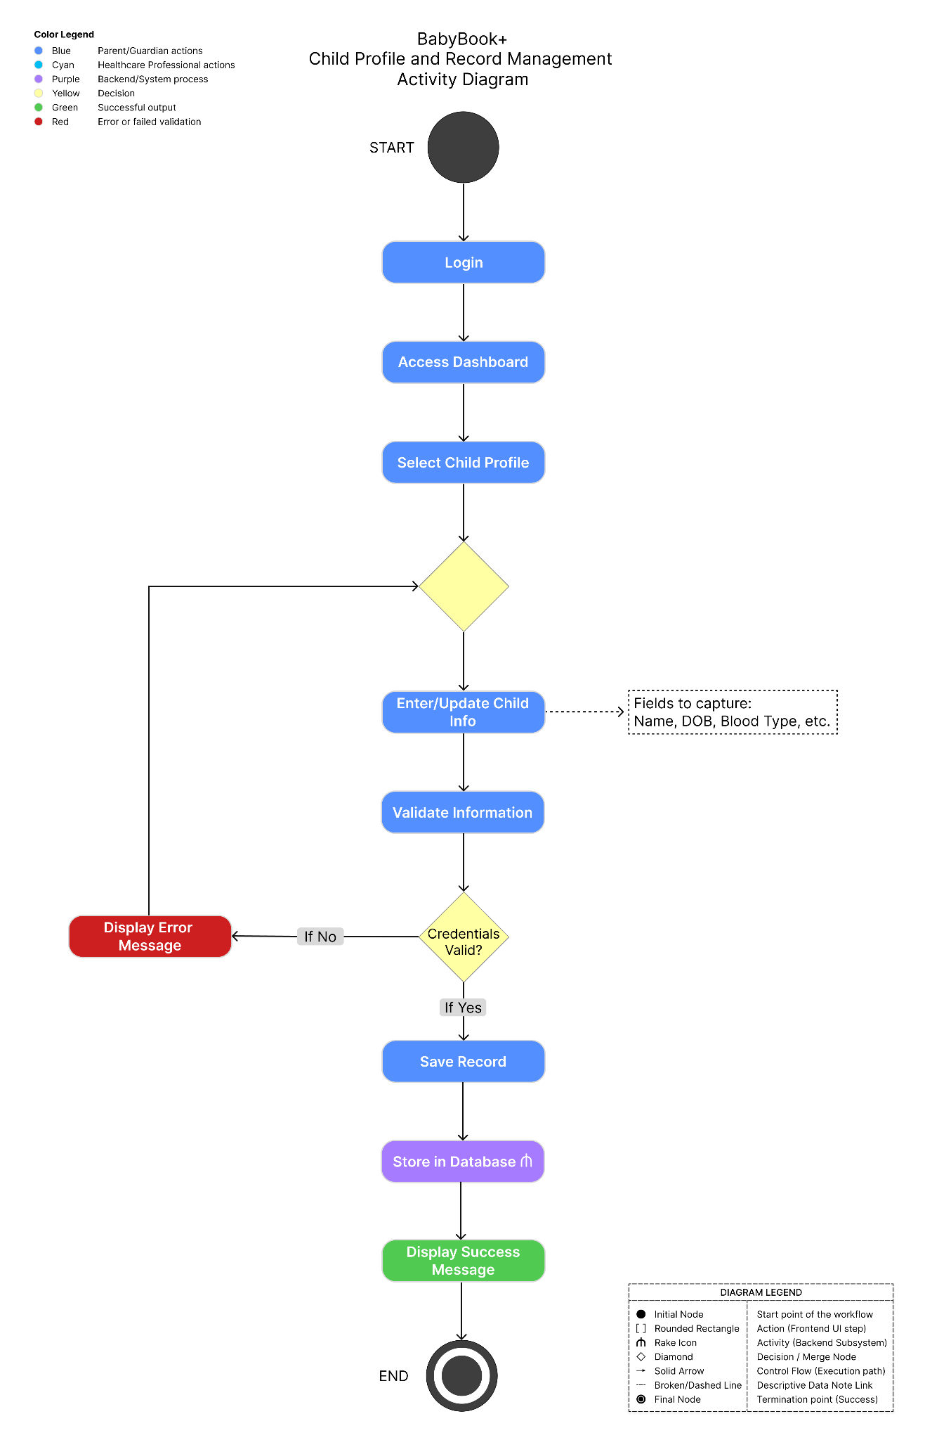
Figure 3.6. Child Profile Management Activity Diagram

c. Health Record Management Activity Diagram
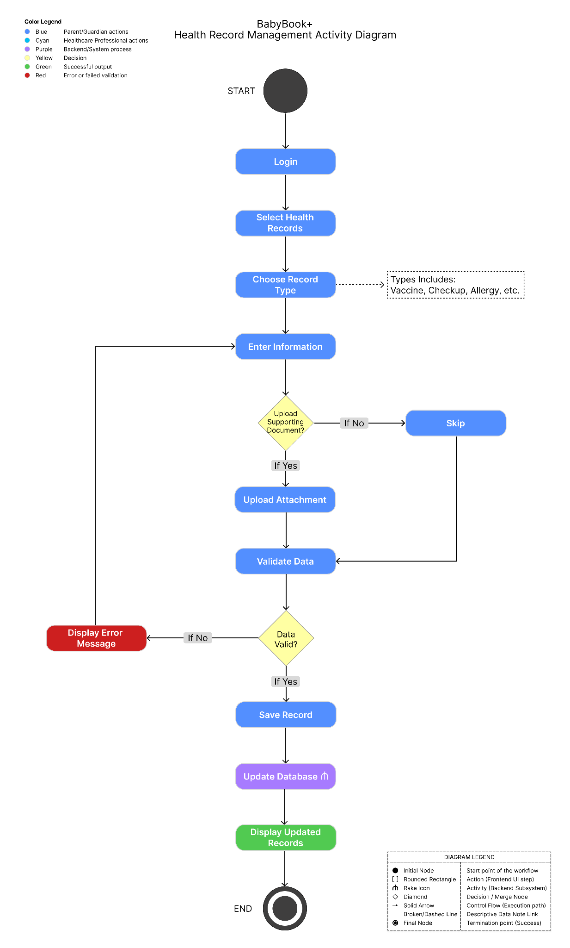
Figure 3.7. Health Record Management Activity Diagram

d. Reminder Notification Activity Diagram
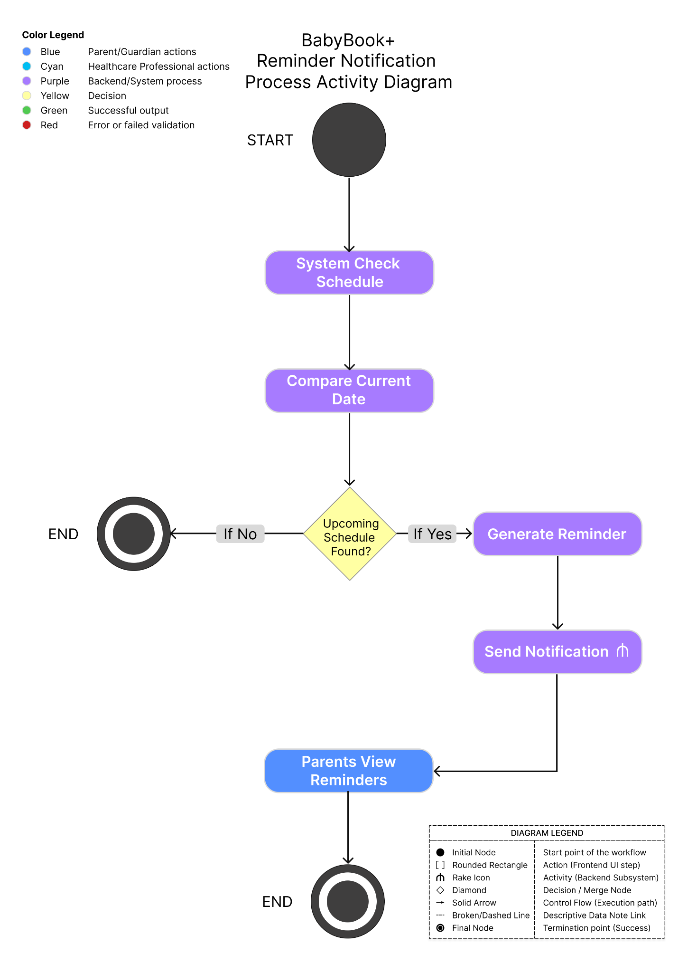
Figure 3.8. Reminder Notification Activity Diagram

e. QR Consultation Access Activity Diagram
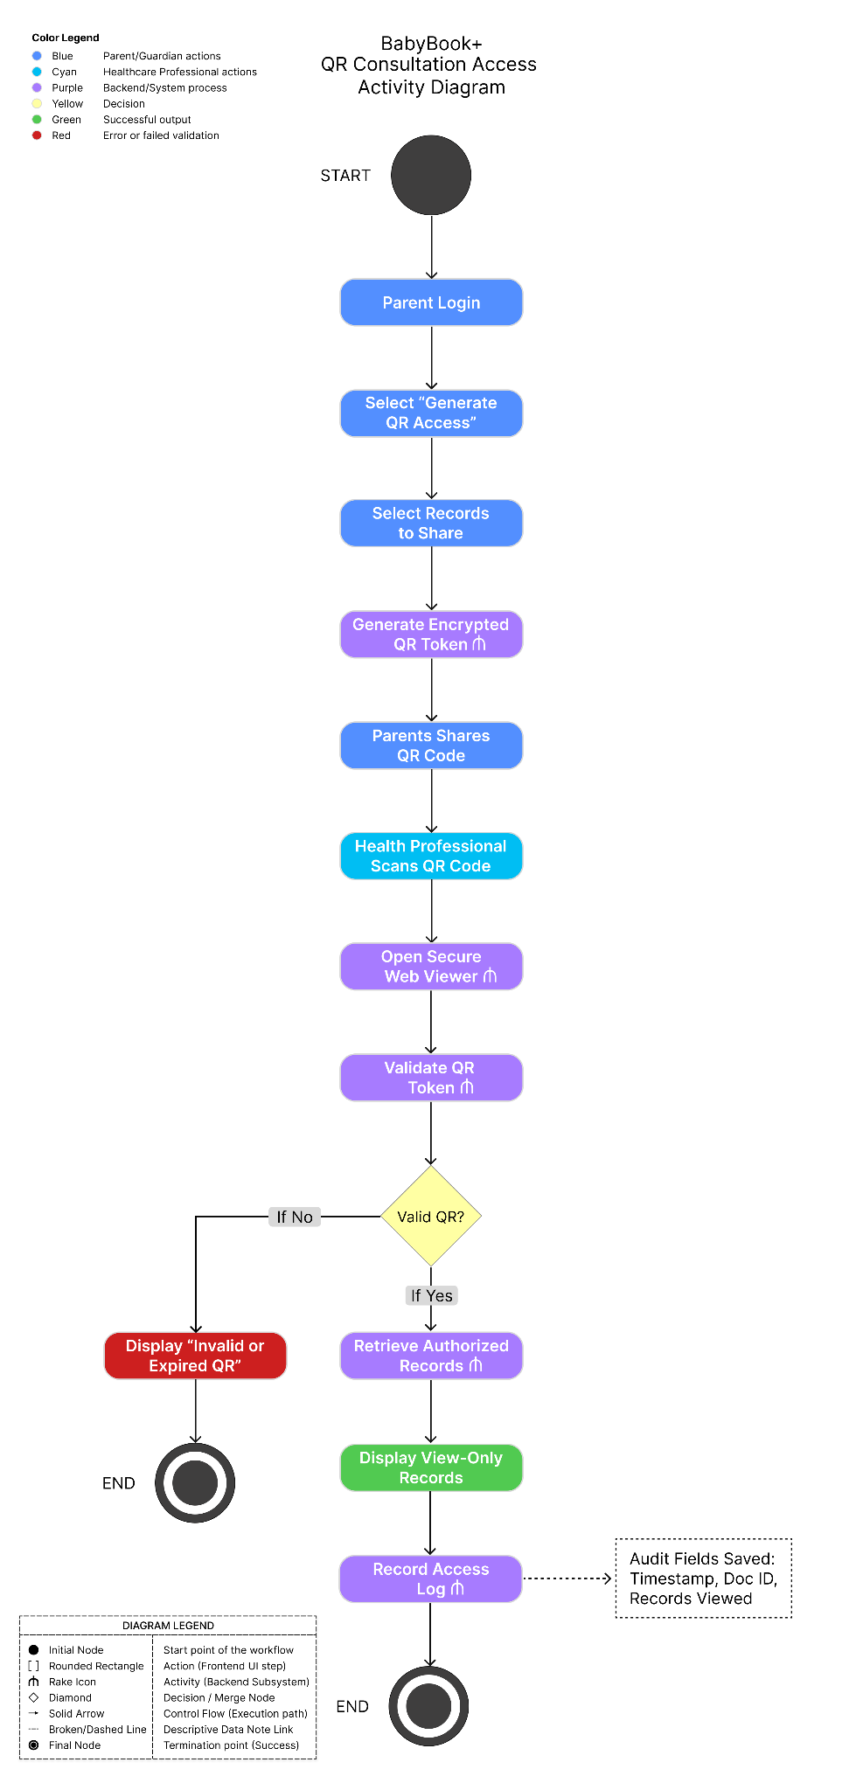
Figure 3.9. QR Consultation Access Activity Diagram

4. Entity Relationship Diagram (ERD)
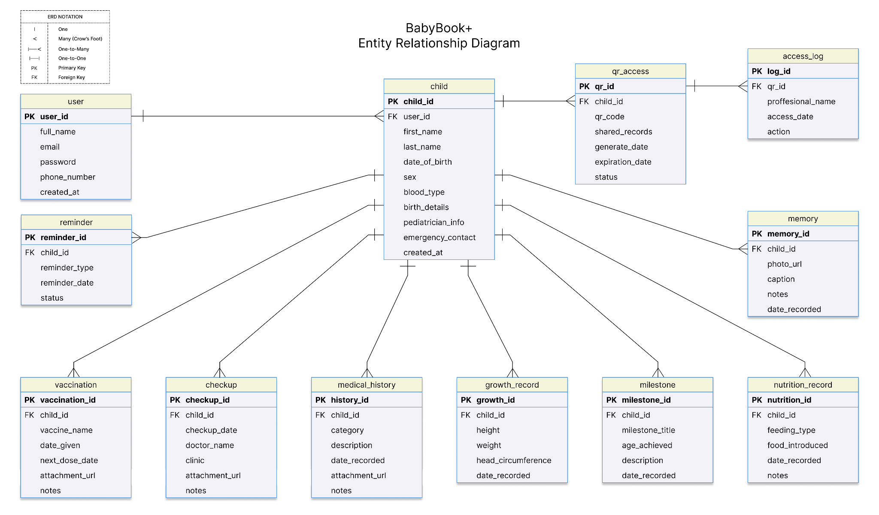
Figure 3.10. Entity Relationship Diagram (ERD) of BabyBook+

5. Database Design
The BabyBook+ database design allows users to organize and analyze data related to child health and development. The database is designed to maintain relational integrity. This allows records to be easily and securely accessed. The database includes functionality for managing child health and development profiles, tracking development, setting reminders, saving notes and memories, and accessing consultations via QR code.
Following Third Normal Form (3NF) principles, the proponents created the BabyBook+ database by realizing the separation of health, development, nutrition, reminders, and consultation access records into different tables. This separation is intended to reduce duplication of records and increase data consistency and expandability of the proposed system.

a. User Table
Table 3.19. User Database Table
Field Name | Data Type | Key | Description
user_id | INT | PK | A unique identifier for user
full_name | VARCHAR(100) |  | Name of Parent / Guardian
email | VARCHAR(100) |  | User email address
password | VARCHAR(255) |  | Encrypted password
phone_number | VARCHAR(20) |  | Contact Information
created_at | DATETIME |  | Account creation date

b. Child Table
Table 3.20. Child Database Table
Field Name | Data Type | Key | Description
child_id | INT | PK | A unique identifier for child
user_id | INT | FK | References user
first_name | VARCHAR(50) |  | First name of child
last_name | VARCHAR(50) |  | Last name of child
date_of_birth | DATE |  | Date of birth
sex | VARCHAR(10) |  | Child’s sex
blood_type | VARCHAR(5) |  | Child’s blood type
birth_details | TEXT |  | Information about child’s birth
pediatrician_info | VARCHAR(100) |  | Pediatrician details
emergency_contact | VARCHAR(100) |  | Emergency contact
created_at | DATETIME |  | Record creation date

c. Vaccination Table
Table 3.21. Vaccination Database Table
Field Name | Data Type | Key | Description
vaccination_id | INT | PK | A unique identifier for vaccine
child_id | INT | FK | References Child
vaccine_name | VARCHAR(100) |  | Vaccine name
date_given | DATE |  | Date administered
next_dose_date | DATE |  | Next vaccination schedule
attachment_url | TEXT |  | Saves image or file of vaccination sticker or immunization card.
notes | TEXT |  | Additional remarks

d. Checkup Table
Table 3.22. Checkup Database Table
Field Name | Data Type | Key | Description
checkup_id | INT | PK | A unique identifier for checkup
child_id | INT | FK | References Child
checkup_date | DATE |  | Date of consultation
doctor_name | VARCHAR(100) |  | Name of attending physician
clinic | VARCHAR(100) |  | Clinic or hospital
attachment_url | TEXT |  | Store prescription, consultation, or other supporting documents.
notes | TEXT |  | Consultation notes

e. Medical History Table
Table 3.23. Medical History Database Table
Field Name | Data Type | Key | Description
history_id | INT | PK | A unique identifier for medical history
child_id | INT | FK | References Child
category | VARCHAR(50) |  | Illness, Allergy, Medication, Hospitalization, Hereditary Condition
description | TEXT |  | Medical information
date_recorded | DATE |  | Date recorded
attachment_url | TEXT |  | Stores medical certificates, lab results, or other supporting documents.
notes | TEXT |  | Additional remarks

f. Growth Record Table
Table 3.24. Growth Record Database Table
Field Name | Data Type | Key | Description
growth_id | INT | PK | A unique identifier for growth record
child_id | INT | FK | References Child
height | DECIMAL(5,2) |  | Height measurement
weight | DECIMAL(5,2) |  | Weight measurement
head_circumference | DECIMAL(5,2) |  | Head circumference
date_recorded | DATE |  | Measurement date

g. Milestone Table
Table 3.25. Milestone Database Table
Field Name | Data Type | Key | Description
milestone_id | INT | PK | A unique identifier for milestone
child_id | INT | FK | References Child
milestone_title | VARCHAR(100) |  | Milestone achieved
age_achieved | VARCHAR(50) |  | Age when achieved
description | TEXT |  | Milestone details
date_recorded | DATE |  | Date recorded

h. Nutrition Record Table
Table 3.26. Nutrition Record Database Table
Field Name | Data Type | Key | Description
nutrition_id | INT | PK | A unique identifier for nutrition
child_id | INT | FK | References Child
feeding_type | VARCHAR(50) |  | Breastfeeding, Formula, Mixed
food_introduced | VARCHAR(100) |  | Food introduced
date_recorded | DATE |  | Date recorded
notes | TEXT |  | Additional remarks

i. Memory Table
Table 3.27. Memory Database Table
Field Name | Data Type | Key | Description
memory_id | INT | PK | A unique identifier for memory
child_id | INT | FK | References Child
photo_url | VARCHAR(255) |  | Stored image location
caption | VARCHAR(255) |  | Photo caption
notes | TEXT |  | Additional notes
date_recorded | DATE |  | Date recorded

j. Reminder Table
Table 3.28. Reminder Database Table
Field Name | Data Type | Key | Description
reminder_id | INT | PK | A unique identifier for reminder
child_id | INT | FK | References Child
reminder_type | VARCHAR(50) |  | Vaccination or Checkup
reminder_date | DATE |  | Scheduled date
status | VARCHAR(20) |  | Pending or Completed

k. QR Access Table
Table 3.29. Shared Records Database Table
Field Name | Data Type | Key | Description
qr_id | INT | PK | A unique identifier for QR access
child_id | INT | FK | References Child
qr_code | VARCHAR(255) |  | Generated QR code
shared_records | VARCHAR(255) |  | Determines which child's records are made available for consultation.
generate_date | DATETIME |  | Date and time QR was generated
expiration_date | DATETIME |  | Date and time QR code will no longer be valid
status | VARCHAR(20) |  | Status QR is: Active, Expired, or Revoked

l. Access Log Table
Table 3.30. Access Log Database Table
Field Name | Data Type | Key | Description
log_id | INT | PK | A unique identifier for access log
qr_id | INT | FK | References QR_Access
professional_name | VARCHAR(100) |  | Healthcare professional name
access_date | DATETIME |  | Date and time accessed
action | VARCHAR(50) |  | Action (view records) performed

REFERENCES
Canadian Paediatric Society. (2024, November 8). Rourke Baby Record: 2024 edition. https://cps.ca/en/tools-outils/rourke-baby-record
Centers for Disease Control and Prevention. (2026a, February 16). CDC’s Milestone Tracker app. U.S. Department of Health and Human Services. https://www.cdc.gov/act-early/milestones-app/index.html
Centers for Disease Control and Prevention. (2026b, February 16). CDC’s developmental milestones. U.S. Department of Health and Human Services. https://www.cdc.gov/act-early/milestones/index.html
DigiVacc. (n.d.). Home. https://digivacc.ph/
HealthHub. (2022, February 8). Child Health Booklet. https://www.healthhub.sg/programmes/parent-hub/child-health-booklet
HealthHub. (n.d.). Children’s Health e-services. https://www.healthhub.sg/programmes/children-health-ehb
Royal College of Paediatrics and Child Health. (n.d.). Personal Child Health Record (PCHR). https://www.rcpch.ac.uk/resources/personal-child-health-record-pchr
Suzuki, S. (2024). Overview of current revision of “Maternal and Child Health Handbook” in Japan. Hypertension Research in Pregnancy, 12(1). https://www.jstage.jst.go.jp/article/jsshp/12/1/12_HRP2023-007/_html/-char/en
Takeuchi, J. (2016). The Mother and Child Health Handbook in Japan as a health promotional tool: An overview of its history, contents, use, benefits, and global influence. Global Pediatric Health, 3. https://pubmed.ncbi.nlm.nih.gov/27336022/
TechNet-21. (2024, February 16). Child Immunization Record, Philippines. https://www.technet-21.org/en/resources/home-based-record/child-immunization-record-phillipines-2
Suhaimi, F. H., & Ghazali, R. (2023). A web-based baby health record system. Applied Information Technology and Computer Science, 4(2), 847–861. https://publisher.uthm.edu.my/periodicals/index.php/aitcs/article/view/12384
Reich, S. M., Bickman, L., Saville, B. R., & Alvarez, J. (2010). The effectiveness of baby books for providing pediatric anticipatory guidance to new mothers. Pediatrics, 125(5), 997–1002. https://doi.org/10.1542/peds.2009-2728
Ochoa, W., Reich, S. M., & Díaz, G. (2021). A randomized control trial of using baby books to reduce new mothers’ feelings of stress and depression. Maternal and Child Health Journal, 25, 1615–1625. https://doi.org/10.1007/s10995-021-03200-9
Chutiyami, M., Wyver, S., & Amin, J. (2019). Are parent-held child health records a valuable health intervention? A systematic review and meta-analysis. International Journal of Environmental Research and Public Health, 16(2), Article 220. https://doi.org/10.3390/ijerph16020220
Rourke Baby Record. (n.d.). The Rourke Baby Record. https://www.rourkebabyrecord.ca/
Beaumont, D. (n.d.). Developing a combined baby record: Using clinical evidence and parent views to create a patient-centred personal child health record. Semantic Scholar. https://www.semanticscholar.org/paper/Developing-a-combined-baby-record%3A-Using-clinical-Beaumont/5a45f1833dd23cf8dd50bc2d624fd1eba9321493
Centers for Disease Control and Prevention. (2026, February 16). CDC’s developmental milestones. U.S. Department of Health and Human Services. https://www.cdc.gov/act-early/milestones/index.html
Centers for Disease Control and Prevention. (2026). CDC milestone tracker app. https://www.cdc.gov/act-early/milestones-app/index.html
Mejia, C. T., et al. (2023). Mobile applications in childhood immunization. TEM Journal, 12(2), 645–656. https://www.temjournal.com/content/122/TEMJournalMay2023_645_656.pdf
MrBaby. (2026). MrBaby [Mobile app]. Apple App Store. https://apps.apple.com/cz/app/mrbaby/id6755685848
Otte, R. A., et al. (2019). Tracker-based personal advice to support the baby's healthy development in a parenting app: Data-driven innovation in the uGrow app. JMIR mHealth and uHealth, 7(7), e12666. https://doi.org/10.2196/12666
TheParentZ. (2026). TheParentZ baby growth tracker [Mobile app]. Google Play Store. https://play.google.com/store/apps/details?id=com.theparentz.rha
TheParentZ. (2026). All-in-one child health & growth tracker app. https://www.theparentz.ai/app
Pediary. (2026). Pediary: Baby health tracker [Mobile app]. Google Play Store. https://play.google.com/store/apps/details?id=net.pediary.android

