Kevin Loi

CMPE 150

March 4, 2018

Lab 3 Solutions

1. Pingall: This should fail, since ICMP traffic should be blocked
   1. 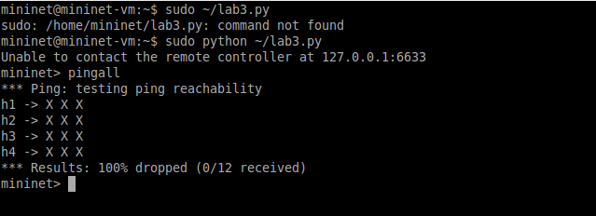Pingall does fail. It should only accept ARP and TCP traffic, nothing else. Since it’s ICMP traffic, it is blocked.
2. Dpctl dump-flows: This should show a few entries. These are the entries that you installed into the switch with of_flow_mod. You’ll need to do this within the timeout you specified in your of_flow_mod for the entries to show up!
   1. 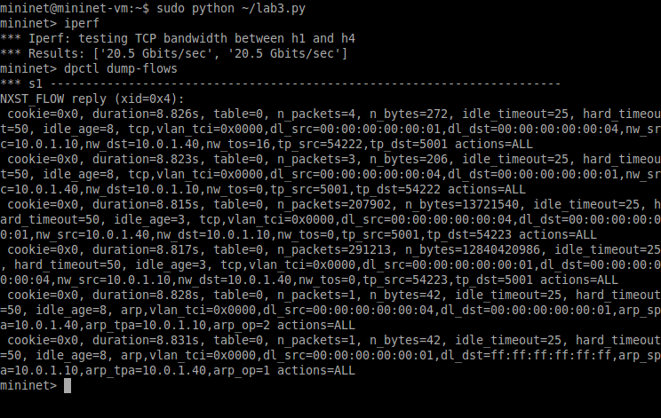If there were no flows, it should have shown no flows. There were flow replies. I used idle_timeout, which I set to 25, and hard_timeout, which I set to 50. Originally I set them to 50 and 100 just to make sure they are working properly.
3. Iperf: This should succeed
   1. Screenshot shown in dpctl dump-flows shows that iperf ran correctly. Iperf is a tool to measure the bandwidth and the quality of a network link. As shown above, that is what happened, so Iperf succeeded.