create table STUDENT_exp7_csa_42(Roll_No int,Name varchar(20),Physics int,Chemistry int,Maths int,primary key(Rollno));



insert into STUDENT_exp7_csa_42 values(1,'vishnu',10,20,33);

insert into STUDENT_exp7_csa_42 values(2,'manu',22,23,45);

insert into STUDENT_exp7_csa_42 values(3,'sandhya',15,12,24);

insert into STUDENT_exp7_csa_42 values(4,'aslam',11,25,50);

insert into STUDENT_exp7_csa_42 values(5,'keerthy',10,20,15);

insert into STUDENT_exp7_csa_42 values(6,'sam',20,20,49);

insert into STUDENT_exp7_csa_42 values(7,'alene',24,21,48);

insert into STUDENT_exp7_csa_42 values(8,'nandha',12,12,25);

insert into STUDENT_exp7_csa_42 values(9,'seban',21,17,40);

insert into STUDENT_exp7_csa_42 values(10,'gadha',22,22,50);

select * from STUDENT_exp7_csa_42 ;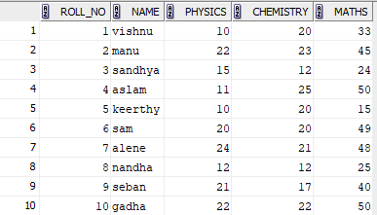

1. select avg(PHYSICS) as Class_Average_Physics from STUDENT_exp7_csa_42 ;



1. select max(Maths) as highest_marks_maths from student_exp7_csa_42;



1. select min(Chemistry) as lowest_marks_maths from student_exp7_csa_42;



1. select count(PHYSICS) from STUDENT_exp7_csa_42 where(PHYSICS>=12);



1. select name from STUDENT_exp7_csa_42 where(PHYSICS>=12 and chemistry>=12 and maths>=25);

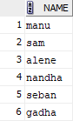

1. select 10*(count(name)) from STUDENT_exp7_csa_42 where(maths>=25);



1. select count(Roll_No)*10 as Overall_Pass from STUDENT_exp7_csa_42 where(MATHS>=25) and (PHYSICS>=12) and (CHEMISTRY>=12);



1. ALTER TABLE STUDENT_exp7_csa_42 ADD(Total_Mark int);

update STUDENT_exp7_csa_42 set Total_Mark=PHYSICS+CHEMISTRY+MATHS;



select avg(Total_Mark) as Class_Average from STUDENT_exp7_csa_42 ;



1. alter table STUDENT_exp7_csa_42 add(Grade varchar(10));

update STUDENT_exp7_csa_42 set Grade='pass' where (MATHS>=25) and (PHYSICS>=12) and (CHEMISTRY>=12);

update STUDENT_exp7_csa_42 set Grade='fail' where (MATHS<25) or (PHYSICS<12) or (CHEMISTRY<12);

select Roll_No,Name,Total_Mark,Grade from STUDENT_exp7_csa_42 order by Total_Mark desc;

