**EXPERIMENT 11**

**TCL COMMANDS**

select * from c22csA41.bank;

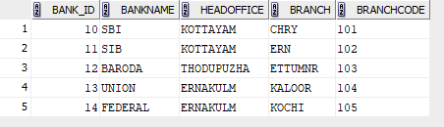

grant select,update on bank_table to c22csA41;



UPDATE C22CSA41.BANK SET BRANCH='PALA' WHERE BANK_ID=10;

select * from c22csA41.bank;

COMMIT;

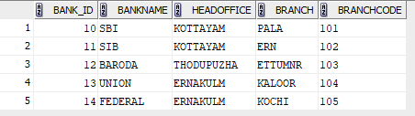

REVOKE SELECT ON BANK_TABLE FROM C22CSA41;

