1)CREATE TABLE items_exp9_csa_42( itemid INT PRIMARY KEY, itemname VARCHAR(50), category VARCHAR(50), price DECIMAL(10, 2), instock INT CHECK(instock >= 0));

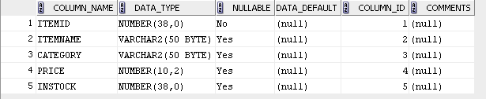

2CREATE TABLE customers_exp9_csa_42(custid INT PRIMARY KEY,custname VARCHAR(50),address VARCHAR(255),state VARCHAR(50));

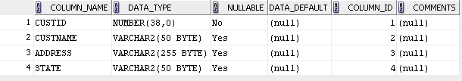

3)CREATE TABLE orders_exp9_csa_42( orderid INT PRIMARY KEY, itemid INT, custid INT, quantity INT CHECK(quantity > 0), orderdate DATE, FOREIGN KEY (itemid) REFERENCES items_exp9_csa_42(itemid), FOREIGN KEY (custid) REFERENCES customers_exp9_csa_42(custid));

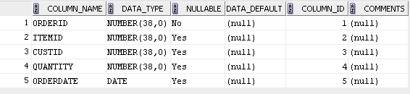

CREATE TABLE delivery_exp9_csa_42( deliveryid INT PRIMARY KEY, custid INT, orderid INT, FOREIGN KEY (custid) REFERENCES customers_exp9_csa_42(custid), FOREIGN KEY (orderid) REFERENCES orders_exp9_csa_42(orderid));

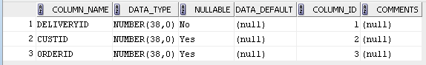

-- 1. List the details of all customers who have placed an order

SELECT DISTINCT c.*FROM customers_exp9_csa_42 cJOIN orders_exp9_csa_42 o ON c.custid = o.custid;

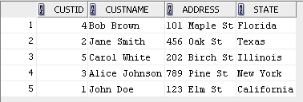

-- 2. List the details of all customers whose orders have been delivered

SELECT DISTINCT c.*FROM customers_exp9_csa_42 c JOIN delivery_exp9_csa_42 d ON c.custid = d.custid;

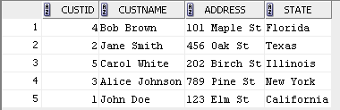

-- 3. Find the order date for all customers whose name starts with the letter ‘J’

SELECT c.custname, o.orderdate FROM customers_exp9_csa_42 c JOIN orders_exp9_csa_42 o ON c.custid = o.custidWHERE c.custname LIKE 'J%';

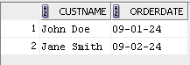

-- 4. Display the name and price of all items bought by the customer ‘Mickey’

SELECT i.itemname, i.priceFROM customers_exp9_csa_42 c JOIN orders_exp9_csa_42 o ON c.custid = o.custid JOIN items_exp9_csa_42 i ON o.itemid = i.itemid WHERE c.custname = 'Mickey';



-- 5. List the details of all customers who have placed an order after January 2013 and not received delivery

SELECT DISTINCT c.*FROM customers_exp9_csa_42 c JOIN orders_exp9_csa_42 o ON c.custid = o.custid LEFT JOIN delivery_exp9_csa_42 d ON o.orderid = d.orderid WHERE o.orderdate > '2013-01-01' AND d.orderid IS NULL;

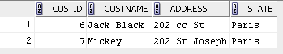

-- 6. Find the itemid of items which has either been ordered or not delivered (Use SET UNION)

SELECT itemid FROM orders_exp9_csa_42 UNION SELECT i.itemid FROM items_exp9_csa_42 I LEFT JOIN delivery_exp9_csa_42d ON i.itemid = d.orderid WHERE d.orderid IS NULL;

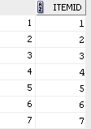

-- 7. Find the custname of all customers who have placed an order and have their orders delivered (Use SET INTERSECTION)

SELECT c.custname FROM customers_exp9_csa_42 c JOIN orders_exp9_csa_42 o ON c.custid = o.custidJOIN delivery_exp9_csa_42d ON o.orderid = d.orderid;

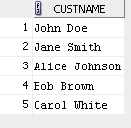

-- 8. Find the custname of all customers who have placed an order but not having their orders delivered (Use SET MINUS)

SELECT c.custname FROM customers_exp9_csa_42 c JOIN orders_exp9_csa_42 o ON c.custid = o.custid LEFT JOIN delivery_exp9_csa_42 d ON o.orderid = d.orderid WHERE d.orderid IS NULL;



-- 9. Find the name of the customer who has placed the most number of orders

SELECT c.custname, COUNT(o.orderid) AS total_orders FROM customers_exp9_csa_42 c JOIN orders_exp9_csa_42 o ON c.custid = o.custid GROUP BY c.custname ORDER BY total_orders DESC LIMIT 1;



-- 10. Find the details of all customers who have purchased items exceeding a price of $5000

SELECT DISTINCT c.* FROM customers_exp9_csa_42 c JOIN orders_exp9_csa_42 o ON c.custid = o.custid JOIN items_exp9_csa_42 i ON o.itemid = i.itemid WHERE i.price > 5000;

-- 11. Find the name and address of customers who have not ordered a ‘Samsung Galaxy S4’

SELECT DISTINCT c.custname, c.address FROM customers_exp9_csa_42 c JOIN orders_exp9_csa_42 o ON c.custid = o.custid JOIN items_exp9_csa_42 i ON o.itemid = i.itemid WHERE i.itemname != 'Samsung Galaxy S4';

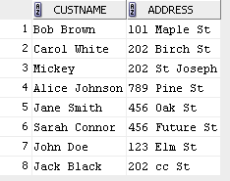

-- 12. Perform Left Outer Join and Right Outer Join on Customers & Orders Table

-- Left Outer Join (All customers and their orders, if any)

SELECT c.*, o.* FROM customers_exp9_csa_42 c LEFT JOIN orders_exp9_csa_42 o ON c.custid = o.custid;

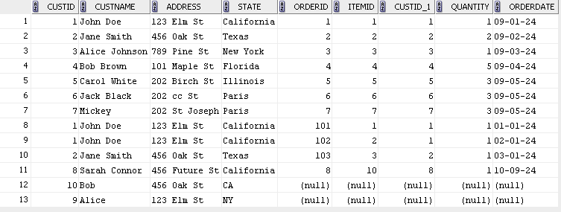

-- Right Outer Join (All orders and their corresponding customers, if any)

SELECT c.*, o.* FROM customers_exp9_csa_42 c RIGHT JOIN orders_exp9_csa_42 o ON c.custid = o.custid;

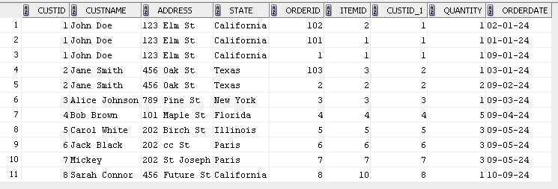

-- 13. Find the details of all customers grouped by state

SELECT state, COUNT(*) AS total_customers FROM customers_exp9_csa_42 GROUP BY state;

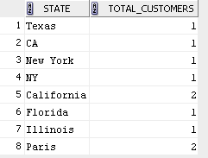

-- 14. Display the details of all items grouped by category and having a price greater than the average price of all items

SELECT category, itemname, price FROM items_exp9_csa_42 WHERE price > (SELECT AVG(price) FROM items_exp9_csa_42) GROUP BY category, itemname, price;

