**EXPERIMENT 10**

create table bank_table(branch_id int,bank_name varchar(20),headoffice varchar(20),branch varchar(20));

insert into bank_table values(1,'sib','tvm','choondacherry');

insert into bank_table values(2,'federal bank','ekm','ktpna');

insert into bank_table values(3,'sbi','tvm','kym');

commit;

Select * from bank_table;

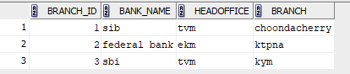

savepoint A;

delete from bank_table where branch_id=2;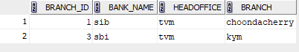

rollback to savepoint A;

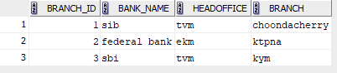

insert into bank_table values(4,'baroda','kym','pala');

Select * from bank_table;

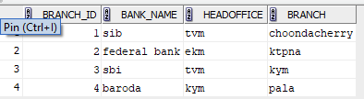

rollback;

Select * from bank_table;

