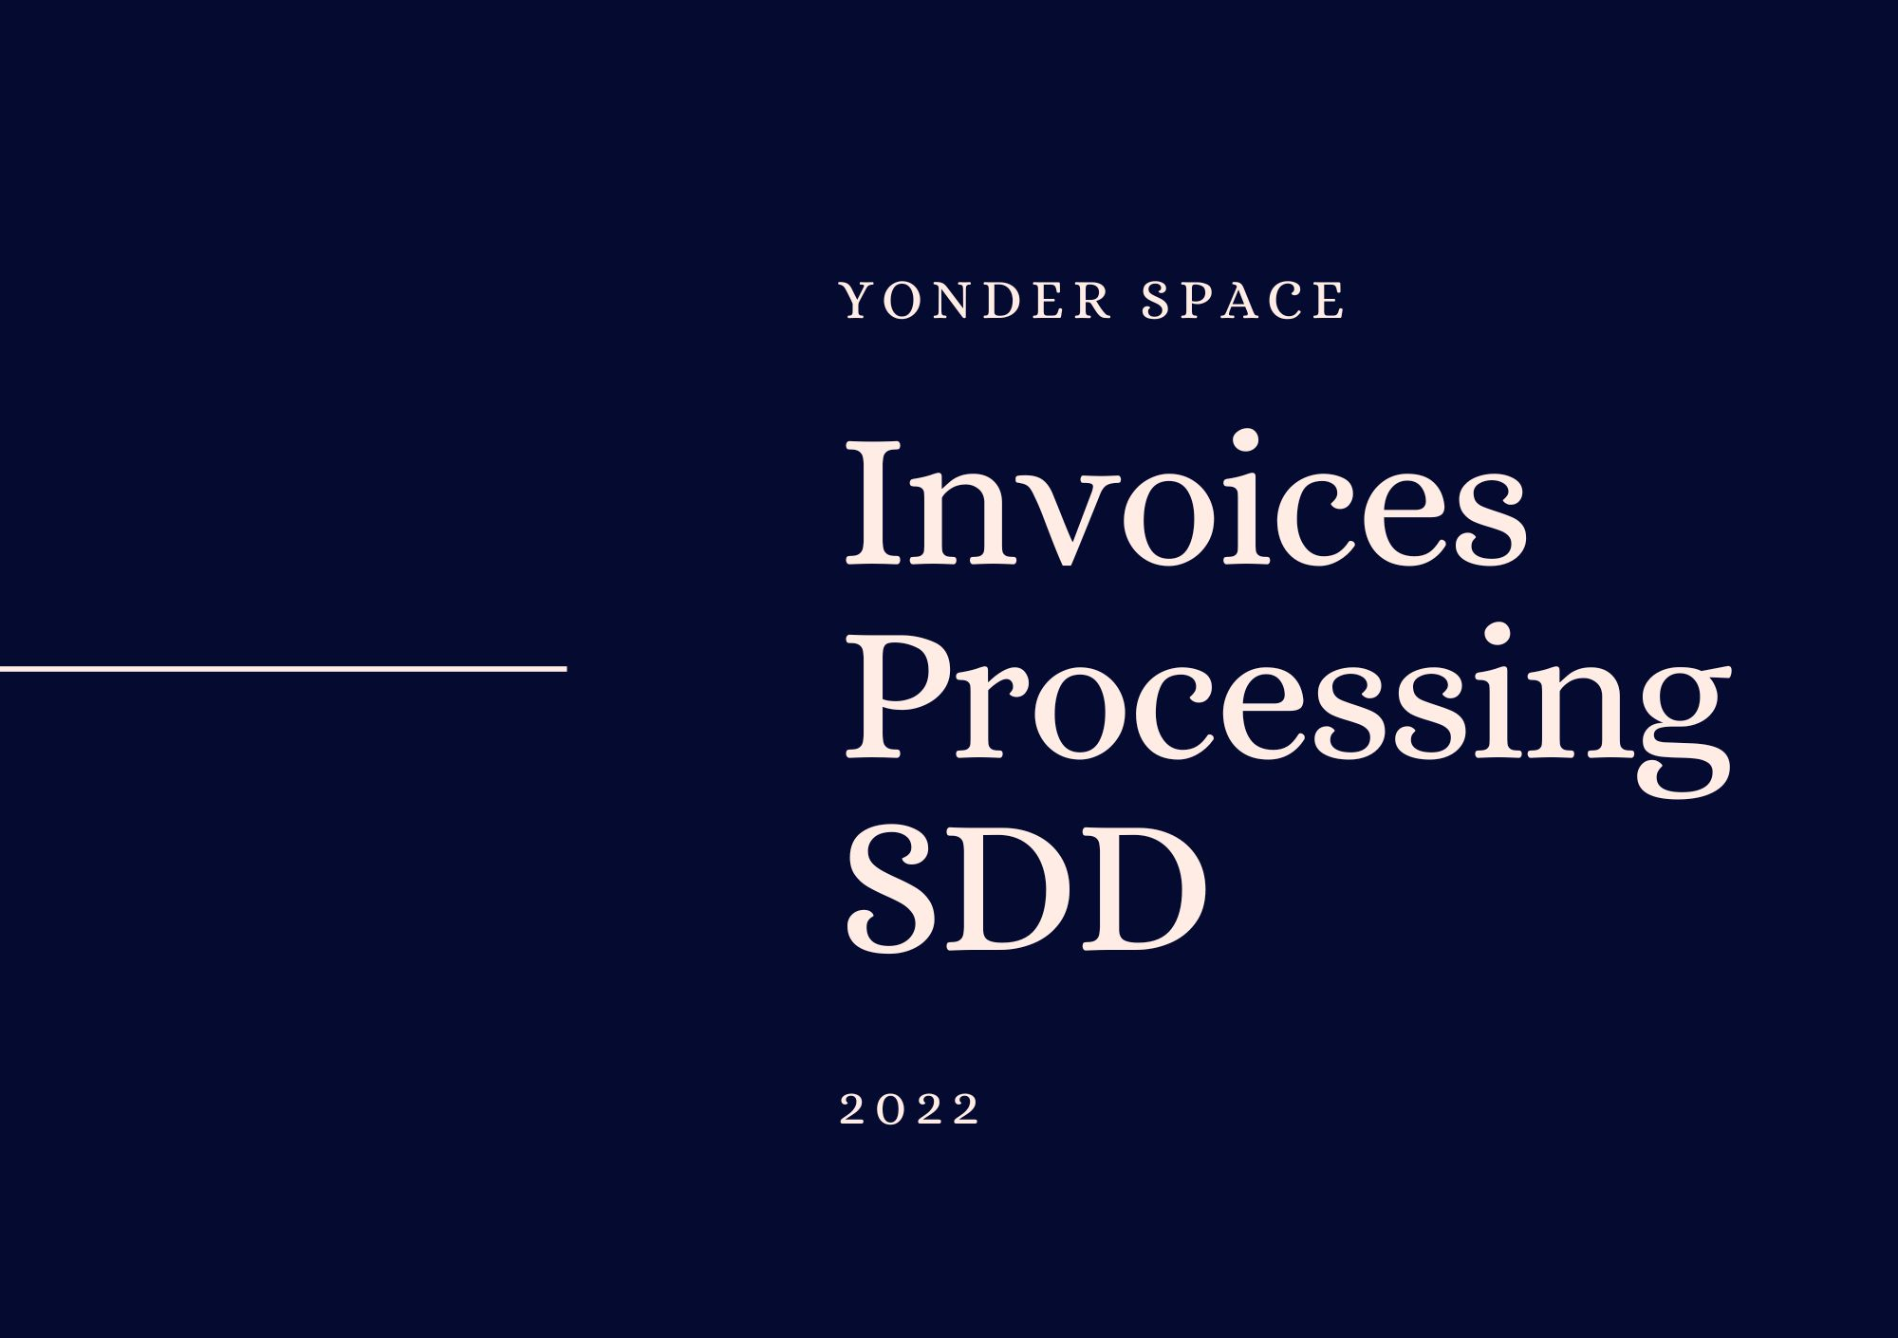­­­­­

|  |  |
| --- | --- |
|  |  |



**Solution Design   
Document (SDD)**



Table of Contents

I. Purpose 3

II. Document History 4

III. Automated process details 5

2 Runtime guide 6

2.1 Master Project Runtime Details 6

2.2 Project(s) workflows 7

2.3 Packages 7

Other Details 8

Future Improvements 8

Other Remarks 8

Glossary 9

# Purpose



Outlines the major components of the Master Project (the overall output of the development, containing one or multiple projects that together cover the scope of the robotic process automation) taking into account all the business restrictions (scheduling, peaks, future increases in volume etc.). The focus of the Solution Architect will be on:

* Robustness;
* Scalability;
* Efficiency;
* Replicability;
* Reusability of component

The information herein is targeted primarily at the developers that will initially implement the solution and subsequently at the support developers in case of change requests.

# Document History

|  |  |  |  |  |  |  |
| --- | --- | --- | --- | --- | --- | --- |
| Date | Version | Role | Name | Organization/ Department | Function | Comments |
|  | 1.0 | Author |  |  | Developer | Final Project |
|  |  |  |  |  |  |  |
|  |  |  |  |  |  |  |
|  |  |  |  |  |  |  |
|  |  |  |  |  |  |  |

# Automated process details

Details filled in need to reflect the actual information for the Master Project released for production. The following table will be populated:

|  |  |
| --- | --- |
| Item | Description |
| Project Name | YonderSpaceInvoices |
| Robot Type | BOR |
| Is Background process?  (No click like UI interaction) | No |
| Orchestrator used? | Yes |
| Scalable | Yes |
| UiPath version used | 21.10.4.0 |

# Runtime guide

## Master Project Runtime Details

Outlines the details of the automated process by filling in the table below.

|  |  |
| --- | --- |
| ITEM NAME | DESCRIPTION |
| Production environment details | Runed manually every 1st day of the month |
| Prerequisites to run | 1st day of the month |
| Input Data | n/a |
| Expected output | email containing archives with invoices sent to accountant |
| How to start the automated process | n/a |
| Reporting (queues reporting, Kibana, Excel or another platform) | n/a |
| How is Orchestrator used? | Assets Store |
| Password policies (mention any specific compliance requests) | Orchestrator used for asset passwords. |
|  |  |
| Stored credentials  (Never use hardcore credentials in the workflow!) | n/a |
|  |  |
| List of queues names | n/a |
| Schedule Details | It is runed manually |
| Multiple Resolutions Supported?  (in case of image automation / Citrix and VDI) | n/a |
| Recommended Resolution | n/a |
| Scalable | Yes |
| Environment used for development  (name, location, configuration details etc) | DEV_1 (personal computer) |
| Environment prerequisites  (OS details, libraries, required apps) | Example: Windows 10, Adobe Reader |
| Repository for project  (where is the developed project stored) | https://github.com/Maribonesso/invoices-extraction |
| Configuration method  (assets, excel file, Json file) | Assets |
| List of reused components | n/a |

## Project(s) workflows

For the workflow files defined below please specify the input and output parameters.

|  |  |  |
| --- | --- | --- |
| Workflow file | Arguments | Description |
| Braintree |  | Logs in and downloads invoice; renames, and moves file to proper folder |
| CompressSendEmail |  | After downloading and renaming all files, bot will compress the folder and send it to accountant email |
| CreateFolderInvoicesYonder |  | Create all folders needed for monthly report |
| Main |  | Flowchart project with all workflows |
| Balance Affecting |  | Downloads PayPal Balance Affecting Doc; renames, and moves file to proper folder |
| Delete cache |  | Deletes PayPal Cache if needed |
| DeletePaypalMessage |  | Deletes PayPal SMS two-factor authentication message from Google Messages |
| Financial Summary EUR |  | Downloads PayPal Financial Summary EUR; renames, and moves file to proper folder |
| Financial Summary USD |  | Downloads PayPal Financial Summary USD; renames, and moves file to proper folder |
| PayPal |  | Flow Chart with all the PayPal processes |
| StartingPaypal | PaypalUser  PaypalPass | Logs in to PayPal |
| Statements |  | Downloads PayPal Statements file; renames, and moves file to proper folder |

## Packages

|  |  |
| --- | --- |
| Package Name | Description |
| DateOperationsEntireMonth : [1.0.3] | Package exclusively created for the project – it is used get first and last day of previous month |
| KanadCharting.Activities : [1.0.0] | Generates SDD automatically |
| Microsoft.Office365.OutlookServices-V2.0 : [2.0.1.2] | To use office if needed |
| UiPath.Mail.Activities : [1.15.0-preview] | To send emails |
| UiPath.System.Activities : [21.10.4] |  |
| UiPath.UIAutomation.Activities : [21.10.5] | Meant to work with User Interface (Optical Character Recognition) |

# Other Details

### Future Improvements

*•* Make the process more resilient to changes the website might have (PayPal)

• Set it up as Unattended Process to be started via Orchestrator

### Other Remarks

The project needs to run every first day of the month

# Glossary

The main terms used in the Solution Architecture Document are defined below:

**Master project** - the overall output of the development, containing one or multiple projects that together cover the scope of the robotic process automation. There is a 1 to 1 connection between the Master Project and the Process to be automated (As presented in the PDD).

**Project** - an UiPath Studio project containing one or multiple workflow files. A project can be converted to a package and run independently, covering a particular scope within the master project. Or multiple projects can be converted into one package depending on the aims and restrictions of the automation. The project is used when defining the development and support phase of the automation.

**Package** - the output of compiling one or multiple projects. A package can be deployed on the robot machine and be executed by the robot service. Only one package can be executed at a given time by a robot. The package is used when defining the running phase of the automation.

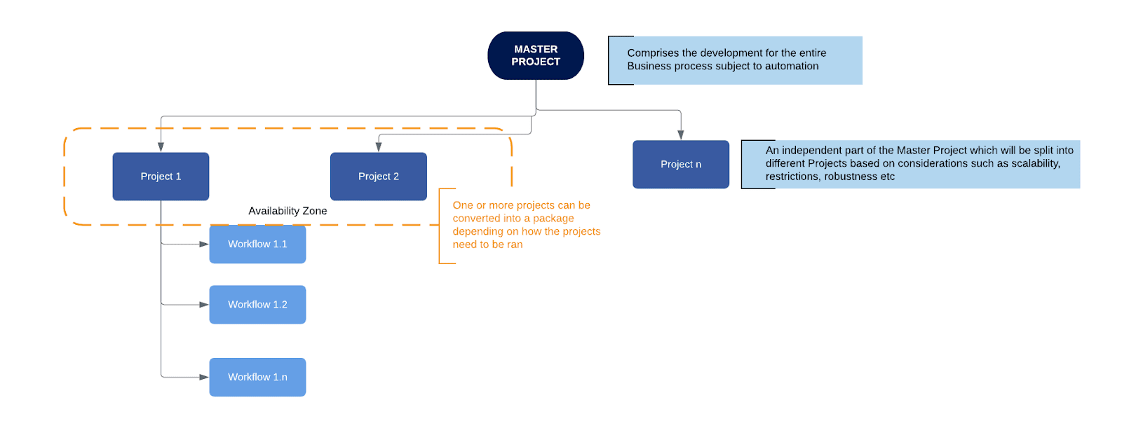**Workflow** - a component of the package, the workflow encapsulates a part of the project logic. The workflow can be of type: sequence, flowchart or state machine. A workflow is saved as an .xaml file inside the project folder. A workflow file can be invoked from another workflow and by default there is an initial workflow file that will run when executing the package.

**Activity** - an action that the robot executes.

**Sequence** - a workflow where activities are executed one after another, in a sequential order

**Flowchart** - a workflow where activities are connected by arrows and the logic of the workflow can be easily followed in a visual manner. The flowchart can also be exported as an image from UiPath studio.

**State machine** - a more advanced way of organizing a workflow, similar to a flowchart.

**BOR** - Back office robot

**FOR** – Front office robot

**Orchestrator** – Enterprise architecture server platform supporting: release management, centralized logging, reporting, auditing and monitoring tools, remote control, centralized scheduling, queue/robot workload management, assets management.