Always check if there are changes to pull from the main branch in the remote repository.

Any remote update will be shown here

­­­PULL

Open Gitbash in your local and enter the command to pull the remote updates in to your local repository

Git pull origin main

When you reload your branch history you can see that you are now working on the latest node.

Developer making updates (push)

In Git gui click rescan to view local updates made by the developer

And then select which update you want to commit in your local

Select the update you want to stage to commit into your local repo.

Click on stage to commit

Commit your updates

Push into remote repository

After clicking the commit button, you should see changes disappeared from the staged changes

Success

In the main github repo you will see changes\updates in the branch. Click on New pull request to ask permission to merge with the main branch.

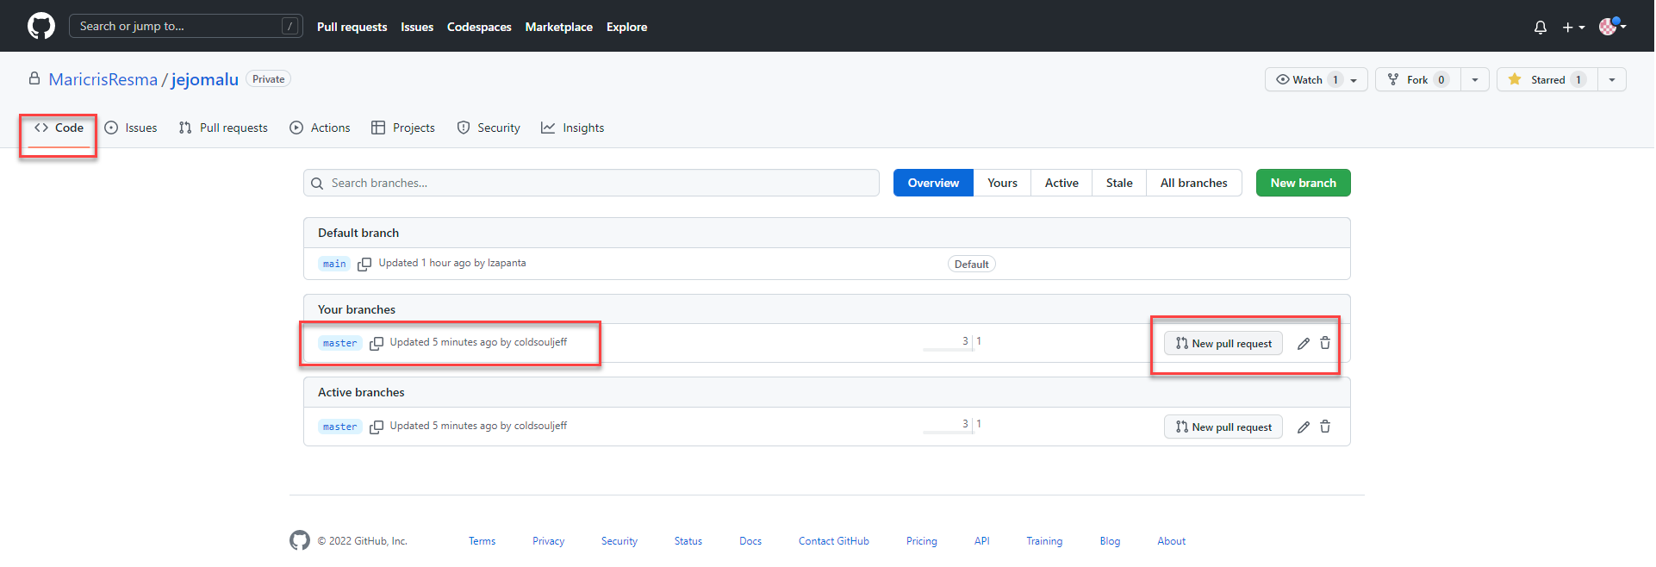

Confirm merge, this button will only show if the branch is not protected by admin.

