

# User manual,

# Java assignment

MSc Applied Bioinformatics,

Marie Schmit

# Set-up and run the program

Open the project in a Java IDE, like NetBeans. Open the files stored in source packages. Clean and build the program, then click on the “run” icon.

If you do not have any IDE installed, open a command prompt window like Windows Prowershell. Go in the repertory where the project is saved and write “javac mainFrame.java” to compile the code, then “java mainframe.java” to run it.

# Functionalities of the program

The first window allow you to choose a file to analyse, either in gtf (.gtf) or in fasta (.fa) format. You can either write the path of the file, or it’s name, in the search bar and chose “browse” to search it, or directly open the file browser by clicking “browse” button. If the format of the chosen file is not fasta or gtf, a message error appears.

Confirm choice of file

Choose another file

Name of the selected file

Open file chooser

Write desired file or path

Once the file is chosen, click “Confirm” to continue. Please not that large files take time to process.

The next page display a menu, depending on the type of file previously chosen. Click again on “Choose new file” to go back to the previous step.

## Fasta files

### Display Text

This command Display the sequence(s) contained in the file. If the file is large, it’s text can be displayed on multiple pages. Use the buttons at the bottom to chose a particular page (Go to page) or navigate between pages (next, previous).

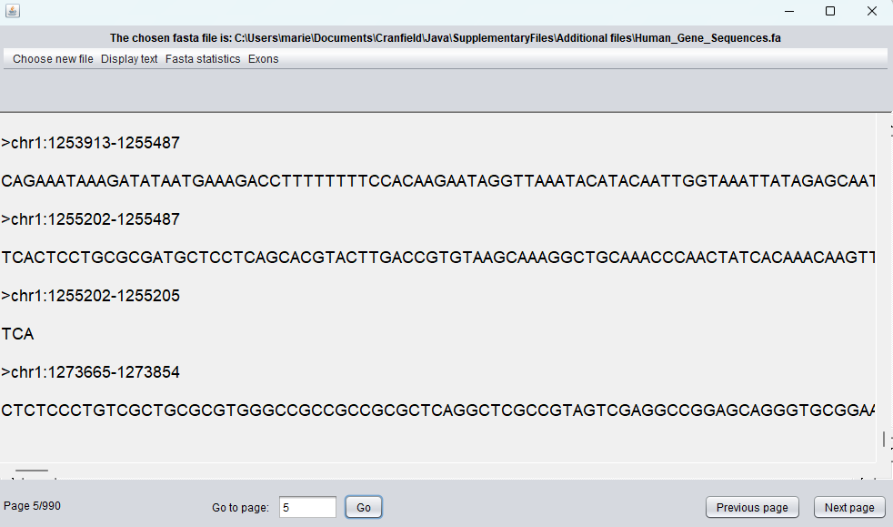

### Fasta statistics

This item allows to display the length of the sequence and its GC content value (or their average values for multiple sequences files). All option displays both.

### Exons

When graphical or textual display of exon is chosen, a new window opens, inviting you to chose a second file. This should be the complementary gtf file of the fasta, containing information on the same gene.

Figure 1 Exons textual display

A graphical display shows sequence or multiple sequences of the fasta file, with blue highlight on exons indicated in the gtf file.

Graphical representation show exons of a single sequence from fasta file, indicated by gtf file. Please note that this option is only available for single sequences. If the sequence is too long to be displayed on the width of the page, it is drawn of the following line.

Figure 2 Exons graphical display, GRch38

## Gtf file

### Display table

Display table option for gtf files is similar to display text of fasta. A page navigator is also available for large files.

### 

Figure 3 Display table with page navigation

### Gtf statistics

Similarly to fasta, those statistics (average number of exons, shortest and longest genes, average length gene), are displayed on the text area.

Figure 4 gtf statistics, all statistics

### Exons

Both exons panels works like fasta’s. The second file chosen should be of fasta format.