Pharmacy-Fragile America
Rural Pharmacy Access and Medicare Spending: A County-Level Case Study (through 2023)

Executive Summary
Across rural America, small town pharmacies are closing, leaving many seniors far from the medicine they need. This project asks whether that lack of access shows up as higher healthcare cost. Using three public datasets joined at the county level, it finds a clear pattern in rural counties: the fewer the pharmacies, the higher the Medicare spending per senior. The most fragile counties, those with zero or one pharmacy, spend about $754 more per senior each year than rural counties with two or more, which adds up to roughly $91 million in extra Medicare spending across 156 counties. The pattern is easy to miss, because large cities hide it, and it appears only once cities are set aside and rural counties are viewed on their own. The gap is also widening over time. For a health focused company, these fragile counties represent both an underserved market and a large, avoidable cost, and a focused, low cost entry could serve patients and lower spending at the same time. The analysis is descriptive rather than causal, and it is offered as a strong, honest starting point for action.
Part 1: The Problem
For many seniors in rural America, the nearest pharmacy can be an hour's drive away. That distance sounds small, until it isn't. One man, who takes blood pressure medicine every night, reaches for his pills one evening and finds the bottle empty. The nearest pharmacy is too far to reach in the dark. The next morning he is rushed and still can't make the long drive. He misses his medicine one day, then two. His blood pressure creeps up, and a few days later he lands in the emergency room.
Now multiply that one man by thousands. Across rural America, small town pharmacies are closing, leaving seniors farther and farther from the medicine they need every day. When people can't easily refill their prescriptions, more of them get sicker and end up in the hospital, and a hospital stay costs Medicare far more than a simple refill ever would.
This project asks a simple question. Do rural areas with fewer pharmacies have higher Medicare spending per senior? And if they do, where should a company like CVS open its next pharmacy, to both serve these communities and bring those costs down?
Part 2: The Data
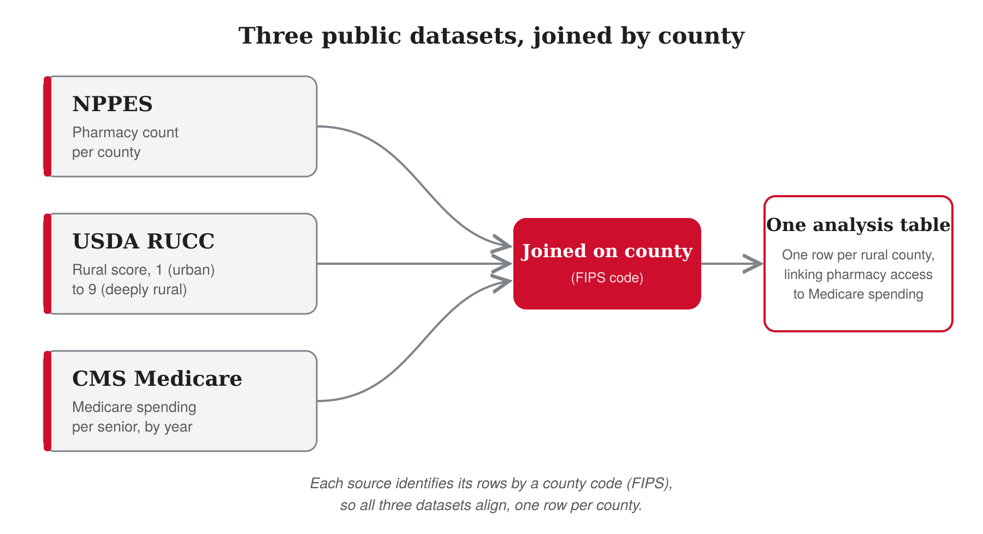
Figure 1. How the three public datasets are joined by county.
The diagram shows the three public datasets used, all free and from the government: NPPES (pharmacy count per county), USDA RUCC (a rural score from 1 urban to 9 deeply rural), and CMS Medicare (Medicare spending per senior, by year). They are joined on the county (FIPS code) to form one analysis table, one row per rural county, linking pharmacy access to Medicare spending.
One note on timing. The Medicare spending data runs through 2023, not to the present day. Every number in this project reflects the years up to 2023.
How the data was prepared, in three stages:
- Raw: each source was loaded exactly as it arrived, with nothing changed, so the original was always kept.
- Clean: text was trimmed, numbers were safely converted, hidden or blank values were marked, and every county code was padded to its full five digits, because some files drop the leading zero.
- Curated: the clean files were joined on the county code into one final table, one row per county each year, ready for analysis.
- Why this matters: keeping the three stages separate means every number can be traced back to its source, which keeps the work honest and easy to check.
This three stage flow is a form of ETL, which stands for Extract, Transform, Load, the standard way data teams prepare data before analysis. To be precise, this project uses the ELT version (Extract, Load, Transform), because the raw files were loaded into the database first and then cleaned and joined there with SQL, rather than cleaned before loading. ETL and ELT are the same idea in a different order, and this project follows the ELT order.
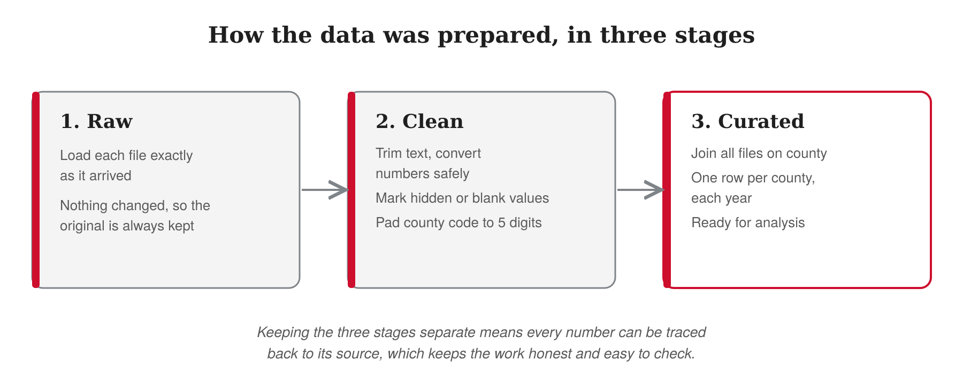
Figure 2. How the raw data was cleaned and joined into one analysis table.
Part 3: What You Found
Insight 1: In rural America, fewer pharmacies go hand in hand with higher Medicare spending per senior.
Looking only at rural counties, a clear pattern appeared. Counties with the most pharmacies spent about $11,156 per senior. Counties with none spent about $12,838. The fewer the pharmacies, the higher the spending, step by step.
In simple terms, the most fragile rural counties, the ones with zero or only one pharmacy, spent about $754 more per senior than rural counties with two or more. There are 156 of these fragile counties, home to about 121,000 seniors. That $754 per senior adds up to roughly $91 million in extra Medicare spending every year.
Insight 2: This pattern is hidden by big cities. It only shows up when you look at rural areas on their own.
At first, the data looked backwards. When I looked at every county in the country together, counties with more pharmacies seemed to have more Medicare spending, not less. That is the opposite of what you would expect.
The reason is cities. Big cities have many pharmacies, and they also have very high medical spending. They have many people, and they have the big hospitals. People often travel from small towns into the city for serious treatment, because that is where the large hospitals and specialists are. So cities are where much of the expensive care actually happens, for reasons that have nothing to do with pharmacies. When cities are mixed into the data, they pull the whole picture in the wrong direction and hide what is really happening in small towns.
When I set the cities aside and looked only at rural counties, the picture flipped. Now the true pattern was clear. In rural areas, fewer pharmacies went with higher spending per senior. Same data, opposite story, once the cities were taken out.
This kind of flip, where a trend reverses once you split the data into the right groups, has a name in statistics: Simpson's paradox. Spotting it, and knowing to look at rural counties on their own, is what turned a confusing result into a clear one.
Insight 3: This gap is not new, and it is getting wider.
This is not a one year fluke. I looked at spending every year from 2019 to 2023, for both groups: rural counties with few pharmacies, and rural counties with more.
In every single year, the fragile counties spent more per senior. And the space between the two groups kept growing. Back in 2019, the fragile counties spent about $220 more per senior. By 2023, that difference had grown to about $754. The gap more than tripled in just five years.
Both groups' costs went up over time, but the fragile counties' costs climbed faster. Whatever is happening in these low pharmacy areas, it is not fading away. It is getting more expensive, year after year.
One honest detail. Spending for both groups dipped in 2020, when the pandemic led many people to put off care. After that, the gap came back and kept widening.
Insight 4: The extra cost is not spread evenly. A small number of counties carry most of it.
The $91 million in extra spending is not shared equally across all 156 fragile counties. It piles up in a handful of them.
Just 15 counties account for about $70 million of that $91 million, which is roughly three quarters of the total. So to make the biggest difference, you would not need to reach all 156 counties at once. You could start with these 15.
Why do these 15 stand out? It comes down to two things together: how much extra each county spends per senior, and how many seniors live there. A county with very high spending but only a few hundred seniors does not add up to much in total. A county with high spending and a good number of seniors is where the real money sits. The top counties are the ones with both.
Part 4: Recommendations
Version A — for CVS Health
The analysis points to a clear opportunity that is well suited to CVS Health.
1. Prioritize the fragile rural counties, beginning with the fifteen that concentrate the most cost.
The excess spending is not evenly spread. Fifteen counties account for roughly three quarters of the total. A focused entry into these counties would reach the largest share of the cost with the smallest footprint.
2. Leverage the CVS Health double advantage.
CVS Health operates as a pharmacy, a health insurer (Aetna), and a pharmacy benefits manager (Caremark). In fragile counties this creates value on two sides at once. As a pharmacy, it can restore access for seniors who have none nearby. As an insurer, it can reduce its own medical costs, since better medication adherence lowers hospital admissions. A pharmacy only competitor captures the retail margin alone. CVS can also capture the downstream savings, a dual position that is difficult for any single line competitor to match.
3. Enter through small, low cost store formats, where CVS can succeed as independents cannot.
Many of these counties are small, so a full scale store is rarely justified. A compact branch, leanly staffed and run at lower overhead, can serve a rural county at a fraction of the cost of a standard location, while offering what delivery cannot: in person counseling, vaccinations, and immediate access when a prescription runs out. Delivery alone is already offered by Amazon Pharmacy and is not a lasting point of difference.
It is important to be honest about the market. Pharmacies are closing across the country. More United States pharmacies closed than opened between 2018 and 2021, and independent pharmacies are under severe strain, with profit margins at their lowest in a decade and roughly one in three owners considering closing. Rural pharmacies are vanishing faster than urban ones.
This does not weaken the case for CVS. It strengthens it. Independent stores are failing not because demand for medicine has fallen, but because low reimbursement from pharmacy benefit managers has squeezed their margins. CVS Health owns its own pharmacy benefits manager (Caremark) and its own insurer (Aetna), which shields it from the very pressure closing independent pharmacies. Because banks lend cautiously, a standalone pharmacy is a difficult project to finance today. A CVS backed branch, supported by its scale and its control of the reimbursement chain, is a far safer and more financeable proposition. In short, CVS can operate profitably where an independent owner cannot.
4. Act now, as the cost of inaction is rising.
The gap between fragile counties and the rest continues to widen. If the recent pace held, it could approach roughly $1,150 per senior by 2026. This figure illustrates the trend rather than a formal forecast, but the direction is consistent. Delay raises the eventual cost, while early action compounds the savings.
Version B — general (for any employer)
The analysis points to a clear and actionable opportunity for any organization involved in pharmacy access, healthcare delivery, or health insurance.
1. Prioritize the fragile rural counties, beginning with the fifteen that concentrate the most cost.
The excess spending is not evenly spread. Fifteen counties account for roughly three quarters of the total. A focused entry into these counties would reach the largest share of the cost with the smallest footprint.
2. Capture value on both sides: access and downstream savings.
The greatest value goes to an organization that benefits not only from filling prescriptions, but also from the medical savings that follow. Improving medication access in fragile counties reduces avoidable hospital admissions, which lowers total healthcare cost. Organizations positioned across both retail pharmacy and healthcare or insurance, such as integrated health companies, insurers, or health systems, can capture both the service revenue and the downstream savings. A pure retail pharmacy captures only the first. The opportunity is therefore strongest for players with a stake in overall patient outcomes, not prescription volume alone.
3. Expand access through low cost models suited to small markets.
Many of these counties are small, so a full scale store is rarely justified. Lower cost approaches, such as compact branch formats, partnerships with existing rural clinics or retailers, or shared service models, can extend access affordably. A physical presence offers what delivery alone cannot: in person counseling, vaccinations, and immediate access when a prescription runs out. Delivery by itself is already served by national players such as Amazon Pharmacy and is not a lasting advantage.
The market context matters. Pharmacies are closing nationwide. More United States pharmacies closed than opened between 2018 and 2021, and independent pharmacies are under severe strain, with margins at a decade low and roughly one in three owners considering closing. The cause is not falling demand but low reimbursement from pharmacy benefit managers. Any organization entering this space should plan for that reimbursement pressure, through scale, integration, or partnership, rather than assume a standalone store will succeed on its own.
4. Act now, as the cost of inaction is rising.
The gap between fragile counties and the rest continues to widen. If the recent pace held, it could approach roughly $1,150 per senior by 2026. This figure illustrates the trend rather than a formal forecast, but the direction is consistent. Delay raises the eventual cost, while early action compounds the savings.
Part 5: Honest Limits
A good analysis is clear about what it can and cannot prove. Here are the limits of this project.
1. This is a pattern, not proof.
The data shows that fewer pharmacies and higher Medicare spending appear together in rural counties. It does not prove that one causes the other. Other things could play a role, such as income, distance to a hospital, or how healthy a community was to begin with. The honest reading is that these two facts are strongly linked, and the link is worth acting on, but this study alone does not prove cause and effect.
2. The data ends in 2023.
The Medicare spending numbers run through 2023, not to the present day. The pattern may have shifted since then, so any decision should be checked against newer data when it becomes available.
3. The pharmacy count is a snapshot.
I counted how many pharmacies exist in each county today, using one national list. This is a reliable picture of access right now, but it cannot perfectly track pharmacies that closed years ago, because closed pharmacies drop out of the list. So this project measures pharmacy access as it stands, not the full history of closures.
4. Small counties can be noisy.
Some fragile counties have only a few hundred seniors. In a small group, one very sick person can swing the average. The pattern across many counties is solid, but any single small county's number should be read with care.
5. This looks at total Medicare spending, not drug spending alone.
The spending figures cover hospital and medical care. The separate Medicare drug benefit (Part D) was not included, because it is published in a different file. Adding it later would sharpen the picture.
Tools and Skills
SQL (SQL Server): cleaned and transformed the raw data into an analysis ready table through a layered pipeline.
Public data: combined three federal datasets (NPPES, USDA RUCC, CMS Medicare Geographic Variation) on the county key.
Analysis: population weighted averages, controlling for urbanization, and separating rate from total.
Tableau: built an interactive dashboard with a map, a trend line, and ranked county charts.
Communication: wrote this case study for a business audience.
Sources (for the market facts in Part 4)
- More US Pharmacies Closed Than Opened In 2018–21 — Health Affairs (2024): https://www.healthaffairs.org/doi/10.1377/hlthaff.2024.00192
- NCPA 2025 Survey of Independent Pharmacy (margins at a decade low; ~1 in 3 owners considering closing): https://ncpa.org/sites/default/files/2025-01/1.27.2025-FinalExecSummary.NCPA_.MemberSurvey.pdf
- The K-Shaped Pharmacy Shakeout: Lost Access in Rural America — Drug Channels (2026): https://www.drugchannels.net/2026/08/the-k-shaped-pharmacy-shakeout.html
- Update on Rural Independently Owned Pharmacy Closures, 2003–2021 — RUPRI Rural Health Research: https://www.ruralhealthresearch.org/alerts/504

