Sample_SRR6175537_fastqc

# Summary

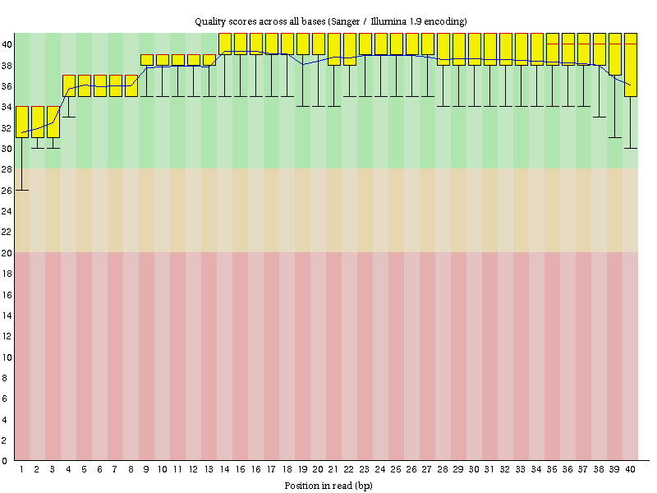

Sample_SRR6175537_fastqc

# Summary



Sample_SRR6175537_fastqc

# Summary



Sample_SRR6175537_fastqc

# Summary



Sample_SRR6175537_fastqc

# Summary



Sample_SRR6175537_fastqc

# Summary



Sample_SRR6175538_fastqc

# Summary

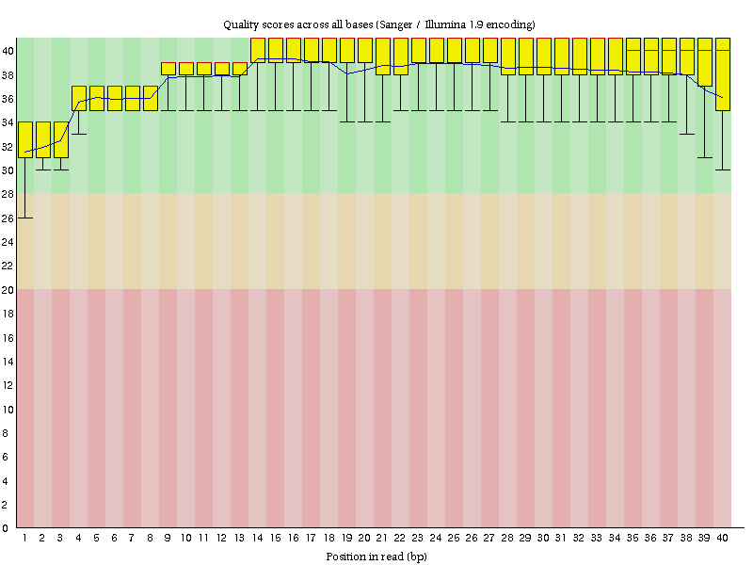

Sample_SRR6175538_fastqc

# Summary



Sample_SRR6175538_fastqc

# Summary



Sample_SRR6175538_fastqc

# Summary



Sample_SRR6175538_fastqc

# Summary



Sample_SRR6175538_fastqc

# Summary



Sample_SRR6175539_fastqc

# Summary

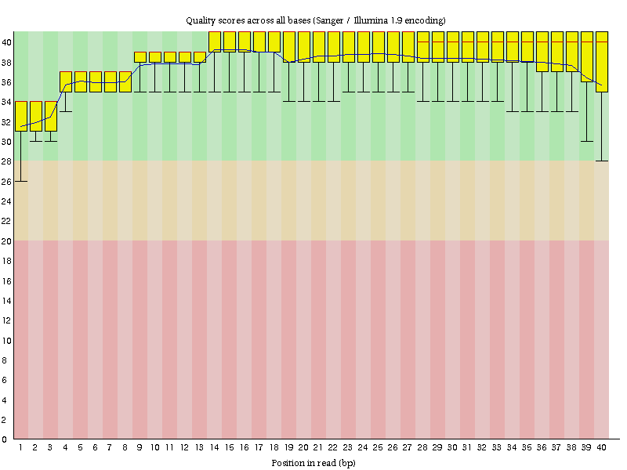

Sample_SRR6175539_fastqc

# Summary



Sample_SRR6175539_fastqc

# Summary



Sample_SRR6175539_fastqc

# Summary



Sample_SRR6175539_fastqc

# Summary



Sample_SRR6175539_fastqc

# Summary



Sample_SRR6175540_fastqc

# Summary

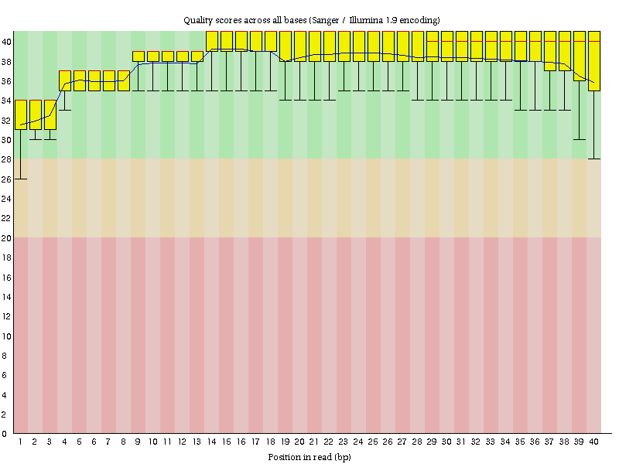

Sample_SRR6175540_fastqc

# Summary



Sample_SRR6175540_fastqc

# Summary



Sample_SRR6175540_fastqc

# Summary



Sample_SRR6175540_fastqc

# Summary



Sample_SRR6175540_fastqc

# Summary



Sample_SRR6175541_fastqc

# Summary

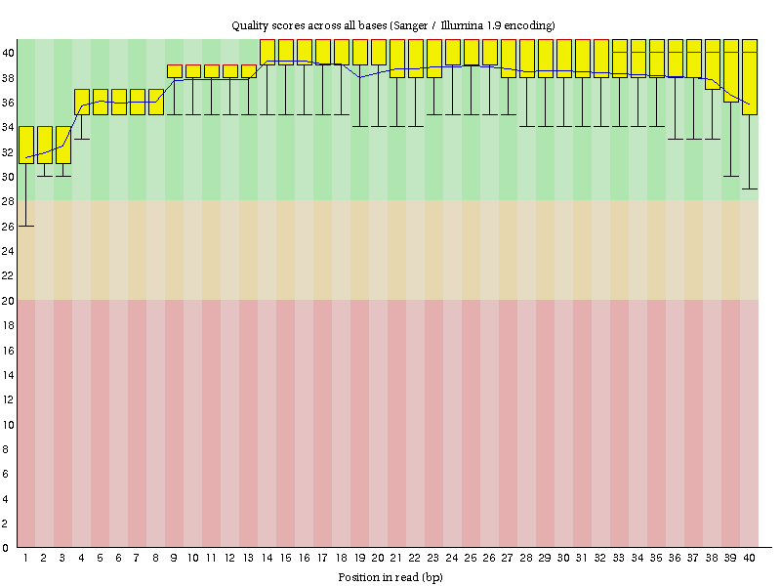

Sample_SRR6175541_fastqc

# Summary



Sample_SRR6175541_fastqc

# Summary



Sample_SRR6175541_fastqc

# Summary



Sample_SRR6175541_fastqc

# Summary



Sample_SRR6175541_fastqc

# Summary



Sample_SRR6175542_fastqc

# Summary

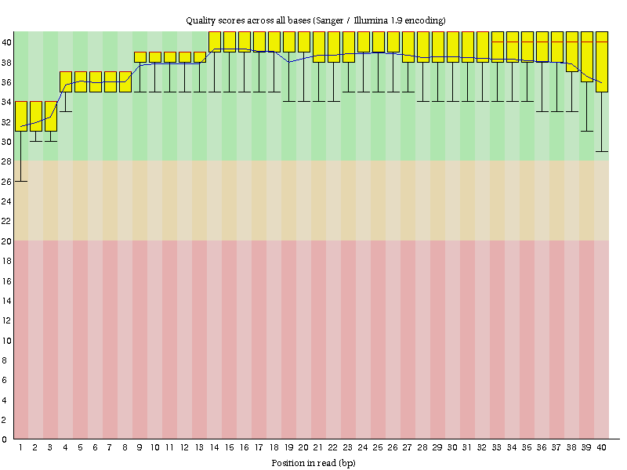

Sample_SRR6175542_fastqc

# Summary



Sample_SRR6175542_fastqc

# Summary



Sample_SRR6175542_fastqc

# Summary



Sample_SRR6175542_fastqc

# Summary



Sample_SRR6175542_fastqc

# Summary



Sample_SRR6175543_fastqc

# Summary

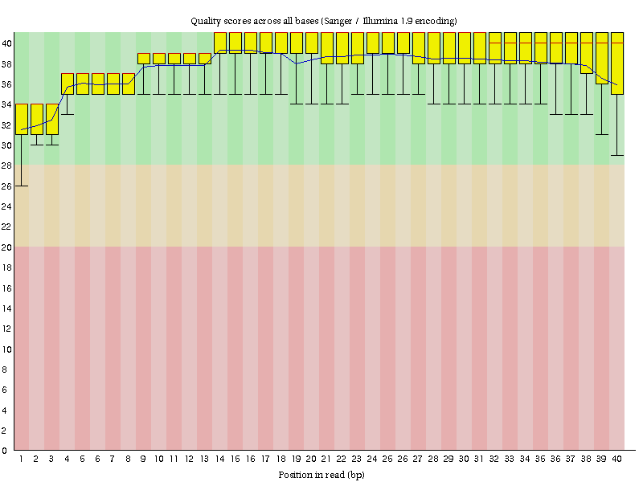

Sample_SRR6175543_fastqc

# Summary



Sample_SRR6175543_fastqc

# Summary



Sample_SRR6175543_fastqc

# Summary



Sample_SRR6175543_fastqc

# Summary



Sample_SRR6175543_fastqc

# Summary



Sample_SRR6175544_fastqc

# Summary

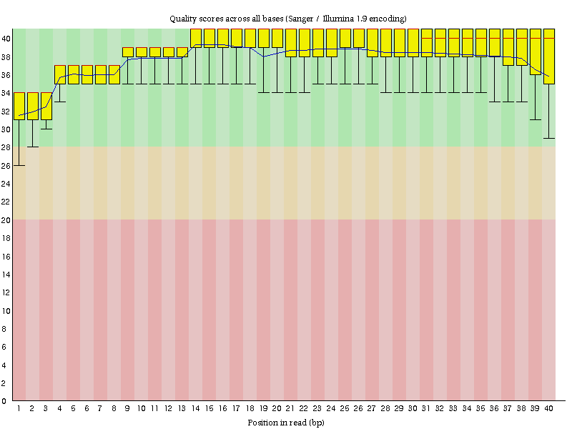

Sample_SRR6175544_fastqc

# Summary



Sample_SRR6175544_fastqc

# Summary



Sample_SRR6175544_fastqc

# Summary



Sample_SRR6175544_fastqc

# Summary



Sample_SRR6175544_fastqc

# Summary



Sample_SRR6175545_fastqc

# Summary

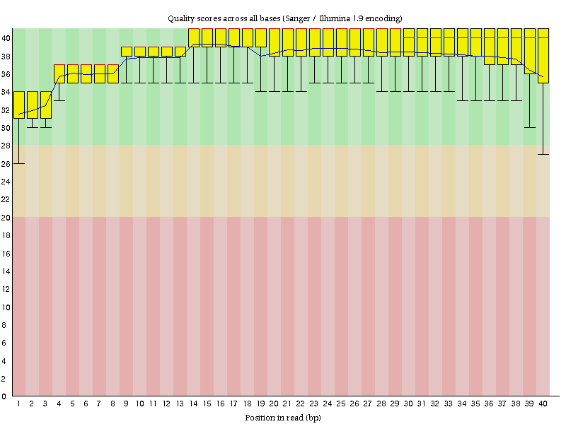

Sample_SRR6175545_fastqc

# Summary



Sample_SRR6175545_fastqc

# Summary



Sample_SRR6175545_fastqc

# Summary



Sample_SRR6175545_fastqc

# Summary



Sample_SRR6175545_fastqc

# Summary



Sample_SRR6175546_fastqc

# Summary

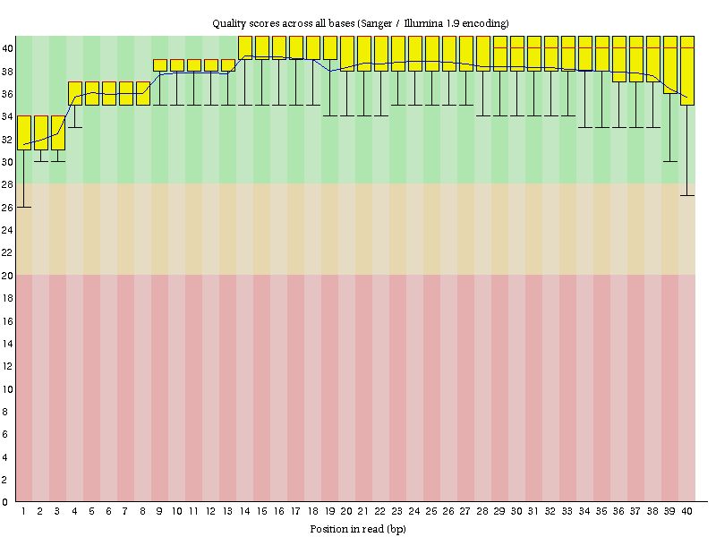

Sample_SRR6175546_fastqc

# Summary



Sample_SRR6175546_fastqc

# Summary



Sample_SRR6175546_fastqc

# Summary



Sample_SRR6175546_fastqc

# Summary



Sample_SRR6175546_fastqc

# Summary



Sample_SRR6175547_fastqc

# Summary

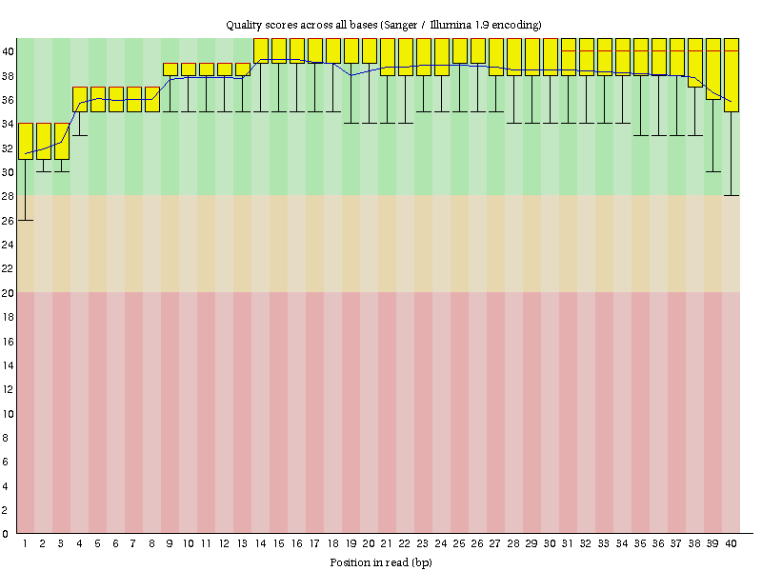

Sample_SRR6175547_fastqc

# Summary



Sample_SRR6175547_fastqc

# Summary



Sample_SRR6175547_fastqc

# Summary



Sample_SRR6175547_fastqc

# Summary



Sample_SRR6175547_fastqc

# Summary



Sample_SRR6175548_fastqc

# Summary

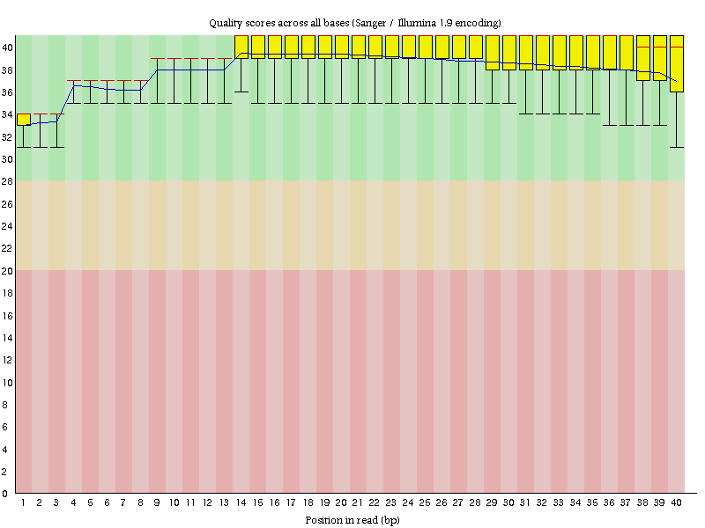

Sample_SRR6175548_fastqc

# Summary



Sample_SRR6175548_fastqc

# Summary



Sample_SRR6175548_fastqc

# Summary



Sample_SRR6175548_fastqc

# Summary



Sample_SRR6175548_fastqc

# Summary



Sample_SRR6175549_fastqc

# Summary

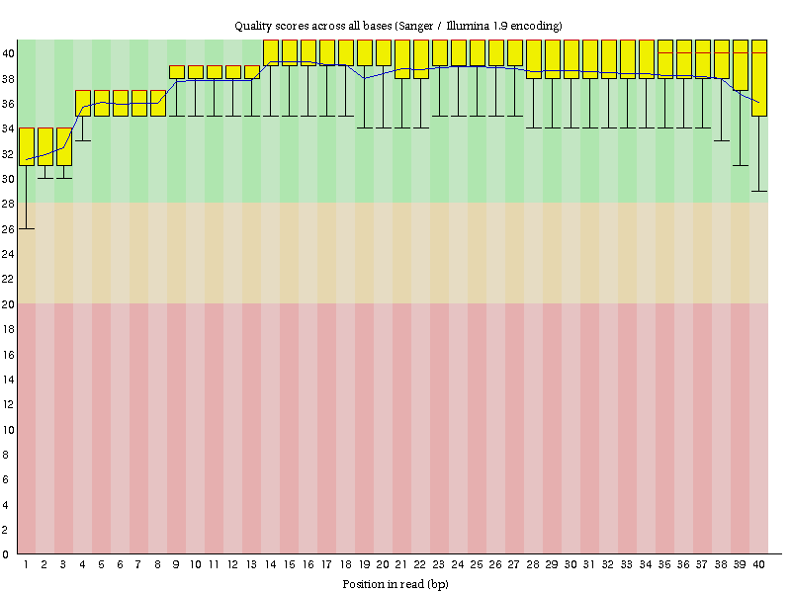

Sample_SRR6175549_fastqc

# Summary



Sample_SRR6175549_fastqc

# Summary



Sample_SRR6175549_fastqc

# Summary



Sample_SRR6175549_fastqc

# Summary



Sample_SRR6175549_fastqc

# Summary



Sample_SRR6175550_fastqc

# Summary

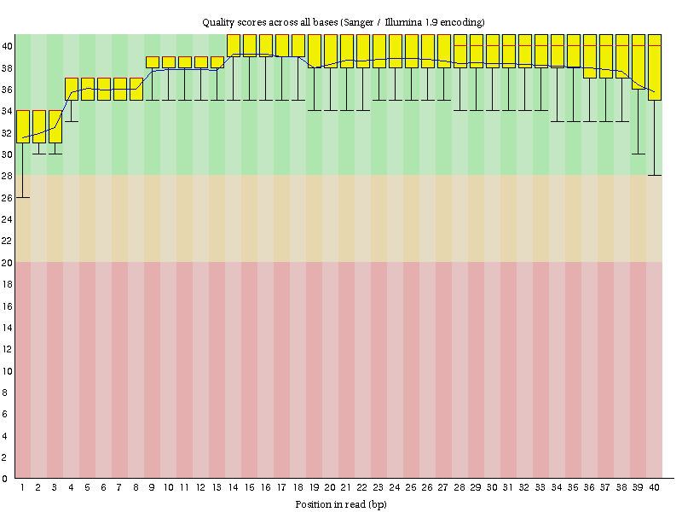

Sample_SRR6175550_fastqc

# Summary



Sample_SRR6175550_fastqc

# Summary



Sample_SRR6175550_fastqc

# Summary



Sample_SRR6175550_fastqc

# Summary



Sample_SRR6175550_fastqc

# Summary



Sample_SRR6175551_fastqc

# Summary

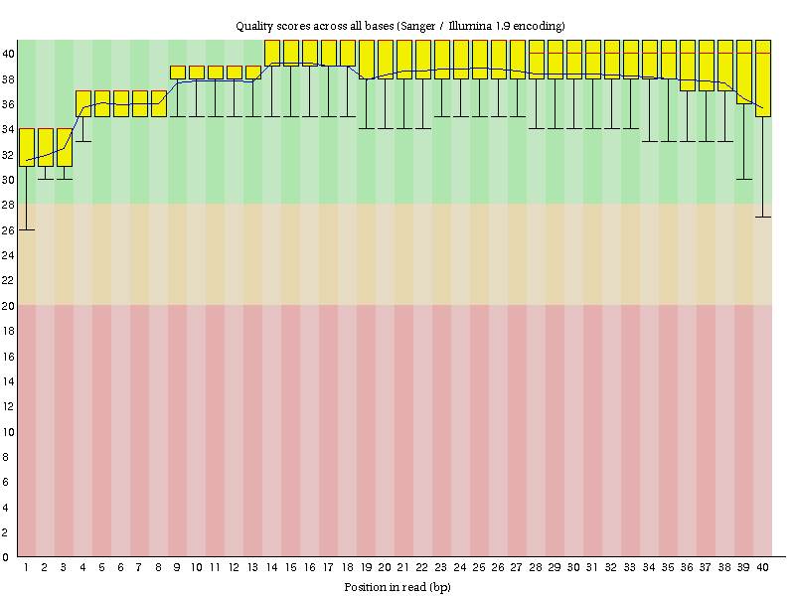

Sample_SRR6175551_fastqc

# Summary



Sample_SRR6175551_fastqc

# Summary



Sample_SRR6175551_fastqc

# Summary



Sample_SRR6175551_fastqc

# Summary



Sample_SRR6175551_fastqc

# Summary



Sample_SRR6175552_fastqc

# Summary

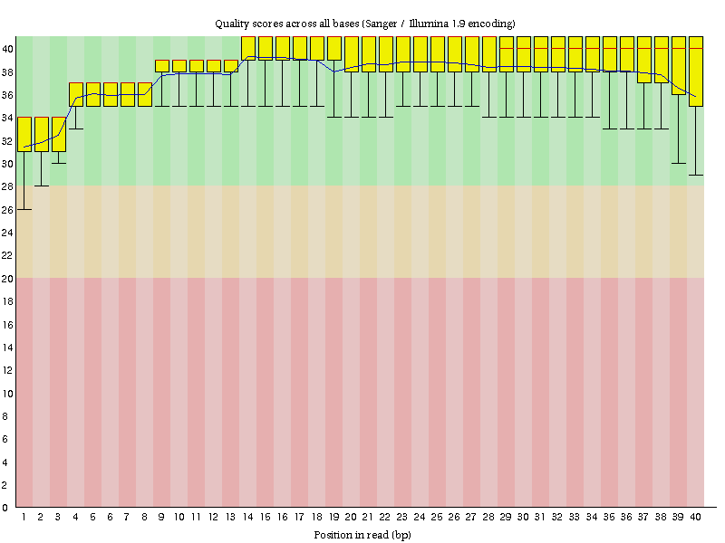

Sample_SRR6175552_fastqc

# Summary



Sample_SRR6175552_fastqc

# Summary



Sample_SRR6175552_fastqc

# Summary



Sample_SRR6175552_fastqc

# Summary



Sample_SRR6175552_fastqc

# Summary

