Data Analytics Implementation

Introduction
The transportation system in Wales faces challenges and opportunities, focusing on integrating land use and transport planning to foster sustainability and efficiency. Key issues include geographical constraints and the need for improved rural connectivity. The Welsh Government emphasizes regional transport plans to ensure equitable access to transportation and services. Enhancing the design and location of new developments supports sustainable transport modes, aiming to reduce car dependence. Rigorous data validation and consistency checks underpin informed decision-making and effective policy implementation, promoting a transport system that meets citizens' needs while fostering sustainability, accessibility, and resilience (Welsh Government, 2014; 2021a; 2021b; 2021c).

Data Pre-processing on relevant tables
Our data analytics report focused on the following tables from the National Survey for Wales, 2013-2014:

- Table 1: Overall satisfaction with state of transport system in Wales, by household type
- Table 3: Overall satisfaction with state of transport system in Wales, by gender
- Table 4: Overall satisfaction with the state of transport system in Wales, by urban/rural area
- Table 6: Overall satisfaction with the state of transport system in Wales, by public services footprint
- Table 17: Have use of a car, by gender
- Table 22: Have use of a car, by limiting long-term illness
- Table 40: Feeling of safety travelling by public transport after dark, by age
- Table 41: Feeling of safety travelling by public transport after dark, by gender

After loading the excel file containing all our data set, a function clean_table is defined to standardise the cleaning and preprocessing steps for each table. This function takes the sheet name, the number of rows to skip, the number of rows to read, the columns to use, and the new column names as parameters. Each relevant table is then preprocessed using the clean_table function. The skip_rows, n_rows, use_cols, and col_names parameters are adjusted for each table based on its structure. After preprocessing, the cleaned data is saved to new CSV files for further analysis.

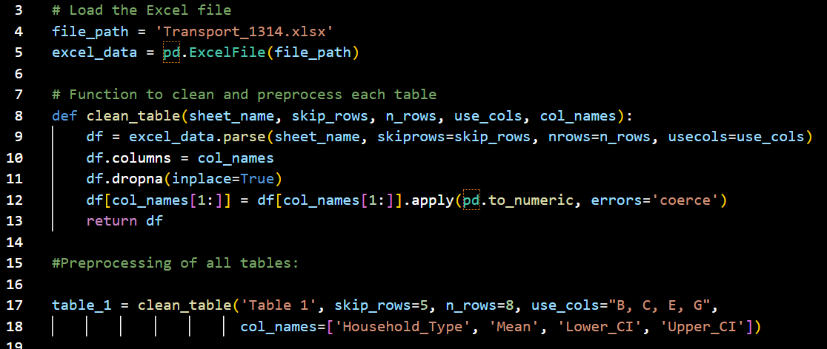clean_relevant_tables.py
Code extract: load file, function to clean tables, function implementation for the first relevant table

Explanation of the Code:
- The clean_table function is reusable for different tables, ensuring consistency in preprocessing steps.
- The skip_rows, n_rows, use_cols, and col_names parameters are tailored for each table to accurately reflect their structure.
- The dropna method removes any additional rows containing NaN values, cleaning the dataset.
- Converting columns to numeric types ensures proper data handling and analysis.
- The cleaned data is saved to CSV files, one for each table, making it ready for further analysis.
This comprehensive preprocessing ensures that the data is clean, consistent, and suitable for detailed analysis, aligning with the objectives of the study.

Data Analysis Implementation

After pre-processing the relevant tables, data analysis can actually start: each csv file containing the clean data relevant for the analysis is now being loaded and analysed through statistical analysis and visualisation.

References

Welsh Government (2014) Technical Advice Note (TAN) 18: Transport. Available from: https://www.gov.wales/technical-advice-note-tan-18-transport [Accessed 1 July 2024].

Welsh Government (2021a) Planning policy and guidance: transport. Available from: https://www.gov.wales/planning-policy-and-guidance-transport [Accessed 1 July 2024].

Welsh Government (2021b) Strategic framework for Welsh Government surveys. Available from: https://www.gov.wales/strategic-framework-welsh-government-surveys [Accessed 1 July 2024].

Welsh Government (2021c) Types of statistics and research. Available from: https://www.gov.wales/types-statistics-and-research [Accessed 1 July 2024].

