Data Analytics Report

Background Research
The transportation system in Wales faces significant challenges and opportunities, as detailed in the Welsh Government's Technical Advice Note (TAN) 18 and associated planning policies. A primary goal is to integrate land use and transport planning to foster a more sustainable and efficient transport network, aiming to reduce private vehicle reliance, decrease carbon emissions, and encourage public transport and active travel modes such as walking and cycling (Welsh Government, 2014).
Key issues include addressing Wales's geographical and infrastructural constraints, such as its varied topography and the need for improved connectivity in rural areas. The Welsh Government underscores the importance of regional transport plans that cater to the distinct needs of urban centres and remote communities, ensuring equitable access to transportation and services (Welsh Government, 2021a).
Moreover, TAN 18 guidance stresses the necessity of enhancing the design and location of new developments to support sustainable transport modes. This approach aims to create less car-dependent communities and promote environmentally friendly travel options (Welsh Government, 2021b). Ensuring data quality and consistency in transportation planning is another critical aspect, with the Welsh Government employing rigorous data validation, consistency checks, and thorough documentation practices. These measures support informed decision-making and effective policy implementation (Welsh Government, 2021c).
Overall, the strategic framework and technical guidelines set by the Welsh Government aim to create a transportation system that meets citizens' needs while promoting sustainability, accessibility, and resilience.

Dataset Overview and UML Diagram

Respondents: Contains demographic details of each respondent.
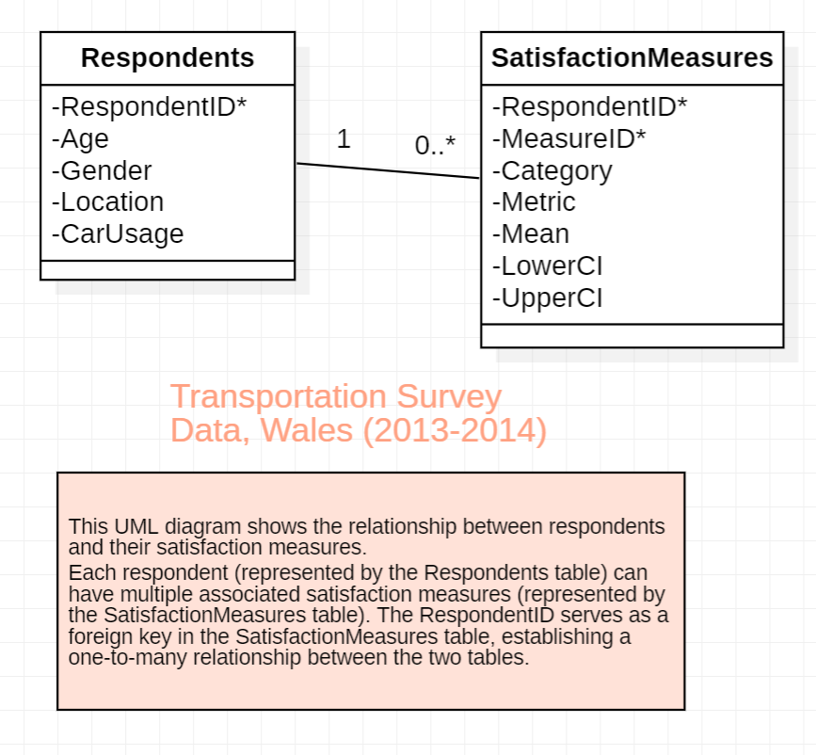Primary Key: Indicated by an asterisk (*) next to the attribute name.
Foreign Key: Indicated by an asterisk (*) next to the attribute name and labeled in the explanatory note.
Multiplicity: Indicates the number of instances in the relationship. For example, 1 and 0..* (i.e. many).
- RespondentID (Primary Key): Unique identifier for each respondent.
- Age
- Gender
- Location
- CarUsage: Indicates if the respondent uses a car.

SatisfactionMeasures: Records various satisfaction metrics related to each respondent.
- RespondentID (Foreign Key): Links to the RespondentID in the Respondents table.
- MeasureID (Primary Key): Unique identifier for each satisfaction measure record.
- Category: Category of the satisfaction measure.
- Metric: Specific metric being measured.
- Mean: Mean satisfaction score.
- LowerCI: Lower bound of the confidence interval for the satisfaction score.
- UpperCI: Upper bound of the confidence interval for the satisfaction score.

This UML diagram was created using StarUML. It depicts the structure and relationships within the dataset, highlighting the one-to-many relationship between respondents and their satisfaction measures.
Each respondent in the survey can have multiple associated satisfaction measures, reflecting their views on different aspects of the transport system. The RespondentID in the SatisfactionMeasures table serves as a foreign key, linking each satisfaction measure back to the corresponding respondent in the Respondents table. This relational design facilitates detailed analysis of satisfaction metrics across different demographic groups, enabling insights into how various factors influence public satisfaction with the transport system.
The attributes in the Respondents table include demographic information and car usage, which are essential for analysing trends and patterns in satisfaction levels. The SatisfactionMeasures table includes attributes for different satisfaction metrics, categorised by specific measures, and includes confidence intervals to indicate the precision of the satisfaction scores.
This structure allows for detailed analysis of satisfaction measures by demographic groups, enabling insights into the effectiveness and areas for improvement in the transport system.

Data Analysis Strategy

To understand citizen satisfaction, usage patterns, and key issues in public transport in Wales, a systematic data analysis strategy has been established, using the Data Pipeline and the Master Data Management Model.

Relevant Tables

The following tables from the National Survey for Wales, 2013-2014, have been selected based on their relevance to the objectives of the analysis:
- Table 1: Overall satisfaction with state of transport system in Wales, by household type
- Table 3: Overall satisfaction with state of transport system in Wales, by gender
- Table 4: Overall satisfaction with the state of transport system in Wales, by urban/rural area
- Table 6: Overall satisfaction with the state of transport system in Wales, by public services footprint
- Table 17: Have use of a car, by gender
- Table 22: Have use of a car, by limiting long-term illness
- Table 40: Feeling of safety travelling by public transport after dark, by age
- Table 41: Feeling of safety travelling by public transport after dark, by gender

This set of tables will enable the policy makers of the transport system in Wales to address several issues relating to transportation, including regional variations, the impact of public services on satisfaction with the transportation system, gender and age disparities, general inclusivity, accessibility of transportation for all, and safety concerns. This strategic selection ensures that the analysis will be addressing multiple facets of public transport satisfaction and usage in Wales.

Data Pipeline Steps

To gain comprehensive insights into citizen satisfaction, usage patterns, and safety concerns in public transport in Wales, we will utilise various data processing and analysis techniques facilitated by the Pandas library. Pandas provides powerful data structures and data analysis tools that are essential for handling large datasets (Pandas Development Team, 2023).
The chosen data pipeline involves several steps, including data extraction, cleaning, integration, and analysis: the DataFrame object in Pandas can be used for efficient data manipulation and analysis (Molin, 2021).

In the above code, the Excel file is loaded using the pd.ExcelFile method, which allows us to parse specific sheets. The parse method is used to load Table 1 from the Excel file. We skip the first 5 rows, read 8 rows of data, and select columns B, C, E, and G. These columns correspond to the household type, mean satisfaction score, lower confidence interval, and upper confidence interval. Columns are renamed to more descriptive names for better clarity: Household_Type, Mean, Lower_CI, and Upper_CI. Any additional rows containing NaN values are removed to clean the dataset. Columns Mean, Lower_CI, and Upper_CI are converted to numeric types to ensure proper data handling and analysis. The cleaned DataFrame is displayed and saved to a new CSV file for further analysis.
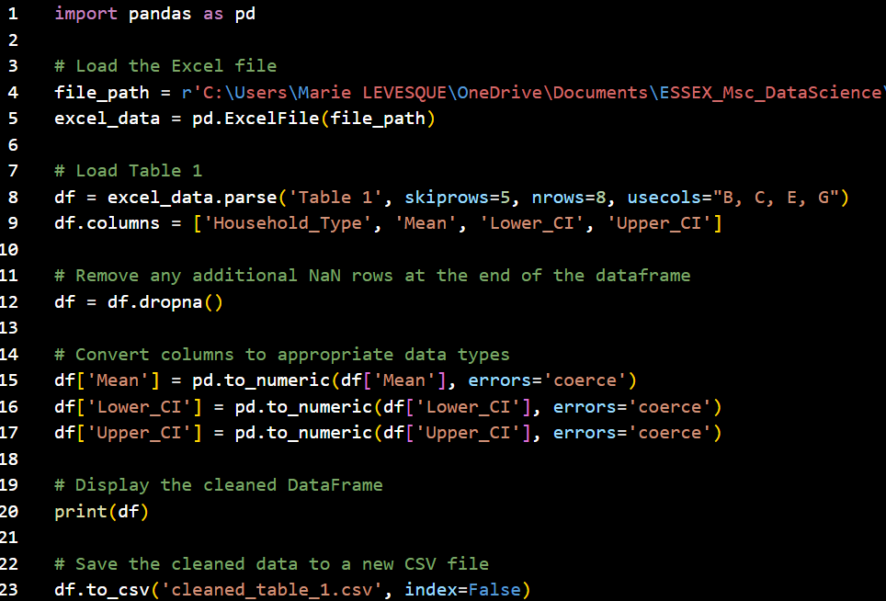clean_table_1.py
Code for extracting and cleaning Table 1's data and saving it to a CSV File.
IDE: Visual Studio Code
The National Survey for Wales, 2013-2014, ensures data quality and consistency through several pre-processing steps and methodological approaches. According to the technical notes provided with the dataset, respondents who did not know the answer to a question or refused to answer have been excluded. This ensures that the data is free from blanks or missing values due to non-response.
To maintain robust results, categories with sparse responses have been combined. The precision of estimates is categorised using the coefficient of variation (CV), with estimates classified as precise, reasonably precise, or acceptable based on the CV. This provides a measure of reliability for each data point.
Each estimate includes a 95% confidence interval, indicating the margin of uncertainty. This statistical measure provides context for interpreting the data and ensures that conclusions drawn are statistically sound. Additionally, sample sizes are unweighted and rounded to the nearest 100 for larger samples, and to the exact number for samples below 100. This rounding facilitates analysis while maintaining the integrity of the sample size data. As a consequence, the dataset is consistent, reliable, and suitable for analysis.

To perform data analysis, data visualisation will provide the necessary insights and enable the policy makers to identify trends and patterns in the dataset. For instance, histograms are useful for an overall view of the distribution of data points, providing a simple and quick visual summary, using the matplotlib Python library.
For visualising the satisfaction scores across different public services footprints (table 6), a boxplot is a suitable choice; indeed, boxplots allow for easy comparison of satisfaction scores across multiple categories. They show the median, quartiles, and potential outliers, providing a clear picture of the distribution of scores within each category. While boxplots don't directly show confidence intervals, they help in understanding the spread and central tendency, which is useful when confidence intervals are narrow (as in this dataset).

In the above code, the csv file containing table 6’s cleaned data is read using Pandas. The code uses matplotlib.pyplot, a library for data visualisation. The plt.boxplot function creates the boxplot. The satisfaction scores (Mean) are grouped by each public services footprint. The x-axis is labelled with the public services footprints, and the y-axis is labelled with the mean satisfaction score. The title provides context for the visualization. The x-axis labels are rotated for better readability.
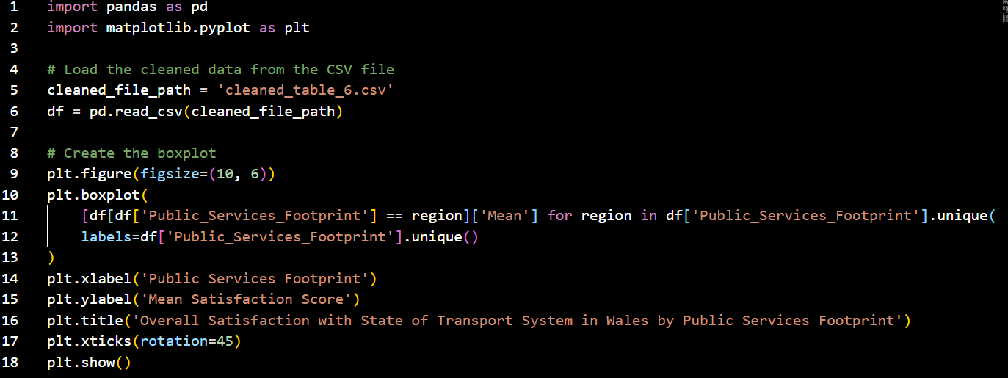boxplot_table_6.py
Code for displaying the cleaned Table 6 data as a boxplot. IDE: Visual Studio Code
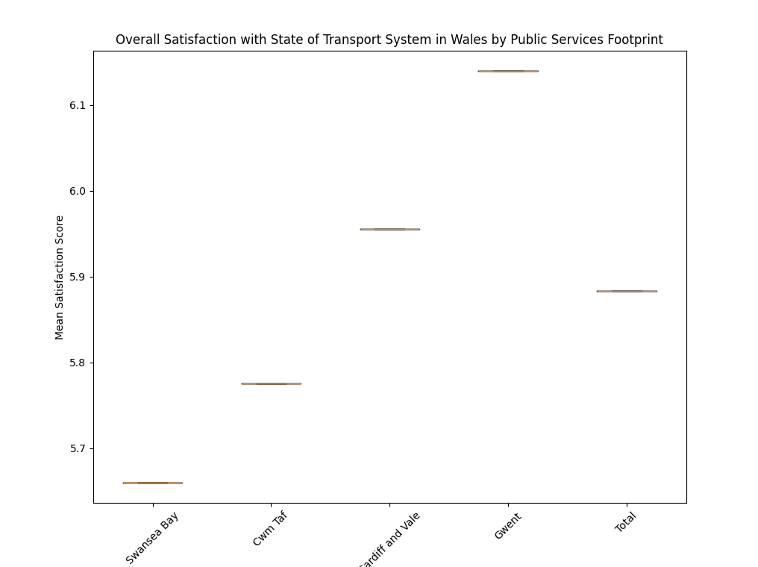
The result is as follows:
The boxplot shows very little variation within each public services footprint, indicating that the mean satisfaction scores are quite consistent within each region.
There are no visible outliers or significant differences within the regions, suggesting a high level of agreement among respondents in each footprint. Swansea Bay and Mid and West are regions with slightly lower satisfaction scores compared to others: targeted improvements could be beneficial in these areas. Gwent, Cardiff and Vale, and North Wales have relatively higher satisfaction scores, indicating better perceived transport services in these regions, and could serve as benchmarks for best practices. However, the boxplot suggests that respondents' perceptions are quite consistent within each region.
To safeguard the analysis from relying only on data visualisation, which may misrepresent data (Tableau, n.d.), statistical analysis will give a stronger and a more complete insight into the dataset, and validate observed trends.

Conclusion

Ensuring data quality and consistency is crucial for analysing satisfaction and usage patterns in Wales' transport system. This involves validation checks, regular consistency reviews, and thorough documentation of data pipeline steps. Applying Master Data Management principles helps maintain a single source of truth, consolidating data for accuracy and currency. This strategy supports reliable analysis, providing actionable insights to improve Wales' transport system through informed decision-making and effective data pipeline design.
References

Infogram (2019) How to Choose the Right Chart for Your Data. Available from: https://infogram.com/blog/choose-the-right-chart/ [Accessed 1 July 2024].

Kirk, A. (2019) Data Visualisation: A Handbook for Data Driven Design. 2nd ed. London: Sage.

Molin, S. (2021) ‘Working with Pandas DataFrames’, in Hands-On Data Analysis with Pandas. United Kingdom: Packt Publishing, Limited.

Pandas Development Team (2023) pandas.DataFrame. Available from: https://pandas.pydata.org/docs/reference/api/pandas.DataFrame.html [Accessed 1 July 2024].

Tableau (n.d) The advantages and benefits of good data visualisation. Available from: https://www.tableau.com/data-insights/data-visualization/advantages-disadvantages [Accessed 1 July 2024].

Welsh Government (2014) Technical Advice Note (TAN) 18: Transport. Available from: https://www.gov.wales/technical-advice-note-tan-18-transport [Accessed 1 July 2024].

Welsh Government (2021a) Planning policy and guidance: transport. Available from: https://www.gov.wales/planning-policy-and-guidance-transport [Accessed 1 July 2024].

Welsh Government (2021b) Strategic framework for Welsh Government surveys. Available from: https://www.gov.wales/strategic-framework-welsh-government-surveys [Accessed 1 July 2024].

Welsh Government (2021c) Types of statistics and research. Available from: https://www.gov.wales/types-statistics-and-research [Accessed 1 July 2024].

