Data Analytics Implementation

Introduction
The transportation system in Wales faces challenges and opportunities, focusing on integrating land use and transport planning to foster sustainability and efficiency. Key issues include geographical constraints and the need for improved rural connectivity. The Welsh Government emphasises regional transport plans to ensure equitable access to transportation and services. Enhancing the design and location of new developments supports sustainable transport modes, aiming to reduce car dependence. Rigorous data validation and consistency checks underpin informed decision-making and effective policy implementation, promoting a transport system that meets citizens' needs while fostering sustainability, accessibility, and resilience (Welsh Government, 2014; 2021a; 2021b; 2021c).

Data Pre-processing on relevant tables
Our data analytics report focused on the following tables from the National Survey for Wales, 2013-2014:

- Table 1: Overall satisfaction with state of transport system in Wales, by household type
- Table 3: Overall satisfaction with state of transport system in Wales, by gender
- Table 4: Overall satisfaction with the state of transport system in Wales, by urban/rural area
- Table 6: Overall satisfaction with the state of transport system in Wales, by public services footprint
- Table 17: Have use of a car, by gender
- Table 22: Have use of a car, by limiting long-term illness
- Table 40: Feeling of safety travelling by public transport after dark, by age
- Table 41: Feeling of safety travelling by public transport after dark, by gender

After loading the excel file containing all our data set, a function clean_table is defined to standardise the cleaning and preprocessing steps for each table. This function takes the sheet name, the number of rows to skip, the number of rows to read, the columns to use, and the new column names as parameters. Each relevant table is then preprocessed using the clean_table function. The skip_rows, n_rows, use_cols, and col_names parameters are adjusted for each table based on its structure. After preprocessing, the cleaned data is saved to new CSV files for further analysis.

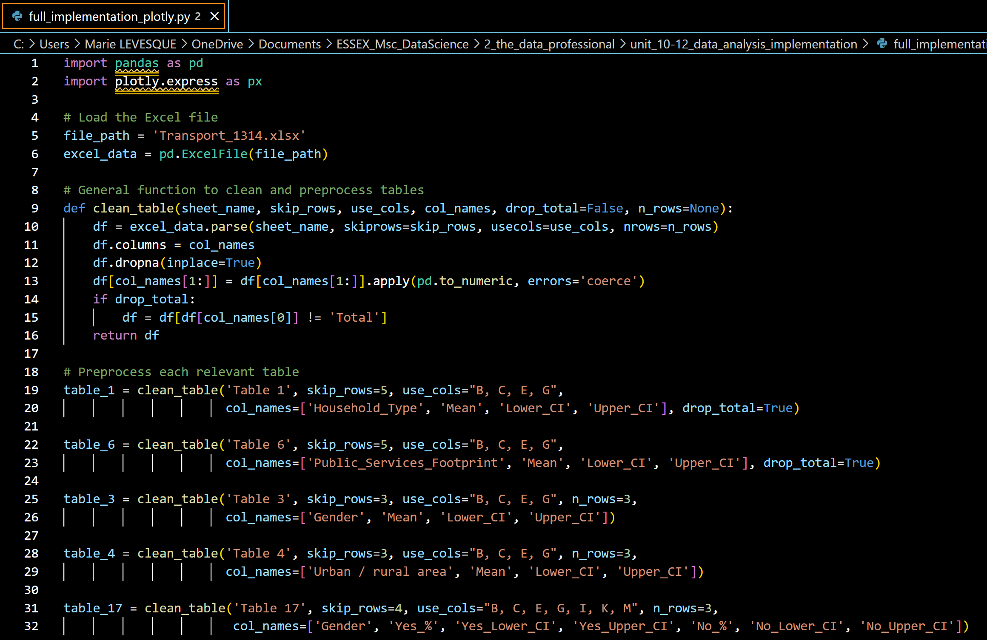full_implementation_plotly.py (IDE: Visual Studio Code)
Code extract: load file, function clean_table to clean all tables and its implementation for the first relevant tables.

Explanation of the Code:
- The clean_table function is reusable for different tables, ensuring consistency in preprocessing steps.
- The skip_rows, n_rows, use_cols, and col_names parameters are tailored for each table to accurately reflect their structure.
- The dropna method removes any additional rows containing NaN values, cleaning the dataset.
- Converting columns to numeric types ensures proper data handling and analysis.
- The cleaned data is saved to CSV files, one for each table, making it ready for further analysis.
This comprehensive preprocessing ensures that the data is clean, consistent, and suitable for detailed analysis, aligning with the objectives of the study.

Data Analysis Implementation

After pre-processing the relevant tables, data analysis can actually start: each csv file containing the clean data relevant for the analysis is now being loaded and analysed through statistical analysis and visualisation. The Plotly library was chosen to represent the entirety of the dataset as bar charts due to its interactive and visually appealing features, which facilitate a deeper understanding of the data patterns and trends.

Preprocessed tables containing cleaned data are saved to CSV files for further analysis. The visualisation code is implemented as follows:
- A single plot_bar_chart function is used to create bar charts with error bars for tables 1 and 6.
- For tables 3, 4, 17, 22, 40, and 41, the data is processed to include error bars where necessary and then visualised using Plotly.

Importance of Data Structure Preservation
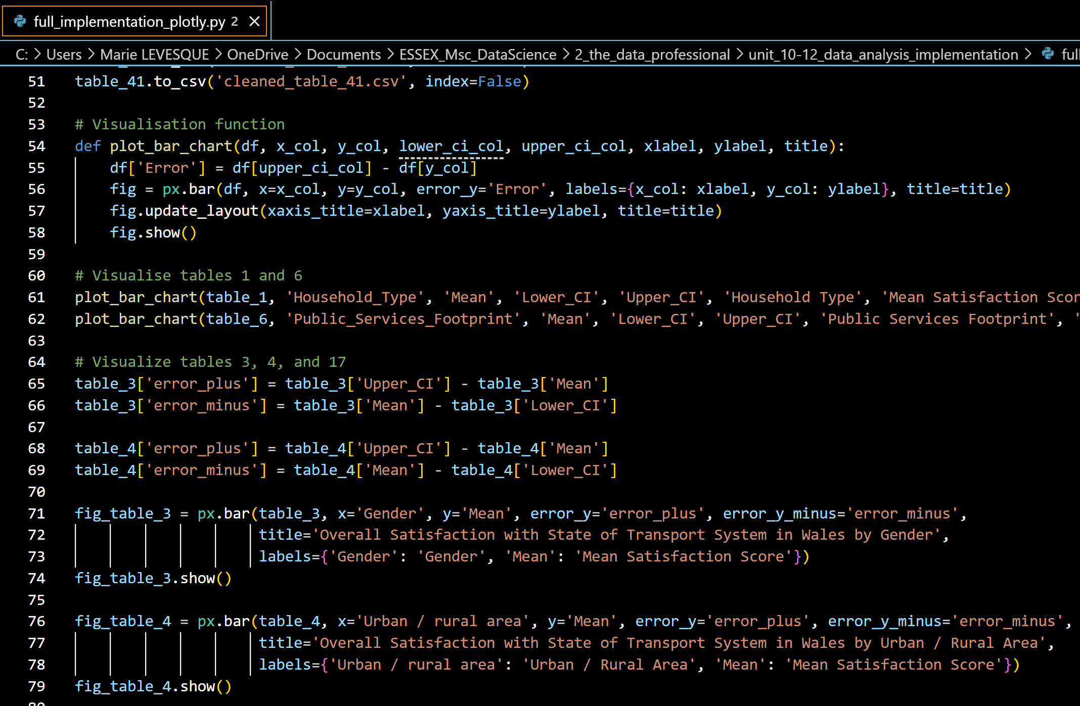full_implementation_plotly.py (IDE: Visual Studio Code)
Code extract: save cleaned data into csv files, function plot_bar_chart to clean all tables and its implementation for the first relevant tables.

The tables have diverse structures, including different column names, numbers of rows, and specific requirements like dropping the 'Total' row or converting data formats. Preserving these structures during preprocessing is crucial for accurate data analysis and visualisation.

Maintaining the original structure ensures that the visualisations accurately represent the data. For example, proper handling of confidence intervals provides more reliable error bars, which are essential for interpreting the data correctly.

For instance, the data visualisation of table 40 is unique as it takes into account several age groups, in regards to predefined levels of safety when considering using public transportation after dark.
The melt function transforms data from a wide format to a long format, which is often necessary for visualisation. In this case:
- id_vars=['Age_Group']: Keeps the Age_Group column fixed, retaining the age groups as they are.
- value_vars=['Very_Safe', 'Fairly_Safe', 'Fairly_Unsafe', 'Very_Unsafe']: Unpivots these columns, each representing a different safety category.
- var_name='Feeling_of_Safety': Names the new column that holds the previous column names (Very_Safe, Fairly_Safe, etc.).
- value_name='Percentage': Names the new column that holds the values from the unpivoted columns.
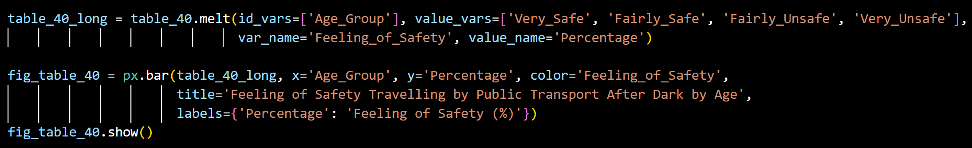Table 40 : data melting and plotting (IDE: Visual Studio Code)
Using functions tailored to each table's structure ensures consistency in data handling, reducing the risk of errors and ensuring that the analysis is robust and reliable.

Data Visualisation and Analysis

Table 1: Overall Satisfaction with State of Transport System in Wales by Household Type
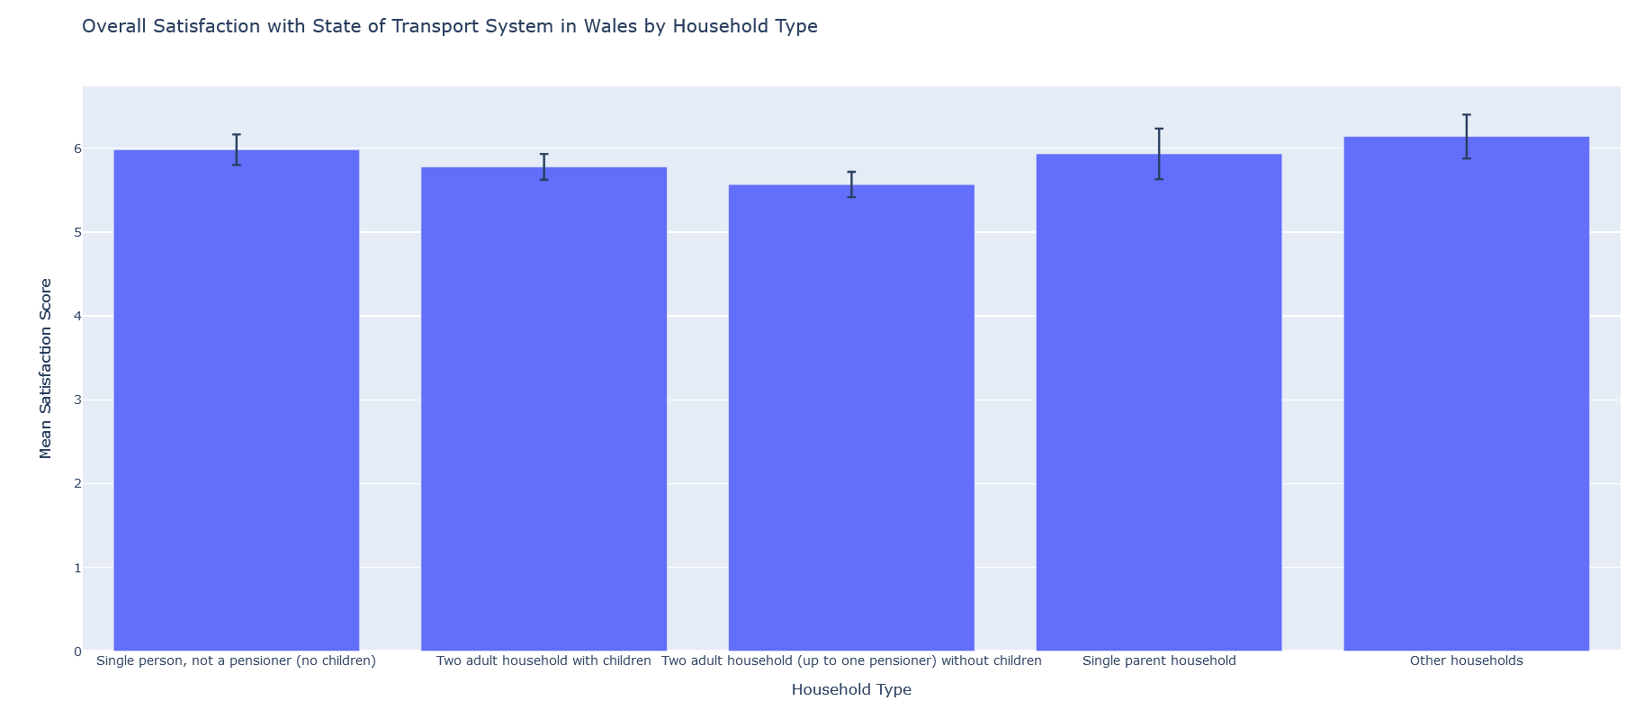Table 1 visualisation: bar chart realised using the Plotly library in Python.
This table provides an insight into how different household types perceive the state of the transport system in Wales. The types of households include single person (not a pensioner, no children), two adult households with children, two adult households (up to one pensioner) without children, single-parent households, and other households.
Interpretation
- The data indicates that "Other households" have the highest mean satisfaction score, followed closely by single-person households (not a pensioner, no children).
- Single-parent households have the lowest satisfaction score, indicating potential issues or dissatisfaction within this group regarding the transport system.
- The confidence intervals show variability in satisfaction, with some household types experiencing more consistent satisfaction levels than others.
Issues
- The lower satisfaction among single-parent households suggests potential barriers or challenges they face with the transport system. This could be due to accessibility issues, financial constraints, or service reliability.
Solutions
- Enhancing accessibility and affordability of transport services specifically targeting single-parent households.
- Implementing policies that offer discounts or subsidies for single-parent households to ease their transportation burden.
- Conducting further studies to understand the specific needs and challenges faced by single-parent households and addressing them accordingly.
Table 3: Overall Satisfaction with State of Transport System in Wales by Gender
This table analyses the overall satisfaction with the transport system across different genders.
Interpretations
- Males have a slightly higher mean satisfaction score compared to females.
- Both genders show similar confidence intervals, suggesting a consistent perception of the transport system's quality among them.
Observed issues
- The slight difference in satisfaction scores could point to gender-specific issues, such as safety concerns, convenience, or service reliability.
Solutions
- Conduct targeted surveys or focus groups to identify and address specific concerns of females regarding the transport system.
- Implement safety measures and awareness campaigns to enhance the perception and reality of safety for female passengers.
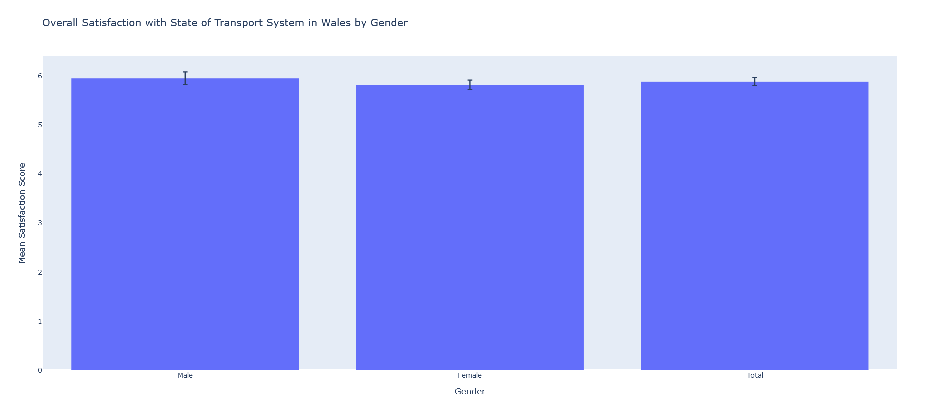Table 3 visualisation: bar chart realised using the Plotly library in Python

Table 4: Overall Satisfaction with State of Transport System in Wales by Urban/Rural Area
This table compares the satisfaction levels between urban and rural areas.
Interpretation
- Urban areas have a higher mean satisfaction score compared to rural areas.
- The confidence intervals are broader for rural areas, indicating more variability in satisfaction levels.
Observed issues
- Rural areas likely face more significant challenges, such as less frequent services, longer travel times, and fewer transportation options.
Solutions
- Improving the frequency and reliability of transport services in rural areas.
- Investing in infrastructure to ensure better connectivity and accessibility for rural residents.
- Introducing flexible transport solutions like demand-responsive transport services to cater to rural needs.
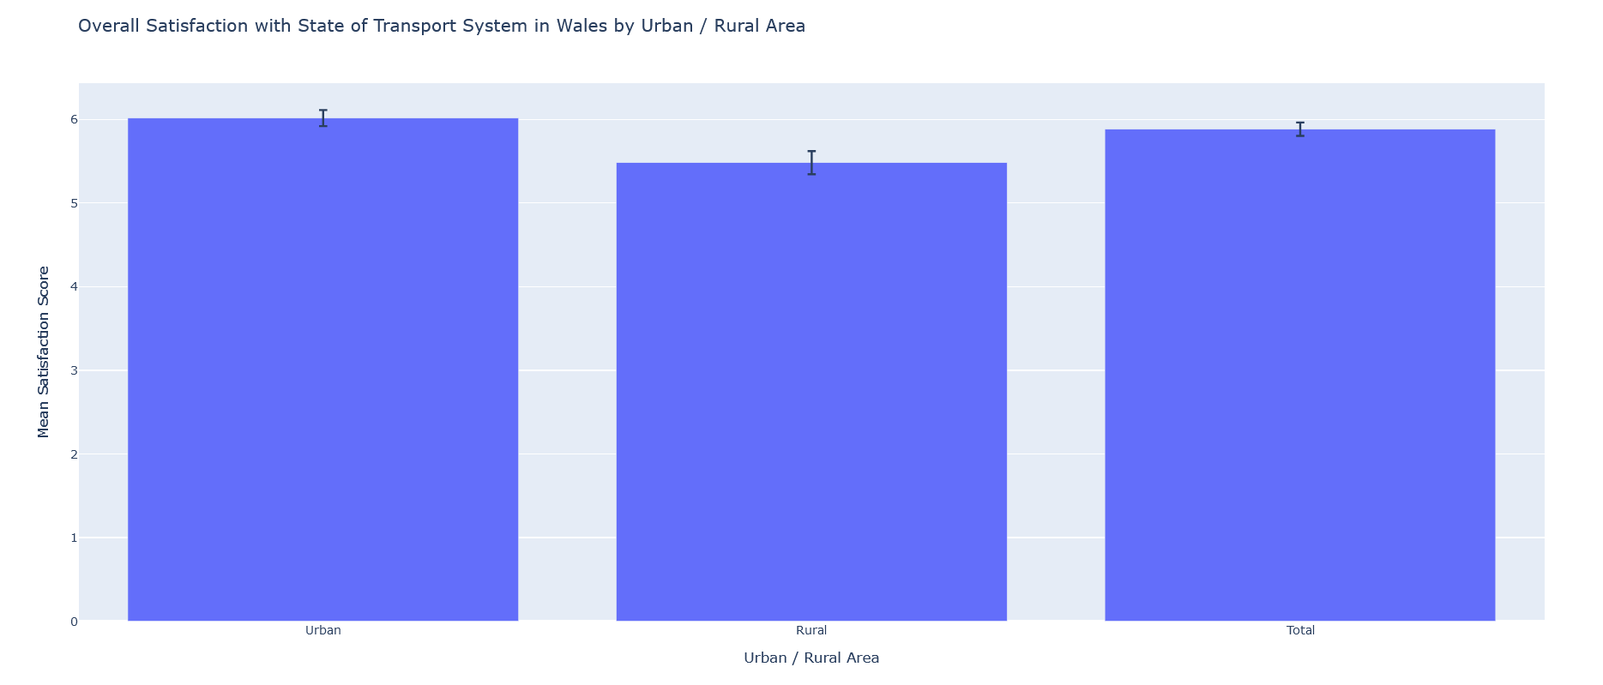Table 4 visualisation: bar chart realised using the Plotly library in Python
Table 6: Overall Satisfaction with State of Transport System in Wales by Public Services Footprint

This table evaluates satisfaction levels based on different public services footprints, which include North Wales, Mid and West Wales, South Wales West (Swansea Bay), South Wales Central (Cwm Taf, Cardiff and Vale), and South Wales East (Gwent).
Interpretation
- Satisfaction levels are fairly consistent across different regions, with slight variations.
- South Wales Central has the highest mean satisfaction score, while Mid and West Wales has the lowest.
Observed issues
- The slight variations suggest regional disparities in transport service quality, accessibility, or coverage.
Solutions
- Conducting regional assessments to identify specific issues and improvement areas.
- Allocating resources and implementing region-specific improvements to enhance the transport system uniformly across Wales.
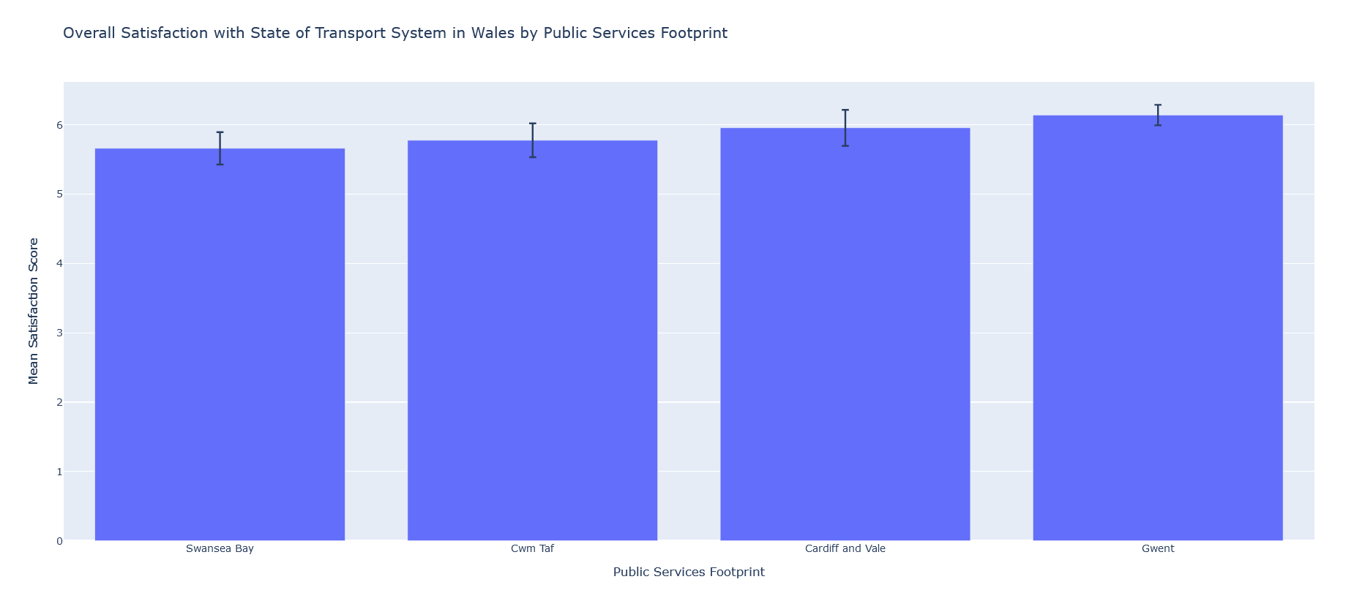Table 6 visualisation: bar chart realised using the Plotly library in Python

Table 17: Have Use of a Car by Gender

This table shows the percentage of males and females who have access to a car.
Interpretation
- A higher percentage of males have access to a car compared to females.
- The confidence intervals indicate consistency in the responses.
Observed issues
- The disparity in car usage could highlight economic or social factors limiting car access for females.
Solutions
- Promoting gender equality in access to transportation means.
- Implementing programs to support car ownership or alternative transport options for females.
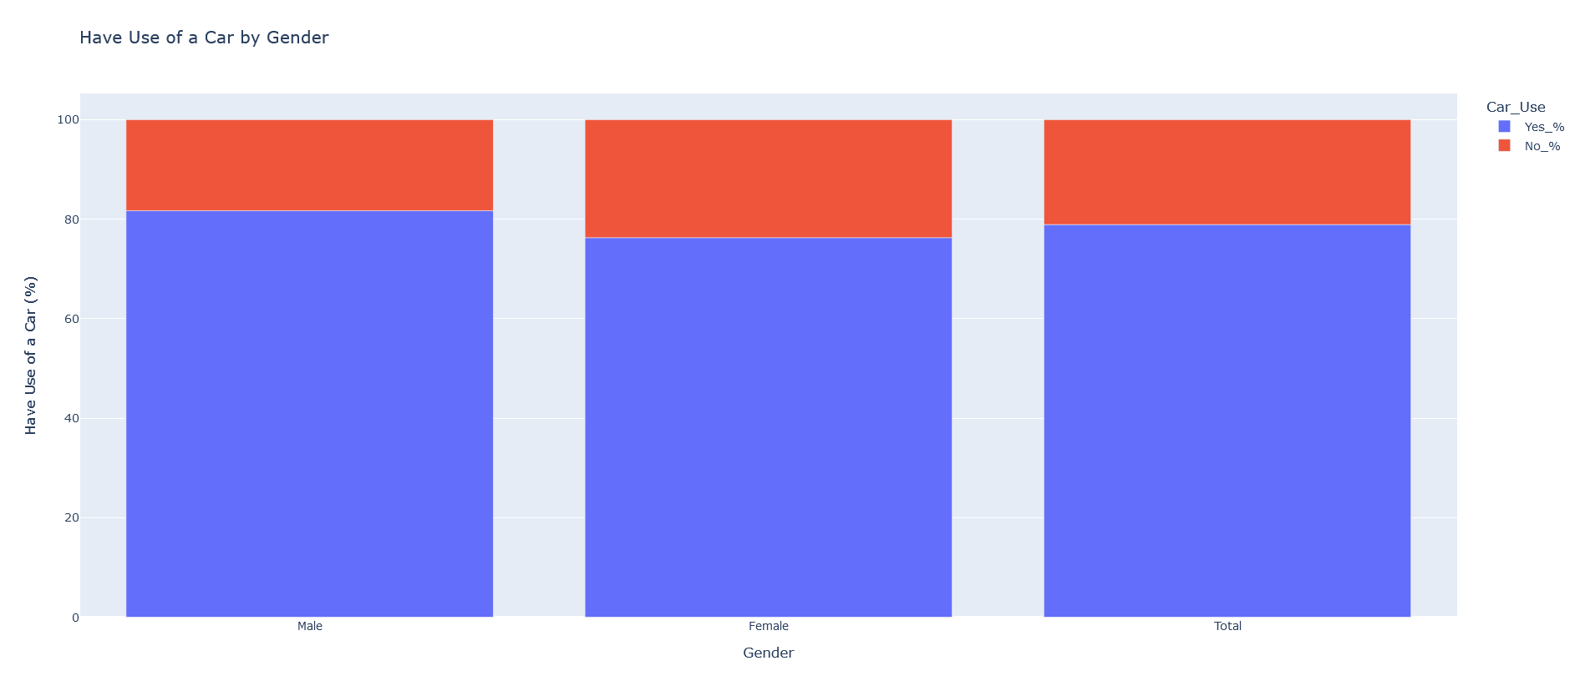Table 17 visualisation: bar chart realised using the Plotly library in Python

Table 22: Have Use of a Car by Limiting Long-Term Illness
This table analyses car usage among individuals with and without limiting long-term illnesses.
Interpretation
- Individuals without limiting long-term illnesses have higher car usage rates.
- The confidence intervals suggest more variability among those with limiting long-term illnesses.
Observed issues
- Individuals with limiting long-term illnesses face challenges in car access, potentially due to physical, economic, or accessibility issues.
Solutions
- Providing support and incentives for car ownership or alternative transport options for individuals with long-term illnesses.
- Enhancing public transport accessibility to cater to the needs of individuals with limiting long-term illnesses.
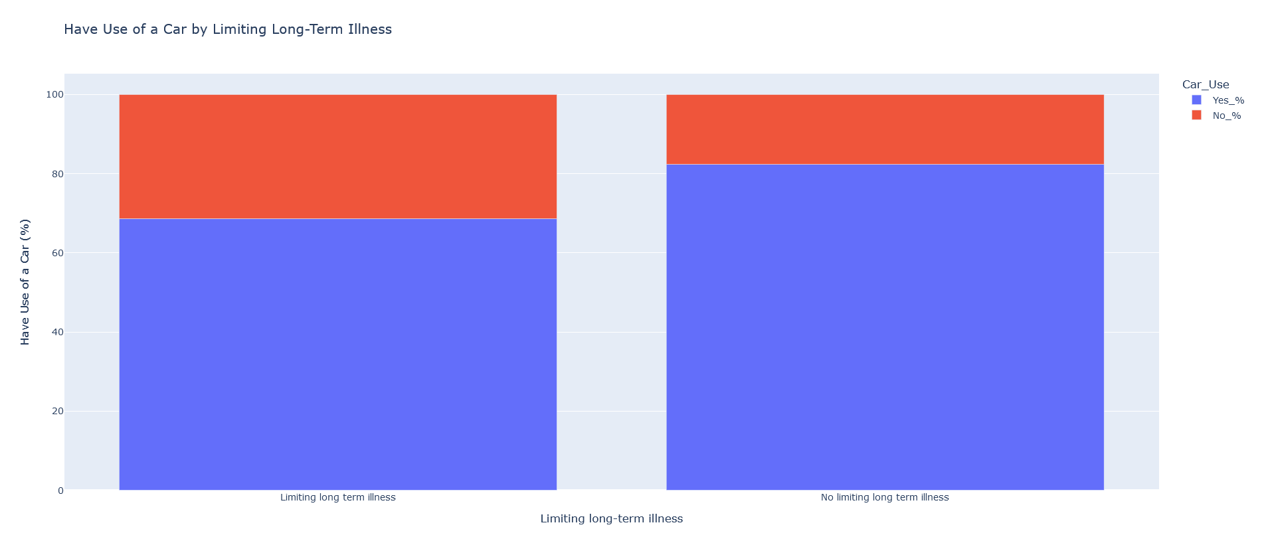Table 22 visualisation: bar chart realised using the Plotly library in Python
Table 40: Feeling of Safety Travelling by Public Transport After Dark by Age
This table assesses the perception of safety when travelling by public transport after dark across different age groups.
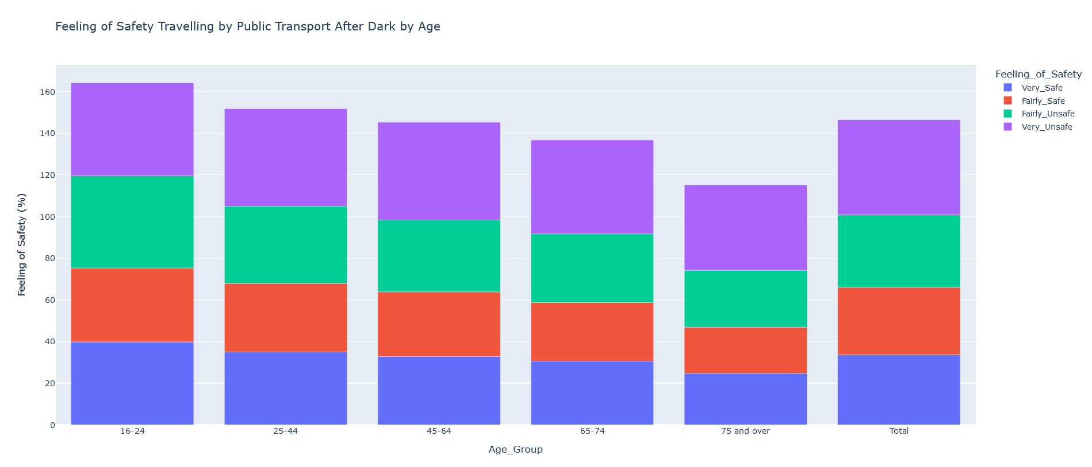Table 40 visualisation: bar chart realised using the Plotly library in Python
Interpretation
- Younger age groups (16-24) feel relatively safer compared to older age groups.
- The 75 and over age group has the highest perception of none safety.
Observed issues
- Older individuals feel less safe travelling by public transport after dark, potentially due to vulnerabilities or previous negative experiences.
Solutions
- Implementing measures to improve safety, such as better lighting, security presence, and monitoring on public transport.
- Conducting awareness campaigns to reassure and educate older passengers about safety measures in place.
Table 41: Feeling of Safety Travelling by Public Transport After Dark by Gender
This table evaluates the feeling of safety while travelling by public transport after dark between genders.
Interpretation
- Females feel significantly less safe compared to males when travelling by public transport after dark.
- The confidence intervals show consistent differences in safety perception between genders.
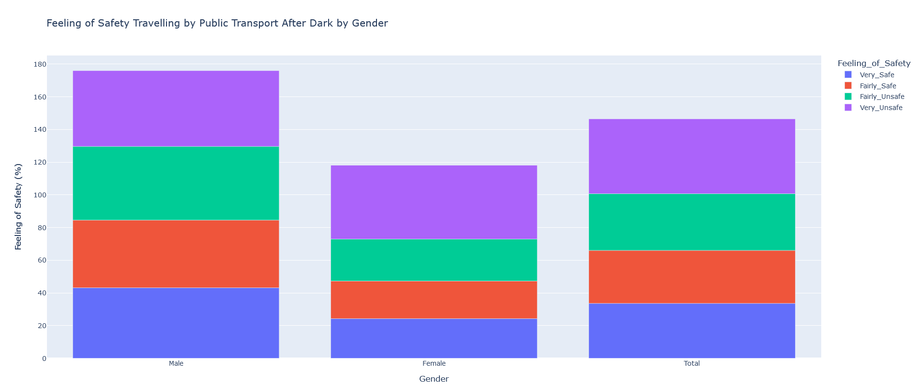Table 41 visualisation: bar chart realised using the Plotly library in Python
Observed issues
- The gender disparity in safety perception highlights concerns about harassment, assault, or other safety issues faced by females.
Solutions
- Increasing security measures, such as surveillance cameras and security personnel, particularly in areas frequented by female passengers.
- Launching public awareness and safety campaigns to address and mitigate safety concerns for females.
The data analysis reveals several key issues and disparities in the transport system in Wales, such as lower satisfaction among single-parent households, females, and rural residents. Safety concerns are prominent among older individuals and females, particularly when travelling by public transport after dark.
To address these issues, it is crucial to implement targeted solutions such as improving accessibility and affordability, enhancing safety measures, and conducting further research to understand specific needs and challenges. These efforts will contribute to a more equitable and efficient transport system in Wales, ensuring better satisfaction and safety for all residents.
General conclusion

The analysis of the National Survey for Wales, 2013-2014, focusing on the state of the transport system, reveals significant insights into various demographic groups and regions across Wales. The use of the Plotly library enabled clear and interactive visualisations, which facilitated a comprehensive understanding of the data.

The comprehensive data analysis provides valuable insights for policymakers and transport planners in Wales. By understanding the specific needs and concerns of different demographic groups and regions, targeted improvements can be made to enhance the overall transport experience. These findings underscore the importance of inclusive and region-specific transport policies to achieve higher satisfaction and better transport services for all residents in Wales.
References

EMC Education Service. (2015) Data Science and Big Data Analytics: Discovering, Analyzing, Visualizing and Presenting Data. Indianapolis: Wiley.

Knaflic, C. (2020) Storytelling with Data: let's practice! John Wiley & Sons, Inc.

Storytelling with Data, n.d. Chart Guide. Storytelling with Data. Available from: https://www.storytellingwithdata.com/chart-guide [Accessed 17 July 2024].
Tableau, n.d. Data Visualization. Tableau. Available from: https://www.tableau.com/data-insights/data-visualization/advantages-disadvantages [Accessed 18 July 2024].
Welsh Government (2014) Technical Advice Note (TAN) 18: Transport. Available from: https://www.gov.wales/technical-advice-note-tan-18-transport [Accessed 1 July 2024].

Welsh Government (2021a) Planning policy and guidance: transport. Available from: https://www.gov.wales/planning-policy-and-guidance-transport [Accessed 1 July 2024].

Welsh Government (2021b) Strategic framework for Welsh Government surveys. Available from: https://www.gov.wales/strategic-framework-welsh-government-surveys [Accessed 1 July 2024].

Welsh Government (2021c) Types of statistics and research. Available from: https://www.gov.wales/types-statistics-and-research [Accessed 1 July 2024].

