**CCT College Dublin**

**Assessment Cover Page**

*To be provided separately as a word doc for students to include with every submission*

| **Module Title:** | MLB_Lvl8 |
| --- | --- |
| **Assessment Title:** | CA2_MLB/DVis_Lvl8 |
| **Lecturer Name:** | *Sam Weiss and James Garza* |
| **Students Full Name:** | Marie Pigott |
| **Student Number:** | Sbs23093 |
| **Assessment Due Date:** | *24nd Nov 2023* |
| **Date of Submission:** | *24th Oct 2023* |

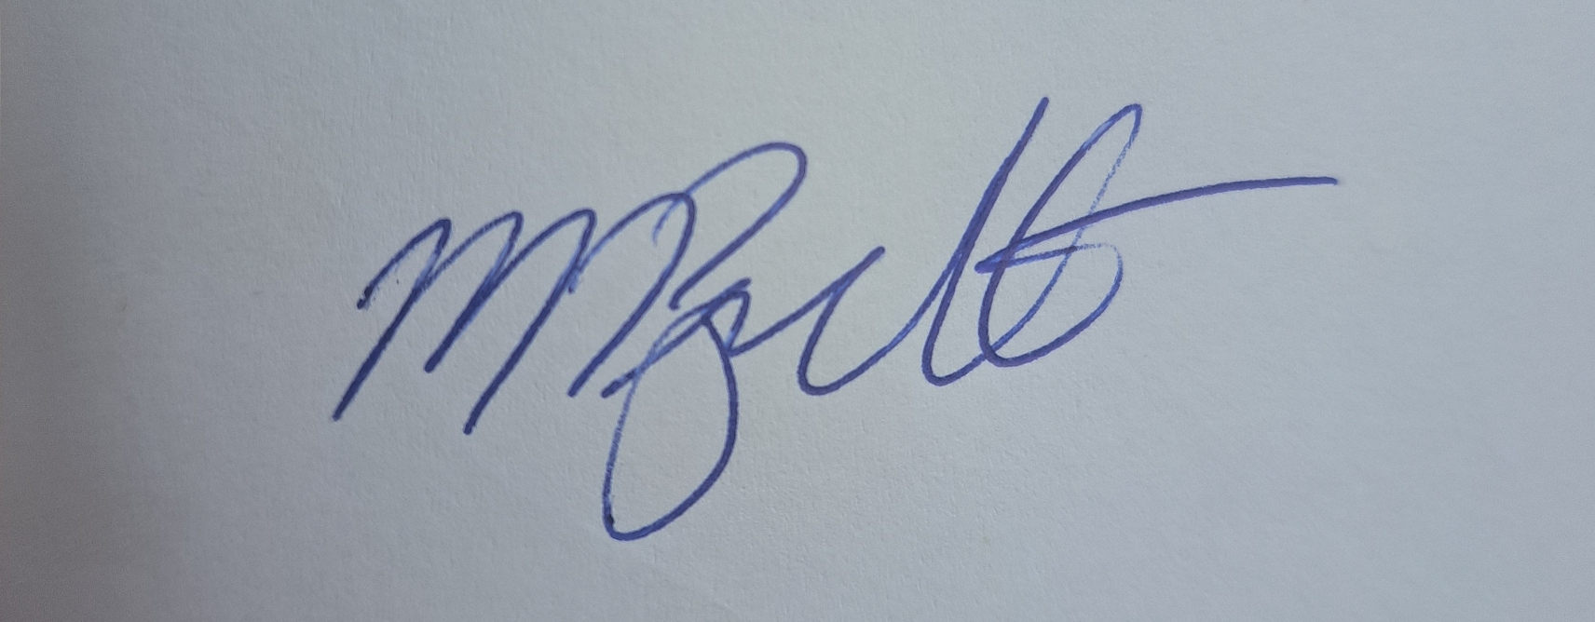

**Declaration**

| By submitting this assessment, I confirm that I have read the CCT policy on Academic Misconduct and understand the implications of submitting work that is not my own or does not appropriately reference material taken from a third party or other source. I declare it to be my own work and that all material from third parties has been appropriately referenced. I further confirm that this work has not previously been submitted for assessment by myself or someone else in CCT College Dublin or any other higher education institution. |
| --- |

### **Strategic Thinking Continuous Assessment, November 2023.**

Individual Reflective Report

**Marie Pigott**

**SBS23093**

1,250words

**The Tasks**

* Dataset
* Code
* Report

*You have been given access to a dataset containing customer transactions for an online retailer and tasked with using your machine learning tools to gain and report on business insights. The audience for this report are non-specialists. In particular, your tasks are:*

***Clustering***

*Apply and evaluate various clustering techniques with the aim of generating actionable insights from the data.*

* *Select and justify the features you will be using.*
* *Apply appropriate clustering algorithms to the dataset.*
* *Evaluate the performance of the algorithms and make a recommendation as to which gives the “best” results.*
* *Include in your report your own interpretation of the results.*

***Market Basket Analysis***

*Perform a market basket analysis of the transaction data.*

* *Include in your report a comparison and evaluation of at least two algorithms.*
* *Include in your report your own interpretation of the results.*

**Challenges**

**Learning Journey**

* Deeper understanding of Data Analytics
* Deeper understanding of AI

**Skills Development**

* Technical Skills
* Collaborative Skills
* What you will do in future projects

| Task | Marks |
| --- | --- |
| Clustering | 60 |
| Data preparation, exploration and feature selection | 10 |
| Clustering | 20 |
| Evaluate and interpret the results | 30 |
| Market Basket Analysis | 40 |
| Apply at least 2 algorithms | 20 |
| Evaluate and interpret the results | 20 |