Display all users in a collection.

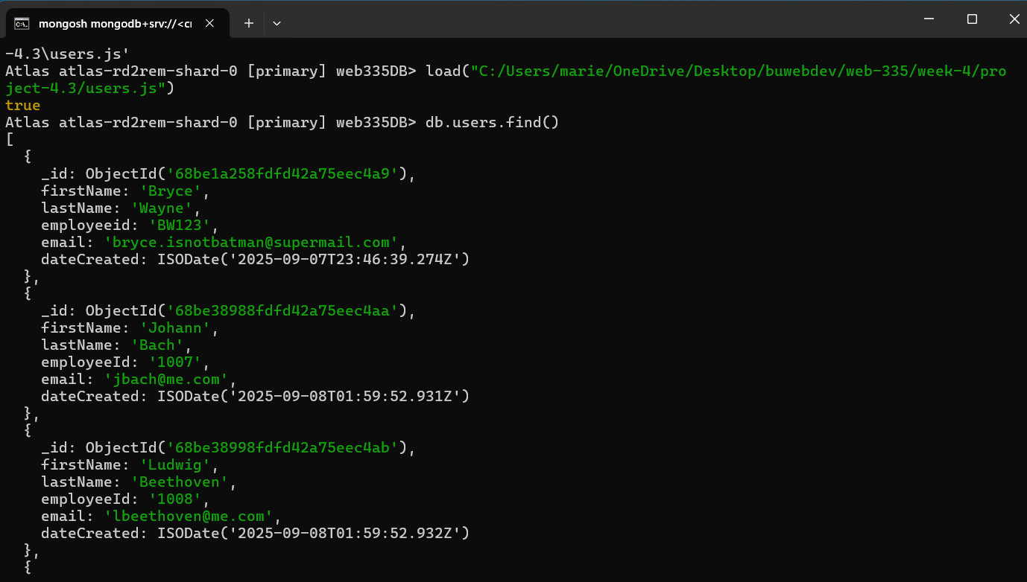

Display the user with the email address [jbach@me.com](mailto:jbach@me.com)

Display the user with the first name Richard

Display the user with the last name Mozart

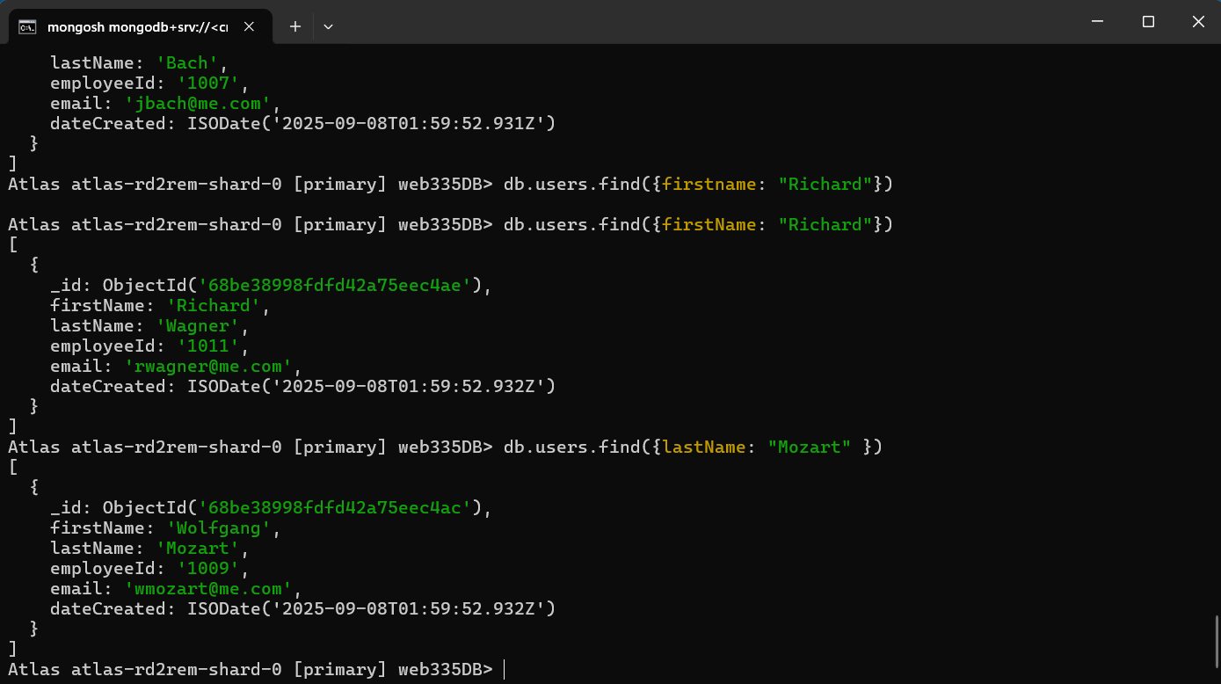

Display the user with the employeeid 1010

