ERTMSFormalSpecs usage in EN50128 SIL4 onboard systems development
White Paper

Stanislas Pinte (stan@ertmssolutions.com)
ERTMS SOLUTIONS – Brussels

Laurent Ferrier (laurent@ertmssolutions.com)
ERTMS SOLUTIONS – Brussels

Darius Blasband (darius@ertmssolutions.com)
ERTMS SOLUTIONS – Brussels

12th of January 2011

The European Railway Traffic Management System (ERTMS) defines standards for interoperability between the onboard train protection systems (ETCS) and the railway infrastructure. The ERTMS specifications are of significant size (350 pages – 39 messages – 47 packets – 176 variables), and as of today are specified informally in plain English.

ERTMSFormalSpecs (EFS) is a project centered on a domain-specific language, designed to express the ERTMS specification in a concise and verifiable formal representation. It aims at being understandable by domain specialists while retaining the ability to be interpreted or translated to efficient executable representations by fully automated means, thereby eliminating the risk factor involved in any human implementation effort.

Using EFS inside an ERTMS onboard unit development must fullfill the requirements posed by CENELEC EN50128 standard, at the highest safety level, SIL4.

This paper shall demonstrate that EFS is suitable for EN50128 SIL4-compliant development and at the same time provides a higher degree of verifiability and testability than traditional formal methods used in the railway industry.
Table of contents

1 Reference Documents 2
2 Acronyms 2
3 Introduction 4
3.1 Scope 4
3.2 Goal 4
4 EFS Description 4
4.1 EFS content 4
4.2 The EFS model 5
4.3 The workbench 5
4.4 Code generation versus interpretation 6
4.5 Scope of EFS in V-cycle 6
4.6 Is EFS a formal method? 7
5 EN50128 SIL4 requirements compliance 9
5.1 Requirements 9
5.1.1 SRS expression and structure 9
5.1.2 Understandability by domain specialists 10
5.1.3 SRTS development and validation 11
5.1.4 Traceability to requirements 11
5.2 SIL4 techniques 11
5.2.1 Use of formal methods 11
5.2.2 Formal proof 11
5.2.3 Symbolic execution 12
5.2.4 Process simulation 12
5.2.5 Structure-based testing 12
6 Conclusion 12

Reference Documents
The following documents are referenced inside that document:

- [EN50128] CENELEC EN50128
- [Subset-026]
- [EFS_Model_Guide]
- [EFS_Workbench_Guide]
- [PolimiCameraRFI_FormalMethods]
- [FmSurvey]
- TODO

Acronyms

EFS | ERTMSFormalSpecs
EVC | ERTMS Vehicule Computer = ERTMS Onboard Unit
ISA | Independent Safety Assessor

Introduction

Scope

This document describes the EFS methodology and tools and discuss its usage inside a CENELEC EN50128 SIL4-compliant ERTMS onboard unit (EVC) development.

In a first section, it describes what EFS is and which tools it includes. The different strategies for integration inside an EVC software development shall be discussed.

In a second section, relevant CENELEC EN50128 requirements for SIL4 Safety Level are identified, and it is demonstrated how EFS fullfill these requirements.

Goal

This paper aims at providing complete evidence to the ISAs in charge of the assessment of the EVC system that the EFS approach is suitable for EN50128 SIL4-compliant EVC development.

EFS Description

EFS content

The EFS product, as illustrated in the following picture, is a product modelling the complete business logic pertaining to an EVC, as specified in [Subset-026].

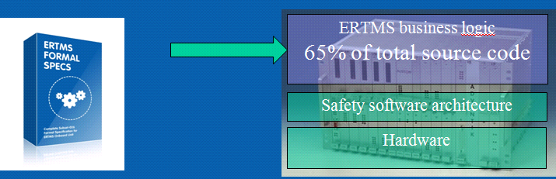

The EFS product is made up of two components, described below in more details, namely, the model and the workbench (EFSW).

The EFS model

The model includes the complete business logic of an EVC, specified in UNISIG Subset-026 specifications, written in the ERTMSFormalSpec language.

The ERTMSFormalSpec language is an ad-hoc language, developed by ERTMS Solutions for the sole purpose of modeling the ERTMS specifications.

Todo: add a screenshot of one rule of the model.

The model also contains a formalization of tests to exercize the rules, made of the UNISIG Subset-076 test cases specifications complemented with additional tests to reach 100% model coverage through testing.

The model can be used directly using a model interpreter, or transformed to source code using automatic code generation tools.

The workbench

The model is a non trivial artifact (estimated at 2000 rules, 500 variables, 1500 tests, 350 pages of specifications), far too large and complex to be managed without ad hoc tools.

The Workbench is a graphical tool designed to develop, maintain, and document model-based development for the Subset-026. It is a desktop application, running on the Microsoft Windows platform.

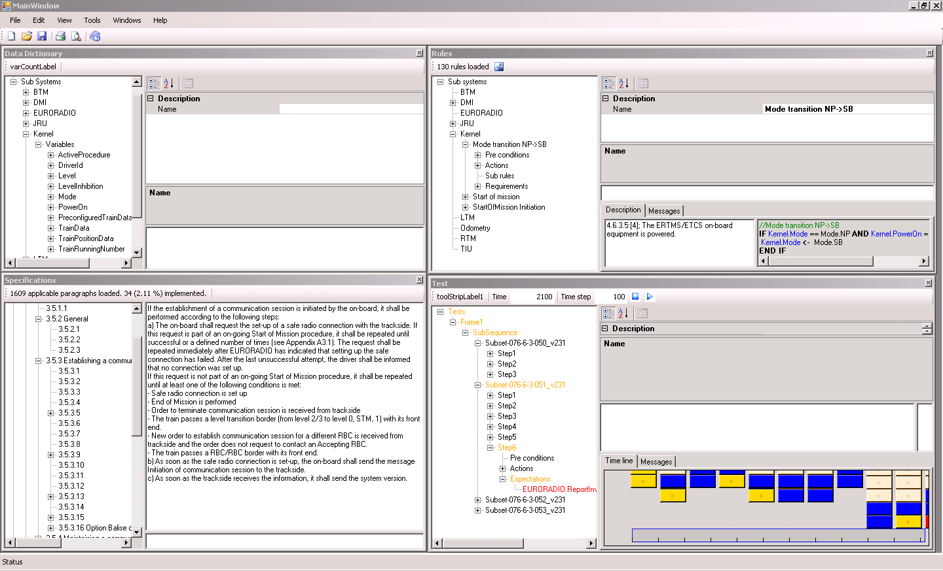

The Workbench provides high-level features:

- Data dictionary browser
- Rule browser
- Test browser and execution environment
- Subset-026 Specification browser
- Managing full traceability between rules and specifications
- Managing full traceability between rules and test cases

Code generation versus interpretation
Idea: show that EFS is 100% independent of chosen safety platform for the EVC. This idea is necessary to proof that the scope of EFS in V-cycle (next section) is limited to SRS and SRTS phases. EFS is not related to arch, design or source code.

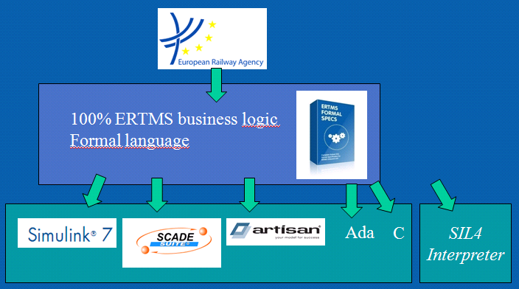

Scope of EFS in V-cycle
Idea: we only cover SRS and SRTS in V-cycle -> shorten the list of requirements we have to obey.

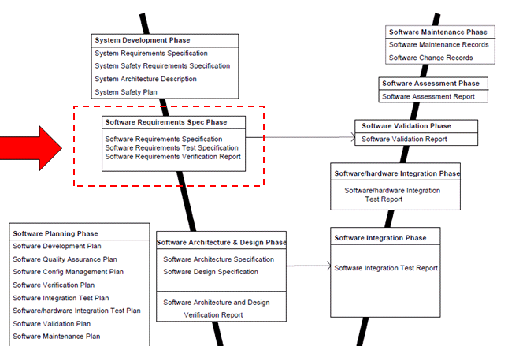

Is EFS a formal method?

[EN50128] defines a formal method as follows:

Formal methods provide a means of developing a description of a system at some stage in its development specification, design or code. The resulting description takes a mathematical form and can be subjected to mathematical analysis to detect various classes of inconsistency or incorrectness.
Moreover, the description can in some cases be analysed by machine with a rigour similar to the syntax checking of a source program by a compiler, or animated to display various aspects of the behaviour of the system described. Animation can give extra confidence that the system meets the real requirement as well as the formally specified requirement.
A formal method will generally offer a notation (generally some form of discrete mathematics being used), a technique for deriving a description in that notation, and various forms of analysis for checking a description for different correctness properties.

Out of that definition, we extract the following aspects to evaluate how far EFS can be considered as a formal method:

- A mean of developing a description of a system
- The description takes a mathematical form
- The description is subject to mathematical analysis to detect inconcistencies or incorrectness
- The description syntax can be checked
- The description can be animated to display the system behaviour

Aspect 1, a mean of developing a description of a system, is the basic purpose of the EFS model, i.e. to describe the business logic of an EVC.

The EFS model obeys a rigorous grammar, fully documented in [EFS_Model_Guide]. This grammar allows the EFS model to be interpreted by a computer program in a non-ambiguous way, which satifies aspect 2: the description takes a mathematical form.

The EFSW is capable of detecting syntax errors in the EFS rules and of more advanced reasoning on the EFS model, including detection of contradicting redundant or underspecified rules. These capabilities cover aspects 3 and 4 (The description is subject to mathematical analysis to detect inconcistencies or incorrectness and The description syntax can be checked).

Last but not least, the EFSW is capable of animating the EFS model to exercise complete functional test cases. The EFSW can display on a timeline all events occuring during animation, providing a visual way to analyze and verify system behaviour. This capability covers the last aspect: the description can be animated to display the system behaviour.

An study of formal methods is provided in [PolimiCameraRFI_FormalMethods]. Inside this study, the following table shows the prescription on specification validation techniques and generation of functional test cases, depending on the integrity class of the system (class A includes SIL 3 and 4, class B includes SIL 1 and 2), its complexity and its temporal features.

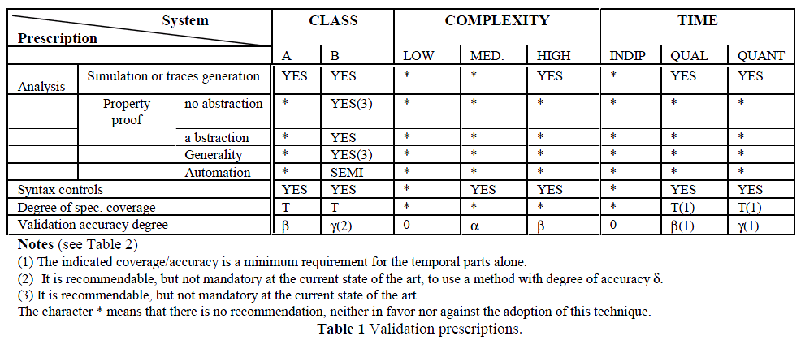

In order to further support the classification of EFS as a formal method, we check which prescriptions made by [PolimiCameraRFI_FormalMethods] are fullfilled by EFS.

EFS supports:

- Analysis by simulation
- Property proof
  - On complete EFS model (no abstraction)
  - Fully automated
- Syntax controls
- Complete specification coverage
- Validation
  - By simulation with 100% EFS model coverage
  - By rechability analysis of EFS rules

As only Property proof with generality is not supported by EFS, we can state that the prescriptions made by [PolimiCameraRFI_FormalMethods] further support the categorization of EFS inside the formal methods.

EN50128 SIL4 requirements compliance
Idea: explain requirement and techniques applicable to software requirements specification procedures. For each one, provide evidence of support using EFS.

The [EN50128] standard defines procedures and techniques for safety-critical railway software development.

Inside [EN50128], according to the selected Safety Integrity Level (SIL level), different sets of techniques are required for the various phases of the development process. In the following sections, we assume that an EVC shall use the SIL4 level.

In section 4.6, we have shown that the scope of the EFS approach covers the System Requirement Specification (SRS) and System Requirement Specification Test (SRTS) phases.

In this section, we start by analyzing all general requirements posed by [EN50128] to the SRS and SRTS phases, and demonstrate that EFS fullfill these requirements.

Then, we take a look at which techniques are required at SIL4 level for the SRS and SRTS phases, and demonstrate that using EFS provides a valid instantiation of these techniques.

Requirements

SRS expression and structure

Requirement 8.4.2 i) of [EN50128] defines how the Software Requirement Specifications should be defined, in terms of attained result:

[EN50128] 8.4.2 To the extent required by the software safety integrity level the Software Requirements Specification shall be expressed and structured in such a way that it is
i) complete, clear precise, unequivocal, verifiable, testable, maintainable and feasible,

complete As EFSW includes bi-directional traceability matrixes between every requirement of the [Subset-026] and the EFS model (the rules and the variables), one can easely demonstrate the completeness of the requirements specifications by using the EFS approach inside its EVC development process.

clear precise, unequivocal The EFS model obeys a rigorous grammar, fully documented in [EFS_Model_Guide]. Animating the EFS model inside the EFSW model interpreter, and testing it using the official [Subset-076] test sequences demonstrate the clear, precise and unequivocal aspects of EFS.

verifiable The EFS language has two fundamental goals: to be understandable by ERTMS domain experts, and to be executable. The EFSW enables the users to perform easy verification of the EFS model, by displaying side-by-side EFS rules and the corresponding english specifications. Next section 5.1.2, Understandability by domain specialists, provides further details.

testeable and feasible The EFSW includes a test environment, allowing to test 100% of the EFS model inside the tool, in a simulated environment, using the official [Subset-076] test specifications. 100% of model coverage by testing is proved by bi-directional rule test coverage reports, showing which elements of which rules have been exercised by which tests, and showing untested rules/fragment of rules.

maintainable The EFSW includes a requirement change impact analysis module, pointing to all rules impacted by a change in 1 requirement, and all tests needing re-run and/or re-design. Requirement change impact helps to maintain the EFS model across different versions of the [Subset-026] and [Subset-076].

Understandability by domain specialists
Requirement 8.4.3 of [EN50128] pose a qualititive requirement on the Software Requirement Specifications:

[EN50128] 8.4.3 The Software Requirements Specification shall include modes of expression and descriptions which are understandable to the responsible personnel involved in the whole life cycle of the system.

The EFS language has been specifically designed to be understandable by domain experts, in order to overcome the flaw of all general-purpose formal languages: they are not understandable by anyone else than the formal language specialists, and make the formalization of the system unverifiable by the real users, the domain experts.
The following picture illustrates the understandability of the EFS language, where the EFS rule pseudocode is show on the right side, in front of the [Subset-026] english language specification on the left side.

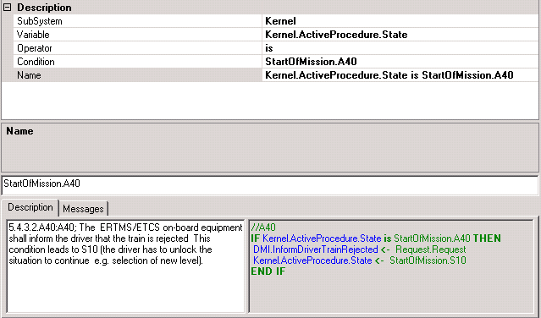

SRTS development and validation
The following requirements of [EN50128] require that a test specification be developed to verify the complete software requirement specifications.

[EN50128] 8.4.13 A Software Requirements Test Specification shall be developed from the Software Requirements Specification. This test specification shall be used for verification of all the requirements as described in the Software Requirements Specification and also as a description of the tests to be performed on the completed software.

[EN50128] 13.4.14 The software shall be tested against the Software Requirements Test Specification. These tests shall show that all of the requirements in the Software Requirements Specification are correctly performed.

The EFS model includes the formal description of all its tests. The EFSW is capable of running these tests against the EFS model inside the EFSW interpreter, and to issue test results, and rule coverage reports.

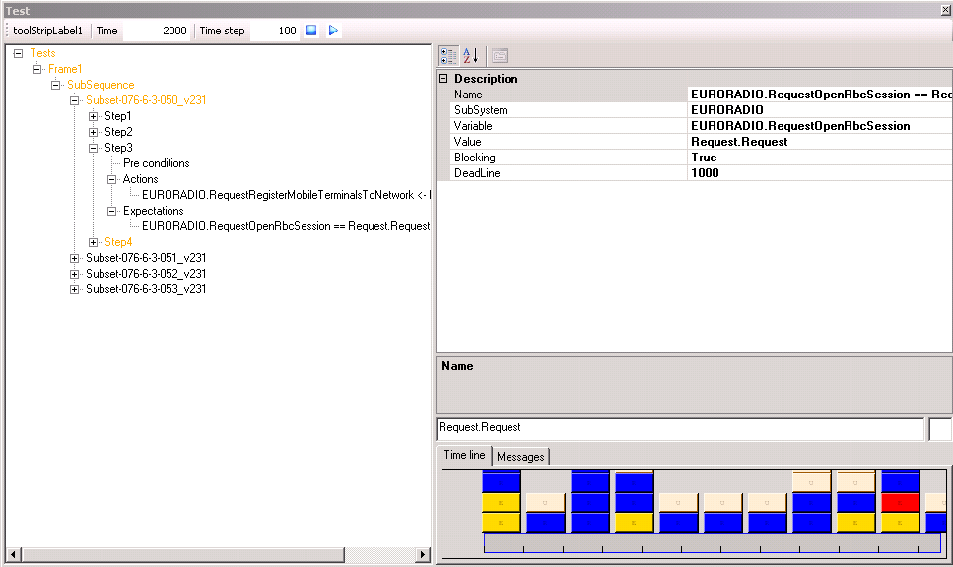

Traditionally, the link between the SRTS and the SRS is manually established, i.e. a human being lists all SRS elements tested by a given test of the SRTS, and manually assess if the tests are really testing the requirements.

Using EFSW, this link is automatically computed: The EFSW provides a rule coverage report, illustrating which part of which rule is exercised for each test, with a granularity of a single rule and of a single test step. Untested rules or part of rules can therefore be univocally identified.

The EFSW includes all official [Subset-076] test sequences, runned against the EFS model inside the EFWS. It is important to note that these [Subset-076] test sequences are the same tests that are performed inside the ERTMS Reference Laboratories, against the final EVCs subsystems.

Having the same tests performed on the formal model of the EVC and on the actual EVC hardware provides a strong evidence of compliance of requirements throughout the whole V-cycle.

Traceability to requirements

[EN50128] insists heavily on requirements traceability:

8.4.15 Traceability to requirements shall be an important consideration in the validation of a safety related system and means shall be provided to allow this to be demonstrated throughout all phases of the lifecycle.

Requirements traceability is central to the EFS approach. Traditionally, traceability is achieved by showing traceability matrixes, linking upstream requirements to sections or fragments in a document (or in source code directly). However, the justification of that traceability link is left to the verifier.

Inside EFS, traceability is bi-directional and visual. Bi-directional as every requirement from the upward specifications [Subset-026] is linked to 1 or more EFS rules, but rules themselves are also linked to 1 or more [Subset-026] requirements. Visual as the EFSW visually enables traceability verification by displaying side-by-side the EFS rules and the linked requirements. Moreover, as the EFS rules language is designed for understandability by domain specialists, the traceability verification is enhanced (See 5.1.2).

SIL4 techniques

B.30 Use of formal methods

Section 4.6, Is EFS a formal method? has shown that EFS is a formal method that can be used for EN50128 software developments.

Usage of this technique is further supported by the scope of the EFS: to model 100% of the [Subset-026] requirements, whereas most of formal methods are limited to a subset of the functionality (like the B language for the STM KVB braking curve calculations).

Modelling 100% of the [Subset-026] requirements further improves the benefit of using a formal method by enabling to test 100% of requirements in the model (Model-in-the-loop tests).

B.31 Formal proof

The following EFS model properties which are proven by the EFSW:

- Correctness of rules syntax
- Non-contradition of rules
- Non-overlapping of rules
- All rules exercised
- All variables used according to type
- All states reachable
- TODO close the list

Proving is done by traversing the EFS model inside the EFSW, in a fully automated manner. This is done by iterating over the rules structure and verifing that assertions are valid for all rules

In order to enable independent verification of the formal proof, the EFSW produces a “proof log”, i.e. a journal of all computations made by the proving routines inside the EFSW, executed on the EFS model.

B.63 Symbolic execution
Idea: inside EFSW we have an interpreter. That interpreter can be used to exercise the rules. Is this symbolic execution?

TODO: check with Laurent and Darius

B.48 Process simulation

[EN50128] requires the formal method to be testeable by process simulation:

[EN50128] D.3 To test the function of a software system, together with its interface to the outside world, without allowing it to modify the real world in any way.

The EFSW tools include a fully functional EFS model interpreter, used to test perform the model in a simulated environment. The simulated environment provides simulated inputs at the interfaces of the system represented by the EFS model.

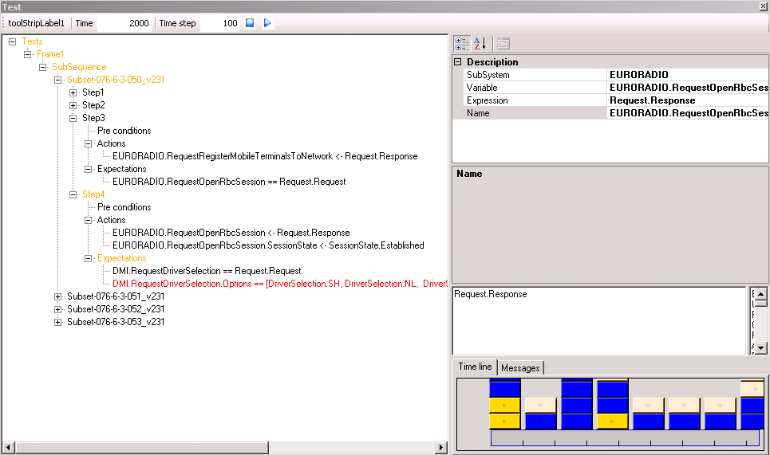

100% of the EFS model rules are tested inside the EFSW tools. Rule coverage reports are provided as evidence, showing by which tests a rule is tested. A detailed test log is available for each test, showing how the EFS model has been simulated

Structure-based testing
Idea: show how EFSW, using its rules testing coverage reports, can show which parts of every statement of every rule has been exercised by what test, and identify untested rules.

As discussed in section 5.1.3 SRTS development and validation, the EFSW provides a rule coverage report. The program elements exercised are at the level of Compound Conditions: every condition in a compound conditional branch (i.e. linked by AND/OR
is exercised).

The EFS model has a 100% coverage level target, and the provided rule coverage reports prove that this target is attained.

Conclusion
In this white paper, we have described the EFS methodology and tools in the context of an EN50128-compliant SIL4 EVC development.

We have shown that all requirements and techniques marked as HR (Highly required) by the standard are fullfilled, and that EFS is therefore a suitable approach for an EVC.

Further research is nevertheless being conducted in the following directions:

- How can EFS be used to improve the quality of the [Subset-026] english-based , informal specifications?
- How can be EFS be used to proof that the EVC using EFS shall never be put in an unsafe state, i.e. how can EFS be used to proof safety-related properties?

For instance, see [FmSurvey] underlining that the [SACEM] project team reported a difficulty in communication between the verifiers and the signalling engineers, who were not familiar with the B-method.
CEDEX, DLR and Multitel as of 1st of January 2011.
See http://www.methode-b.com/documentation_b/ClearSy-Industrial_Use_of_B.pdf Slide 5, “B Software: industrial references”

