
ERTMSFormalSpec Workbench
User Guide
Version 0.9.0

Table of contents
1 Table of contents 2
2 Revision history 4
3 Introduction 5
3.1 References 5
3.2 Terms and definitions 5
4 EFSW Introduction 6
4.1 The language 6
4.2 The workbench 6
4.3 Workbench installation 7
4.4 Initial workbench state 7
4.4.1 Opening a EFS file 7
5 Subset-026 Specification browser 8
5.1 Opening the specification browser 8
5.2 Specification browser description 8
5.2.1 Overview 8
5.2.2 Requirements identification 10
5.2.3 Tools related to the specification view 11
5.3 Process related to requirements 12
5.3.1 Review the requirements 12
5.3.2 Create the model for the requirement 13
5.3.3 Update the model of an Implemented requirement 13
6 Data dictionary browser 14
6.1 Opening the data dictionary browser 14
6.2 Data dictionary browser description 14
6.2.1 Overview 14
6.2.2 Tools related to the data dictionary view 15
6.2.3 Shortcuts view 16
6.3 Name spaces 16
6.4 Data types 17
6.5 Procedures 18
6.6 Variables 19
6.6.1 Sub variables 20
6.7 Functions 20
6.8 Rules 21
6.8.1 Specific case: a rule declared in a state 23
6.8.2 Pre-conditions 24
6.8.3 Actions 24
6.9 Model validations 24
6.10 Expressions 27
7 State diagrams 28
7.1 Display a state diagram 28
7.2 Manipulations of a state diagram 29
7.2.1 Add a new state 29
7.2.2 Add a new transition 29
7.2.3 Selecting element in a state diagram 29
8 Test browser and execution environment 30
8.1 Opening the test browser 30
8.2 Test browser description 30
8.2.1 Overview 30
8.2.2 Tools related to the test view 31
8.2.3 Test actions 31
8.3 Test step 31
8.3.1 Actions 32
8.3.2 Expectation 32
8.4 Test step execution 32
8.5 Test Case, Sub sequence and Frame execution 34
8.6 Time Line 35
9 Translations 37
9.1 Open the translation view 37
9.2 Translation view description 37
9.2.1 Overview 37
9.2.2 Tools related to the translation view 38
9.3 Apply translation rules 39
10 Reports 40
10.1 Specification coverage report 40
10.1.1 Purpose 40
10.1.2 Structure 40
10.1.3 Launch the specification reporting 41
10.1.4 Spec issues report 43
10.2 Dynamic tests coverage report 43
10.2.1 Purpose 43
10.2.2 Structure 43
10.2.3 Launch the test coverage reporting 44
10.3 Data dictionary report 45
10.3.1 Purpose 45
10.3.2 Structure 45
10.3.3 Launch the model report 46

Revision history
Version | Date | Name | Description | Paragraphs
0.2.1 | 15/12/2010 | Stanislas Pinte | First version | All
0.2.2 | 15/12/2010 | Laurent Ferier | Document revision | All
0.2.3 | 06/01/2011 | Svitlana Lukicheva | Added in/out variables | 5.3, 6.4
0.3.1 | 28/01/2011 | Laurent Ferier | Document revision according to release 0.3 | All
0.3.2 | 21/02/2011 | Svitlana Lukicheva | Added chapter "Reports" | 8
0.4.0 | 04/03/2011 | Laurent Ferier | Document revision according to release 0.4 | All
0.5.0 | 05/04/2011 | Laurent Ferier | Document revision according to release 0.5 | All
0.6.0 | 13/05/2011 | Svitlana Lukicheva, Laurent Ferier | Document revision according to release 0.6 | All
0.7.0 | 17/10/2012 | Svitlana Lukicheva, Laurent Ferier | Document revision according to release 0.7 | All

Introduction
This document is a User’s Guide to the ERTMSFormalSpecs Workbench (EFSW). It details the features and functions of the ESFW.

References
Index | Title | Date
[1] | EFSW Technical design | 15/12/2010

Terms and definitions
Term | Definition
BL | Baseline
ESFW | ERTMSFormalSpecs Workbench
EFS | ERTMSFormalSpecs

EFSW Introduction

The language
The ERTMSFormalSpecs language is an ad-hoc language, developed by ERTMS Solutions for the sole purpose of modeling the ERTMS specifications.
The EFS model is made up of a data dictionary, containing all the variables of the model, a set of rules and other modeling elements, organized hierarchically. Even though the model is not mathematically very sophisticated, its complexity lies in the sheer amount of rules and variables.
The EFS model is a non-trivial artifact (estimated at 2000 rules, 500 variables, 1500 tests, 500 pages of specifications), far too large and complex to be managed without ad hoc tools.

The workbench
The EFSW is a graphical tool designed to develop, maintain, and document model-based development for the Subset-026. It is a desktop application, running on the Microsoft Windows platform.
The Workbench provides high-level features:
- Data dictionary browser
- Test browser and execution environment
- Subset-026 Specification browser
- Managing full specification traceability
- between declarations (type, functions and variables) and specifications
- between rules and specifications
- Managing full traceability between test cases and the requirements they verify. The workbench can also be used to determine the rules exercised by a specific test case.

The EFSW provides all features and functions necessary to support these high-level features, explained in details in the following sections.
The EFSW is composed of three main windows, which provide a different view on the modeled system
- The specification window provides a view of all the requirements related to the system. See Section 5 for further information about the specification window.
- The data dictionary window is used to model the system. It allows to create types, variables and procedures, functions. Section 6 further details this window.
- The test window allows to specify tests on the modeled system, allows executing them and provides reports on the executed tests. See Section 7 for further information about the test window.

Workbench installation
The complete EFS environment is distributed in a setup file which automatically installs the tool in the installation directory
C:\Program Files\ERTMSSolutions\ERTMSFormalSpecs

This can be changed during the setup phase. The installation process creates icons in the start menu to launch the EFS workbench and access the documentation.
The installer also checks that the required .NET framework 4.0 is installed on the target machine before performing the installation.

Initial workbench state
When the application is run, the display is empty, as depicted in Figure 1.
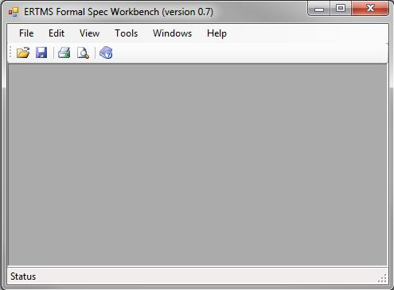
Figure 1 – Initial EFSW screen display

Opening a EFS file
An EFS file must be opened to be able to model the system. Such files are located in the following directory
${installationDirectory}\doc\specs\

When the EFS file is loaded, specification browsers (see Section 5), data dictionary browsers (see Section 6) and the test browser (see Section 8) can be opened using the Tools menu.
Several files can be opened at the same time. The resulting modeled EFS system is the combination of those files. This allows, for instance, to add project specific behavior to a given system.

Subset-026 Specification browser
The specification view is used to display the requirements to be modeled. It can contain requirements from UNISIG Subset-026, or project specific requirements.

Opening the specification browser
The specification browser can be displayed using the Tools\Specifications\Show specification view as depicted in Figure 2.
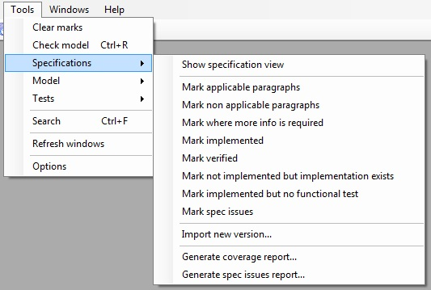
Figure 2 – Tools related to the specification view
If several EFS files have been opened, a dialog box is provided to select the EFS file on which the specification view should be opened.

Specification browser description

Overview
The specification browser is decomposed into several parts, as depicted in Figure 3.
- The left tree view displays the input specifications in hierarchical order. It faithfully mirrors the content of the UNISIG Subset-026.
- The upper middle part, a property view, allows to visualize details of the element selected in the tree view. These details are:
  - The name, as displayed in the tree view
  - The type of element. These types can be either
    - Title: corresponds to a title in the text specification
    - Definition: corresponds to a definition in the textual representation
    - Note: corresponds to an explicative note
    - Deleted: indicates that the paragraph has been deleted in the requirement document, and does no more require any model
    - Requirement: corresponds to a requirement that must be satisfied by the modeled system
    - Table header: corresponds to a header of a table
    - Problem: obsolete
  - The scope of the requirement
    - Track: the paragraph only provides requirements for the trackside
    - On Board Unit: the paragraph only provides requirements for the on board unit
    - On Board Unit and Track: the paragraph provides requirements for both trackside and on board unit
  - A reviewed indication: requirement as provided in Subset-026 may not be directly fit to the modeling. For instance, they need be split into several sub requirements. The flag indicates that the requirement has been reviewed by the requirement analyst and is ready for modeling.
  - A more info required indication: the implementation of certain requirements may require some additional information to be completed. In this case they are marked with the flag “More info required”.
  - A spec issue indication: the requirement is incomplete of contains an error
  - The implementation status indicates in which state this requirement is
  - N/A: no information
  - Implemented: the requirement has been implemented
  - Not implementable: the requirement cannot be implemented, because it is a title, a definition or it has been deleted.
  - New revision available: the requirement changed after the import of a new version of the specification; its implementation needs to be reviewed
  - The unique identifier which univocally identifies the model element in the model
- The upper right part, a messages view, can be used to visualize messages provided by the Workbench on the selected element (see Section 6.9 and 8.5).
- The lower right part of the window is decomposed into several tabs, which are active depending on the selected element
- Specification: provides the text associated to the currently selected paragraph.
- Comment: provides meta-information related to the selected item.
- Implementation: lists the set of model elements implementing the current requirement.

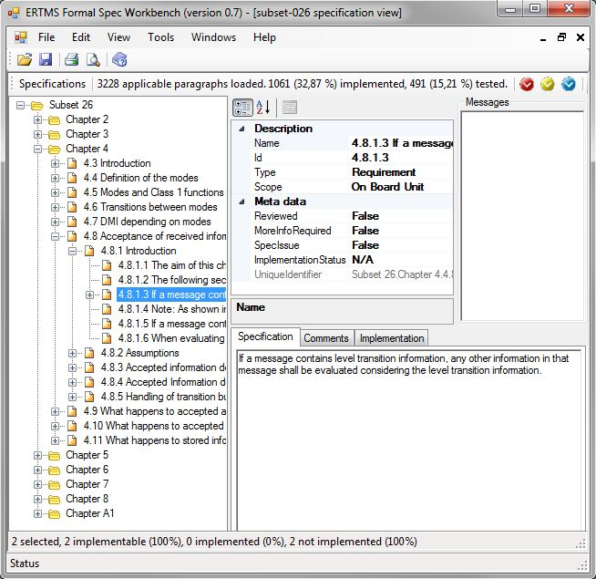
Figure 3 – Specifications browser

Requirements identification
The identifiers of the requirements, as depicted in Figure 4, correspond to the identifier used inside the Subset-026, with the following extensions:
- Requirements containing one table are further divided in sub-requirements, by adding an extra number to the identifier for each row of the table. (For instance, Chapter 4, paragraph 4.7.2 “DMI versus Mode table”) and adding before the requirement number the keyword
- Table for the table header and
- Entry for each table line.
- When a requirement is further split into several requirements, a sub number is added to the requirement number

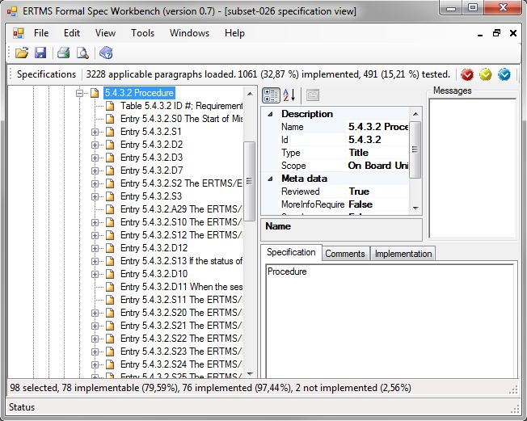
Figure 4 – Handling of tabular requirements in specifications browser

Tools related to the specification view
The Figure 2 shows the actions which can be executed on the specification.

Search for (non) applicable paragraphs
Not all requirements in Subset-026 require an implementation. The EFS Workbench can be used to find the requirements that require an implementation, using the Mark applicable tool. This marks all requirements which require to be modeled in the system. A requirement requires a model when its type is Requirement.
In the same way, the Mark non applicable tool allows to mark all paragraphs which do not require an implementation.

Search for paragraphs requiring additional information
The paragraphs requiring more information to be implemented can be found using the Mark where more info is needed tool. This marks all requirements which require some additional information to be modeled in the system.

Search for unimplemented requirements
Un-implemented requirements can be found using the Mark implemented tool. This marks all requirements whose implementation is not complete. The implementation of a requirement is complete when
- The requirement status is Implemented
- All model elements associated to this requirement are also marked as Implemented.

Search for requirements that have not been verified
Requirements that have not successfully passed the review process can be found using the Mark verified tool. This marks all requirements which have not been verified, that is, an implemented requirement for which at least one model is not marked as verified.

Search for requirements that have not been verified
The Mark not implemented but implementation exists tool allows to show all requirements for which an implementation is available, but their status is still not implemented.

Search for implemented requirements without functional tests
The requirements that are implemented but not yet covered by a functional test can be found using the Mark implemented but no functional test tool. This marks all requirements that are marked as implemented but are not yet covered by functional tests.

Search for implemented requirements without functional tests
It a requirement contains an error, or is incomplete, it is marked as spec issue. The Mark spec issues tool allows to mark all the spec issues that have already been detected.

Process related to requirements
Requirements exported from Subset-026 are manually exported in XML format and imported in the Workbench using the import requirement tool. This procedure can be launched using the Import new version tool as depicted in Figure 2. If another version of the Subset-026 was already imported, it will be overridden by the new one.

Review the requirements
Requirements must be reviewed for several reasons
- The conversion process between Subset-026 and XML file is manual, hence error prone.
- Review the type and the scope associated to the requirement.
- Requirements expressed in Subset-026 are not directly ready for modeling: some requirements are too small and must be merged with their neighbors; some others are too big and should be split.

As soon as requirements have been reviewed, the reviewer changes the Reviewed status of the requirement as True, as depicted in Figure 5.
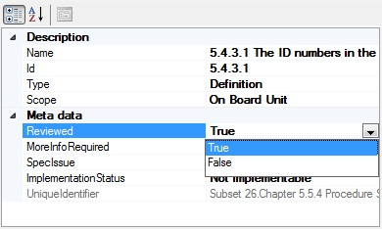
Figure 5 – Requirement has been reviewed
The tool presented in Section 5.2.3.4 allows to easily determine the requirements that still require to be reviewed.

Create the model for the requirement
Once the requirement has been modeled, the engineer changes the Implementation status of the requirement as Implemented. The tool presented in Section 5.2.3.2 allows to determine the requirements that still requires some modeling.

Update the model of an Implemented requirement
As soon as a model related to a requirement changes, the implementation status of the requirement automatically switches back from Implemented to N/A.

Data dictionary browser
The data dictionary browser is used to model the requirement as proposed in the specification window. This window can be used to model several items
- Types to be used by other model elements
- Variables & procedures which provide the system’s state
- Functions which factorize common computations on the system
- Rules which provide the system dynamics

Opening the data dictionary browser
The data dictionary browser can be displayed using the Tools\Model\Show model view as depicted in Figure 6.
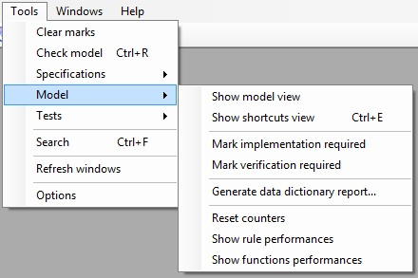
Figure 6 – Tools related to the data dictionary view
If several EFS files have been opened, a dialog box is provided to select the EFS file on which the data dictionary browser should be opened.

Data dictionary browser description

Overview
The data dictionary browser is decomposed into several parts, as shown in Figure 7.
- The left tree view allows to select an element in the model.
- The upper middle part, a property view, allows to visualize details of the element selected in the tree view.
- The upper right part, a messages view, can be used to visualize messages provided by the Workbench on the selected element (see Section 6.9 and 8.5).
- The lower right part of the window is decomposed into several tabs, which are active depending on the selected element
- Description: active only for elements related to a requirement. This view provides a textual description of the requirements related to the item (left part) and a pseudo-code describing the how the corresponding requirement has been implemented by the selected item (right part).
- Expression: displays the information associated to the current element, depending on its type:
  - for variables and types, their value
  - for function cases, pre-conditions, actions or expectations, their expression
  - Comment: provides meta-information related to the selected item.
  - Usage: the set of elements that are using the selected element. This usage view is available for types (in that case, it provides the variables that are instances of the corresponding type) and variables (in that case, it provides the rules that either read or write the content of the variable).

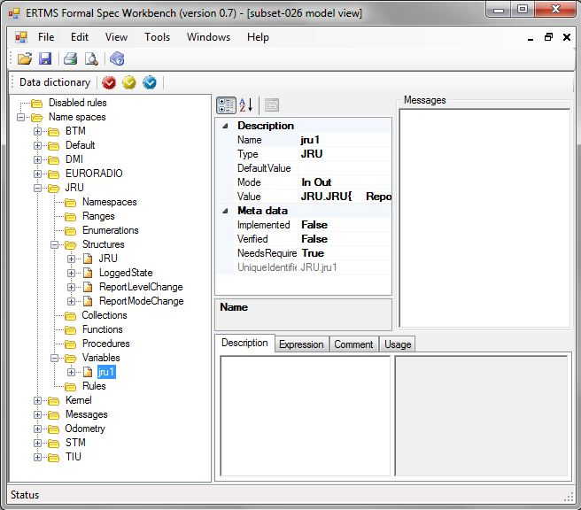
Figure 7 – Data Dictionary and name spaces

Tools related to the data dictionary view
The Figure 6 shows the actions which can be executed on the model.

Search for elements requiring an implementation
The Mark implementation required tool allows to display all the model elements that have not yet been marked as implemented.

Search for elements requiring a verification
The Mark verification required tool allows to display all the model elements which implementation has not yet been verified.

Shortcuts view
EFSW provides a way to quickly access some model elements, without searching it in the Data Dictionary view. These elements, named shortcuts, are situated in the shortcuts view, depicted in the Figure 8. The shortcuts can be created by drag and dropping model elements; they can then be assembled in different folders of the shortcut view. The folders can be created, deleted and renamed using the contextual menu actions.
To select in the model view the model element corresponding to a shortcut, just double-click on the latter.
The shortcut view is available using the Show shortcuts view tool, as depicted in Figure 6.
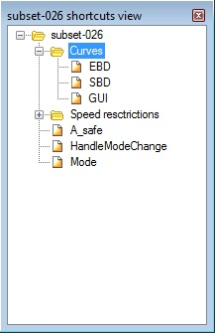
Figure 8 – Shortcuts view

Name spaces
Elements of the data dictionary are structured using Name spaces to group them together. Each namespace allows to define
- sub namespaces
- various data types necessary to support the model (ranges, enumerations, structures, collections and procedure sets). See Section 6.4.
- procedures and variables which model the system state. See Sections 6.5 and 6.6.
- functions which factorize common computations. See Section 6.7.
- rules which specify the system dynamics. See Section 6.8.

For instance Figure 7 displays the following name spaces: BTM, Default, DMI, EURORADIO, JRU, Kernel, Messages, Odometry, STM and TIU. It also displays the types and variables available for “JRU”. The variable jru1 is selected and its details are available on the right part of the window.

Data types
The data types that can be modeled by the EFS Workbench are the followings
- Ranges: specify a numeric value with a low bound and a high bound. It is characterized by
- A name, which identifies this type in the system.
- A precision (Integer or Floating point).
- A default value.
- A min value.
- A max value.
- Special values: a set of values that have a particular meaning (for example, infinity, NA, …).

- Enumerations: specify a set of discrete values identified by a name. For instance the Data State enumeration can be of the following values:
- DataState.Invalid
- DataState.Unknown
- DataState.Valid
An enumeration is characterized by
- A name, which identifies this type in the system.
- A default value.
An enumeration can contain sub-enumerations, representing subsets of the enumeration’s values. For instance the Mode enumeration (representing the modes of a train) has a sub-enumeration “Mode.MA”, which contains all the possible modes that can be received in a Movement Authority.

- Structures: match the C-like struct. They are characterized by
- A name, which identifies this type in the system.
- A set of sub elements related to the structure.
- A set of rules which provide the dynamic behavior of the structure’s variables.
- A set of procedures which are available on all instances of that structure.

- Collections: Allow listing several values. Collections are typed: all elements of the same collection must be of the same type. They are characterized by
- A name, which identifies this type in the system.
- A max size, which indicates the maximum number of elements can be contained in the collection.
- A type, which identifies the type of the collection.
- A default value.

Additional information about data types is also available
- The related requirements, presented as sub-nodes of the data type on the left part of the window. They indicate the requirements that are modeled by the corresponding data type. One can add a new requirement to this list by drag & drop between the requirement expressed in the specification view and the data type requirement node.
- Implemented: indicates that the implementation of the data type is complete and can be reviewed
- Verified: indicates that the review has been performed on the data type and it corresponds to the related requirements. Any modification of the corresponding type removes the verified status, this indicates that a new review must be performed
- NeedsRequirement: indicates that a requirement is expected to be linked to this element.

Data type manipulations (add/remove) are performed in the workbench thanks to the contextual menu actions. Properties about types are altered using the property view on the right part of the Data Dictionary Browser.

Procedures
Procedures are used to keep track of the current system state. They define a process that should be followed by the system and are characterized by a state machine which indicates in which state of the process the procedure is, and provides the transitions between each states using Rules (see Section 6.8). Each one of these procedures is characterized by
- A name, which identifies this procedure in the system.
- Parameters: the formal parameters for this procedure.
- Rules: the rules to be activated when the procedure is called.
- A state machine, which defines a set of states in which the procedure can be. It also specifies an initial state: the state in which the state machine begins its execution.

A state machine is characterized by
- The set of states of this state machine.
- The initial state in which this state machine starts.
- The set of rules.
The state diagram representation of the state machine is available through the state diagram view, as described in Section 7.
A state is characterized by a name which identifies this state, along with the enclosing states and the enclosing procedure, in the system. Each state can be decomposed by a new state machine.
The related requirements, implemented, verified and needs requirement information about procedures are also available and follow the description provided in Section 6.4.

Variables
Variables are used to keep track of the current system state. They are characterized by
- A name, which identifies, along with the enclosing sub system/variable, the variable in the system.
- A type, as defined above.
- A default value, which overrides the default value specified for the type (if any).
- A mode:
- Internal: the variable is used by the EFS model only.
- Outgoing: the variable is written by the EFS model and read by the outside world.
- Incoming: the variable is written by the outside world and read by the EFS model.
- In/Out: the variable is used by both the outside world and the EFS model.
- Constant: the variable is initialized at EFS start up. Its values then never changes. It pertains to the “Data Prep”.
- A value, which is the current value of the variable.

The related requirements, implemented, verified and needs requirement information about variables are also available and follow the description provided in Section 6.4.
Variable manipulations (add/remove) are performed using the contextual menu. Properties about variables are altered using the property view on the right part of the Data Dictionary Browser.

Sub variables
When the variable’s type is a structure, it is decomposed into several sub variables (according to the type’s structure).
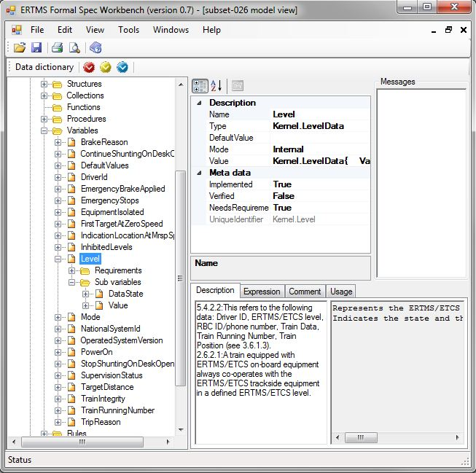
Figure 9 – Level variable & sub variables

Functions
Functions allow factorizing common computations in a single location. They are identified by a unique name and their return type and can have several parameters. Functions can be used to model complex functions such as

f(x) = if x > 0 and x < 100 : x²+1
if x > 100 : 2 x

by defining several cases (for this example, 2 cases). Each case may have several pre-conditions. The value of the function is computed according to the expression associated to the match case. Note that pre-conditions of cases must be mutually exclusive and can only consider parameter values or constants.
An empty pre-condition is always evaluated to true.
An example of a function permitting to calculate the confidence interval of a train is depicted in Figure 10.
The related requirements, implemented, verified and needs requirement information about functions are also available and follow the description provided in Section 6.4.
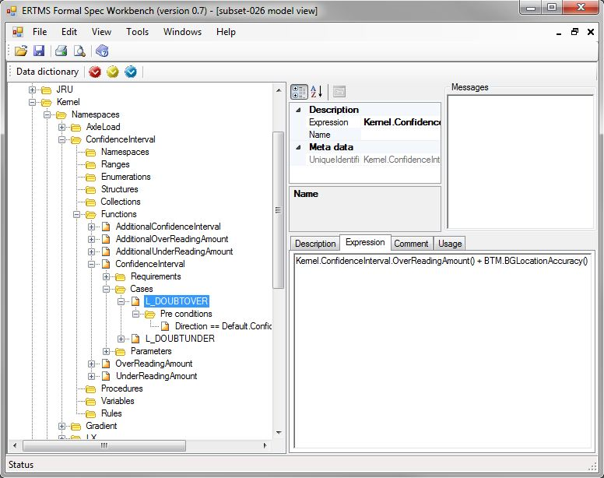
Figure 10 – Example of a function
Functions manipulations (add/remove) are performed using the contextual menu. Properties about functions are altered using the property view on the right part of the Data Dictionary Browser.

Rules
Rules model the behavior of the system. A rule is characterized by the following items:
- The rule name, which allows to identify it in the system.
- The rule priority. This indicates the part of the activation cycle in which the rule can be activated. The priorities are the following
- Input verification: First part of the activation cycle. This phase handles verification of the IN variables.
- Update internal variables, this part of the cycle is performed after the input verification is complete. It updates the internal variables according to the data found in input data.
- Processing. This phase is performed after the update internal variable phase is complete. It is the main processing for the system.
- Update output variables. Based on the result of the processing phase, the output variables are updated during the update output phase.
- Clean Up: Cleans the contents of variables used during this cycle. This is the last step of the cycle.
- The mutually exclusive rule conditions. Only one of the rule’s conditions can be activated when a rule is activated. When several conditions could be activated, the EFS interpreter activates the first one.

Each rule condition holds the following information
- The pre-conditions, specifying when the rule condition can be activated. A condition can be activated if all its pre-conditions are satisfied (see below).
- The actions, specifying what to do when the rule condition is activated. An action consists of modifying the state of the system.
- The sub-rules, which can only be activated if the enclosing rule condition is activated.
- The requirements implemented by that rule.

The related requirements, implemented, verified and needs requirement information about rules are also available and follow the description provided in Section 6.4.
Rules manipulations (add/remove) are performed using the contextual menu. Reordering of rule conditions inside a rule or of rules inside a procedure can be done by dragging the rule or rule condition to move and dropping it on the rule or rule condition which will follow it while holding down the key “alt”. Properties about rules are altered using the property view on the right part of the Data Dictionary Browser.

Specific case: a rule declared in a state
When a rule is declared in a state, it is only triggered when (as usual) its pre-conditions are satisfied but also when the current state of the state machine corresponds to the state in which the rule is declared. For instance, the Figure 11 displays the sub rule related to the state StartOfMission.A40.

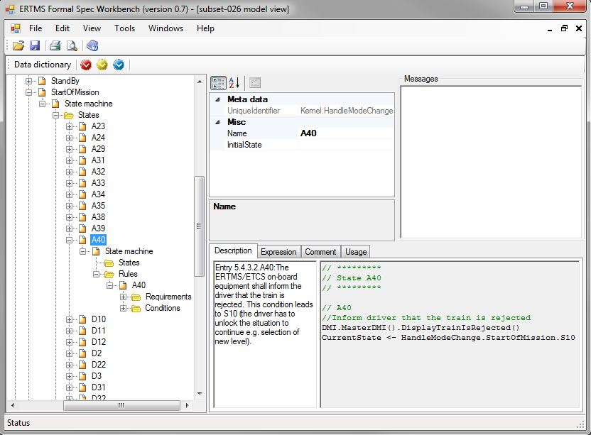
Figure 11 – Sub-rule example: Start of mission procedure, sub-rule A40
The rule A40 is triggered only when its pre-condition is satisfied (always true) and the current state of the state machine is A40 or a substate of A40). When that rule is activated, it executes two following actions
- The procedure HandleModeChange changes its state to the state S10.
- The procedure DisplayTrainIsRejected of the master DMI is called and informs the driver that the train is rejected.
Please note that this also corresponds to a transition in a state diagram, as it is represented as such in the corresponding state diagram (see Section 7).

Pre-conditions
Each rule has a list of one or more pre-conditions that must all be true for a rule to be triggered. Each pre-condition is defined by its name, containing the plain text of the expression associated to this pre-condition.

Actions
Each rule contains a set of actions which are executed when the rule is activated. An action is defined by its name, containing the plain text of the expression associated to this action. The action can be a variable update or a procedure call.

Model validations
The model validation engine can be activated by selecting the menu item Tools/Check model which performs the following checks:
Model | Description | Severity
Expression | Expressions must be syntactically correct | Error
Expression | Expressions must be type correct | Error
Expression | Designators used in expressions must refer to a valid model element | Error
Expression | Designators used in expressions must have a valid type | Error
Expression | IN operator should be used instead of == between expressions of type StateMachine.  This is used to verify that expressions of the form  CurrentState == S1  is not used, since this does not take sub states of S1 into consideration and would result to false if CurrentState is S1.subS1 | Warning
Typed Element | The declaration of a typed element (variable, procedure, structure element, function) defined in the model must have a valid type | Error
Typed Element | Recursive types are not allowed | Error
Field of a structure | The mode of a field of a structure must be at least more restrictive than the mode of its enclosing field according to the following table | Warning
  Enclosing field | Field
  Enclosing field | Constant | Incoming | In/Out | Internal | Outgoing
  Constant | 
  Incoming
  In/Out
  Internal
  Outgoing
State machine | The initial state of a state machine is not empty and corresponds to a state of that state machine | Error
State machine | The name of states in a state machine are valid (e.g. do not contain space) | Error
Type | Types are uniquely identified | Error
Type | A type should define a valid default value | Error
Variable | The variable semantics cannot be empty. Fill the field comment defined for the variable | Info
Requirement related | When the implementation of a requirement is completed, all model element which implement that requirement must also be marked as “implementation completed”. | Info
Requirement related | A model element related to a requirement (type, variable, procedure, function, rule) should refer to at least one requirement. This is only true if the flag NeedsRequirement is set to true.  Either set the flag NeedsRequirement to false or provide a link to a requirement. | Info
Requirement link | The link to a requirement must refer to a valid requirement | Error
Rule | If one of the pre-condition is in the form  Variable == ‘Request.Response’  there must be an action which sets that variable to ‘Request.Disabled’. This ensures that all requests for which a response was received are disabled. | Error
Rule | An incoming variable cannot be modified by the EFS. | Error
Rule | An outgoing variable cannot be read by the EFS. | Error
PreCondition | The variable on which the pre-condition is computed must exist in the system | Error
PreCondition | The variable type must match the Operand type, according to the operator semantics. The resulting value must be a Boolean. | Error
PreCondition | Operator == should not be used for state comparison | Warning
PreCondition | Operator != should not be used for state comparison | Warning
Action | The variable which is modified by the action must exist in the system | Error
Action | The variable type must match the expression type | Error
Expectation | The variable which is checked by the expectation must exist in the system | Error
Expectation | The variable which is checked by an expectation must match the expression type | Error
Paragraph | Paragraph state does not correspond to implementation status. This can occur in several cases  - The paragraph has been modeled but is not applicable  - The paragraph model state is N/A or is Not Implementable but the paragraph is applicable. | Warning

After the validation is performed, each node of the data dictionary view is displayed according to the following rule in the following color:
- Red: an error has been found on the corresponding item.
- Orange: an error has been found in one of the sub elements.
- Brown: a warning (and no error) has been found on the item.
- Yellow: a warning (and no error) has been found in one of the sub elements.
- Blue: an informative message (and no error nor warning) has been found on the item.
- Light blue: an informative message (and no error nor warning) has been found in one of the sub elements.
- Black: nothing has been found either on this item or one of its sub elements.

Figure 12 shows an example of the result of the Check model action. In this case, there is an error on one of the actions of the rule Update LRBG Values, and info messages on several items of the tree view.
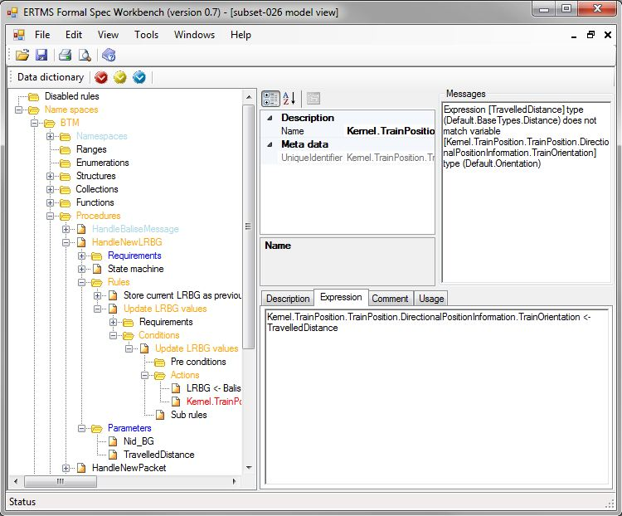
Figure 12 – Example of model warnings/errors
The buttons ,  and  can be used to navigate to respectively the next error, warning or information message, according to the selected node in the tree.

Expressions
Expressions are used by the EFSWorkbench to evaluate values for pre-conditions (see Section 6.8.2), actions (see Section 6.8.3) and expectations (see Section 8.3.2). They follow the BFN grammar described in the EFSW Technical Guide (see [1]).

State diagrams
State machines described in the system can be visualized using state diagram view.

Display a state diagram
To display a state machine, select the corresponding procedure or state machine in the data dictionary window, in the contextual menu, select View state diagram.
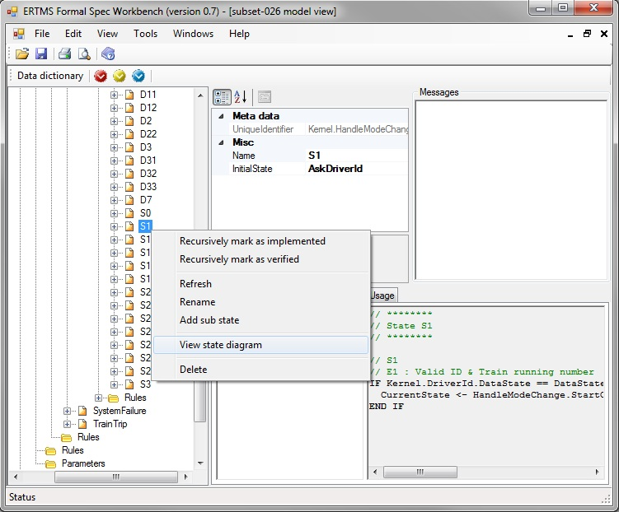
Figure 13 – View the state diagram associated to a procedure
Based on the state machine information and on the rules of the model, the Workbench builds the state diagram representation of the state machine and displays it in a new window, as depicted in Figure 14.
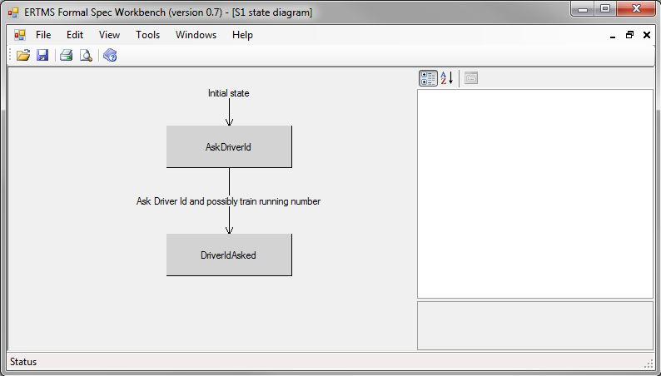
Figure 14 – State diagram view

Manipulations of a state diagram
New states and new transitions can be added in the state diagram using the graphical view, using the contextual view.
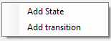
Figure 15 – Contextual menu for a state diagram

Add a new state
To add a new state, select Add state in the state diagram window contextual menu. This creates a new state in the corresponding state machine and updates the state diagram accordingly.

Add a new transition
A new transition is added by selecting Add transition in the same contextual window. This creates a new rule associated to this state machine whose pre-condition checks that the current state machine is in the source state of the transition, and adds an action which sets the current state machine state to the target state of the transition. Details about the transition (such as additional pre-conditions) can be accessed through the data dictionary view.

Selecting element in a state diagram
When a state or a transition is selected, its details are displayed in the right side of the window and the corresponding element is selected in the Data Dictionary window.

Test browser and execution environment
The EFSW provides an environment to define and run several kinds of tests:
- UNISIG Subset-076 test sequences
- Additional functional tests targeted at EFS model coverage
- User-defined tests

Opening the test browser
The test browser can be displayed using the Tools\Tests\Show tests view as depicted in Figure 16.
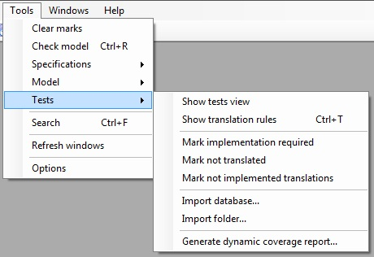
Figure 16 – Tools related to the test view

Test browser description

Overview
The test browser is decomposed into several parts, as shown in Figure 17.
- The left tree view represents the tests structure and allows to select a test element. Tests are structured in the following way:
  - at the top level, tests are grouped into test frames
  - each frame is decomposed into sub sequences
  - each sub sequence is decomposed into test cases
  - each test case is decomposed into several ordered steps
  - each step is decomposed into several ordered sub-steps
- The upper middle part, a property view, allows to visualize details of the element selected in the tree view.
- The upper right part, a messages view, can be used to visualize messages provided by the Workbench on the selected element (see Section 6.9 and 8.5).
- The lower right part of the window is decomposed into several tabs, which are active depending on the selected element
- Description: text editor allowing to enter free text expressions.
- Time line: displays expectations, rule activations and variable updates which occurred during the test (see 8.6);
- Comment: provides meta-information related to the selected item.

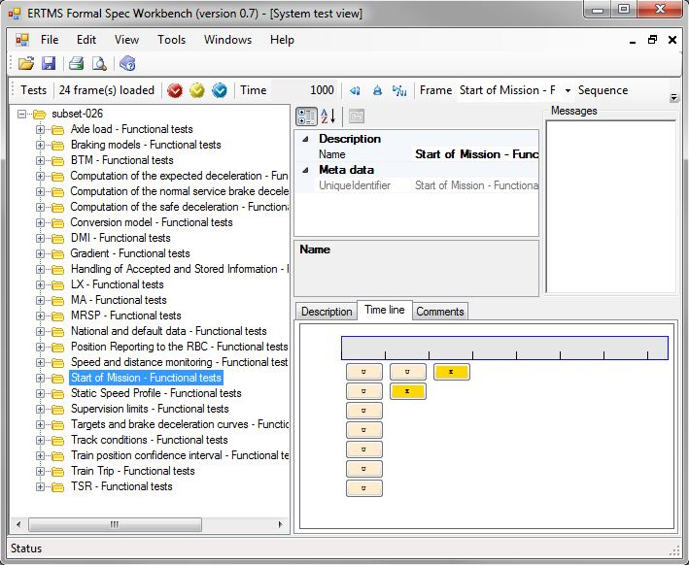
Figure 17 – Test browser details

Tools related to the test view
The Figure 16 shows the actions which can be executed on the tests structure.

Search for test elements requiring an implementation
The Mark implementation required tool allows to display all the test elements that have not yet been marked as implemented.

Test actions
The stop button allows reinitializing the test infrastructure whereas the play button allows activating the interpretation machine once. This modifies the event displayed in the time line (see 8.6)

Test step
A step is composed of a list of ordered sub-steps, which contain a set of actions and a set of expectations.

Actions
Once the step is activated, it modifies the state of the system by applying all actions related to that step (see 6.8.3 for actions application). After that, the interpreter is activated until all expectations of this step are either reached or failed.

Expectation
Expectations describe constraints about the system state which must be satisfied once a step is activated. Expectations hold the following information
- Name: corresponds to a boolean expression which should be evaluated to True in order to be considered successful.
- Blocking: false indicates that the following sub-step can be activated, even if this expectation is not reached.
- DeadLine: provides the time after which the expectation should be satisfied before the expectation is considered as Failed.

Test step execution
Activating a test step is achieved by selecting the contextual menu Run until expectation reached. This activates all previous steps until their expectations are reached, including this step. Activating a step without checking that all its expectations are reached is performed using the contextual menu item Run once. The test execution environment inner workings are fully described in the EFSW Technical Guide, in section 5 “Interpretation Model” (See [1]). Activating a step updates the time line according to the raised events (see 8.6).
After a step has been executed, the corresponding test tree node is displayed according to the color coding convention explained in Section 6.9: failed expectations are displayed in red as depicted by Figure 18.
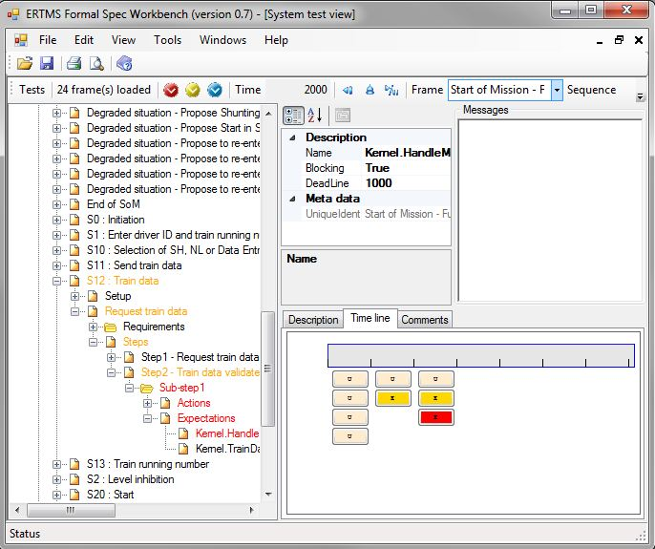
Figure 18 – Failed expectation

Test Case, Sub sequence and Frame execution
The contextual menu item Execute can be selected to
- Execute a test case enclosed in a subsequence, when applied on a test case.
- Execute all test cases of a sub sequence, when applied on a sub sequence.
- Execute all sub sequences in a test frame, when applied on a test frame.
- Execute all tests frames, when applied at the top of the tree view.

After the test has been executed, failed expectations are displayed in red as depicted by Figure 19, enclosing nodes are displayed in orange. In this case, the Time Line is not updated with the test events (see 8.6).
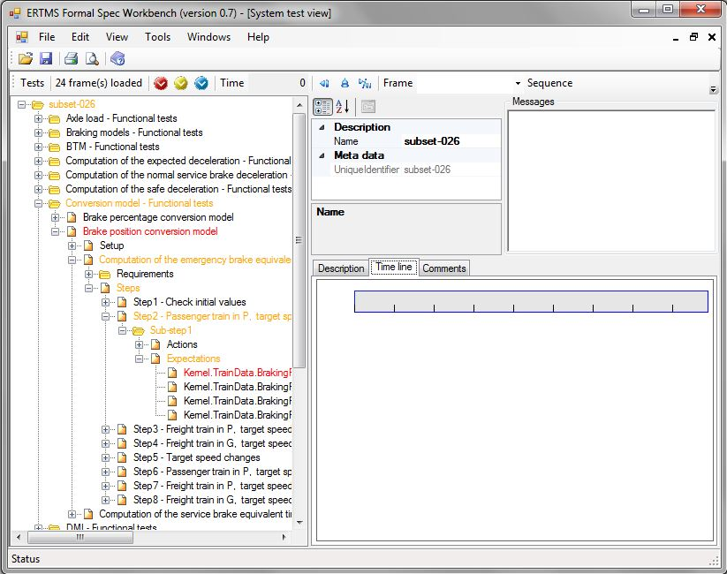
Figure 19 – Executing all the tests - failed tests are marked in orange

Time Line
The timeline component displays graphically events that occurred in a test:
- Activated rules are displayed in blue. Clicking on the blue button navigates to the rule inside the Rule Browser component.
- Variable updates are displayed in light rose. Clicking on the rose button navigates to the variable in the Data Dictionary component.
- Unfulfilled expects are displayed in grey. Clicking them navigates to the expect in the test browser.
- Fulfilled expects are displayed in yellow. Clicking them navigates to the expect in the test browser.
- Failed expects are displayed in red. Clicking them navigates to the expect in the test browser.

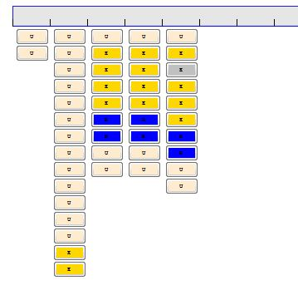
Figure 20 – Timeline component

The Workbench provides a means to filter the displayed elements of the time line, in order to limit their number. This can be done thanks to Configure filter field of the time line’s contextual menu, as depicted below.
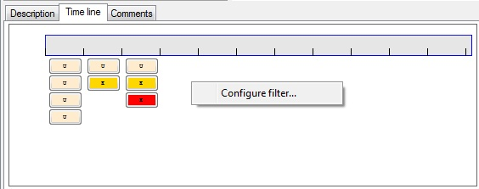
Figure 21 – Contextual menu to configure the time line filter
The Figure 22 shows the filter options. These options are:
- Show or hide rule activations.
- Show or hide variable updates.
- Show or hide expectations.
- Namespace filtering.
- Regular expression filtering.

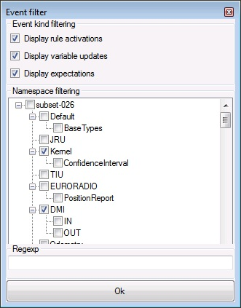
Figure 22 – Filter options

Translations
Translations can be defined to automatically translate tests steps imported from Subset-076 into actions, and expectations.

Open the translation view
The translation view can be opened using the tool menu entry Tools/Tests/Show translation rules, as depicted in Figure 16.
If several EFS files have been opened, a dialog box is provided to select the EFS file on which the translation view should be opened.

Translation view description

Overview
The translation view allows to specify pattern matching rules which translate into actions and expectations. The translation browser is decomposed into several parts, as shown in Figure 23.
- The left tree view represents the translations. A translation contains a set of source texts, which represent the text that has to be translated, and the set of actions and expectations corresponding to these texts.
- The upper middle part, a property view, allows to visualize details of the translation selected in the tree view (the implementation status and the name, corresponding to the text associated to the translation).
- The upper right part, a messages view, can be used to visualize messages provided by the Workbench on the selected element (see Section 6.9 and 8.5).
- The lower right part of the window shows the expression(s) corresponding to the selected translation.

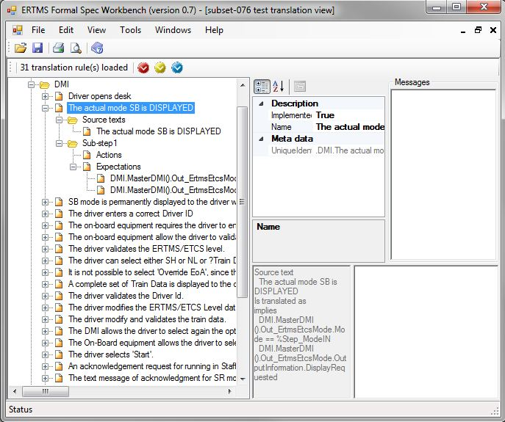
Figure 23 – Translation view
Each entry of the translation view provides the list of matching texts and the pre-conditions, actions, expectations or post actions to be placed in the step whose text matches one of the source text provided.

Tools related to the translation view
The Figure 16 shows the actions which can be executed on the tests structure.

Search for not translated tests
The Mark not translated tool allows to display all the test steps which require a translation but are not yet translated.

Search for not implemented translations
The Mark not implemented translations tool allows to display all the translations which have not yet been implemented.

Import a database
The Import database tool allows to import a subset 76 test database as a new test sequence.

Import a folder
The Import folder tool allows to import all subset 76 database test sequences located in a directory in EFS.

Apply translation rules
To apply translation rules, open the test browser, select a node in the tree view, and in the contextual menu, select Apply translation rules, as shown below.
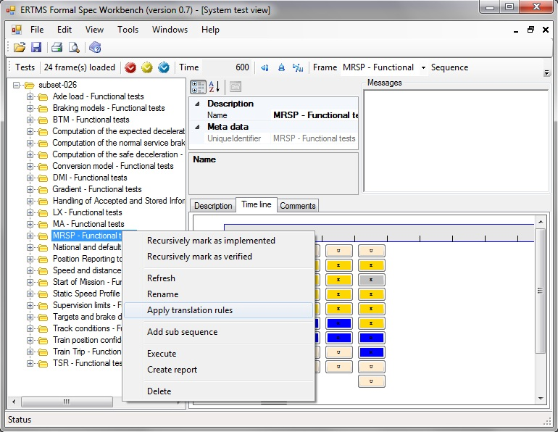
Figure 24 – Apply translation rules
This updates all the nodes enclosed by the selected node according to translation rules.

Reports
The EFSW provides the possibility to generate reports in pdf format which provides data about coverage of the specification by the model, as described in Section 10.1, and dynamic model coverage resulting of the test executions as described in Section 10.2.

Specification coverage report

Purpose
The purpose of the specification coverage report is to provide requirement coverage information based on the modeled elements, along with implementation statistics.
The specification coverage part of the report provides the status of all the requirements specified in the requirement document. This status can be one of the followings:
- Implemented: indicating that the modeling of the requirement is complete. This also ensures that all model elements which model this requirement are also marked as implemented..
- N/A. indicates that the implementation status of this paragraph is not yet known. In this case, implementation is not performed.
- Not implementable. Indicates that the paragraph does not need to be implemented because it is not a requirement.

The requirement coverage report provides the list of all the requirements of the specification along with the model elements that implement them.
The model coverage report provides the list of requirements associated to each model element.

Structure
The specification coverage report can be composed of four following chapters:
- Specification coverage. This chapter can be composed of two sections:
- Statistics. This section provides a table with the following information:
  - Total number of specification paragraphs.
  - Number of applicable paragraphs. The paragraph is applicable if its scope is "OBU" (on board unit) or "OBU and Track" and if its type is "Requirement".
  - Number and percentage of covered paragraphs. This percentage is computed from the total number of applicable paragraphs. A paragraph is considered as covered if it is marked as "implemented" and all the EFS elements that are related to this paragraph are marked as "implemented".
  - Specification. This section provides a table with an entry for each specification paragraph. For each paragraph the table provides its scope ("OBU", "OBU and Track" or "Track"), its type and its implementation status.
- Covered requirements. This chapter provides the list of requirements covered by the model and can be composed of two following sections:
- Statistics. This section provides a table with the following information:
  - Number of applicable paragraphs.
  - Number and percentage of covered requirements.
  - Covered requirements. This section provides a table with an entry for each covered requirement. For each covered requirement, the table provides the list of the model elements that implement it with the associated comment.
- Non-covered requirements. This chapter provides the list of requirements that are not yet covered by the model and can be composed of two following sections:
- Statistics. This section provides a table with the following information:
  - Number of applicable paragraphs.
  - Number and percentage of non-covered requirements.
  - Non-covered requirements. This section provides the list with the non-covered requirements.
- Model coverage. This chapter provides the list of implemented model elements and can be composed of the following sections:
- Statistics. This section provides a table with the following information:
  - Number of implemented model elements.
  - Number and percentage of modeled paragraphs.
  - Implemented rules. This section provides a table containing an entry for each implemented rule. For each implemented rule the table provides the (list of) the paragraph(s) it implements.
  - Implemented types. This section provides a table containing an entry for each implemented type. For each implemented type the table provides the (list of) the paragraph(s) it implements.
  - Implemented variables. This section provides a table containing an entry for each implemented variable. For each implemented variable the table provides the (list of) the paragraph(s) it implements.

Launch the specification reporting
The specification coverage report creation window is accessible via Tools/Specifications/Generate coverage report... (See Figure 25).
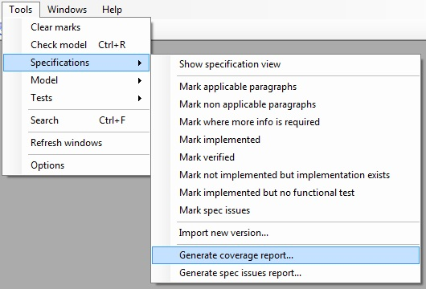
Figure 25 – Launch the specification coverage report
This opens the dialog which allows to select the report options, as depicted below
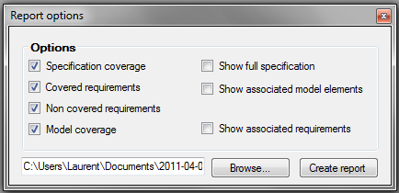
Figure 26 – Specification coverage report options
The figure above shows the window permitting to select the different report options. The check boxes in the left column allow to create the corresponding report chapters (described in Section 10.1.2) with their "Statistics" section. The check boxes of the right column allow to add additional information described below:
- Show full specification check box is accessible only when the "Specification coverage" check box is selected. This option allows to add the "Specification" section to "Specification coverage" chapter.
- Show associated model elements check box is accessible only when the "Covered requirements" check box is selected. This option allows to add the information about the elements implementing the covered requirements in "Covered requirements" section of "Covered requirements" chapter.
- Show associated requirements check box is accessible only when the "Model coverage" check box is selected. This option allows to add the list of requirements modelled by each model element in the sections "Implemented rules", "Implemented types" and "Implemented variables" of "Model coverage" chapter.

The "Browse" button allows to select the name and the folder of the generated report.

Spec issues report
The Tools/Specifications/Generate spec issues report... tool allows to create a report containing:
- all the spec issues that have been detected during the implementation of the model.
- all the design choices that have been made during the implementation of the model

Dynamic tests coverage report

Purpose
The purposes of the dynamic tests coverage report are to provide model elements dynamic coverage by either all the implemented tests, a specific test frame, a specific sub sequence, a specific test case or a specific step of a test
The report can also be used to provide the log associated to a particular step of a test. This log information contains the sequence of operations executed by the step along with the time when these operations occurred.

Structure
The dynamic tests coverage report can provide the information at different levels (called filters) of the tests tree (frames, sub sequences, test cases or steps) depending on user's choice (see Section 10.2.3). The topmost level is that of frames. A level can be included in the report if it is the topmost level or if its enclosing level is included in the report.
The report can be created for the whole tests set of the model or for a certain element of the tests tree. In that case the level of a selected element is the topmost. For example, a report can concern
- The whole tests tree, containing information of all its levels
- All the available frames
- All the frames and all the sub sequences
- A particular sub sequence with all it sub cases
- A particular test case

For each item of each selected level the report provides the percentage of activated rules of the EFS model and (if selected) the list of these rules and/or the list of rules that weren't activated. This information is computed as follows:
- For a step, the list of activated rules is computed by executing it and collecting the activated rules of its time line (see section 8.6)
- The rules activated by a test case are the set of rules activated by all its steps
- The rules activated by a sub sequence are the set of rules activated by all its test cases
- The rules activated by a frame are the set of rules activated by all its sub sequences

Launch the test coverage reporting
The specification coverage report creation window is accessible via Tools/Tests/Generate dynamic coverage report... (see figure belowError: Reference source not found).
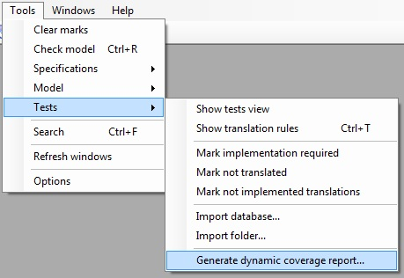
Figure 27 – Launch the dynamic test coverage report

The option of a partial report creation for a selected item of the tests tree is accessible via the "Create report" option from its contextual menu.
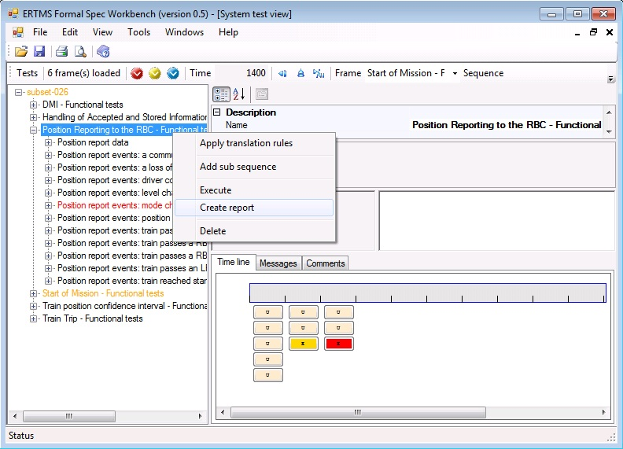
Figure 28 – Report creation for a specific sub sequence
This action opens the dialog box displayed below.
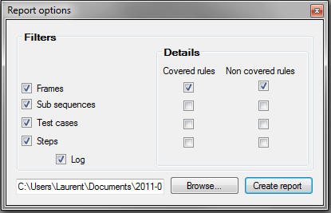
Figure 29 – Dynamic tests coverage report options
The figure Figure 29 shows the window permitting to select the different report options. The check boxes in "Filters" group box allow to select the different levels of the report (see section 10.2.2). The corresponding check boxes in the "Details" group box allow to add the list of covered and/or not covered rules to the corresponding level. "Log" check box allows to display the log information for the different steps.

The "Browse" button allows to select the name and the folder of the generated report.

Data dictionary report

Purpose
The purpose of the data dictionary report is to provide information about the model elements whose implementation is complete. The report can be created on two different levels of details:
- Default level: the report provides only the list of implemented model elements together with their associated requirements.
- Detailed level: the report provides all the available details for each implemented model element.

Structure
The report is divided in several chapters each one corresponding to one of the data dictionary namespace. Depending on the user’s choice, each chapter can contain information about its
- Ranges. For each implemented range of the current name space, the report contains information about its min and max values, about its default value and precision. The list of its special values is also provided.
- Enumerations. For each implemented enumeration of the current name space, the report provides the list of its possible values together with its default value.
- Structures. For each implemented structure of the current name space, the report provides the description of its sub-elements, its procedures and its rules.
- Collections. For each implemented collection of the current name space, the report provides its type, its max size and its default value.
- Functions. For each implemented function of the current name space, the report provides its return type, the description of its parameters and its cases (their pre-conditions and expressions).
- Procedures. For each implemented procedure of the current name space, the report provides the description of its parameters, rules and the state machine.
- Variables. For each implemented variable of the current name space, the report provides its type, default value (if any) and its mode.
- Rules. For each implemented rule of the current name space, the report provides the description of all its rule conditions and its priority.

For each one of the elements described above, the data dictionary report provides a comment describing its utility. If a model element which implementation is not yet compete contains some sub elements that are already implemented, this element is also included in the report. Each model element of the report contains also a table describing its implementation and verification statuses.

Launch the model report
The data dictionary report creation window is accessible via Tools/Model/Generate data dictionary report... (see Figure 30).
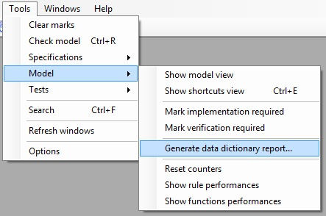
Figure 30 – Launch the data dictionary report

This opens the dialog which allows to select the report options, as depicted below.
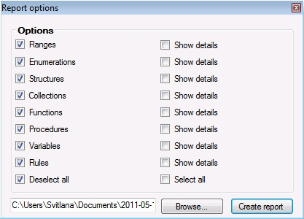
Figure 31 – Data dictionary report options
The different check boxes allow to select the type of elements to be included in the report, and precise if the latter has to describe the details of these elements.

This kind of function is mainly used in braking curve computation
In other words, a sub-rule is active when its pre-conditions and all the pre-conditions of all its parent rule conditions are satisfied.
For now, only blocking expectations are implemented

