**Title: The Influence of Commodity Returns (Gold and Oil) on Stock Market Indices (S&P 500 and NASDAQ) in 2024**

Author: Mariem Briki

BA Business Analytics 2023-2026

Marie Curie-Sklodowska University

Course: Econometrics

Course Instructor: mgr. Arleta Kedra

Date of report: 28 April, 2024

Author Note

This project was prepared by Mariem Briki as part of the course requirements for the Econometrics course taught by mgr. Arleta Kedra at Marie Curie-Skłodowska University. The work is an original student submission conducted during the spring semester of 2025.

Abstract

This research explores the dynamic relationship between major commodities—Gold and Oil—and stock market indices, namely the S&P 500 and NASDAQ, during the year 2024. Recognizing the increasing relevance of commodities in financial market volatility, this project utilizes econometric modeling to quantify the impact of commodity returns on stock index performance. The findings reveal that Gold significantly influences S&P 500 returns, while Oil returns are a major determinant of NASDAQ performance. Through a rigorous methodology involving assumption verification and statistical validation, the study offers insights into cross-market interactions and suggests avenues for future exploration.

Keywords: Gold Returns, Oil Returns, Stock Market Indices, S&P 500, NASDAQ, Econometric Modeling, Financial Analysis, Market Volatility.

1. Introduction

Understanding the influence of commodities on stock markets is crucial in financial economics. Gold serves as a hedge against financial market volatility (*Baur & Lucey, 2010*), while oil prices have a direct impact on macroeconomic activity and stock market performance (*Sadorsky, 1999*). This study explores the impact of Gold and Oil returns on the S&P 500 and NASDAQ indices during the year 2024.

# Literature Review

Baur and Lucey (2010) analyzed gold's behavior as a hedge and safe haven, finding gold effective in extreme market downturns. Sadorsky (1999) demonstrated that oil price volatility significantly influences stock returns and market risk. Kilian and Park (2009) differentiated between oil demand and supply shocks, showing nuanced effects on stock returns. Narayan and Narayan (2010) modeled oil price volatility and its transmission to financial markets. Hammoudeh and Aleisa (2004) explored dynamic linkages between GCC stock markets and NYMEX oil futures, highlighting cross-market dependencies.

1. Research Question and Hypotheses

Research Question: How do Gold and Oil returns impact S&P 500 and NASDAQ returns during 2024?

Hypotheses:

- **H₀**: Gold and Oil returns have no significant impact on S&P 500 and NASDAQ returns.

- **H₁**: Gold and Oil returns have a significant impact on S&P 500 and NASDAQ returns.

1. Data Description

The dataset was collected from Kaggle (nazaninmottaghi2022/financial-data) and covers daily closing prices for the S&P 500, NASDAQ, Gold, and Oil from 2019 to 2024; however, as per project requirements, the dataset has been cleaned and minimized to include daily data from January 2024 until December 2024. Returns were calculated as percentage changes from daily closing prices. The dataset is recent, verifiable, and suitable for econometric analysis.

## Descriptive Statistics and Visualization

Descriptive statistics highlighted differences in volatility across assets, with NASDAQ and Oil returns exhibiting greater variability compared to Gold and S&P 500 returns. Histograms indicated near-symmetric distributions for most returns, although slight skewness was observed in Oil returns. Correlation heatmaps revealed a strong positive relationship between NASDAQ and Oil returns, suggesting potential spillover effects.

|  |  |  |  |  |
| --- | --- | --- | --- | --- |
| **Statistic** | **S&P 500 Return** | **NASDAQ Return** | **Gold Return** | **Oil Return** |
| Count | 250 | 250 | 250 | 250 |
| Mean | 0.019998 | 0.117474 | 0.097723 | 0.091016 |
| Standard Deviation | 1.819740 | 1.136225 | 0.954792 | 0.798307 |
| Minimum | -6.129843 | -3.639088 | -3.435546 | -2.996880 |
| 25th Percentile (Q1) | -1.059903 | -0.389594 | -0.378638 | -0.289551 |
| Median (Q2) | -0.020574 | 0.164193 | 0.176819 | 0.105391 |
| 75th Percentile (Q3) | 1.240307 | 0.833778 | 0.753424 | 0.566177 |
| Maximum | 5.149787 | 2.957152 | 2.013978 | 2.529593 |

**Interpretation:**

- The mean return indicates the average daily performance. NASDAQ had a higher mean (0.12%) than S&P 500 (0.02%).

- Standard deviation shows volatility; S&P 500 was more volatile (1.82%) than NASDAQ (1.14%).

- Minimum and maximum values reflect the largest daily losses and gains, highlighting the presence of market shocks.

***Volatility*** measures the degree of variation in returns over time; higher volatility indicates greater uncertainty and larger fluctuations in asset prices, while lower volatility suggests more stable and predictable movements.

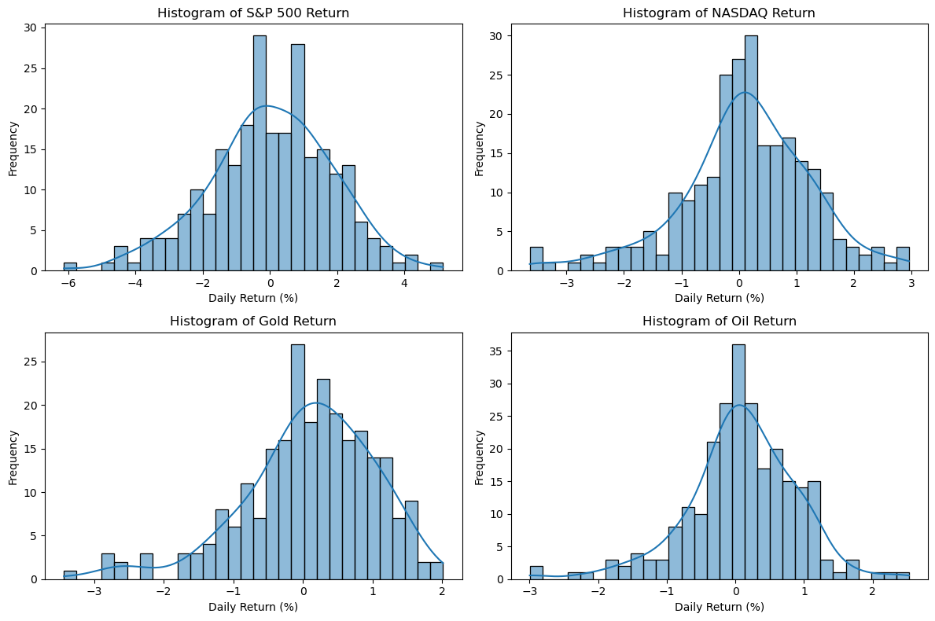

Figure . Histograms included from Jupyter Notebook: financial_data_modeling.ipynb, section 2.1

Overall, the returns of S&P 500, NASDAQ, Gold, and Oil are centered around zero, reflecting small average daily movements.

- The S&P 500 shows slight left-skewness, indicating that large negative returns occur more often than large positive ones.

- The NASDAQ returns are fairly symmetric but with a very mild right skew, suggesting a slight tendency toward positive daily changes.

- Gold returns exhibit a noticeable right skew, with occasional sharp positive returns, likely reflecting its role as a safe-haven asset during market uncertainty.

The distribution shapes for all assets suggest that while returns are approximately normal, they display mild skewness and moderate kurtosis, meaning returns are not perfectly normally distributed.

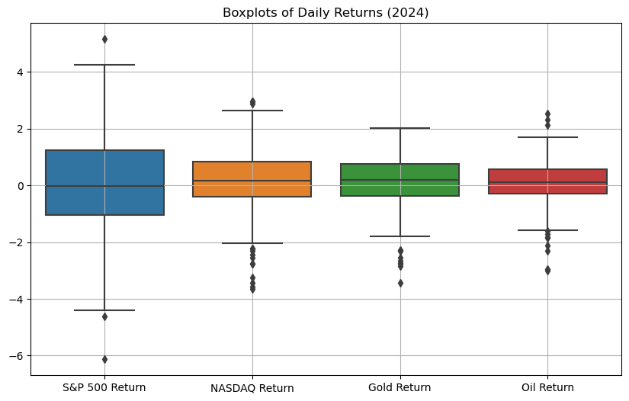Figure . Boxplot figure included from Jupyter Notebook: financial_data_modeling.ipynb, section 2.3

**Interpretation:**

- S&P 500 returns show the widest interquartile range (IQR) and the largest spread of outliers, indicating the highest volatility and exposure to extreme movements among the four assets.

- Gold and Oil returns are more tightly clustered around the median, reflecting relatively lower daily variability compared to stock indices.

- Across all assets, small but visible outliers highlight occasional sharp market events, with S&P 500 experiencing the most extreme daily losses and gains.

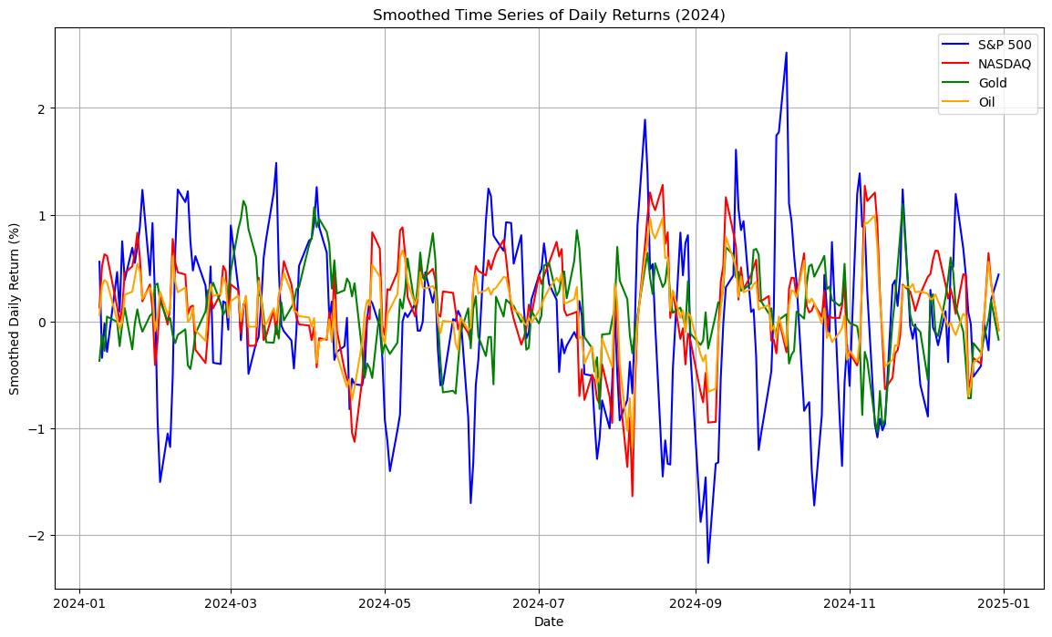

Figure . Time series included from Jupyter Notebook: financial_data_modeling.ipynb, section 2.4

**Interpretation:**

- The S&P 500 (blue line) exhibits the highest amplitude in its movements, with noticeable spikes both upwards and downwards, especially around mid-year (June–July) and in the final quarter of 2024.

- NASDAQ, Gold, and Oil display relatively tighter fluctuations and more stable paths compared to the S&P 500, although occasional synchronized movements are visible, suggesting some common macroeconomic influences.

- Periods of high volatility across all assets can correspond to major financial or geopolitical events, though further investigation would be needed to precisely link events to movements.

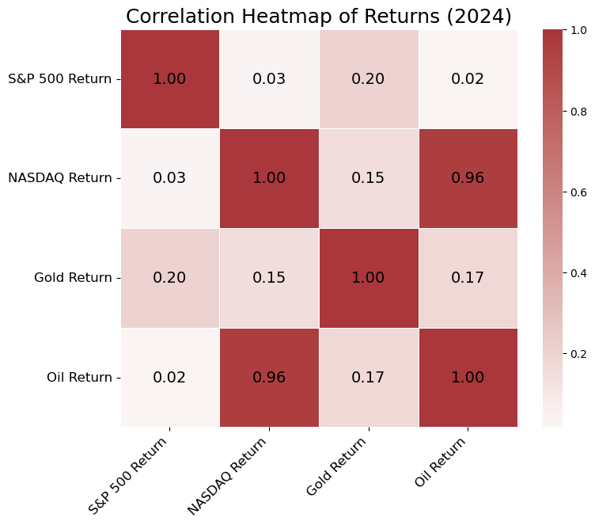

Figure . Correlation Heatmap included from Jupyter Notebook: financial_data_modeling.ipynb, sec 2.5

**Interpretation:**

- NASDAQ and Oil returns are highly positively correlated (0.96).

- S&P 500 returns have very weak correlations with all other assets: 0.03 with NASDAQ, 0.20 with Gold, and 0.02 with Oil, suggesting S&P 500 movements were relatively independent.

- Gold returns exhibit low positive correlations with both stock indices and Oil, indicating that Gold behaved relatively independently, reinforcing its role as a diversification or safe-haven asset.

## Econometric Modeling

To investigate the relationship between commodity returns and stock indices, two Ordinary Least Squares (OLS) regression models were specified:

**Model Specification:**

For the S&P 500 index:

$${SP500_Return}_{t}​=β0​+β1​×{Gold_Return​}_{t}+β2​×{Oil_Return}_{t}​+ϵ_{t}​$$

For the NASDAQ index:

$${NASDAQ_Return}_{t}​=α0​+α1​×{Gold_Return​}_{t}+α2​×{Oil_Return}_{t}​+ϵ_{t}​$$

Where:

* β0, α0 ​ represent the intercepts,
* β1, α1 ​ measure the sensitivity of stock returns to Gold returns,
* β2, α2 ​ measure the sensitivity of stock returns to Oil returns,
* ϵt, ut are error terms capturing unobserved influences at time t.

OLS was chosen due to its simplicity, interpretability, and effectiveness under classical assumptions.

**Model Diagnostics:**

* Linearity: Residuals vs Fitted plots displayed random dispersion without systematic patterns.
* Homoskedasticity: Breusch-Pagan tests produced p-values > 0.05, indicating constant variance.
* Normality: Shapiro-Wilk tests confirmed normal distribution of residuals (p > 0.05).

**Results:**

* S&P 500 Model: R² = 0.0418; Adjusted R² = 0.0341; RMSE = 1.7777.
* NASDAQ Model: R² = 0.9183; Adjusted R² = 0.9176; RMSE = 0.3241.

**Interpretation:**

* In the S&P 500 model, Gold returns were statistically significant, suggesting their influence on market movements.
* In the NASDAQ model, Oil returns exhibited a strong and statistically significant effect, reflecting NASDAQ's sensitivity to macroeconomic factors

*\*for a more detailed presentation of the econometric modeling process, including explicit residual diagnostics, visual interpretations, and full coding output, please refer to the accompanying Jupyter Notebook file financial_data_modeling.ipynb submitted with this report.*

## Conclusions and Discussion

The findings partially support the research hypotheses. Gold returns significantly impact S&P 500 returns, while Oil returns significantly drive NASDAQ returns. The stronger goodness of fit in the NASDAQ model suggests that Oil market developments are more tightly linked to technology-oriented equities. Gold prices show a significant influence on S&P 500 returns, consistent with the role of gold as an alternative investment during periods of market uncertainty.  
  
However, limitations include the relatively short analysis period and the exclusion of other potential explanatory variables; he models use only two independent variables (Gold and Oil returns), while stock indices are influenced by a much wider set of factors (macroeconomic data, monetary policy, geopolitical events). Moreover, the low R² in the S&P 500 model indicates that many important factors affecting S&P 500 returns are missing.

Future research could address these limitations by incorporating a broader set of predictors such as interest rates, inflation rates, corporate earnings, and geopolitical risk indices. To better capture complex financial dynamics, exploring sector-specific effects, and applying non-linear econometric models such as GARCH or regime-switching models is an option to look into. Sector-specific analysis could also reveal different sensitivities within sectors of the stock market to commodity price movements.

References

Baur, D. G., & Lucey, B. M. (2010). Is gold a hedge or a safe haven? An analysis of stocks, bonds and gold. Financial Review, 45(2), 217–229. https://doi.org/10.1111/j.1540-6288.2010.00244.x

Hammoudeh, S., & Aleisa, E. (2004). Dynamic relationships among GCC stock markets and NYMEX oil futures. Contemporary Economic Policy, 22(2), 250–269. https://doi.org/10.1093/cep/byh018

Kilian, L., & Park, C. (2009). The impact of oil price shocks on the U.S. stock market. International Economic Review, 50(4), 1267–1287. https://onlinelibrary.wiley.com/doi/10.1111/j.1468-2354.2009.00568.x

Narayan, P. K., & Narayan, S. (2010). Modelling oil price volatility. Energy Economics, 32(2), 496–502. https://www.sciencedirect.com/science/article/pii/S030142150700331X

Sadorsky, P. (1999). Oil price shocks and stock market activity. Energy Economics, 21(5), 449–469. <https://doi.org/10.1016/S0140-9883(99)00020-1>

**Table of Figures**

Figure 1. Histograms included from Jupyter Notebook: financial_data_modeling.ipynb, section 2.1 5

Figure 2. Boxplot figure included from Jupyter Notebook: financial_data_modeling.ipynb, section 2.3 6

Figure 3. Time series included from Jupyter Notebook: financial_data_modeling.ipynb, section 2.4 7

Figure 4. Correlation Heatmap included from Jupyter Notebook: financial_data_modeling.ipynb, sec 2.5 8