Electronic Geek Bag

A Little Workshop in E-Sewing

by
Mariemurasaki
Shinnamon
Teschi

Introduction
This guide is part of the sewable electronics workshop „Electronic Geek Bag“ first hold at the 32c3 congress

For more Information on the Workshop go to:
https://events.ccc.de/congress/2015/wiki/Assembly:Electronic_GeekBag

All workshop material can be found at:
https://github.com/Mariemurasaki/Electronic-Geek-Bag


This work is licensed under the Creative Commons Attribution 4.0 International License. To view a copy of this license, visit http://creativecommons.org/licenses/by/4.0/
Attribution goes to: Marion Uebernickel (https://github.com/Mariemurasaki)
Sewing with conductive thread

Use a piece of conductive thread, about 40 cm long, and thread one end into a sewing needle with a sharp tip. Make a knot into the other end of the thread. Put your electronic component into place and fix it with a piece of scotch tape - the pin you want to connect first must not be covered by the tape, of course.

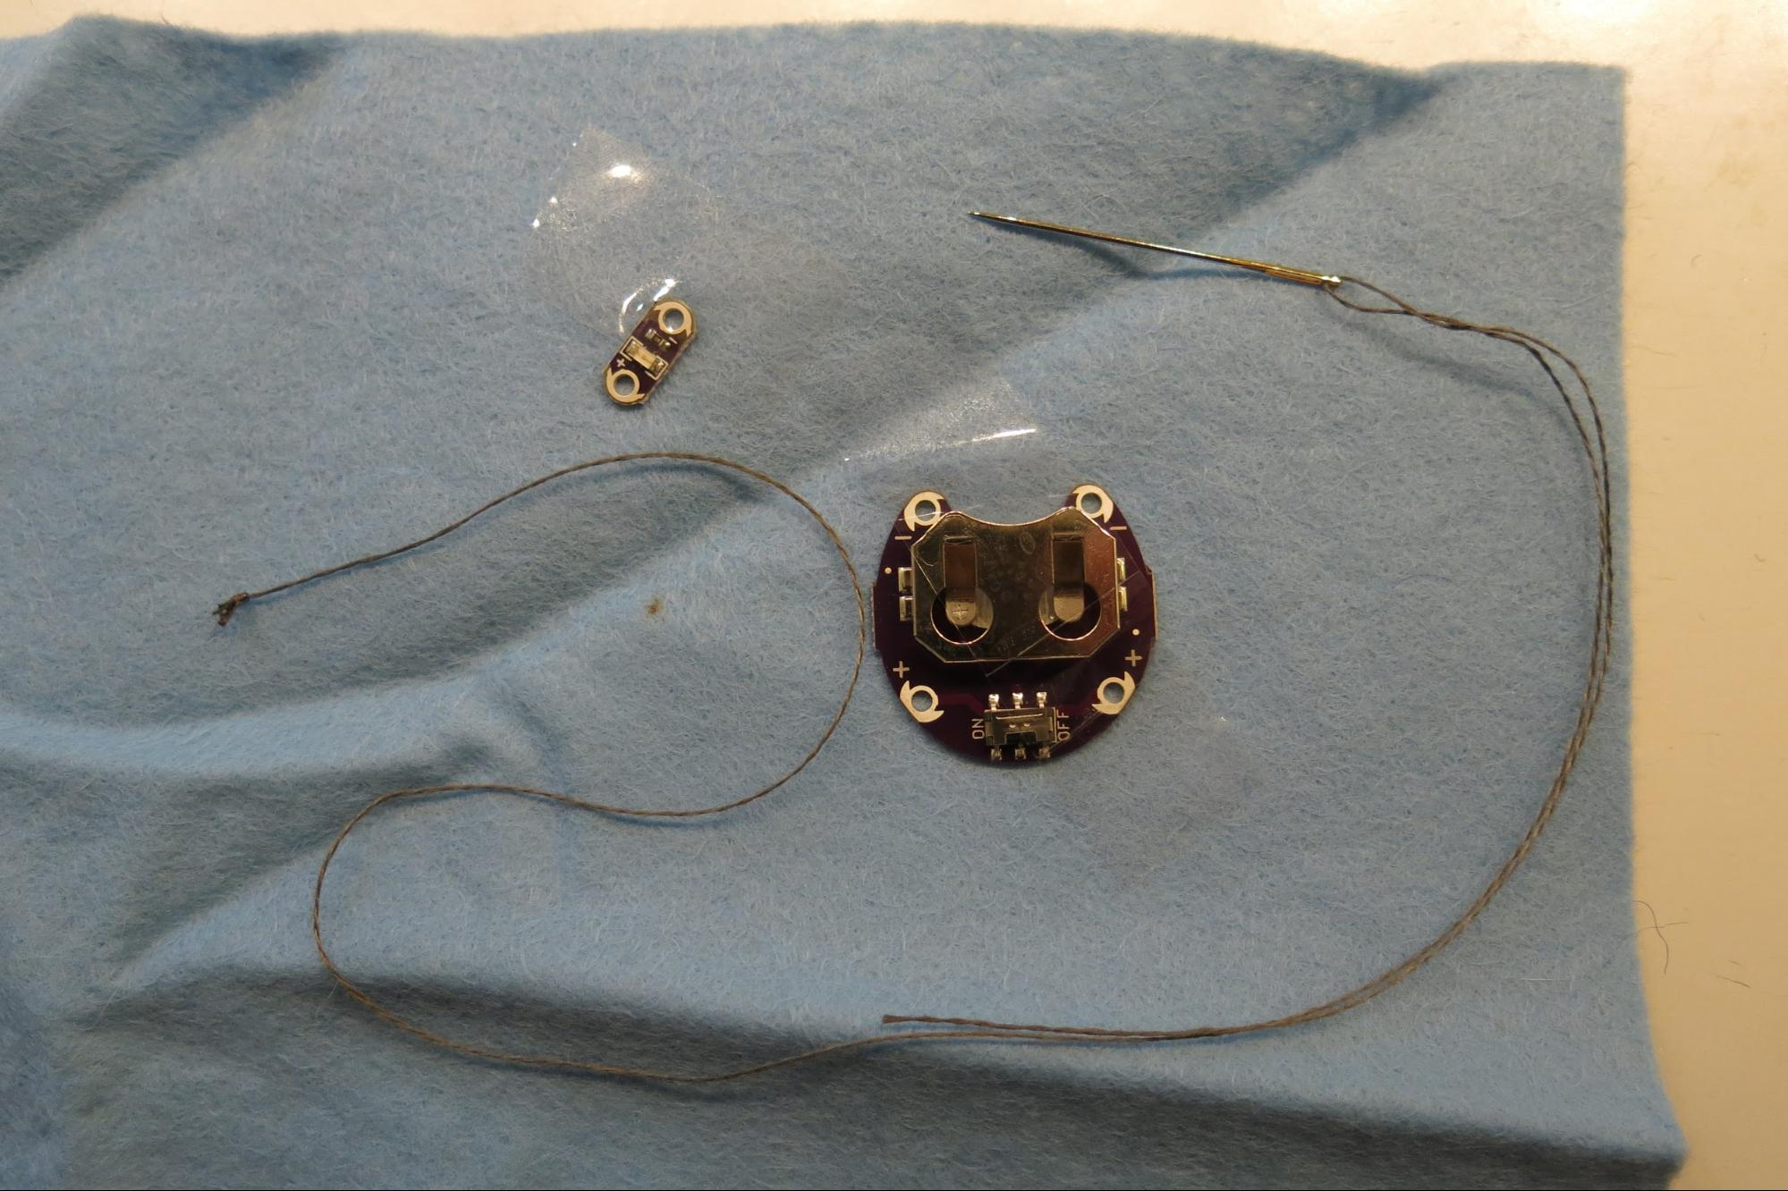

Now take the needle and go with it through the fabric from the left (the backward) side, then guide the needle through the hole in your electronic component that corresponds to the pin you want to connect. Stitch back into the fabric next to the pin to the back side, and let the needle come forward through the hole in your electronic component again. Repeat this for about three to five times and remember to pull the thread tight after each stitch (just so tight that it does not appear lose will be enough, otherwise your conductive thread will break).
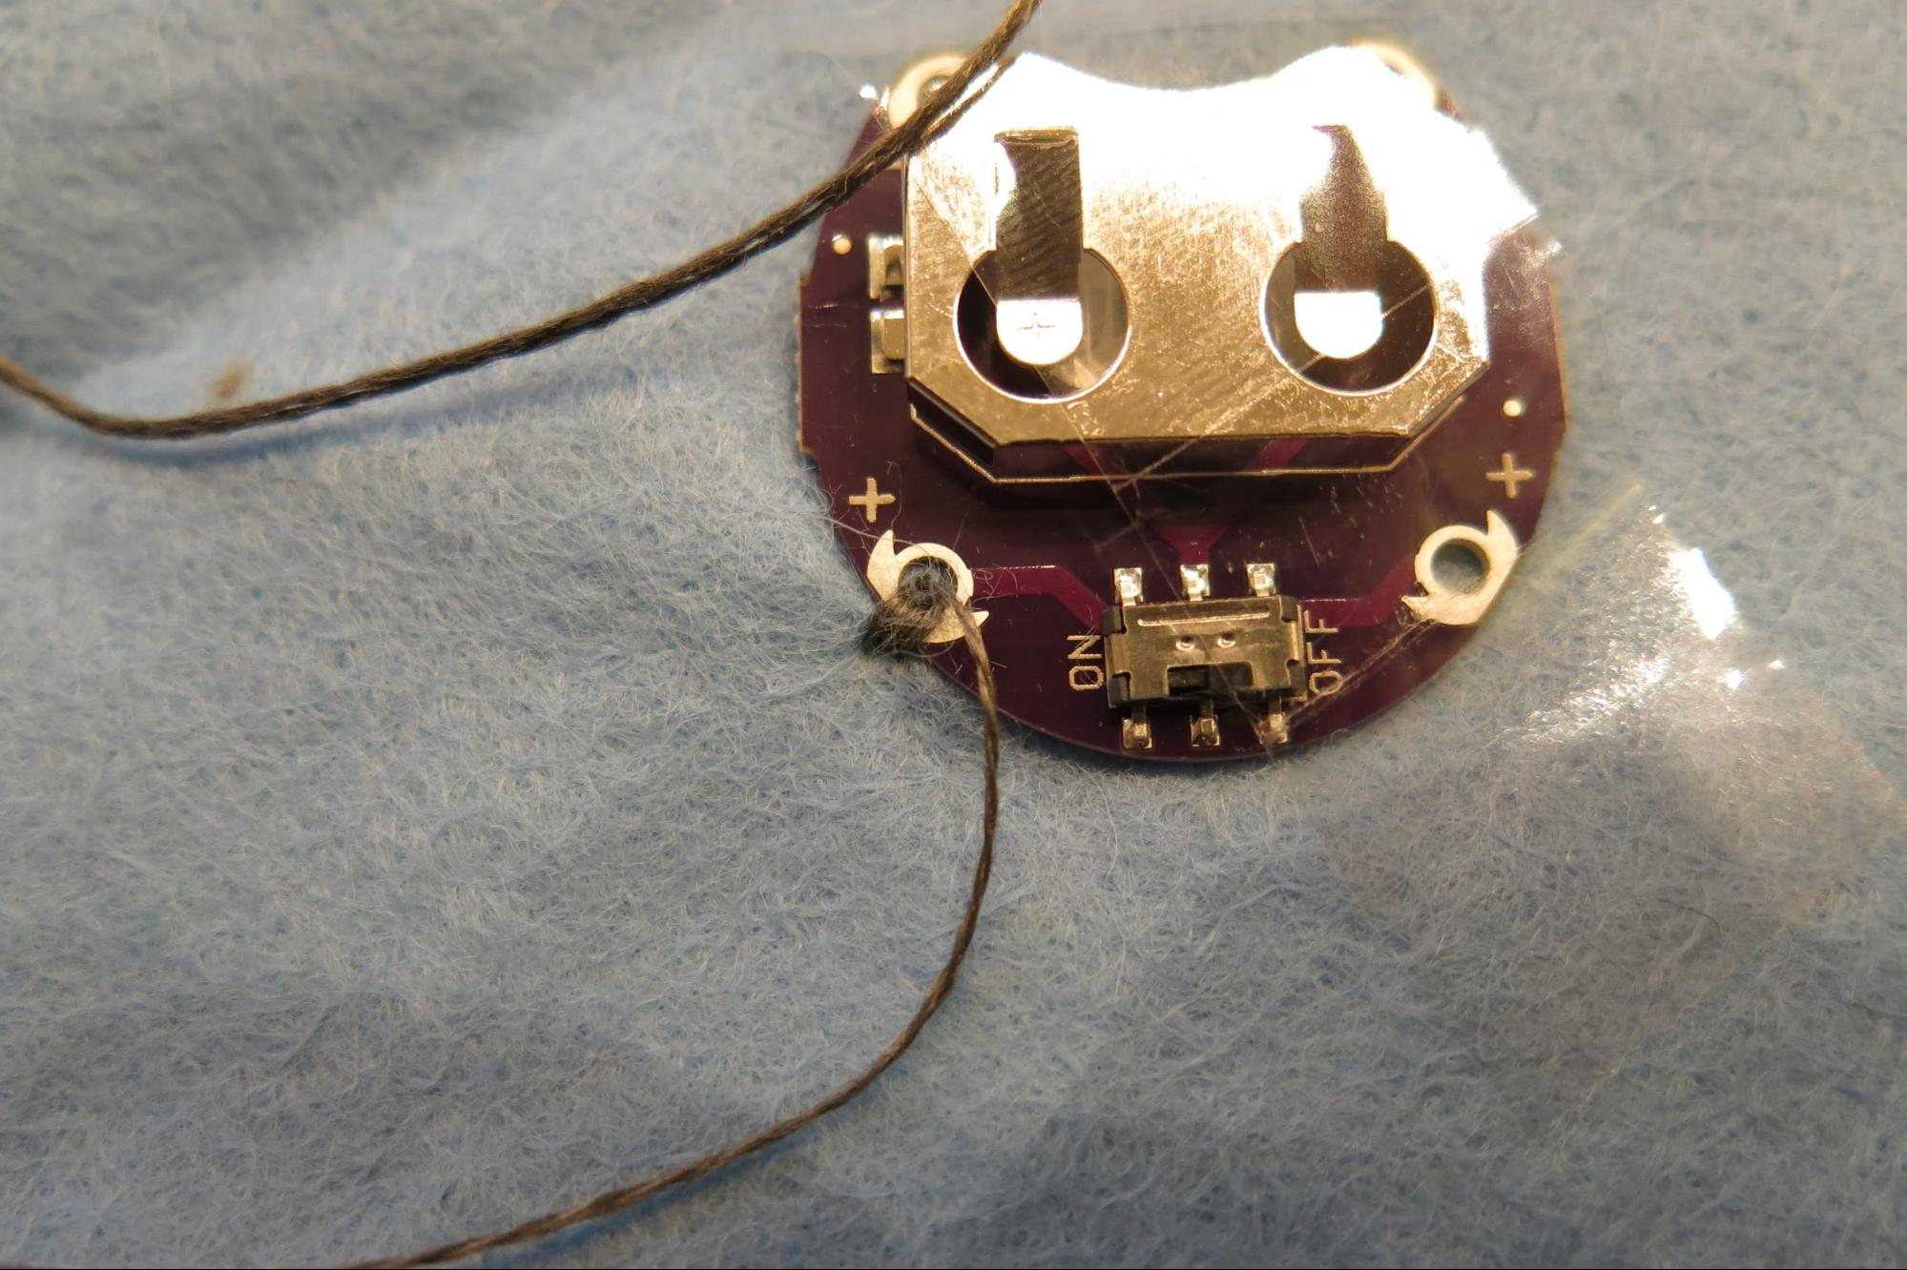

Now, sew all the way to the second electronic component with running stitches, this time not pulling them tightly. The stitch length can be anything between 0.5 and 5 cm, but usually something about 1 to 2 cm works best.
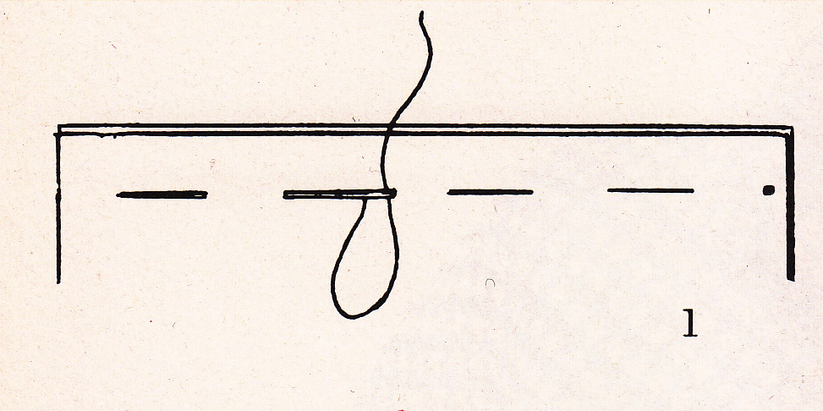
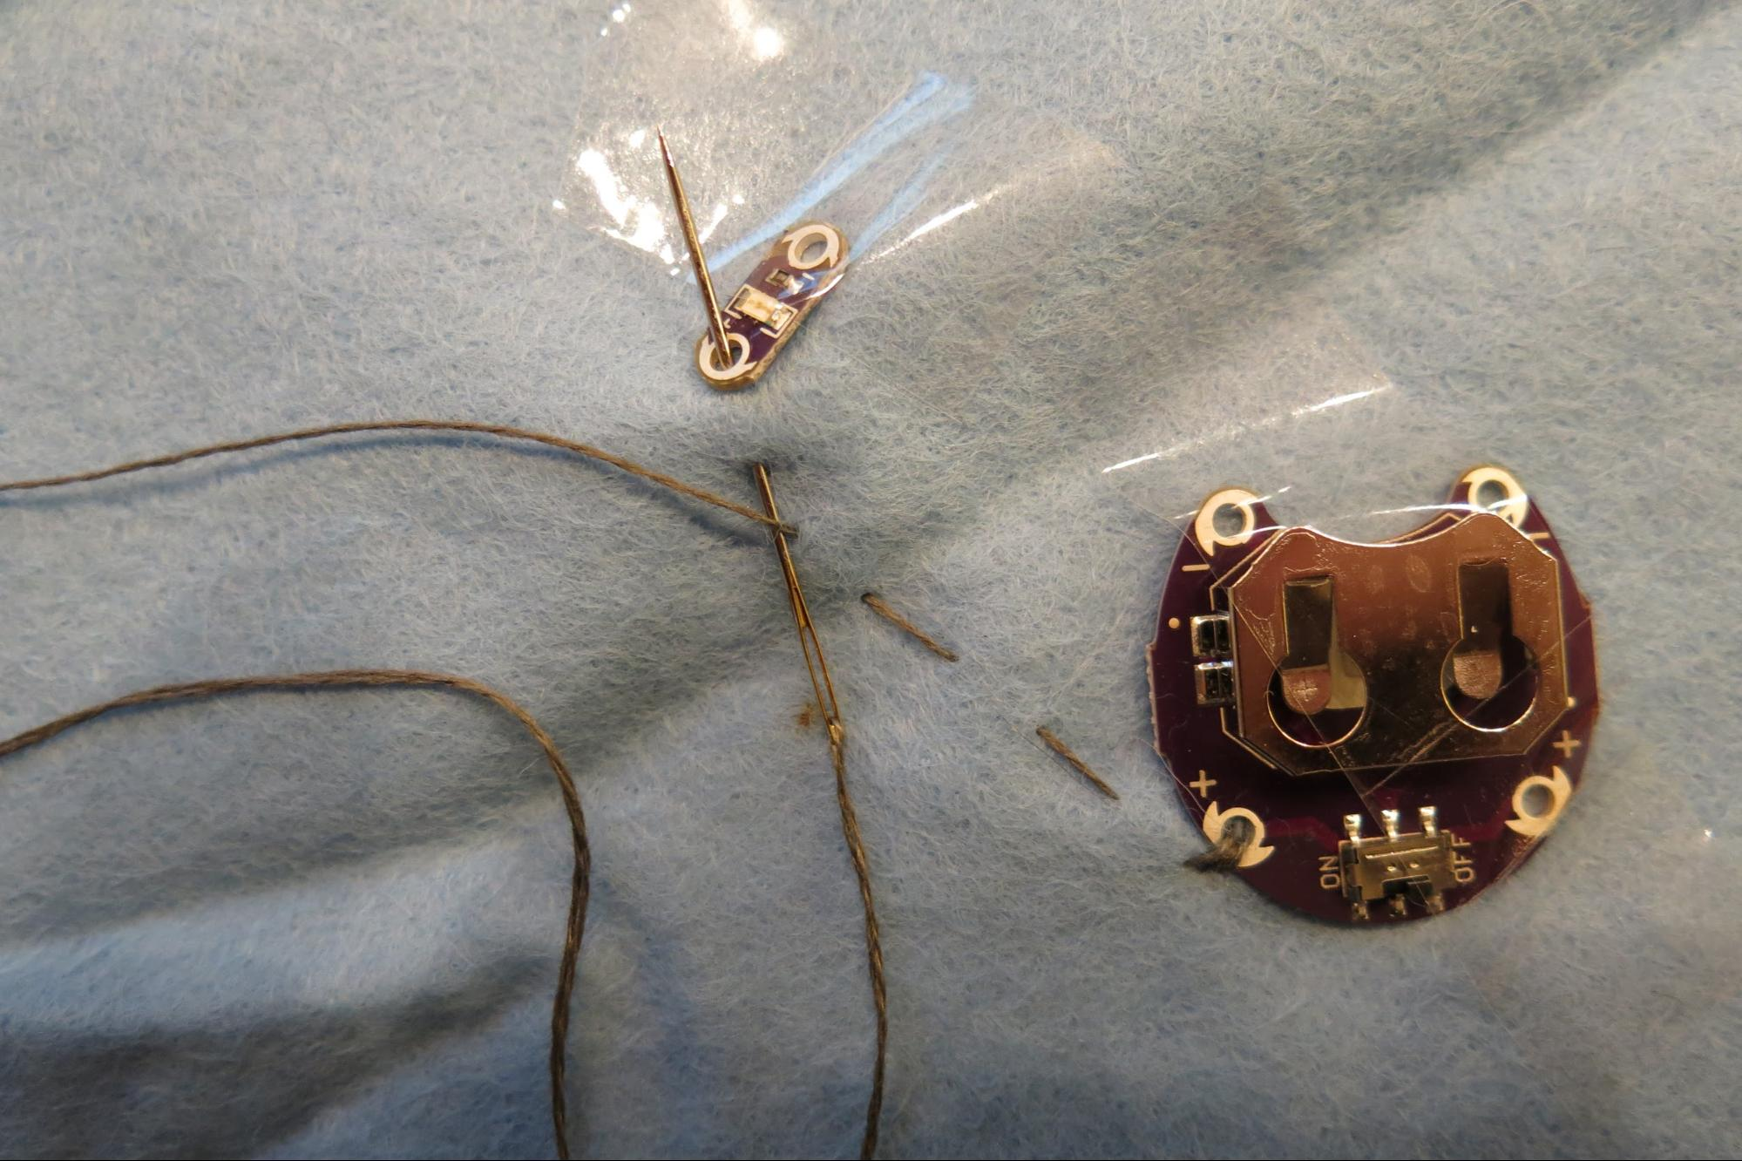

When you have reached your second electronic component that the first one has to connect with, again do about five stitches through the hole corresponding to the connecting pin.
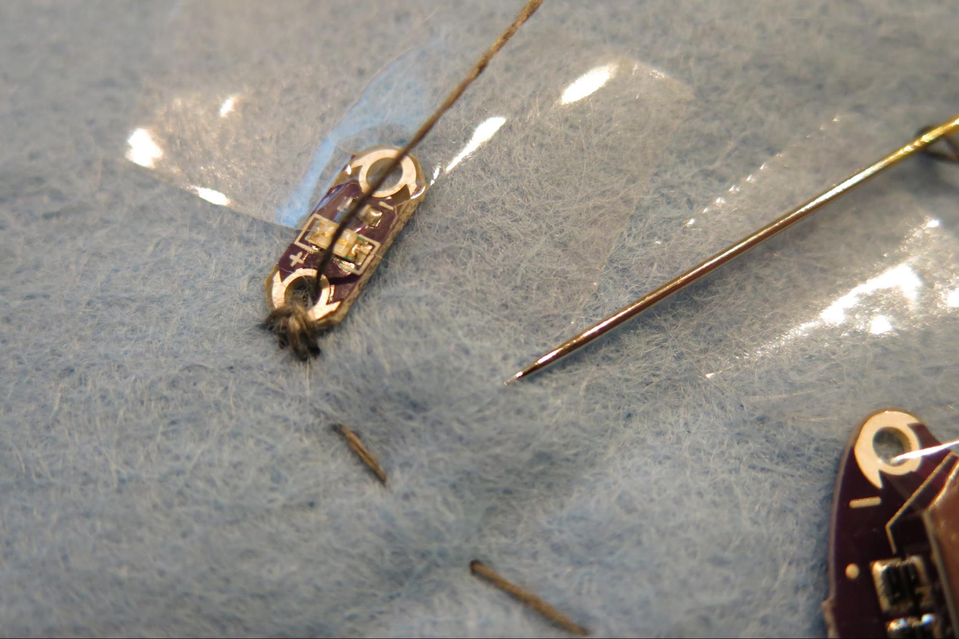

To secure your thread, pull the needle crosswards through the last stitches for three or four times (you should feel a bit of resistance at the needle for the last stitch), then cut the thread closely. Your first connection is done!

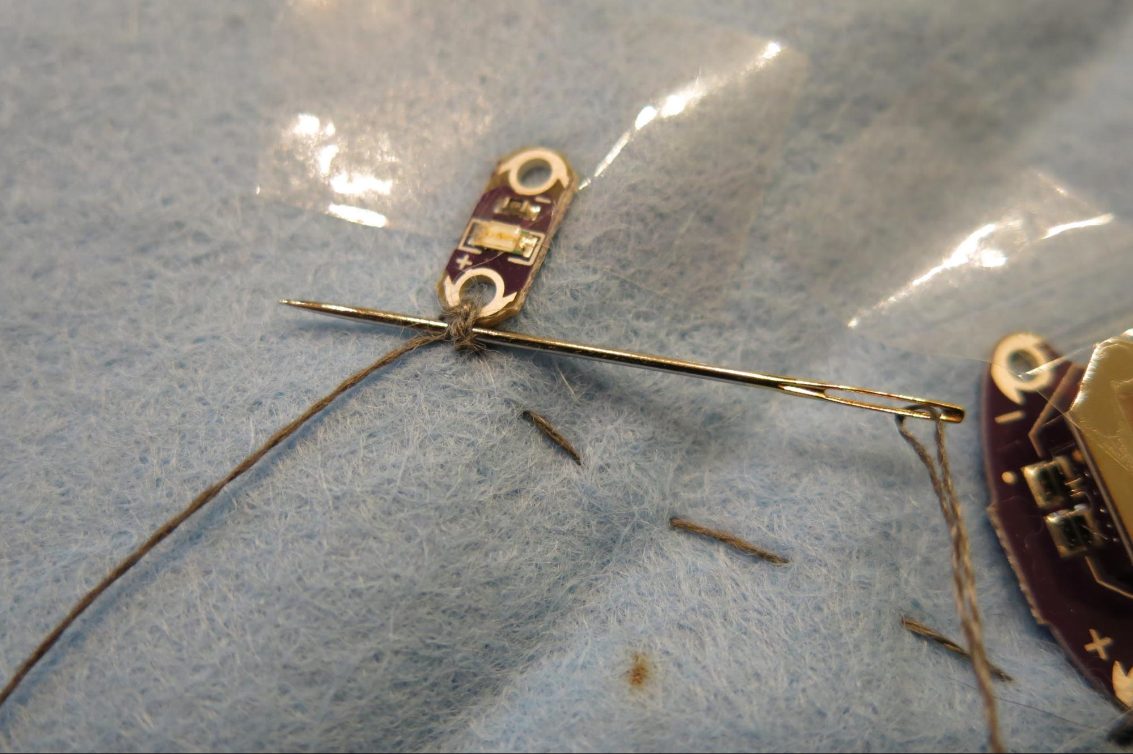

Do the same for all of the remaining connections. You can reuse the conductive thread as long as it appears to be long enough for the next connection.

Optional: To avoid corrosion of the conductive thread and to gain further fixation of the connections between the thread and the electronic components, you can brush the connections or the whole sewn thread with nail polish.

A completed simple circuit looks like this:
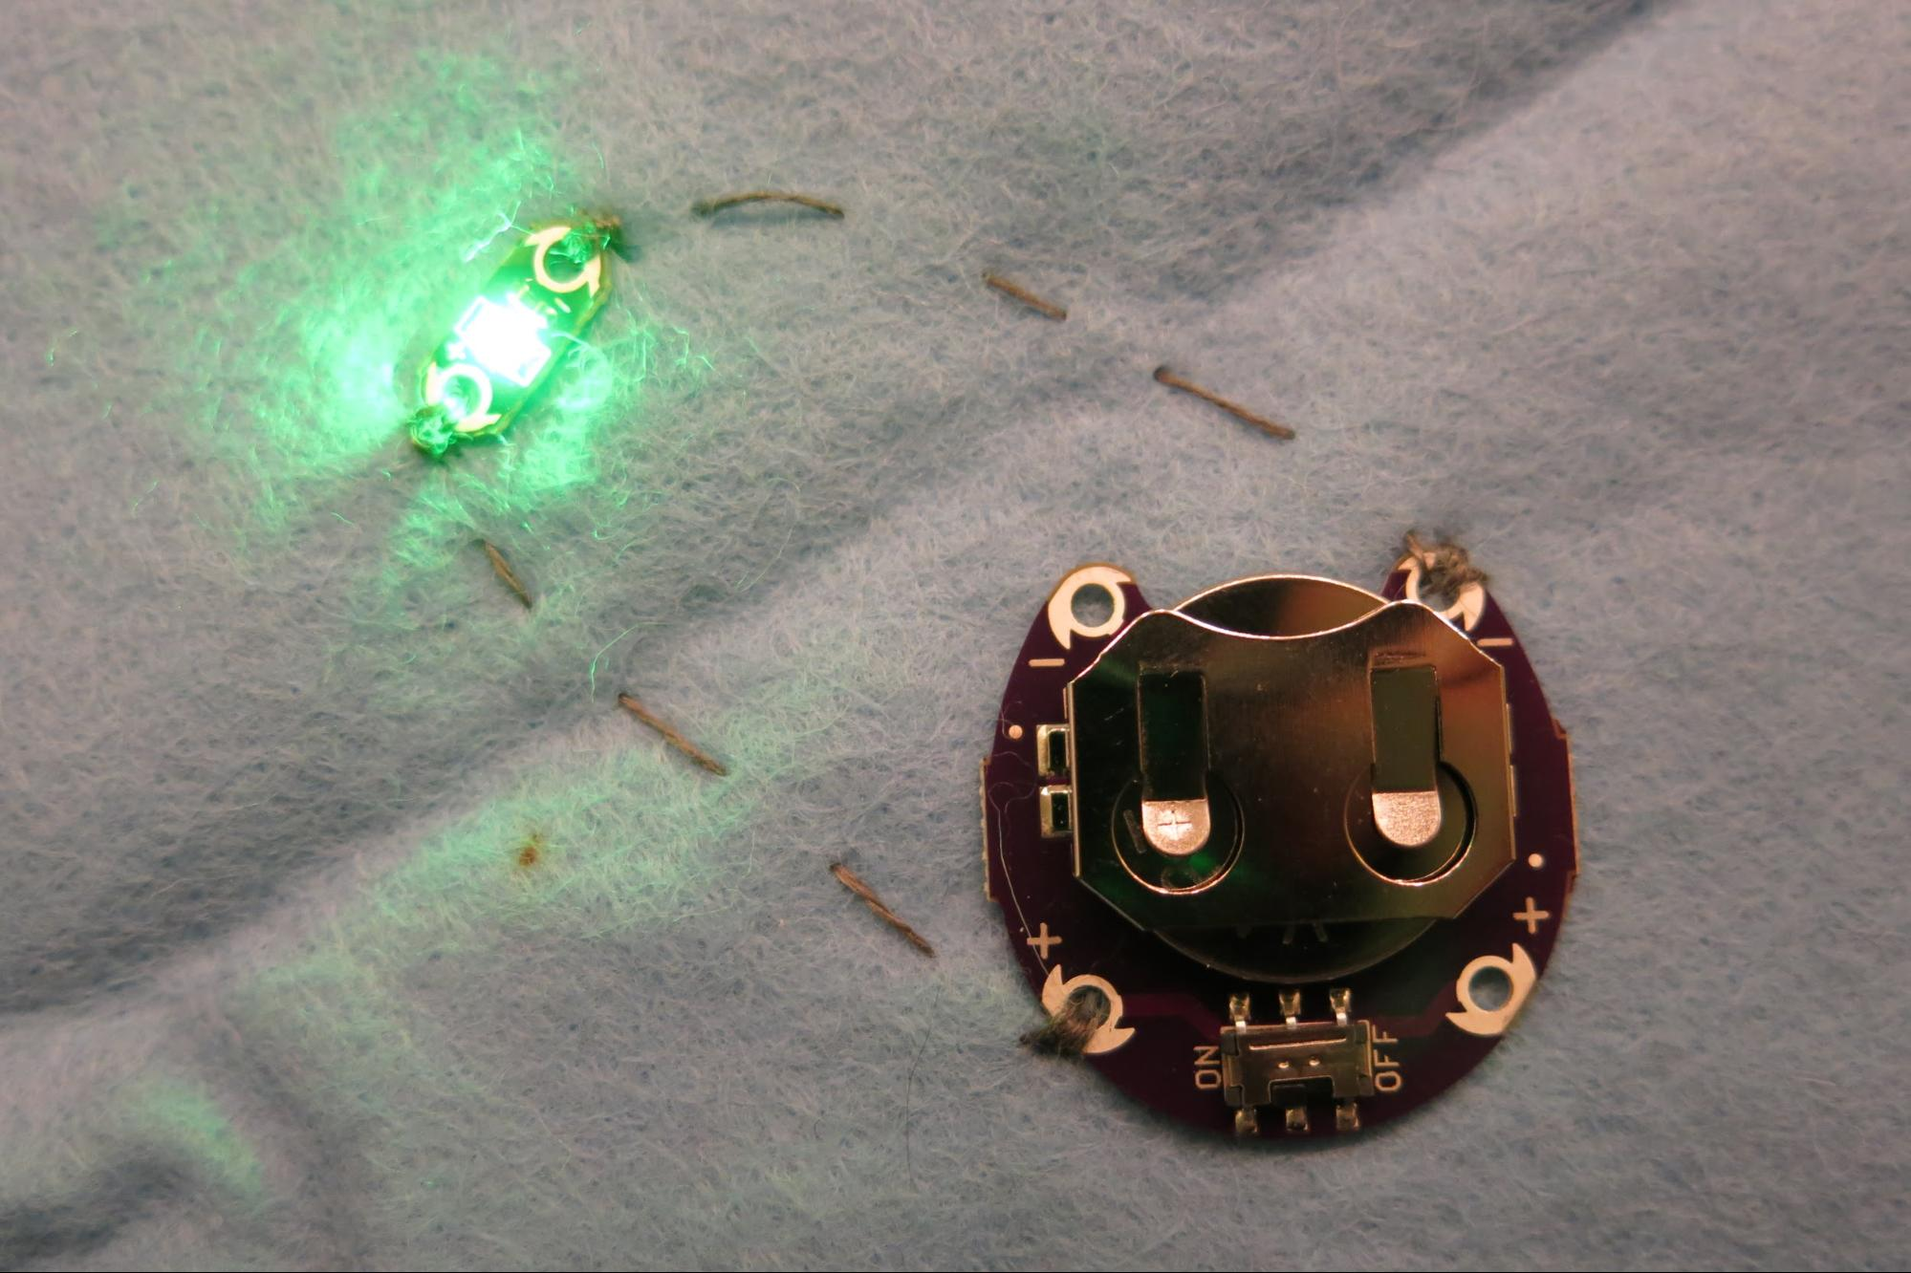

Making the bags

For our bags, felt motifs are cut and glued to a bag. Electronical components sewn either on top of or under the motif, with most of the connections hidden behind.

You will need:

- fabric bag
- felt
- glue for textiles (we recommend Gütermann HT2)
- scissors, sewing needle (with a sharp tip), pins
- crayon pen, trickmarker, or simply a pencil
- conductive thread
- electronic components according to the circuit you are planning to make
- crocodile clips might be helpful to test the circuit before sewing it

How to make it:

Use the template and the crayon pen or trickmarker to draw your application motif onto your bag and onto the felt. Cut out the felt motif. Draw placement of the electronic components and their connections onto your motif on the bag. On the felt, mark the positions of the electronic components to be placed on the motif.

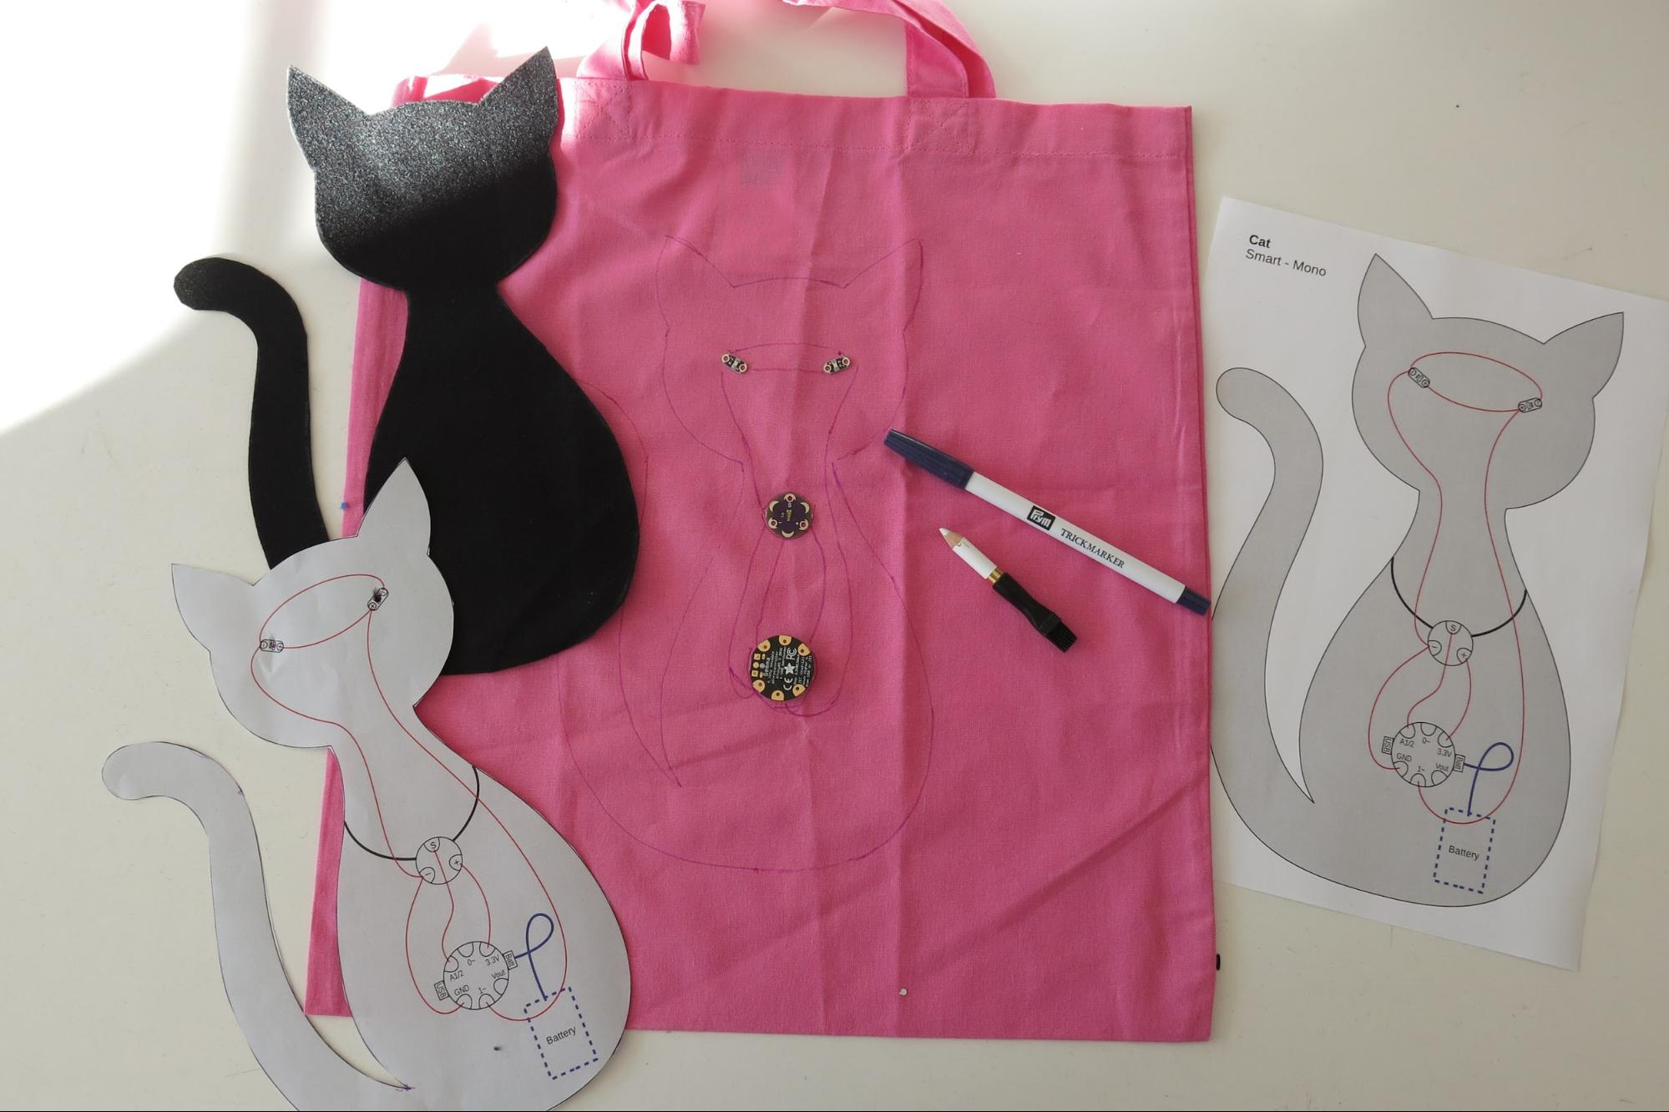

Now sew your electronic components and connections onto your bag.
Here you have 2 options:
- either sew the component directly to the bag and let it shine through holes you punch into the motive (which is a bit easier to sew)
- or sew the component onto the motive (e.g. because you want the electronics to be a feature), which is a little more difficult and therefore described below in more detail.
The GEMMA always goes to the inside of the bag (mainly to have the battery hidden)

Most important:
Always sew with one hand inside the bag and the other hand outside of the bag, as you don’t want to sew your bag closed by accident! Holding one hand inside the bag to take the needle will avoid this!

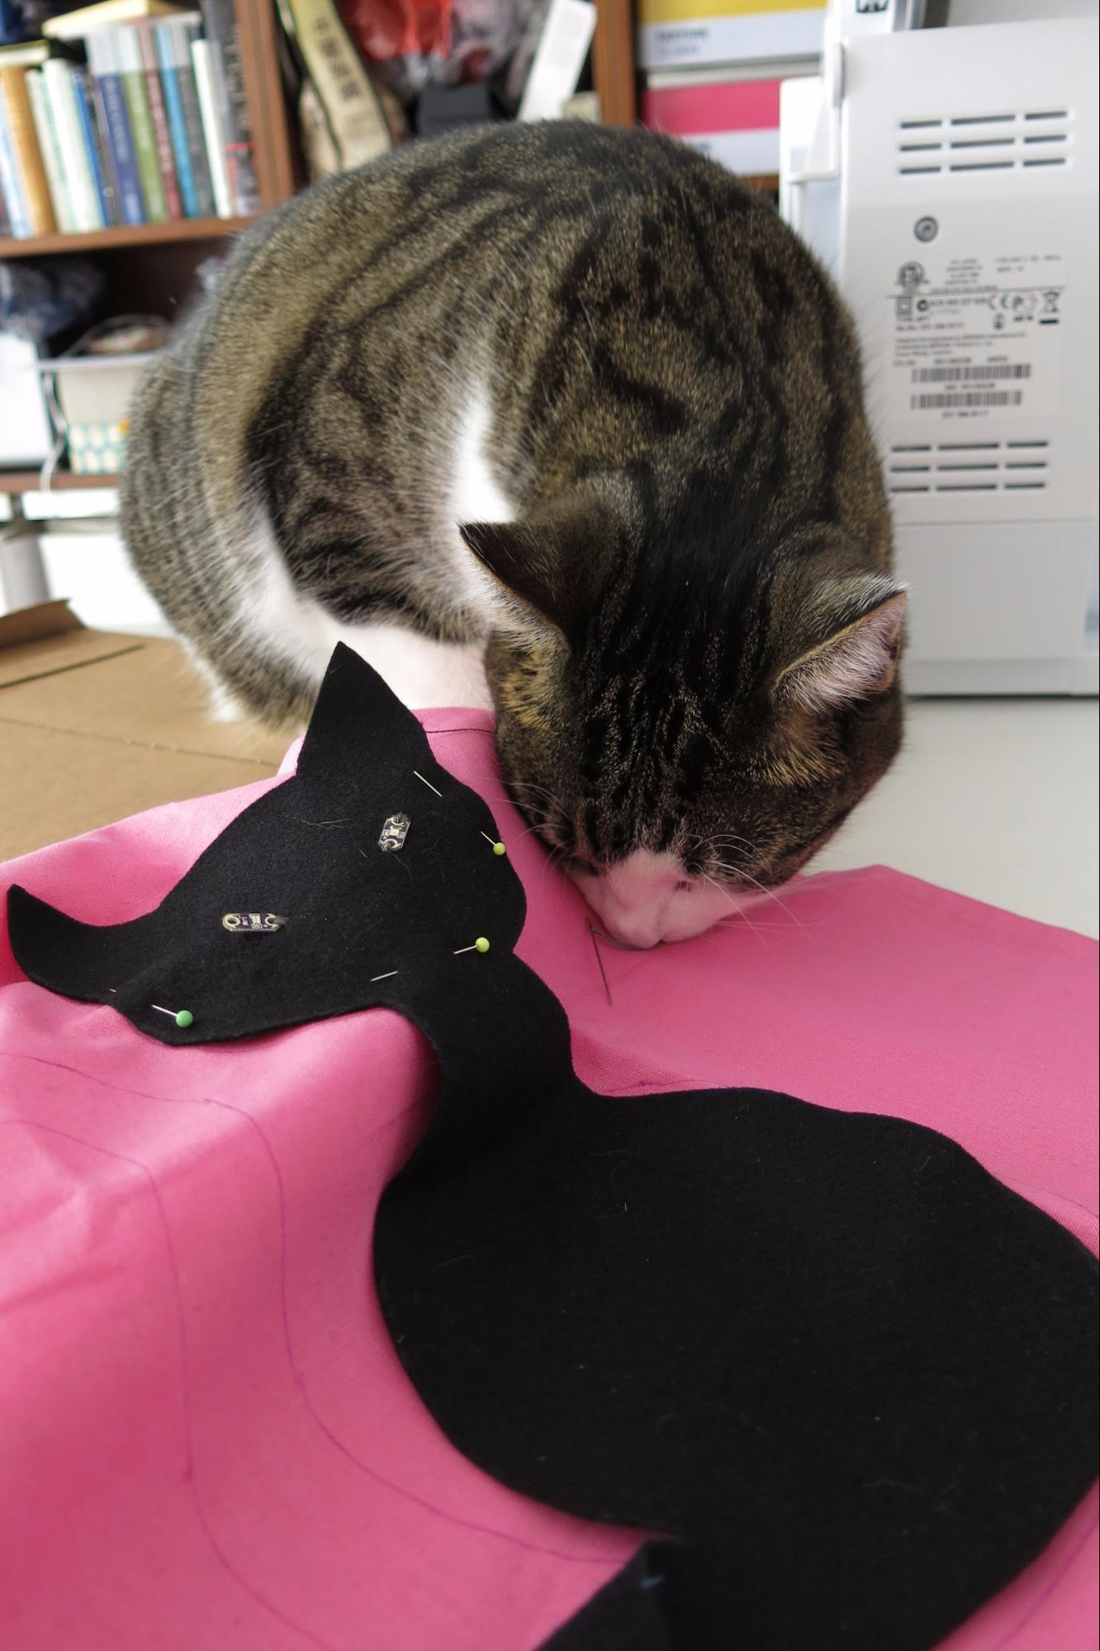
A real cat might want to help you with the sewing.

How to sew a circuit with the electronic
components on the felt motif and the connections hidden behind:

Fix the components with scotch tape to the felt motif, the place where you want them to be installed. Pin the motif to your bag just around where the components are, so that the rest of the motif is hanging freely. Thread your needle with conductive thread.
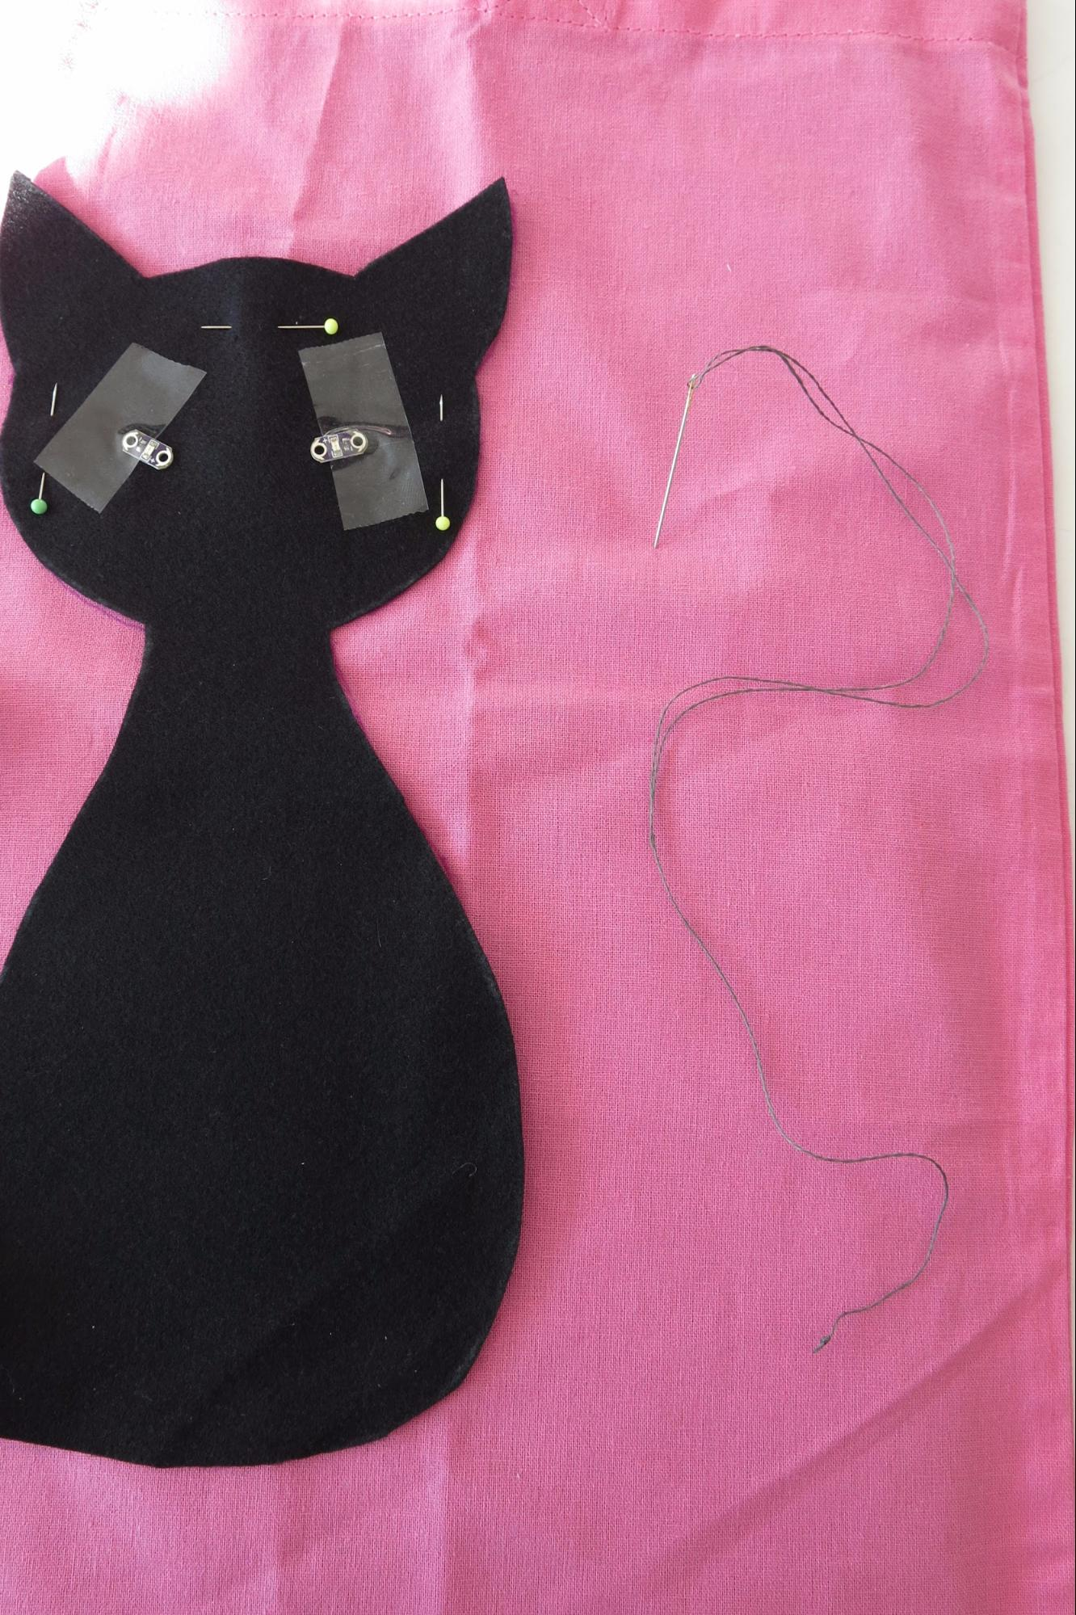

Sew the first component on with the needle going through both the bag and the motif…
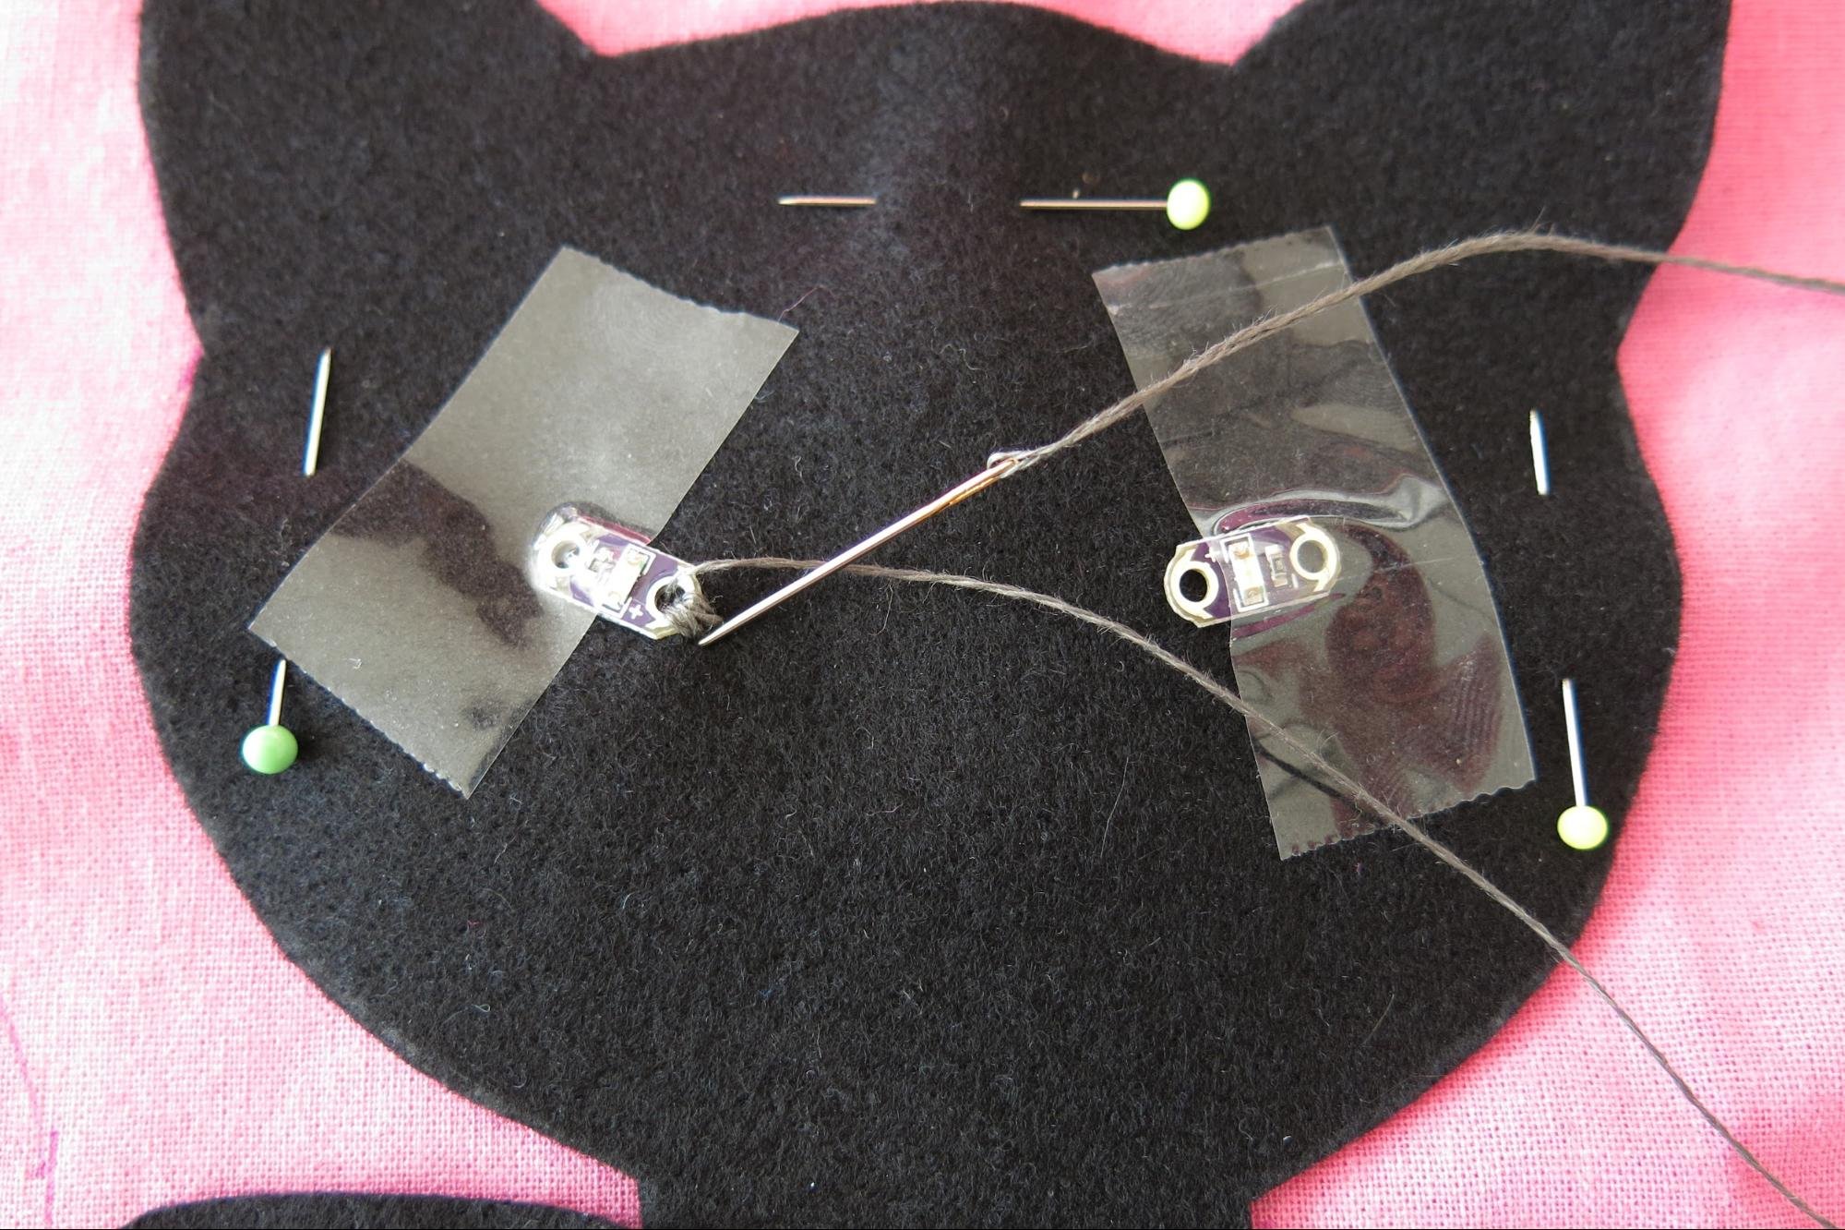

...then push the needle through to the inner bag, fold the motif away and sew the connection all the way to the second component (you might want to take off one or two pins and reinstall them afterwards).
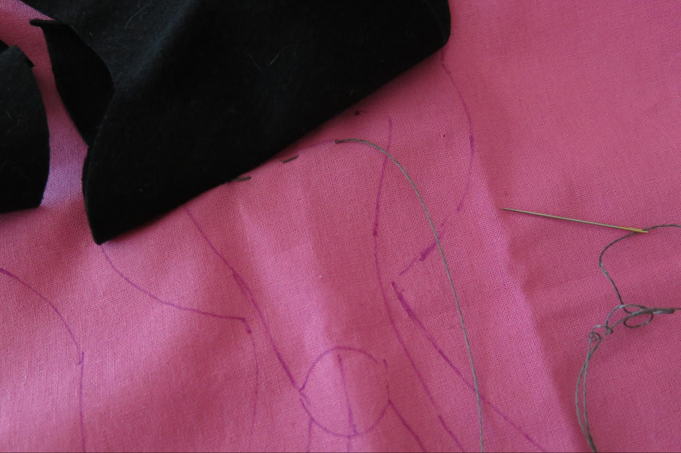
Now fold the motif back and sew the second component, stitching through both the bag and the motif again.

Do the same for the other connections as well.
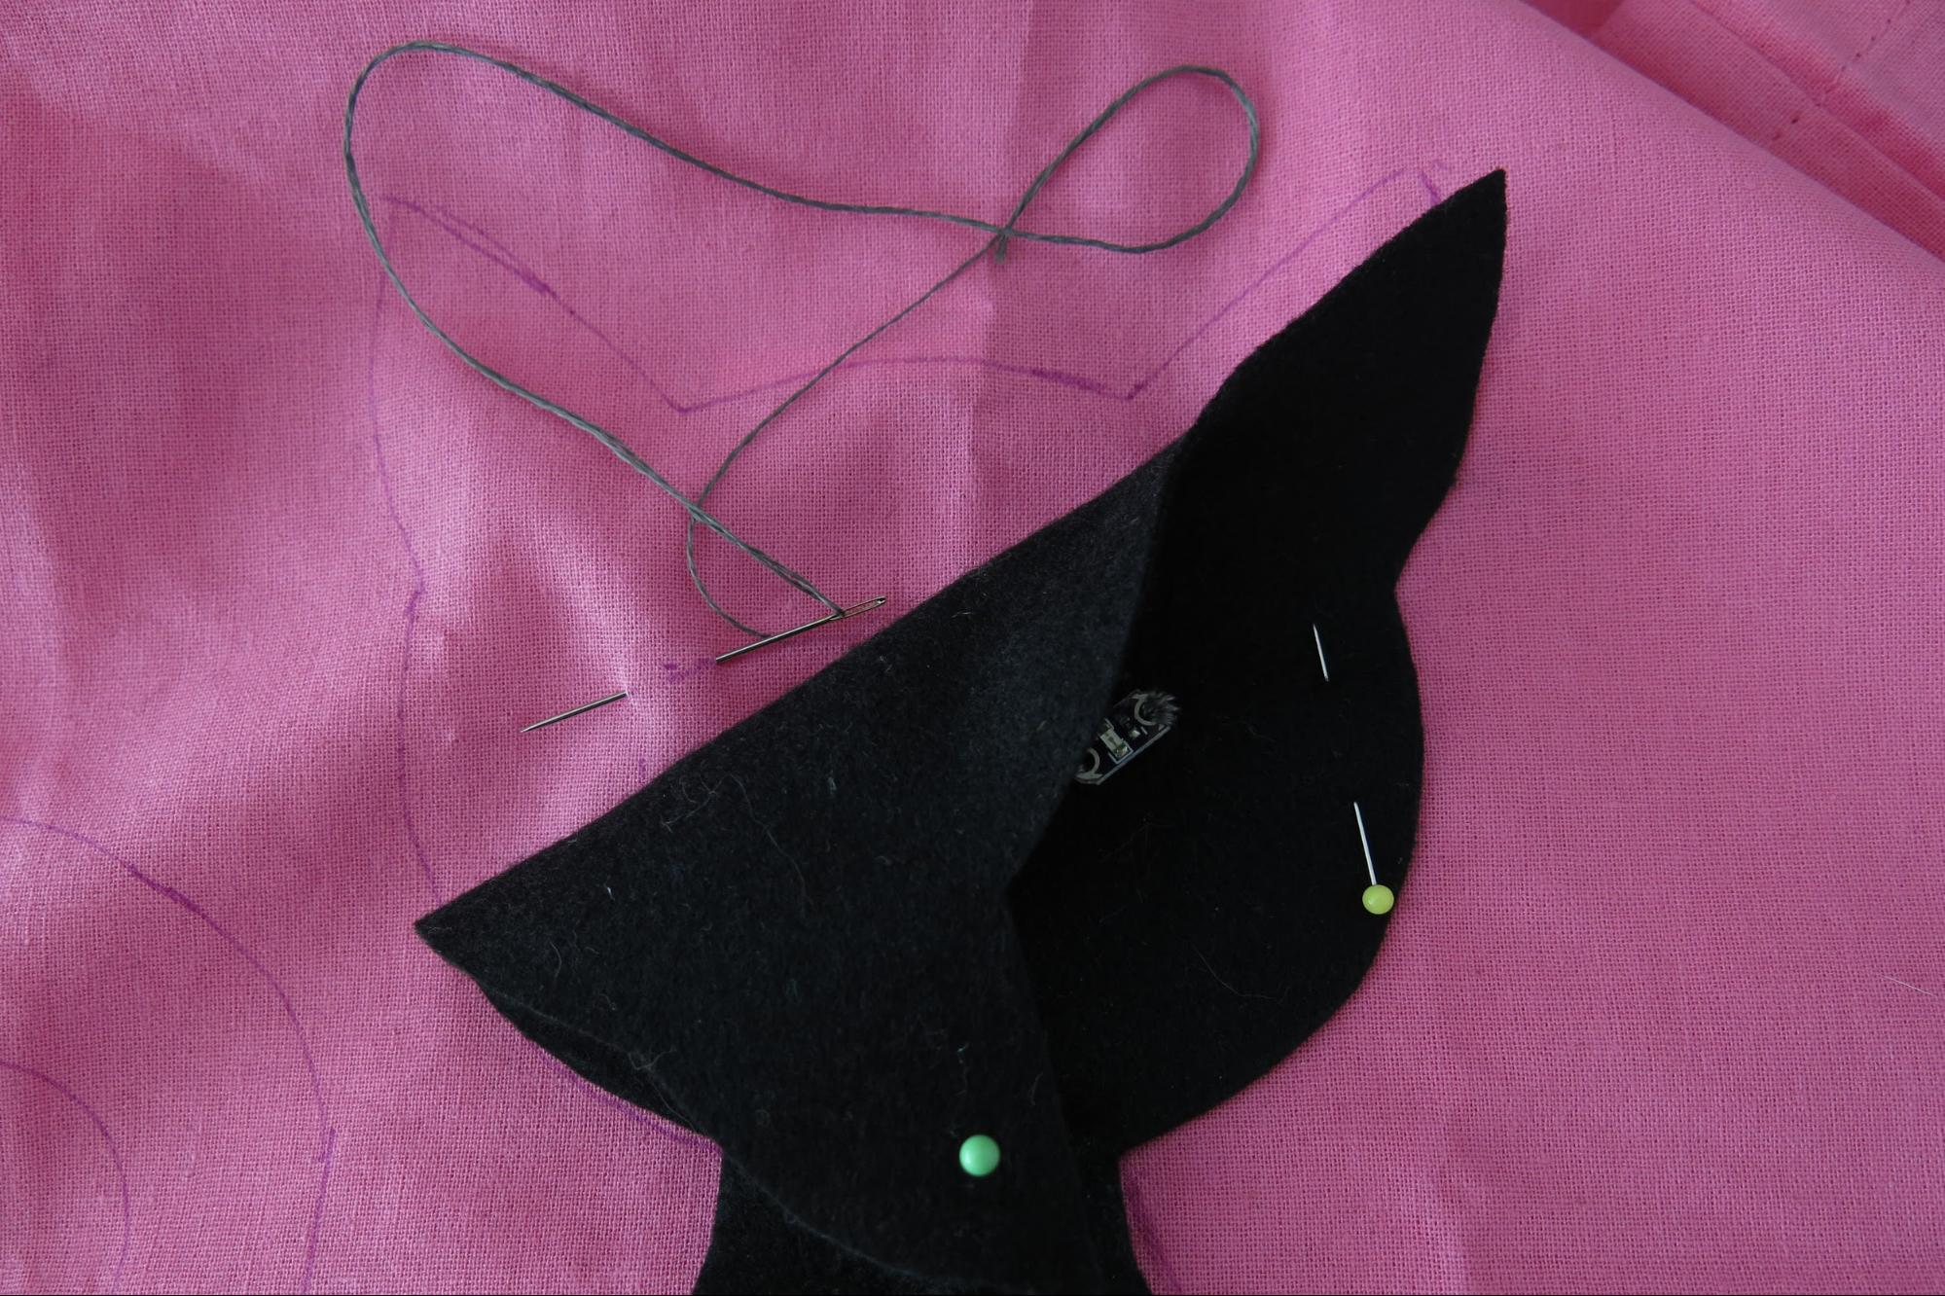

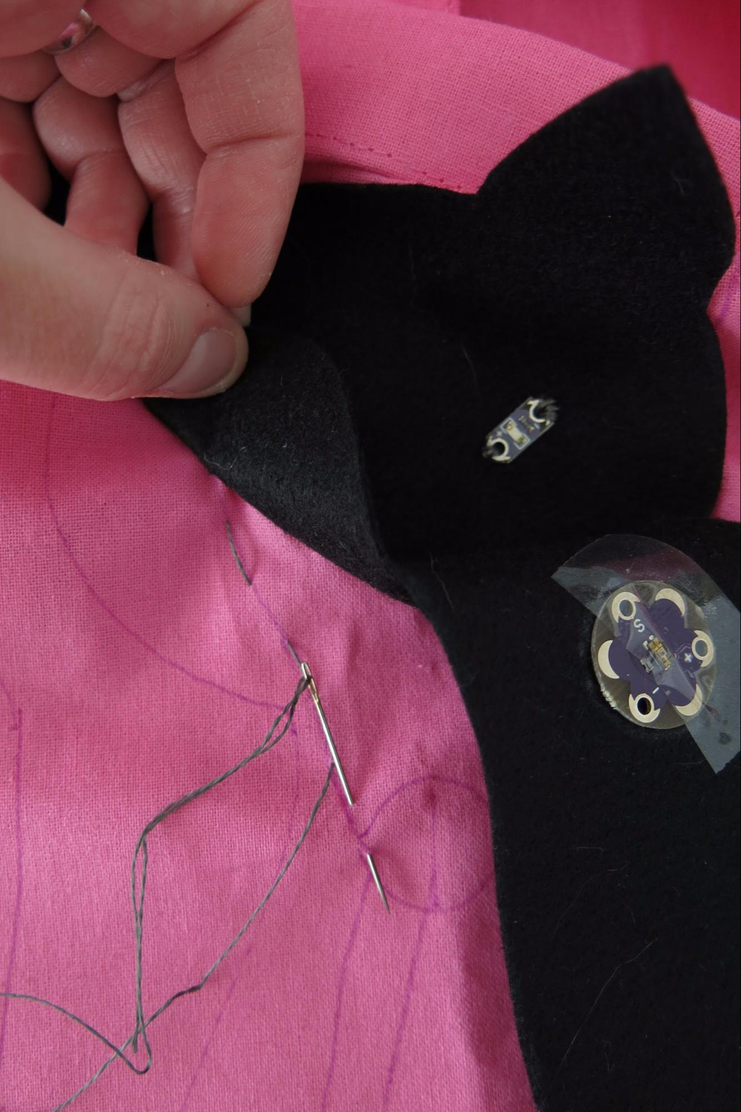

How to connect with the Gemma or battery holder inside the bag:

Start with sewing the outside component’s pin to the bag, then fold the motif away.
Sew all the way down until you reach the electronic component inside the bag.
Push the needle to the inner bag side, then turn the bag inside out and sew the connection to the inner electronic part.

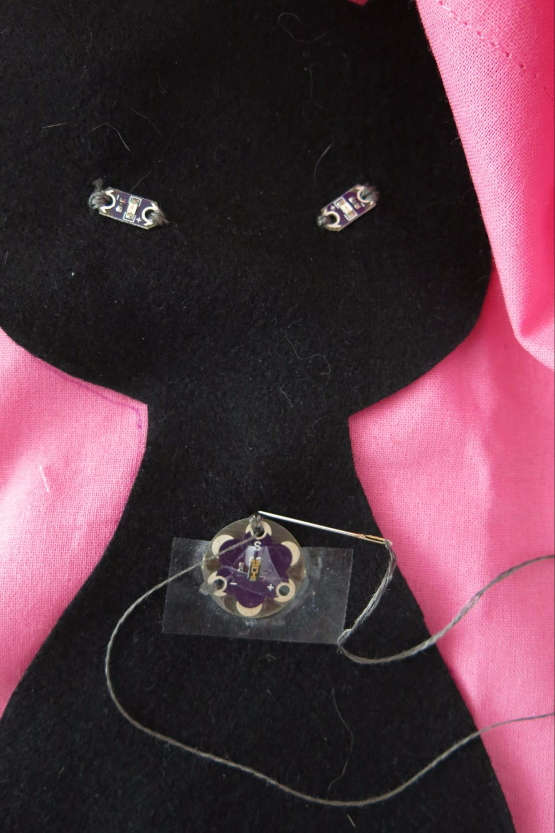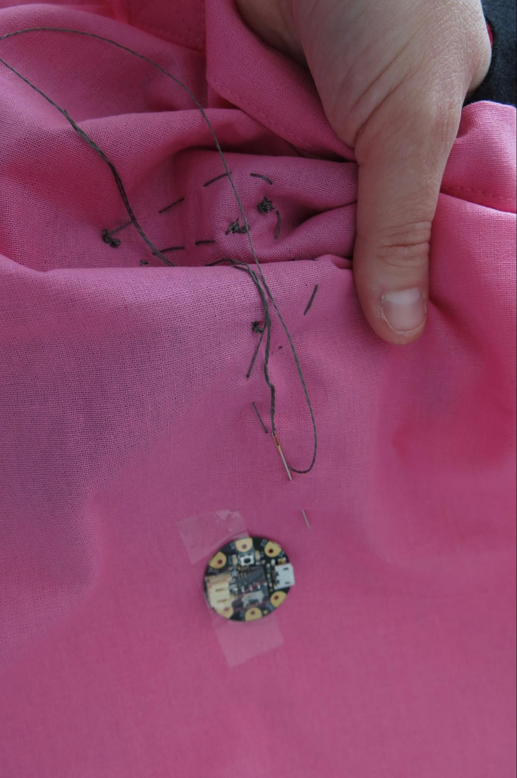

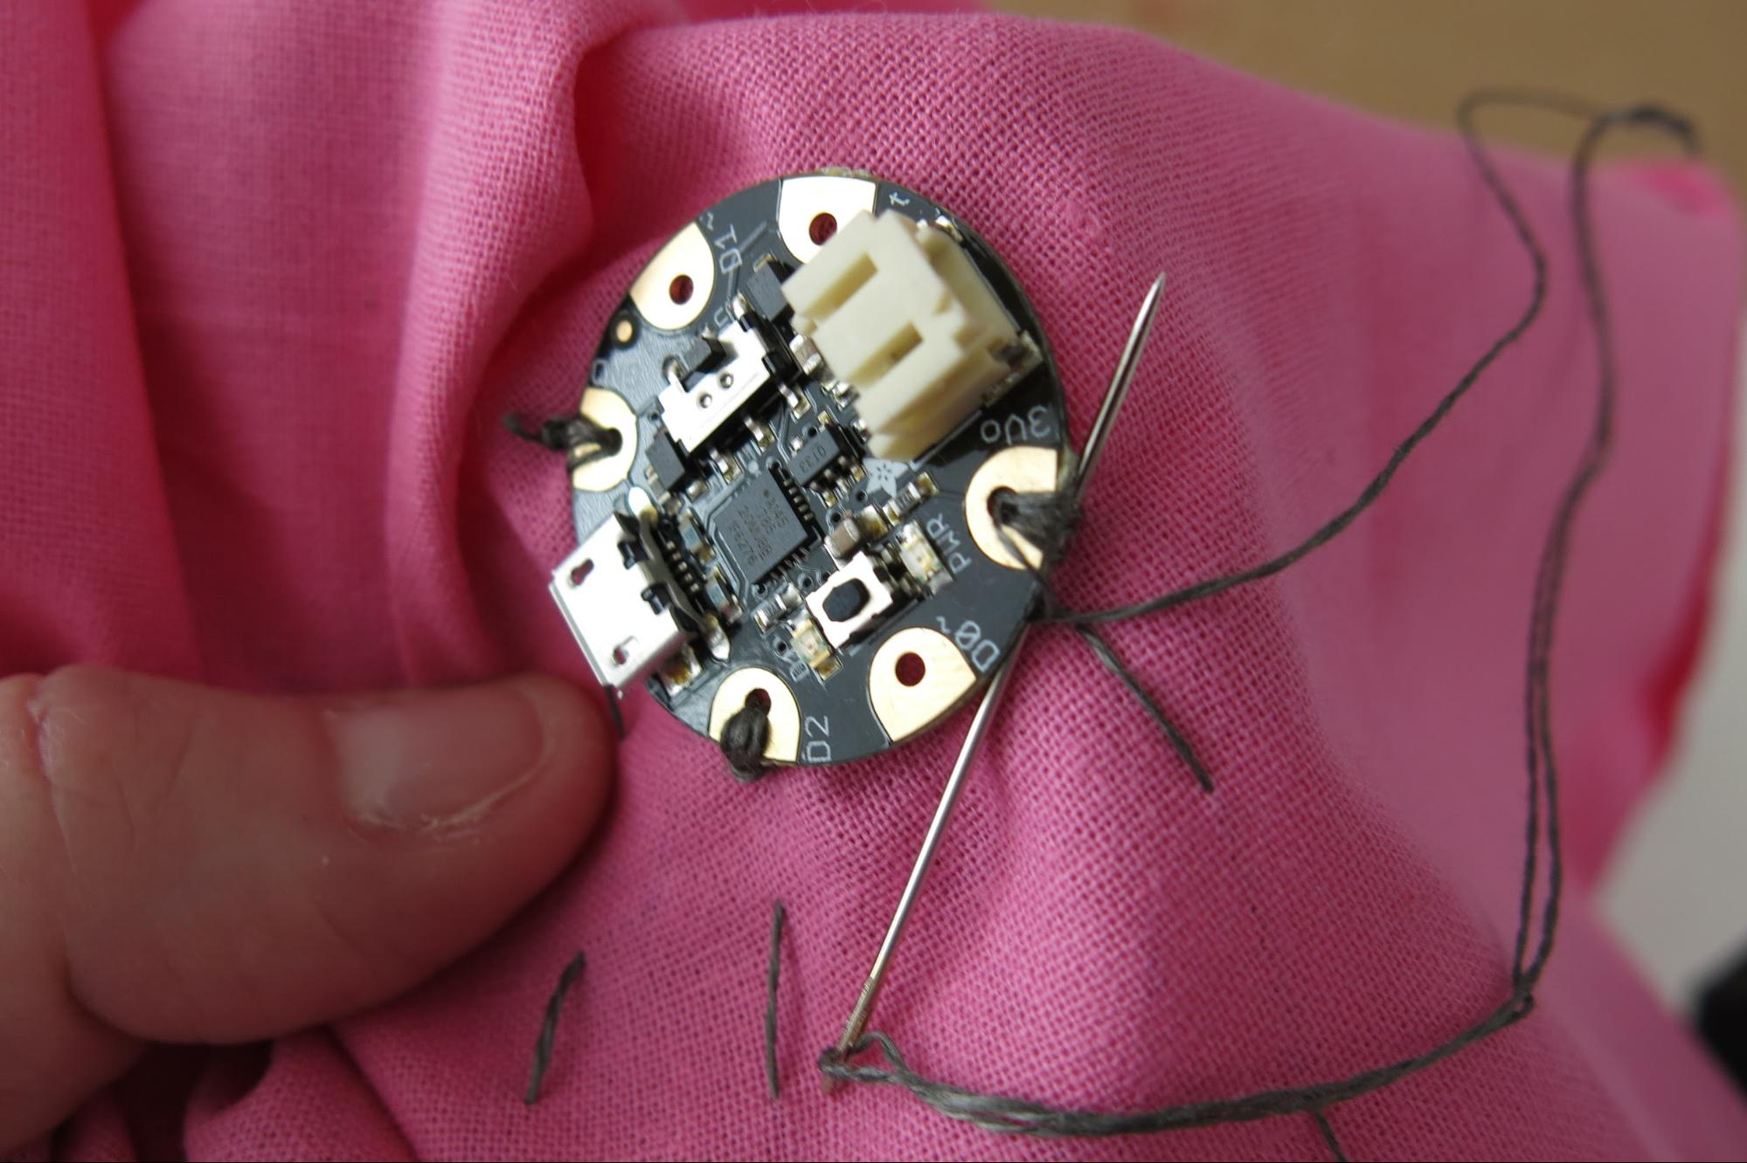

When all the components are sewn on, it is an excellent idea to test the circuit before glueing the motif onto the bag!
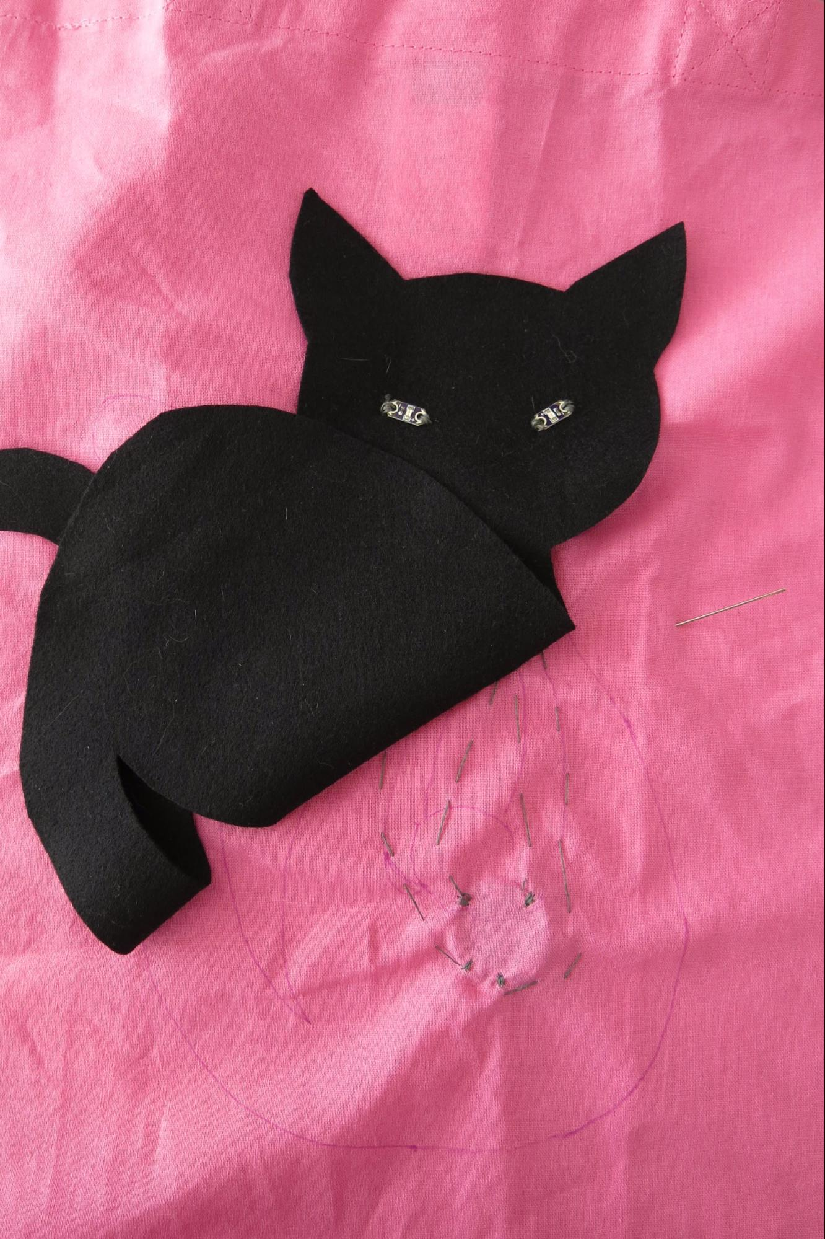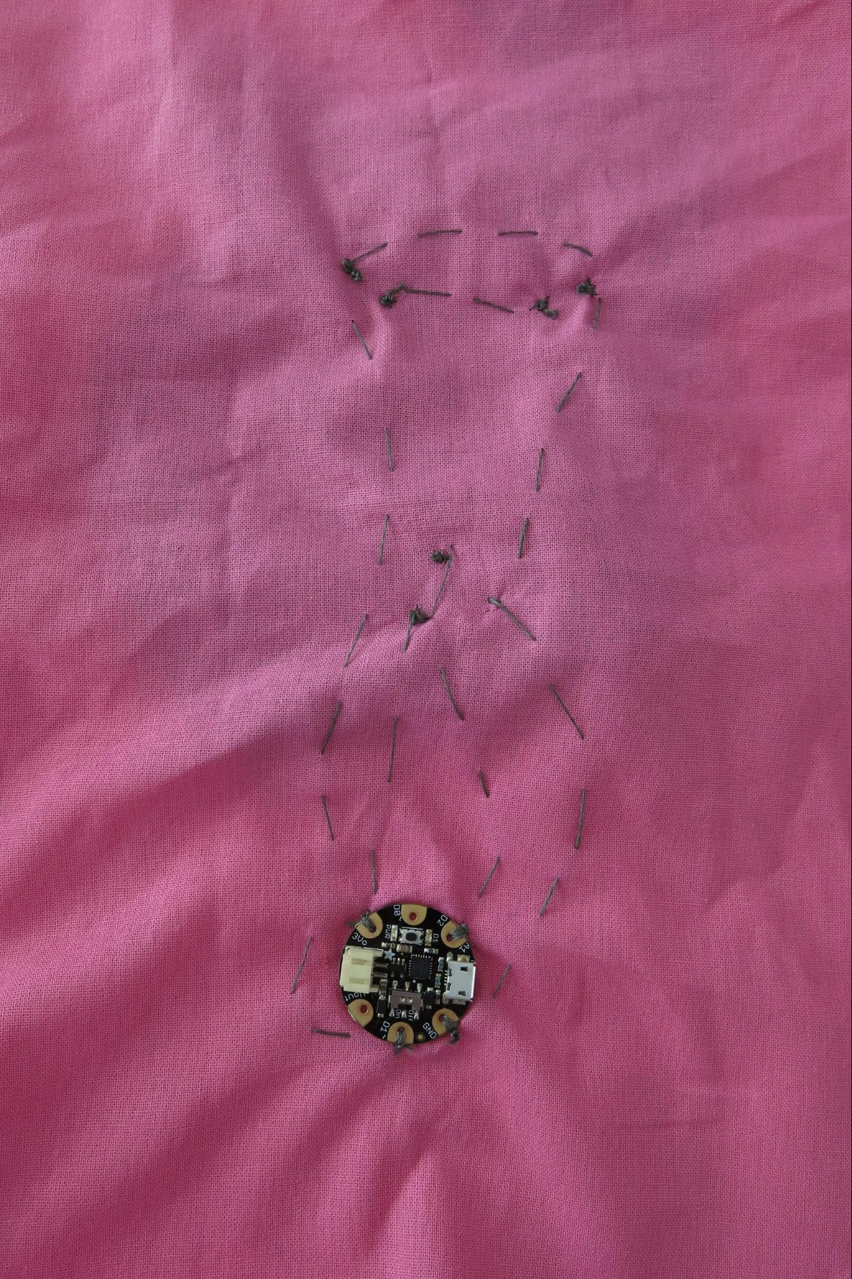

Now cut a piece of felt a few centimeters bigger than your LiPo and pin it to the inner side of the bag where you want the LiPo to be (it should be under the motif so that the sewing stitches can not be seen from the outer side). Fix it around your LiPo with pins, then sew it to your bag with a few running stitches and normal i.e. non-conductive thread.
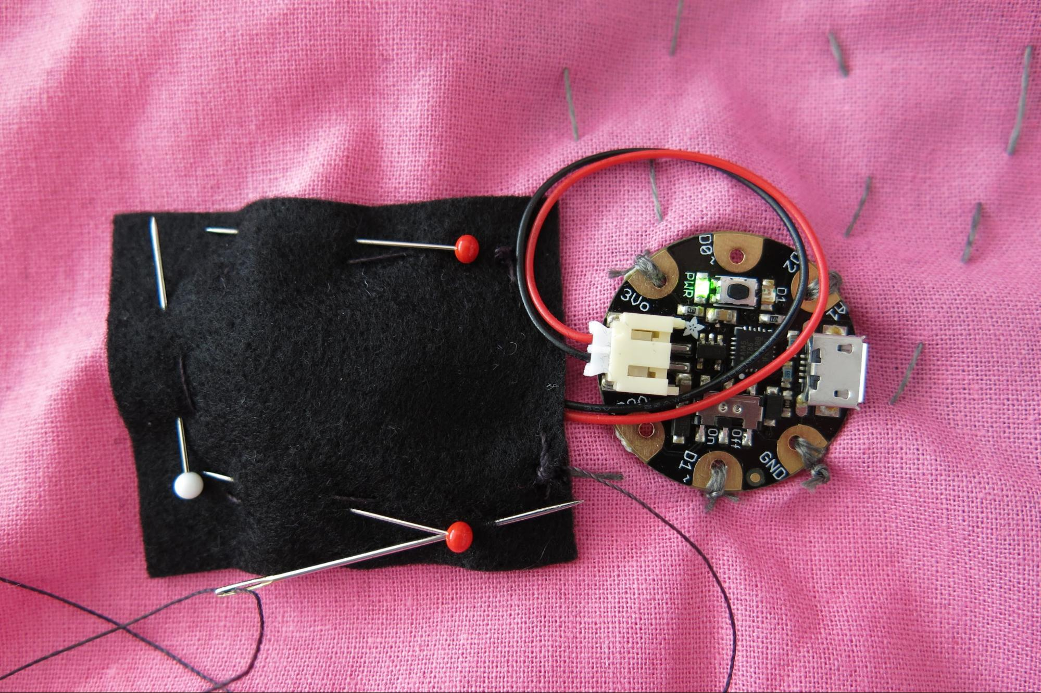

Turn the bag right side out again and glue your motif onto the bag.
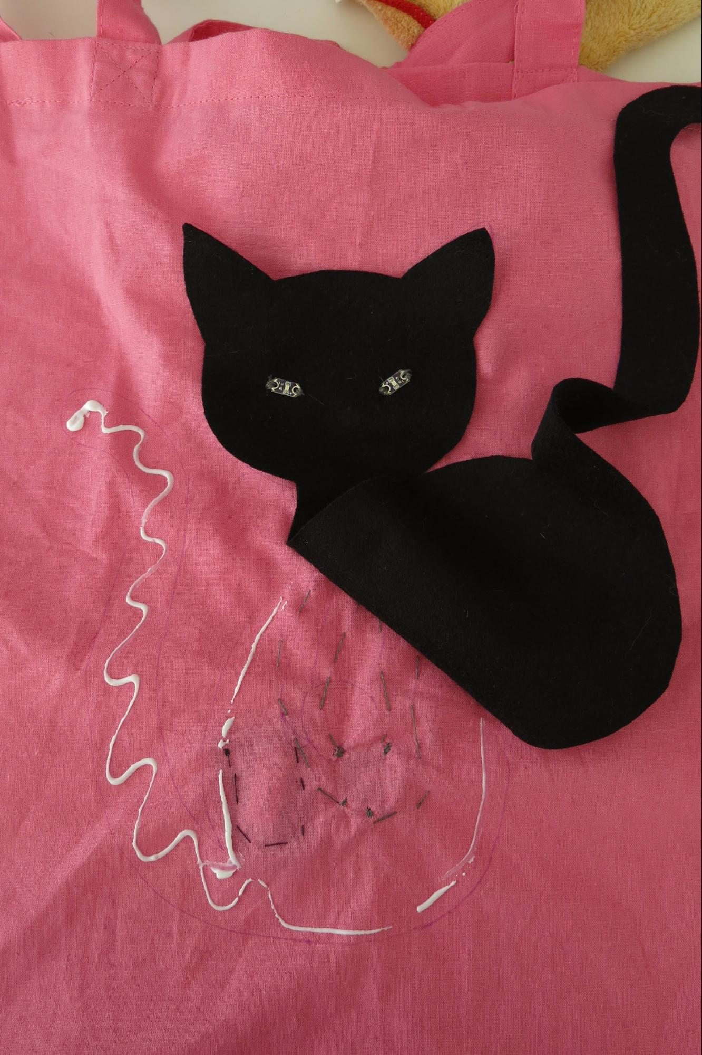

If you have electronical components sewn directly to the bag under the felt and want just the “active part” of the LED or sensor (not the base and the circuit connections) to show through the motif:

Before glueing the motif to the bag, lay it in place. With a crayon or crayon pen, rub over the LEDs or sensors to show the exact place of the active part. Punch a hole into the motif right where the marking is, then glue the motif to the bag.

If you want, you can finish your motif by painting it with textile markers.
Allow for the glue and textile markers to dry for about 30 minutes while not loading the bag yet!

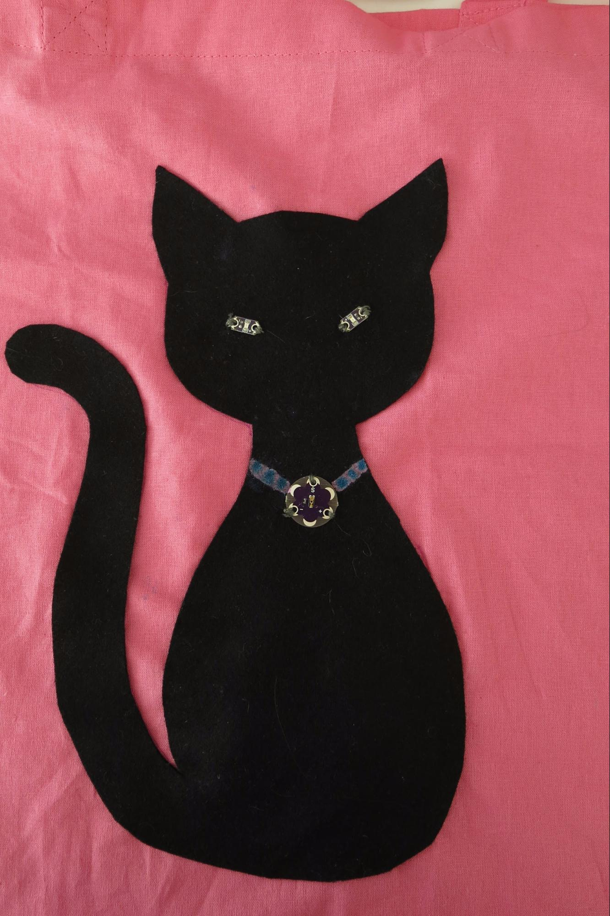

Notes on sewing on jersey and knit fabrics

If you want to embellish your t-shirt or pullover with some cool electronics, you will have to sew your connections with a stitch that is able to stretch, to accommodate for the stretchiness of the fabric, otherwise your conductive thread connection might break when the garment is worn.
A stretchy stitch is easy to sew: just push the needle through the fabric horizontally to the direction in which you are sewing.

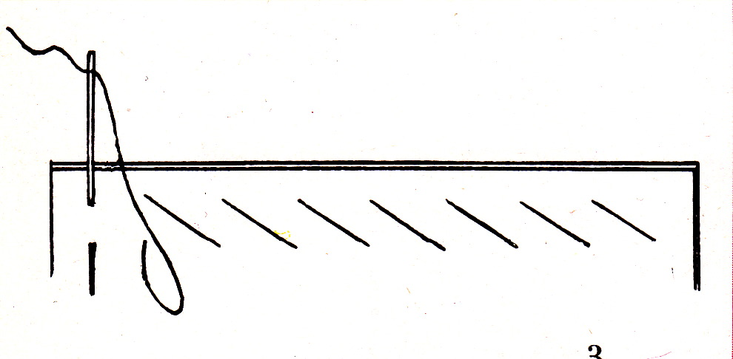

Installing Software on the bag
In this part we describe shortly how you set-up the development environment (Arduino) and put software on the GEMMA within the Bag. This is a fairly standard procedure and there are probably better guides around. e.g.:
- https://learn.adafruit.com/adafruit-arduino-ide-setup
- https://www.arduino.cc/en/Guide/HomePage

Installation

Download & Install Arduino for your OS (1.6.7 should be fine)
- Note: Linux users usually install a very old version via apt-get, and then download and run the current version from the Arduino web page

Preparing Arduino to build sketches for the Adafruit GEMMA

Run Arduino
- open: File -> Preferences
- add the following URL into "Additional Boards Manager URLs"
https://adafruit.github.io/arduino-board-index/package_adafruit_index.json
(see also: https://learn.adafruit.com/add-boards-arduino-v164/overview)

Restart Arduino
- open: Tools -> Board: "..." -> Board Manager…
  - search for: "adafruit"
  - install "Adafruit AVR Boards" (newest should be fine, we used 1.4.1)
  - close the board manager
- select: Tools -> Board "..." -> Adafruit Gemma 8MHz
- select: Tools -> Programmer "..." -> USBtinyISP

Install the Neopixel Library
- open: Sketch -> Include Library -> Manage Libraries…
- search for: "neopixel"
- select: "Adafruit Neopixel"
- select: "Version 1.0.2" (!! This is important !!)
- click: Install

Downloading the GeekBag sketches from Github
(including all documentation)

Get the source-code
- either by downloading the ZIP from:
https://github.com/Mariemurasaki/Electronic-Geek-Bag/archive/master.zip
and unpacking it into your sketchbook-folder:
(if you don't know where it is located, it is shown in Arduino via: File -> Preferences)
- or cloning the project via GIT

Restart Arduino

Opening a sketch and compiling it

Open e.g. the "smart-neo"
- choose: File -> Sketchbook -> Electronic-Geek-Bag -> code -> smart-rgb
(this opens a new window, you can close the old one)
- Click the "Verify" icon on the upper-left
  - the compilation should run through without errors and the status line should say "Done compiling."

Uploading the sketch to the GEMMA

Connect the GEMMA via USB and turn it on
(or if already connected press the RESET-Button)
- the GEMMA's red LED will pulse for a while indicating it being in Bootloader mode.

Click the "Upload" icon
- the Upload should run through without errors
- This step fails from time to time on the Gemma, try again by:
  - waiting a few seconds
  - resetting the Gemma
  - waiting for the pulsing light
  - clicking the "Upload" icon again
- Note: if you don't have a battery attached to the GEMMA, you can also reset by unplugging USB

Known Issues

Cannot upload in Linux installation
with the error message "avrdude: Warning: cannot open USB device: Permission denied"
- You need to give yourself permissions to the device by creating a udev rule. see: https://learn.adafruit.com/adafruit-arduino-ide-setup/linux-setup

Cannot upload in Windows 8 or 10 systems
you probably just need a different set of drivers, see: https://forums.adafruit.com/viewtopic.php?f=20&t=78892

Issues with USB 3.0 on OS-X
We had someone not being able to flash with OSX and USB-3.0. There was an article somewhere stating that using an USB-2.0-Hub might fix the issue, we couldn't try that out though

Out of flash memory
The amount of Flash memory on the Gemma is a bit limited. Therefore we need to use an older version of the Neopixel library (1.0.2). Downgrade if necessary (the code also asserts this now.)
If you need a bit more space for own stuff you can free up some space by:
- setting GLOBAL_BRIGHTNESS to 0
- removing some animations
- removing the battery saving code (sleep_delay_util, delayWithPowersave and deepSleepWhileBright) and replace all the function calls to it with “delay(100)”

Advanced users can:
- check what takes how much memory by
  - enabling logging during compile in Arduino settings
  - locate the .elf file
  - run “avr-objdump -D” on the .elf file, which provides information what exactly is in the flash-memory.
- using a different color-wheel implementation.
Apparently the color-wheel implementation from the FastLED library is smaller than the implementation in the sketch.
As an example how to use that instead, have a look at “smart-rgb-ghost-6pixel.ino”
- getting rid of new & delete from the neopixel library itself, as this is only ever used to dynamically allocate the buffer for the pixels when initialized. If you pass the buffer to the constructor, the new and delete would not be necessary.

Where to buy parts
Here’s a list of shops where we bought parts in the past.

In Germany:

Watterott: http://www.watterott.com/de/Wearables

Exp Tech: http://www.exp-tech.de/catalogsearch/result/?q=wearables

Flikto: http://www.flikto.de

In Switzerland:

PlayZone: http://www.play-zone.ch/de/elektronik-kit-zubehoer/wearables.html

Boxtec: http://shop.boxtec.ch/textilien-c-195.html

From the Manufacturers:

Adafruit: https://www.adafruit.com/category/65

Sparkfun: https://www.sparkfun.com/categories/204

Bonus Project: Smartphone Glove

You will need:
- a glove
- a wooden spoon
- sewing needle
- conductive thread

How to make it:

Put the spoon handle into the finger of the glove that is used to operate the smartphone. Thread a sewing needle with conductive thread and make a knot into the other end of the thread. Then sew several stitches (about 10 will do) right at the fingertip and secure the thread by stitching three to four times horizontally through the first stitches. Cut off the thread.

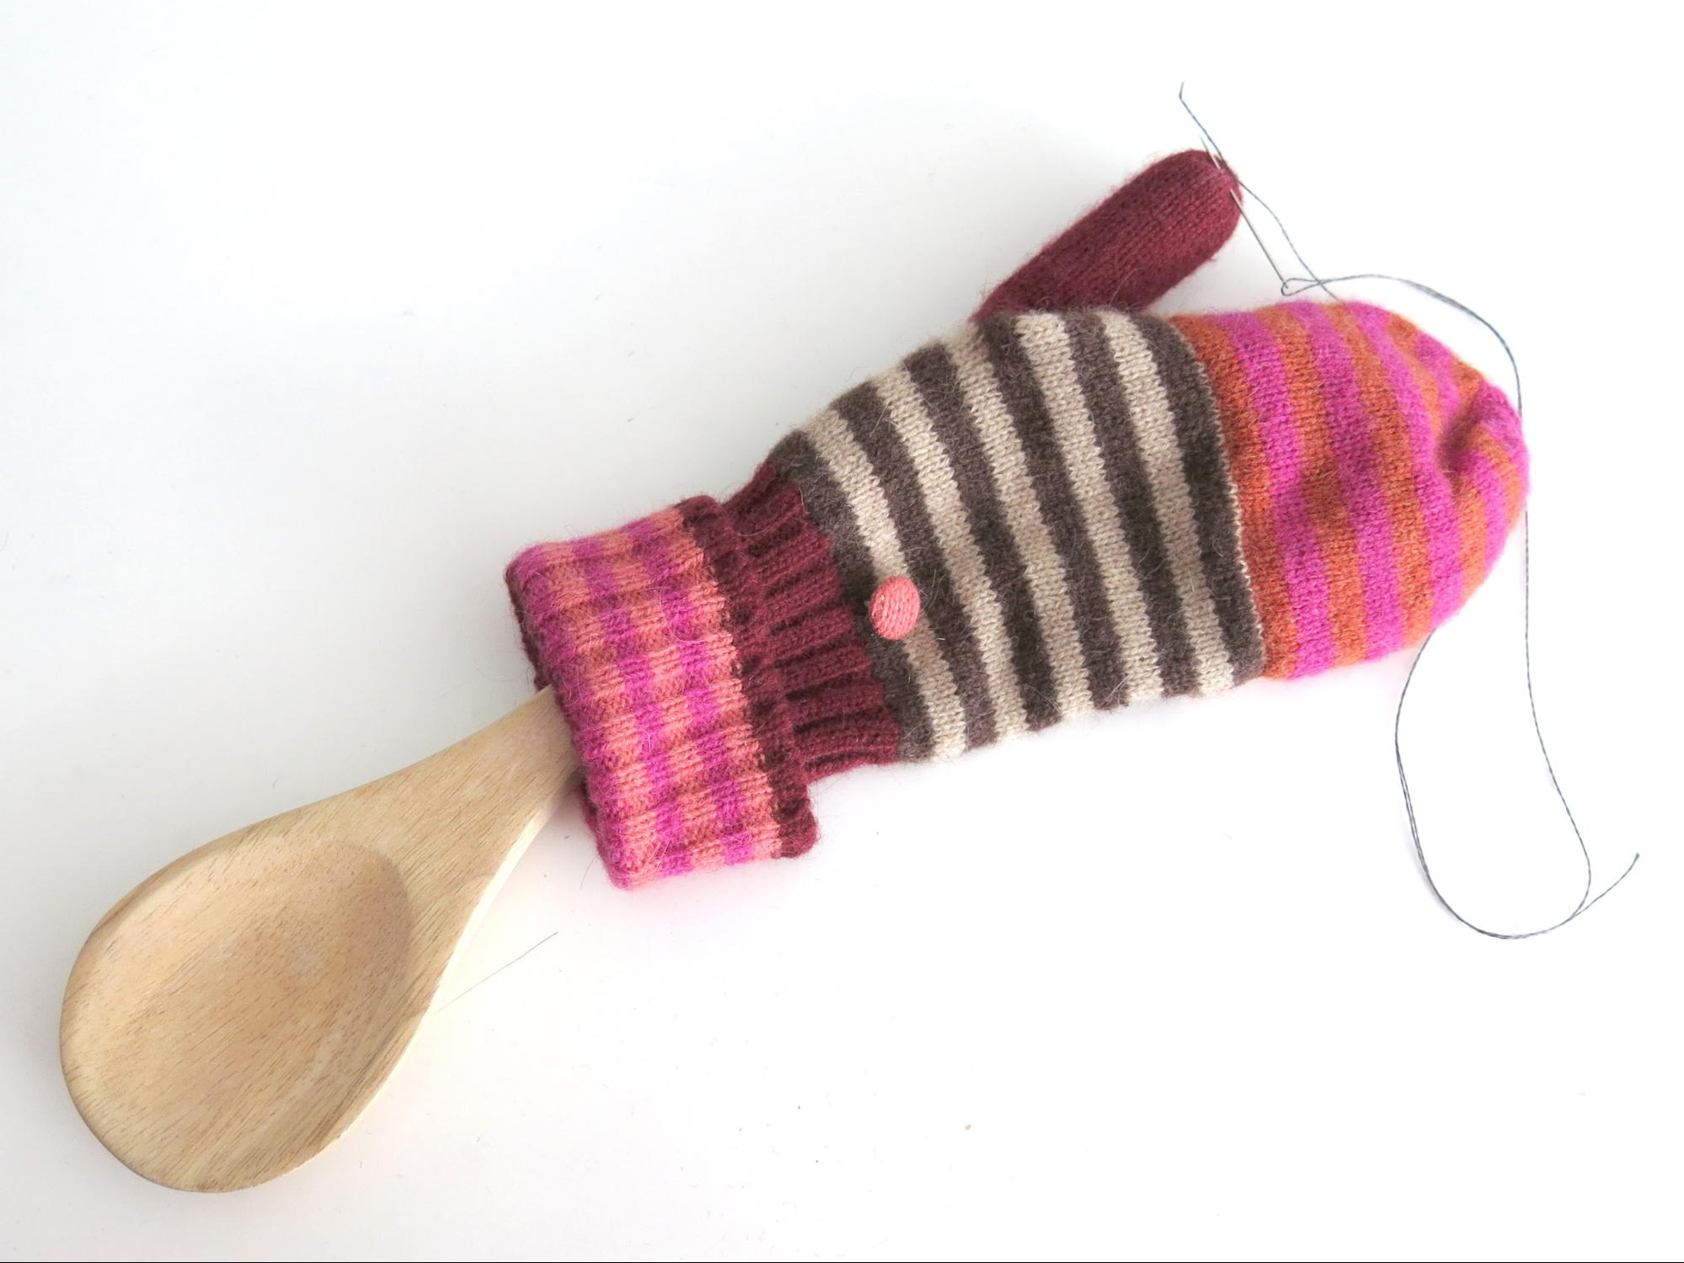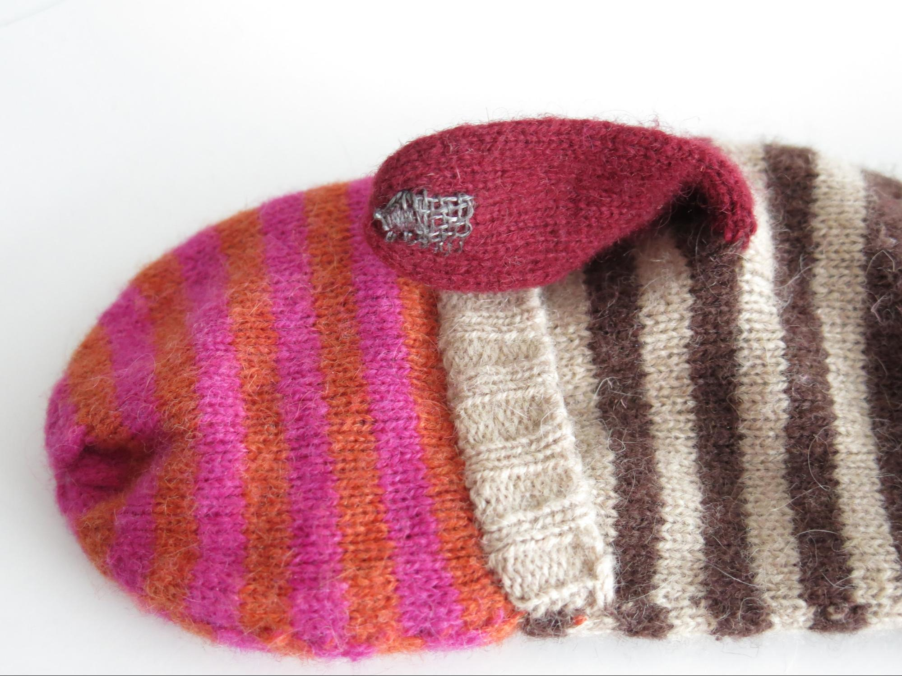

Note: use at your own risk, we take no liability for any scratches or other damages this does to your phone.
(The glove is in active use and at least didn’t hurt my own phone, though)

Picture from: Pauline Reynard, Vogue Sewing Book, New York 1964
Picture from: Pauline Reynard, Vogue Sewing Book, New York 1964

