# construct the argument parse and parse the arguments

ap = argparse.ArgumentParser()

ap.add_argument("-d", "--dataset", required=True,

help="path to input dataset")

ap.add_argument("-m", "--model", required=True,

help="path to output model")

ap.add_argument("-p", "--plot", type=str, default="plot.png",

help="path to output loss/accuracy plot")

args = vars(ap.parse_args())

# initialize the number of epochs to train for, initia learning rate,

# and batch size

#EPOCHS = 1

INIT_LR = 0.005

#BS = 500

# initialize the data and labels

print("[INFO] loading images...")

data = []

labels = []

# grab the image paths and randomly shuffle them

imagePaths = sorted(list(paths.list_images(args["dataset"])))

random.seed(42)

random.shuffle(imagePaths)

# loop over the input images

for imagePath in imagePaths:

# load the image, pre-process it, and store it in the data list

image = cv2.imread(imagePath)

image = cv2.cvtColor(image, cv2.COLOR_BGR2GRAY)

image = cv2.resize(image, (40, 40))

image = img_to_array(image)

data.append(image)

# extract the class label from the image path and update the

# labels list

label = imagePath.split(os.path.sep)[-2]

label = 1 if label == "whales" else 0

labels.append(label)

data = np.array(data, dtype="float")

labels = np.array(labels)

print(data.shape)

# partition the data into training and testing splits using 75% of

# the data for training and the remaining 25% for testing

(trainX, testX, trainY, testY) = train_test_split(data,

labels, test_size=0.25, random_state=42)

print(trainX.shape)

# convert the labels from integers to vectors

trainY = to_categorical(trainY, num_classes=2)

testY = to_categorical(testY, num_classes=2)

# initialize the model

# Sub-Spectrogram Size

splitSize = 10

# Mel-bins overlap

overlap = 5

# Time Indices

timeInd = 40

melSize=40

# Channels used

channels = 1

height=40

width=40

depth=1

inputShape = (height, width, depth)

outputs = []

# if we are using "channels first", update the input shape

if K.image_data_format() == "channels_first":

inputShape = (depth, height, width)

inputLayer = Input(inputShape)

print(inputLayer.shape)

subSize = int(splitSize / 10)

i = 0

inputs = []

toconcat = []

y_test = []

y_train = []

y_test.append(testY)

y_train.append(trainY)

while (overlap * i <= melSize - splitSize):

INPUT = Lambda(lambda inputLayer: inputLayer[:, i * overlap:i * overlap + splitSize, :, :],

output_shape=(splitSize, timeInd, channels))(inputLayer)

#Reshape tensor for 1D modeling

INPUT= Lambda(lambda INPUT:INPUT[:,:,:,-1])(INPUT)

CONV = Conv1D(128, kernel_size=200, padding='same', kernel_initializer="he_normal")(INPUT)

CONV = Activation('relu')(CONV)

outputs.append(CONV)

i=i+1

#print(INPUT.shape)

x = Concatenate()(outputs)

print(x.shape)

x = GRU(128,return_sequences=True)(x)

print(x.shape)

x = GRU(128,return_sequences=True)(x)

x = GRU(128,return_sequences=True)(x)

# return the constructed network architecture

#print(i)

FLATTEN = Flatten()(x)

out = Dense(500, activation='relu')(FLATTEN)

out = Dense(2, activation='sigmoid')(out)

out = Dense(2, activation='softmax')(out)

outputs.append(out)

# construct the image generator for data augmentation

# initialize the model

print("[INFO] compiling model...")

model = Model(inputs=inputLayer,outputs=out)

opt = SGD(lr=INIT_LR, decay=INIT_LR / EPOCHS)

model.compile(loss="binary_crossentropy", optimizer=opt,

metrics=["accuracy"])

# train the network

print("[INFO] training network...")

#H = model.fit(trainX, trainY, batch_size=BS,

# validation_data=(testX, testY), steps_per_epoch=len(trainX) // BS,

# epochs=EPOCHS, verbose=1)

model.fit(trainX, y_train, batch_size=180, epochs=20,

verbose=1,validation_data=(testX, y_test), shuffle=True)

print("[INFO] serializing network...")

model.save(args["model"])

After 1st epoch:

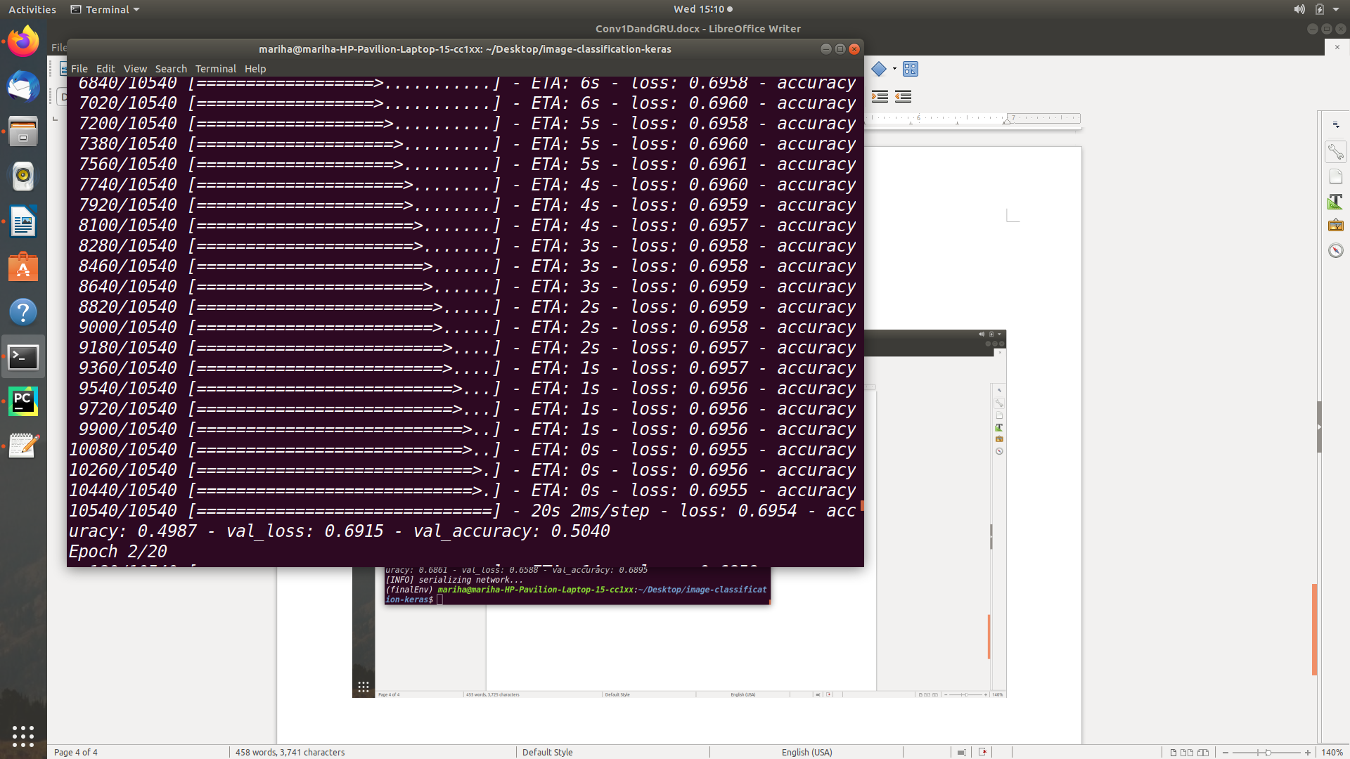

After 20 epochs

