# Photo Manager setting up

In order to initialize the data, start the cmd and run the commands in the script ‘/Documentation/PhotosScript.txt’. It’s important to run the sections separated with the whitespaces one by one in the specified order. Please confirm that the mongo instance is hosted on 127.0.0.1:27017



After the initialization, you should get 11 albums and 37 photos in the database.

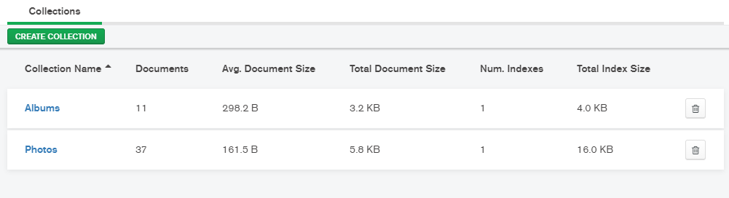

Once set up, you can start working with the application.

# Photo Manager specification

## Navigation menu

Navigation menu contains such items:

* Home
* Albums
* Login, Register links for unauthorized users/ User icon & name for authorized users

## Home

Demo page with a sample photo gallery.

## Authorization

There are login and authorization pages where the user data such as email, password and name is validated.

The user’s email should be unique and the password should contain > 6 symbols.

Once the user is logged in, the user’s name is displayed in the navigation menu.

In order to log out tap the link with the user name.

## Albums

The main page containing the gallery of albums.

It contains the menu with the buttons “View”, “Edit”, “Add” and “Remove” for the authorized users.

There are 2 ways to view the photos in the album:

1. Tap the album cover
2. Select an album (check it off in the left top corner), click “View” button (authorized option)

In order to edit, add and remove albums use the corresponding menu buttons.

On the album editor page you can change the name, description and select the photos to include in the album.

! Please note that the album name must be unique, name and description should not be empty

## Photos

On the album photos page there is a photo gallery and a menu for the authorized users.

There are 2 ways to view the photos in the album:

1. Tap the image
2. Select multiple photos (check it off in the left top corner), click “View” button (authorized option)

There is possible to edit and add multiple photos at once using the same editor.

Within the photo editor there are 2 editing modes, which allow you to set the common photos description on or off.

!Please note that only .jpeg format is allowed, once the .png photo is found, the uploading process finishes.

You can find the sample images for the testing purposes in the ‘/Documentation/Images’ folder.